
Contents
Reflective Commentary………………………………………………………………………………………………………………… 2-5
References…………………………………………………………………………………………………………………………………. 6
Portfolio of Evidence
Evidence 1: Support Connect Information……………………………….……………………………………………………. 7
Section A: Wellbeing Section of Support Connects’ Website…………………………….…………………………… 7
Section B: End of Employment Letter from Support Connect Ltd…………………………………………………... 8
Evidence 2: SCVS Information……………………………………………………………………………………………………… 9
Section A: SCVS Website………………………………………………………………………………………………………… 10
Section B: SCVS Values……………………………………………………………………………………………………………11
Section C: Volunteer Centre & Contact Information……………………………………………………………………. 12
Section D: Email Correspondence Regarding Interview..………………………………………………..…………. 12-13
Section E: Email Correspondence Regarding References……………………………………………….……………. 14
Section F: Training Confirmation………………………………………………………………………………..……………. 15
Evidence 3: Carmarthenshire Youth Support Service Information…………………………………….………………. 16
Section A: Carmarthenshire County Council Job Vacancy Website………………………………..……………… 16
Section B: Applied for the Role………………………………………………………………………………………………… 17
Section C: Invitation for Interview…………………………………………………………………………….………………. 18
Section D: Preparation of Presentation……………………………………………………………………..………………. 19
Section E: Job Offer and Acceptance………………………………………………………………………..………………. 20
Evidence 4: Training and Participation………………………………………………………………………………………….. 21
Section A: Involve Volunteer Training PowerPoint Slides (Day 1)……………………………………..……………… 21
Section B: Involve Volunteer Safeguarding Training PowerPoint Slides (Day 2)………………….………………. 22
Evidence 5: Reflective Logs……………………………………………………………………………………………………. 23-29
References…………………………………………………………………………………………………………………..……………… 30
Appendices………………………………………………………………………………………………………………….……………… 31
Appendix A – Involve Volunteer Handbook…………………………………………………………………………………… 31
Appendix B – Hours Logged………………………………………………………………………………………………………. 32
Appendix C – ReAct Plus Funding………………………………………………………………………………..…………….. 32
Appendix D – Coleg Sir Gar Education & Training Course Level 3…………………………………….…………. 32-33
Appendix E – CPD Courses Completed……………………………………………………………………..……………..… 33

Reflective Commentary
Using Gibbs’ 6-stage Reflective Cycle (1988) as cited by the University of Edinburgh (2020), I will be reflecting upon the journey I have had in relation to the placement element of the counselling module, how it has helped me utilise counselling skills, and the opportunities I have had thus far.
Initially, my placement for this module was to be my place of work, Support Connect Ltd, I felt happy using my workplace as I knew I would support enough clients to practice my counselling and active listening skills and reflect upon areas for development within my skill set. However, in January I found I was being made redundant from my role as a wellbeing mentor due to an issue with the company generating enough work to sustain my role within the organisation.
The announcement of redundancy came as a surprise. Being made redundant was incredibly difficult, upsetting, and something I did not think I would ever have to experience. As stated by MIND (2024), redundancy can cause stress, anxiety and exacerbate existing mental health conditions, whether the redundancy was expected or not. I have been diagnosed with borderline personality disorder back in 2023, therefore experiencing emotions is challenging for me, particularly those that are negative. It was important for me to persevere through the difficulties that were inevitably coming my way. In order to do this, I remained focused on knowing my rights as an employee and researching the amount of notice I should be given by my employer, any pay I should be entitled to, or any time off I should be granted for interviews or meetings. I researched through the ACAS website and Citizens Advice Bureau; I also called them to confirm some information regarding financial concerns.
Upskilling myself has been an integral part of my life and career since I left school back in 2014. It was imperative for me that I continued a journey of self-development professionally. In order to do this, I signed up with Careers Wales for the ReAct+ funding, which would have enabled me to enrol and complete certain courses relevant to my career goals. I spoke with Carly via Teams and started pulling together some ideas of different mental health and wellbeing related courses I would be interested in completing. In completing my research, I found a 16-week education and training level 3 course held in Coleg Sir Gar which I became interested in completing as well as a youth work qualification, however, I required a placement working with young people. I signed up for the education and training course to begin on 31st January, which unfortunately became postponed two days prior to the start date. I felt deflated and disappointed. Ingram (2020) stated redundancy has been known to cause a wide range of emotions in people, including guilt, shame, embarrassment, self-doubt, rejection, and feelings of failure. Shock and denial are typical reactions to a sudden redundancy, and they are frequently accompanied by resentment and rage. I found employment before I could draw down any React Plus funding, therefore, this did not materialise. This frustrated me as I spent a lot of time waiting for my Careers Wales worker to prepare my documentation to access the funding, however, on the other hand, I was thrilled I was able to gain employment.
To maximise any potential interest from employers, I completed a CPD course on exercise and mental health and a youth work level 3 diploma qualification (appendix E). I thoroughly enjoyed both CPD courses and enhanced my knowledge and understanding of youth work, what it entails and what skills I need in order to succeed in the role, such as being supportive, setting boundaries, listening, and offering support and guidance. I found the courses interesting and was able to use them as a unique selling point in my interview, which I feel attracted my new employer. Research by Rodd and Stewart (2009) suggests youth workers have multidimensional relationships with young people, have an educational influence and therapeutic value. Furthermore, it is considered that these connections are essential to the way youth workers interact with adolescents.
In the interim, I found Swansea Centre for Voluntary Services (SCVS) through university. After some research, I decided to contact the organisation to express an interest in volunteering. According to the Welsh Government (2023), only 30% of people volunteered in 2022-23, which also states 37% of those who volunteer have a higher-level educational qualification. I volunteered some 10 years ago and thoroughly enjoyed my time. Volunteering with a wellbeing project helping others would have been a great opportunity for me to showcase and practice my counselling and active listening skills. Martin (2024) stated training for a volunteer role in an organisation will help hone core competencies and expand existing counselling expertise and practical skills. I was hopeful there would be a chance to practice client interactions post training so I could further enhance my skills prior to the assessment in class.
On 21st January, I found some employment vacancies with Carmarthenshire County Council, one role as a Universal Health and Wellbeing Worker, another as a Homelessness Worker, and the third as a College Based Youth Worker. I applied for all three roles. On 8th February, I had an interview for the Universal Health and Wellbeing Worker role and was offered the job straightaway. I also had an interview offer for 9th February for the College Based Youth Worker role and an interview on 15th February for the Homelessness Worker role, both of which I decided to decline after being offered the initial role. Securing employment made me feel elated. I felt incredibly proud of myself for remaining determined, focussed, and hardworking throughout such a challenging time.
On 22nd January, I had my informal interview with Emma from SCVS to discuss my experience and skills, why I want to volunteer, and what my interests are to best match me with a suitable person in need of a volunteer. I felt apprehensive prior to the interview, but Emma made me feel comfortable and informed me it would be fairly informal. Jones & Pinkney (1989) as cited in McCarthy & Goffin (2004) stated applicants usually have little control over employment interviews, and this can make them feel more anxious. Heimberg, Keller, & Peca-Baker (1986) as cited in McCarthy & Goffin (2004) said given that a job interview is a highly evaluative situation, it is not surprising anxiety is a natural part of the process.
I was invited to two training sessions with SCVS on 20th and 27th February which I had to complete prior to being able to start volunteering. I learnt a lot about the organisation during the sessions and found the safeguarding training informative. Since completing the training, I have not had any communication with the staff from SCVS and as a result have not been able to begin volunteering. I have found this particularly frustrating as I was relying on this placement to upskill myself and provide me with a space to practice my counselling skills for this module.
On 15th April I began my new employment with Carmarthenshire County Council’s youth support service and have thoroughly enjoyed my first week. The new role is going to provide me with new opportunities to practice my active listening, supporting, and other counselling skills in order to continually develop as a youth worker and professional. My new role will be to attend youth clubs and provide health and wellbeing support to children and young people. I will also be supporting in activities and residential visits whereby my safeguarding knowledge and skills will become imperative.
Throughout this process I have developed my counselling skills, attending skills, organisational skills, safeguarding skills, confidentiality skills, communication skills and my overall transferable skills, by designing and completing a presentation for my interview (section D of evidence). I have shown I am diverse and can react and adapt to any situation.
If I was to redo this module, I would have liked to have not been made redundant as this would have allowed me to practice my skills learnt in class, additionally, it would have provided me with feedback from my clients and ways in which I could develop my skills further. Upon reflection, I feel I handled the whole process extremely well considering the challenges I have faced during the module. I have learnt how strong I am as an individual, and how resilient I am towards change and working through difficult situations. Financially, it has been significantly challenging too, but I have always found a way to remain positive. I have exceeded the expectations of myself and others around me as others expected me to fail or need therapeutic support.
My action steps moving forward are to continue to contact SCVS for an opportunity to volunteer and help in the community, continue to train, and upskill by completing a food hygiene qualification, lowland leader course, and a coasteering leader course in work. I will continue to improve my active listening skills and communication skills by building good rapport with the children and young people I will now be working alongside.

References
Gibbs, G. (1988). Learning by doing: A guide to teaching and learning methods. Further Education Unit. Oxford Polytechnic: Oxford.
Igram, C. (2020). 6 ways to cope with the mental health impact of redundancy. https://welldoing.org/article/6-ways-cope-mental-health-impact-redundancy#:~:text=Individuals%20have%20reported%20many%20reactions,combined%20with%20anger%20and%20resentment.
McCarthy, J., & Goffin, R. (2004). Measuring job interview anxiety: beyond weak knees and sweaty palms. https://doi.org/10.1111/j.1744-6570.2004.00002.x
MIND. (2024). Coping with redundancy. https://www.mind.org.uk/workplace/mental-health-at-work/coping-with-redundancy/#:~:text=Whether%20expected%20or%20sudden%2C%20redundancy,existing%20mental%20health%20problems%20worse
Rodd, H. & Stewart, H. (2009). The glue that holds our work together: the role and nature of relationships in youth work. https://search.informit.org/doi/epdf/10.3316/ielapa.334710730515201
University of Edinburgh. (2020). Gibb’s Reflective Cycle. https://www.ed.ac.uk/reflection/reflectors-toolkit/reflecting-on-experience/gibbs-reflective-cycle
Welsh Government. (2023). Volunteering (National Survey for Wales): April 2022 to March 2023. https://www.gov.wales/volunteering-national-survey-wales-april-2022-march-2023-html#:~:text=clubs%20or%20organisations.-,Main%20findings,being%20male

Portfolio of Evidence
Evidence 1: Support Connect Information
Section A – Wellbeing Section of Support Connect Website
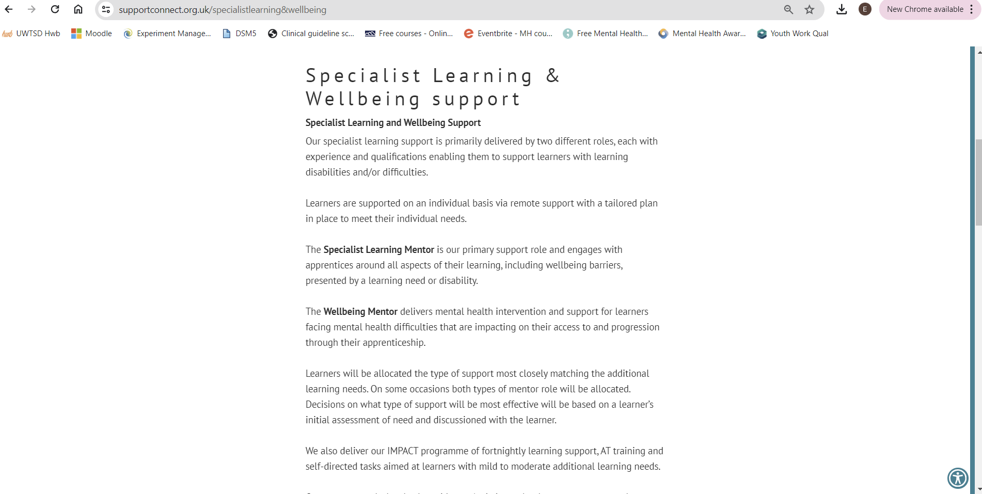
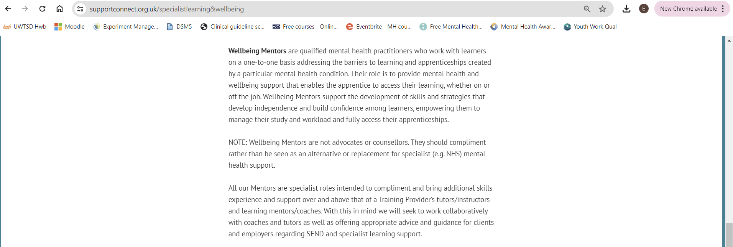
This section of the Support Connect website provides the apprentice, training provider, or family members with helpful information on the skills of the employees and the types of issues the wellbeing mentors can assist with. This role provided me with daily opportunities to practice my empathic listening skills, communication skills, and counselling skills. I would provide mental health and wellbeing support, strategies and advice to apprentices aged 16 and above. I was supporting those with family, financial, mental health, and neurodiversity difficulties. I undertook further training about neurodiversity and found this useful to use in my practice, for example, providing them extra time to answer questions, repeating tasks, breaking down chunks of information, and not asking too many questions. This enables the individual to communicate better.

(Support Connect, 2022).
Section B - End of Employment Letter from Support Connect Ltd.
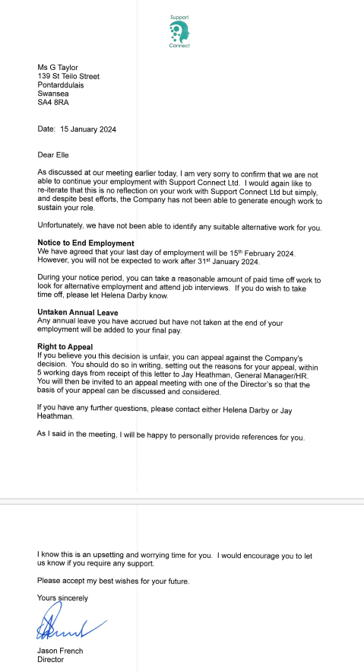
On 15th January 2024, I received this letter following a meeting discussing terminating my employment with Support Connect due to a lack of work generated by the company. This was an extremely upsetting time for me; however, I was determined to make a success of my new found unemployment and made it my primary focus to find a new position elsewhere.

Evidence 2: SCVS Information
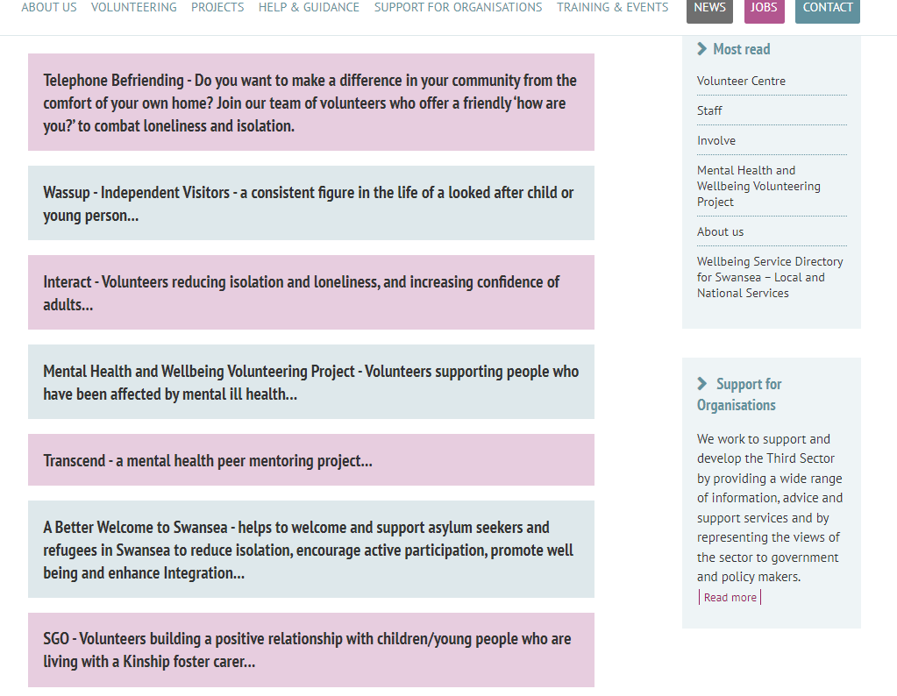
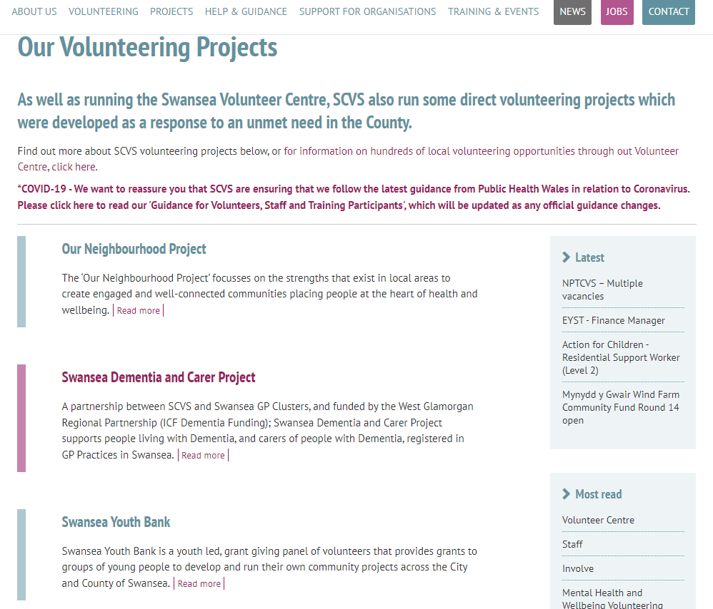
Section A – SCVS Website
The SCVS website is how I found the Involve projects. The website was easy to navigate and gave me some important information.
Upon initial research the Transcend and Mental Health and Wellbeing projects were the ones I decided to enquire about. However, Wassup is the project I have taken a particular interest in since the training and is the project I have requested to volunteer with.

(Swansea Centre for Voluntary Services (SCVS), 2015)

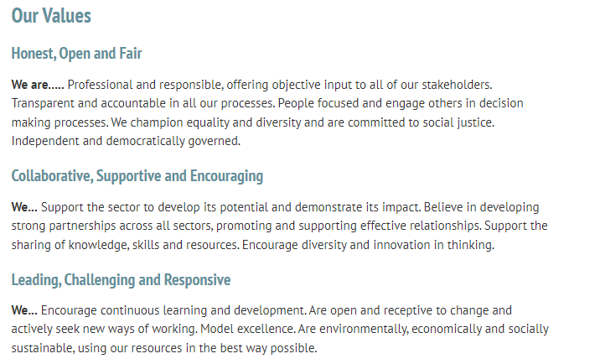
Section B – SCVS Values
The values of the organisation are important to me as I want to feel supported and be treated well by others. I wanted the values to align with my own when professionalism and skills are involved. This section of the website made me feel confident in my decision to move forward in contacting SCVS.

(Swansea Centre for Voluntary Services (SCVS), 2015)

Section C – Volunteer Centre & Contact Information
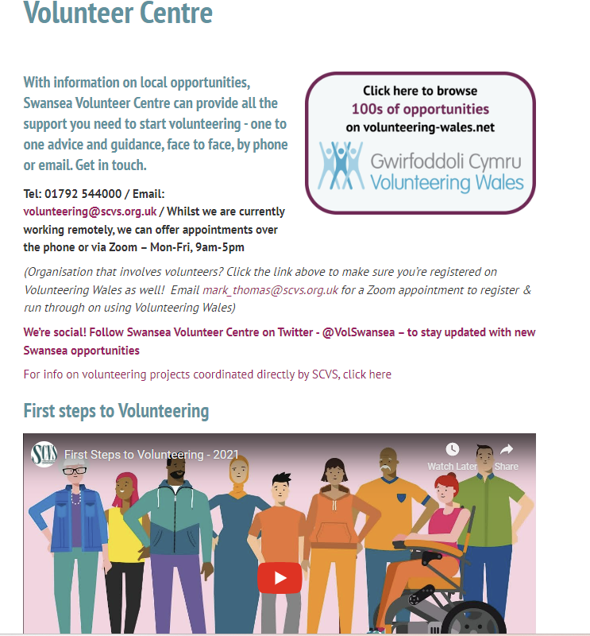
I used the contact details listed to e-mail the team to register my interest in volunteering.
I watched the 5-minute video on the First Steps to Volunteering and found this helpful. It gave me information to consider when making my decision and gave me an idea of what the volunteering could involve.
I particularly liked the section which stated how it will impact the individual as well as the volunteer.
I am a visual learner, therefore having the visual video tool was easy for me to understand.

(Swansea Centre for Voluntary Services (SCVS), 2015)

Section D – Email Correspondence Regarding Interview
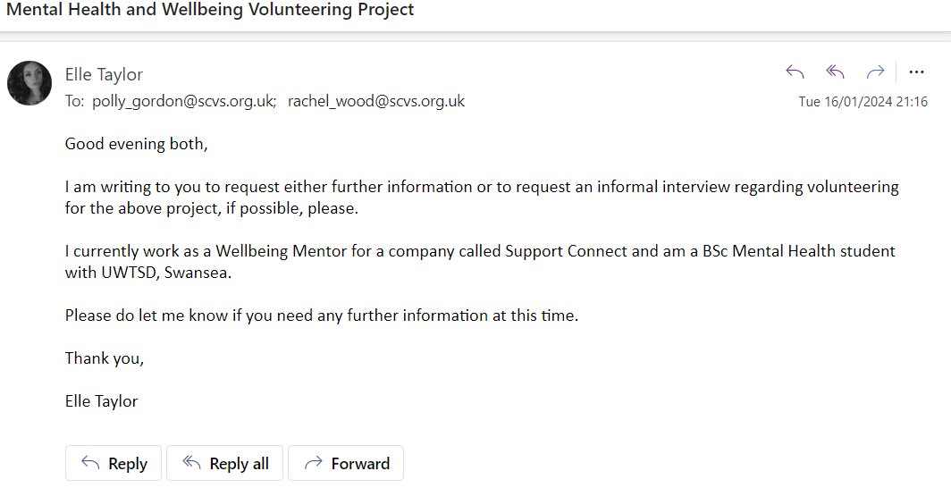
These emails show the initial correspondence I had with SCVS. I sent the emails on 16th January 2024 expressing my interest in two projects – Mental Health and Wellbeing and Transcend. I chose to email regarding these projects as they seemed to be the closest ones to my line of work as a Wellbeing Mentor. However, after the training I decided to follow a different path as I had been successful in gaining employment as a Youth Worker so felt working with younger children on the Wassup project would be more suitable.
The following emails are the chain between Emma and myself arranging my interview.

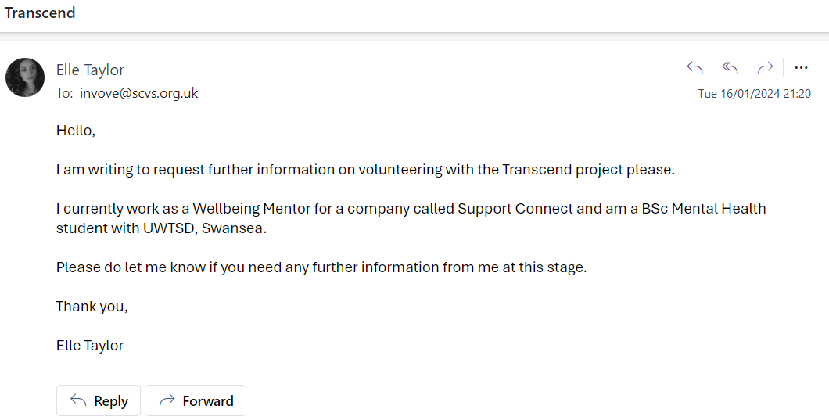

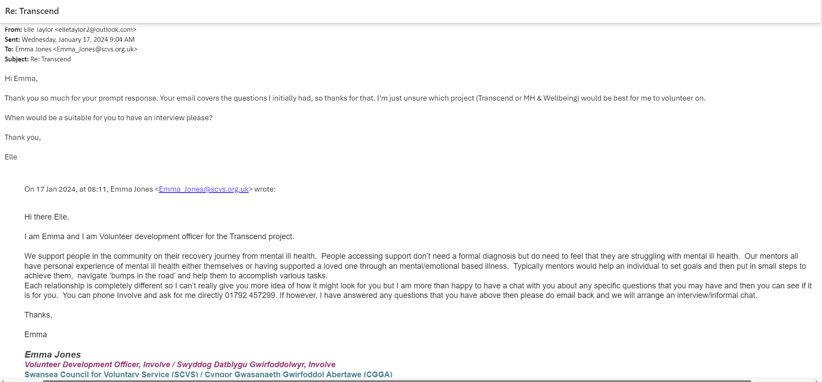

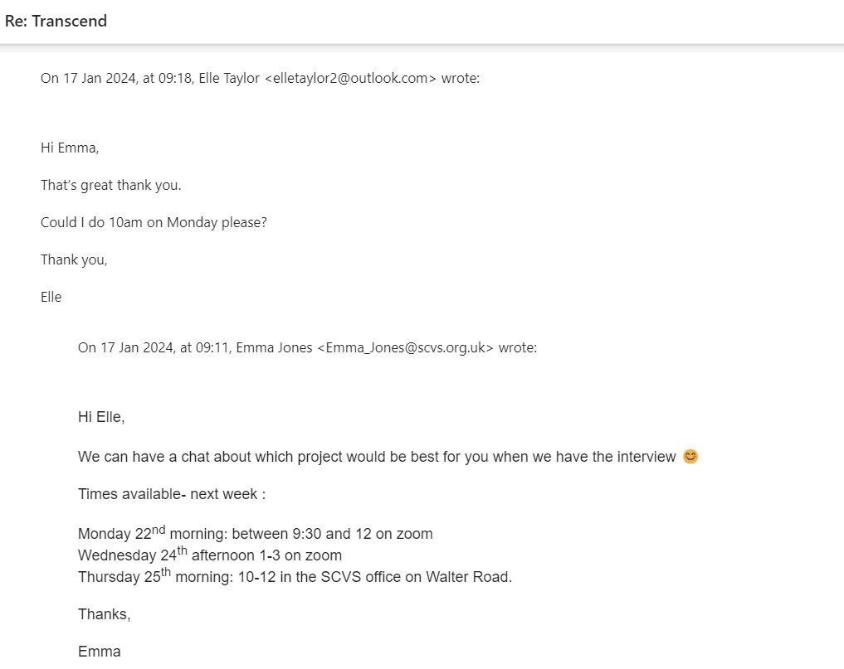

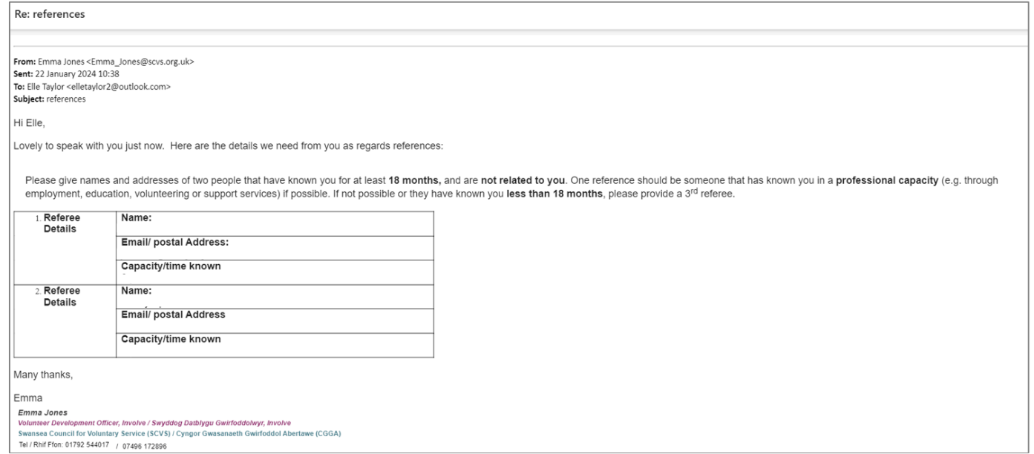
Section E – Email Correspondence Regarding References

During the interview, Emma said I would be required to submit two references for pre-volunteering checks. Post-interview, she sent me the email and I replied straightaway in order to try and move the process on as quickly as possible.

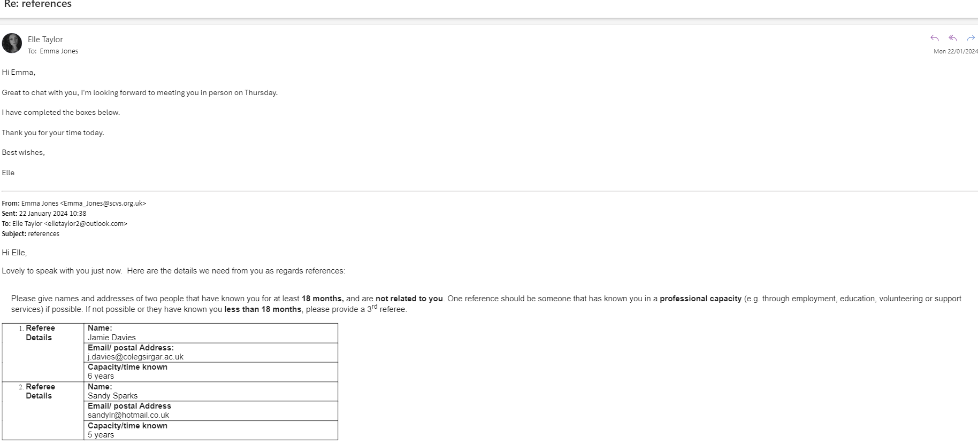

Section F – Training Confirmation
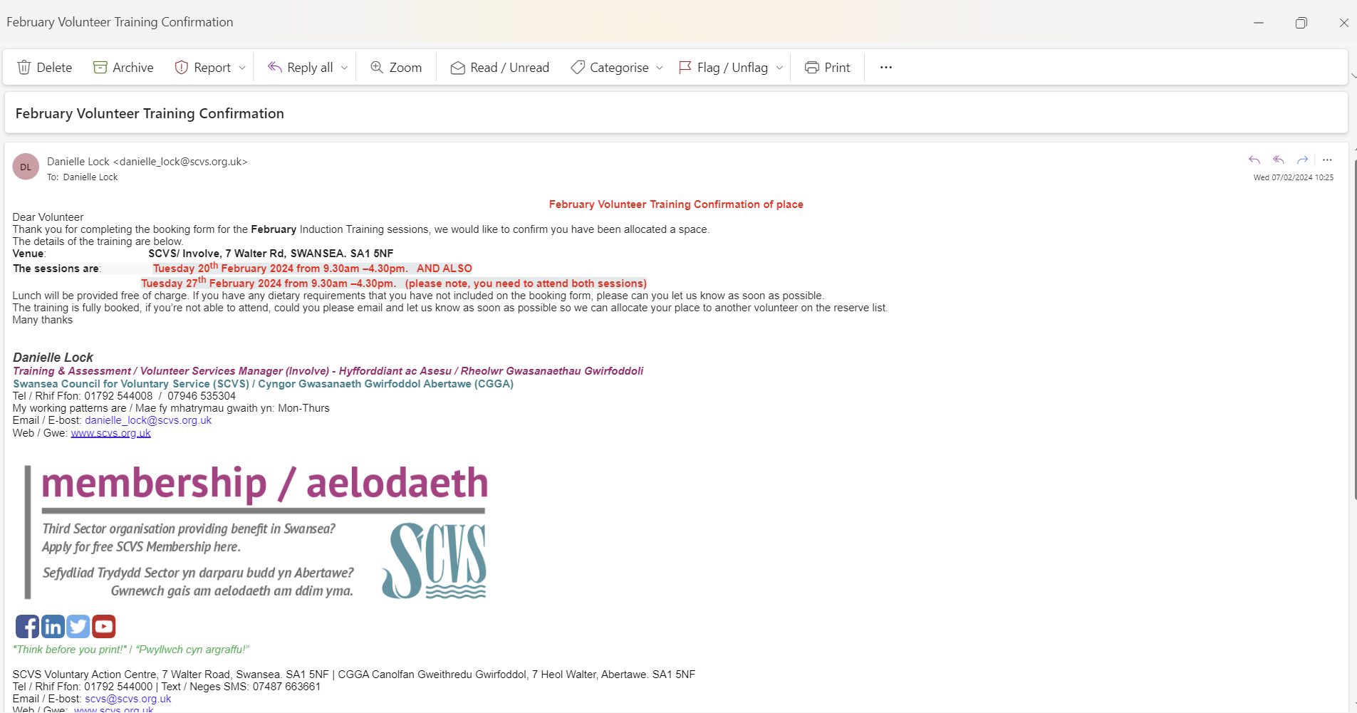
Danielle from SCVS sent me an email confirmation of my space for the February training sessions. In order to pass the training, I needed to attend both training sessions held on 20th and 27th February.

Evidence 3: Carmarthenshire Youth Support Service Information
Section A – Carmarthenshire County Council Job Vacancy Website
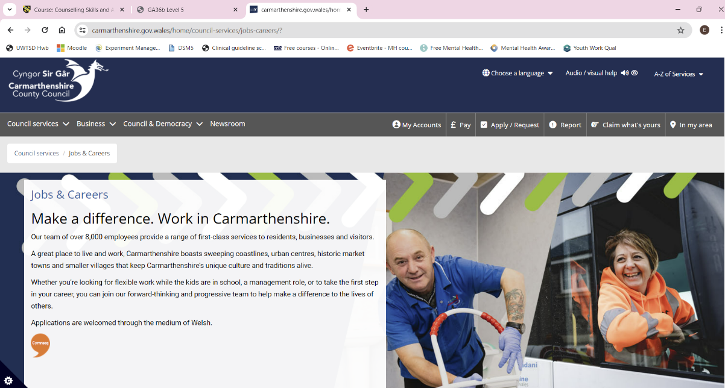

(Carmarthenshire County Council, 2024).

Section B – Applied for the Role
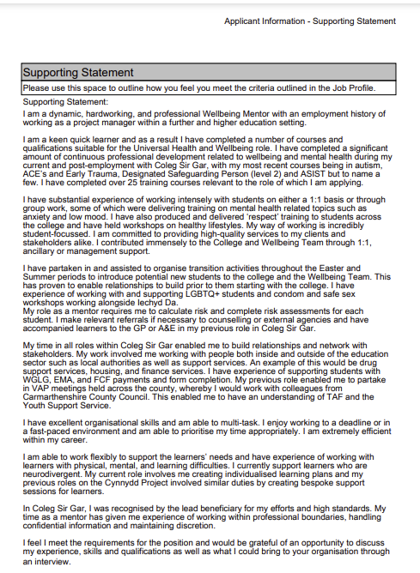

The supporting statement forms part of the application form I submitted in order to apply for the role of Universal Health and Wellbeing Worker with Carmarthenshire County Council. I tried to ensure I wrote about my skills, experience and behaviour which would make me a good candidate for the role.

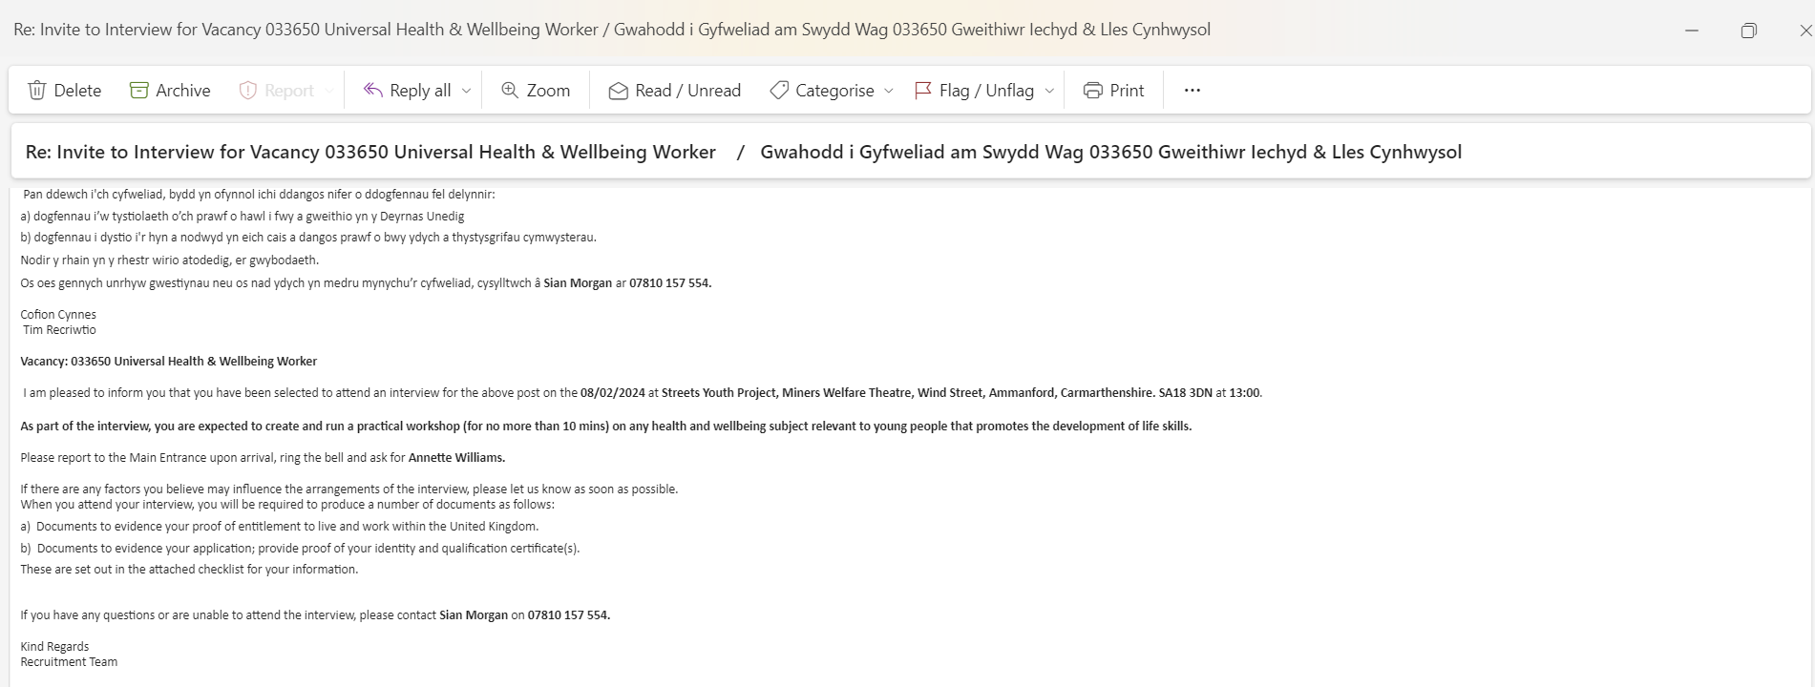
Section C – Invitation for Interview
On 25th January I received the email above inviting me for an interview for the post. The interview was scheduled for 8th February. I was required to produce a practical workshop relevant to young people which promoted the development of life skills. After much deliberation and thought, I chose to focus my presentation on sexual health.

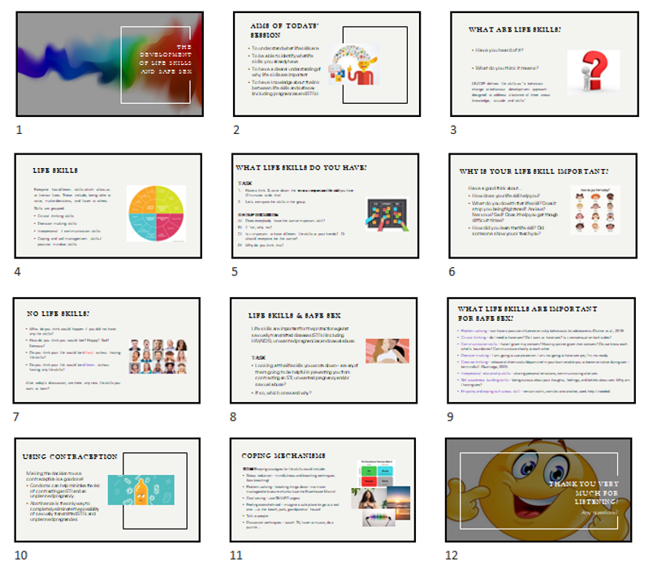
Section D: Preparation of Presentation
In order to prepare the presentation for the interview, I called upon my previous experience and knowledge from sexual health courses I have completed. I also conducted some research on ‘life skills’ to ensure I was capturing the correct information. This presentation was hugely important to me as was succeeding in the interview, due to my passion for wanting to continue working with children and young people facing challenges and difficulties. I spent a lot of time preparing the presentation to ensure it was fluid and professional.

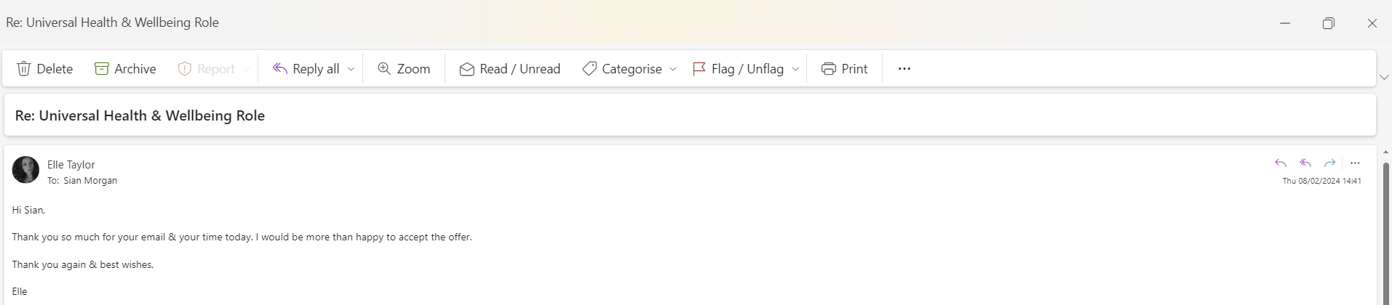
Section E: Job Offer & Acceptance
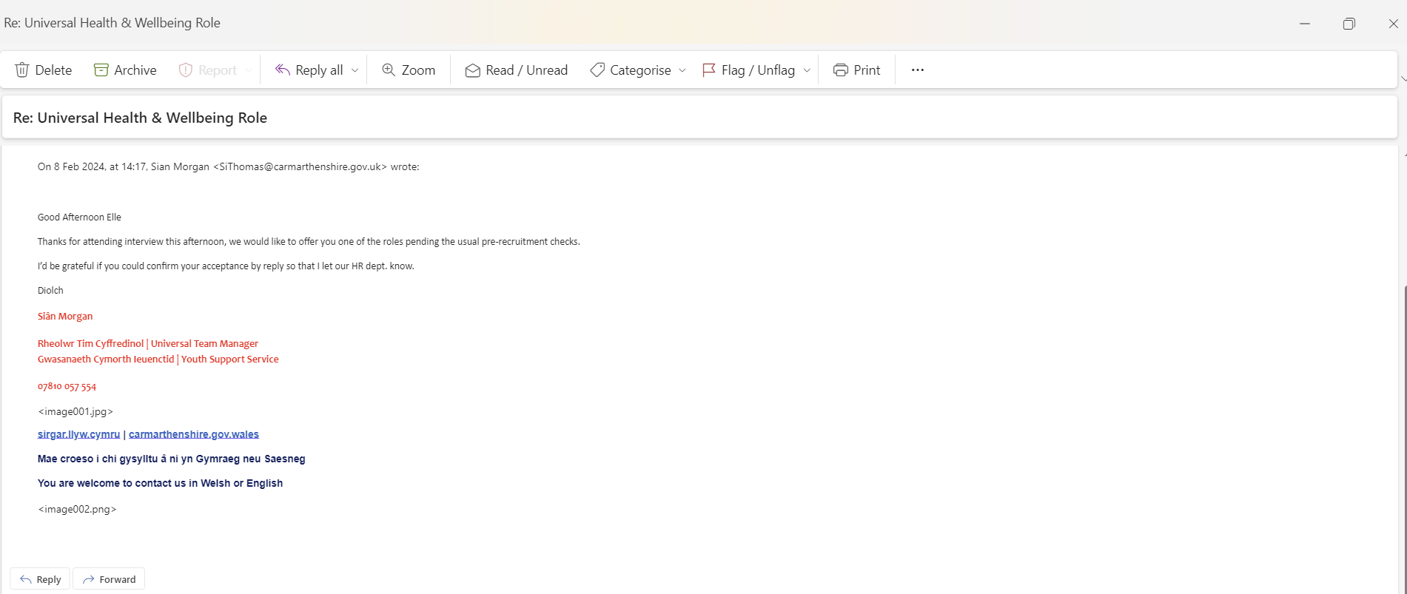
45 minutes post-interview, Sian called me and offered me the position. She followed the call up with an email to officially have the offer and acceptance in writing. I felt relieved to have secured employment and thrilled the interview process went as successfully as I’d hoped. I was looking forward to beginning my new employment. I had pre-employment checks to complete and had to apply for an enhanced DBS check. I returned and submitted all the required documentation as I was hoping to be in post relatively quickly, however, the process did take over two months in total.

Evidence 4 – Participation and Training
Section A: Involve Volunteer Training PowerPoint Slides (Day 1)
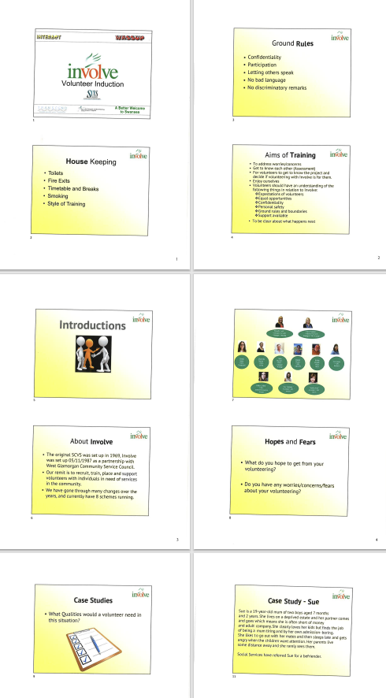

The PowerPoint slides were presented to us during day 1 of the SCVS training. This training session was more interactive which I enjoyed.

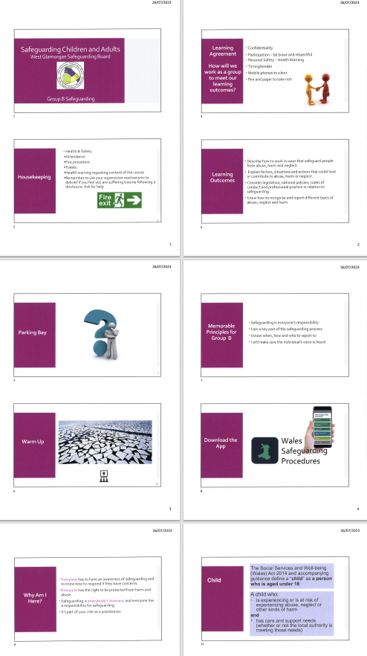
Section B: Involve Volunteer Safeguarding Training PowerPoint Slides (Day 2)

The safeguarding PowerPoint slides were presented to us during day 2 of the SCVS training. I found this session difficult to engage with as I have already covered safeguarding training in previous posts and it was not very interactive, additionally, there was a lot of information to take in.

Evidence 5 – Reflective Logs
The entries from the reflective logbook relating to the organisations can be found below. The logs detail different tasks I undertook as part of the assignment and reflect upon my thoughts, feelings, actions, and emotions during the process.
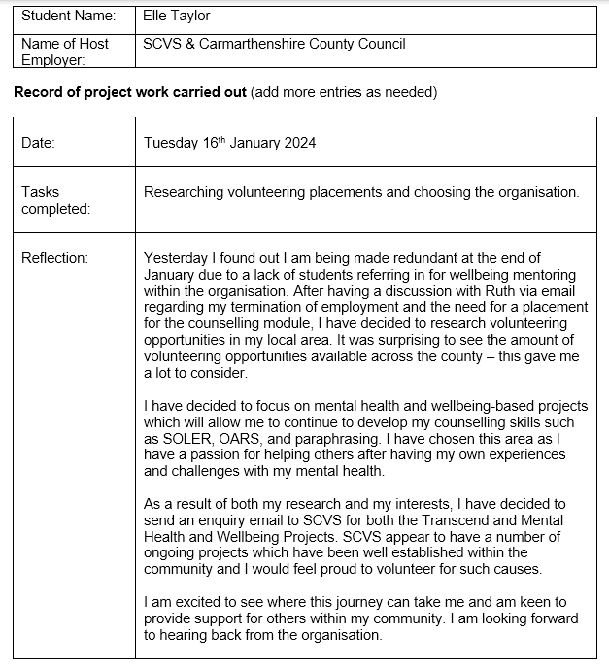
1)

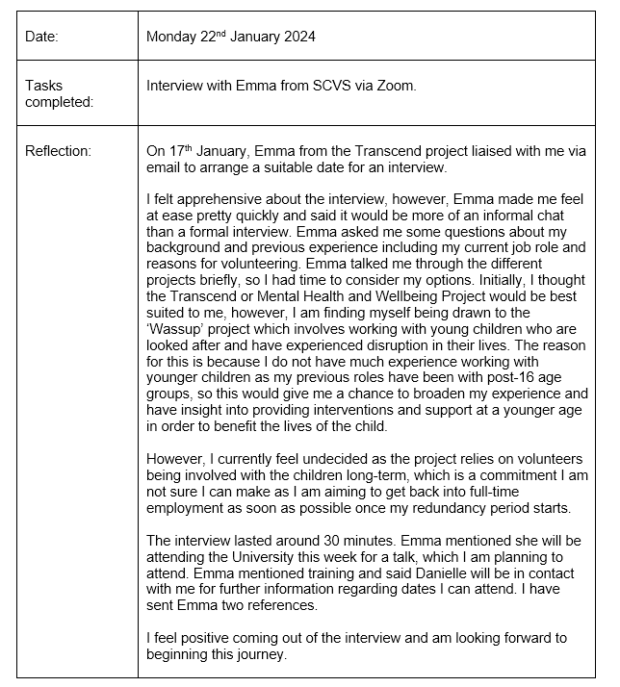
2)

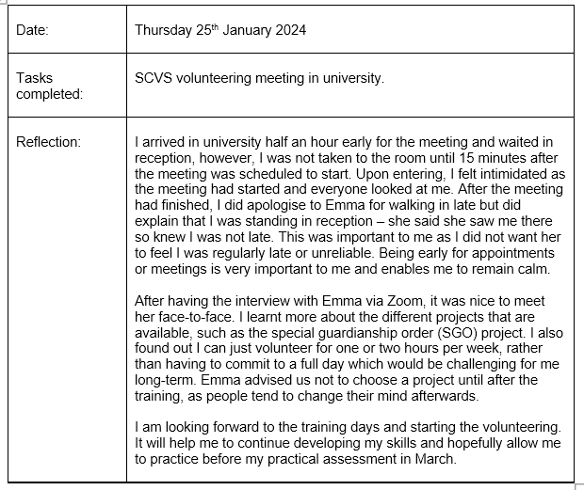
3)

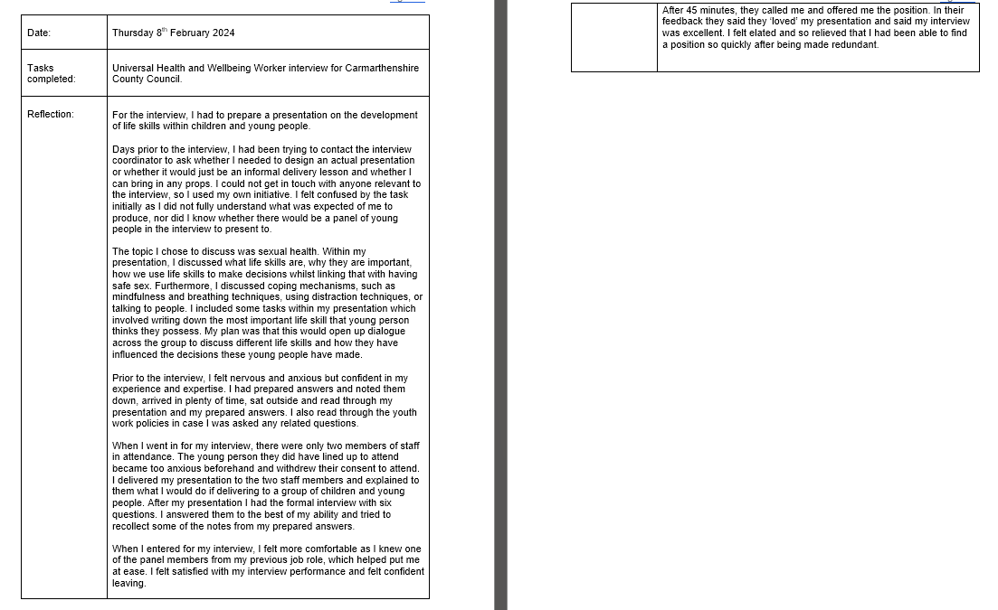
4)

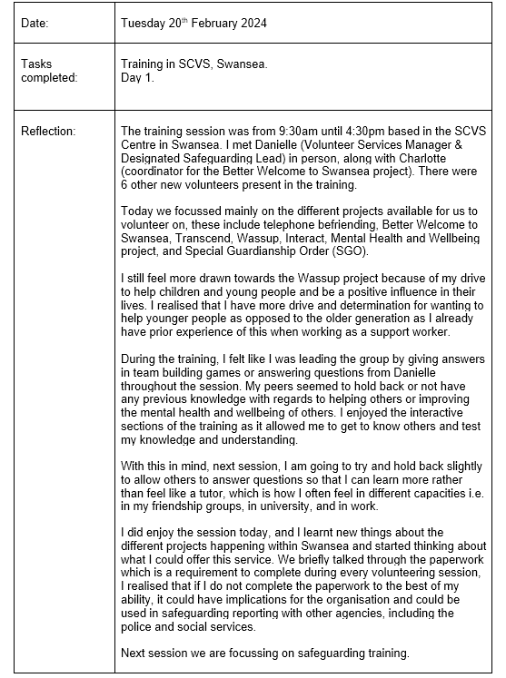
5)
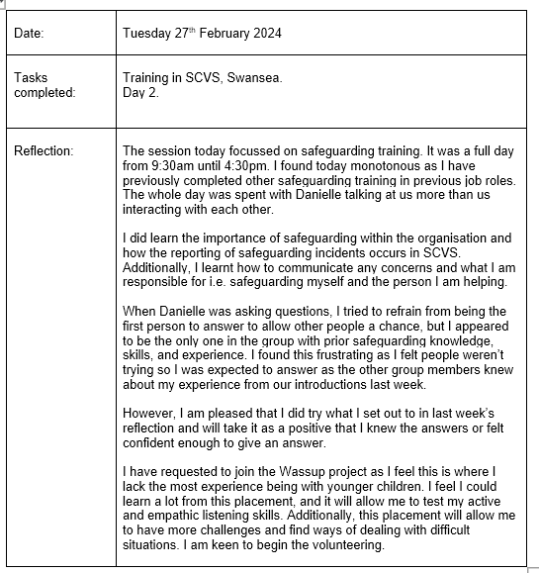
6)

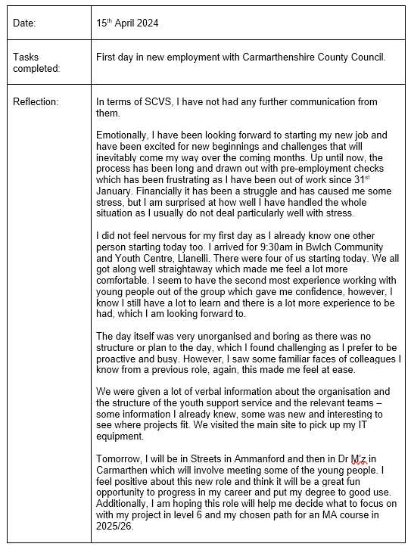
7)

References
Carmarthenshire County Council. (2024). Jobs and Careers. https://www.carmarthenshire.gov.wales/home/council-services/jobs-careers/
Support Connect. (2022). Specialist learning and wellbeing support. https://www.supportconnect.org.uk/specialistlearning&wellbeing
Swansea Centre for Voluntary Services. (2015). Involve. https://www.scvs.org.uk/involve

Appendices
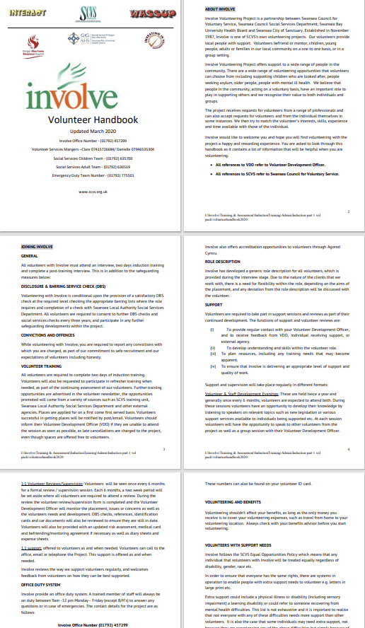
Appendix A – Involve Volunteer Handbook

Appendix B - Hours Logged
Agenda / Task | Number of Hours
Time spent researching volunteering organisations | 2 hours
Time spent applying for employment opportunities | 4 hours
Interview with Emma from SCVS | 30 mins
Volunteering meeting at university | 1 hour
CPD completion | 5 hours
Time spent preparing for interview | 4 hours
Job interview with Carmarthenshire County Council | 1 hour
SCVS training day 1 | 7 hours
SCVS training day 2 | 7 hours
First day in new employment | 7 hours
Total hours | 38.5 hours

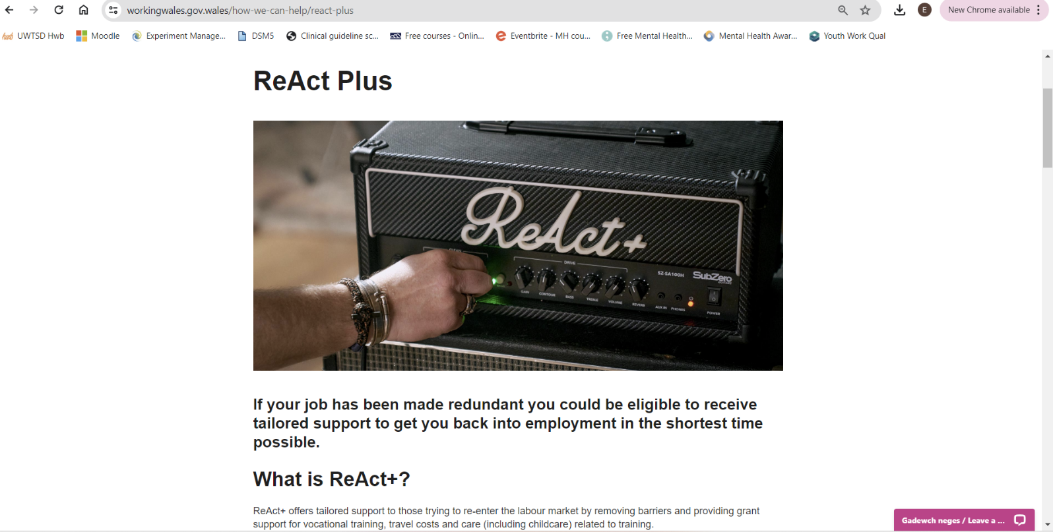
Appendix C – ReAct Plus Funding

Appendix D – Coleg Sir Gar Education and Training Level 3 Course
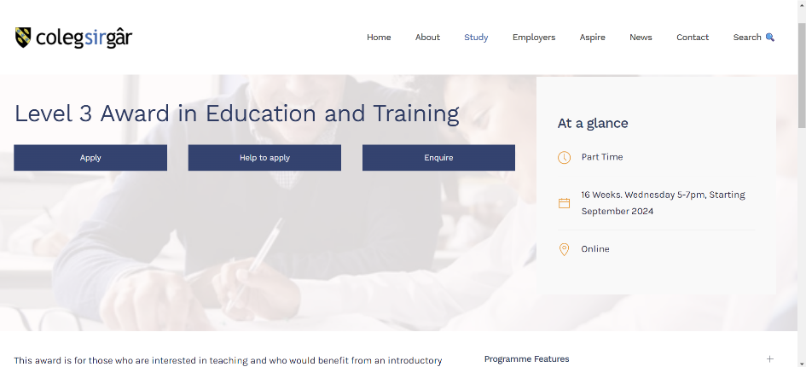
Screenshot of the Coleg Sir Gar website for the level 3 award in education and training qualification I have enrolled on which will begin in September.

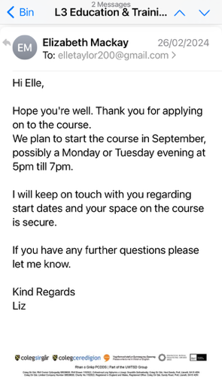
Confirmation email from the course coordinator in Coleg Sir Gar stating my place on the course is secure for September.

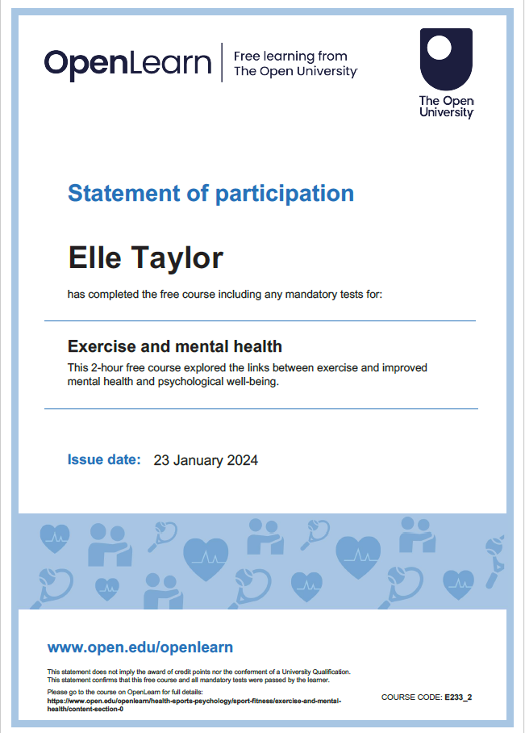
Appendix E – Completed CPD


