Module number: LCBB6004
Module name: Strategic Management and Sustainability
Title of the assessment: Assessment 1 – Case Study: Volkswagen
Student name: Alexandru Ionut Stefaroi
Student number: 1914985
Submission date:16.09.2022

Introduction
Strategic business management is focusing on the future of an organisation regarding all the aspects to improve its activity, but also to align to the current and the future business environment trends. Developing a strategy is crucial for a business, therefore all the aspects need to be analysed, such as the past performance of the company, also the lesson learnt in the past, thus in this way a new business strategy can be created (Lynch, 2018). This report is focusing on a case analysis of Volkswagen where the business environment and its strategy is analysed to evaluate the business activity in the past and how this is influencing the future of the organisation. Additionally, this report aims to present the key business strategies of the case study of Volkswagen in the past five years, also highlighting the resources and capabilities of the company to align with the current business environment trends. Furthermore, the report will be analysing the level of the competitivity of the business and its adaptability in developing a sustainable strategy and protecting the environment. Also, the report will provide further recommendations for Volkswagen to develop new sustainable practices that will help the business to achieve its objectives also protecting the environment.
Company Background
Volkswagen Group represents one of the worldwide leaders in car manufacturing, which was founded in 1937 in Germany and became a multinational automotive company. Over the years the company has extended and currently there are around 662,575 employees in all the companies around the world (Volkswagen, 2020). The business strategy was to create and expand the newest technology in the car industry, therefore the company has become an important player in the car market. Also, the finances of this business shown how successful the company is as per the latest report in 2021 shows a profit of EUR 250.000 million (Volkswagen, 2021). Volkswagen had shown that 2021 was a successful year as the revenue was higher than the previous year, therefore the business is expecting in 2022 that the sales will be increased with 7 percent to 8,5 percent. In regards of the dividends the Volkswagen Board Members had decided that will be increased to EUR 7.50 per ordinary share (Volkswagen, 2021). According to Statista (2022), the market share for Volkswagen is around 11.78 percent in United Kingdom and this data shown (See Appendix, Figure 1) that there was an increase since the diesel scandal, therefore it can be said that the company strategy is successful and sustainable in the car industry. This company has developed many strategies that aims to increase the company profits; however, the diesel scandal was one of the biggest issues that the business had faced, and the company had to reamend its strategies and plans in order to be able to compete with the other car manufacturers. Creating new strategies in a car industry was a challenged task for Volkswagen as many structures and systems had to be reconfigured to still be able to activate in the car industry (Painter et al, 2017). In order to develop new strategy, the business had to evaluate different factors that affected the company following the diesel scandal.
Key Business Strategies of Volkswagen
Volkswagen emission scandal was the key factor that, in a way, forced the business to create new strategies and regain its popularity within the car marketplace (Barth et al, 2022). However, in order to change its business policy, the company had to analyse different external factors that influence the business by using Porter’s generic strategies as source of competitive strategy.
Following the emission scandal, Volkswagen had shaped the strategy in the past five years strategically to still be able to compete in the car industry market, therefore the business had focussed its attention onto the cost leadership. The business brought new concepts of cars and the manufacturing cost has been efficiently managed, also the new system introduced of eco-friendly cars highlighted the determination of this company to succussed in this business environment (Hanno et al, 2019)
Another factor that influenced the business strategy is the differentiation from the other competitors in the market, therefore Volkswagen had developed new car with unique specifications that aimed to regain the leading role in the car industry. All the strategies developed after the emission scandal had been focused on producing eco friendly products (Hanno et al, 2019). Another aspect of differentiation of Volkswagen is the marketing strategy the company developed it, where one side was to re-gain its popularity and o the other side to promote the newly created products (Volkswagen, 20202). The key strategy of Volkswagen helps the business to develop and revamp its activity following the emission scandal and the financial and reputation loses of the business.
Resources and capabilities of Volkswagen
The resources and capabilities of a business contributes to the long-term company strategy and potentially to compete advantages. In order to highlight if the resources and capabilities are aligned to the business strategy a SWOT analysis needs to be developed to understand the business needs and the area where the company is successful. The strength of Volkswagen is that the company was one of the most important players in the car industry, therefore despite the diesel scandal, the company still has a good position in this industry (Volkswagen, 2020). Regarding the weakness of the company is the high competition that is facing, especially with the diesel scandal, therefore the company lost its leading place in the car industry (Hassan, 2019). The opportunity that Volkswagen has is the innovative designs that was introduced by the company, which put the business in the front of the other competitors when it comes to the technology that the organisation is offering (Hanno, 2019). Furthermore, the threats that the company is facing are the external factors such as: the other electrical car manufacturing may be offering high quality products which may affect the sales of the Volkswagen.
SWOT analysis provides a clear view of how the resources and capabilities are used by Volkswagen; therefore, it could be observed that the business strategies have been aligned with the company resources.
UK Automobile industry and Volkswagen
Volkswagen is an important competitor in the car industry in UK, therefore is important for the business to align its resource and capabilities with the current environment trends. In order to understand the current tends and to establish future plans the business needs to identify several factors that may affect the business activity in present and future. PESTLE analysis provides a clear view for Volkswagen and can establish its new strategies based on the factors analysed.
The political and legal environment factor aims to refer to the numerous regulations introduced by the governments; therefore, Volkswagen needs to adapt is strategy accordingly to the regulations, especially to the products that are affecting the environment. In this case the company needs to remove those products from the manufacturing and new products needs to be developed, which it may cost the company extra money (Saric et al, 2020).
The economic environment represents a key factor for Volkswagen, as the car industry is a key industry for UK, therefore helps the economy to also grow the business revenue (Saric et al 2019). By manufacturing cars, Volkswagen offers the opportunity to other industries to develop, such as the glass and steel production, thus increasing the economy level into other industries.
In regards of the sociocultural environment, Volkswagen had lost in this area, and this is due to the trust and credibility from its customers, and this is referring to the diesel scandal. Additionally, worldwide has been noticed an increased focus on protecting the environment, thus Volkswagen is facing a negative effect due to its past issues. The company needs to carefully analyse this sociocultural factor and create new plans that aims to satisfy the customer’s needs, protecting the environment and improving its reputation within society (Saric et al, 2019).
Furthermore, the technological environment is an area where Volkswagen needs to carry out in depth research and adopt new strategy to develop innovative technology and to provides the best services for their clients. Currently the technology has the most innovative ideas which makes the customers to buy the newest products and have the most up to date technology, thus the business must change its strategy and develop unique products (Saric et al, 2019).
PESTLE analysis helps the company to understand the business environment and the customers’ needs in order to become the most successful organisation in the car industry.
Recommendations of sustainable business practices for Volkswagen
The current trends of car industry environment are tending to become more eco-friendly, therefore the business needs to change their strategies to be able to achieve their objectives. In the case study of Volkswagen, there are multiple ways that the company needs to address. One of it is to develop products that are not affecting the environment by using more electricity and reducing fuel fossils (Volkswagen, 2021). Also, the company needs to focus on the younger generation needs in order to become sustainable and have customers in future, by creating cars that protecting the environment, also a high quality of the technology. In order to become more competitive, Volkswagen needs to carefully analyse its competitor’s activity and following this the company needs to create better products that their competitors cannot achieve. Additionally developing a strategy sustainability will help the business to develop new policies that are targeting the clients, but also the employees , thus the company will be changing internally and it will obtain great results externally, where te clients will have better products (Volkswagen, 2020).
Conclusion
To conclude, this business report of Volkswagen highlighted that having a well develop strategy helps the business to accomplish it objectives and meet the customers needs. The key strategies play an important role in the development Volkswagen in the car industry, therefore the business will be able to become again one of the top leaders in this industry, while is recovering from the diesel scandal. Understanding the internal and external factors provides to Volkswagen essential information’s that could be used in the new plans that ais to innovate the car industry. Also developing a sustainable strategy, Volkswagen will be able to become one of the most modern companies that produces eco-friendly cars.

Reference list
Barth, F., Eckert, C., Gatzert, N. and Scholz, H. (2021) ‘Spillover Effects from the Volkswagen Emissions Scandal: An Analysis of Stock and Corporate Bond Markets’, Journal of Business Research, 74, pp.37-76.
Hanno, M. and Akinsaya, D. (2019) ‘A Real Time Case Analysis Volkswagen’, Research Gate, pp.1-24.
Hassan, A. (2019) ‘Evaluating the Marketing Communication Strategy of Volkswagen in Post-Crisis Period: Application of Image Repair Theory’, International Journal of Marketing Studies, 11(2), pp. 87-101.
Lynch, R. (2015) Strategic Management. 7 ed. Harlow: Pearson Education Limited.
Painter, C. and Martins, J. (2017) ‘Organisational communication management during the Volkswagen diesel emissions scandal: A hermeneutic study in attribution, crisis management, and information orientation’, Wiley- Research Article, 24, pp.204-218.
Saric, M. and Rosi, B. (2020) ‘SWOT and PEST Analysis of the Volkswagen Group’, Scholar Journals of Arts, Humanities and Social Arts. pp.414-419.
Statista (2022) ‘Volkswagen car market share in the United Kingdom from December 2016 to December 2020’. Available at: • UK: Volkswagen car market share 2016-2020 | Statista (Accessed date: 2.09.2022).
Volkswagen (2020) ‘Sustainability Report’, Available at: Nonfinancial_Report_2020_e.pdf (volkswagenag.com) (Accessed date: 1.09.2022).
Volkswagen (2021) ‘Volkswagen Group achieve solid results in 2021 and drive forwards its transformation to NEW AUTO’. Available at: Volkswagen Group achieves solid results in 2021 and drives forward its transformation to NEW AUTO (volkswagenag.com) (Accessed date, 2.09. 2022).

Appendix
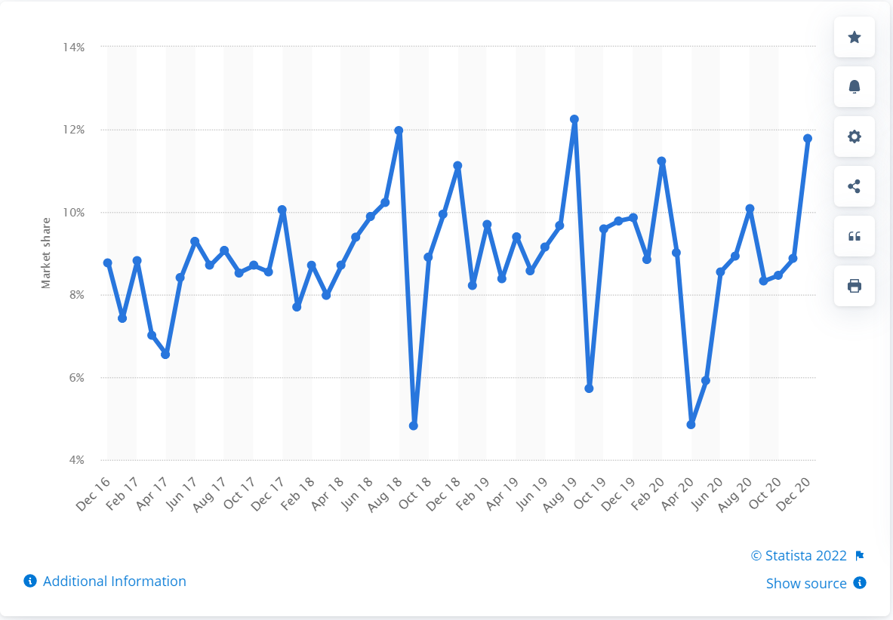
Figure 1

