Application Development (Web)
  - Lecture 8a Lab Tutorial Exercise

Searching and Paging: The Models

Objectives
The aim of this lab exercise is to create the models and views that will be used to apply searching (filtering) and paging functionality.

The Model Classes
First, you need to create some enums.
An enum (enumeration type) contains a fixed set of named constants. If you think of the days of the week, there can only ever be seven, so you can use an enum to define these. Each value is separated by a comma(,) and maps to an integral value. The first item is usually 0, and the other values increase by one i.e. 1, 2, 3. You can also specify other values.
enum Days
{
Sunday,
Monday,
Tuesday,
Wednesday,
Thursday,
Friday,
Saturday
}

Creating Enums (Enumeration Type) for Film Searching
- Go the GoMovies2020.Shared project
- Create a new folder called Enums
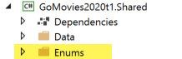
- Right-click on the folder and create two new class files:
  - FilmFilterColumns
  - FilmSortOptions
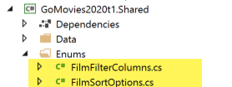

FilmFilterColumns Enum
This enum will define the column(s) in the Film table that the user can apply filter search strings too.
- First you need to import the data annotations library. Add the following at the top of the class:
- Next, change the default class definition as follows:
  - Make the access level public
  - Change it from a class to an enum.
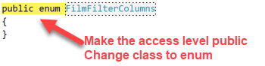
- Next, add the following options to the enum and add data annotations to display user-friendly labels for each value. Please feel free to add additional search columns.
  - NoFilter
  - ByTitle
  - ByGenre
  - ByCast
  - ByTitleGenreCast
  - ByReviewRating
  - ByReleaseYear
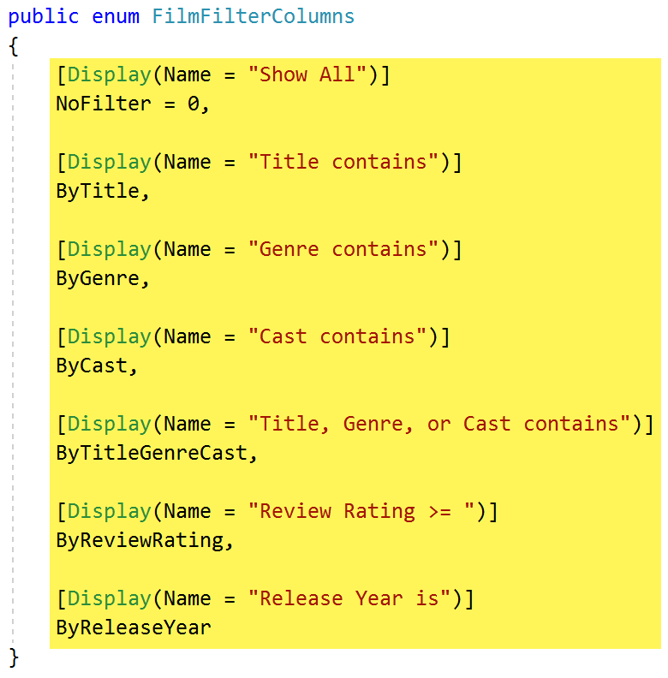
[Display(Name = "Show All")]
NoFilter = 0,

FilmSortOptions Enum
This enum will define the sorting options when displaying films to users.
- Repeat steps 4 and 5 above.
  - Import the data annotations library.
  - Make the access level public
  - Change it from a class to an enum
- Add the following options for this enum.
Enum Option | Data Annotation Display Name
DefaultOrder | Sort by…
ByTitle | Title ↑
ByReleaseDate | Release Date ↑
ByReleaseDateDesc | Release Date ↓
ByReviewRating | Review Rating ↑
ByReviewRatingDesc | Review Rating ↓

FilmFilterViewModel
- Go the GoMovies2020.Shared project
- Locate the ViewModels folder.
- Right-click on the folder and add a new class called FilmsFilterViewModel.
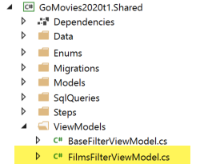
- First you need to import some additional libraries. Add the following at the top of the class:
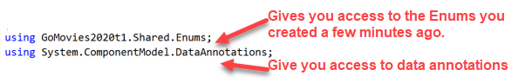
- Next, change the default class definition as follows:
  - Make the access level public.
  - Change it inherit from BaseFilterViewModel i.e. “: BaseFilterViewModel”.
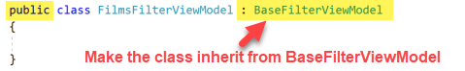

- Next you need to add three properties that will be used for the filtering functionality (I have shown you how to add the first one below):
Property | Data Type | Data Annotation Display Name | Description
FilterField | FilmFilterColumns  (one of the enum types created above) | Filter By | For the user to specify what column to search
FilterSearchString | string | Search For | For the user to specify the search string to apply
SortBy | FilmSortOptions  (one of the enum types created above) | Sort By | For the user to specify what column to sort the results returned

Example code for the first property, FilterField.
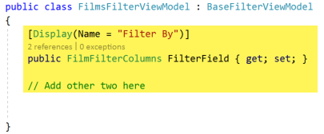
- Save your changes.
- Go to Part b: The Controller

