Contents
Introduction: 2
The proposal 5
Search Strategy 6
Results 7
Emerging Themes 8
Inappropriate A&E attendances 9
Clinical Decision Support Systems – Risks and Opportunities 9
Self-triage 10
Grading of Evidence 10
Identified Gaps 11
Implementation 12
Risks and constraints 12
Evaluation 14
Effectiveness 15
Safety 15
Efficiency 16

Introduction:
It is well established in research and anecdotally that use of emergency services such as ambulance or accident and emergency is very poor, up to 40% are classed as inappropriate according to the paper written in the British Journal of General Practitioners (Ismail, S. et al., 2013). This inappropriate attendance reduces the time available for more serious medical needs to be met in a timely manner. We have seen the rise in pressures on emergency services over the last few years (Gardner, T., 2019). This is not the only issue affecting patient flow, it is well known that social services and community services are under resourced to provide the level of care required to discharge patients from beds (Welsh Government, 2022). Bed blockers as they can be termed are those that are medically fit for discharge from acute hospitals but lack the provision to be cared for in a step-down hospital or in their own home. This stagnation ends up causing a pinch point at the front door, increasing risk of harm, people have died waiting in corridors or in ambulances outside accident and emergency departments (The Guardian, 2022).
There have been many attempts at educating the public about what requires an A&E attendance (figure 1), but the message does not appear to be getting through or is not targeting the right audience or in the right environment as the work by The Health Foundation clearly indicates ever increasing numbers. Within Wales, 111 was developed in 2016 and was available in all Health Boards in 2022 (NHS Wales, 2018) and provides a triage service via telephone, staffed by non-medical trained individuals utilising a set of questions and flow charts, which then, depending on the result of the checklist, direct the individual to a number of different options, such as a phone call from a clinician, attend a pharmacy, self-care, or A&E. This information is recorded within the NHS Wales 111 service patient record but is not available outside of this system, so wherever a patient presents after calling, the story must be repeated, and a new record begun if required.
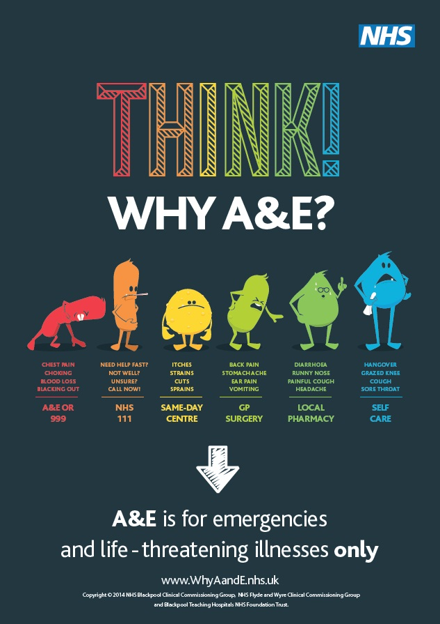
Figure 1 (Think! Why A&E? and help everyone receive the right care | Blackpool Teaching Hospitals NHS Foundation Trust, no date)
This paper will consider the creation and introduction of a patient facing clinical decision support tool (CDS), utilising the patient identification functionality found within the NHS Wales App to assist in the appropriate signposting of paediatric patients. As it will be accessed via the NHS Wales app, the information inputted during the session will be made available to any clinician who requires access to it, that may be a pharmacist, an allied health professional or a doctor and this will form part of the overall patient clinical record. This specific enhancement, the availability of details recorded during the self-triage, forms the basis of this assignment as it tackles some of the most challenging aspects of healthcare delivery in Wales, repeated clinical history taking, poor interoperability and inappropriate attendances at accident and emergency departments.
The CDS tool, which will henceforth be referred to as the app, will be based upon the same clinical decision-making matrix that the NHS Wales 111 service uses, which is clinically robust and has been assured at all levels within the NHS, but importantly will be available via all smart devices and computers with a data connection. Patients and the public are sometimes reticent in calling staffed phone lines as they may be nervous or unsure and wish to have some support before calling. NHS England (2017) proposed a similar app and expected as many as 30% of individuals would utilise the app’s functionality rather than call the 111 helpline. The app will be advertised extensively on social media and through normal advertising avenues seeking to drive people towards the app rather than phoning, as this will free up call handlers who can offer advice to those who may not be able to access the app or prefer to get human support.
This paper will examine the evidence surrounding clinical decision support tools within emergency and unplanned care, the use of apps to direct patient choice and the benefits of the public choosing the right setting to attend in terms of outcomes and impact on services. Following this examination of the literature surrounding CDS tools aimed at signposting and the potential interoperability of such apps with electronic patient records (EPR), the paper will look at the risks and constraints of implementing such an app and finally will discuss how the app will be evaluated.
Figure 2 below is the process map created to describe the application’s proposed workflow. The plan for the enhancement also feeds a significant feedback loop, which should be the subject of significant investment and research and that is Machine Learning and Artificial Intelligence. By using user inputs to the application, the recommended decision, the actual decision by the user, as in, where did they end up going compared to the recommendation and the reported outcomes, a more complete picture can be developed, improving recommendations as knowledge increases.
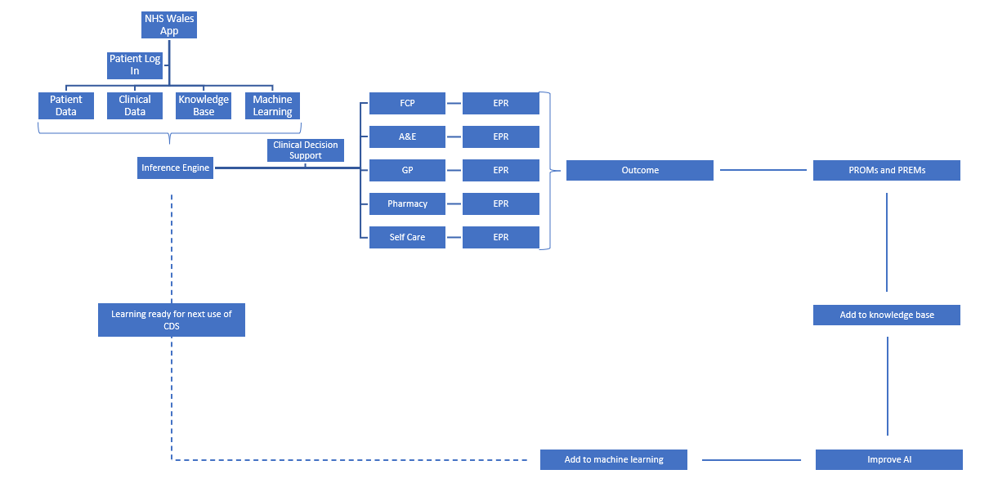
Figure 2 Application Workflow
The rest of this assignment will consider the literature surrounding CDS in the area of paediatric self/parent triage and the potential impact such an app could have on the NHS in Wales, including the potential improved clinical outcomes for individuals.

The proposal
This paper sets out to address the creation of a nationally available clinical decision support tool (CDS), specifically considering the signposting of parents who have concerns about their child to the most appropriate setting. The CDS will be found within the NHS Wales App and utilise the same single patient identification standards, allowing for information to be made available within the electronic patient record (EPR).
This paper acknowledges that similar offerings are already available within England and Wales, the NHS Wales 111 symptom checker (NHS Wales, 2023) is a web based solution which guides individuals through a series of questions which change depending on the previous answer selected, culminating in a recommendation and OneAdvanced’s Odyssey software (Clinical Decision Support | Advanced, 2023)which is for both patients and clinicians and acts as a primary care triage tool and can link directly to an EPR, if available, however the NHS Wales symptom checker does not name the individual and so cannot automatically package data to be viewed in the patient’s electronic patient record. OneAdvanced is a 3rd party supplier and the technology used is proprietary and this has often proven a difficult barrier to overcome (Warren et al., 2019) and so interoperability with NHS Wales architecture is the main constraint with this option, however if interoperable standards existed, the systems could send collected data to clinicians within NHS Wales environments, such as primary or secondary care.
For the purpose of the paper, a critical literature review was undertaken regarding the application of decision support tools within the area of primary care paediatric self-triage. Due to the specificity of this topic, there is a paucity in available literature relating to primary care paediatric triage, therefore, Boolean operators “and” and “or” were applied to ensure as much literature as possible was gathered, including grey literature in order to evaluate the proposed solution.
As with any literature review, the hierarchy of evidence (Guyatt et al., 1995) and (Greenhalgh, T., 1997) is the most appropriate place to start considering the quality of the evidence being reviewed. Systematic reviews and meta-analysis’ are considered the highest quality research because they deliver a clear and comprehensive overview of the available evidence on the subject matter being considered (Poklepovic, T., and Tanveer, S., 2019). As highlighted in figure 2 below, at the top of the pyramid sits the highest quality research, and that peak is a systematic review or meta-analysis. Therefore, this paper sought to base it’s finding upon any systematic reviews and one such paper is by Kwan et al., (2020).
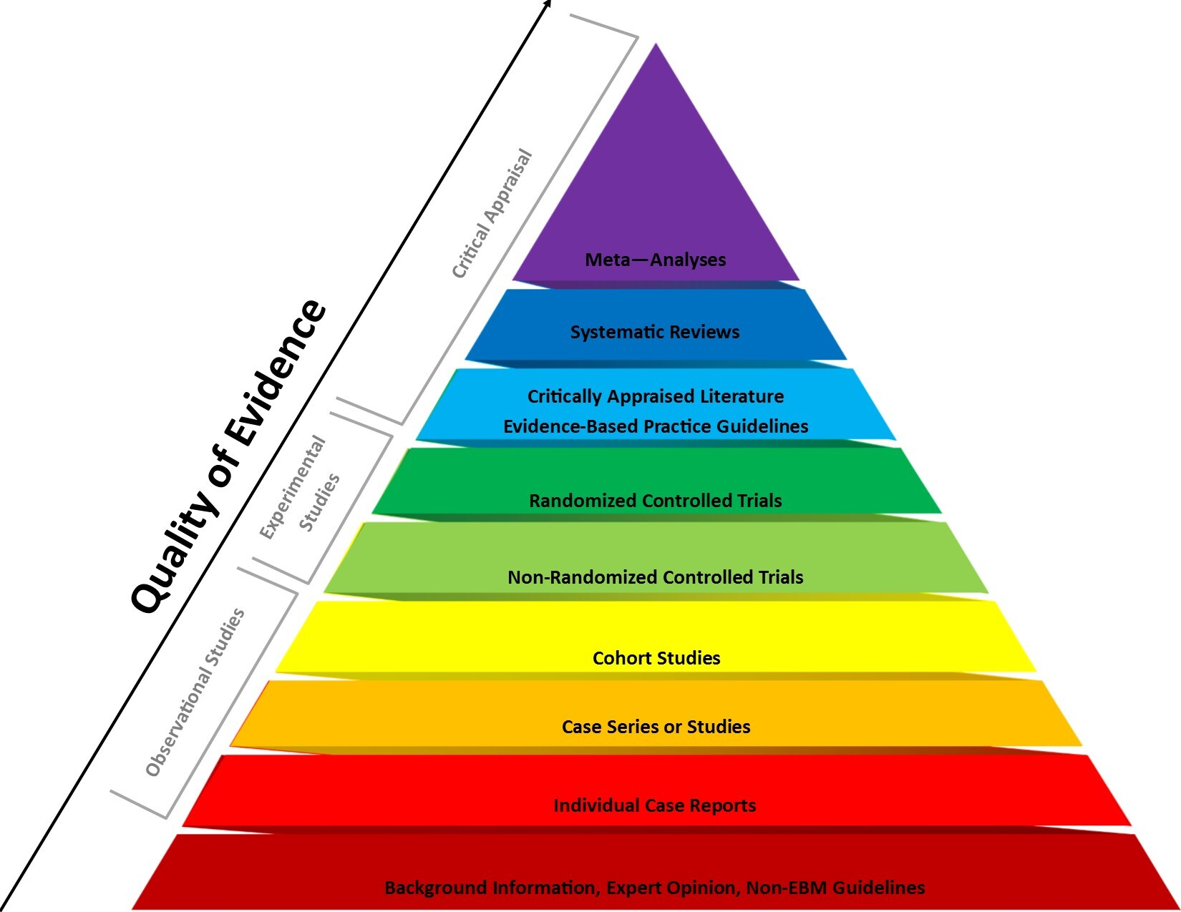
Figure 3 (What is the Hierarchy of Evidence? | Research Square, no date)
Kwan et al., (2020) although not specifically about paediatric pre-hospital clinical decision support tool, as a systematic review of the evidence scores highly on the quality of evidence hierarchy and so acted as a valid and assured starting point. This paper identifies through a systematic review and meta-analysis of randomised or quasi-randomised controlled trials reporting absolute improvements in the percentage of patients receiving care recommended by CDS. The results showed CDS’ increased the proportion of patients achieving guideline-based targets and concluded with CDS appear to achieve small to moderate improvements in targeted processes of care.

Search Strategy
By undertaking a literature search, the reader is provided with the opportunity to learn more about the subject in question. The initial search was broad intentionally, in order to capture as much relevant information as possible.
A series of searches was undertaken in four main databases, Cinahl, University of Wales Trinity St David’s Library, Pub Med and Cochrane. The search phrases used were as follows:
1 – Self triage
2 – Parent triage
3 – Clinical Decision Support app
4 – Signposting primary care
5 – Inappropriate attendance
The completed search list was then subjected to the exclusion criterion, in this instance the exclusion criterion was articles must be peer reviewed, must be published in English, written post 2003 and have full text available.

Results
This paper will use the Preferred Reporting Items for Systematic Review Meta-Analysis (PRISMA) model (figure 4) to undertake the evaluation of the databases and the subsequent articles within. As the figures clearly demonstrate there were significant numbers in terms of total numbers, but on further analysis, the largest returns came from ‘self-triage’, where the average numbers were in the thousands and the lowest response area was found in ‘clinical decision support apps’ with an average of just a hundred from the four databases.
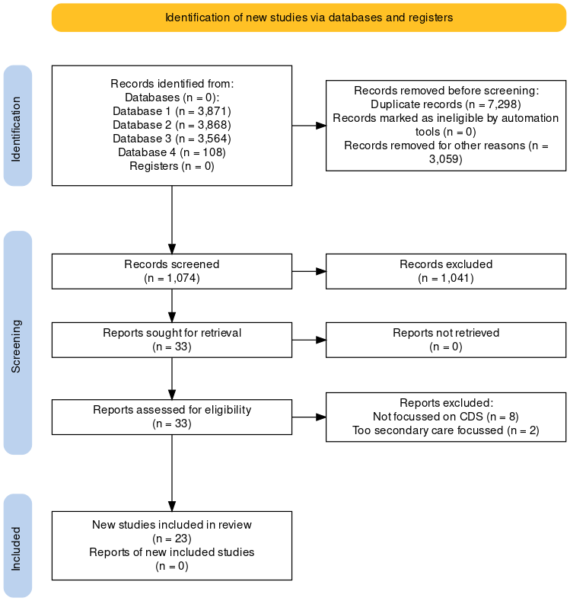
Figure 4 PRISMA

Emerging Themes
Following the identification of the 23 studies, each paper was reviewed in full, ensuring as much as practicable that personal biases were identified and mitigated and following this review a number of emerging themes became evident. This paper will evaluate each of the key themes identified via the review, concluding in the grading of the quality of the papers used and identifying any gaps noted in the existing evidence base. The themes identified were inappropriate accident and emergency attendances, benefits and risks of CDS and self-triage validity.

Inappropriate A&E attendances

Patients dying outside A&E, hospital corridors as makeshift wards
(The Guardian, 2022)
The stark headline above provokes an emotive reaction ot eh situation in local hospitals and helps give this theme context and perspective. Murphy, A., (1998) states that there is ‘no accepted practical definition of what constitutes an appropriate attender to an A&E’ and as a result the variability ranges from 6% to 80% regarding the visits judged to be inappropriate, whereas Ismail, S., (2013) propose that the figure of inappropriate attendances is closer to 40%. Whichever figure you take, this puts an immense pressure upon the resources found within Health Services and Governments and has an impact on the ability of services to run efficiently. The cost of these A&E attendances has not been calculated but is suggested to be vast and something which requires further research in order to evaluate the impact on the overall budget. (Martin et al., 2002) undertook research across Essex evaluating the impact of good primary care availability and noted that this reduced the inappropriate attendance at A&E down to 16.5% at a 95% confidence interval. However, waiting times and GP availability is already stretched with Torjesen, I., (2022) reporting that there was a net loss of 662 individual GPs or 473 whole time equivalents in 2021. It is clear from this evidence that the number of inappropriate attendances at A&E is causing significant issues for Health Boards in terms of cost and waiting times, but that simply moving all individuals to primary care does not alleviate the problem.

Clinical Decision Support Systems – Risks and Opportunities
Clinical decision support (CDS) has been around for some time, Sutton et al., (2020) wrote that early examples were first used in the 1980’s and have since seen a rapid evolution and can now be found in many hospital settings and workflows, increasing the global adoption of electronic medical records. However, they state the use of CDS is not without risks and go on to describe the best evidenced-based recommendations for minimising risk in CDS design, implementation, evaluation and maintenance. This is supported by the work of Watson, Tribe and Shennan, (2019) who describe the rapid uptake of digitisation but argue that the pace of medical research and publication poses a significant risk to CDSS. The argue that the number of clinical trials is scarce and the variation of development pathways and the regulation of CDSS apps is great, needing further review and validation in order to improve the confidence of both clinicians and the public. In short, developers of CDSS’ must rise to the challenge of modernising its approach in order to capitalise on the opportunities offered by digitalisation. This scarcity of peer reviewed papers was highlighted by Carter et al., (2019) who state that despite the increasing use of medical mobile phone applications by both clinicians and the public, the evidence simply does not exist to support it. The paper goes on to identify the main themes in the development of CDS and they are satisfaction, ease of use, multifunctioning and user centred design.

Self-triage
Self-triage is defined as the ‘process by which patients evaluate their health to determine whether or not to see their doctor’, (Eijk et al., 2014) and the implementation proposed by this paper seeks to be a smartphone-based application which will signpost parents concerned about their child to the most appropriate location. Sensely.com, (2023) is a patient/clinician targeted application which seeks to tailor questions through a series of questions, culminating in a recommendation/signposting to the most appropriate location with the details being available depending on the computer systems in use at the destination. The NHS in England in their Five year look ahead (NHS England, 2017) reported data from a similar programme in Australia stating that 33% of people ran through the telephone or online symptom checker when made available. Eijk et al., (2014) also noted that with subsequent iterations of the question stack and flow, the accuracy of self-triage improved, and this finding should be further investigated using AI and machine learning in order to improve the learning offered by thousands of users and their preferences as discussed by Medlock et al., (2016) who discussed the twin track model of CDSS, AI simply expands upon this through automatically updating new learning and behaviours. Rajasagaram, U. et al., (2009) highlighted the disparity of reported pain in paediatrics between a nurse, a parent, and the child, with the nurses score being significantly lower and this must be considered when developing a signposting CDSS via parental reporting.

Grading of Evidence
Grading of Recommendations, Assessment, Development and Evaluations (GRADE) is a transparent framework for developing and presenting summaries of evidence and provides a systematic approach for making clinical practice recommendations (Bestpractice.bmj.com, 2023). This paper reviewed the GRADE approach to reviewing and presenting evidence in order to only use the most appropriate and suitable research in the development of CDS application. The clinical question in this instance is, how can a CDS app, working as part of the NHS Wales app environment, signpost patients safely and reliably to the most appropriate setting and then deliver the required data to the EPR securely, specifically paediatric patients.
There are 4 levels of evidence, also known as certainty of evidence and these are very low, low, moderate and high.
Very low – The true effect is probably markedly different from the estimated effect
Low – The true effect might be markedly different from the estimated effect
Moderate – The authors believe that the true effect is probably close to the estimated effect
High – The authors have a lot of confidence that the true effect is similar to the estimated effect

A systematic review provides the best estimate of the effect size for each outcome, but as mentioned previously, there is a scarcity of empirical research into the clinical question posed by this paper and as a result the effects are more difficult to observe, resulting in a lower grading of the evidence. It is worth noting that GRADE is subjective and merely presents a framework for the assessment of research. Evidence can be made less certain through 5 domains:
1 - Risk of bias due to inherent limitations in design or conduct and GRADE is designed to rate at outcome level, not study level.
2 – Imprecision – if the confidence interval is lower the 95% this can affect the rating, but also if the sample size is too small.
3 – Inconsistency – finding multiple studies with similar outcomes shows consistency, but small or standalone studies with little or no overlapping outcomes with other studies should lead to a lowering of the grading.
4 – Indirectness – Studies should directly compare the interventions of interest in the population of interest, reporting the outcomes for decision making.
5 – Publication bias – this is more common with observational studies or studies funded by industries who have a vested interest in the outcome and leave the grader having to guess if information has been intentionally omitted.

Grading the effectiveness of this research means using GRADE to evaluate the confidence the author has in the evidence surrounding a CDS via a mobile application for paediatric patients. There is simply not the quality of evidence available to score any more than low currently and a recommendation of the paper should be for further research in this area.

Identified Gaps
The main conclusion from this literature review was the paucity of systematic reviews and meta-analysis’ surrounding paediatric signposting applications in primary care and is the single most important recommendation from this review.
As there were no systematic reviews in the area of CDS for paediatric patients signposting this paper had to rely on ‘grey literature’ and evidence of low confidence according to the GRADE scoring method.
There was also a distinct lack of evidence available surrounding CDS’ and AI/machine learning and would be a strong recommendation for research moving forward, given that this is a significant potential benefit of the app.
Currently, there is limited system interoperability within NHS Wales and it is therefore beyond the ability of this paper to investigate the implication of patient level data automatically populating an EPR but should be a serious consideration for any implementation.

Implementation
“Considerable attention has been given to the understanding the vital role of context when implementing change initiatives in healthcare systems” (Maniatopoulos et al., 2020, p. 328). This statement encapsulates the learning that has been driven by many failed digital transformational aspirations, such as the National Programme for IT (Justinia, 2017), which is projected to have cost £80 billion and although there are some legacy parts, the whole has failed.
Where this app has an advantage over large scale transformations that have failed before is the pre-existing structure. It is already in use, with increasing numbers of users and there is clearly a demand for the service as evidenced in NHS England’s planned roll out statement. The main enhancement offered by the CDS for paediatric patients is the patient identifiable information stored within the app, which links directly to the person’s EPR and can signpost affectively based on patient data and historical use of the app.

Risks and constraints
One of the major risks to the app being implemented across the NHS ecosystem within Wales is the current architecture on which most NHS systems are built. They are generally closed systems that require a large amount of technical coding to make even small changes and are far for unified across the Country, so the app would need to be created to be interoperable with every single version of any EPR required. The risk associated with this is that this is incredibly time consuming and costly and would have to be repeated every time a system somewhere had a change made to it.
The app would have an intrinsic risk due to its complete dependency upon data repositories. Bonney and Bonney, (2011) stated that any CDS is built upon access to well-structured and standardised data, which can be used to create information and improve the CDS’ ability to perform. This risk is a universal one, affecting all CDS’ and not just this app. As knowledge changes, the repository that the app relies on must be updated with immediate effect or risk producing a signposting error that leads to patient harm.
This risk leads neatly onto the second risk, knowledge management. The repository is up to date with the latest data, is well structured and completely standardised but how does that translate into actionable knowledge? There must be the ability to provide context to the data, or it remains just that, data. When data is given context, you can begin to build stories, develop workflows specific to the individual in question.
The risk of poorly standardised and coded data is the potential to misinterpret clinical data and expose the individual to a risk of harm, which is something that should be avoided at all costs. The premise of CDS’ is that data is effectively mined, including the outcomes, and is built upon, refining the decision output over time to improve outcomes. However, if data is poorly standardised, then there is a risk that bad data is overlaid with bad knowledge resulting in an increased risk. While there is an argument to be had regarding completely structured data against free text, it is the opinion of the author that there must be room for both. Structured data where appropriate but allowing for the narrative to be recorded giving context and meaning. By doing it this way, we avoid viewing patient’s purely through their data and remember they are individuals.
The application must consider the workflow of both users and receivers of the information. The receivers in this instance will be registered healthcare professionals via the EPR, but again context gives meaning to the data and simply being presented with structured responses increases the chances of a missed piece of highly relevant information, so any pre-populated data must form part of the normal workflow of clinicians, adding to their ability to diagnose, not force them down a diagnostic cul de sac.
Finally, the risk which raises the most concerns as it will be difficult to manage is the potential for user’s to intentionally select ‘worse’ responses in order to drive the CDS to make the decision they prefer, such as A&E or an ambulance. There was a lack of research into this area but could be something that should be researched through retrospective studies into self-reported answers and the healthcare professional’s clinical diagnosis.
The above are the risks associated with the implementation of this app specifically, so the following methods would be implemented at the same time or built into the design to reduce the likelihood of the risk being realised.
Open standards and modular based applications must be the way forward for fast and highly responsive services. The NHS in Wales must stop relying on monolithic type services that lack the ability to configure to fit with the varied local requirements, whilst remaining accessible to all. This was highlighted by the architecture review for DHCW (Digital Health and Care Wales, 2019).
The introduction of SNOMED CT (SNOMED International, 2023) and the ability to take free text and create coding means that the argument over structure or non-structured data is rendered moot. All digital systems should be based upon this ontology.
The application must be subject to robust and frequent review by clinical safety officers (CSO’s) throughout NHS Wales in order to ensure best practice is maintained including the outcomes for users and that any incidents of harm are comprehensively analysed via root cause analysis (RCA) methodology. The CSO’s must have the ability to turn off the app or limit its functionality if a serious flaw is found as there is too much risk posed to individuals who trust the output of such apps.
The management of users abusing the app to jump waiting lists is one which must be carefully examined as there is a risk that the machine learning or AI algorithm will identify frequent offenders and lower their priority in a time when they genuinely do require emergency care. Such users should be flagged and require a manual review of their answers and a follow up phone call triage to ensure they get the right advice.
The implementation of the paediatric self-triage enhancement to the NHS Wales app builds upon the work of NHS Wales 111 and the Digital Services for Patients and the Public and so already has a significant user base and strong guidelines and workflows. Therefore, it is expected that with the above risks managed effectively the implementation would be successful.

Evaluation
The implementation must be both service and user led, to ensure it aligns with current best practice and supports individuals and their clinicians to undertake their roles effectively. The use of time-in-motion studies, waiting times at various locations, volume of attendances at pharmacies or other primary care locations pre- and post- implementation are just some of the measures that must be used to prove the efficacy of the app. Also, the outcomes both clinical and patient reported must be considered and education offered to ensure those that are directed to self-care receive the most appropriate advice and are able to follow it safely.
The introduction of a paediatric self-triage signposting CDS tool is one which must be evaluated carefully and frequently. There are many reasons why this is the case but the most pertinent are the risk of incorrect signposting resulting in harm – either by user error or by CDS making incorrect recommendations based on answers selected and secondly to review the outcome measures of all the users who sought medical advice via the app rather than more conventional means. As previously mentioned, there is a paucity of high-quality evidence surrounding paediatric self-triage and as such there must be research built into the implementation plan to ensure the outcomes are as expected and desired.

Effectiveness
Does the app perform as expected when used by non-medical users and does it consistently make the right recommendation?

This is the single most important question when evaluating the effectiveness of the app. The potential outcomes are subject to a number of variables outside the control of the app itself, such as adherence to treatment plans by the user, so it is not always fair to say the total outcome is the responsibility of the app, but rather the decision of where to signpost the individual needs to be reviewed against the opinions of medical professionals or the NHS Wales 111 service in regards to what they would have recommended.
The app is not purely designed to reduce attendances at A&E but rather to reduce the number of inappropriate attendances, which, as stated earlier, accounts for around 40% of all attendances in A&E’s. Therefore, one must not simply count the numbers through the door, but evaluate who and why people are attending, rating the appropriateness, and comparing against what the app recommended. There must also be a review of the recommendations versus the actual destination of users; Do they correlate or is the trust lacking and the pull of A&E too great for those unsure about the best course of action?
A major potential flaw with this app, or with the health service as a whole, is the 24-hour nature of applications when compared to the office hours of pharmacies, first contact practitioners and primary care. If the recommendation is pharmacy at 0200 on a Sunday morning, then there is no option but to wait or attend A&E. However, the app could overcome this with giving personalised recommendations of opening times and locations of the suggested services, meaning users would have more information about how long they must wait. There could even be live waiting times at the local A&E, highlighting that waiting may in fact be the quicker option, however this would require interoperability between many other systems and would require investment if developing communication standards between each piece of software, if open standards are not adhered to.

Safety
Any application or piece of software which provides a recommended course of action needs to be considered against the Medicines and Healthcare Products Regulatory Agency (MHRA) framework, (Grainger, 2023), appendix 1 regarding the “Medical devices: software applications guidance” gives a number of examples of software that is unlikely to be consider a medical device and software that only signposts the user to suitable care, so it is reasonable to assume this application would not need to be regulated as a medical device. However, there are changes due in June 2023 which will see Wales enter re-alignment with EU regulations and so there must be continual assessment of the application to ensure it is conforming to current guidance.
ISO 31000 (ISO, 2023) is another framework associated with organisational risk management and although it does explicitly focus of the application itself, it is a framework used by the organisation to ensure best practice and corporate governance compared internationally.
Finally, there is DCB0129 (NHS Digital, 2018) is not currently mandated within Wales, but this is currently being considered as a standard which manufacturers and health Boards in Wales should adhere to. DCB0129 is an information standard concerning clinical risk management: its application in the manufacture of health IT systems. Consideration must also be given to DCB0160 which is the standard for deploying organisations and considers the risks associated in this area. These standards are not specific to medical devices but must be adopted in all circumstances where digital products are deployed or developed to support health and social care services. They represent best practice and provide a framework for clinical risk management.

Efficiency
The major benefits of digital solutions is the ability to remotely and retrospectively examine multiple aspects of the data. With a signposting application such as this paper is proposing, the ability to count total numbers of users signed up, the number of unique uses and number of repeat uses would indicate whether the implementation had been initially successful and secondly whether the app was useful as people returned to use it multiple times.
A retrospective review into inappropriate numbers of attendances at A&E could be performed using app data, EPR records and clinical outcomes to ascertain whether recommendations were followed and whether there was an overall drop in unnecessary attendances. It must be made clear that not all people will use the app prior to making a decision about their destination, so there should be work done educating all health care professionals advising them to recommend the app for first line advice.
The app could also form part of a study into numbers of people attending pharmacy’s or other new, innovative, primary care locations, and whether there was a resulting increase in volume of patient use, an improvement in outcome or patient reported experience.

Bestpractice.bmj.com (2023) What is GRADE? | BMJ Best Practice. Available at: https://bestpractice.bmj.com/info/toolkit/learn-ebm/what-is-grade/ (Accessed: 7 February 2023).
Bonney, W. and Bonney, W. (2011) ‘Impacts and Risks of Adopting Clinical Decision Support Systems’, Efficient Decision Support Systems - Practice and Challenges in Biomedical Related Domain [Preprint]. Available at: https://doi.org/10.5772/16265.
Carter, J. et al. (2019) ‘Mobile phone apps for clinical decision support in pregnancy: a scoping review’, BMC Medical Informatics and Decision Making, 19(1). Available at: https://doi.org/10.1186/s12911-019-0954-1.
Clinical Decision Support | Advanced (2023). Available at: https://www.oneadvanced.com/solutions/odyssey/ (Accessed: 16 February 2023).
Digital Health and Care Wales (2019) ‘TECHNOLOGY INNOVATION PROOF OF CONCEPT Market Engagement Digital Architecture Review Final Report’.
Eijk, E.S.V. et al. (2014) ‘Towards patient self-triage in the ophthalmic emergency department: sensitivity and specificity of a self-triage instrument’, Acta Ophthalmologica, 92(7), pp. 697–700. Available at: https://doi.org/10.1111/AOS.12342.
Gardner Tim (2019) A&Es under pressure: what the data can tell us - The Health Foundation, The Health Foundation. Available at: https://www.health.org.uk/news-and-comment/blogs/aes-under-pressure-what-the-data-can-tell-us (Accessed: 8 February 2023).
Grainger, D. (2023) ‘Guidance: Medical device stand-alone software including apps (including IVDMDs) v1.10’.
Greenhalgh, T. (1997) ‘How to read a paper : getting your bearings (deciding what the paper is about)’, BMJ, 315(7102), pp. 243–246. Available at: https://doi.org/10.1136/BMJ.315.7102.243.
Guyatt, G.H. et al. (1995) ‘Users’ Guides to the Medical Literature: IX. A Method for Grading Health Care Recommendations’, JAMA, 274(22), pp. 1800–1804. Available at: https://doi.org/10.1001/JAMA.1995.03530220066035.
Ismail, S.A., Gibbons, D.C. and Gnani, S. (2013) ‘Reducing inappropriate accident and emergency department attendances: A systematic review of primary care service interventions’, British Journal of General Practice, 63(617). Available at: https://doi.org/10.3399/bjgp13X675395.
ISO - International Organization for Standardization (2023). Available at: https://www.iso.org/home.html (Accessed: 16 February 2023).
Justinia, T. (2017) ‘The UK’s National Programme for IT: Why was it dismantled?’, Health services management research, 30(1), pp. 2–9. Available at: https://doi.org/10.1177/0951484816662492.
Kwan, J.L. et al. (2020) ‘Computerised clinical decision support systems and absolute improvements in care: meta-analysis of controlled clinical trials’, BMJ, p. m3216. Available at: https://doi.org/10.1136/bmj.m3216.
Maniatopoulos, G. et al. (2020) ‘Large-scale health system transformation in the United Kingdom: Implementing the new care models in the NHS’, Journal of Health Organization and Management, 34(3), pp. 325–344. Available at: https://doi.org/10.1108/JHOM-05-2019-0144/FULL/PDF.
Martin, A. et al. (2002) ‘“Inappropriate” attendance at an accident and emergency department by adults registered in local general practices: How is it related to their use of primary care?’, Journal of Health Services Research and Policy, 7(3), pp. 160–165. Available at: https://doi.org/10.1258/135581902760082463.
Medlock, S. et al. (2016) ‘Modeling information flows in clinical decision support: key insights for enhancing system effectiveness’, Journal of the American Medical Informatics Association, 23(5), pp. 1001–1006. Available at: https://doi.org/10.1093/jamia/ocv177.
Murphy, A.W. (1998) ‘“Inappropriate” attenders at accident and emergency departments. I: Definition, incidence and reasons for attendance’, Family Practice, 15(1), pp. 23–32. Available at: https://doi.org/10.1093/fampra/15.1.23.
NHS Digital (2018) DCB0129: Clinical Risk Management: its Application in the Manufacture of Health IT Systems - NHS Digital. Available at: https://digital.nhs.uk/data-and-information/information-standards/information-standards-and-data-collections-including-extractions/publications-and-notifications/standards-and-collections/dcb0129-clinical-risk-management-its-application-in-the-manufacture-of-health-it-systems (Accessed: 10 February 2023).
NHS England (2017) ‘NEXT STEPS ON THE NHS FIVE YEAR FORWARD VIEW’.
NHS Wales (2018) Welsh Ambulance Service NHS Trust | 111 Wales. Available at: https://web.archive.org/web/20180629083912/http://www.was-tr.wales.nhs.uk/Default.aspx?pageId=315&lan=en (Accessed: 19 January 2023).
NHS Wales (2023) NHS 111 Wales, 111 NHS Wales. Available at: https://111.wales.nhs.uk/ (Accessed: 19 January 2023).
Poklepovic Pericic Tina and Tanveer Sarah (2019) Why systematic reviews matter. Available at: https://www.elsevier.com/connect/authors-update/why-systematic-reviews-matter (Accessed: 8 February 2023).
Rajasagaram, U. et al. (2009) ‘Paediatric pain assessment: Differences between triage nurse, child and parent’, Journal of Paediatrics and Child Health, 45(4), pp. 199–203. Available at: https://doi.org/10.1111/j.1440-1754.2008.01454.x.
Sensely.com (2023) Sensely: Conversational AI to improve health and drive member engagement, Sensely.com. Available at: https://sensely.com/ (Accessed: 7 February 2023).
SNOMED - Home | SNOMED International (no date). Available at: https://www.snomed.org/ (Accessed: 16 February 2023).
Sutton, R.T. et al. (2020) ‘An overview of clinical decision support systems: benefits, risks, and strategies for success’, npj Digital Medicine 2020 3:1, 3(1), pp. 1–10. Available at: https://doi.org/10.1038/s41746-020-0221-y.
The Guardian (2022) Patients dying outside A&E, hospital corridors as makeshift wards – and it’s only October | Gaby Hinsliff | The Guardian, The Guardian. Available at: https://www.theguardian.com/commentisfree/2022/oct/28/patients-ae-hospital-corridors-wards-rishi-sunak-nhs (Accessed: 19 January 2023).
Think! Why A&E? and help everyone receive the right care | Blackpool Teaching Hospitals NHS Foundation Trust (no date). Available at: https://www.bfwh.nhs.uk/think-why-ae-and-help-everyone-receive-the-right-care/ (Accessed: 17 February 2023).
Torjesen, I. (2022) ‘One in three GPs intends to quit within five years, survey finds’, BMJ, 377, p. o983. Available at: https://doi.org/10.1136/BMJ.O983.
Warren, L.R. et al. (2019) ‘Improving data sharing between acute hospitals in England: an overview of health record system distribution and retrospective observational analysis of inter-hospital transitions of care’, BMJ Open, 9(12), p. e031637. Available at: https://doi.org/10.1136/BMJOPEN-2019-031637.
Watson, H.A., Tribe, R.M. and Shennan, A.H. (2019) ‘The role of medical smartphone apps in clinical decision-support: A literature review’, Artificial Intelligence in Medicine, 100. Available at: https://doi.org/10.1016/j.artmed.2019.101707.
Welsh Government (2022) Health Minister warns about the ‘extraordinary pressure’ the health and social care system is currently under in Wales | GOV.WALES. Available at: https://www.gov.wales/health-minister-warns-about-extraordinary-pressure-health-and-social-care-system-currently-under (Accessed: 8 February 2023).
What is the Hierarchy of Evidence? | Research Square (no date). Available at: https://www.researchsquare.com/blog/what-is-the-hierarchy-of-evidence (Accessed: 17 February 2023).

