Assessment 2: “Health condition: Risk of having a heart attack or stroke within the context of people living in the UK”
STUDENT NAME: LILIANA TURBATU
STUDENT ID: 1919066
LECTURER NAME: LAILA SURANI
MODULE NAME: INTRODUCTION TO PHYSIOLOGY
MODULE NAME: BMHP 5003

Table of Contents
Introduction 3
Anatomy and Physiology of the health condition 3
Health and Lifestyle routine measures 5
Health and Social Care practice 7
Recommendations 8
Conclusion 9
References 10

Introduction
A heart attack or stroke occurs when the flow of blood to the heart is blocked which is often caused by the buildup of fat, cholesterol, or other substances that form plaque in the arteries. In addition, a plaque can interrupt the blood flow that feeds the heart resulting in damage or destruction of the heart muscle. In the year 2017, it has been identified that around 43,384 deaths were caused due to heart and circulatory diseases under-75s, (Siddique, 2019). In addition, such a number is expected to increase in the forthcoming years. Based on such context, in this report, a detailed analysis of the anatomy and physiology along with health and lifestyle routine measures of the heart attack or stroke health condition in terms of the people living in the UK has been put forward. Other than that, the health and special care practice of NHS in terms of the health condition that can inform care planning for communities and individuals has been further discussed. Lastly, a brief recommendation has been provided for people with heart attack or stroke health conditions.

Anatomy and Physiology of the health condition
It has been well stated by Holmes et al. (2020), the anatomy of a heart attack or stroke is based on the inability of the heart to supply the needed blood flow which leads to oxygen delivery to peripheral organs and tissues. This in turn results in reduces exercise capacity, shortness of breath, and fatigue. In extreme cases, it can also result in organ dysfunction or renal failure in some patients.
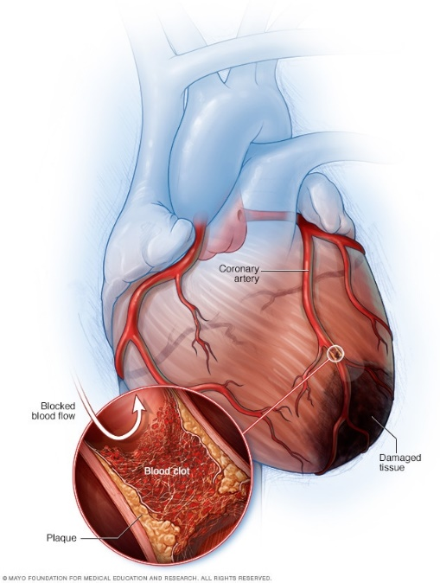
Fig: 1 (Anatomy and physiology of heart attack or stroke)
Source: (Mayoclinic.org, 2022)
The above figure indicates the anatomy and physiology of heart attack among people suffering from this health condition. The anatomy and physiology aspects indicate common heart attack signs and symptoms including lightheadedness, aching sensation in the chest, cold swear, heartburn, and indigestion. However, Mafham and Baigent (2021) argued that it is not necessarily imply that all people who have heart attacks will have similar anatomy or physiology or severity of symptoms. It is expected that some people can have severe pain while some have mild pain and some people do not depict any symptoms at all. On the contrary, heart disease can be referred to as hypertension and coronary artery diseases that are associated with other cardiovascular diseases such as chronic heart failure, myocardial infarction, and irregular heartbeat.
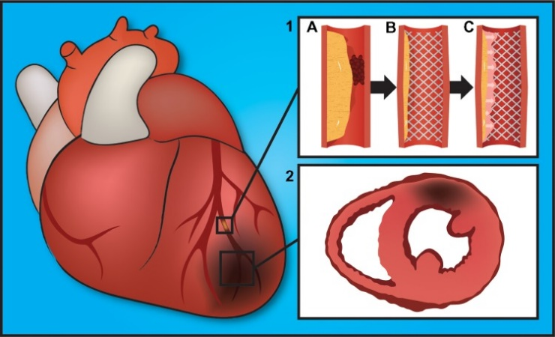
Fig: 2 (Physiological characteristics of cardiovascular disease such as heart attack or failure)
Source: (Ruiz-Esparza et al. 2013)
In terms of the above figure, each stage of cardiovascular disease can be well represented by novel biomarkers and tissue architecture. For instance, myocardial infarction causes the blood vessels to become leaky in the left ventricle favoring nanoparticle penetration of the tissue, (Byrne et al. 2020). The physiological presentations and progression of coronary artery disease are well indicated through (1) which leads to atherosclerosis plaque building up in the artery resulting in blood clots (A). Upon stent compression, the artery widens up and compresses the plaque (B) while occluding the blood flow due to decreasing in-stent restenosis (C). As a result, it generates myocardial infarction or heart attack in a localised area of the dead heart muscle and ischemia (2).
As per Williams et al. (2020), primary hypertension is a cardiovascular condition because of the increased blood pressure in the arteries, and such aspects are correlated with aging, genetic factors, high salt intake, insulin resistance, and high alcohol intake. It can lead to heart failure or attack and other heart diseases. Other than that, coronary artery disease is a common risk factor for congestive heart failure and myocardial infarction as it is defined as plaque buildup in the coronary arteries that supply oxygen-rich blood to the heart muscle. As stated by Thornton (2020), the principal characteristics of heart failure or attack are hypertrophy or left ventricular dilation resulting from damage to cardiac myocytes or dysfunction to molecular components. As a result, the clinical symptoms are well-identified in the patients suffering from this health condition due to circulatory abnormalities. Additionally, inflammatory biomarkers and cytokines play a significant role in the progression and pathogenesis of heart failure.

Health and Lifestyle routine measures
As put forward by Masroor (2020), it is essential for measuring the daily health and lifestyle routine of individuals suffering from heart disease or stroke by gathering information on body functioning. The major risk factors for heart disease include blood pressure, cholesterol, triglycerides as well as glucose level. Based on such context, it is highly essential for individuals to comprehend the risk factors and keep tabs on their cardiovascular health. High blood pressure increases the risk of stroke and heart disease which means that the need to make lifestyle changes or medication that can complement the health is highly essential to measure. On the other hand, Mafham et al. (2020) argued that lipoprotein profiles are essential for measuring in terms of health and lifestyle routine for assessing cholesterol and triglycerides levels of an individual. Specifically, older women and men have a higher risk of heart disease or stroke due to higher levels of triglycerides. Furthermore, diabetes also increases the risks of heart disease and stroke which means that the health and lifestyle routine of individuals has to be well changed while regular assessment of blood glucose levels to prevent heart attacks or strokes.
Other than that, Pessoa-Amorim et al. (2020) indicated that routine health and lifestyle measures in terms of body weight are highly essential to carry out by individuals for assessing whether they are obese or overweight. As overweight or obesity can increase the risk for heart disease, stroke, diabetes, and other health problems, it is essential to measure this aspect in terms of the daily routine for preventing heart diseases at the initial level. On the other hand, smoking and drinking is the major cause of premature death in the United Kingdom, as per Banatvala (2020). In terms of gathering information on the body function of individuals suffering from heart disease or stroke condition, the need to analyse the daily smoking and drinking habits is essential to consider. In addition, the level of physical activity carried out by the individuals is further essential to assess as these aspects indicate major signs and symptoms of heart diseases. This means that the need to measure with routine tests in terms of the risk of heart disease has become imperative for individuals in the UK for prevention and remedy.
Healthcare organisations like NHS conducts campaigns as well as assess lifestyle and routine measures of individuals for preventing and managing the risk of heart diseases including strokes and heart attacks, (England.nhs.uk, 2022). The lifestyle questionnaire includes smoking habits, alcohol consumption, physical activities, and other daily routines of individuals which guides professionals to devise effective care plans in terms of information about the body's functioning. In addition, compliance with these tests and routine checkups, while enhancing health and lifestyle aspects, can assist to not only gathering relevant information on body functioning of individuals with this health condition but also such data can assist to prevent and treat heart diseases such as heart attacks and strokes.

Health and Social Care practice
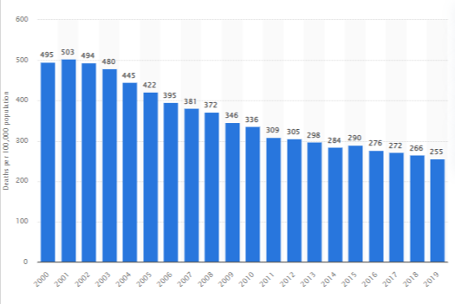
Fig: 3 (Death rates from heart diseases in the UK)
Source: (Stewart, 2021)
Based on the above figure, it can be stated that in the year 2019, there were around 255 deaths per 100,000 population from cardiovascular diseases in the UK. Specifically, in the year 2019, around 775 thousand patients were admitted to hospitals for heart diseases. The major causes behind such increasing numbers were smoking and alcohol consumption in the UK. In addition, a 14% increase in the number of patients suffering from high blood pressure has been identified since the year 2016 in the UK due to an increase in body weight, (Stewart, 2021). This means that the concern surrounding the cardiovascular disease has been extreme and significant due to the highest mortality frequency for coronary heart disease in the UK.
Based on such context, UK-based healthcare institutions like NHS offers free health check-up for individuals for analyzing the risk of heart disease and stroke. The organization conducts extensive campaigns at different clinics where lifestyle questionnaires and General Practice Physical Activity Questionnaire are significantly used to assess the health risks in terms of heart disease and stroke among the people living in the UK, (Rectorymeadowsurgery.co.uk, 2022). This healthcare practice and policy assistance to analyse the cardiovascular risk of developing a circulation or heart problem over the next 10 years. The healthcare professional describes the risk as high, low, or moderate based on the scores indicated by the individuals. In addition, in order to get accurate results, the assessment of body mass index, diabetes risk assessment, blood pressure, physical activity assessment result, cholesterol levels, and alcohol use score are well-considered, (Nhs.uk, 2022). Hence, it can be stated that this information and measurements about body functioning can assist professionals to devise effective care planning for individuals along with communities.
On the other hand, NHS further launches a lifesaving campaign for tackling heart attack myths to encourage people to dial 999 when they comprehend the early signs of a heart attack, (England.nhs.uk, 2022). It has been analyzed that around 86,500 people suffered from a heart attack between April 2019- March 2020 across the UK which led to the rise of the campaign for supporting the people and offering them a better and healthy living. These campaigns are specifically designed to prevent deaths with earlier treatment by analyzing their daily lifestyle and routine for recognizing the vital signs of heart attack or strokes. In addition, the questionnaire further acts as a tool for recognizing the vital signs of heart attacks. Till now, around 1.1 million people survived a heart attack in the UK due to the practices, policies, and campaigns conducted by healthcare organisations like NHS.

Recommendations
Based on the above analysis, the following are the recommendations that must be well considered by people suffering from heart diseases such as heart attacks or strokes, who are living in the UK.
- Quitting smoking: It is essential for individuals suffering from this heart condition to stop smoking as it is one of the major causes of heart attacks or strokes. Healthcare organisations like NHS offer free local NHS Stop Smoking Services which can support individuals to quit smoking at ease, (England.nhs.uk, 2022).
- Enhancing fitness level: In order to eliminate diabetes or high blood pressure, it is recommended to individuals exercise for 150 minutes a week for bringing both weight and blood pressure down while benefitting well-being, (Hamer et al. 2020).
- Reducing weight: Individuals with high BMI are at significant risk of several health conditions including cancers, heart disease, and stroke. Hence, it is essential to reduce weight for healthy living and to prevent health conditions.
- Eating well: It is essential for individuals with a health condition to eat a balanced diet including grains, vegetables, and fruits for reducing the risk of cardiovascular disease.
- Cutting back on alcohol: It is essential to keep blood pressure in check and highly advised to drink not more than 14 units of alcohol per week on a regular basis, (Diener, 2020).

Conclusion
In conclusion, it can be stated that the increasing rate of cardiovascular disease in the UK has been a huge concern for people, professionals, and healthcare organisations. It is highly essential for people to focus on assessing their lifestyle and routine measures about their body functioning for preventing the risks associated with a heart attack or stroke health conditions. Additionally, the healthcare organisations like NHS are offering free check-ups by conducting lifestyle and physical activity questionnaires as well as campaigns to detect the early signs of heart attacks or strokes while preventing them from severity. However, it is imperative for individuals living in the UK to comply with the healthcare practices and policies initiated by the healthcare organisation and focus on healthy lifestyles and routines.

References
Banatvala, J., 2020. COVID-19 testing delays and pathology services in the UK. Lancet, 395(10240), p.1831.
Byrne, P., Cullinan, J., Mintzes, B. and Smith, S.M., 2020. UK deal over inclisiran. BMJ, 368.
Diener, H.C., 2020. The risks or lack thereof of migraine treatments in vascular disease. Headache: The Journal of Head and Face Pain, 60(3), pp.649-653.
England.nhs.uk. 2022. NHS England » NHS launches lifesaving campaign to tackle heart attack myths. [online] Available at: <https://www.england.nhs.uk/2022/02/nhs-launches-lifesaving-campaign-to-tackle-heart-attack-myths/> [Accessed 30 March 2022].
Hamer, M., Kivimäki, M., Gale, C.R. and Batty, G.D., 2020. Lifestyle risk factors, inflammatory mechanisms, and COVID-19 hospitalization: A community-based cohort study of 387,109 adults in UK. Brain, behavior, and immunity, 87, pp.184-187.
Holmes, J.L., Brake, S., Docherty, M., Lilford, R. and Watson, S., 2020. Emergency ambulance services for heart attack and stroke during UK's COVID-19 lockdown. The Lancet, 395(10237), pp.e93-e94.
Mafham, M. and Baigent, C., 2021. What is the association of COVID-19 with heart attacks and strokes?. The Lancet, 398(10300), pp.561-563.
Mafham, M.M., Spata, E., Goldacre, R., Gair, D., Curnow, P., Bray, M., Hollings, S., Roebuck, C., Gale, C.P., Mamas, M.A. and Deanfield, J.E., 2020. COVID-19 pandemic and admission rates for and management of acute coronary syndromes in England. The Lancet, 396(10248), pp.381-389.
Masroor, S., 2020. Collateral damage of COVID‐19 pandemic: delayed medical care. Journal of cardiac surgery, 35(6), pp.1345-1347.
Mayoclinic.org. 2022. Heart attack - Symptoms and causes. [online] Available at: <https://www.mayoclinic.org/diseases-conditions/heart-attack/symptoms-causes/syc-20373106> [Accessed 30 March 2022].
Nhs.uk. 2022. Your NHS Health Check results and action plan. [online] Available at: <https://www.nhs.uk/conditions/nhs-health-check/your-nhs-health-check-results-and-action-plan/> [Accessed 30 March 2022].
Pessoa-Amorim, G., Camm, C.F., Gajendragadkar, P., De Maria, G.L., Arsac, C., Laroche, C., Zamorano, J.L., Weidinger, F., Achenbach, S., Maggioni, A.P. and Gale, C.P., 2020. Admission of patients with STEMI since the outbreak of the COVID-19 pandemic: a survey by the European Society of Cardiology. European Heart Journal-Quality of Care and Clinical Outcomes, 6(3), pp.210-216.
Rectorymeadowsurgery.co.uk. 2022. Lifestyle Questionnaire. [online] Available at: <https://www.rectorymeadowsurgery.co.uk/website/K82001/files/X%204%20Lifestyle%20Questionnaire%20(new).pdf> [Accessed 30 March 2022].
Ruiz-Esparza, G.U., Flores-Arredondo, J.H., Segura-Ibarra, V., Torre-Amione, G., Ferrari, M., Blanco, E. and Serda, R.E., 2013. The physiology of cardiovascular disease and innovative liposomal platforms for therapy. International journal of nanomedicine, 8, p.629.
Siddique, H., 2019. UK heart disease fatalities on the rise for first time in 50 years. [online] the Guardian. Available at: <https://www.theguardian.com/society/2019/may/13/heart-circulatory-disease-fatalities-on-rise-in-uk> [Accessed 30 March 2022].
Stewart, C., 2021. Cardiovascular disease mortality rate in the UK 2000-2019 | Statista. [online] Statista. Available at: <https://www.statista.com/statistics/940678/cardiovascular-disease-mortality-rate-in-the-united-kingdom-uk/> [Accessed 30 March 2022].
Stewart, C., 2021. Topic: Cardiovascular disease in the UK. [online] Available at: <https://www.statista.com/topics/5003/cardiovascular-disease-in-the-uk/#dossierKeyfigures> [Accessed 30 March 2022].
Thornton, J., 2020. Covid-19: A&E visits in England fall by 25% in week after lockdown.
Williams, R., Jenkins, D.A., Ashcroft, D.M., Brown, B., Campbell, S., Carr, M.J., Cheraghi-Sohi, S., Kapur, N., Thomas, O., Webb, R.T. and Peek, N., 2020. Diagnosis of physical and mental health conditions in primary care during the COVID-19 pandemic: a retrospective cohort study. The Lancet Public Health, 5(10), pp.e543-e550.

