
Nanna Ryder
1700085
Emily Thomas
Based on evidence from current research and policy as well as on data gathered from a group questionnaire, critically discuss an inclusive approach to supporting the needs of a particular group of pupils. Focus on one specific learning difficulty, disability or additional need for your discussion. Use ICT skills developed within the module to present your findings. Word count: 4396 (4000 +/- 10%)

The Welsh-Government has a new aim of transforming the system of Additional Learning Needs (ALN) ensuring children with ALN are supported to defeat learning-barriers and ensure they achieve their full-potential (WG,2018a).Within Wales, one-quarter of learners have some form of ALN(Holland,2016)evidently, it has been recognised by the government change needs to occur immediately to create inclusive-practice. This will consist of giving children with ALN individual-development plans aiming to deliver tangible outcomes contributing in a meaningful way to the child’s achievement of their full potential(WG,2018a). The sole aim of the ALN and Education Tribunal (Wales)Act(2018) is to benefit all learners making inclusivity a must.
Children’s rights should be at the core of whole-school planning and delivery when creating an inclusive-environment(Holland,2017).The UN Convention on the Rights of the Child(UNCRC,1989)advocates within article-29 every child, regardless of ability, religion, race or need has a right to an education enabling children to reach their full-potential becoming ratified within the Welsh government in 2004. Dependent on age, children are mostly/entirely dependent on adults and their best interests are not always taken into consideration therefore, it is the duty of those working with children to ensure these rights are enforced(Holland,2017).This will create an inclusive-education-system, ensuring all learners are inspired, motivated and supported to reach their full-potential, regardless of ability, being one of the Welsh government’s aims(WG,2018b).However, it is not solely the responsibility of those working with children to create an inclusive-environment, it is also the responsibility of peers. Children with ALN are at an increased risk of bullying due to lack of peer support(Sellgren,2014).Consequently, a variety of factors arise such as further social-skill challenges and additional vulnerability, affected by societal means as well as their ALN, suggesting it is the duty of peers to ensure an inclusive, equal environment. Maslow’s Hierarchy of Needs propose what is needed to grow as a person, one being “love, affection and belonging”(Maslow,1954).This suggests if a child with ALN does not receive this in-and-out of education, their self-esteem will decrease therefore some children may feel challenged and powerless in changing their circumstances manifesting into challenging behaviour(Glazzard et al,2015).It is acknowledged children with ALN should normally be educated in mainstream schools(WG,2004)therefore peers must understand others needs or it will become a learning barrier.
Children identified with autistic spectrum disorder(ASD)face barriers to learning as there is a possibility of bullying. Statistics convey over 40% of children with ASD have experienced bullying throughout mainstream schools(Aynsley-Green,2006)facing major, long-term consequences including: behavioural issues, low self-esteem and poor concentration(NAS,2015).It is recognised children with ASD face issues including a difficulty forming affective relationships, social-communication and repetitive patterns of behaviour(Kanner,1943).Nevertheless, there are other challenges facing children with ASD within day-to-day life, which need to be recognised both as a teacher and as a person within society. It is acknowledged ¾ of children with ASD have co-morbidities such as cognitive-problems, neurological conditions, mental-health and sensory problems(Research-Autism,2017a).This correlates with respondents’ viewpoints shown in appendix-1, conveying 12 out of 17 respondents have witnessed anxiety within children with ASD suggesting it is a common additional-need. The National Autistic society prove this stating a high-level of anxiety can be experienced daily(NAS,2017a).Therefore, understanding the co-occurrence of patterns can be the first step in creating an inclusive-environment, as the facilitator needs to understand how to create an environment suited to the individual considering the uniqueness of each child.

Within Wales, more than 30,000 people have ASD(Mosalski,2019)and 6,000 of these are school-aged(Evans,2011).70% of children with ASD are educated within mainstream schools and those remaining are within specialist-provisions as different environments suit different children (Ambitious about autism,2017).Consequently, teachers should expect to teach a child with ASD during their career thus should have an understanding of the condition(Evans,2011)hence the reasoning behind creating the questionnaire and further research regarding ASD. It is recognised teachers require the knowledge of individual-skills each child incorporates into classrooms to effectively target instruction towards pupils’ learning needs(York,2014). Kilday(2018)agrees arguing it is essential teachers thoroughly understand the physical, social, intellectual needs of children. Both advocate the importance of understanding the uniqueness of pupils when working as a facilitator and how to support them. Therefore, the reasoning behind primary-research was to gain insight into how children with ASD are supported within mainstream primary and secondary schools to further enhance knowledge of how to accommodate when teaching, aiming for inclusive-practice. However, all learners possess different needs yet concealed by the umbrella term of ASD. Therefore according to Estyn(2019) it is essential practitioners recognise learners with ASD are on a ‘spectrum’ encountering widely differing learning-needs. Hence, it was important to recognise through primary-research how each school differs in using strategies, which aid children in coping with challenges.
Prior to sending out the questionnaire it was important to comply with the General Data Protection Guidelines(2018) thus informed individuals about the collection and use of their personal-data confirming they understand the privacy information through the use of a cover letter(see file.)Therefore, the participants understand why they are answering allowing us to comply with data-protection noting how the data will be stored, ensuring anonymity conveying an ethical code of research. When researching, ethics were extensively considered throughout becoming mindful to ensure the questionnaire would not cause distress to any participants and also abiding by legal frameworks such as GDPR 2018. The National Foundation for Educational Research in England and Wales(NFER,2014)propose it is essential to receive senior-leader support regarding questionnaires before commencing research, reviewing it before administration, which we completed. This ensured we conducted the research ethically and correctly. Additionally, NFER(2014)suggest participants must give consent to be involved in the research and can be active (opt-in) or passive (opt-out.) This was taken into consideration allowing potential participants to opt-out of the questionnaire at any time, complying with BERA(2018)as there was respect for all participants who engaged stating how their data will be stored, reported on and when it will be deleted.
Questionnaires allow for extensive research to be carried out(Mcleod,2018). According to Wright(2005)questionnaires offer a mechanism through which research can acquire access to people who share specific attitudes and values regarding an issue. Utilising questionnaires for research allows the analyst to gain insight into a variety of differing attitudes to further analyse the topic, in this instance being ASD. Mcleod(2018)agrees advocating questionnaires offer great anonymity, are less expensive than interviews and participants are able to complete them without judgement therefore ideal to receive honest and truthful responses. However, Hunter(2012)concludes questionnaires permit sample bias, technophobia and can receive lower response rates than face-to-face questionnaires. However, through e-questionnaires, open and closed-questions can be asked to collect data, which is beneficial as it means both quantitative and qualitative data can be obtained receiving more dependable results(Mcleod,2018).

Within the questionnaire open-ended questions were asked through text-format to receive qualitative data. This allows for rich data to be gathered as it explores attitudes and perceptions considering experiences as they are lived and felt(NFER,2013).Consequently, this allowed for an in-depth understanding to occur as it gave a variety of answers and attitudes to strategies used to support children with ASD. Although, Mcleod(2018) disagrees proclaiming these are time-consuming to answer and analyse thus a smaller sample size may be obtained. NFER (2013)agrees suggesting findings cannot be generalised. Therefore, these questions were used when necessary to elaborate on viewpoints. Hence, questions such as multiple-choice, ranking and liquid-scale questions were asked to gather quantitative data. Quantitative research often explores a topic broadly and lacks detail(Mcleod,2018). Nevertheless, findings can be generalised and a large sample size can be obtained as, questions are quick and simplistic to answer(NFER,2013). Consequently, these questions were highly utilised as the data is factual and impersonal, minimising biases the researcher could have.
The questionnaire was sent to primary and secondary schools within Swansea, Neath Port-Talbot and Pembrokeshire with seventeen participants responding.
ASD is acknowledged as the most common childhood neurological disorder(Lindsay et al,2014,p.4)implying within teaching careers, it is likely interaction with a child with ASD will occur therefore need to understand the strategies to help them achieve their full-potential.

This is proven within primary-research (figure-1) conveying 100% of respondents have encountered a child with ASD, portraying it as the most common ALN in this instance. According to Estyn(2019), the current estimated numbers of learners with ASD is around one in sixty-eight and one in every dual-form entry primary class emphasising the fact someone who works in education will interact with children with ASD, proving the primary-research as reliable. However, Estyn(2019)suggests there is only 3 in a comprehensive year group out of 200 learners suggesting perhaps children can “grow out of ASD”(Laurance,2013).It is argued children do not grow out of ASD, it is with early intervention and good educational programs children make significant progress(Ontario-MOE,2007).Therefore, a plausible reason for a decrease in children with ASD within mainstream-schools could be due to some parents allowing their children to go to special-units depending on the severity of ASD(NAS,2016a).Nevertheless, analysing the primary-research seven out of seventeen respondents work in a secondary-school and 100% of them have still interacted with children with ASD conveying they do attend secondary education. Children with ALN are presumed to attend mainstream schools(ERW,2018)thus need to recognise the need behind each learner to create inclusivity.
Evans(2011)advocates every teacher should have a deeper understanding of ASD and is an initial step in creating inclusive-practice. The Welsh Government’s(2018b)viewpoint corresponds recommending all learners with ALN be “supported to overcome learning barriers”(p.2).However, according to Estyn(2019)this can only be achieved when staff consider each individual need as excellent schools have and maintain a “good understanding of the needs of pupils” providing them with unique support. This conveys excellent practice within schools only occurs when staff have a good understanding regarding the attributes of ASD therefore can give pupils individual support unique to them as “the way ASD impacts on one individual will be different to the way it impacts on another individual”(WG,2019) emphasising the consideration staff need for each child.

Number of Respondents
Agreement of Respondents
Individuals with ASD differ greatly regarding boys and girls. The most extensive reported male to female ratio regarding ASD prevalence is 4-5:1 (Lai et al,2015)portraying more boys than girls are identified with ASD. Analysing the primary-research (figure-2) twelve out of seventeen respondents agree or strongly agree with the statement conveying within primary and secondary schools, it is recognised there are more boys than girls with ASD. This is additionally recognised by Estyn(2019)who state “five times as many males as females are diagnosed with ASD” conveying the primary-research as valid. This suggests the remaining five participants who responded with “neither agree nor disagree” and “disagree” convey they do not know the characteristics regarding ASD contending with Evans’ viewpoint previously stated concerning the knowledge regarding ASD.
However, the 4:1 male bias may be due to the under recognition and undiagnosed females, ascertainment bias and issues of diagnostic instruments(Lai et al,2015).Therefore could potentially argue the 4:1 boy to girl ASD ratio established by Kanner(1943)is uncertain. Although, according to the National Autistic Society(2018)the genetic differences mean girls are less likely to inherit autism than boys, also girls are better at camouflaging their difficulties conveying the issue in identifying ASD in girls, thus cannot fathom from the primary-research who is correct. This is additionally supported by Butter(2017)as girls may be better at imitating socially-appropriate behaviours possessing fewer behaviour problems than boys emphasising the difficult diagnosis.
From analysing secondary-research, the misdiagnosis of ASD within girls can become a large learning-barrier. Rudy(2018)exclaims the confusion in diagnosis is due to our sexist-society as girls are expected to be quieter and less assertive. Therefore girls who withdraw themselves from situations could be labelled as ‘feminine’ compared to boys with similar behaviour considered as ‘atypical.’ This conveys girls will not receive the unique support they need suggesting staff need to become aware of ASD attributes within girls giving them similar support to children with ASD if they portray some characteristics. Nevertheless, it should not become a learning-barrier, as teachers need to adapt their strategies to successfully teach the child. Throughout the professional teaching experience (PTE), interaction with boys with ASD was more common as no interaction with girls occurred, conveying either there are more boys with ASD or perhaps girls are undiagnosed.
The quantitative data gathered from this question is weak regarding how to create an inclusive approach as no questions were asked to expand on their reasoning behind their answer whether they believe girls are misdiagnosed. This limits the validity of research, as it has not given us an insight into how boys and girls with ASD are taught within the classroom limiting the data as it is general and could be more specific. Regardless of whether the child with ASD is a boy or girl, they both need to be included therefore further research was completed regarding strategies used for support.
Willis(2009) proposes inclusion goes beyond mainstream schooling stating “to fully include children, they need to become a member of the classroom community” conveying for successful learning to occur, children need to feel like a valued member of society relating to Maslow’s hierarchy of needs(1954) to feel a sense of belonging. Analysing appendix-2, over 60% of people within 1983 believed education was an issue facing children with ASD, needing drastic improvement(Gillott,Furniss&Walter,2001).Therefore within the 1992 Autism-Europe Congress, children with ASD now had “the right to an accessible and appropriate education”(Autism-Europe,2013)thus the beginning of inclusive-practice. Allen and Cowdery(2004)propose children with ASD benefit more when specific strategies are used within a natural-environment amongst peers. However, merely placing a child with ALN in an environment with peers does not ensure “meaningful” inclusion will occur(Willis,2009).Therefore, a variety of strategies can be utilised to create inclusive-practice for children with ASD to learn amongst others. The Welsh Government(2019)advocate strategies focused on developing social-skills and academic attainment can improve school readiness and children’s well-being simultaneously improving their interaction with peers to make inclusive-practice successful(WG,2019).
Figure-2 and 3 portray the respondents’ viewpoints regarding the most and least effective strategies when interacting with children with ASD. It is acknowledged children with ASD have an insistence and appreciate following routines often needing routine to help them understand the world around them(NAS,2017b).However, it is recognised non-autistic pupils appreciate routine too, thus is helpful to every class member(Heick,2017).Using a routine for the whole class promotes equality as pupils are receiving the same strategy following a similar routine, thus no child is excluded. Research suggests teachers will continue to use classroom routines for pupils with ASD, as teachers have observed it is effective for all students (Denning& Moody,2013).This correlates with figure-3 as 71% of respondents believe using a classroom-routine is most effective when teaching a child with ASD conveying its success. Children with ASD like to know what they are supposed to do, thus a classroom routine can be reassuring(Willis,2009). Experiencing PTE and interacting with a child with ASD, they function best when a structured and predictable routine is in place, the effectiveness recognised within figure-3. Additionally respondents’ viewpoints are expanded, many of them discussing the importance of routine highlighted in red within appendix-3. Many respondents discuss there is a need for routine for the individual to understand what is expected throughout the day and “is key to minimising anxiety.” During times of change, students are likely to engage with aggressive behaviour and refuse tasks, often increasing their anxiety(Flannery&Horner,1994)one of the co-morbidities found in children with ASD(appendix 1.) Naturally children with ASD repeat these routines, which can lead to behaviour becoming ritualistic and obsessively rigid(NAS,2016b); a disadvantage to the strategy. Within Oak Field Primary pupils with ASD select to attend set sessions(Estyn,2017a)therefore Estyn suggest within excellent schools children with ASD should create their own classroom routines potentially minimising the risk of anxiety and becoming too ritualistic.

Within appendix-3, many respondents discuss visual-strategies, which 12% believe was the most effective (figure-3). This could be because visual supports help to provide structure simultaneously encouraging independence, confidence and avoids frustration providing opportunities for interaction with non-verbal children, overcoming the learning barrier of communication (NAS,2016c).These include a picture exchange communication system (PECS), which Estyn has recognised as excellent practice. Ysgol Plas Brondyffryn utilise this strategy for further support, helping children with ASD communicate their needs using visual materials instead of auditory information(Estyn,2016a)as most children with ASD are visual learners (Hobbs,2019).Within the structured teaching pyramid (appendix-4) at the top is visual methods of teaching suggesting it is of most importance in comparison to routines and rituals. However, it contrasts to the primary-research as 71% believe classroom-routine is more effective with only 12% believing visual support is most effective implying professionals need to look at the individual to see what works best for them.
Analysing the primary-research, 76% of respondents believe video modelling is the least effective strategy when teaching children with ASD. Video modelling is a method of teaching when an individual learns a behaviour or skill by watching a video demonstrating that skill(Research-Autism,2017b).It can assist functional living and communication skills helping to keep attention of all pupils(Woods,2015)implying it is effective for learners with ASD to learn skills to assist them in and out of school thus surprising many respondents feel this is the least effective strategy. It can also assist learners without ASD making it more inclusive. Although, the primary-research contrasts to Estyn’s(2012)excellent practice where Ysgol Maes Hyfryd utilises ICT in classes to improve the effectiveness of teaching and learning including the use of video to equip students with future skills. However, the Welsh Government(2019)differs in opinion stating “individuals with ASD may find imitation difficult, and may need to be taught this foundation-skill specifically” correlating with respondents views within the primary-research. Nevertheless, it is analysing what works best for the individual as “no one method, process or product will work for all children”(Willis,2009,p.11)corresponding with a respondents viewpoint who states “learn their traits and which strategy to use depending on shown behaviours”(appendix-3.)
Examining figure-3,4 and appendix-3, they possess good validity as it combines quantitative with qualitative data giving respondents the opportunity to expand on their answer allowing for more reliable research. This gives more of an insight into how inclusive-practice is created through using different strategies regarding children with ASD.
These strategies can only be utilised with correct training. Estyn (2019,p.8)proposes management within schools should guarantee all staff receive basic training in supporting learners with ASD as teachers will interact with these children throughout their career. The Welsh Government aims to let children achieve their full potential within an inclusive and supportive environments(Estyn,2018a). It is recognised teachers do not have adequate training. NASUWT(2018)advocates six in ten teachers have not been given the training required to teach autistic children.
Figure 5
A chart to depict the training respondents have received to support children with ASD.

Figure 6
A table depicting the effectiveness of ASD training (1 being not effective and 10 being extremely effective.)

Respondents | Number regarding effectiveness
Respondent 1 | 7
Respondent 2 | 6
Respondent 3 | 9
Respondent 4 | 5
Respondent 5 | 5
Respondent 6 | 6
Respondent 7 | 8
Respondent 8 | 8
Respondent 9 | 9
Respondent 10 | 10
Respondent 11 | 9
Respondent 12 | 5
Respondent 13 | 9
Respondent 14 | 7
Within figure-5 fourteen out of seventeen respondents have received a form of training to enhance their knowledge regarding children with ASD contrasting with NASUWT’s research. However, three respondents have not received any training regarding ASD, which is concerning as 100% of respondents have taught/interacted with a child with ASD shown in figure-1. This conveys they have interacted with a child with ASD not understanding the characteristics, strategies and methods used to support as Farrell concludes through training, teachers learn procedures incorporated into day-to-day teaching and learning(Farrell,2012)conveying training is a must however evidently, is not mandatory. Within excellent schools including Malpas Court Primary, “training supports receptive and expressive language therapies, enhancing learning using specific resources and making learning relevant and exciting”(Estyn,2017b)conveying training supports children with ASD’s learning, creating new experiences relevant to their lives, emphasising how training is essential. The most popular training is ‘INSET day’ with 12 out of 17 respondents receiving this, as teachers have to be in school, thus no excuse not to receive training.
Analysing figure-6, the average rating describing the effectiveness of training is 7.36/10 portraying training is influential. This contrasts with NASUWT’s(2018)research as within case studies they state teachers make reference to the “impact lack of training has on their ability to support learners with ALN...many teachers have reported training has not helped them complete their job more effectively” suggesting there is an enormity of opinions regarding effectiveness of training as it contrasts greatly to the primary-research. Although according to Estyn’s effective practice, St Helen’s primary school state there has been a decrease in training-courses and outside agency time therefore the school responded by providing in-house training(Estyn,2016b)implying effective training can be utilised without even leaving school, suggesting all practitioners should utilise training to enhance their knowledge.
Although this question conveys training respondents have received, it does not convey the effectiveness of each form of training, merely a general overview, leaving a gap in research. Even so, respondents have given ASD training a high score however, some lack confidence when teaching pupils with ASD.
Agreement of Respondents
Number of Respondents
Figure-7 conveys the confidence respondents have teaching children with ASD. A NASWUT case study states teachers feel “reduced TA support, larger classes and an increase in ALN makes teaching more difficult” (NASUWT,2018)suggesting confidence is low due to lack of support thus questioning how can an inclusive approach be achieved if teachers are not self-confident. Saggers(2016)agrees teachers lack confidence when teaching pupils with ASD contrasting to the primary-research as twelve out of sixteen respondents agree or strongly agree they are confident when teaching. Although, four respondents still remain hesitant in their abilities possibly due to the lack of teaching assistants, training or funding within schools. Although, within figure-6 it is evident respondents find training effective. The reasoning behind a lack of confidence could be due to a decrease in funding; as eleven out of seventeen respondents strongly disagree, disagree or are unsure the funding received is adequate to support learners with ASD(appendix-5.)This primary-research corresponds with Saggers(2016)stating funding; training and lack of support-staff is a learning barrier for children with ASD. Additionally, within appendix-6 NASUWT conveys 68% of staff do not feel they receive enough support due to lack of training and staff. This cannot be supported from the primary-research due to only receiving quantitative data, which does not portray why the respondents are hesitant in their teaching abilities, limiting research.
Saggers(2016)proposes funding impacts on resource effectiveness within schools suggesting this can limit inclusivity and individual support. When creating an inclusive atmosphere it is important to motivate children making this a priority proposing “no child should be excluded from learning; every attempt must be made to support pupils who have barriers to participation, learning and achievement”(Glazzard et al,2015,p.124)thus resources can be utilised to assist creating an inclusive-approach allowing children to be within the classroom yet use differing resources for individual support.

Resources
The resources respondents have used.

Children with autism face learning-barriers including delayed social development, communication and rigidity of thought and behaviour also known as the “triad of impairments”(Wing&Gould,1979).For inclusivity to succeed a variety of resources can help children with ASD overcome these barriers. Analysing the primary-research, the most popular resource is visual timetables and communication cards with twelve and ten out of seventeen respondents using them for support. Analysing the open-ended questions (appendix-7) evidently many respondents feel strongly regarding visual-resources as it aids children in communicating whether they are happy or distressed before escalating proving essential to minimising anxiety, crucial for pupils who are non-verbal. Research reveals approximately 40% of children with ASD are non-verbal(Willis,2009)therefore visual-resources are invaluable. Reflecting upon PTE, using visual communication cards was significant in providing a process of communication. It did not just benefit the child it also benefitted the student-teacher as it allowed understanding to occur of what they wanted and how to respond back. This is recognised by Estyn(2018b)within Cogan Primary creating a positive inclusive-environment utilising visual-communication tools on a daily basis. Using these daily suggest children are comfortable and can build their confidence both socially and mentally overcoming their learning barrier. Evidently from appendix-7 some rely too heavily on these distracting from the main task, contrasting to Estyn therefore need to use resources suited the individual.

Another popular resource is ear-defenders with nine out of seventeen respondents using this as children with autism are often sensitive to noise (Caws,2015)thus able to reduce incoming sounds simultaneously minimising stress. Analysing appendix-7, some children find ear-defenders uncomfortable negatively affecting their learning. Morris(2009)agrees suggesting any child would be uncomfortable wearing “bulky industrial sized ear muffs” emphasising you need to look at the individuals needs.

Six out of seventeen respondents have used ‘Social-Stories’ to help children with ASD. Social-stories facilitate the inclusion of pupils successfully introducing changes, new routines and how to behave appropriately in specific situations(Gray&Garrand,1993).It has been recognised it decreases inappropriate behaviour simultaneously teaching children how to respond to others(Willis,2009). Estyn(n.d)has recognised effective practice within Coedcae School who use social-stories to promote good behaviour to assist vulnerable learners, implying they can be included within mainstream classes through the use of social-stories. However, the primary-research contrasts to the value of social-stories with only six out of seventeen respondents utilising it questioning its effectiveness. However analysing appendix-7 one respondent labels social-stories as “invaluable” corresponding with Kokina and Kern’s(2010)meta-analysis (appendix-8) conveying there is a variety of opinion regarding effectiveness of resources. Although, it is important to acknowledge “all people on the autism spectrum learn and develop differently”(NAS,2016d)advocating different resources suit different children.
This question was crucial to identify which resources are most effective and has achieved this with respondents supporting their answers with reasoning thus giving reliable answers. Therefore the validity of this question is good, as it has merged quantitative and qualitative data together providing a deeper understanding into the world of professionals.
Concluding, it is clear from primary and secondary research inclusive-practice occurs if the correct strategies and resources are utilised including classroom routines, visual-supports, video-modelling and social-stories, naming a few. However, these can only be used effectively if facilitators and staff have been trained successfully as from secondary-research it is clear training is required for excellent practice. Nevertheless, it is evident there is no cohesive way of inclusive-practice as all teachers differ regarding their resources and teaching-strategies due to no individual child with ASD being the same. Kilday(2018)proposes teachers need to understand the social and intellectual needs of children advocating the importance of understanding the uniqueness of children in order for successful support. Therefore, as long as staff understand characteristics of children with ASD and use strategies suiting the individual aiding them in overcoming their learning-barriers, effective practice can occur. The primary-research (questionnaire) assisted in understanding how to establish inclusive-practice by merging qualitative and quantitative data to receive general responses that could also be expanded on. However, there were gaps within research as there was no comment on the different teaching strategies used regarding boys and girls and no responses were expanded regarding children’s co-morbidities limiting research affecting knowledge regarding inclusive-practice. Overall, analysing primary and secondary-research allowed for understanding to occur regarding the inclusion of children with ASD.

Reference List
Additional Learning Needs And Educational Tribunal (Wales) Act. Explanatory Memorandum Incorporating the Regulatory Impact Assessment and Explanatory Notes, 2018. [online] Available at: https://gov.wales/sites/default/files/publications/2018-04/additional-learning-needs-and-education-tribunal-wales-act-2018-explanatory-memorandum.pdf (Accessed: April 18th 2019).
Allen, K.E. Cowdery, G.E. (2004). The Exceptional Child: Inclusion in Early Childhood. Albany: Delmar.

Ambitious About Autism. (2017). Stats and facts. Ambitious about Autism. Available at: https://www.ambitiousaboutautism.org.uk/stats-and-facts [Accessed April 26, 2019].

Autism Europe. (2013). 30 Years of Autism-Europe. LINK, pp.1–26.
Aynsley-Green, A. (2006). B is for Bullied: the experiences of children with autism and their families. [online]. Available at: https://network.autism.org.uk/sites/default/files/ckfinder/files/B_is_for_bullied%5B1%5D.pdf (Accessed: April 19th 2019).

British Educational Research Association [BERA]. (2018).
Ethical Guidelines for Educational Research, fourth edition, London: BERA. [online]. Available at: https://www.bera.ac.uk/researchers-resources/publications/ethical- guidelines-for-educational-research-2018 (Accessed: 21st April 2019).

Butter, E. (2017). Autism Spectrum Disorders: The Difference Between Boys and Girls. [online]. Available at: https://www.nationwidechildrens.org/family-resources-education/700childrens/2017/04/autism-spectrum-disorders-the-difference-between-boys-and-girls (Accessed: April 21st 2019).
Caws, A. (2015). The Benefits of Ear Defenders for Sensory Integration. Sensory Direct. Available at: https://www.sensorydirect.com/2015/12/the-benefits-of-ear-defenders-for-sensory-integration/ [Accessed April 26, 2019].

Cosgrave, G. (n.d). Are Social Stories Effective? Are Social Stories Effective? - Educate Autism. Available at: http://www.educateautism.com/social-stories/are-social-stories-effective.html [Accessed April 26, 2019].
Denning, C. B. Moody, A. K. (2013). Supporting Students with Autism Spectrum Disorders in Inclusive Settings: Rethinking Instruction and Design, Electronic Journal for Inclusive Education, 3 (1)
ERW. (2018). Update- Additional Learning Needs and Educational Tribunal [Wales] Act 2018. [online]. Available at: https://www.erw.wales/news/update-additional-learning-needs-and-education-tribunal-wales-act-2018/ (Accessed: April 21st 2019).
Estyn. (2012). Leading the way online. [online]. Available at: https://www.estyn.gov.wales/effective-practice/leading-way-online (Accessed April 23rd 2019).
Estyn. (2016). Helping children with additional learning needs reach their potential. [online]. Available at: https://www.estyn.gov.wales/effective-practice/helping-children-additional-learning-needs-reach-their-potential (Accessed: April 23rd 2019). (b)
Estyn. (2016). Sharing Expertise with parents, carers and schools. [online]. Available at: https://www.estyn.gov.wales/effective-practice/sharing-expertise-parents-carers-and-schools (Accessed April 22nd 2019). (a)
Estyn. (2017). Improving pupil outcomes through highly effective nurture provision. [online]. Available at: https://www.estyn.gov.wales/effective-practice/improving-pupil-outcomes-through-highly-effective-nurture-provision (Accessed: April 22nd 2019). (a)

Estyn. (2017). Supporting pupils with Speech, Language and Communication Needs to improve oracy and wellbeing. [online]. Available at: https://www.estyn.gov.wales/effective-practice/supporting-pupils-speech-language-and-communication-needs-improve-oracy-and (Accessed April 24th 2019). (b)
Estyn. (2018). School encourages caring and inclusive learning environment. [online]. Available at: https://www.estyn.gov.wales/effective-practice/school-encourages-caring-and-inclusive-learning-environment-0 (Accessed: 24th April 2019). (b)
Estyn. (2018). Supplementary Guidance: Additional Learning Needs. [online]. Available at: https://www.estyn.gov.wales/sites/default/files/documents/NIA%20Supplementary%20guidance%20-%20additional%20learning%20needs.pdf (Accessed: April 23rd 2019). (a)

Estyn. (2019). Supplementary Guidance: Autism Spectrum Disorder. Cardiff: Crown. [online]. Available at: https://www.estyn.gov.wales/sites/default/files/documents/Supplementary%20guidance%20-%20ASD.pdf. (Accessed: April 20th 2019).
Estyn. (n.d). A highly effective graduated response that promotes inclusion successfully. [online]. Available at: https://www.estyn.gov.wales/effective-practice/highly-effective-graduated-response-promotes-inclusion-successfully (Accessed: April 24th 2019).

Evans, R. (2011). The Life We Choose: Shaping Autism Services in Wales. National Autistic Society Cymru.
Farrell, M. (2012). Educating Special Children. 2nd Ed. Oxon: Routledge.

Flannery, K. B. & Horner, R. (1994). The relationship between predictability and problem behavior for students with severe disabilities. Journal of Behavioral Education, 4, 157-176.
GDPR. (2018). Guide to the General Data Protection Regulation (GDPR). ICO. Available at: https://ico.org.uk/for-organisations/guide-to-data-protection/guide-to-the-general-data-protection-regulation-gdpr/ [Accessed April 26, 2019].

Gillott, A. Furniss, F. & Walter, A. (2001). Anxiety in High-Functioning Children with Autism. Autism, 5(3), pp.277–286.
Glazzard, J. et al. (2015). Teaching and Supporting Children with Special Educational Needs and Disabilities in Primary Schools. 2nd edition. London: Sage.
Gray, C.A. and Garand, J.D., (1993). Social stories: Improving responses of students with autism with accurate social information. Focus on autistic behavior, 8(1), pp.1-10.

Heick, T. (2017). Autism Awareness Month: 6 Strategies For Teaching Students With Autism. TeachThought. Available at: https://www.teachthought.com/pedagogy/autism-awareness-month-6-strategies-for-teaching-students-with-autism/ [Accessed April 26, 2019].

Hobbs, K. (2019). The Benefits of Visual Supports for Children with Autism. Autism Parenting Magazine. Available at: https://www.autismparentingmagazine.com/benefits-of-autism-visual-supports/ [Accessed April 26, 2019].

Holland, S. (2016) ‘More support call for children with special needs’ BBC News, 23rd September. [online]. Available at: https://www.bbc.co.uk/news/uk-wales-37449031 (Accessed: April 18th 2019).
Holland, S. (2017). The Right Way: A Children’s Rights Approach For Education in Wales. [online]. Available at: https://www.childcomwales.org.uk/wp-content/uploads/2017/05/The-Right-Way-Education.pdf (Accessed: April 18th 2019).
Hume, K., 2019. Visual Structure in the School Setting. Reading Rockets. Available at: http://www.readingrockets.org/article/visual-structure-school-setting [Accessed April 26, 2019].

Hunter, L., 2012. Challenging the reported disadvantages of e-questionnaires and addressing methodological issues of online data collection. Nurse researcher, 20(1).
Kanner, L. (1943). ‘Autistic Disturbances of affective contact’ Nervous Child 2, 217-250.
Wright, K. (2005). Researching Internet-Based Populations: Advantages and Disadvantages of Online Survey Research, Online Questionnaire Authoring Software Packages, and Web Survey Services, Journal of Computer-Mediated Communication, Volume 10, Issue 3, 1 JCMC1034, https://doi.org/10.1111/j.1083-6101.2005.tb00259.x

Kilday, J. (2018). Why is study of child development important for teachers? [online]. Available at: https://www.quora.com/Why-is-study-of-child-development-important-for-teachers (Accessed: April 20th 2019).
Kokina, A. and Kern, L., 2010. Social Story™ interventions for students with autism spectrum disorders: A meta-analysis. Journal of autism and developmental disorders, 40(7), pp.812-826.

Lai, M.-C. et al., 2015. Sex/Gender Differences and Autism: Setting the Scene for Future Research. Journal of the American Academy of Child & Adolescent Psychiatry, 54(1), pp.11–24.

Laurance, J. (2013). Identifying transition from 'autistic' to functioning like their peers could lead to effective therapies The Independent. Available at: https://www.independent.co.uk/life-style/health-and-families/health-news/children-can-grow-out-of-autism-psychologists-say-challenging-the-established-view-that-it-is-a-8452847.html [Accessed April 21st, 2019].
Lindsay, S et al. (2014) Exploring teachers' strategies for including children with autism spectrum disorder in mainstream classrooms, International Journal of Inclusive Education, 18:2, 101-122, DOI:
10.1080/13603116.2012.758320

Maslow, A. (1954). Motivation and Personality. New York: Harper.

Mcleod, S. (2018). Questionnaire. Simply Psychology. Available at: https://www.simplypsychology.org/questionnaires.html [Accessed April 26, 2019].

Morris, R. (2009). Managing sound sensitivity in autism spectrum disorder: New technologies for customized intervention (Doctoral dissertation, Massachusetts Institute of Technology).

Mosalski, R. (2019). The reality of families living with autism and why their hopes for major changes look set to be dashed. [online]. Available at: https://www.walesonline.co.uk/news/politics/reality-families-living-autism--15653527 (Accessed: April 20th 2019).
NASUWT. (2018). Special Educational Needs (SEN), Additional Learning Needs (ALN) and Additional Support Needs (ASN). [online]. Available at: https://www.nasuwt.org.uk/uploads/assets/uploaded/843fe4e0-fb73-408f-b2d69e1c48a95dfe.pdf (Accessed: 24th 2019).
National Autistic Society. (2015). A Bullying Guide for Parents. [online] Available at: https://www.autism.org.uk/about/in-education/bullying/guide-parents.aspx (Accessed: April 19th 2019).(NAS)
National Autistic Society. (2016). Autism. [online]. Available at: https://www.autism.org.uk/about/what-is/asd.aspx (Accessed April 24th 2019). (NASd).

National Autistic Society. (2016). Choosing between mainstream and special school. [online]. Available at: https://www.autism.org.uk/about/in-education/choosing-school/mainstream-special.aspx (Accessed April 21st 2019). (NASa)
National Autistic Society. (2016). Obsessions, repetitive behaviour and routines. [online]. Available at: https://www.autism.org.uk/about/behaviour/obsessions-repetitive-routines.aspx (Accessed: April 23rd 2019). (NASb)
National Autistic Society. (2016). Visual Supports. [online]. Available at: https://www.autism.org.uk/about/strategies/visual-supports.aspx (Accessed: April 22nd 2019). (NASc)
National Autistic Society. (2017). Teaching Young Children on the Autism Spectrum. [online] Available at: https://www.autism.org.uk/professionals/teachers/teaching-young-children.aspx (Accessed: April 22nd 2019.) (NASb)
National Autistic Society. (2017). Understanding Anxiety at School. [online]. Available at: https://www.autism.org.uk/professionals/teachers/classroom/understanding-anxiety.aspx (Accessed: 19th April 2019). (NASa)
National Autistic Society. (2018). Gender and Autism. [online]. Available at: https://www.autism.org.uk/about/what-is/gender.aspx (Accessed: April 21st 2019). (NAS)

National Foundation For Educational Research in England and Wales (NFER). (2014). How to… develop a questionnaire survey- Ask the right questions. [online]. Available at: https://www.nfer.ac.uk/media/2126/resm06.pdf (Accessed: April 21st 2019).

National Foundation For Educational Research in England and Wales (NFER). (2013). How to…run qualitative and quantitative research- from definitions to analysis. [online]. Available at: https://www.nfer.ac.uk/media/2123/resm03.pdf (Accessed: April 21st 2019).
Ontario Ministry of Education. (2007). Effective Educational Practices for Students with Autism Spectrum Disorders. A Resource Guide. [online] Available at: http://www.edu.gov.on.ca/eng/general/elemsec/speced/autismspecdis.pdf (Accessed: April 21st 2019). (Ontario MOE).

Research Autism UK, 2017. Video Modelling and Autism Ranking: Video Modelling and Autism - Interventions - Research Autism. Available at: http://www.researchautism.net/interventions/101/video-modelling-and-autism [Accessed April 26, 2019]. (b)

Research Autism, 2017. Common Issues and Challenges facing Children on the Autism Spectrum. Research Autism | Children and Young People with Autism | Issues and Challenges - Research Autism. Available at: http://www.researchautism.net/autism/children-and-young-people-on-the-autism-spectrum/challenges-facing-children-on-the-autism-spectrum [Accessed April 26, 2019]. (a)

Rudy, L.J. (2018). Could Your Daughter Be Autistic? 11 Signs of Autism in Girls. Verywell Health. Available at: https://www.verywellhealth.com/signs-of-autism-in-girls-260304 [Accessed April 26, 2019].

Saggers, B. (2016). Supporting students with autism in the classroom: what teachers need to know. The Conversation. Available at: https://theconversation.com/supporting-students-with-autism-in-the-classroom-what-teachers-need-to-know-64814 [Accessed April 26, 2019].

Sellgren, K. (2014). Disabled children 'more likely to be bullied'. BBC News. [online]. Available at: https://www.bbc.co.uk/news/education-27902500 [Accessed April 26, 2019].

UNCRC General Assembly. (1989). Convention on the Rights of the Child, United Nations, Treaty Series, vol. 1577, p. 3, available at: https://www.savethechildren.org.uk/what-we-do/childrens-rights/united-nations-convention-of-the-rights-of-the-child [accessed 29 April 2019]
Welsh Government. (2004). Special Educational Needs Code of Practice for Wales. Cardiff: Crown. [online]. Available at https://learning.gov.wales/docs/learningwales/publications/131016-sen-code-of-practice-for-wales-en.pdf (Accessed: April 19th 2019).
Welsh Government. (2018). Additional Learning Needs (ALN) Transformation Programme. [online] Available at: https://gov.wales/sites/default/files/publications/2018-09/additional-learning-needs-aln-transformation-programme-v2.pdf (Accessed: April 18th 2019). (WGa)
Welsh Government. (2018) Draft Additional Learning Needs Code for Wales. Cardiff: Crown. [online]. Available at: https://gov.wales/sites/default/files/consultations/2018-12/draft-additional-learning-needs-code-for-wales_0.pdf (Accessed: April 18th 2019). (WGb)
Welsh Government. (2019). Support for Children and Young People with Autistic Spectrum Disorder (ASD) in educational settings. Cardiff: Crown. [online] Available at: https://gov.wales/sites/default/files/publications/2019-01/ways-of-supporting-learners-with-autistic-spectrum-disorder-asd.pdf (Accessed April 21st 2019). (WG)
Willis, C. (2009). Creating Inclusive Learning Environments for Young Children- What to do Monday morning. London: Sage.
Wing, L. Gould, J. (1979). Severe Impairments of Social Interaction and Associated Abnormalities in Children: Epidemiology and Classification. Journal of Autism and Developmental Disorders 9, 11-29.

Woods, M. (2015). Video Modeling: Why Your Child With Autism Needs It: Special Friends Ministry. [video]. Available at: https://www.youtube.com/watch?v=Qt6KYIMNgow (Accessed: April 23rd 2019).

York, B. (2014). Know the Child: The Importance of Teacher Knowledge of Individual Students' Skills (KISS). [online]. Available at: https://cepa.stanford.edu/content/know-child-importance-teacher-knowledge-individual-students-skills-kiss (Accessed: April 20th 2019).

Appendices
Appendix 1
Additional Learning Needs
Number of respondents

Appendix 2

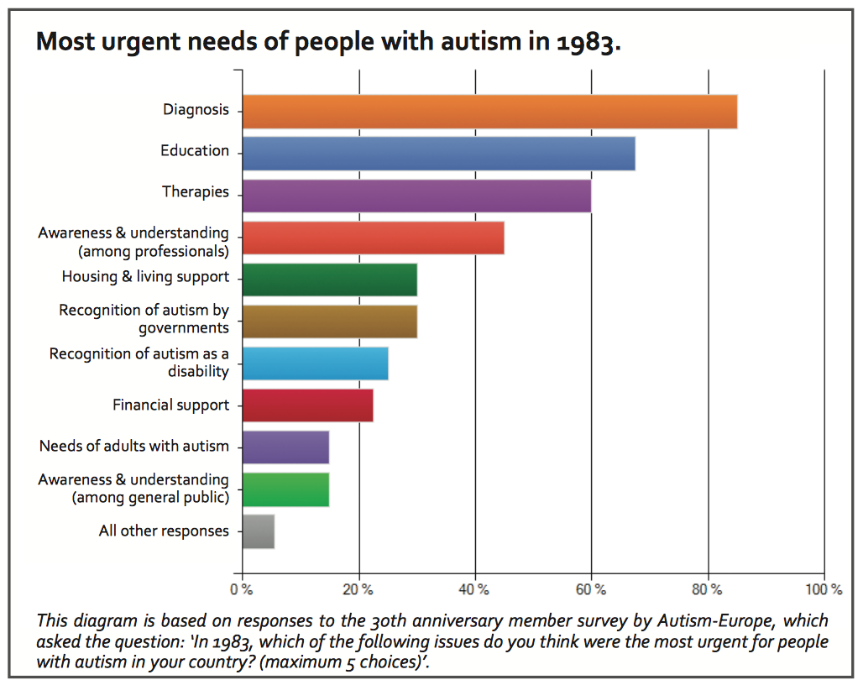
Gillott, A. Furniss, F. & Walter, A. (2001). Anxiety in High-Functioning Children with Autism. Autism, 5(3), pp.277–286.

Appendix 3

Looking at the above strategies, how would you adapt these within your teaching? Please discuss strategies not included that you may have used.

I have noticed that location of pupils in the classroom makes a difference, being close/distanced from others that can trigger emotional response in the pupil. I check that the pupil understands the task they have been asked to do, and support where and when needed.

Utilising classroom support / 1:1 to create a structured routine (including activities during break times) and to provide incentives (now we are writing, then we will play etc.). Creating an individual work station that is appealing and personal to the child. Creating a learning environment that is not over stimulating has proved essential, use of natural tones, plain black display backing etc.

Make them achievable and not isolating

Visual timetable Extra support when there are elements of choice (eg choice board) One to one support

Consistent routine at the start of each lesson. Clear, short instructions /explanations.

Soften my tone. Simplify my language so that it is clear and direct. Provide visuals for both myself and child to use. Visual timetable and daily routine are key to minimising anxiety. Run through visual timetable daily. Ensure sensory breaks are incorporated into weekly timetable.

Simplified communication when giving out instructions Behaviour chart with reward linked to his/her interests Visual routine for his / her to know what to expect from the day Keep the routine esp the morning as structured and similar as possible

Having a sensory chart for the child to express what they feel throughout pictures if they are non verbal. Learn their traits and which strategy to use depending on shown behaviours

Appendix 4

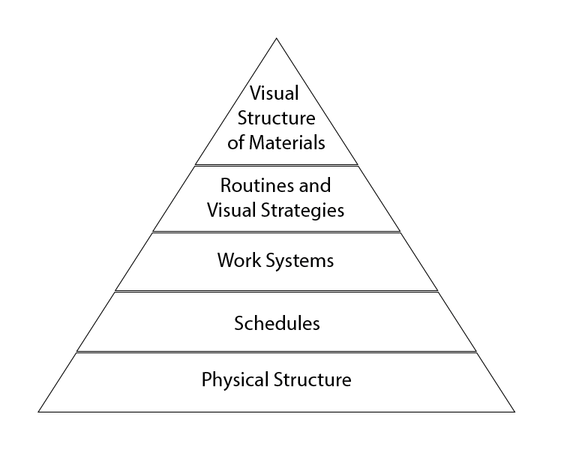

Hume, K., 2019. Visual Structure in the School Setting. Reading Rockets. Available at: http://www.readingrockets.org/article/visual-structure-school-setting [Accessed April 26, 2019].

Appendix 5
Number of respondents
Agreement of respondents

Appendix 6
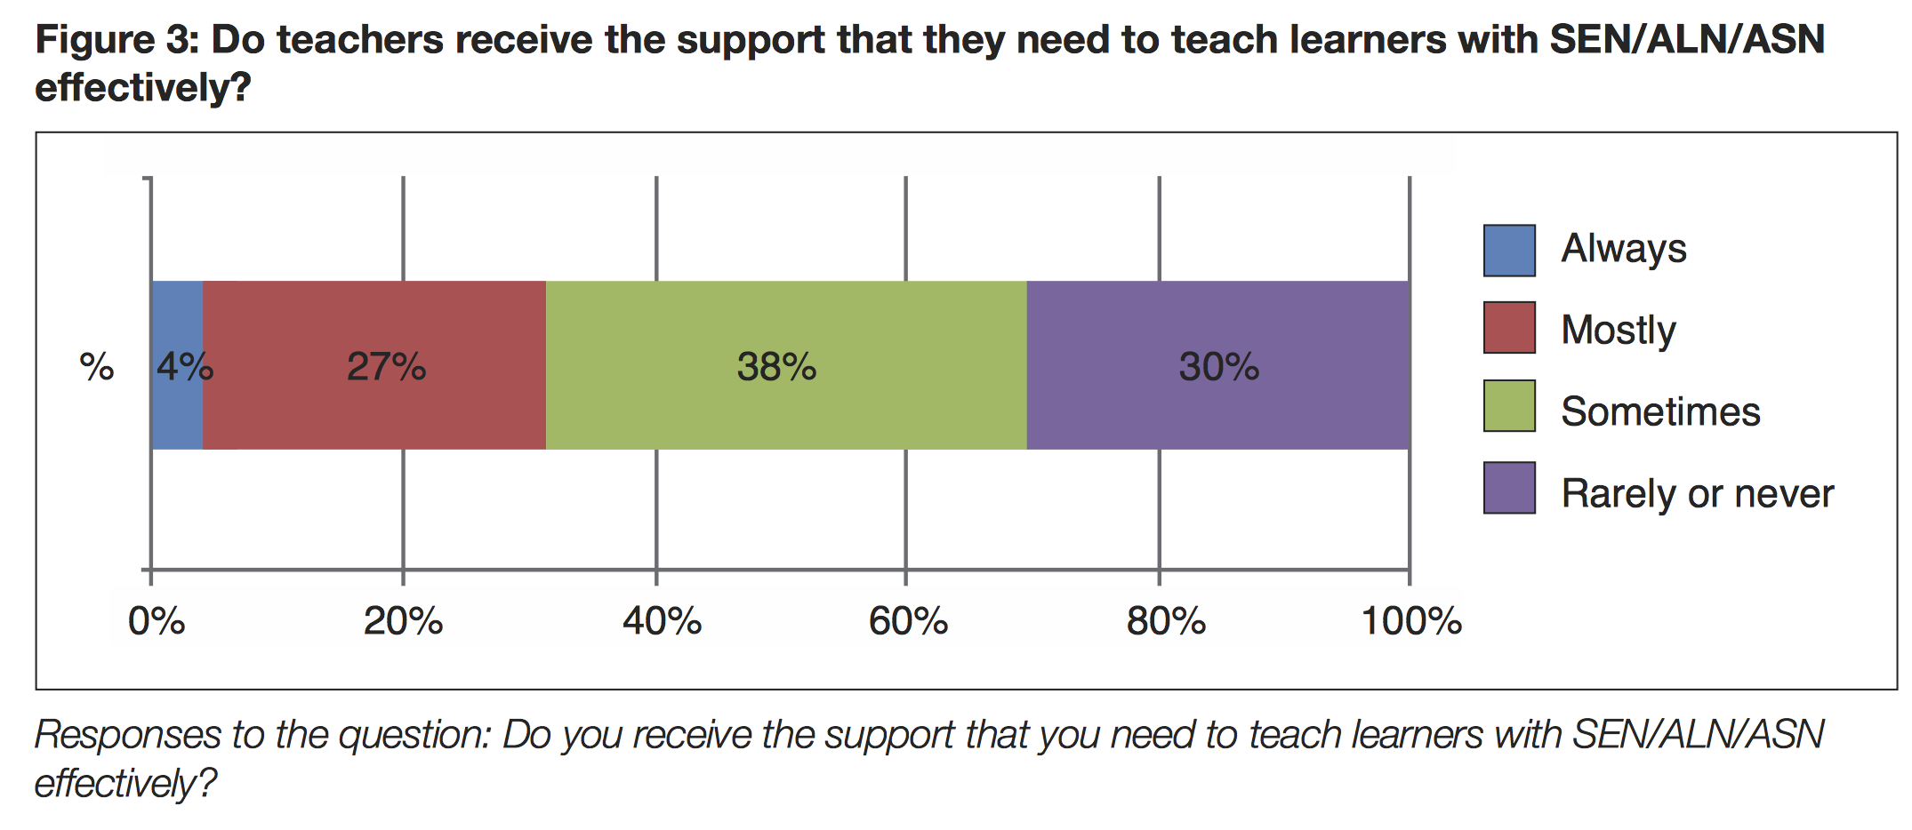

NASUWT. (2018). Special Educational Needs (SEN), Additional Learning Needs (ALN) and Additional Support Needs (ASN). [online]. Available at: https://www.nasuwt.org.uk/uploads/assets/uploaded/843fe4e0-fb73-408f-b2d69e1c48a95dfe.pdf (Accessed: 24th 2019).

Appendix 7

To what extent are these resources effective?
This helps the pupil feel like they have some control for their feelings when they walk into the classroom, which can be very overwhelming for them with so many pupils/noise etc. This also aids the pupil in communicating with the teacher visually when they feel happy or distressed before it escalates.

Each used at pupils choice, depending on their needs and emotions.

All depends on the pupil and how their day is going, routine is important for them

Visual timetables are effective as they show the routine during the day however can be challenging when something needs to change quickly that you couldn’t allow time for to explain the changes. Visual communication cards are very useful for some children who find it difficult to verbalise. Ear defenders can be effective when there is too much noise however some children find them uncomfortable and can affect learning negatively if used when teaching on the carpet.

I found a visual timetable extremely effective

Gives them a sense of independence so I find them incredibly effective
Very useful in mild ASD child. Severe needs require more support which I cannot not provide on my own

Unique to each individual.

Visual timetables and communication cards have proved essential in establishing routine and minimising anxiety. Social stories, in my experience, are invaluable.

Some children can become overly reliant on the resources or they can become used as an escape from the main activity.

Appendix 8
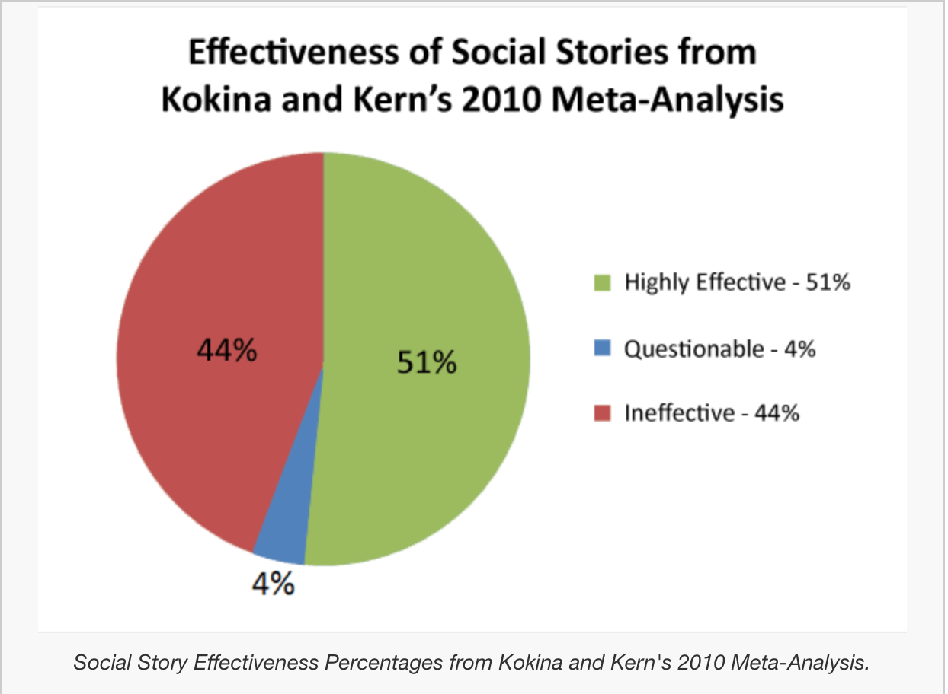

Cosgrave, G. (n.d). Are Social Stories Effective? Are Social Stories Effective? - Educate Autism. Available at: http://www.educateautism.com/social-stories/are-social-stories-effective.html [Accessed April 26, 2019].

