

Student Name: Valentina Somnik
Student ID: 2020147
Module: Financial Management
ASSIGNMENT TWO

Table of Contents
TASK ONE: The Continental Hotel Budget Planner 3
TASK TWO 4
A) Traditional Based Budget & Zero-Based Budgeting 4
A1) Traditional Based Budgeting 4
A2) Zero Based Budgeting 4
A3) Traditional Budgeting vs Zero-Based Budgeting 5
B) The process of zero-base budget and how can this be implemented 5
C. Can budgeting control support sustainability 6
List of References 7

TASK ONE: The Continental Hotel Budget Planner

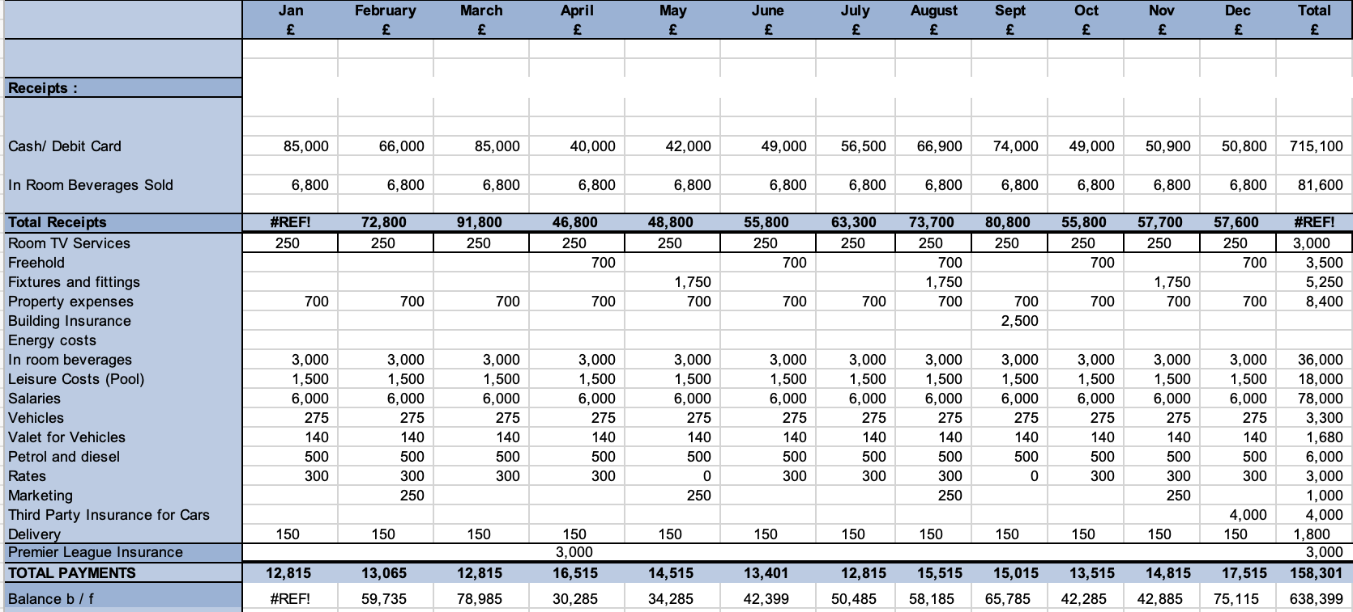

TASK TWO

Traditional Based Budget & Zero-Based Budgeting

A1) Traditional Based Budgeting

Customary planning is a strategy that relies upon that very year's spending to do the planning for the ongoing year. The main advantage of going for this kind of planning is effortlessness. If an organization follows this sort of planning, it doesn't have to reconsider each thing on the rundown. All things being equal, they can take a gander at the earlier year's spending and afterward add/deduct expansion rate, market circumstance, shopper interest, and so on.

The vast majority and organizations favour this kind of planning since they can sit with anything information they have with them, and afterward they can make a financial plan rapidly.

Customary planning is exceptionally normal since it saves time, and on the off chance that you can be gradual in your methodology, you can rapidly sort out the amount you might have to spend as an organization/person. Assuming you return and ponder how your financial plan your costs, you will see that the overall inclination is to look in reverse and perceive how you have spent your cash (Brock, 2022).

A2) Zero Based Budgeting

To begin with, this approach is a planning method in which all costs per new period must be justified. The zero-based planning process begins “zero-based” and analyses the needs and costs of each feature within the association. Second, whether each financial plan is higher or lower than the previous plan, the financial plan avoids what is needed for the next time frame.
Because it does have particular nature, a the ZBB plan can be a long-running migration cycle, examining several useful areas at once or using a group of pioneers. There is sex. Zero-based planning helps reduce costs by avoiding increased coverage and reduced spending plans from previous periods. Still, this is a time-consuming interaction that takes significantly longer than traditional cost-based planning.

A3) Traditional Budgeting vs Zero-Based Budgeting

Conventional planning brings for gradual increments over past financial plans, like a 2% increment in spending, rather than a support of both old and new costs, as called for with zero-based planning. W q d f g r t r e w s d f v c x s f g h y t r e w s W q d f g r t r e w s d f v c x s f g h y t r e w s W q d f g r t r e w s d f v c x s f g h y t r e w s W q d f g r t r e w s d f v c x s f g h y t r e w s W q d f g r t r e w s d f v c x s f g h y t r e w s W q d f g r t r e w s d f v c x s f g h y t r e w s
Conventional planning likewise just dissects just new uses, while ZBB begins from nothing and requires a defence of old, repeating costs notwithstanding new consumptions. Zero-based planning intends to put the onus on chiefs to legitimize costs and means to drive an incentive for an association by improving expenses and not simply income. W q d f g r t r e w s d f v c x s f g h y t r e w s W q d f g r t r e w s d f v c x s f g h y t r e w s W q d f g r t r e w s d f v c x s f g h y t r e w s W q d f g r t r e w s d f v c x s f g h y t r e w s W q d f g r t r e w s d f v c x s f g h y t r e w s W q d f g r t r e w s d f v c x s f g h y t r e w s

The process of zero-base budget and how can this be implemented

Organizations can create or change their own remarkable ways to deal with ZBB, and the accompanying five stages can give a standard to execution (Shah, 2007).
W q d f g r t r e w s d f v c x s f g h y t r e w s W q d f g r t r e w s d f v c x s f g h y t r e w s W q d f g r t r e w s d f v c x s f g h y t r e w s W q d f g r t r e w s d f v c x s f g h y t r e w s W q d f g r t r e w s d f v c x s f g h y t r e w s W q d f g r t r e w s d f v c x s f g h y t r e w s
Begin: Start at ground zero. Make another yearly spending plan without any preparation without involving last year's actuals as a pattern.
Assess: Assess each cost region. Wipe out and lessen superfluous exercises or administrations.
Legitimize: Represent all parts of the spending plan. Distinguish savvy, applicable, and cost-saving regions.
Smooth out: Figure out what exercises ought to be performed and how. Mechanize and normalize processes where conceivable.
Execute: Carry out extensive preparation and execution processes. Convey clear plans, jobs, and obligations. W q d f g r t r e w s d f v c x s f g h y t r e w s W q d f g r t r e w s d f v c x s f g h y t r e w s W q d f g r t r e w s d f v c x s f g h y t r e w s W q d f g r t r e w s d f v c x s f g h y t r e w s W q d f g r t r e w s d f v c x s f g h y t r e w s W q d f g r t r e w s d f v c x s f g h y t r e w s
Some suggested practices to `Zero-Based Budgeting include:
- Adopt a positive approach. ZBB is more than just slashing costs. It’s a necessary step for freeing the resources and funds needed for business renewal and growth initiatives. Working with the business leaders, you can use internal and external benchmarking to illustrate profitability gaps needing to be closed and explain exactly what will happen to the savings (Ana Plan, 2022).
- Identify quick wins. First, focus the Zero-Based Budgeting initiative on larger, more stable business units that are struggling with profitability, or specific overhead areas (such as SG & A) where large overhead costs are not clearly understood. Such a decision not only strengthens the reasons for adopting ZBB, but also provides maximum cost savings while minimizing the impact on other parts of the organization. W q d f g r t r e w s d f v c x s f g h y t r e w s W q d f g r t r e w s d f v c x s f g h y t r e w s W q d f g r t r e w s d f v c x s f g h y t r e w s W q d f g r t r e w s d f v c x s f g h y t r e w s W q d f g r t r e w s d f v c x s f g h y t r e w s W q d f g r t r e w s d f v c x s f g h y t r e w s

C. Can budgeting control support sustainability
A manageable spending plan is a spending plan where a client's pay meets or surpasses their costs. It very well may be founded on assessed or real costs and pay (HUD Exchange, 2020). A financial plan may likewise be viewed as practical assuming the spending plan shows the way that the client would be able or can't stand to live in their ongoing lodging and shows the client a way to a positive net gain. A reasonable spending plan is one which gives the client clear decisions in tough spots (McKinney, 2017). W q d f g r t r e w s d f v c x s f g h y t r e w s W q d f g r t r e w s d f v c x s f g h y t r e w s W q d f g r t r e w s d f v c x s f g h y t r e w s W q d f g r t r e w s d f v c x s f g h y t r e w s W q d f g r t r e w s d f v c x s f g h y t r e w s W q d f g r t r e w s d f v c x s f g h y t r e w s
Manageable bookkeeping has frequently been seen as the safeguard of multinationals packed with assets. In any case, in France, little and medium-sized organizations have shown extraordinary interest and flexibility in adjusting to change in this field.
The model assists organizations with turning out to be more manageable by representing natural and social execution in a non-financial manner. A bookkeeping framework represents actual progressions of recently characterized markers. It additionally puts the obligation regarding supportability execution essentially with the CFO. W q d f g r t r e w s d f v c x s f g h y t r e w s W q d f g r t r e w s d f v c x s f g h y t r e w s W q d f g r t r e w s d f v c x s f g h y t r e w s W q d f g r t r e w s d f v c x s f g h y t r e w s W q d f g r t r e w s d f v c x s f g h y t r e w s W q d f g r t r e w s d f v c x s f g h y t r e w s
To make it simpler for SMEs, the model likewise involves a similar language as in monetary bookkeeping, for example, a spending plan and other bookkeeping based terms (Strow, 2010). W q d f g r t r e w s d f v c x s f g h y t r e w s W q d f g r t r e w s d f v c x s f g h y t r e w s W q d f g r t r e w s d f v c x s f g h y t r e w s W q d f g r t r e w s d f v c x s f g h y t r e w s W q d f g r t r e w s d f v c x s f g h y t r e w s W q d f g r t r e w s d f v c x s f g h y t r e w s

List of References

Ana Plan (2022) The ultimate guide to zero-based budgeting. (online) available on: https://www.anaplan.com/blog/zbb-zero-based-budgeting-guide/ last accessed on: 2nd July 2022

Brock, T. (2022) Zero-based budgeting. Investopedia.

HUD Exchange, (2021) What is a sustainable budget. (online) available on: https://www.hudexchange.info/faqs/programs/housing-counseling/counseling-delivery/what-is-a-sustainable-budget/ last accessed on: 2nd July 2022

McKinney, J. B. (2017) Budgeting for Sustainability: an approach. 1st Edition. McFarland.

Shah, A. (2007) Budgeting and Budgetary Institutions. 1st Edition. World Bank Publications

Strow, B. K. (2010) Sustainable Budgeting. 2nd Edition. Western Kentucky University.

