Programme: MSc Public Health and Social Care in Practice
Module: Social Epidemiology and Public Health Development
Assignment Title: Component 2 Analytical Report
Chosen topic: Disability and Health Inequalities

Module Code: LCHS7000
STUDENT NAME: Kashish Sunilbhai Ardeshna
STUDENT NO.: 2539014
Lecturer Name: Muhammad Aliyu

TABLE OF CONTENTS:
Task 1: Social Epidemiological Analysis
- Introduction
- Contextual background and underlying factors
2.1 Higher Rates of Dementia
2.2 Low Rates of Access to Healthcare
2.3 Higher Mortality Rates Among Older People
2.4 Social Isolation and Loneliness
2.5 Poverty and Financial Insecurity
2.6 Poor and Unsuitable Housing
- National Response to Reduce Health Inequalities
3.1 Improving Dementia Diagnosis
3.2 Dame Barbara Windsor Dementia Goals
- Organisation Supporting the Chosen Group
4.1 Wider Role in Addressing Health Inequalities
4.2 Goals and Research
4.3 How it helps older people

- Conclusion

Task 2: Epidemiological Analysis
- INTRODUCTION
1.1 Definition and Impact on Health, Society, and Culture
1.2 Epidemiological Information Globally and in the UK
- Epidemiological Analysis of Multiple Sclerosis in the UK
  - Public Health Measures: Prevention, Protection and Promotion
  - Key Determinants and Risk Factors
  - Identification of People Affected
  - Monitoring and Surveillance
  - Short- and Long-Term Public Health Impact
  - Proposed Health Intervention Programme
  - Culturally Sensitive Intervention Program Design and Evaluation
    - Intervention Program Design: Community-Based MS Physiotherapy Programme
    - Evaluation Plan
  - Strengths and Weaknesses of the Epidemiological Approach
3 CONCLUSION
4 REFERENCES

Task 1: Social Epidemiological Analysis
Topic: Disability Inequality and Health Inequalities in the UK: A Social Epidemiological Analysis
1. Introduction:
Disability is an important public health and health-inequality issue in the UK. Disabled people experience poorer outcomes across health, employment, housing, wellbeing and social participation compared with non-disabled people (ONS, 2021). Disability can also create barriers to accessing healthcare, including difficulties with communication, accessibility and reasonable adjustments (NHS England, 2025). In England, 17.7% of the population (9.8 million people) were disabled in Census 2021, while in Wales the figure was 21.1% (670,000 people) (ONS, 2023). Social and economic circumstances influence these inequalities and can contribute to poorer health and quality of life.
2. Contextual background and underlying factors
Selected Target Group: Older People Aged 65 Years and Over in the UK
2.1 Higher Rates of Dementia
Epidemiological Data & Risk Analysis
Dementia poses a critical health inequality for older adults, with 483,000 individuals aged 65 and over in England diagnosed as of December 2024, indicating a prevalence of 4.2%. This figure varies geographically, ranging from 3.6% to 4.8%, which underscores significant disparities in diagnosis (Office for Health Improvement and Disparities, 2025).
Solutions & Public Health Challenges
Addressing this issue requires early diagnosis, enhanced access to memory assessment services, and integrated health and social care. However, challenges such as regional discrepancies in diagnosis and rising demand for services remain significant hurdles.

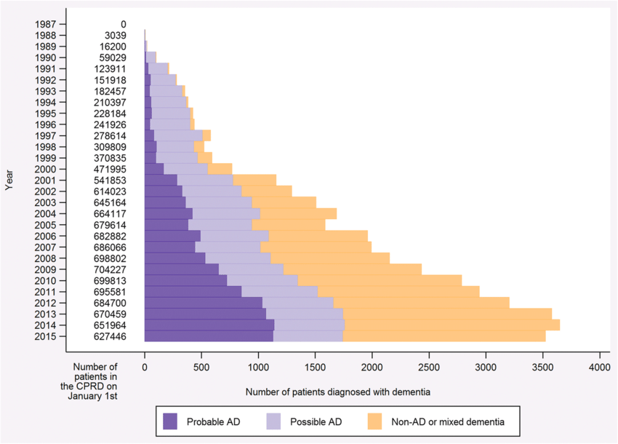
Source: Walker et al. (2018).
1987: 0 patients diagnosed 2000: 471,995 patients 2005: 679,614 patients 2010: 699,813 patients 2015: 627,446 patients
2.2 Low Rates of Access to Healthcare
Epidemiological Data & Risk Analysis
Older adults frequently encounter obstacles in accessing healthcare due to mobility issues, limited digital skills, transportation difficulties, and residing in deprived areas. A recent survey indicated that 24% of adults aged 65 and over had unmet needs for assistance with daily activities, with disparities ranging from 16% in the least deprived areas to 40% in the most deprived regions.
Solutions & Public Health Challenges
To enhance access, it's crucial to improve community healthcare, provide accessible transportation, offer non-digital appointment options, and establish outreach services. NHS services need to consider digital exclusion and the varied needs of older individuals when planning healthcare access.
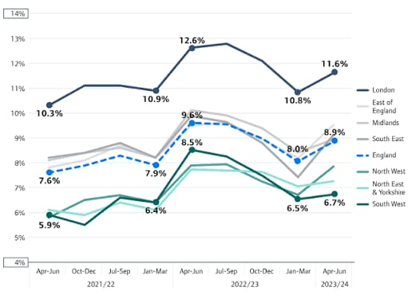
Source: Care Quality Commission (2023)
2.3 Higher Mortality Rates Among Older People
Epidemiological Data & Risk Analysis
Mortality rates rise with age. In 2024, there were 568,613 deaths in England and Wales (Office for National Statistics, 2025). Life expectancy at 65 was 18.7 years for males and 21.2 for females. Older adults are at high risk for chronic conditions, with socioeconomic disparities worsening health outcomes (Office for Health Improvement and Disparities, 2025).
Solutions & Public Health Challenges
Reducing mortality requires early diagnosis and management of chronic conditions, vaccinations, and screening programs, alongside addressing socioeconomic factors like poverty.
2.4 Social Isolation and Loneliness
Social Context & Risk Analysis
Loneliness affects about 940,000 older adults in the UK, with 270,000 spending weeks without conversation (Age UK, 2024). Factors like bereavement and health issues contribute to this, leading to worse physical and mental health outcomes (Age UK, 2024).
Solutions & Public Health Challenges
Initiatives like befriending services and social groups can help. Accessible transport is vital, but barriers like mobility issues remain significant.
2.5 Poverty and Financial Insecurity
Social Context & Risk Analysis
Financial insecurity greatly affects older individuals' health by limiting access to essentials like food and heating. About 21% of single pensioners live in relative poverty after housing costs, with 20% of those aged 85 and older facing similar situations (HM Treasury, 2025). This strain can lead to poor nutrition and hinder access to services.
Solutions & Public Health Challenges
Increasing access to benefits, financial advice, and community support can alleviate some pressures, but rising living costs and limited incomes remain significant challenges for many older adults.
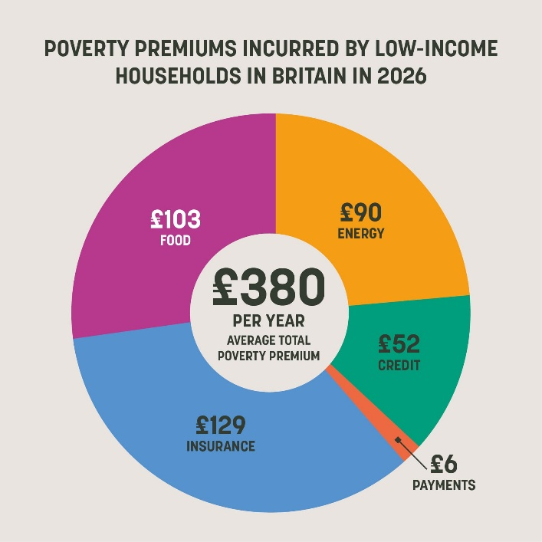
Source: Evans and Davies (2026)
2.6 Poor and Unsuitable Housing
Social Context & Risk Analysis
Poor housing adversely affects older people's health, with approximately 1.1 million older individuals in England living in unfit conditions. Issues such as dampness, infestations, and plumbing problems can lead to respiratory and cardiovascular problems and increased fall risk.
Solutions & Public Health Challenges
Addressing these inequalities requires initiatives like home adaptations, improved heating and insulation, and housing inspections. However, challenges persist, particularly in the availability and affordability of adequate housing for older adults.
3. National Response to Reduce Health Inequalities
3.1 Improving Dementia Diagnosis
The NHS has committed to a national goal where two-thirds of individuals living with dementia receive a formal diagnosis. As of March 2025, the dementia diagnosis rate stood at 65.6%, nearing the target of 66.7% (NHS England, 2025). Efforts include sharing best practices, bolstering Integrated Care Boards, and enhancing dementia pathways, particularly within care homes.
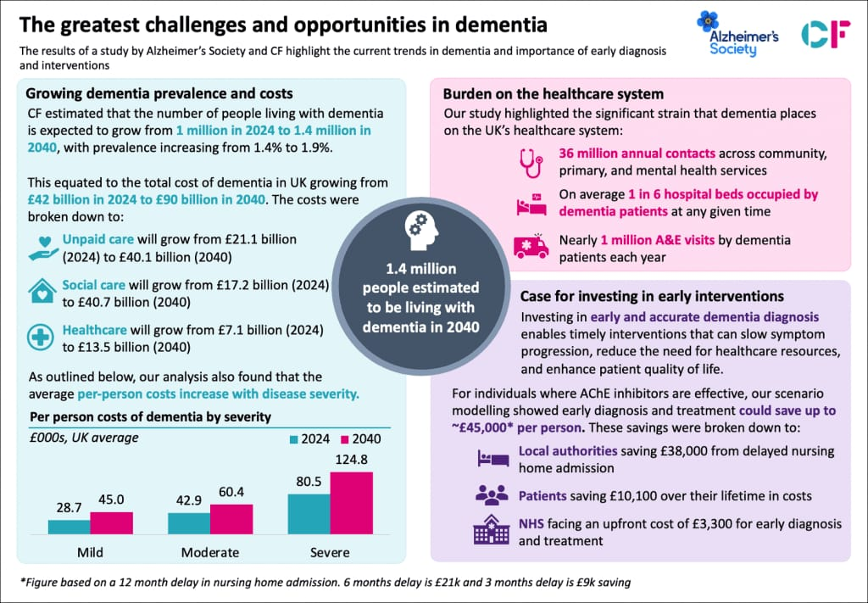
Source: Carnall Farrar (2024), Alzheimer’s Society.
3.2 Dame Barbara Windsor Dementia Goals
The Dame Barbara Windsor Dementia Goals focus on advancing dementia research and innovation, including better diagnosis and treatment. This initiative brings together government, NHS, and researchers to improve solutions for those affected by dementia (Department for Health and Social Care, 2026).
4. Organisation Supporting the Chosen Group
4.1 Wider Role in Addressing Health Inequalities
Alzheimer’s Society is a prominent UK charity supporting individuals affected by dementia. It addresses inequalities in diagnosis and care through advocacy and research funding (Alzheimer’s Society, 2026).
4.2 Goals and Research:
Alzheimer’s Society focuses on improving care and diagnosis, influencing policy, and funding research, having invested over £124 million in dementia-related research since 1989 (Alzheimer’s Society, 2026).
4.3 How it helps older people
Provides dementia advice and support. - Funds relevant research. - Campaigns for improved dementia services.
- Conclusion:
Older people in the UK face significant health and social inequalities, such as dementia, multimorbidity, loneliness, and financial insecurity, influenced by age, income, and access to services (NHS England, 2026). To address these issues, national strategies should focus on prevention, early intervention, and integrated care, which are vital for supporting older adults' independence (NHS England, 2026). A healthy-ageing approach can help older individuals live longer, healthier lives and reduce community disparities (Office for Health Improvement and Disparities, 2023).
Task 2: Epidemiological Analysis
1. INTRODUCTION
1.1 Definition and Impact on Health, Society, and Culture
Multiple sclerosis (MS) is a chronic neurological condition where the immune system attacks nerve fibres, disrupting communication in the central nervous system (MS Society, 2024). It often presents with symptoms like fatigue, numbness, and cognitive difficulties (MS Society, 2025). Typically diagnosed in early adulthood, MS can significantly impact work and social life, affecting mental health and financial stability. About 85% of patients start with relapsing-remitting MS, experiencing cycles of symptoms (MS Society, 2024). The condition not only influences personal wellbeing but also alters family dynamics and societal perceptions of disability. Access to care varies globally, creating inequalities in treatment and support for those affected (Multiple Sclerosis International Federation, 2023). Addressing MS requires a holistic approach that combines medical and social support.
1.2 Epidemiological Information Globally and in the UK
Multiple sclerosis (MS) affects approximately 2.9 million people worldwide, with a global prevalence of around 36 cases per 100,000 population. Women are affected about twice as often as men, and diagnosis commonly occurs around the age of 32 (Walton et al., 2020). More recent GBD 2021 estimates reported 1.89 million prevalent cases globally in 2021, demonstrating how estimates vary according to epidemiological methods and data sources (She et al., 2025).
In the UK, over 150,000 people live with MS, with approximately 7,100 new diagnoses each year, equivalent to around 1 in 400 people. Women represent approximately 71% of people with MS (MS Society, 2024). Differences between estimates highlight the importance of considering data quality, case definitions and methodology when interpreting MS epidemiology.
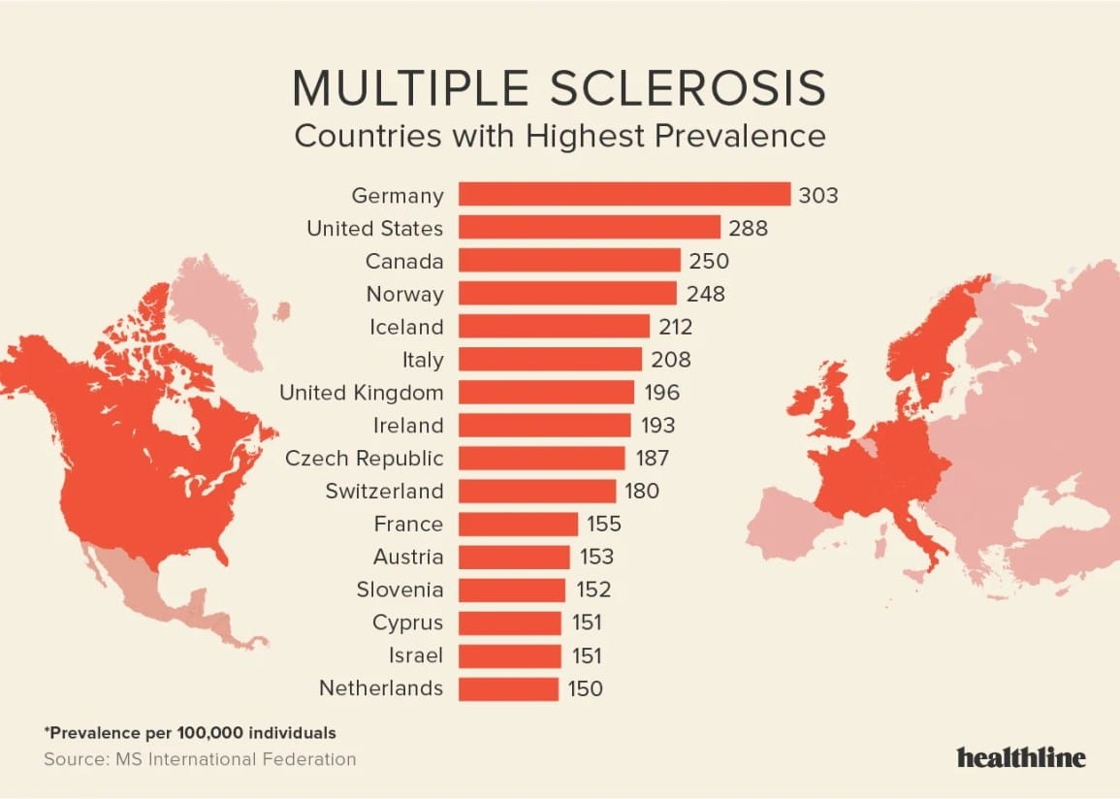
Source: Healthline (2025), based on MS International Federation (MSIF) data
2. Epidemiological Analysis of Multiple Sclerosis in the UK
  - Public Health Measures: Prevention, Protection and Promotion

The 3 Ps: Multiple sclerosis (MS) currently cannot be prevented, as its exact cause remains elusive. Therefore, public health strategies in the UK focus on reducing modifiable risks, preventing complications, and promoting overall well-being.
The target population for this public health analysis is adults living with or at risk of Multiple Sclerosis (MS) in Camden, London. Camden is a diverse central London borough with approximately 217,000 residents and considerable variation in socioeconomic circumstances across neighbourhoods.
Prevention (Primary) efforts target factors like smoking, obesity, and low vitamin D levels, but they should not be seen as foolproof means of preventing MS (Dobson and Giovannoni, 2019).
Protection (Secondary) involves early diagnosis, effective management of relapses, disease-modifying therapies, and vaccination advice. The National Institute for Health and Care Excellence (NICE) emphasises comprehensive assessments to tailor treatment based on disease type and activity (NICE, 2026).
Promotion (Tertiary) efforts encourage physical activity, healthy living, self-management, and psychological health, ensuring individuals lead fulfilling lives despite their diagnosis.

  - Key Determinants and Risk Factors
MS risk stems from a mix of genetic and environmental factors. Research points to Epstein–Barr virus infection, smoking, low vitamin D exposure, and adolescent obesity as significant contributors (Olsson, Barcellos, and Alfredsson, 2017). Notably, MS prevalence is higher in regions farther from the equator, suggesting environmental influences play a role. While these factors can increase risk, they aren't definitive causes; genetic predisposition also plays a part, illustrating the complexity of MS (Dobson and Giovannoni, 2019).

  - Identification of People Affected
Understanding who is affected by MS is crucial for effective resource allocation. Data from Public Health England indicated a prevalence of around 190 cases per 100,000 people, suggesting approximately 105,800 individuals live with MS in England. Notably, prevalence is higher among women, particularly those aged 60-69 (Public Health England, 2020). The MS Society estimates the number living with MS in the UK has surpassed 150,000, with about 7,100 new diagnoses annually, highlighting the importance of accurate public health data (MS Society, 2026).

Source: MS Society, 2022

  - Monitoring and Surveillance
In the UK, several key monitoring and surveillance systems collect vital data on Multiple Sclerosis (MS):
1. UK MS Register: This combines patient-reported questionnaires with clinical data, allowing patients to share information about their symptoms, quality of life, and disability over time (UK MS Register, 2026).
2. Routine NHS Clinical Data: NHS MS services collect clinical information such as diagnosis, MS type, disability (using the EDSS), disease progression, and treatments. This data is essential for tracking treatment effectiveness (UK MS Register, 2026).
3. Hospital Episode Statistics (HES): HES records NHS hospital admissions and outpatient visits, helping monitor healthcare use among those with MS, though it doesn’t cover all care provided outside hospitals (NHS England, 2026).
4. Patient-Reported Outcome Measures (PROMs): The UK MS Register also collects data on the impact of MS, including fatigue and mental health, providing insights into how the condition affects daily life (UK MS Register, 2026).
These systems play a critical role in understanding and improving MS care.

  - Short- and Long-Term Public Health Impact
In the short term, MS can lead to significant health challenges such as fatigue, mobility issues, and emotional distress, negatively impacting daily activities (NHS, 2026).
Long-term effects may include increased disability and the need for ongoing rehabilitation and support, resulting in substantial costs for individuals, families, and the healthcare system. The growing MS population emphasises the need for specialised neurological services (MS Society, 2024).
  - Proposed Health Intervention Programme
An effective intervention could be an integrated early-management and rehabilitation program offered through NHS neurology services. This would include rapid referrals, annual reviews, personalised symptom assessments, and support for physical activity and smoking cessation (NICE, 2026). Exercise-based rehabilitation should be central, as evidence shows it can help reduce MS-related fatigue and improve overall functional outcomes (Pearson et al., 2015/2017).
2.7 Culturally Sensitive Intervention Program Design and Evaluation
2.7.1 Intervention Program Design: Community-Based MS Physiotherapy Programme
Phase 1: Baseline (Before Intervention)
Record patient participation rates in MS services.
Measure waiting times for MS services.
Assess mobility, disability levels, and quality of life.
Collect patient-reported outcomes via the UK MS Register (UK MS Register, 2026).
Phase 2: Six-Month Evaluation
Compare participation rates with the baseline.
Check for reductions in waiting times.
Reassess mobility and quality of life.
Gather patient feedback for barriers and improvements.
Phase 3: Twelve-Month Evaluation
Compare all outcomes with baseline and six-month results.
Assess sustainability of improvements in mobility and quality of life.
Review patient-reported outcomes for overall effectiveness (UK MS Register, 2026).
2.7.2 Evaluation Plan
RE-AIM Framework for Multiple Sclerosis in the UK
A community-based physiotherapy and exercise intervention for people with MS can be evaluated using the RE-AIM framework (Glasgow et al., 2019).
Reach: Measure participation rates among people with MS, including various age groups and socioeconomic backgrounds.
Effectiveness: Assess improvements in mobility, fatigue, and quality of life at baseline, 6 months, and 12 months (NICE, 2022).
Adoption: Evaluate the willingness of NHS MS services and physiotherapists to provide the intervention.
Implementation: Check if the program is delivered consistently and adapted to meet individual needs (NICE, 2022).
Maintenance: Assess whether health improvements and regular physical activity continue after the program ends. This framework allows for a comprehensive evaluation of the intervention's impact and sustainability.
Source: Belza, Toobert and Glasgow (2007)
2.8 Strengths and Weaknesses of the Epidemiological Approach
- Strengths of the UK MS Surveillance:
Multiple Data Sources:
Integrates clinical information, NHS data, and patient-reported outcomes for a comprehensive understanding of MS’s impact (UK MS Register, 2026).
Longitudinal Monitoring:
Collects questionnaires every six months, allowing for tracking changes in symptoms, disability, and quality of life over time (UK MS Register, 2026).
Large Population Data:
Utilizes primary-care records to estimate MS prevalence and incidence, supporting effective healthcare planning (Public Health England, 2020).
- Weaknesses of the UK MS Surveillance:
Sampling Bias:
Voluntary participation may result in a non-representative sample of the MS population (Jacobs et al., 2024).
Incomplete Routine Data:
Primary-care datasets can have missing or incomplete records, affecting data quality and reliability (Public Health England, 2020).
Digital Exclusion:
Online patient-reported data may under-represent individuals with limited digital access or technology skills (Ford et al., 2012).

3. CONCLUSION:
Multiple Sclerosis (MS) is a significant public health concern in the UK, impacting over 150,000 individuals and resulting in approximately 7,100 new diagnoses each year (MS Society, 2024). The prevalence of MS varies by age and sex, and various social and socioeconomic factors can shape how individuals experience the condition and access care.
To effectively address these challenges, continuous monitoring and surveillance through platforms like the UK MS Register and NHS data are essential. This data helps identify evolving needs and guides service planning (UK MS Register, 2026). Interventions should prioritize early diagnosis, prompt treatment, rehabilitation, reduced waiting times, and overall improvement in quality of life. Evaluating these interventions at baseline, six months, and twelve months can help determine their effectiveness.
By combining rigorous epidemiological evidence with insights from patients’ experiences, the UK can work towards creating more equitable, person-centred MS services that truly meet the needs of those affected.
REFERENCES:
- Office for National Statistics (ONS) (2022) ‘Outcomes for disabled people in the UK: 2021’. Available at: ONS – Outcomes for disabled people in the UK (Accessed: 25 July 2026).
- Office for National Statistics (ONS) (2023) ‘Disability, England and Wales: Census 2021’. Available at: ONS – Disability, England and Wales (Accessed: 25 July 2026).
- NHS England (2025) ‘Primary Care Dementia Data, March 2025’. Available at: NHS England – Primary Care Dementia Data (Accessed: 25 July 2026).
- Office for Health Improvement and Disparities (2025) ‘Dementia profile: prevalence and supporting well topics statistical commentary, March 2025’. Available at: GOV.UK – Dementia profile (Accessed: 25 July 2026).
- Walker, V.M., Davies, N.M., Kehoe, P.G. and Martin, R.M. (2018) ‘What is the impact of regulatory guidance and expiry of drug patents on dementia drug prescriptions in England? A trend analysis in the Clinical Practice Research Datalink’, Alzheimer’s Research & Therapy, 10, 51. Available at: Alzheimer's Research & Therapy – Walker et al. (Accessed: 25 July 2026).
- NHS England (2025) ‘NHS England performance report 2024/25’. Available at: NHS England – Performance report (Accessed: 25 July 2026).
- Office for National Statistics (ONS) (2025) ‘Death registration summary statistics, England and Wales: 2024’. Available at: ONS – Death registration statistics 2024 (Accessed: 25 July 2026).
- Office for National Statistics (ONS) (2025) ‘National life tables – life expectancy in the UK: 2022 to 2024’. Available at: ONS – National life tables (Accessed: 25 July 2026).
- Age UK (2024) ‘Building on success to beat loneliness’. Available at: Age UK – Building on success to beat loneliness (Accessed: 25 July 2026).
- Barnett, K., Mercer, S.W., Norbury, M., Watt, G., Wyke, S. and Guthrie, B. (2012) ‘Epidemiology of multimorbidity and implications for health care, research, and medical education: a cross-sectional study’, The Lancet, 380(9836), pp. 37–43. Available at: PubMed – Barnett et al. (Accessed: 25 July 2026).
- Benichou, O. and Lord, S.R. (2016) ‘Rationale for strengthening muscle to prevent falls and fractures: a review of the evidence’, Calcified Tissue International, 98(6), pp. 531–545. Available at: PubMed – Benichou and Lord (Accessed: 25 July 2026).
- Department for Health and Social Care (2026) ‘Dame Barbara Windsor Dementia Goals’. Available at: GOV.UK – Dame Barbara Windsor Dementia Goals (Accessed: 25 July 2026).
- Office for Life Sciences, Department of Health and Social Care and Department for Science, Innovation and Technology (2026) ‘Life Sciences Healthcare Goals’. Available at: GOV.UK – Life Sciences Healthcare Goals (Accessed: 25 July 2026).
- MS Society (2024) ‘MS in the UK’. Available at: MS Society – MS in the UK (Accessed: 25 July 2026).
- MS Society (2024) ‘Number of people living with MS in UK increases’. Available at: MS Society – Number of people living with MS in UK increases (Accessed: 25 July 2026).
- MS Society (2024) ‘What is multiple sclerosis (MS)?’. Available at: MS Society – What is MS? (Accessed: 25 July 2026).
- MS Society (2024) ‘Relapsing remitting MS’. Available at: MS Society – Relapsing remitting MS (Accessed: 25 July 2026).
- Walton, C., King, R., Rechtman, L. et al. (2020) ‘Rising prevalence of multiple sclerosis worldwide: insights from the Atlas of MS, third edition’, Multiple Sclerosis Journal, 26(14). Available at: Multiple Sclerosis Journal – Walton et al. (Accessed: 25 July 2026).
- Public Health England (2020) ‘Multiple sclerosis: prevalence, incidence and smoking status’. Available at: GOV.UK – Multiple sclerosis prevalence and incidence (Accessed: 25 July 2026).
- Dobson, R. and Giovannoni, G. (2019) ‘Multiple sclerosis – a review’, European Journal of Neurology, 26(1), pp. 27–40. Available at: Wiley – Multiple sclerosis: a review (Accessed: 25 July 2026).
- Olsson, T., Barcellos, L.F. and Alfredsson, L. (2017) ‘Interactions between genetic, lifestyle and environmental risk factors for multiple sclerosis’, Nature Reviews Neurology, 13, pp. 25–36. Available at: Nature – Olsson et al. (Accessed: 25 July 2026).
- NICE (2022, updated 2026) Multiple sclerosis in adults: management (NG220). Available at: NICE – Multiple sclerosis in adults (Accessed: 25 July 2026).
- Ford, D.V., Jones, K.H., Middleton, R.M. et al. (2012) ‘The feasibility of collecting information from people with Multiple Sclerosis for the UK MS Register via a web portal: characterising a cohort of people with MS’, BMC Medical Informatics and Decision Making, 12, 73. Available at: BMC – Ford et al. (Accessed: 25 July 2026).
- UK MS Register (2026) ‘Our Data’. Available at: UK MS Register – Our Data (Accessed: 25 July 2026).
- UK MS Register (2026) ‘Frequently Asked Questions’. Available at: UK MS Register – FAQ (Accessed: 25 July 2026).
- Jacobs, B.M., Schalk, L., Tregaskis-Daniels, E. et al. (2024) ‘The relationship between ethnicity and multiple sclerosis characteristics in the United Kingdom: a UK MS Register study’, Multiple Sclerosis Journal, 30(11–12), pp. 1544–1555. Available at: Multiple Sclerosis Journal – Jacobs et al. (Accessed: 25 July 2026).
- Glasgow, R.E., Harden, S.M., Gaglio, B. et al. (2019) ‘RE-AIM planning and evaluation framework: adapting to new science and practice with a 20-year review’, Frontiers in Public Health, 7, 64. Available at: Frontiers in Public Health – Glasgow et al. (Accessed: 25 July 2026).
- NHS England (2026) ‘Data sets processed in the National Data Integration Tenant of the NHS Federated Data Platform’. Available at: NHS England – Data sets (Accessed: 25 July 2026).
- Alzheimer’s Society (2026) ‘Who we are’. Available at: Alzheimer’s Society – Who we are (Accessed: 25 July 2026).
- Alzheimer’s Society (2026) ‘Our research’. Available at: Alzheimer’s Society – Our research (Accessed: 25 July 2026).
- Simmonds, L., et al. (2018) ‘What is the impact of regulatory guidance and expiry of drug patents on dementia drug prescriptions in England? A trend analysis in the Clinical Practice Research Datalink’, BMC Medicine, 16, 151. Available at: (Accessed: 25 July 2026).
- Carnall Farrar (2024) Multiple Sclerosis in England. 24 April. Available at: https://www.carnallfarrar.com/multiple-sclerosis-in-england-cf-snapshot/ (Accessed: 25 July 2026)
- Care Quality Commission (2023) The state of health care and adult social care in England 2022/23. London: Care Quality Commission. Available at: CQC – The health and care workforce (Accessed: 25 July 2026).
- Evans, J. and Davies, S. (2026) Paying more for less: The poverty premium in 2026. Personal Finance Research Centre, University of Bristol, commissioned by Fair By Design. Available at: University of Bristol – Paying more for less: The poverty premium in 2026 (Accessed: 25 July 2026).

