Student Name: Shamila Qamar
Student ID: 2436303
Module Code: LCHS4003
Module Title: Introduction to Health and Social Care
Lecturer Name: Azida Zainol
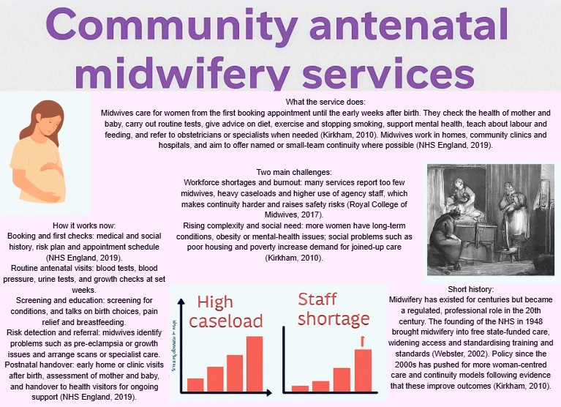
References
NICE (2019) Antenatal care for uncomplicated pregnancies. London: National Institute for Health and Care Excellence. Available at: https://www.nice.org.uk/guidance/cg62 (Accessed: 18 October 2025).
Saving Babies’ Lives Care Bundle V2 (2019) NHS England and NHS Improvement. Available at: https://www.england.nhs.uk/publication/saving-babies-lives-care-bundle-version-2/ (Accessed: 18 October 2025).
Maternity Transformation Programme (2016) Better Births: Improving outcomes of maternity services in England. London: NHS England. Available at: https://www.england.nhs.uk/publication/maternity-transformation/ (Accessed: 18 October 2025).
MBRRACE-UK (2020) Perinatal mortality surveillance report for births. Available at: https://www.npeu.ox.ac.uk/mbrrace-uk/reports (Accessed: 18 October 2025).

Task 2 Essay 600 words
Origins and founding principles of the NHS.
The National Health Service (NHS) was created in 1948 as part of a wider post-war reconstruction of the British welfare state, driven by public demand for social security and improved health after the privations of the Second World War (Timmins, 2018). The idea of a universal, state-funded health service drew on earlier debates about social citizenship and the Beveridge proposals for tackling “want, disease, ignorance, squalor and idleness.” Politically, the wartime experience and the 1945 Labour government gave the impetus and mandate to deliver a comprehensive service that would be free at the point of use, funded from general taxation, and available to all residents, regardless of income (Timmins, 2018). Aneurin Bevan and other architects framed the NHS around three core principles: universality, comprehensiveness and free access at delivery; these were intended both as moral commitments to equality and as pragmatic means to remove financial barriers that had long prevented poorer citizens from obtaining timely care (Department of Health, 2000).
Structurally, the NHS replaced a patchwork of voluntary hospitals, municipal services, and private practitioners with a national framework able to plan capacity and distribute resources across regions. The choice to rely on public funding rather than an insurance model reflected a vision of health care as a social right and a public good, financed through solidarity rather than contributions tied to employment or earnings (Timmins, 2018). Early NHS policy prioritised expanding hospital capacity, standardising training for health professionals and ensuring basic provision of maternal, infectious-disease and chronic-care services. These founding arrangements set expectations of universal entitlement and central coordination that continue to shape debates about the NHS’s purpose and limits.
Current structure and functioning
The contemporary NHS remains an integrated idea but is operationally fragmented: health services are now devolved across England, Scotland, Wales, and Northern Ireland, each with its own budgetary and policy settings. In England, major reforms since the 1990s and 2000s introduced market mechanisms, purchaser-provider splits, and later moves toward integrated care systems intended to foster collaboration between hospitals, primary care, social services, and community providers (Department of Health, 2000; Le Grand, 2006). Primary care is delivered by independent contractor general practitioners who function as gatekeepers, while hospital trusts provide acute and specialised services; commissioning and accountability mechanisms have shifted between local and central control as successive governments seek the right balance of autonomy, efficiency, and equity.
Operational strengths include universal legal entitlement, the ability to mobilise resources at scale for public-health programmes, and an expert clinical workforce capable of delivering complex care. Weaknesses are persistent: demand growth from an ageing population and multi-morbidity, constrained public funding relative to need, and workforce shortages across nursing, general practice and specialist roles create long waiting times and variable access across regions. Market-style reforms and outsourcing of elective services have expanded capacity in some areas but risk fragmenting care pathways and weakening continuity if incentives misalign with equity goals (Pollock, 2004; Le Grand, 2006). Integration initiatives show promise but require sustained funding, clear governance, and interoperable data systems to translate rhetoric into better patient journeys.
Critical assessment and implications
The NHS still embodies its founding principles in law and ethos, but policy choices over the past three decades have introduced tensions between efficiency, market incentives, and equity. Levers such as performance targets and competition can drive short-term gains yet also produce perverse incentives that distort clinical priorities and neglect prevention (Le Grand, 2006). Pollock argues that greater reliance on private provision risks incremental privatisation and erosion of the NHS’s universal character unless tightly regulated and publicly accountable (Pollock, 2004). To sustain the NHS’s core mission policymakers must commit to long-term funding rises proportionate to demographic and technological change, invest in workforce restoration, and protect continuity and preventive care. Reconnecting health and social care budgets, strengthening primary and community services, and aligning incentives with public-health goals are essential to preserve universality while improving responsiveness and value for money.
References
Department of Health (two thousand) The NHS Plan: A plan for investment, a plan for reform. London: Department of Health. Available at: https://webarchive.nationalarchives.gov.uk/ukgwa/20130124045407/http://www.dh.gov.uk/en/Publicationsandstatistics/Publications/PublicationsPolicyAndGuidance/DH_4009697 (Accessed: 18 October 2025).
Le Grand, J. (2006) Motivation, agency, and public policy: Of knights and knaves, pawns, and queens. Oxford: Oxford University Press. Available at: https://global.oup.com/academic/product/motivation-agency-and-public-policy-9780199271517 (Accessed: 18 October 2025).
Pollock, A. (2004) NHS plc: The privatisation of our healthcare. London: Verso. Available at: https://www.versobooks.com/books/ (Accessed: 18 October 2025).
Timmins, N. (2018) The five giants: A biography of the Welfare State. 2nd edn. London: HarperCollins. Available at: https://www.harpercollins.co.uk/

