COMPUTER SYSTEM
M4X01500
Screenshot 1
Shows that I have successfully installed server one and client one
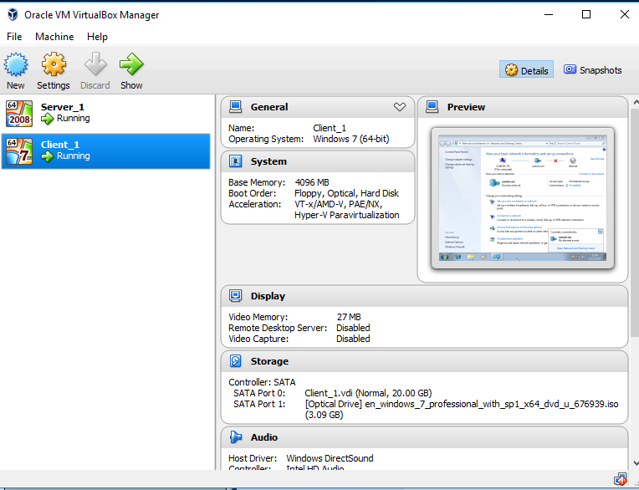
Screenshot 2 &3
This demonstrates server one and client one pinging with four sent, four received and zero lost
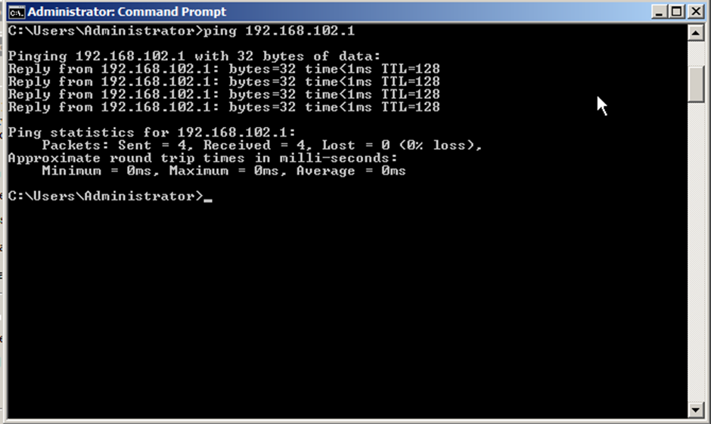
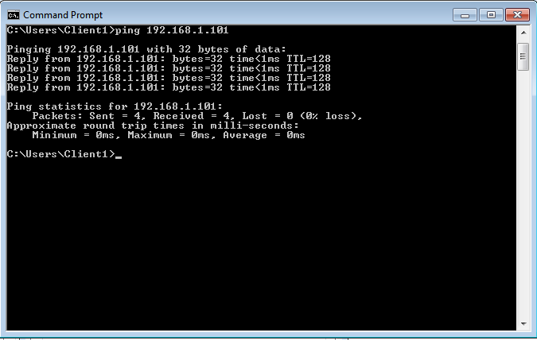
Screenshot 4
This shows that I have changed the IP addresses and correctly applied DNS server for both client one and server one so changed the name of network to PrivateNet
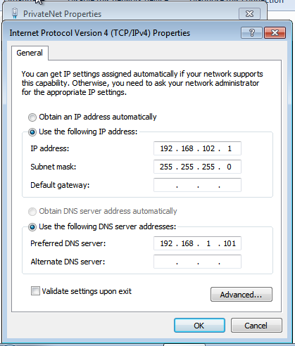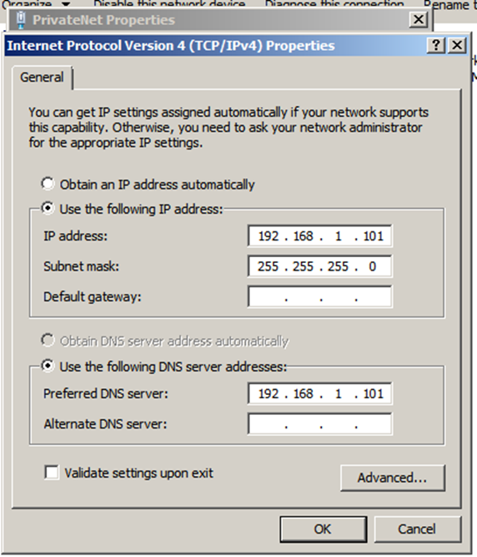

Screenshot 5
clearly shows that I’ve installed an active domain under the name of uwtsd.com
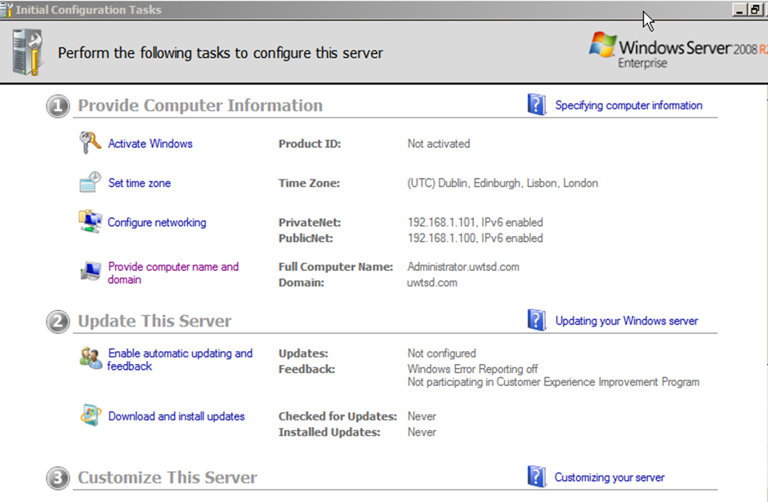
Screenshot 6
As you can see client one in the users and computers so the client can access the domain
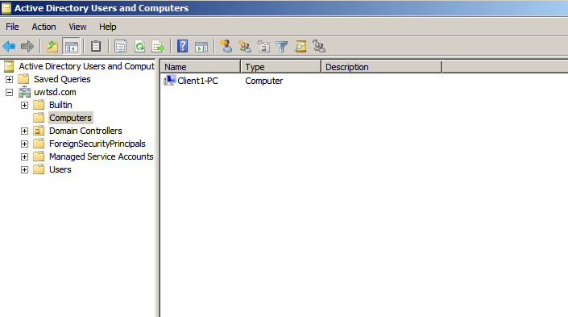

Screenshot 7
Clearly displays the logging in to the domain via using the client computer

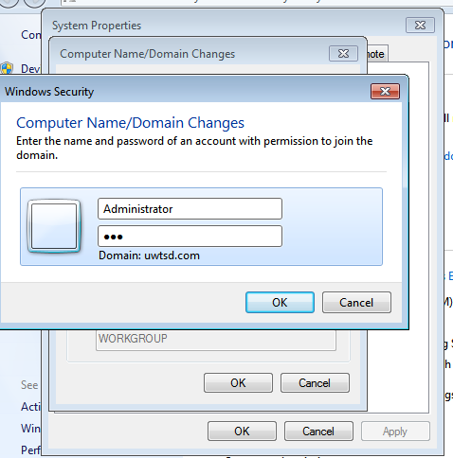
Screenshot 8
showing successfully logged in to the new domain
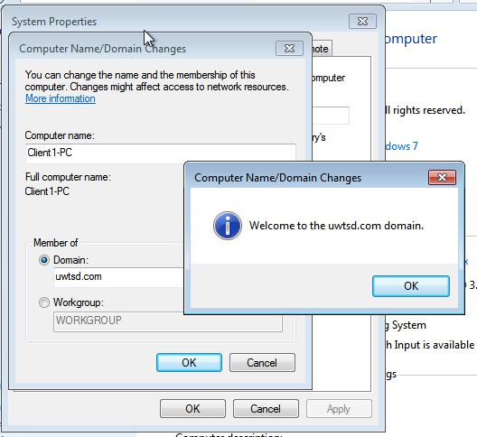

Screenshot 9
This demonstrates the connect on network sharing centre has been successful client one is using uwtsd.com network
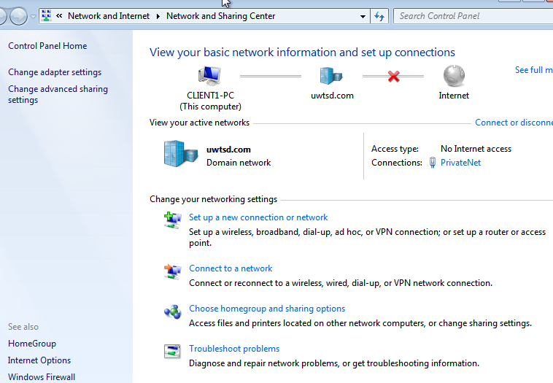
Screenshot 10
proof of installing DHCP and creating DHCP scope with the start IP address and end IP addresses for client one
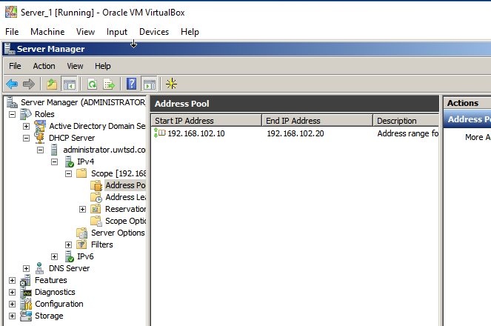
Screenshot 11
As you can see the scope option have been edited showing the clients IP address added to the router
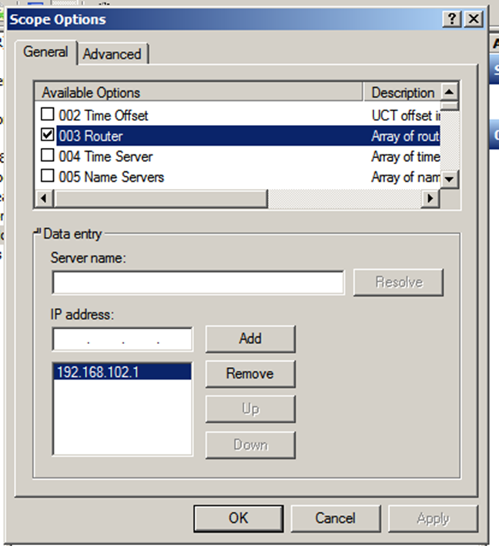

A). State the benefits of using Type 2 Hypervisor virtualisation software in your design. Comment on the strengths and weaknesses of the VirtualBox platform used in your network.
[1] by using virtualisation software, we were able to create two virtual servers and two clients OS and connect both server 1 and client 1 together using networking the [2] software allowed us to have multiple OS running on 1 PC by taking parts of the pc memory to create the virtual machines that are so named” host machines “ the software its self is very cleaver but does have its weaknesses [3] when you have multiple host machines running at the same time can slow down the performance of the pc and the other host machines depending on how many programs you have running on each, one of the strengths [3] is that you can run virtual machines on one pc but with them being separated from each other’s there different PC OS all on one computer.

B). Explain, with use of diagrams, the significance of the following terms: Active Directory Forests, Trees, Parent and Child Domains.
Figure 1 is a diagram displaying an active forest domain with child domain and parent domain
[4]the domain is the centre of the logical structure in an active directory all computers that share a common directory database are on secure shared connection between the domains each domain holds information only to do with its chosen topic of domain, an active directory forest is the best form of structure in an active directory every individual forest shares a individuals database an “administrator from one forest cannot access another forest” [5]
Figure 1
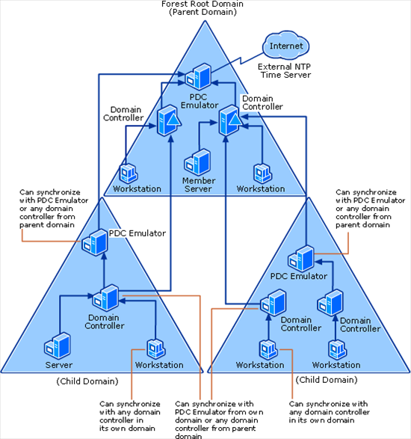 [6]

C). Investigate and document the main roles and responsibilities of an Active Directory Domain Controller.
[7]An active directory use domain controller and “multiple-master model” ordinarily both are the equivalent of each other when it comes down to writing and reading directory information. Unfortunately, some roles cannot be equalled out evenly between both domain controllers, in other words no more than one domain can be changed at a time, an active directory domain controller has many responsibilities such as [8]allowing access to other domains through a secure connection allowing the person to access resources in that domain.

D). What actions could we take in the event of a Domain Controller becoming unavailable?
[8] if a domain control becomes unavailable you would be to deactivate the main domain controller through the administrator and transfer another domain controller to take place of the former domain controller

References
.
[1] | Rouse, Margaret, "searchserverVirtualization," whatis.com, 12 2014. [Online]. Available: http://searchservervirtualization.techtarget.com/definition/hosted-hypervisor-Type-2-hypervisor.
[2] | Wikipedia, "https://en.wikipedia.org/wiki/Hypervisor," wikipedia, 20 November 2017. [Online].
[3] | sirial server, "WHAT IS VIRTUAL MACHINE?," Serial server , [Online]. Available: http://www.serial-server.net/virtual-machine/.
[4] | TECH-FAQ, "TECH-FAQ," [Online]. Available: http://www.tech-faq.com/tree-and-forest-in-active-directory.html.
[5] | Rouse, Margaret, "searchwindowsserver," whatis.com, [Online]. Available: http://searchwindowsserver.techtarget.com/definition/Active-Directory-forest-AD-forest.
[6] | Microsoft, "Microsoft-TechNet," INSEAD, 12 March 2015. [Online]. Available: https://social.technet.microsoft.com/wiki/contents/articles/18573.time-synchronization-in-active-directory-forests.aspx.
[7] | S. Clines and . M. Loughry, "dummies a wiley brand," dummies a wiley brand, [Online]. Available: http://www.dummies.com/programming/networking/roles-of-the-active-directory-domain-controllers/.
[8] | techopedia, "techopedia," techopedia, [Online]. Available: https://www.techopedia.com/definition/4193/domain-controller-dc.

