INTERNET TECH SECURITY
ACCA4018
Matthew James
1809299

03/05/2019

Contents
1. Abstract 2
2. Website 2
2.1 specification 2
2.2 Designing of the website 2
2.3 Website pages 6
2.4 Validating HTML code 8
2.5 Accessibility evaluation: 9
2.5.1 Future improvement 10
2.6 Search engine optimisation (SEO) 10
3. References 10
Bibliography 10

Abstract
This report will detail the design and implementation of a website that the author has created through learning at the university. The main areas that will be discussed are, the designing of the website which includes the specification, site maps and a wire diagram, the coding of the HTML and the CSS within the website and the methods/ tools and techniques used within the website.

Website

2.1 specification
The author has designed a website for a computer repair service based in Barry, Vale of Glamorgan.
The purpose of this website is to be a platform for the business “Barry Tech Services” in order to deliver a variety of I.T related assistance to a range of customers, services include: cleaning systems, virus scanning and selling of third-party supplies such as operating systems such as windows 7,8,8.1,10 and Linux distributions.

Designing of the website
The author began by designing a wire diagram of the website before implementing it into software to visualise it.
As this website is based of a template, the wire diagrams will only include the header, nav and title once in an attempt to make it clearer
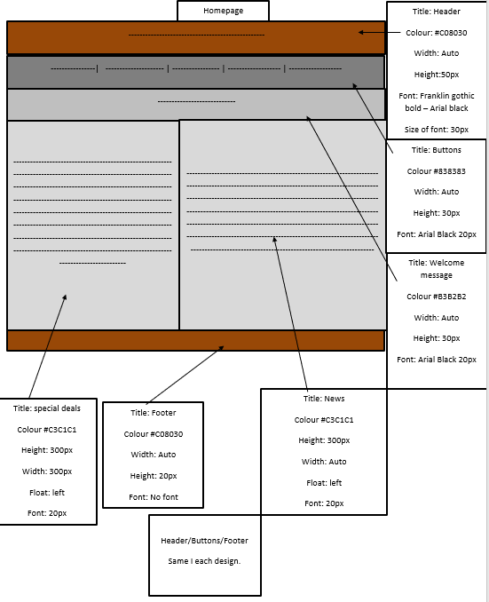
Figure 1 - Wire diagram - HomePage
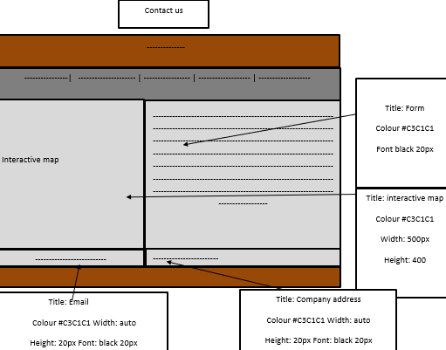
Figure 2 - Wire diagram - Contact us
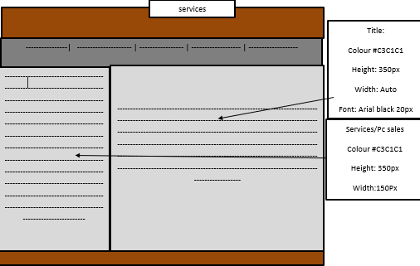
Figure 3 - Wire diagram - Services

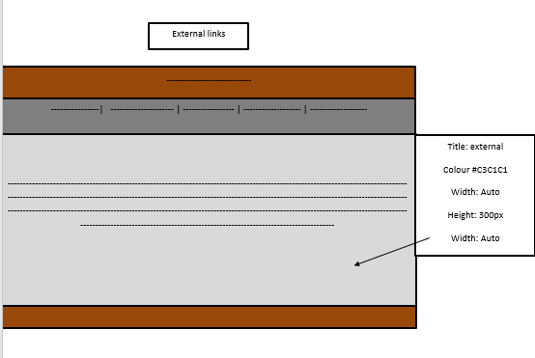
Figure 4 - Wire diagram - External links
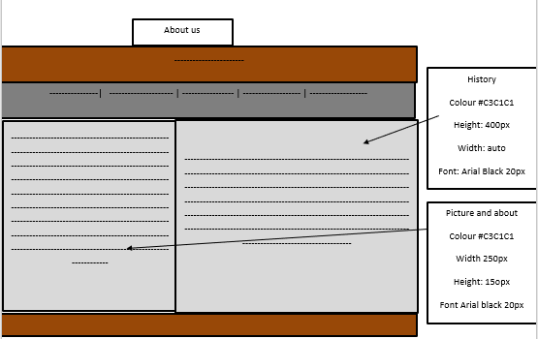
Figure 5 - Wire diagram - About us

Site map:
The author created a site map to display how the webpages are going to interact with each other.
The site map is a way to design how and what pages are going to be by implementing them into an actual website. The site map acts as a guide for the author. This approach allows the author to create a template design no which a pages content is build.

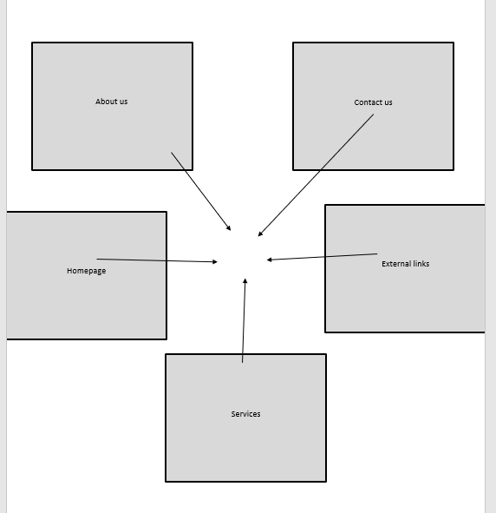
Figure 6 - Site map

Website pages

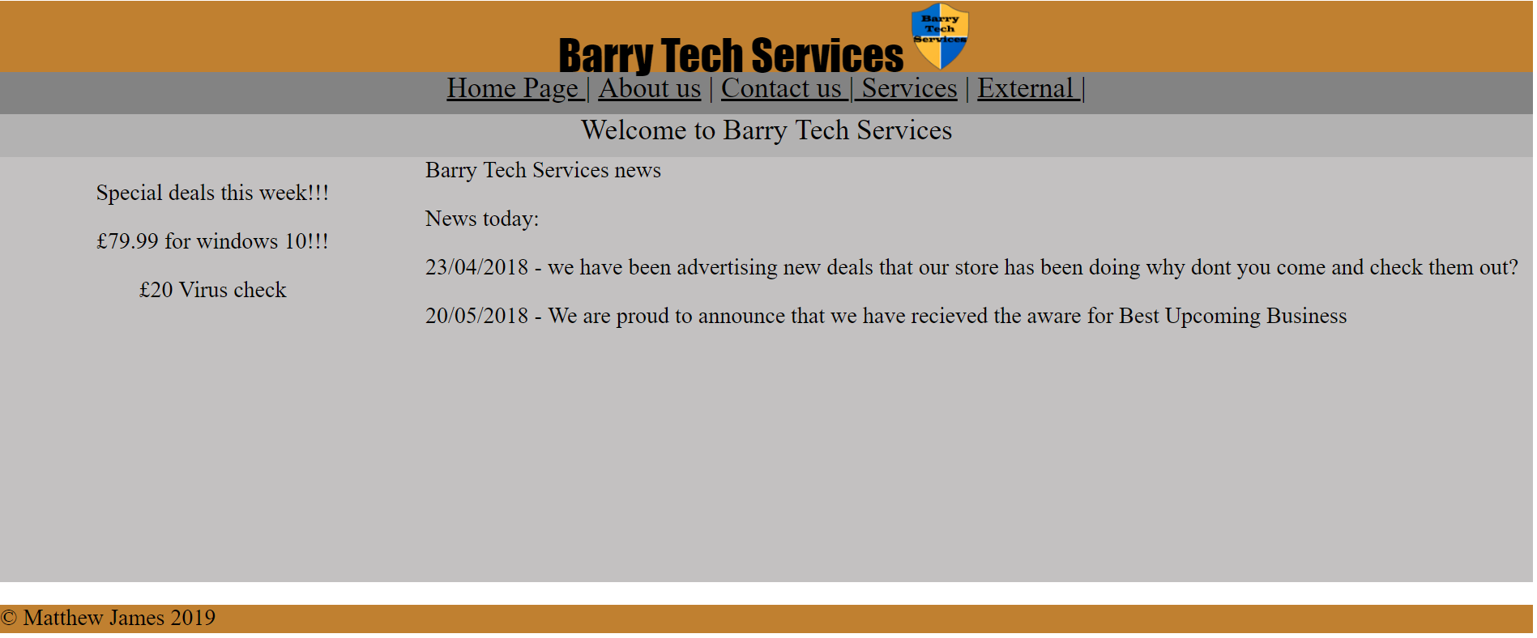
Figure 7 - Website Homepage
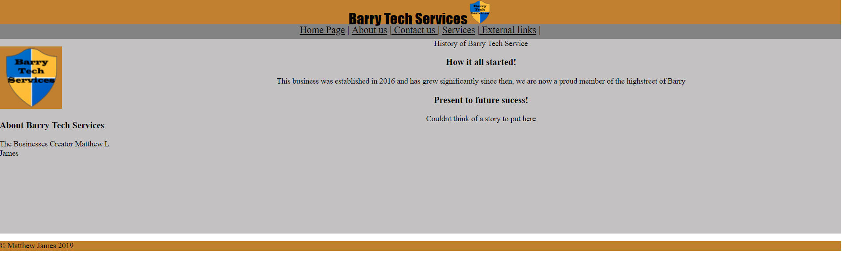
Figure 8 - Website About us
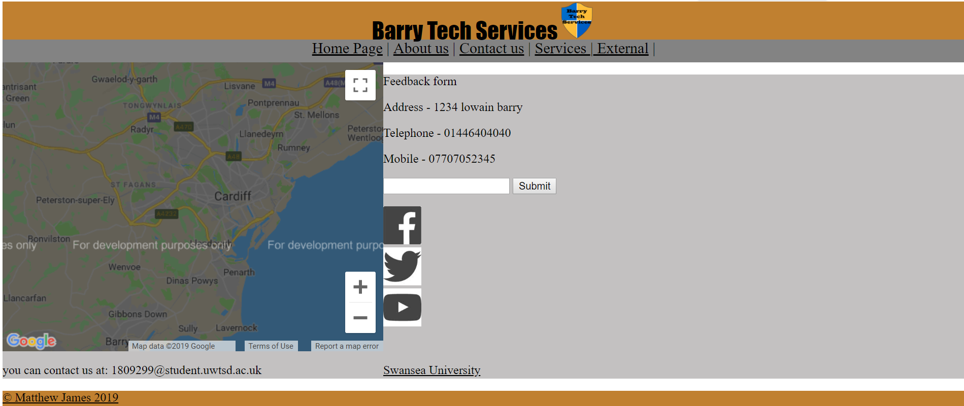
Figure 9 - Website Contact us

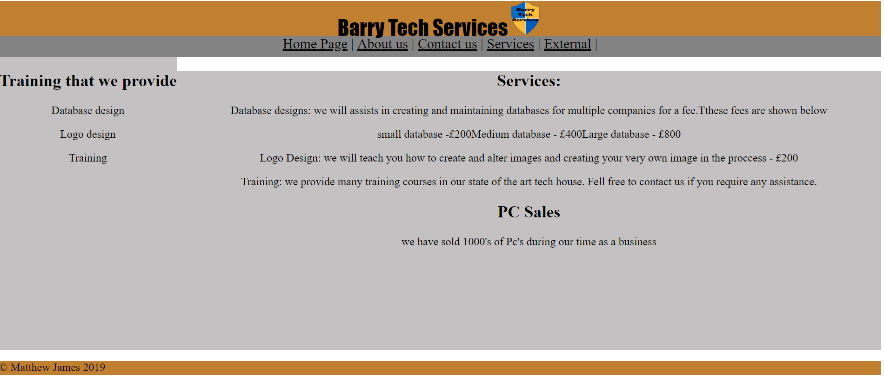
Figure 10 - Website Services
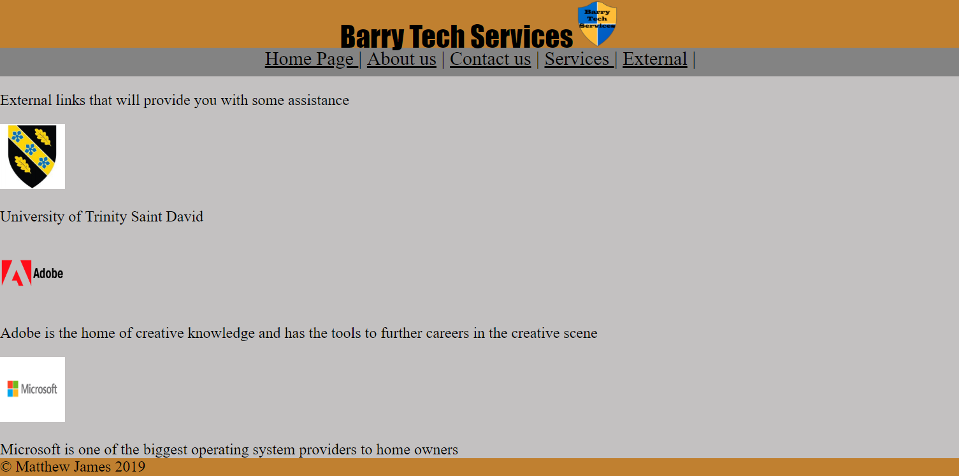
Figure 11 - Website External links

2.4 Validating HTML code
To validate the code, the author will be using a validator provided by W3C, this validator will check the HTML code within the authors webpage and look for anything that may cause faults and should be fixed while providing suggestions for those faults. [1]
Initial testing
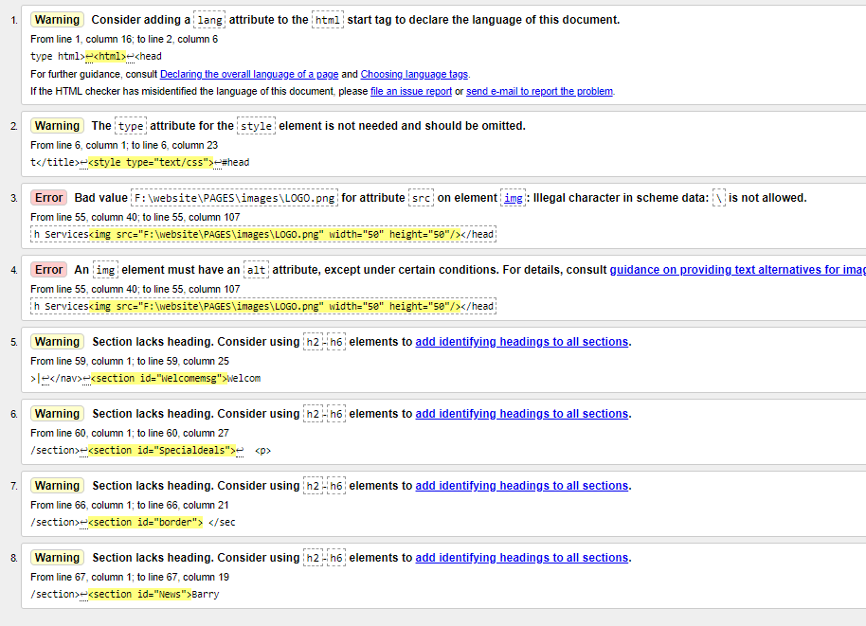
Figure 12 Homepage testing initial results

Fixed errors:
The author fixed these errors by changing the file path as they were “illegal characters” swapping the path from \pages \images \... to /pages/images/…, while changing this the author also corrected another error, the author added an “alt” which is used when an image cannot be reach it will swap to that text
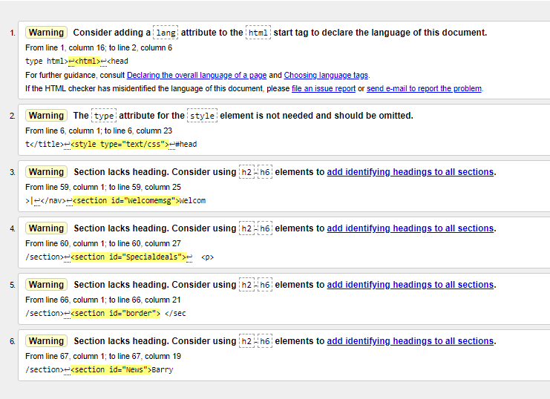
Figure 13 - Homepage testing Fixed

2.5 Accessibility evaluation:
The author attempted to use aXe [2] as their evaluation tool but could not use it as the plugin did not work, a similar plugin WAVE evaluation tool will be used to identify the design, usability and content of the website as shown in figure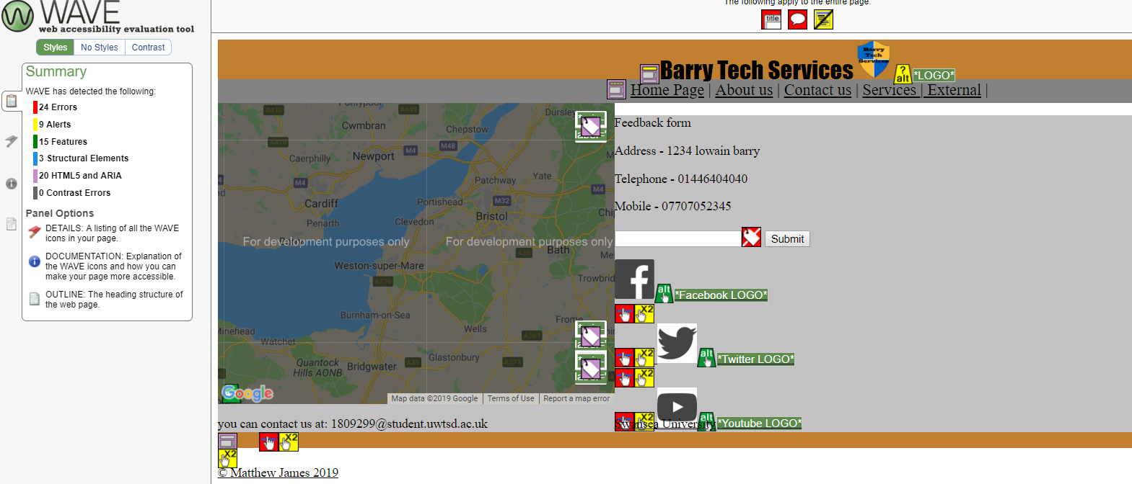
Figure 14 - WAVE Contact Us Test
WAVE evaluation tool [3] has highlighted via the code, as the author has written the HTML & CSS within the same file, the evaluator is not picking up the css which is changing the way that the title is presented to the user.
Most HTML and CSS as written in two different files, the author had to do the website this way as a means to implement the google Application programming interface (API), this has made it hard for the author to quickly address any errors within the code. Most errors within the webpage is no “alternative text” which is used when an image or object cannot be reached, a text line will be used to serve the hyperlink/function which the image usually has

2.5.1 Future improvement
This can be improved with separating the HTML & CSS file into different documents so that tools such as these can operate at 100% functionality.
The design of the website could have been more thought out, things such as social media API’s imbedded into the website could have had a positive affect on the users experience on the website.

2.6 Search engine optimisation (SEO)

Search engine optimisation [4] is the process of maximizing the number of visitors on a website so that it appears higher on search listing for search engines such as Google, Bing and Yahoo.

References

Bibliography

[1] | W3C, “Markup Validation Service,” W3C, [Online]. Available: https://validator.w3.org/. [Accessed 03 05 2019].
[2] | aXe, “aXe,” aXe, 25 3 2019. [Online]. Available: https://chrome.google.com/webstore/detail/axe/lhdoppojpmngadmnindnejefpokejbdd. [Accessed 03 05 2019].
[3] | WAVE, “WAVE,” WAVE, 17 11 2017. [Online]. Available: https://chrome.google.com/webstore/detail/wave-evaluation-tool/jbbplnpkjmmeebjpijfedlgcdilocofh. [Accessed 02 05 2019].
[4] | S. e. Journal, “4 Most Important Ranking Factors, According to SEO Industry Studies,” SEJ, 03 02 2017. [Online]. Available: https://www.searchenginejournal.com/4-important-ranking-factors-according-seo-industry-studies/184619/. [Accessed 03 05 2019].

