Ways of perceiving (ADDA4023)
Essay: Imaginary Exhibition. Feminism through artworks.
Tara Evans

‘What does it feel like to be Woman?’

Introduction:
This exhibition is about feminism and what it is like to be a Woman.
Throughout this exhibition, I aim to help the audience feel a sense of what it is to be like a woman.
‘Feminism, the first wave of which began with the suffrage movement in the mid-1800s, looks vastly different today than it did generations ago’ (Alfonseca.P1, 2023)
Feminism over the past few years has turned onto equality for all genders and Identities. For this exhibition I will be focusing on what it is like to be Woman and how it feels to be one today, we are still fighting for women to be in ‘male-Dominated’ fields.
“We're seeing more women leaders, we're seeing more women scholars, we're seeing more activists, we're just seeing women really go out in their own authenticity in their own identities and live more truly and authentically.” (Alfonseca.P1, 2023) . There is a lot of misogyny and taboo against women when it comes to Periods, sexual health and reproductive rights.
Throughout this exhibition, I would like to portray all of these in my selective artworks chosen to exhibit, these artworks will be a range of medias and techniques. I will be explorative with the flow of range of media. I explore how it ‘feel’s to be a woman’ in today’s society where misogyny is very much still present and are skyrocketing higher each month.
Through a collection of mixed media work, I aim to perfectly capture the pros and cons of being a woman. I will try and explore these works representing and protesting for women, I will seek to break down these stereotypes and the misrepresentation of perfection.
Context & Artists and Artworks:
Through the curation of this exhibition, I ‘sought to create a dialogue between the viewer and the artwork through the inclusion of women's perspective’ (The art story, P.1, 2015). On various aspects of feminism such as Women’s life, Difficulties and taboo.
This Exhibition is featuring works of Judy Chicago (1972), Miriam Schapiro (1972), Barbara Kruger (1989), Martha Rosler (1975), Rei Kawakubo (1997). This Exhibition offers a diverse range of medias and representees of feminism back in 1900’s, each work explores interesting and captivated themes and meets the themes and mixed mediums presented.
Judy Chicago is an American artist who explores the medium of installations with real life objects and created ‘some of the visual context of the women’s liberation movement in the 1970s and beyond.’ (Britannica, P.g.1, 2004). Miriam Schapiro’s and Judy Chicago’s Womanhouse was an Important feminist art installation created in the early seventies, for this project Chicago and Schapiro transformed a rundown building with help of their past female students and local female practising artists. Menstruation Bathroom in Womanhouse by Judy Chicago had three bathrooms all representing all different aspects and stages of a women’s life. The menstruation bathroom was a white bathroom, with shelves filled with menstrual hygiene products and deodorants. ‘There were soiled Kotex in a white plastic trash can and Tampax on the floor.’ (Graf, MA Art History, 2023)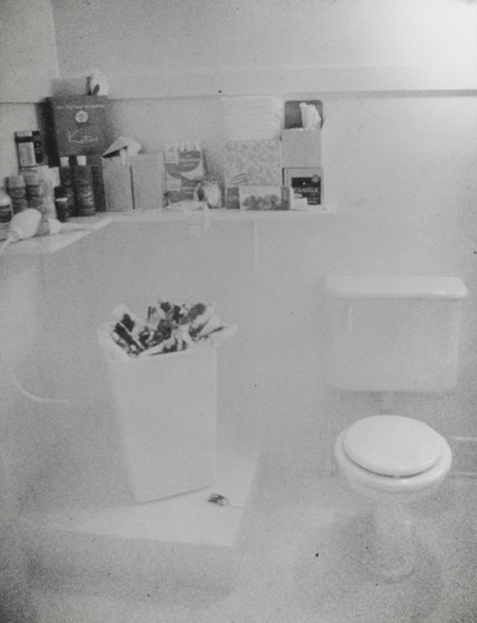
Date: 1972
Medium: Photograph, Gelatine sliver print on paper.
Dimensions: Image: 660 x 504 mm mount: 764 x 612 mm.
Collection: Tate modern Museum.
I have also included another work by Judy Chicago which is her 2020 version of the Menstruation bathroom. They will be near each other in the exhibition.

Carrying on from WomensHouse, I have also included another installation by Miriam Schapiro.
Miriam Schapiro is an American Painter, Sculptor and Printmaker. Born in 1923.
‘In her femmage and assemblages, Schapiro incorporated elements of craft and low art, such as sewing, that had been excluded from the realm of "fine art" and merely described as "woman's work." ‘(The art story, 2004). The Dollhouse is a piece playfully portraying a saying said by men back in 1970’s “A women’s place is in the home”. In the dollhouse there is a Kitchen, Nursery, and a boudoir room representing a white, middle-class women of Schapiro’s time. Which was expected to achieve as a housemaker, mother, maid and a sexual high status to her husband, a boudoir room was in every middle-class martial house with high expectations. Schapiro created this dollhouse to perfectly represent the house layout of people from her generation in the early 1920’s. ‘Womanhouse was a watershed in feminist art, attracting thousands of visitors. It was also a transformative experience for Schapiro, who subsequently dedicated her work to celebrating female experience and feminine crafts. "I was trained to be an artist by men," she said, "but I learned how to express myself from women."’ ( SAAM,2025)
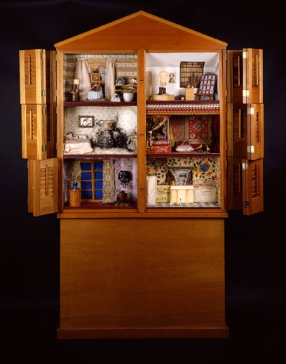
Date: 1972
Medium: Wood and mixed media of fabrics
Dimensions: 202.6 x 208.3 x 21.6 cm.
Barbara Kruger is an American Conceptual artist and collagist that associates pictures form generational periods in her works. ‘Kruger rose to prominence in the early 1980s, creating large-scale black-and-white photo-based images often framed in red and overlaid with the language of direct address.’ (Zwirner, D. 2021) Kurger has made a huge variety of collections that have been exhibited worldwide. ‘Her captions often include pronouns such as “you”, “your”, “I”, “we”, and “they”, which seek to address cultural constructions of power, identity, and sexuality' (Artland magazine. 2020). I have included two works for my exhibition of Barbara Kruger, ‘your body is a battleground’ (1989) and ‘Untiled artwork’ (2020).
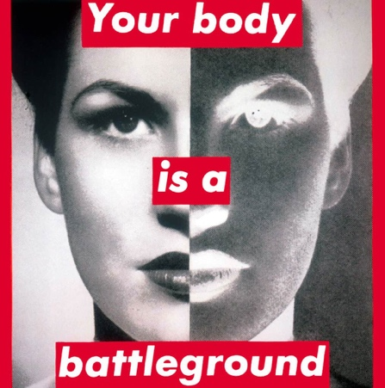 Date: 1989
Medium: Paper and collage. Dimensions: 27 x 22 in

Date: 2020
Medium: Screenprint, text.
Dimensions: 12ft
Marther Rosler is an American, Brooklyn based artist that works with video, photography and test installation. Rosler explores the issues from day-to-day events. ‘Rosler has for many years produced works on war and the national security climate, connecting life at home with the conduct of war abroad’ (MarthaRosler,self introduction)
Coming away from her known works connected with war, I have been interested in her video installation from 1975. ‘Semiotics of the kitchen’ as she makes noises with pots and pans, sharp obects. While punctuating the rage of oppressive ‘women’ only roles.
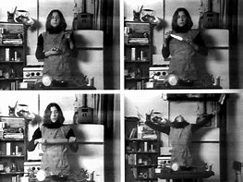 Date; 1975.
Medium: Video (Black and White, Sound)
Duration: 6:09 mins.
Rei Kawakubo is a Japanese self-taught Japanese fashion designer. Kawakubo is well known for her clothing designs and her high end fashion label.
‘Back in 1973 when Rei Kawakubo founded Comme des Garçons, she questioned everything. She was anything but conventional. Body Meets Dress, Dress Meets Body is a collection by Rei Kawakubo of Comme des Garçons For Spring Summer 1997.’ (ayerhs, fashion magazine)
‘Rei Kawakubo is a designer who unmistakably helped pioneer this renegade aesthetic, a woman whose creations have never accepted the body as a limitation and who tackled the cultural tropes of female body image and its connection to clothing in her Spring/Summer 1997 collection, titled "Body Meets Dress, Dress Meets Body" – widely remembered as the "lumps and bumps" collection.’ (An0ther, O.Ahmed, 2016)
Kawabuko, decided days before the fashion show that she was going to enhance Women’s features by lining garments with kidney-shaped down pillows sewn into slip linings. This created an illusion with the model’s bodies. The bodies were distorted and shaped with the clothing itself other than the body shaping the clothing. This drew attention away from the model’s bodies to the clothing and material of Kawakubo’s designs.
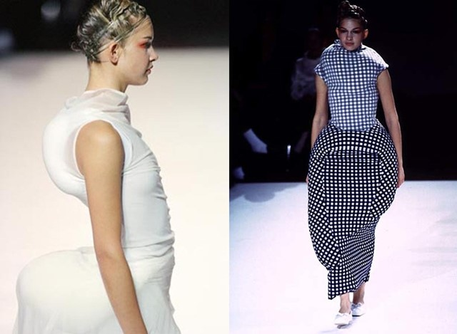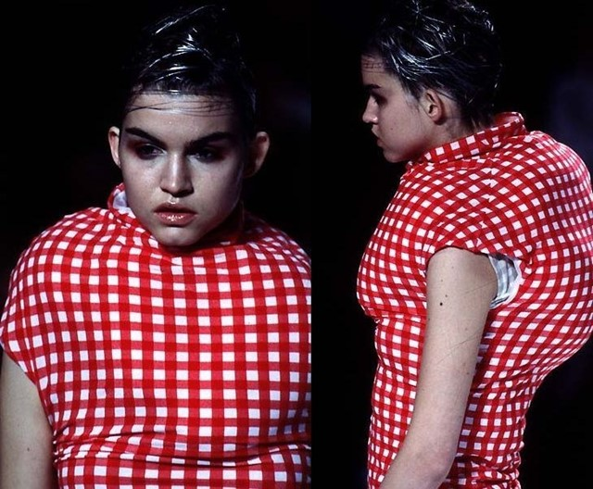
Date: 1997
Collection: Comme Des Garcons, S/S97.

This exhibition offers a variety of styles and opportunity to engage with feminism. Through the diverse mediums with video, Fashion and wood. This creates a new insight to creating narratives and help the viewer reflect about the situation, of ‘What’s it like to be a woman?’. I hope I managed to convey the vulnerability and raw emotion of feminism portrayed in art through the many decades.
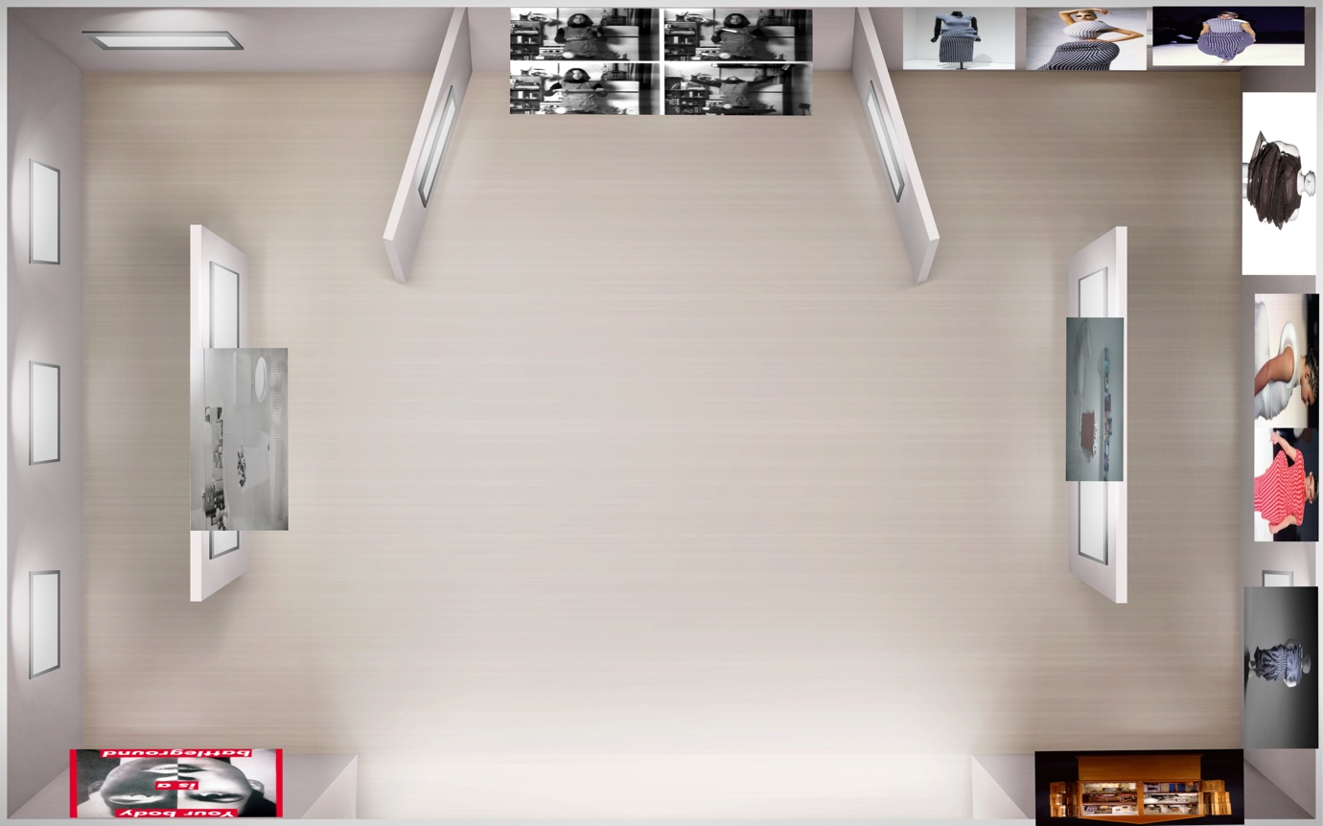
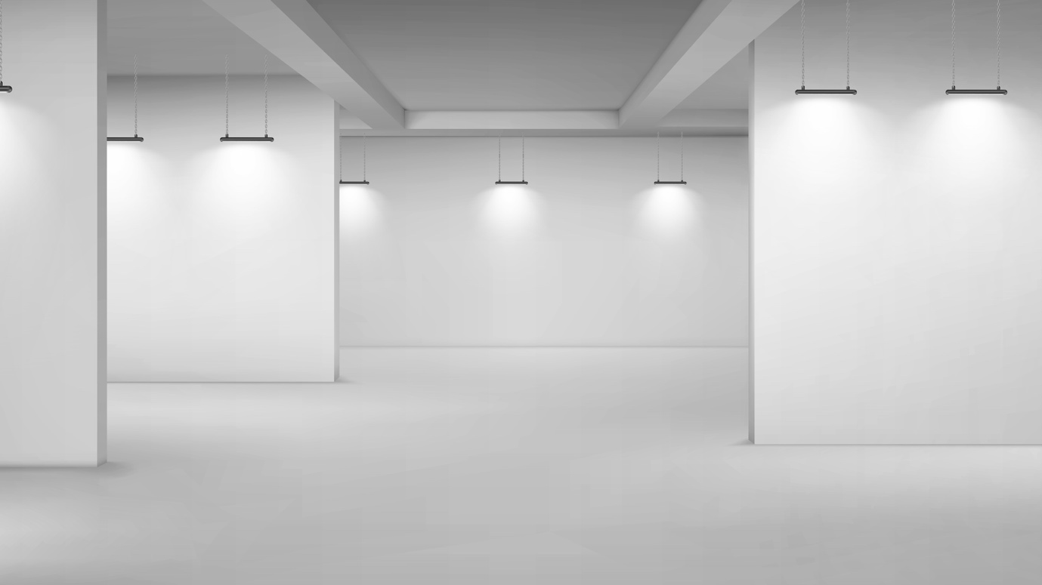
This clear front is the lighting of the wall lights, to give a dramatic and contrasting lights: I wanted to create a dramatic effect and draw more attention to all, and every artwork placed in the exhibition. I’m using overhead and behind lights to cause direct highlight to the mixed media artworks and to create shadows.
Use of sculpture: I have used ‘Dollhouse’ in my exhibition. This gives a setting iof what houses looked like back in the early 1970’s. This gives a sense of raw emotion and vulnerability but, also a sense of relaxation.
Placement of the images: I have placed these images accordingly to what feels right. I have spread them throughout the exhibition, so each artwork has their own space and feeling when seeing them. To stop them from clashing.
The dimensions of the images: All the images have different dimensions to explore different narratives and emotions.

BIBLIOGRAPHY
- (Alfonseca.P1, 2023.)
- (The art story, P.1, 2015)
- (Britannica, P.g.1, 2004)
- ‘(The art story, 2004).
- (Graf,MA Art History, 2023)
- (Zwirner, D. 2021) Feminist Art: History & Most Relevant Artists | Artland Magazine
- Martha Rosler. Semiotics of the Kitchen. 1975 | MoMA
- (MarthaRosler,self introduction) about the artist — martha rosler
- (ayerhs, fashion magazine)Body Meets Dress, Dress Meets Body: Comme des Garçons Spring 1997 – Ayerhs Magazine
- (An0ther, O.Ahmed, 2016) Lumps and Bumps at Comme des Garçons S/S97 | AnOther

The front view of the back art works.

