Application of Computer Aided Engineering Processes
L5 Computer-Aided Engineering Module (OME Degree) – ACDB5007
Alex Lamdin
4th January 2025

Abstract
In this report the use and benefit of CAD software and CAE software packages within design tasks is evaluated. Specifically, the Solidworks® CAD program and the ANSYS® suite of softwares. An initial validation is carried out utilising simple metallurgical deformation, comparing the simulated results to a manually calculated one. Then, an assembly, in this case a representative of a light-duty lorry crane is modelled within Solidworks®. This assembly is then imported into ANSYS® and evaluated to find the working load capacity. The features within ANSYS are then utilised to evaluate the effects of temperature upon the crane (representing global weather extremes) and to investigate possible design optimisation and reduction of material. Following this, the discovered benefits and limitations of CAE are discussed.

Table of Contents
- Introduction
- Validation of Simulated Results
  - Validation Case Overview
  - Analytical/Theoretical Results
  - Simulated Result
  - Validation Discussion/Conclusion
- CAD Modelling (Using Solidworks®)
  - Test Case Overview
  - Part modelling
  - Assembly Modelling
- Simulation (Using ANSYS LS-Dyna® Software Suite)
  - Simulation & Structural Analysis
  - Results
  - Thermal Influence
- Discussion – Use of CAE as a Design Tool
  - Advantages
  - Disadvantages & Limitations
- Conclusion
- References & Bibliography

1. Introduction
In the modern era, technology is playing an ever increasing part in engineering, at all stages from initial concepts, through design and to manufacture. Where machined parts used to be made by hand on manual tools and machinery by a skilled machinist, with little more than a paper drawing and micrometer to guide them, the burden of these task is ever increasingly becoming computerized, leading to the birth of the concept of CAE (Computer Aided Engineering).
The roots of CAE can be traced back to the mid-20th century, with the first CNC (Computer Numerically Controlled) machine being credited to James Parsons in 1949, amid an air force research project intended to optimise wing design.^{[1]} Whilst the position of the machining spindle was technically computer controlled, this being the electro-mechanical era, the shape required was still calculated by an IBM electromechanical calculator, the results of which were then hand punched into a punch card, to be inserted into and read by the machine, so the design process was still far from automated.
The first true computer numerical control system, PRONTO, was created by James Hanratty in 1957. This developed into the DAC (Design Automated Computer) in 1963, where the term CAD (Computer Aided Design) we know today was born. That same year, the first graphical user interface CAD program, namely SKTECHPAD was launched, and since then the development of CAD has been constant, with advances, improvements and refinements being brought out almost as quickly as they are found. [2]
In the 1970s, the two sides were integrated for the first time, with CAD programs integrating provisions for CAM (Computer Aided Machining), supposedly achieving the engineering holy grail – in essence pushing a button and having a perfectly machined part emerge out of a machine at the other end, made to a high tolerance and with little risk of human error.
In the digital age, and where engineers of all disciplines are designing products that are more complex, require more precision and require manufacturing faster than ever before, the advantages of CAE are obvious. The suite of tasks that can be undertaken in CAE has now vastly expanded to include dynamic and structural analyses, Finite Element Analysis (FEA), fluid dynamics and much more.
However, as with most technology, CAE still has its downsides, namely the how the computer can still “get things wrong”, particularly with highly complex pieces of work, where it encounters the limits of the data it’s been inputted or trained with. This report, at a fairly simple level, explores the use of CAE to evaluate and optimise a design, and discusses some of the potential limitations.

2. Validation of Simulated Results
2.1. Validation Case Overview
In order to reassure us that the software packages we plan on using throughout this report are suitable for the analysis we want to carry out, a simplified test case was devised and modelled twice. One model was created using the software packages, and the other was modelled theoretically using formulae.
In this instance, the test case in question was a horizontal cantilever beam fixed at one end, consisting of a 2 metre length of 150mm square box section profile, with a 5mm wall thickness, constructed from ASTM A36 “Structural” steel. A known force was then applied to the other end of the beam, acting vertically downwards upon the other end. The test forces used were in 2.5 KN intervals between 5 and 25 kN.
It was determined that the most efficient way to compare the results was to compare the maximum vertical deflection of the loaded end of the beam in both the calculated and simulated models.
2.2. Analytical/Theoretical Results
The deflection formula for a cantilever beam is shown below:
$$δ_{max} =\frac{F ×L^{3}}{3E ×I }$$
Where:
- δ_{max} is the maximum displacement at the end of the cantilever beam. (mm)
- F is the load (N)
- L is the unsupported length of the beam (mm)
- E is the Elastic/Young’s modulus of the material (N/mm²)
- I is the moment of inertia (mm⁴)
As such, in order to use this formula to calculate a maximum displacement value for our model, we will need to find the Elastic/Young’s modulus of the A36 Steel and Calculate the moment of Inertia for our box section profile.
For the former, a value was found on an online materials database ^{[3]}, and was found to be 200GPa, which is equivalent to 200,000 N/mm².
To find the moment of inertia of a box section profile, the following formula is used:
$$I= \frac{WH^{3}}{12}- \frac{{wh}^{3}}{12}$$
Where W and w are the external and internal widths of the box section respectively, and H and h are the external and internal heights of the box section respectively. Obviously, in the case of a square section this can be simplified to the one external and one internal measurement, each to the fourth power. As such:
$$I=\frac{{(Ext.)}^{4}}{12}- \frac{{(Int.)}^{4}}{12}$$
$$I=\frac{{150}^{4}}{12}- \frac{{140}^{4}}{12}$$
$$I=10174166.67 {mm}^{4}$$
This can then be put into the deflection formula:
$$δ_{max} =\frac{F ×{(2000)}^{3}}{3(200,000) ×(10174166.67) }$$
Where F is changed to our test values between 5 and 25 kN. Using the formula, the following results for the maximum vertical deflection were produced:
Test No. | Load Force (kN) | Calculated Maximum Vertical Deflection (mm)
1 | 5 | 6.55
2 | 7.5 | 9.82
3 | 10 | 13.11
4 | 12.5 | 16.38
5 | 15 | 19.66
6 | 17.5 | 22.93
7 | 20 | 26.21
8 | 22.5 | 29.49
9 | 25 | 32.76
Table 1 – Calculated Validation Results
2.3. Simulated Result
For the Simulated Model, the beam was drawn up in Solidworks® (Figure 1) and then exported into ANSYS®. The Workbench was used to launch a static structural analysis in ANSYS® Mechanical, following which the parameters of ASTM A36 Steel were retrieved from the ANSYS® material library and assigned to our model.
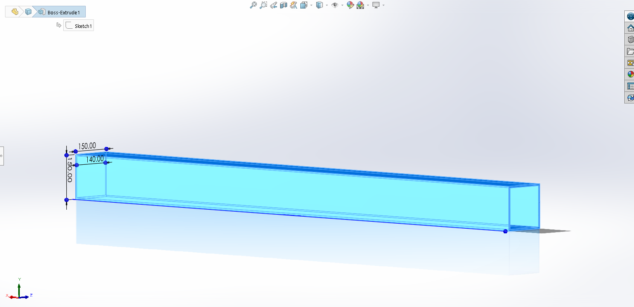
Fig.1 – Validation Test Case Beam in Solidworks®
Since this was a very simple model, the software’s automatically recommended mesh size and element type, namely Hexahedron “Hex” Elements, were used.
The analysis setting were then set. One end face was assigned as a fixed support, whilst the other end had the force applied perpendicular to it (Figure 2), in this case acting in the negative vertical vector to simulate a cantilever beam, a very rough approximation of the crane Jib in the second part of this report.
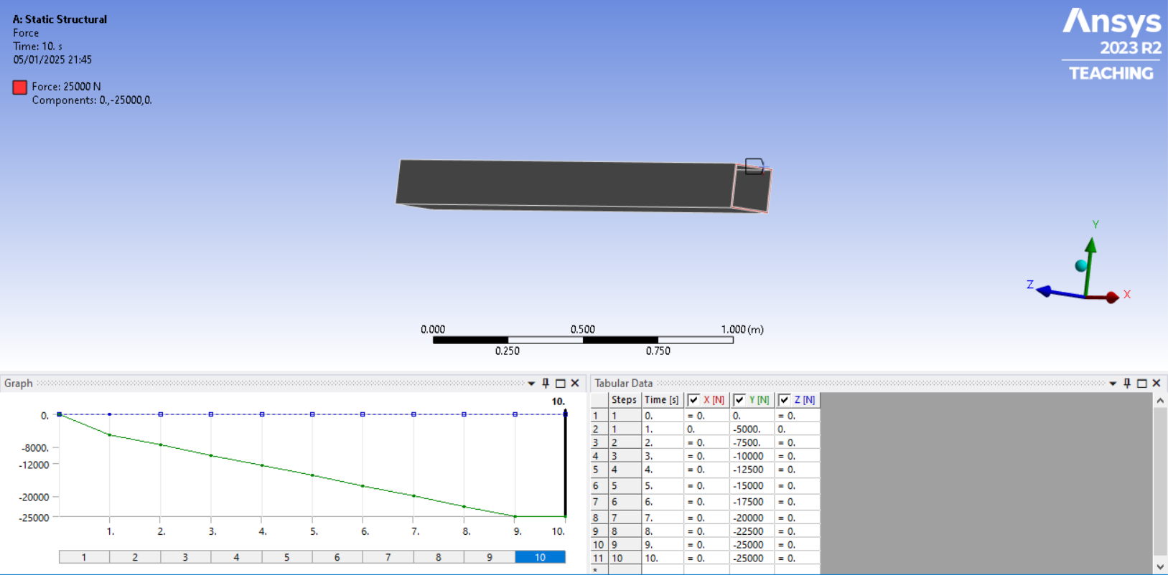
Fig. 2 – Force application in ANSYS®
The analysis was set to run 10 Steps over 10 seconds, increasing in 2.5kN amounts, with the first loaded step being 5kN.
Finally, the solutions was set to record Directional Deformation, specifically in the Y-Plane. ANSYS® also provides the option of Total Deformation, which could also have been run, and would likely have given a similar set of results, but the formula used for the previous part of the validation only measures vertical deflection in one plane, and as such Directional Deformation was chosen to provide the best comparison for the simulated model.
The model was then solved and ran (Figure 3) and the results are shown in Table 2.
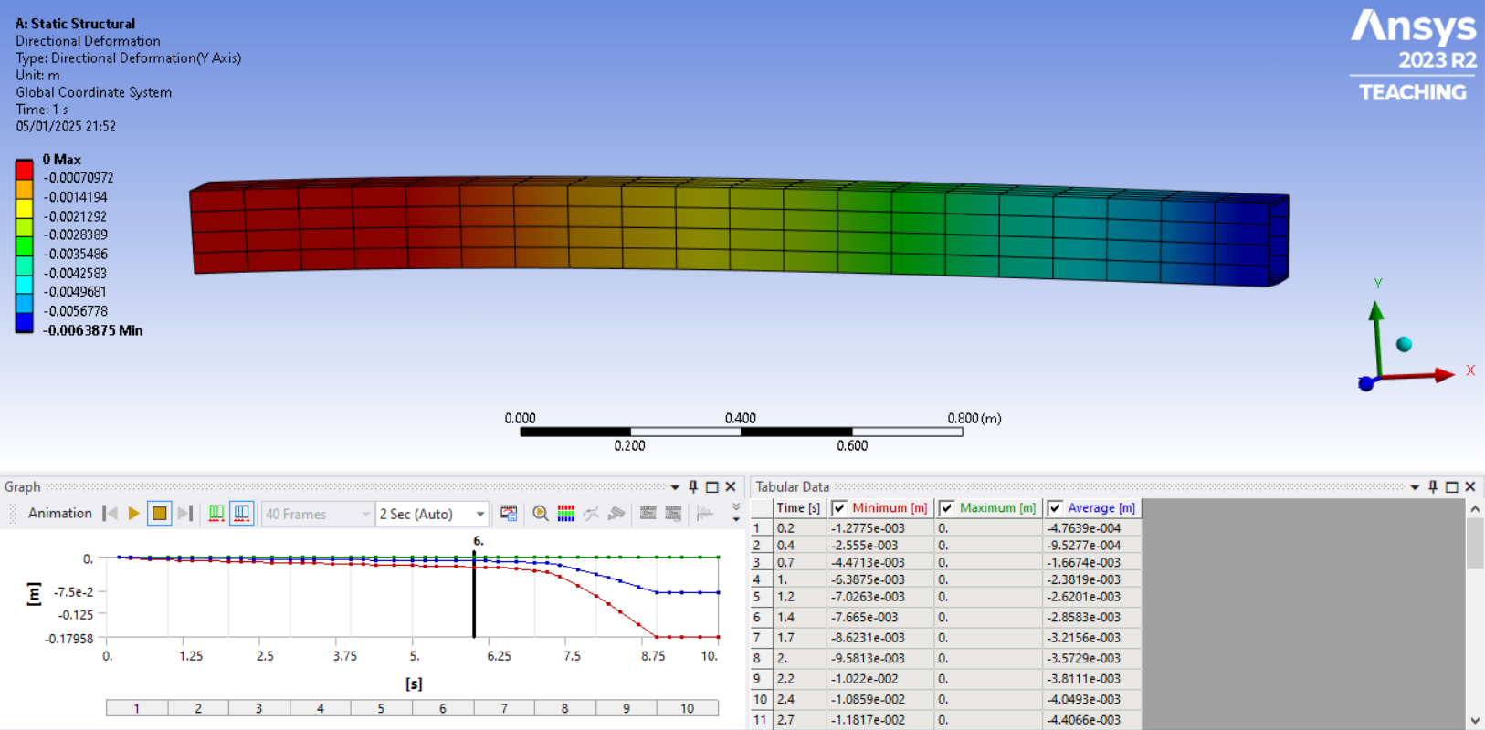
Fig. 3 – ANSYS® Validation Results
Test No. | Load Force (kN) | Simulated Maximum Vertical Deflection (mm)
1 | 5 | 6.39
2 | 7.5 | 9.58
3 | 10 | 12.78
4 | 12.5 | 15.97
5 | 15 | 19.16
6 | 17.5 | 22.36
7 | 20 | 29.94
8 | 22.5 | 88.16
9 | 25 | 179.58
Table 2 – Simulated Validation Results
2.4. Validation Discussion/Conclusion
Following the completion of both models, the results were gathered. Both sets of results can be seen in Table 3, below. Also in Table 3 is a column showing the percentage difference between the calculated and simulated results. The two sets of results are also shown on Graph 1.
Test No. | Load Force  (kN) | Calculated Value (mm) | Simulated Value  (mm) | % Difference
1 | 5 | 6.55 | 6.39 | 2.44
2 | 7.5 | 9.82 | 9.58 | 2.44
3 | 10 | 13.11 | 12.78 | 2.52
4 | 12.5 | 16.38 | 15.97 | 2.50
5 | 15 | 19.66 | 19.16 | 2.54
6 | 17.5 | 22.93 | 22.36 | 2.49
7 | 20 | 26.21 | 29.94 | (-)14.23
8 | 22.5 | 29.49 | 88.16 | (-)198.95
9 | 25 | 32.76 | 179.58 | (-)448.17
Table 3 – Validation Results Comparison.
Graph 1 – Validation Results
As can be seen above, the simulated results follow the calculated values extremely closely, with an approximately 2.5% difference, until the 20kN Force is applied, when they begin to separate. As the 22.5kN and 25kN forces are applied, the deformation increases exponentially.
The likely explanation for this is that, in reality, and in the ANSYS® model utilising the higher level of data available in the materials library (Figure 4), the A36 steel beam exceeds its elastic limit, it’s yield point, and starts deforming plastically, past which point the Young’s modulus is no longer applicable.
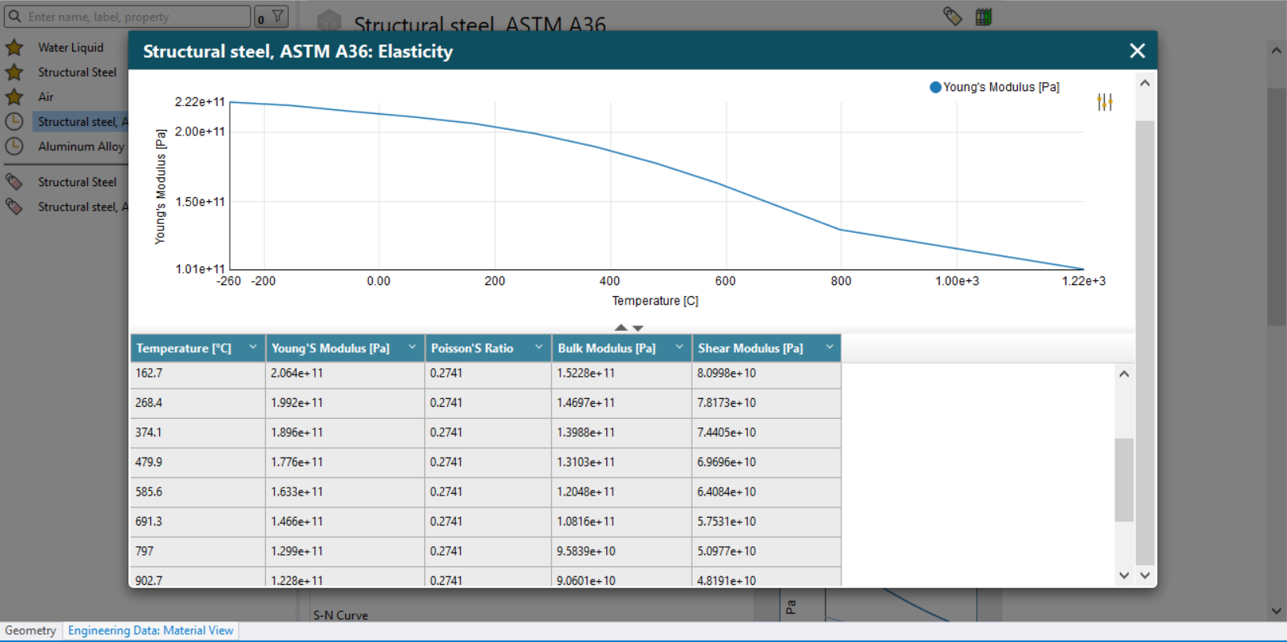
Fig. 4 – An example of the higher level of material data in the ANSYS® Materials Library.
This is, of course, not taken into account by the simple formula for calculating deflection, which believes that it will continue to deform elastically indefinitely, and as such the calculated values indicate it continuing to deflect in a consistent manner as the higher loads are applied, and hence the calculated and simulated values separate.
In conclusion, however, these results do succeed in showing that the ANSYS® software suite is able to produce valid results; and even has the potential to be more accurate than manually calculated figures.

3. CAD Modelling (Using Solidworks®)
3.1. Test Case Overview
The test case that was chosen is that of a small telescopic loader crane with a three section telescopic boom. This type of crane can usually be found mounted to various vehicles in the construction and service industries, as well as marinised versions being found on workboats. Various companies such as Palfinger®, Hiab®, Atlas® and HMF® make these cranes, however geometries vary significantly between brands and as such a representative generic example was designed for this task. An example of a similar crane can be seen below in Figure 5.
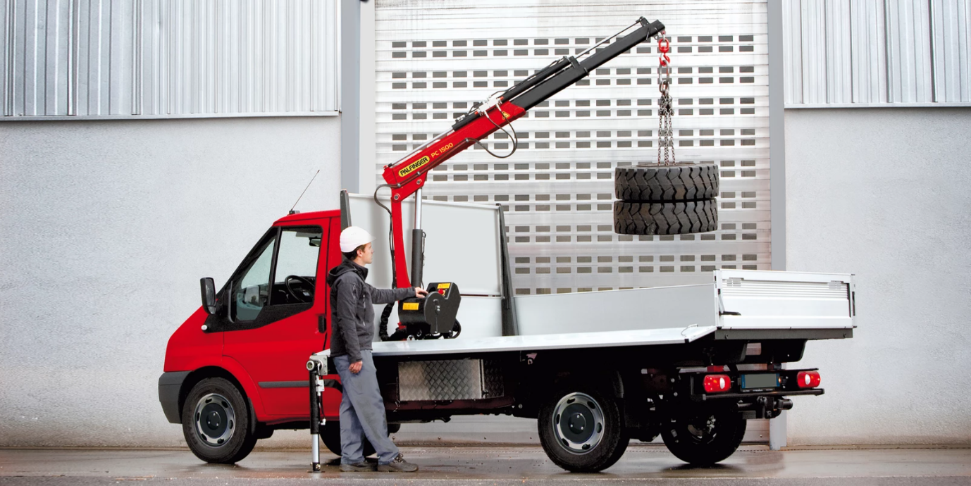
Fig. 5 - Example of a Small Telescopic Loader Cranes^{[4]}
It was decided that since this was a structural study, only structural components would be modelled, and as such hydraulic hoses, valves etc were not modelled, only the pedestal, boom, telescopic sections, hydraulic cylinders and connecting hardware.
The test case conducted measured the deformation of the crane at various extension levels when load forces were applied, in order to define the load limits of the crane.
3.2. Part Modelling
Each of the 22 individual parts were modelled in Solidworks®, with the components initially being drawn using the sketching tool before being pulled out into 3D models using the extrusion tool. This rough extruded model could then be refined using the extruded cut, lofting, shell and chamfer/filleting tools. The parts modelled included the pedestal, the three sections of boom, the pistons and cylinders within the hydraulic rams, and the connecting pins, bushing and washers. Some of the parts modelled can be seen in Figures 6-8.
It is worth noting that due to the precision of Solidworks®, parts could be drawn to sub millimetre accuracy and neighbouring components could be inserted for reference if necessary. This made it very easy to ensure all parts would align correctly and have a full range of movement.
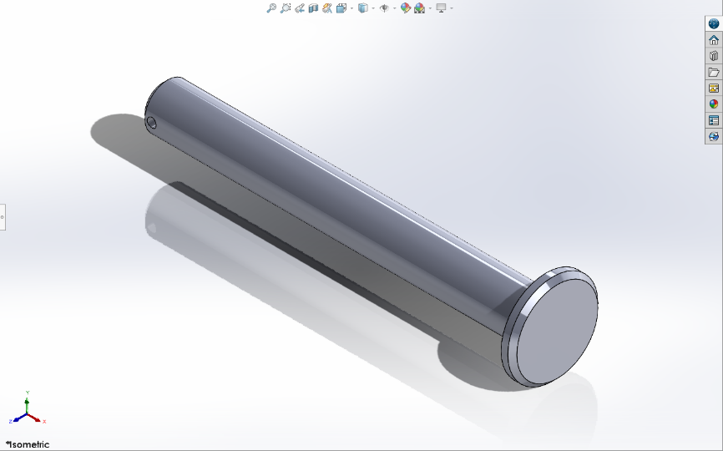
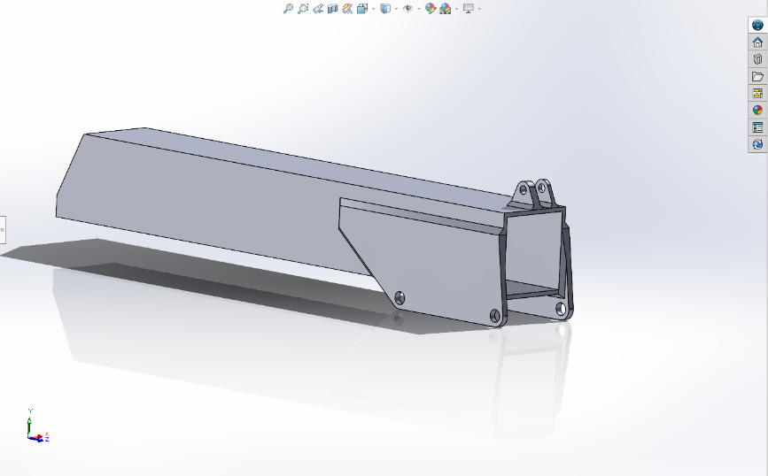
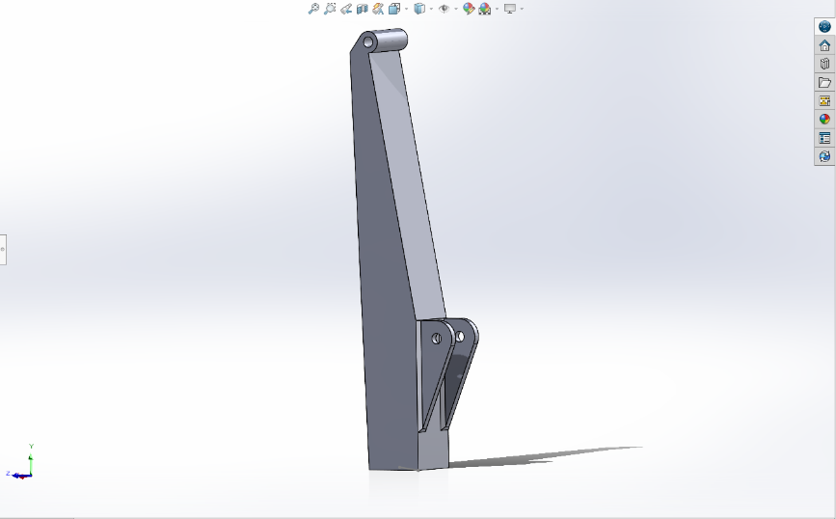
Fig. 6 – The Crane Pedestal Drawn in Solidworks®
Fig. 7 – The 1st Boom Section Drawn in Solidworks®
Fig. 8 – One of the connecting pins drawn in Solidworks®

3.3. Assembly Modelling
All of the parts individually modelled were imported into a Solidworks® Assembly and brought together. Using this, it was easy to see if any part dimensions, movement angles or collision points had been incorrectly judged/measured. Any issues found were simply rectified, in most cases by opening the part file, making the minor changes necessary and “rebuilding” the assembly, without the requirement to start assembling it from scratch.
It was realised that in order for the lifting capacity at (horizontal) full extension to be accurately measured, the main lift cylinder between the pedestal and the boom would need to be modelled as a rigid prop, as otherwise any loads would simply compress the cylinder and lower the arm. In order to achieve this, the external dimensions of the completed cylinder were taken. The required extension for the boom to be horizontal was then calculated, and a rigid representative cylinder, with no moving rod or hollow for hydraulic fluid was created. This was then used to replace the initial sliding cylinder in the final assembly. This lift cylinder substitute can be seen in Figure 9.
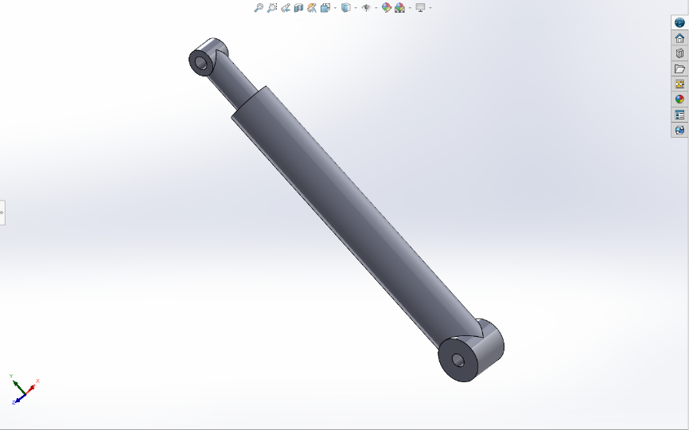
Fig. 9 – Main Lift Ram Fixed Substitute
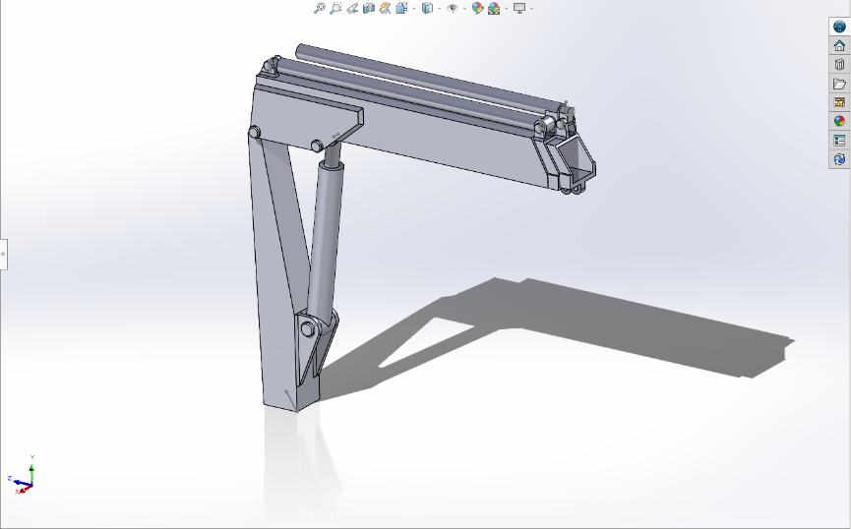
Finally, the parts within the assembly had movement boundaries and mates defined to ensure that the completed assembly could be manipulated within the movement window of the crane had it been real. As such contact points and movement limits were assigned to stop the parts from moving “through” each other, and movement limits were defined at the maximum extension of the hydraulic rams to stop the pistons from being pulled out of the cylinders. The final completed assembly can be seen in Figures 10 and 11.
Fig. 10 – Completed Assembly in Solidworks® - Boom Retracted.

Fig. 11 – Completed Assembly in Solidworks® - Boom Extended.
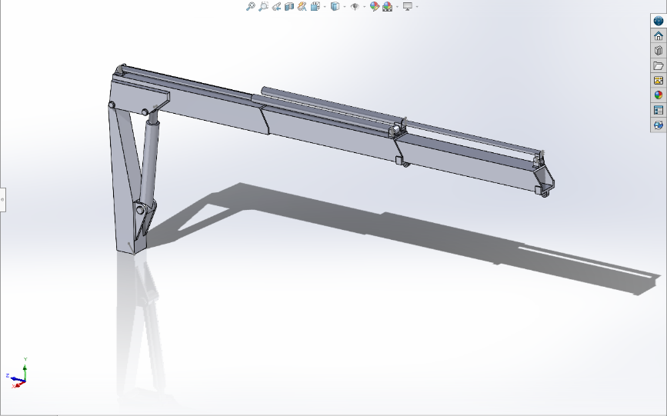
Whilst it is possible to assign materials in Solidworks®, the decision was made to assign materials once the model had been imported into ANSYS®, due to a wider range of data being available, and to ensure that the simulation were optimised with the best possible parameters.
4. Simulation (Using ANSYS LS-Dyna® Software Suite)
4.1. Simulation & Structural Analysis
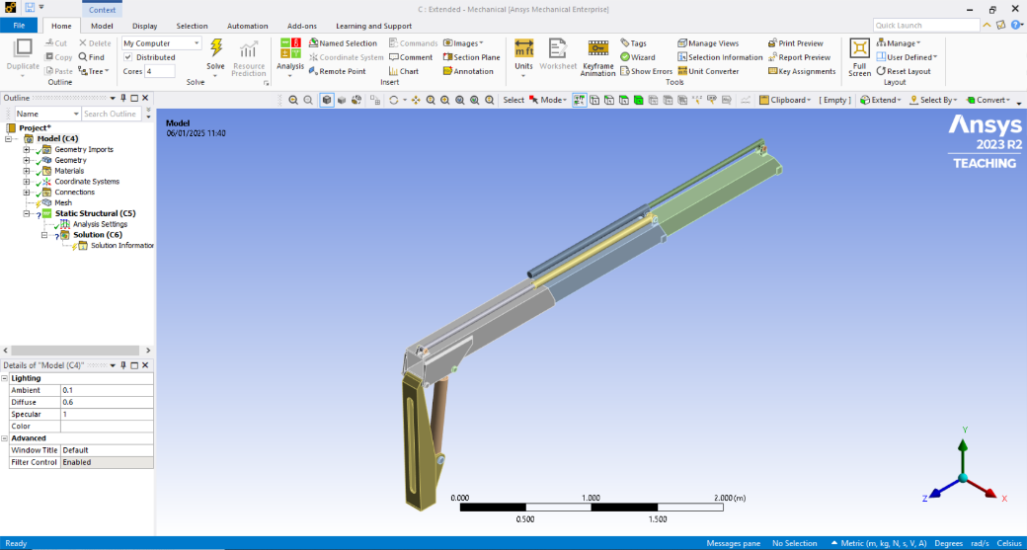
In order to evaluate the working load capacities of the crane, the completed Solidworks® assembly was then exported into ANSYS®. The Workbench was used to launch a static structural analysis in ANSYS® Mechanical, and three test instances were set up with the boom at Full extension, 50% extension and completely retracted. An example of this is shown in Figure 12.
Fig. 12 – Crane Geometry established within ANSYS® Static Structural
In all three, the boundary and simulation conditions were applied in much the same manner, with the base of the crane pedestal was assigned as a fixed support (Figure 13), as it would be in actuality if the crane were to be mounted to a vehicle or vessel.
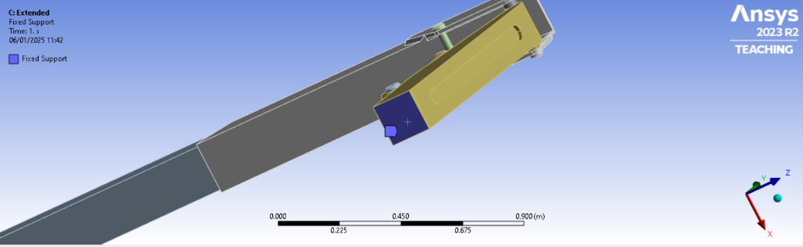
Fig. 13 – Fixed Support Assignment
A downwards acting Load force was assigned to the lifting eye at the end of the boom. (Figure 14) This was applied as a ramped force between 0 – 30kN, allowing us to monitor the strain and displacement experienced by the crane at varying forces.
As there are multiple manufacturers of such loader cranes, and all of them use specific steel mixes which they have optimised for this scenario, the compositions are somewhat commercially sensitive and not available for use. As such, I have chosen to provide a rough approximation using normalized high Strength Low Alloy (HSLA) AISI 4140 Steel, which is similar to the Tata Steel® Proprietary HSLA steels used by one of the most popular crane manufacturers, Palfinger® [5]. As such, the parameters of AISI 4140 Steel were retrieved from the ANSYS® material library (Figure 15) and assigned to our model.

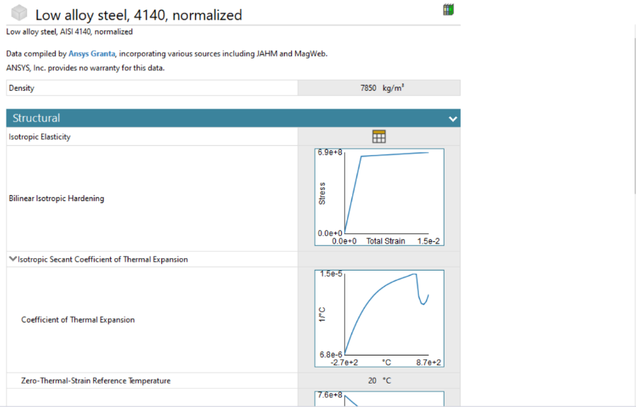
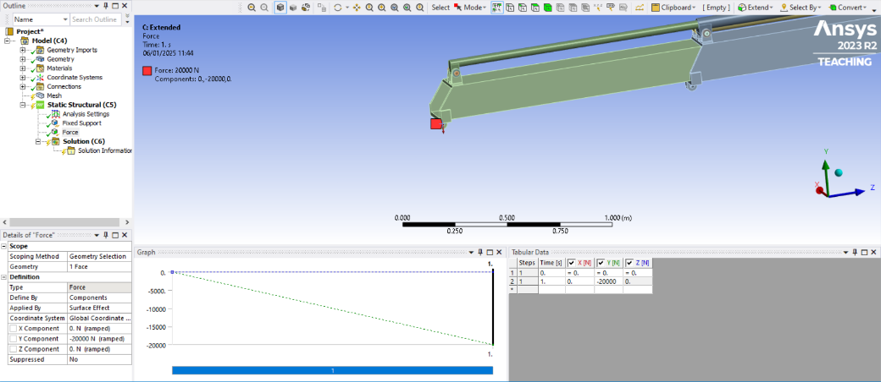
Fig. 14 – Applied Load Force Assignment
Fig. 15 - ANSYS® Material parameters for AISI 4140 Normalized Steel.
Due to the variety of shapes within our model (both curves, angular and large flat surfaces), I decided to mesh it using tetrahedral elements. (Figure 16) The automatic sizing recommended within ANSYS® was used.
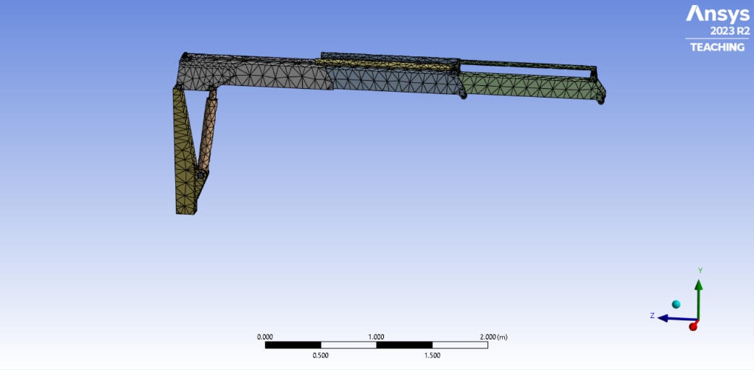
Fig. 16 – Meshing the Model in ANSYS®
Finally, the environmental conditions were set to an ambient temperature of 20°C within ANSYS® The model was validated and solved.

4.2. Results
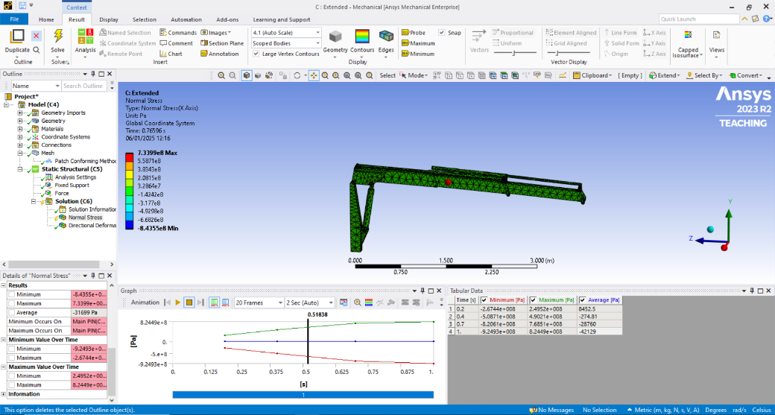
Following the solving of the model, the results were analysed. An example of the initial simulation results can be seen in Figure 17.
Fig. 17 –Crane Load Simulation in ANSYS® (Fully Extended)
In order to calculate the Safe Working Load (SWL) of our crane, we need to establish both the braking strain/yield point of the material used and then combine that with the safety factor required. The formula for this is shown below.
$$SWL \left(kg\right)=\frac{F_{B}}{3} ÷G$$
Using the material database within Ansys, the yield strength of AISI 4140 Steel is taken to be 6.522 x10⁸ Pa (652.2 MPa, 0.65 GPa) This is similar to multiple material manufacturer’s stated specification and as such is taken to be valid^{[6]}. Utilising the results from our simulation, we can see what load force is applied when this stress is exceeded at each extension length, F_{B}. This is shown in Column 2 of Table 4 below. Most small cranes have a safety factor of 3:1, so the SWL Force is shown in Column 3. Finally, this is converted into a SWL weight in column 4 (Accepting the value of gravity, G, to be 9.81 m/s²).
Extension Length | F_{B} (N) | SWL (N) | SWL (kg)
Retracted | 24062.3 | 8020.7 | 817.6
50% | 15324.7 | 5108.2 | 520.7
Extended | 10871.2 | 3623.7 | 369.4
Table 4 – Analysis Results and SWL (Ambient)
4.3 Thermal Influence
Since telescopic loader cranes are frequently used worldwide, they are likely to be subjected to extremes of temperature. One installed on a vehicle operating in the arctic, for example, could be subjected to -40°C temperatures, whilst one installed on a military vehicle in the desert could experience quite the opposite at +50° C. Some mounted on ships may be subjected to both.
To ensure that the crane was capable of maintaining the majority of its SWL across all environments, the simulations were re-run with the temperature set to -40°C and +50°C respectively. This was changed in the analysis settings. (Figure 18)
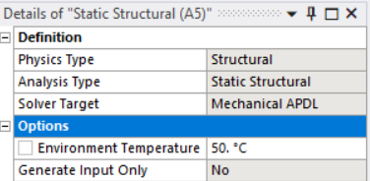
Fig. 18 – Environmental temperature Settings in ANSYS®
The results of these further simulations are shown in Table 5.
Environmental Temperature (°C) | Load at which Yield Strength is exceeded (N)
Environmental Temperature (°C) | Retracted | 50% | Extended
- 40 | 24518.4 (+1.9%) | 15628.1 (+2.0%) | 11103.8 (+2.1%)
+ 20 | 24062.3 | 15324.7 | 10871.2
+ 50 | 23546.6 (-2.2%) | 14972.8 (-2.4%) | 10648.5 (-2.0%)
Table 5 – Analysis Results at Various Temperatures
As we can see, at -40°C our SWL is on increased by arrange of 1.9-3.5% and at +50°C it is reduced by 2.2 to 2.9%.
5. Discussion – Use of CAE as a Design Tool
5.1. Advantages
As seen throughout both tasks, CAE brings many advantages to the design/engineering process, and indeed makes it possible to analyse some things that would not be possible without it, and to a high degree of precision. These advantages are summarised below:
- CAD allows parts to be drawn up digitally without the requirement to redraw on paper or make revisions on physical prototypes.
- CAD allows all of the parts in an assembly to be drawn up separately and then combined, manipulated and evaluated to ensure compatibility prior to production of a prototype.
- Components designed in CAD can be easily exported into a wide range of CNC and automated machinery, streamlining production and allowing manufacture with incredibly high precision and within infinitely repeatable tight tolerances not possible with human manufacture.
- Interconnection of CAE programs allows designed parts to be instantly transferred into a plethora of simulation and Analysis software, allowing engineers to access more types of analysis than would be possible within physical & economic realities.
- CAE allows access to a huge range of material properties, making material choices to be more robustly made.
- CAE significantly reduces, and often negates, the need for destructive testing of physical items.
- CAE allows better record keeping of version control for iterated designs.
- CAD files and CAE results files can be stored, re-ran and traced without risk of loss or damage, provided the correct storage methods are used.
5.2. Disadvantages & Limitations
Whilst there are many benefits to using CAE within the design process, it is important to remember that it is still not perfect, and that any software/program has limits which we need to be aware of. These include:
- Almost all of the major commercial CAE providers have variable pricing structures for software licencing, often going into the 10s of thousands per licence. This can be unaffordable and as such, engineering companies may find their CAE capabilities limited by which packages they can afford.
- For more complex simulations, a huge amount of computing power is required. This can be expensive to buy, costly to run/maintain and can require a large amount of expertise to utilise fully.
- Material Simulations are only ever to the standard of the level of accuracy and detail provided in their material information sources. Basic material models and details may produce incorrect results due to factors not being considered.
- Environmental factors are difficult to convey fully in a digital environment, particularly in fluid and more complex analyses. Whilst known forces, resistances and environment conditions can usually be applied, again these are limited to the amount of detail put in and won’t always take account of some natural phenomena.
- Material models assume everything to be perfect unless told otherwise. Wels are assumed to be immaculate and materials are assumed to be absolutely flawless, where in reality, minor flaws and deviances are usually always present.

6. Conclusion
To conclude, CAE has revolutionised modern engineering practice. The introduction of CAD has allowed parts to be created easily in 3D, revised as much as they need, and tested for compatibility all in the digital space prior to the production of a prototype. These designs can then be instantly exported into CAE analysis suites and be tested against a wide range of stresses, forces, conditions and interactions, with that loop being able to be cycled as often as is necessary for revisions to be made before re-analysis. Once a final design is reached, the link into modern CAM allows components to be manufactured with the push of a button, increasing commercial efficiency, product quality and consistency.
The tasks within this report have shown that CAE is an amazing set of tools to assist a design process, but one that has to be treated as just that – a tool. One of which the limitations, both of the analysis software and the data fed into it, must be known and borne in mind and that a great degree of skill must be learnt in order to extract the best from it.
With CAE ever more important, and with technology continually advancing, the possibilities are almost endless and provide a huge help in advancing engineering innovation as a whole in all fields.

7. References & Bibliography
- S.R. Kabir. (2024, Apr. 8). Who Invented the CNC Machine? [Online]. Available: https://historycooperative.org/who-invented-the-cnc-machine/
- A. Beck. (2017, Sept. 26) 60 Years of CAD infographic – The History of CAD since 1957 [Online]. Available: https://www.3dfindit.com/en/engiclopedia/60-years-of-cad-infographic-the-history-of-cad-since-1957
- World Material. ASTM A36 Steel Properties, Modulus of Elasticity, Yield Strength, Material Density, Hardness & Equivalent [Online]. Available: https://www.theworldmaterial.com/astm-a36-steel/
- Palfinger AG. PC 1500 Compact [Online]. Available: https://www.palfinger.com/en-gb/products/loader-cranes/models/pc-1500-compact_p_631H
- Tata Steel Europe. (2023, Nov.) Case Study: Palfinger AG (Tata Steel supports PALFINGER with an extended service Ympress® E690TM/S700MC steel used an innovative crane solution) [Online]. Available: https://products.tatasteelnederland.com/applications/engineering/case-studies/palfinger
- J. Otai. (2023, April 28) Strength and hardness of 4140 steel at different temperatures [Online]. Available: https://www.otaisteel.com/strength-and-hardness-of-4140-steel/

