Design and Manufacture Case Study
MUST REFERENCE MYSELF BEFORE HANDING IN
ACDA5021
Luke Malcolm (2030773)
2024
Contents
1. Executive Summary 2
2. Background 2
3. Systems Engineering Methodology 2
4. Requirements 3
5. Stakeholders 4
6. QFD 1 4
7. Function Means Analysis 4
8. QFD 2 5
9. Report Assumptions 5
The Rifle – Functional Decomposition 5
10. Barrel 5
Anatomy 5
Basic Information 6
Customer Requirements - Barrel 6
Functions 6
11. Manufacturing 7
12. Process Flow 7
13. Failure Modes 8
14. Manufacturing Requirements 8
15.Manufacturing QFD 1 9
16. Process Function Means Analysis 11
17. QFD 3 13
18. Button Rifling 14
19. Parameter Diagram 16
20. What-Why Table 17
21. Recommended Measures 19
Control Factors 19
22. QFD 4 20
23. Limitations of the Systems Toolset 21
24. Conclusion 22
25. Future Work 22
Bibliography 23

1. Executive Summary
This report explores the application of the systems engineering toolset to the manufacturing of rifle barrels. The manufacturing steps will be decided on and discussed; and a most critical process identified. Once this process has been identified, key noises and controls will be identified, and measures to negate their effects proposed.
The button rifling is deemed to be the most important process step. The most important control factors that require monitoring relate to the button wear and the button and barrel clearance. The most important noise factors requiring control are the bore diameter and button wear. Measures to monitor and control these, respectively, are shown in section 21 of the report.

2. Background
Using a typical precision rifle barrel as an example, this report aims to propose a solution for manufacture and assist in the design of the case itself using the systems toolset, up to (but not including) the QFD 4 stage.
Using the example of a precision rifle barrel, this report aims to propose a solution for manufacture and assist in the design of the barrel itself, up to and including the QFD 4 stage.
The following will be explored:
- Key customer requirements
- Critical system functionality
- Derivation of concept and design choices
- Failure modes
- Critical design features
- Manufacturing processes
  - Process steps
  - Process control measures

3. Systems Engineering Methodology
Large sections of the following discussion are taken from a similar report by the same author, which focussed on cartridge case development [1]. The systems engineering process description and methodology remains the same.
An outline of the “systems approach” will be covered in the following report. This will involve an overview of the entire process, and a case study involving rifle barrel from the QFD 2 point onwards.
Systems engineering is an interdisciplinary engineering and management field that focuses on design, integration, and management to manage a system over its life cycle. It defines a “system” as a combination of elements that function together to produce the capability required to meet a need [1]. It looks closely at the way the parts come together and interconnect (inputs and outputs) to deliver a function. When a project is guided by a systems approach, a coherent and correct end product should be achieved, without that end product being wholly dominated by the perspective of a single engineering discipline.
Key to the systems engineering approach is the identification of issues earlier in a project or system life cycle, allowing for significant cost savings down the line. Research has shown that increasing the percentage of systems engineering effort in a project leads to better project success rates, with a correlation of up to 80%. It is important to note, however, that the optimum proportion of overall project costs that should be allocated to the systems engineering process is between 10% and 14%. Beyond this, the return on investment diminishes sharply due to unwarranted process [2].

4. Requirements
Key to the systems process is the concept of the “requirement”. While this may seem initially straightforward, there are three broad sets of requirements (which can be further broken down into subsets in some instances. These are as follows [3]:
- Operational Requirements
- Functional Requirements
- Non-functional Requirements
  - Non-functional Performance Requirements
  - Non-functional System Requirements
  - Non-functional Implementation Requirements
An Operational Requirement defines the major purpose of a system (what it does at its core) together with any key overarching contextual constrains.
A Functional Requirement specifies what the system must do in order to satisfy the Operational Requirement. This should typically be a “verb-noun” relationship, describing an action.
A Non-functional Requirement specifies how (or how well) the system does something. This is split into three further categories:
Non-functional Performance Requirements are linked to functional requirements. They generally specify target values linked to a certain functional characteristic.
Non-functional System Requirements define constraints that affect the entire system – often including physical attributes (size, weight, maintain, etc etc).
Non-functional Implementation Requirements dictate how the system is built with regards to specific technologies, compliance with specific legislation, etc etc.
For example, in the case of a round of a precision rifle barrel:
Operational Requirements: Barrel must enable the associated rifle system to consistently deliver a terminal effect
Functional Requirement: Barrel must be compatible with the Accuracy International L115A4 rifle system
Non-functional Performance Requirement: Barrel must not exhibit a Point of Impact (POI) shift over X Milliradians after being removed and refitted
Non-functional System: Barrel must be 686mm long
Non-functional Implementation Requirement: Chamber dimensions must comply with the CIP 338 Lapua Mag. document

5. Stakeholders
A key step at the conception of a programme in which a systems approach is being taken is the development of a stakeholder influence map. This is a simple tool for capturing the stakeholders (and potential stakeholders) of a system, and their associated interactions and influences [4]. This is conducted in three steps –
- Brainstorm all potential stakeholders. A stakeholder is defined as anybody who comes into contact with, has an interest pertaining to, or is affected by the system at any point in its life cycle.
- Identify natural “groups” of stakeholders, who have similar views and requirements. Name each group.
- Using the groups identified in step 2, draw a map capturing their interactions
The map can then be reviewed, and a decision can be made as to who requirements must be sought from, who requirements should be sought from, and who can be ignored.
The stakeholders are then consulted as to their requirements. These requirements should be “sanity checked” and a bid/no-bid decision can be made from a commercial standpoint (if relevant).
Following this, the requirements can be input into Quality Function Deployment (QFD) 1 framework.

6. QFD 1
The QFD 1 process shows the customer’s needs (requirements) against the necessary functionality of the system. Often, customer requirements will be woolly. These must be translated into concise technical requirements when being placed in QFD 1 – performance must always be measurable. Translating vague requirements is something that care must be taken over, lest one be inadvertently be changed or misconstrued. Any errors will be carried forward, which in part defeats the object of the systems engineering process.
The output of QFD 1 is a graph showing the importance of each function relative to the others. This output is important because (for example) one function may not be exceptionally important in any one individual requirement - and be overlooked as such - but it may outperform all other functions cumulatively. The same principle applies across other QFD stages. The overall “big picture” view given by QFD is valuable because of this. QFD also ensures that requirements can easily be traced back throughout the process and that the needs of the customer stay at the forefront.

7. Function Means Analysis
After QFD 1, a Functional Means Analysis (FMA) should be carried out. This is where all functions are listed, and their associated means of being carried out are also listed. From this, a “winning concept” can be picked using a Pugh (or other multi-criteria analysis). This is outside the scope of this report. Subject Matter Expert input should be considered throughout the FMA, but also not overly-relied on, lest a potentially good concept be ruled out due to the misgivings of one individual.

8. QFD 2
Following QFD 1 (which has dictated a critical function) and the first FMA, QFD 2 can be performed. This compares the functions (given in QFD 1) to the winning means selected in the FMA. This then ensures that the chosen design satisfies the technical requirements of the project and gives a ranking of critical system subcomponents.

9. Report Assumptions
This report assumes that a full functional analysis and QFD 2 (on the rifle) has been performed, resulting in the gun barrel being deemed the most important subsystem of the rifle. Whether or not this is the case in practice is debatable (although the author suspects that the barrel is likely to be one of the top two subcomponents were a QFD 2 to be performed), although the manufacturing steps and surprising amount of potential noise and associated control factors associated with the barrel itself make it uniquely well-suited to be used as an example of the systems toolset.

The Rifle – Functional Decomposition
The typical bolt-action precision rifle can be broken down into six main parts:
- Bolt
  - Contains the pressure of firing at the rear
  - Houses the firing pin
  - Feeds, extracts, and ejects the cartridges/cases
- Barrel
  - Allows the round to be fired
  - Stabilises the bullet
  - Provides a mounting interface to muzzle devices
- Action
  - Receives/joins bolt, barrel, stock, and trigger
  - Fitted with an optics mounting/interface rail
  - Holds the magazine in place
- Stock (or chassis)
  - Interface between rifle and shooter
- Trigger
  - Holds and releases firing pin on command
- Magazine
  - Houses the cartridges
  - Presents the cartridges for feeding at the correct angle
The remainder of this paper will focus on the barrel itself.

10. Barrel
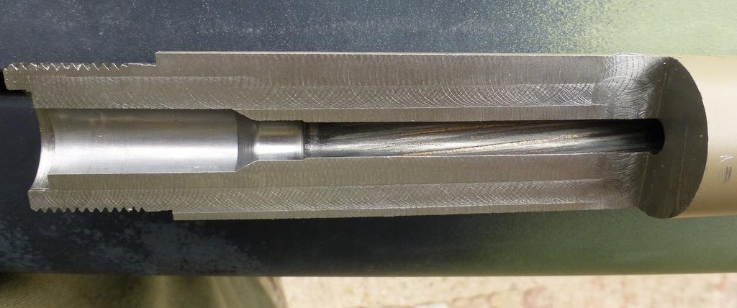
Figure 1 – Sectioned Barrel – Chamber End [6]

Basic Information
The barrel on a precision rifle has several jobs to do. Principally, it must withstand the pressure generated by the cartridge firing – this is often in excess of 3,500bar, not to mention the incredibly hot gas flow it must endure and subsequent erosion. It must endure this over and over, even when the heat of firing softens the steel of the barrel and it is not allowed to cool between shots. It must remain accurate and consistent throughout. The gradual transition from chamber to rifling is key, specifically the distance from the ogive of the bullet when it is fully seated in the chamber to the lands of the rifling (termed “jump”). As the barrel erodes, this distance grows, typically resulting in less accuracy.
The rifling must be at a twist rate sufficient to stabilise the projectiles in the desired weight range, however it must not over-spin them lest the bullets tear themselves apart on exit (which while not common, is far from unheard of).
Barrel life is typically measured in thousands of rounds. A typical precision rifle barrel is expected to last 3,000 to 5,000 rounds (although much more is achievable in practice depending on usage and cleaning). This can also be measured in seconds – assuming a bullet takes 0.002 seconds to exit the barrel, 5,000 rounds puts the barrel at 10 seconds of life [6].
The barrel must also be easy to clean – a smooth internal finish means fouling can be wiped out comparatively easily. Excessive fouling leads to excessive pressures and as such an even shorter life.

Customer Requirements - Barrel
The customer requirements for ammunition would generally consist of some operational requirements, non-functional performance, and non-functional implementation requirements. These would pertain to the all-up round (or a part thereof) and not focus on the case specifically (specific requirements for hybrid or polymer cases, etc notwithstanding). Generally, the requirements would focus on ammunition conformity to CIP or NATO standards – these dictate dimensions, pressures, tolerances, headspace, etc etc. While the case has a large part to play in fulfilling many of these requirements, aside from dimensional limits, it is responsible for tying the other components together in such a way that the all-up round will meet its requirements.

Functions
The basic functions of a rifle barrel are as follows:
- Allows the round to be chambered
- Provides the necessary confinement for the combustion process and material for the case to obturate against
- Ensures stability of the projectile
- Acts as a heat sink (removing combustion heat from the system)
- Provides a mounting interface for any required muzzle devices (muzzle brake, signature reduction system, etc)

11. Manufacturing
The manufacturing of a barrel, conceptually, is relatively simple. A tube must have what is effectively a very long thread formed internally, and an internal chambering, and two external threads. However, the tolerances involved and high quality standards that must be upheld, which pose problems in manufacture.
The first step is to decide how the barrel will be manufactured, from a basic functional standpoint. This is done in a process flow.
Note that the current barrel fitted to the L115A4 rifle used in this paper as an example is fluted. The author has omitted fluting from their process flow as they believe the disadvantages of fluting outweigh the benefits, and that a precision rifle barrel should not, where possible, be fluted.

12. Process Flow

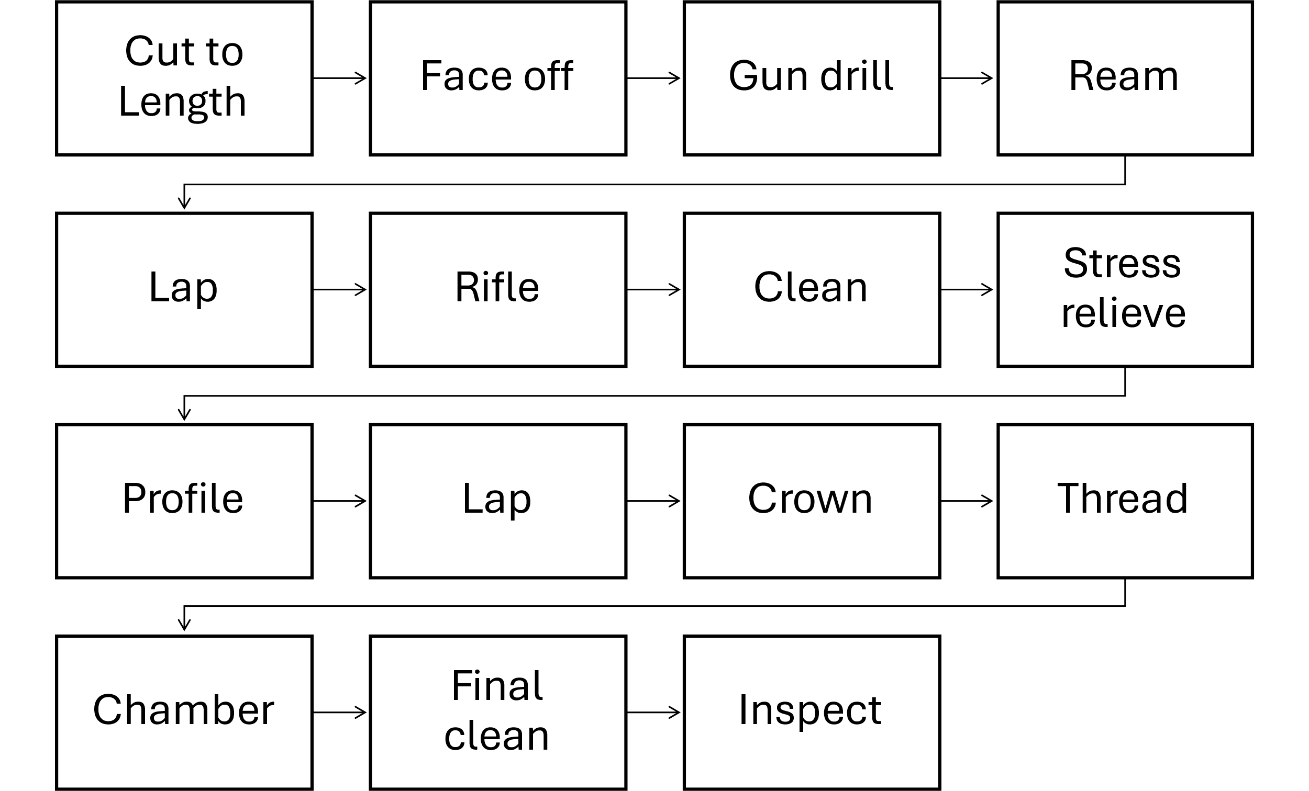
Figure 2 - Process Flow for Barrel Production

The Process Flow defines the process functionality – in other words, what each step of the process must do. At this stage, avoid going into specific manufacturing methods, unless there is absolutely no other feasible way. Terms like “create”, “fill”, “form”, “join”, “attach”, etc. should be used.
Following the process flow, manufacturing requirements must be gathered – however, an intermediate step is to investigate potential failure modes.

13. Failure Modes
Possible failure modes for each block of the process flow are examined and tabulated. These are examined against the effect on the system, the effect seen by the user (and associated severities), along with the mechanism, probability of occurrence, ease of detection, and a proposed detection and/or prevention method. Each is ranked on a scale from 1 to 10.
The severity, multiplied by the chances of occurrence, multiplied by the ease of detection, result in a Risk Priority Number (RPN). This aids in deciding which failure modes must be addressed first, and also tells the user which manufacturing step will have the biggest impact on the design should it fail.
This should first be performed in the design stage – known as a Design Failure Mode and Effects Analysis (DFMEA) Enormous cost savings can be made by addressing potential failure modes I the design stage rather than later on in the product lifecycle [7]. Other forms of FMEA exist (for example, Functional), but this paper focuses on design and manufacture early on in the lifecycle. Furthermore, the RPN figure feeds into QFD 4. This will be discussed later on in the document.
In the example of gun barrel manufacture, the DFMEA with respect to the processes used is fairly straightforward. Detection is generally reasonably simple thanks to most potential failure modes being dimensional (even where these are difficult to measure directly). Occurrence is wholly dependent on the quality of the manufacturing process, manning, and tooling. The severity descriptors are up for debate in this instance – does it apply solely to the process or to the finished product in a service environment?
An initial assessment of RPNs proved that the chambering of the rifle was the most important to control – while a low-quality barrel may not be accurate or consistent, a badly cut chamber can in some circumstances result in dangerous faults.

14. Manufacturing Requirements
Manufacturing requirements are the requirements of the manufacturing process itself. These may pertain to costs, capacity, reliability, quality, and safety. For the purposes of this paper, a generic set of manufacturing requirements will be used [8], which adequately covers the process. Note that no specifics regarding cost are within the scope of this paper.
Once both manufacturing functionality (from the process flow) and manufacturing requirements have been identified, the Manufacturing QFD 1 can be completed.
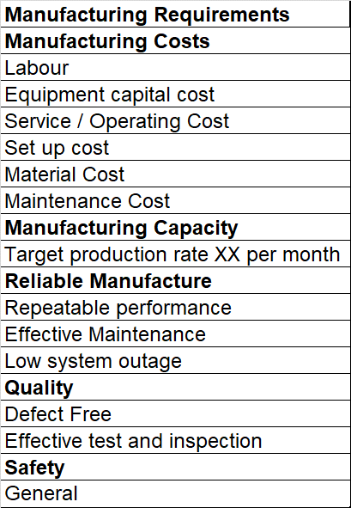
Figure 3 – Generic Manufacturing Requirements

15.Manufacturing QFD 1
The Manufacturing QFD 1 places the manufacturing requirements against the manufacturing functionality – in doing so, assigning an importance to each of the processes.
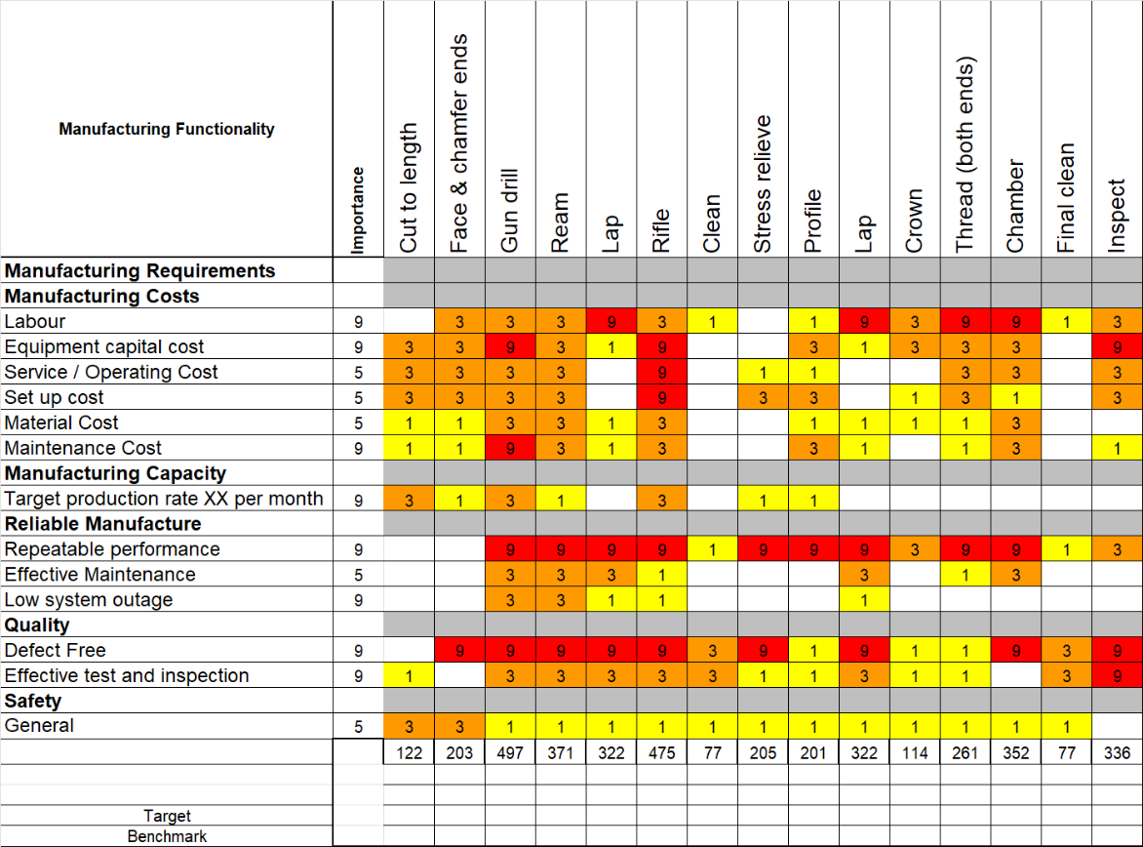
Figure 4 - Manufacturing QFD 1
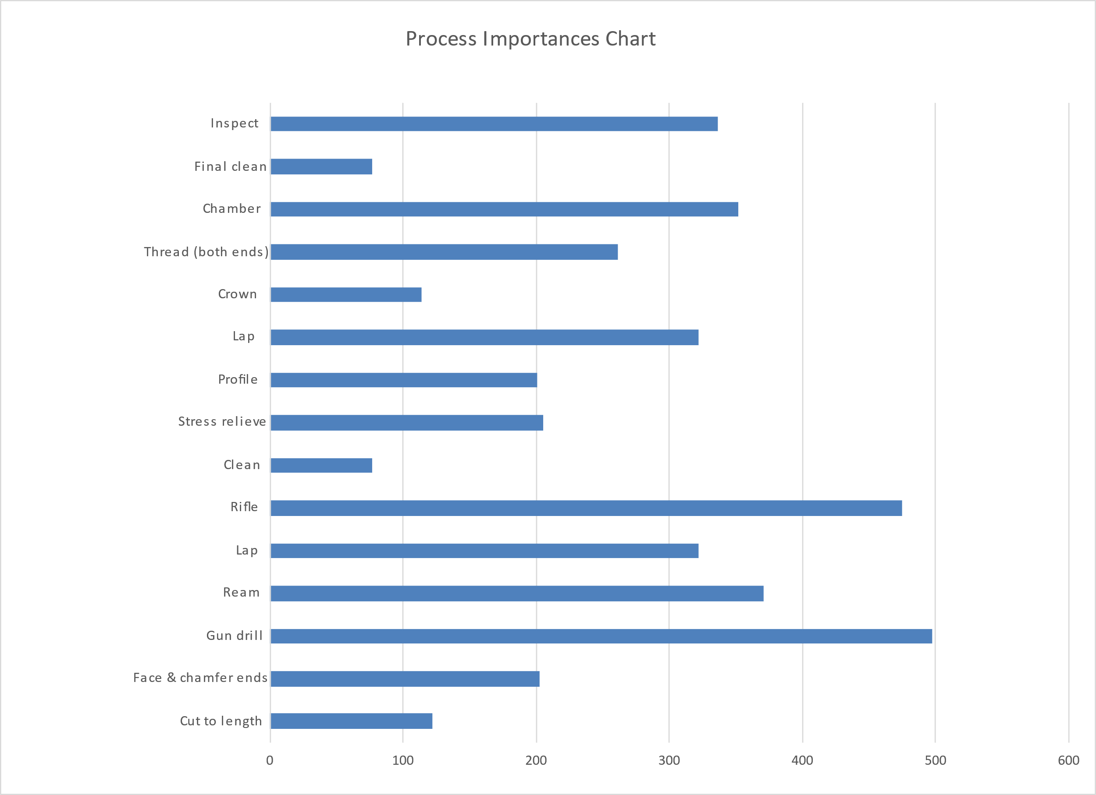
Figure 5 - Process Importances Chart
The author is unsurprised to see the gun drilling being the most important, followed by the rifling, chambering, and inspection – this is the exact “hierarchy” that the process is based on. If the initial gun drill is low-quality, everything that comes afterwards will be negatively affected. The same goes for the rifling and the chambering.

16. Process Function Means Analysis
In this step, the various manufacturing processes are listed, along with a variety of potential means of accomplishing those processes.
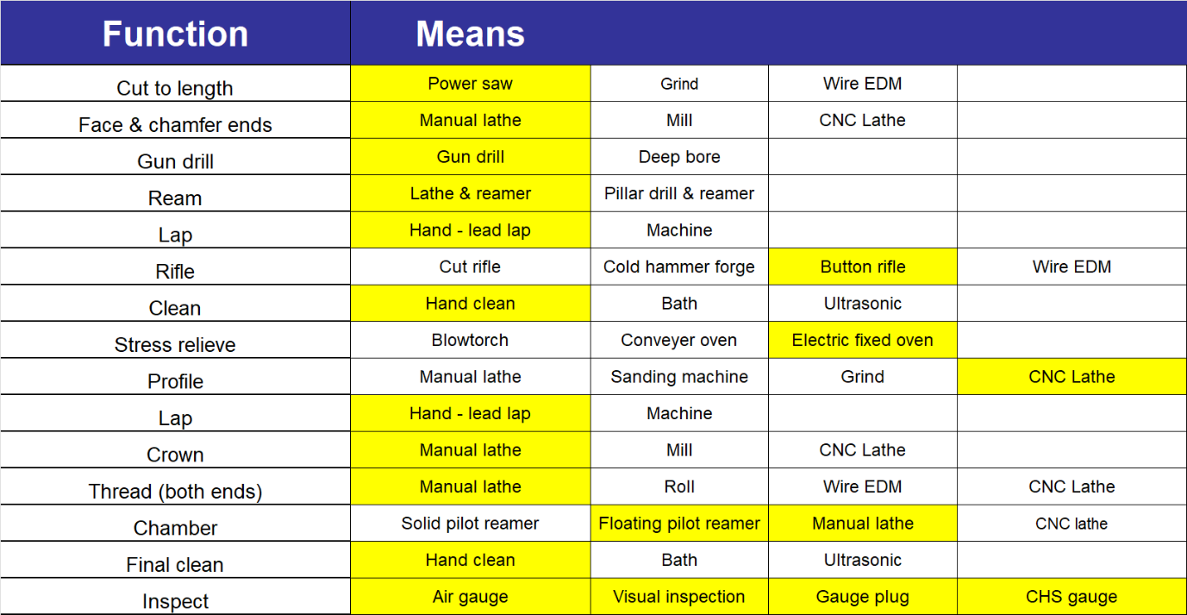
Figure 6 - Process Function Means Analysis
Manufacturing SME advice should be sought when listing and deciding on process means, but advice from any one person should not be overly-relied on, lest a potentially good process be ruled out due to the misgivings of one individual. If no risks are taken, and no effort is made to at least investigate or research avant-garde means, no advancement will ever be made. As such, the unusual should not be ruled out for simply being different to the industry standard.
The winning means are then selected via a Pugh (or other multi-criteria) analysis. This often requires deeply specialist knowledge of a variety of processes and the local manufacturing environment – and as such, will not be covered in the report. The rationale for choosing each process is detailed below:
Cut to length: a power saw has been chosen for this task because at this current stage, the barrel does not need to be of an exacting length – a millimetre one way or the other does not make a difference. Often, the end inch of a barrel is cut at the end of the process due to having been held forcefully between centres. Grinding is unnecessarily wasteful and wire EDM is too expensive and the dimensional accuracy it gives is not required.
Face & chamfer ends: A manual lathe can be used for this task. Squareness is the most important attribute here. A CNC lathe could do the job equally well, however a manual lathe is cheaper and the facing operation is quick. A mill is likely to be able to hold the barrel vertically.
Gun drill: The gun drilling technique has not changed significantly since the second world war. Many 1940s gun drilling machines are still in use today. The tip of the special bits used is designed such that the forces acting on it help to keep it on a central axis. A boring bar is not sufficient for a gun barrel due to the depth/diameter ratio.
Ream: A manual lathe and reamer can be used to accomplish this task, as it is straightforward and not very time-consuming.
Lap: The traditional – and best – method of lapping a rifle barrel is performed by blocking the barrel a few inches from the muzzle and pouring molten lead into it from the muzzle, to form a “slug” a few inches long. This slug is left to cool and then removed and trimmed, before being coated in lapping paste and passed up and down the barrel. There are no practical machine alternatives known to the author.
Rifle: Button rifling has been selected by the author. Traditionally, the best match barrels in existence are “cut rifled”, a process in which a single cutter is used to slowly remove material from the inside of the bore, forming the rifling. This leaves an excellent surface finish which is easy to clean and imparts virtually no stress to the barrel – however, it is time consuming, expensive, and in the case of a service weapon (even on a sniper system) – a waste. Cold Hammer Forging is a common bulk barrel production method in which a barrel is repeatedly hammered around its radius at a very high frequency into an internal mandrel or form. This method imparts an enormous amount of stress into the barrel that can be difficult to relieve using conventional stress-relieving techniques. The equipment is also very expensive. Button rifling, in which a button consisting of the reverse imprint of the desired rifling is slowly forced through the bore is, simple and delivers excellent results. While it does impart stress into the barrel, this is easily removed. It leaves a good surface finish (that can be improved further by lapping, like any other method) and is relatively cheap. The best button rifled barrels perform virtually identically to the best cut rifled barrels. Wire EDM is a novel technique in the barrel making world, and while it offers the possibility for an internal finish so good directly out of the machine that it does not require lapping, the associated costs are currently prohibitive.
Clean: Simple hand-cleaning using patches and solvents is perfectly adequate. Most of what is being cleaned from the barrel is lubricant or cutting fluid, not dirt that requires agitation or complete immersion.
Stress relieve: A simple oven will be used for stress relief. Neither blowtorches nor conveyer ovens are precise enough, heat the barrel evenly enough, or allow the requisite cooling time.
Profile: In the profiling operation, a considerable amount of material is removed and “hand feel” is not important. As such, a CNC lathe will be employed.
Crown: In the crowning operation, only a tiny amount of material is removed. This can be done in one step in comparatively little time on a manual lathe. “Feel” is of medium importance.
Thread: The thread on the chamber end of the barrel is critical to the final headspace. “Feel” is important. As such, it shall be cut by hand. The thread on the muzzle is less important in this respect.
Chamber: For the best accuracy, chambering must be done by hand, for feel, on a manual lathe. Solid pilot reamers are more durable and longer-lasting (and as such suited more to bulk production), however for the best in precision a barrel should be chambered with a self-centring floating pilot reamer.
Inspect: All available methods of inspection will be used. Air gauging will be used to measure the bore diameter throughout the length of the barrel. Borescopes will be employed for visual inspection of surface finish and any internal defects. Headspace gauges will be used on a factory action to check headspace.

17. QFD 3
This step of the QFD process takes the specific manufacturing functionality and places it against the means – resulting in a means importance chart.

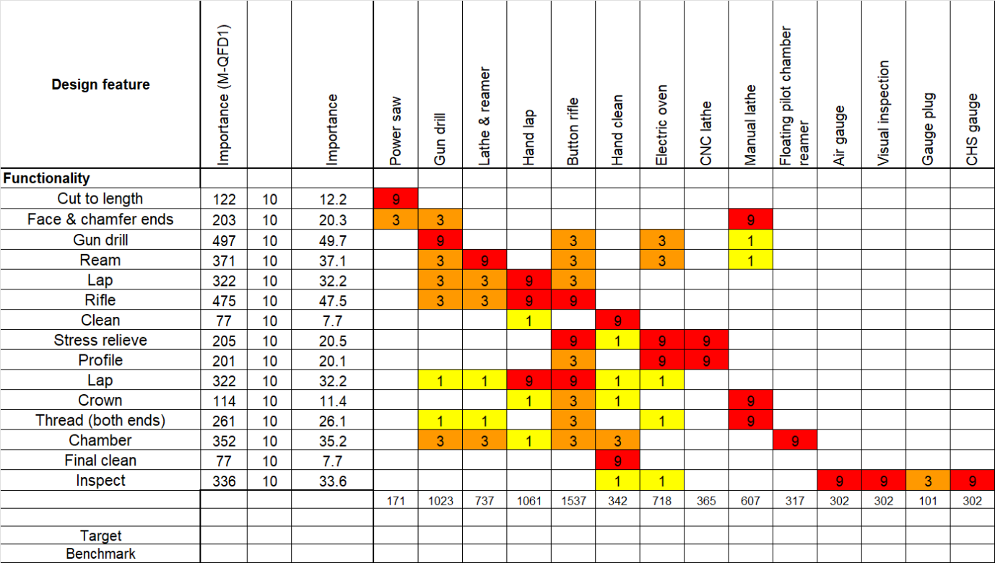
Figure 7 - Manufacturing QFD 2
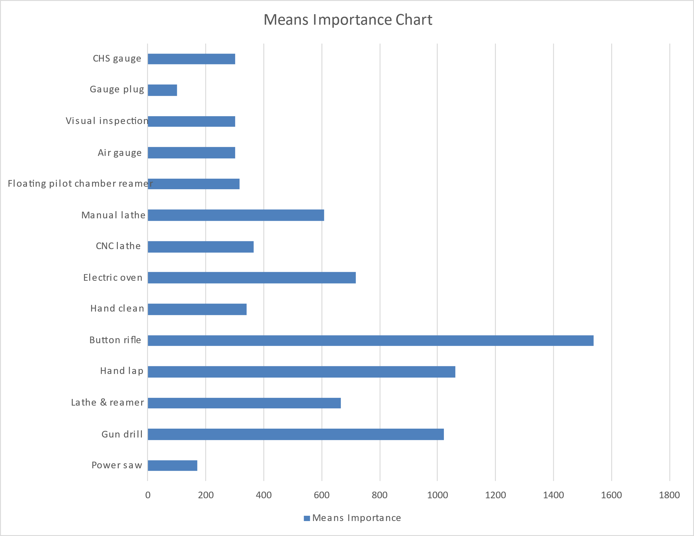
Figure 8 - Manufacturing QFD 2 Means Importance

The Manufacturing QFD 2 – often known as QFD 3 - ranks the means importance. As can be seen from Figure 8, the most important means are the button rifling, followed by hand lapping and gun drilling
As it was deemed to be the most important following manufacturing QFD 2, the subsequent steps in this report will pertain to the button rifling process itself.

18. Button Rifling
Button rifling is a cold forming process in which the “button” (which has a reverse imprint of the desired rifling ground into it) is pulled (or sometimes pushed) through the drilled, reamed, and once-lapped blank. The lands and grooves are engraved into the bore as the button passes. The button itself is fitted to the end of a rod, which rotates as the button advances through the blank so as to give the required twist rate.
Figure 10 shows a button rifling machine. The barrel would be fixed on the right hand side of the central metal plate, with the button rod running from the “chuck” on T-shaped piece on the left, through the barrel. The hydraulic rams would then pull the T-shaped piece to the left as the chuck rotates, as the barrel is held against the central metal plate. This would drag the button through the barrel, producing the rifling.
There are several considerations in this process. Firstly, the button itself and the rod attached to it must withstand huge forces across what is a relatively small cross-sectional area (it can take circa. 4.5 tons of force to pull the button down the barrel [9]).
Due to the forces involved in the cold forming of the rifling, the type of lubricant selected is particularly important. This is traditionally proprietary to each barrel maker and is often a well-guarded trade secret. One well-respected barrel maker is known to use a kind of soap rather than an oil! [10].
Finally, due to buttoning being a cold-forming method, stress will be imparted to the inside of the barrel. Adequate stress relief must be performed afterwards – is this is not undertaken, as the barrel is profiled following the rifling process, the bore will expand (as by removing material from the outside, stress will be released) – this expansionwill not be uniform down the length of the bore either, as the finished profiled barrel will have a gradual taper down its length; more material will have been removed at the muzzle than at the chamber.
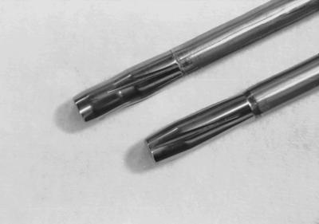
Figure 9 – Rifling Button [9]
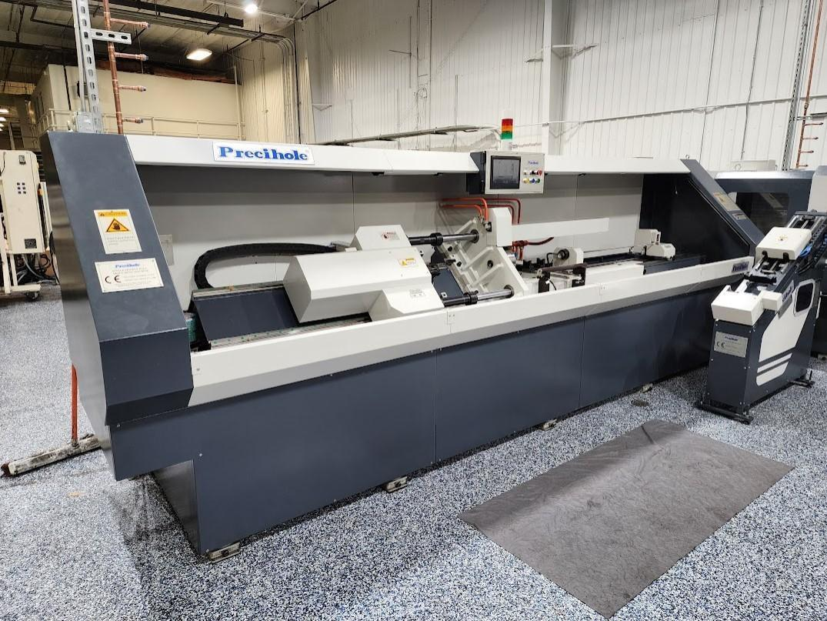
Figure 10 – Button Rifling Machine [11]

19. Parameter Diagram
The Parameter Diagram (P-diagram) is used to identify the inputs to a system while relating those inputs to the desired output, while considering noise and control factors. Noise factors are considered to be anything that affects the output of the system – these can be unit-to-unit variation, deterioration, or environmental factors. Control factors are what we can control – materials, tolerances, building environments, etc.
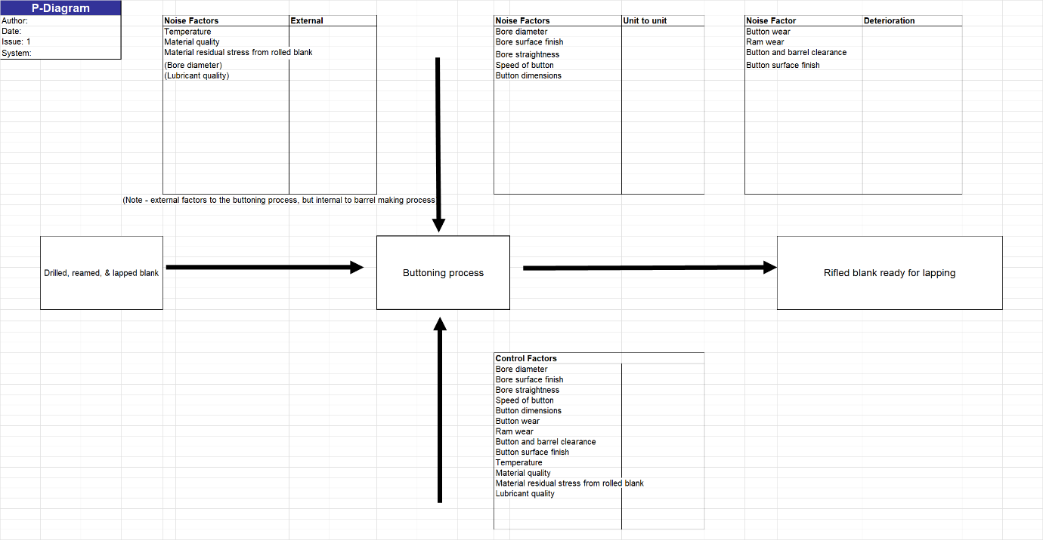
Figure 11 - Parameter Diagram for Buttoning Process
Once the P-diagram has been completed, a “what-why” table can be begun, using the noise factors and control factors identified.

20. What-Why Table
The what-why table allows a controls chart and a noise chart to be generated. These show, respectively, which controls require the most care, and which noises require reducing.
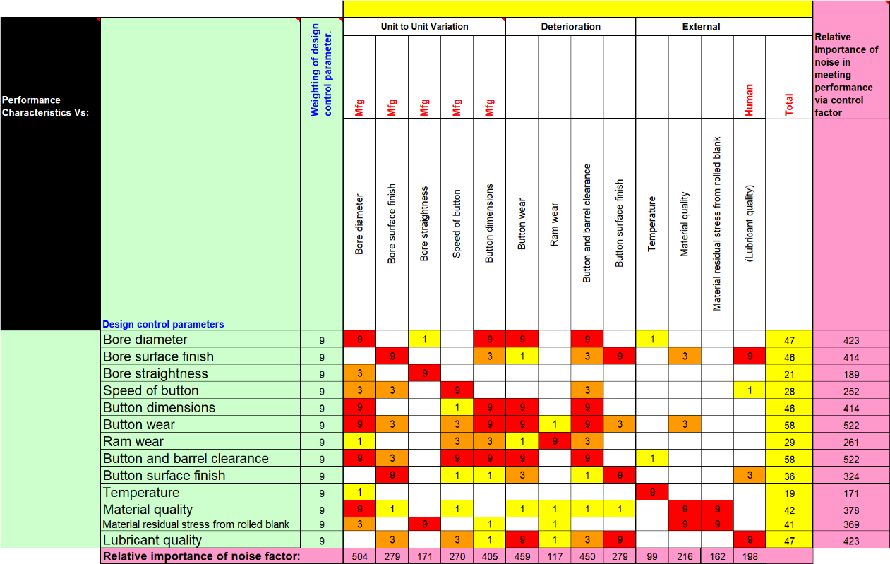
Figure 12 - What-Why Table for Drawing Process
On the left-hand side of the table, the control parameters are listed. At the top, the noises are shown. A high, medium, or low value (or, no value at all) is assigned to each noise depending on how much it affects each respective control.

Figure 13 - Key Controls Chart for Buttoning Process
As shown in Figure 13, the two highest-ranked key controls are the button and barrel clearance, and the button wear. Joint second are bore diameter and lubricant quality, joint third are the button dimensions and the bore surface finish.
These top controls are generally interlinked in this case – for example, button and barrel clearance is a function of button dimensions, wear, and bore dimensions. This is good news, as by introducing relatively few control measures (compared to the number of top key controls) many of the key controls can be managed effectively.
It is little surprise to the author to find button and barrel clearance/dimensions so high up the controls list. If the button and barrel clearance is too tight, flaws are likely to be introduced into the barrel, and the subsequent stress relief may not be sufficient to stop the bore expanding when the barrel is profiled – resulting in a less accurate barrel. The chance of breaking the button or rod is also much higher, writing off expensive tooling and potentially damaging a machine. If the clearance is too loose (or the button is heavily worn), the rifling will be of worse depth and worse quality/surface finish. The button may not self-centre as effectively either. This will also lead to a much less accurate barrel.

Figure 14 - Key Noise Factors Chart
Figure 15 demonstrates that the main noise that needs controlling is the bore diameter, followed by button wear, and the button and barrel clearance. Given the key controls, the key noises are not a surprise. The key controls shall adequately manage these noise factors.

21. Recommended Measures
Measures that can be taken to monitor and control the top three control factors and noises respectively are proposed below:

Control Factors
- Button and barrel clearance
  - Air-gauging of barrel prior to buttoning process
  - Measurement of button prior to buttoning process
- Button wear
  - Microscope inspection of button
  - Shadowgraph/vision machine measurement of button
- Bore diameter
  - Air-gauging of barrel prior to buttoning process
- Lubricant quality
  - Batch buying
  - Keep to one manufacturer, even if an “identical spec” lubricant is found elsewhere
The proposed noise factors will adequately control all of the major noise factors identified by Figure 15.

22. QFD 4
Following this step, QFD 4 can be performed. On the left-hand side of the QFD matrix, the critical process characteristics are listed, along with a weighting – this is based off the RPN figure gained from the DFMEA. The control measures are listed across the top. Rankings are assigned, and as a result, a determination is made as to which controls are the most useful, and consequently the development of quality targets for each control. This information is potentially useful in the development of inspection/quality documents, or work instructions [12].
Figure 15 - QFD 4
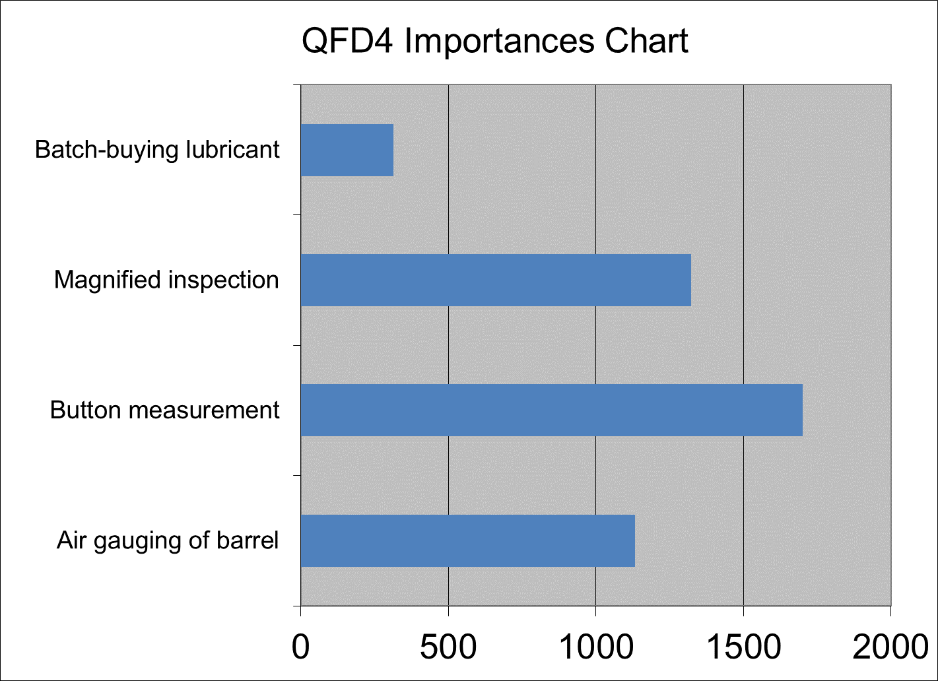
Figure 16 - QFD 4 Importances Chart
As can be seen in Figure 16, the most important control measure is the button measurement. While this is possible to do with a Coordinate Measuring Machine (CMM), the author recommends that a vision machine (an optoelectronic shadowgraph equivalent) is used to measure the complex geometries of the button that a ball-tipped CMM may struggle for consistency with.

23. Limitations of the Systems Toolset
Like many advanced engineering tools, the main limitation of the systems engineering toolset is the ability and understanding of the user - to understand not only the toolset at their disposal, but also the item (or process) it is being applied to. The systems toolset – at its heart – is numerical, and focuses on the relationship between parts, processes, requirements, customer needs, etc. Without a deep understanding of the process, dependencies cannot be assigned realistic values. Without realistic values, the output of each step will be incorrect. Errors can easily be carried forwards. The systems toolset itself is also complex and requires deep understanding to use effectively. As such, standard practice would be for the process to be carried out iteratively by a “panel”, consulting with various SMEs as frequently as is necessary to ensure that the process moves in the right direction from both a pure systems and a technical standpoint.

24. Conclusion
This report has given a basic overview of how the systems toolset can be applied to the manufacturing of a rifle barrel, specifically focussing on the button rifling process. Key controls and noises have been identified, and measures to monitor the controls and control the noises have been formally identified and proposed in section 21.

25. Future Work
The most important consideration in any future work should be a Pugh analysis. This shall ideally also be completed in the various stages to fully understand the cost and benefit associated with both different process functions and their associated control importances and noise controls. Ultimately, were this to be performed as part of a real production setup rather than a purely academic exercise, a key main driving factor would be cost, and as such, the associated (often severe) compromise – the impact of which has been wholly excluded from this report, and as such, this work must be taken in isolation and cost should be fully considered in any future works.

Bibliography

[1] | National Aeronautics and Space Administration, “SEH 2.0 Fundamentals of Systems Engineering,” [Online]. Available: https://www.nasa.gov/reference/2-0-fundamentals-of-systems-engineering/. [Accessed 05 2024].
[2] | Wiley, “The Importance Of Systems Engineering: Enhancing Success And Efficiency,” 2023. [Online]. Available: https://www.wiley.com/en-us/network/professional-development/careers/engineering/the-importance-of-systems-engineering-enhancing-success-and-efficiency.
[3] | D. Holley, Performing Functional/Behavioural Analysis, 2024.
[4] | S. Burge, “The Systems Engineering Tool Box,” 2011.
[5] | D. Cali, “An Introduction to Rifle Cases,” [Online]. Available: https://bisonballistics.com/articles/an-introduction-to-rifle-cases.
[6] | “Gone in Six Seconds — The Shocking Truth of Barrel Life,” 16 September 2011. [Online]. Available: https://bulletin.accurateshooter.com/2011/09/gone-in-six-seconds-barrel-life/. [Accessed 17 07 2024].
[7] | D. S. Burge, “A Systems Approach to Failure Modes, Mechanisms, Effects and Causes,” 2014.
[8] | D. Holley, Design Book Shell BLANK.
[9] | G. Kolbe, “THE MAKING OF A RIFLED BARREL,” 03 2010. [Online]. Available: http://www.geoffrey-kolbe.com/articles/bmart.htm. [Accessed 17 07 2024].
[10] | How A Precision Rifle Barrel Is Made: with International Barrels Inc.. [Film]. LifeLine, 2017.
[11] | Machnet.com, 2021 PRECIHOLE BRVN 12/1-800 SINGLE SPINDLE BUTTON RIFLING MACHINE - BRAND NEW!.
[12] | Quality-One International, “Quality Function Deployment,” [Online]. Available: https://quality-one.com/qfd.
[13] | NZ Herald, “American troops fire 250,000 bullets for every local they kill,” 25 September 2005. [Online]. Available: https://www.nzherald.co.nz/world/american-troops-fire-250000-bullets-for-every-local-they-kill/FJ3MGCMA7QDIIKS2STPNP6D4KI/#:~:text=WASHINGTON%20-%20United%20States%20forces%20have%20fired%20so,that%20American%20ammunition-makers%20cannot%20keep%20up%20wit.
[14] | Macrodyne, “Deep Drawing 101”.
[15] | SFTC Deform, Drawn Shell Casing Simulation, 2020.

