WORDCOUNT:
MENU ENGINEERING
ASSIGMENT 2
STUDENT ID: 2233751
STUDENT NAME: IASMINA CIRPACI
LECTURE: FFION CUMBERPATCH
MODULE: FOOD AND BEVERAGE OPERATION
wordcount 425
The menu I am choosing for Trinity hotel chain is De Jour menu because it changes daily depending on what the chef has available in the kitchen or sometimes even what the chef has prepared that the for the restaurant. I liked this menu because its not the same food everyday the changes and has a variety of foods in the menu. for example chicken du jour means the chicken that is de jour is available that day. De Jour mean of the day. My target people are ordinary people that like to eat in the restaurant. The people that choose to eat in a restaurant always expect more they are paying for the dish. They need the food hot on time and the dish to look nice. The taste and the quality of the food is what keeps the customers to come to the restaurant. Soup is always the most common du jour items that’s is listed in the menu. Often de jour menu is displayed on a chalkboard or on a digital screen. Most chefs will sometimes use du jour menu interchangeably with a special menu. A chef that know explained to me that he viewed the du jour menu as a menu that uses fresh and seasonal ingredients whereas a specials menu is comprised of either leftover ingredients or dishes that need to be sold before they go bad and turn the food into food waste. Most people like to order du jour menu because they expect the menu to be fresh. Also the customers like du jour menus to be served quickly. There is more menus than de jour for example we also have a la carte menu which provide customer intensive selection with each priced like the seasonal menus it shows us that the menu changes according to the time of the year in winter people need more calories than in the summer because in the summer people don’t go much often to restaurant than the winter also customers need in winter more rich foods. Also a simple menu is imported because it will help us reduce waste. I choose to serve this menu because its nice a simple it looks nice and colorful on the plate. I choose chicken breast served with beans and mash patato because chicken is very popular most people choose it because it is very low in fat.


TRINITY HOTEL CHAIN MENU: DE JOUR 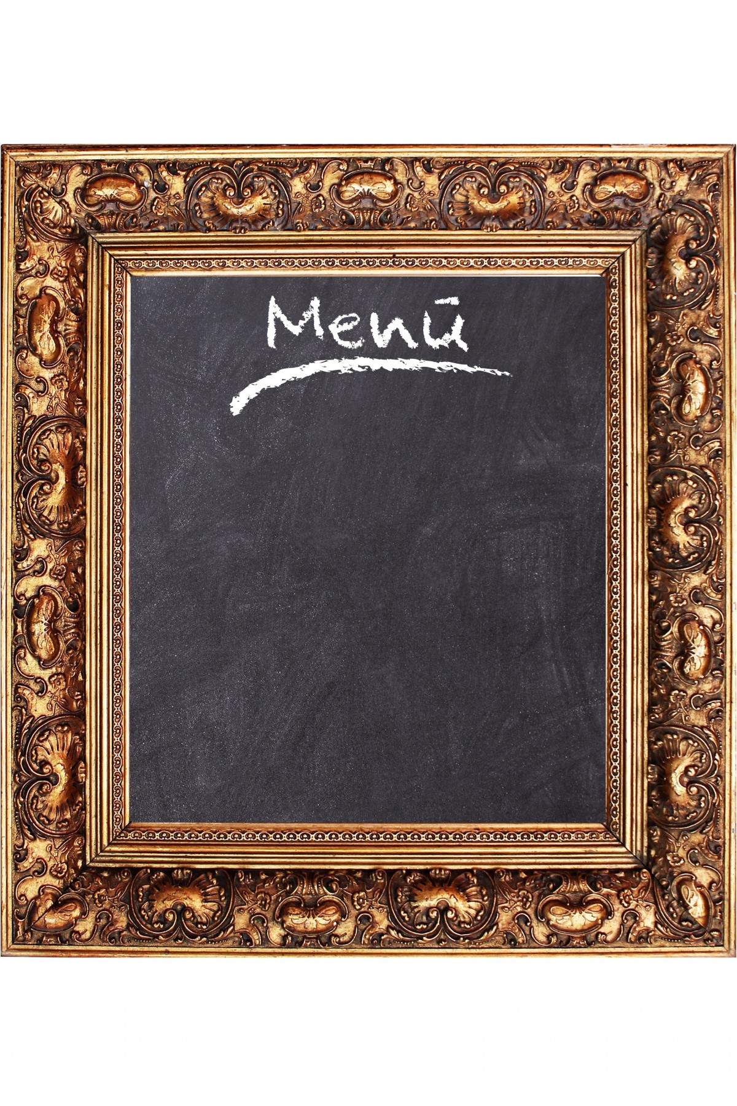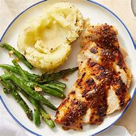
STARTER:
1.CHEFS SPECIAL VEGETABLE SOUP SERVED WITH BROWN BREAD
2.CAPRESE SALAD (MOZZARELLA,CHERRY TOMATO BASIL BALSAMIC)
3.GOAT CHEESE AND RED ONION TART SALAD

2 COURSE MEAU MEALS 25.99POUNDS
3 COURSE MENU MEALS 34.99 POUNDS PER PERSON.
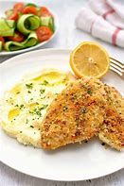
MAINS:
1.ROASTED CHICKEN BREAST(served with fricassee of white bean, green peas broad bean and mashed patato)
2. SLOW ROASTED PORK BELLY( served with dauphionoise potato, apple compote and five spice jus)
3.PERL BARLEY RISOTTO ( served with pumpkin roasted onion and caerphilly.)

DESSERTS:
1.BLACKBEERY CHEESE CAKE(served with white or dark chocolate) =12.99pounds
2.PEAL LAS, DATE PUREE(served with oat cakes or pickled walnut)=8.99 pounds
3.CREPES SUZETTE( serverd with orange sauce)=5.99 pounds.
DRINKS:
1.FRESH JUICE: (orange or apple )
2.SOFT DRINKS(coke, light coke, sprite ,tonic)

TRINITY HOTEL MENU.
DESSERTS:
1.BLACKBEERY CHEESE CAKE(served with white or dark chocolate) =12.99pounds
2.PEAL LAS, DATE PUREE(served with oat cakes or pickled walnut)=8.99 pounds
3.CREPES SUZETTE( serverd with orange sauce)=5.99 pounds.

BEERS. SOFT DRINKS. REDWINES: WHITE WINE:
1.phoenix 1. Coke, sprite, Fanta. 1.Barbera. 1.viognier.
2. Guinness. 2. Fresh orange juice and apple juice 2.coopers hawk red. 2.mascato.
If you are lactose or gluten free there are separate menu.
DRINKS.

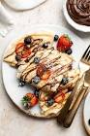
REFERENCES:
https://www.google.com/search?hl=en-IE&gbv=2&biw=1354&bih=651&tbm=isch&oq=&aqs=&q=crepes
https://www.menubly.com/blog/du-jour-menu
https://www.yelp.com/biz/du-jour-restaurant-scott
https://www.google.com/url?esrc=s&q=&rct=j&sa=U&url=https://www.menubly.com/blog/du-jour-menu/&ved=2ahUKEwiSmIG6nbT_AhWUbcAKHZ2OCBEQFnoECAUQBQ&usg=AOvVaw3pK1SjHu-zCHBAbK_rkkb2
https://www.google.com/url?esrc=s&q=&rct=j&sa=U&url=https://www.repleterecipes.com/blog/du-jour-menu-examples/&ved=2ahUKEwiSmIG6nbT_AhWUbcAKHZ2OCBEQFnoECAIQAg&usg=AOvVaw1MU2XvrSiHQZS7YqaK0h3v
https://www.hotelowner.co.uk/157577-trinity-hotel-ltd-goes-into-administration/
https://www.hotelowner.co.uk/157577-trinity-hotel-ltd-goes-into-administration/
https://www.happy-journey.com/tdh-menu-vs-cycle-menu-vs-du-jour-vs-a-la-carte/2032
https://www.theinghamswan.co.uk/du-jour-menu
https://www.bing.com/search?q=hotel+logo&form=EDGEAR&qs=HS&cvid=a6365d81e72b4064aeb4ef8e7aaee020&cc=US&setlang=en-US&elv=AQj93OAhDTi*HzTv1paQdniXgaIXJ1hNeD0xJBtFkFxc4EeJ1gyLM1rjV1QuCmyQYsXDI*zavloBAroNh2wPph39FrIZmBSsB1NVIztYtNT1

