Promoting Early Mathematical Awareness and Numeracy Skills Through Play
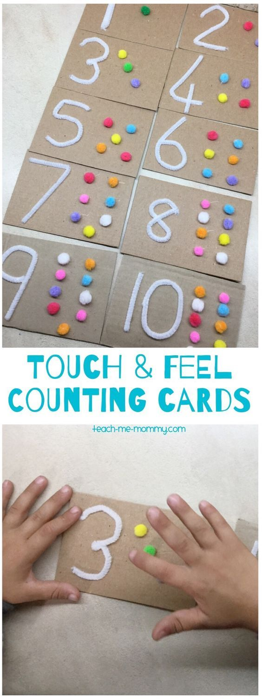
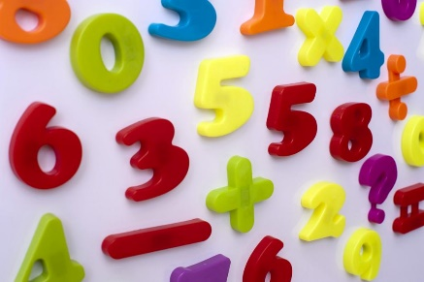

Source: Simms, No Date

Source: Pinterest, no date

Activity Plan Promoting Math Concepts and Numeracy Skills
A group of children aged 3-5 will be participating in a finger painting Counting activity. The activity consists of three different work sheets; one will be caterpillars, the other ladybirds and butterflies. Each activity sheet will have a different purpose to it, as well as the concept of counting. For example, the caterpillar worksheet will look at patterns; the children will be given a variety of different coloured paint and will be able to create a pattern as they count the dots. The ladybird work sheet will look at number bonds to 10; on one side of the lady bird there will be a number of dots (from one to nine), on the other side, the children will be able to work out the remaining sum to complete 10; they will have to write the sum underneath the ladybird, for example 6+4= 10. The butterfly worksheet will consist of the concept symmetry; one side of the butterfly will have a pattern on it, on the other side, the children must try and attempt to their best ability to create the same pattern, they will then have to count all the dots and write the number down in the box provided. This activity promotes the math concepts of counting and patterns. This activity will be a good aid for the children to continue learning as they will be able to take it home and be able to repeatedly count the dots and recognise the different patterns they have created.
Evaluation of Activity Plan
The activity above looks at the concepts of counting, addition and pattern. It is set out for children aged 4-6 (reception to year one) and will be conducted in the classroom. The activity will be done in a safe environment (classroom). A class of 28 children will be conducting this activity in a circuit style programme. The children will be split into three groups of nine to ten to conduct this activity. There will be a need of at least three members of staff to help conduct this activity to follow the staff to child ratio 1:13 provided by the government for health and safety (Department for Education, 2013).
According to the Welsh Assembly Government’s(2015) Curriculum for Wales: Foundation Phase Framework , by reception, a child should be able to recite numbers 0-20 forwards and backwards and recognise and repeat patterns of three including colour and clapping patterns ; by year one, they should be able to their number bonds to 10, for example 3+7 and should be able to show an understanding of repeating patterns that include shape and number. All three activity sheets promote these criteria, so the children will be following what is suggested what they n need to learn. The Department for Education and Employment (DfEE) (2000), say that by the end of nursery and the beginning of reception, a child should be able to count to 10. The activity sheets provide this opportunity for the children to learn as they count the dots to create the caterpillar and finish the ladybugs. The DfEE (2000) continues to say that children should be able to recognise, recreate and talk about simple patterns. This is shown through the third worksheet with the pattern butterflies.
In early years settings such as nurseries or schools, ‘No child should be excluded or disadvantaged because of ethnicity, culture…special educational needs, disability or gender’ (Foundation Years, no Date: 14). This activity does not discriminate against any of the above and children with all needs will be able to participate within the activity; there will be a teacher supervising each group of children always for any difficult encounters they may approach. For children who have not quite conquered number bonds to ten, some children may find the second (ladybug) worksheet a bit difficult; the teacher will be there for any questions that need to be answered or for help.
Resources for this activity include: paint, pencils and worksheets. The teacher will provide these to the children. Not only will this painting activity provide learning for mathematical concepts but will children learn and develop their fine motor skills and learn about colour mixing (Kelly, 2016); this activity will allow children to get messy and enjoy painting through finger painting or using paint brushes but for some children it may relieve stress and can show different emotions through what colours they pick to finish the activity (Kelly, 2016). Not only will the children be learning but so will teachers and practitioners to support this development. The final worksheet (butterflies), will look at pattern. Working with pattern, children will be able to explore new vocabulary such as: ‘wavy, curved, zig-zag, straight, bendy, arched…thick and thin’ (Tucker: 2014:62). Once the worksheets have been completed and marked by the practitioner involved they will be able to place them on display for the children to see. By placing pattern work upon walls and displays allows the children to realise that pattern is all around them (Tucker, 2014: 63).
The role of the adult within this activity it to observe and assess how well the children complete the task. There is a form of informal and formal observation within this activity: the teacher and other practitioners will be able to informally assess the children by asking questions throughout the activity; this allows the adult to interpret the children’s mathematical thinking and learning (Taylor & Harris, 2014: 93). The formal assessment for this activity involves the teacher collecting all worksheets and formally marking them; this will show the teacher what each child needs work on or how well they are doing on certain concepts of mathematics. As well as assessing and recording the children’s work, this activity will enable teachers to observe how the children are with one another. It is important for the teacher to note how children interact, how the engage in the activity and how they use different mathematical concepts with each other (Tucker, 2014: 124).

Resources and How they are Implemented through Play
For children, play is a natural way to learn; they can explore, examine and recreate the world around them simpler for them (Early Years: the organisation for young children, no date) and in childhood curriculum and pedagogy, play is critical for development (Docket and Perry, no date). According to Woods (2008), citied in Docket and Perry (no date), play is a way in which children can demonstrate how they learn which help them to scaffold the learning for others. For young children, play is freedom and flexibility for children (Taylor & Harris, 2014). Pound (1999) suggests that mathematics has its own language and as a parent, practitioner or caregiver, should be enjoy the way children create and make meanings instead of rushing them into writing their numbers 1 – 10. Constructivists and or social constructivists theories from Piaget (1952), Vygotsky (1978) and Bruner (1990) suggest that early childhood practice is important through active play from the children (Taylor & Harris, 2014: 33).
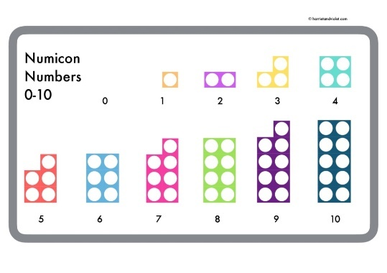
In early years settings or schools, teachers and practitioners have the responsibility to provide a range of resources and materials for the children to use to develop their learning (Montague-Smith, 2002). A teacher can provide: concreate materials, symbols, language and pictures to help with mathematical development (Haylock & Cockburn, 2013: 7). Concrete materials are anything that is physical, and children can use to help develop their mathematical concepts, for example: several different objects, blocks, counters and coins (Haylock & Cockburn, 2013: 7). Numicon is a very good concreate material aid for children to develop their counting (Haylock & Cockburn, 2013: 10), the children can count the holes and do simple addition and subtraction by adding other Numicon pieces to create a sum (Haylock & Cockburn, 2013: 11). For language materials, books and rhymes help develop mathematical concepts of patterns and counting. According Piaget and Inhelder (1967), citied in Montague-Smith (2002: 64), Children will find it difficult to copy a sequence but in nursery classes, children start to develop sequences through music, words and rhymes. A simple clapping pattern will be shown for the children to practice including clapping their name and practicing the syllables or clapping a rhyme such as ‘one two three four five once I caught a fish alive’ (Montague-Smith, 2002: 64). Other rhymes such as, ‘there were five in the bed’, ’10 green bottles’ and ‘5 speckle frogs’ will look at the concepts of counting, addition and subtraction (Haylock & Cockburn, 2013). By doing these rhymes, during play time or just normal lessons, the child will not realise they are learning because it is fun. In classrooms or childcare settings, numerals should be purposefully placed for children to see (Tucker, 2014). By displaying a sign, for example, 3 cars on a board, followed by the corresponding number and written word, positively reinforces the connection between them and the children will learn how to read and write the number (Tucker, 2014: 13).
Source: Harriet & Violet, No Date
Learning maths does not have to be done just within a classroom. Theorists such as Froebel, McMillian and Pestalozzi support outdoor learning as a good way for children to develop their fine motor skills (Taylor & Harris, 2014: 61). A lot of resources can be found in the outside environment and it is the responsibility of the adult to promote outside learning for the children (Tucker, 2014). School playgrounds provide children with numerous opportunities for an understanding of mathematical concepts including: height, direction, speed, shape and space (Taylor & Harris, 2014: 33). Tucker (2014: 24) provides resources that support mathematical development in outdoor environment including: big number tiles, permanent ground markings; these can be used to show numbers to park up big equipment such as tricycles and scooters: the children will be able associate each piece of equipment with the number on the floor. Although outdoor learning does not always associate itself with mathematics, it allows the children to develop general concepts of maths such as counting sticks, rocks and leaves (Taylor & Harris, 2014: 64).
The Role of the Adult and how they Monitor and Plan for Children’s Mathematical Development
In everyday life, we use mathematics; through counting, ordering and calculating measurements (Pound, 1999: 1). According to the Department for Education and Skills (2002), children in the early years will learn to develop the mathematical concepts of counting, early addition and subtraction, measurements and shapes and space. Under the concept of counting and number, children in nursery will learn how to recite numbers 0-10, forwards and backwards and by reception, they should be able to do this with numbers 0-20 (Welsh Assembly Government, 2015: 30). Under the concept of patterns, in reception, children will learn to a copy basic patterns through clapping rhymes or threading activities, by year one, they should be able to demonstrate an understanding of repeating patterns (WAG, 2015: 35). It is responsibility of the adult to help them through this development.
In early years setting, practitioners need to carefully plan maths in the classroom to ensure learning (Montague-Smith, 2002: 142). There are three types of planning for mathematical development and these are long term planning; this is look at the outcomes for the child over a period of 1-3 years, medium term planning; this looks at planning outcomes over a week period and short-term planning; this looks at planning outcomes and setting them for the week ahead (Montague- Smith, 2002: 142). A teacher or practitioner may plan to set out a ‘end-product’ and will have to look if the process of play needs to be brought into the development of mathematical concepts (Taylor & Harris, 2014: 43). To ensure mathematical development, practitioners must strategize efficient approaches to ensure that mathematical concepts are clearly visible within the classroom through a range of resources and materials; it would be impractical if one section of the classroom was set up for different academic developments; it needs to be explored in all areas of the classroom (Montague-Smith, 2002: 142).
Part of planning math in the early years, will look at how some children differ in learning styles and time. It is the responsibility of the teacher or early years practitioner to plan this out by placing children into groups to focus on one concept of maths (Montague- Smith, 2002: 144), for example, a group of six children will need practice on counting, whereas another group of children will need to work on their shapes. Some children learn better through hands on experiences, so as an adult, they should plan to make math real for the children by teaching it in a way that children will learn; school has many opportunities to support this such as clean up time; the teacher should get the children to name the shape, colour and count the toys as they tidy up (Brookes Publishing, 2014). This can also be done at home through mealtimes and asking questions such as “What shape is the plate? or do we have enough spoons” (Brookes Publishing, 2014); this allows the children to develop their concepts of numbers and shapes. Part of being a teacher or practitioner, you will have to plan for children’s diverse needs (Foundation Years, No Date). They must plan opportunities that will help children with additional learning needs which can help build their self esteem and must provide a supportive and safe environment for children with additional learning needs, so they don’t feel harassed due to their difficulties (Foundation Years, No Date: 17).
To ensure that the child is learning, teachers and practitioners have the responsibility of monitoring and assessing the children. This can be down through creating assessment criteria which should be created when planning lessons for the children (Montague-Smith, 2002: 150). Part of assessing the children is to record significant achievements that they do (Montague-Smith, 2002: 151). Montague-Smith, (2002:151), argues that the following achievements should be written down to show that assessment has been done: the first time the child says or does something for the first time and what can be significant to one child to another. Clarke and Atkinson (1996) citied in Montague-Smith (2002:151) have divided categories for significant achievements and some of the these include: physical skills: using a pencil or crayon to write down numbers; Social Skills: taking it in turns to throw a dice and process skills: being able to make estimates of counters or equipment before counting accurately. Assessing and monitoring children can be done through informal and formal assessments: informal assessments includes focusing on the children as they play and how they deal with mathematical problems that will arise, whereas formal assessments involve tests and discussion to help see what the children will need to work on (Montague-Smith, 2002).
Partnerships between parents and practitioners is not negotiable but essential for the child’s mathematical development (Pound, 1999: 95). For many adults, maths was a torturous subject in school, and play had nothing to do with maths (Early Years: the organisation for young children, no date), which may affect parents trying to implement maths at home. However, parents have a responsibility to help make math more enjoyable, so their children will subconsciously learn (Early Years Matters, 2018), this can be done by counting the stairs to bed, counting cars and homes on the way to school or nursery or counting how many oranges are in a pack when they are out shopping (Montague- Smith, 2002: 25). A program created by Little Counters (Brookes Publishing, 2014), suggest four main concepts to help develop children’s mathematical skills: using mathematical talk; this can happen at any time of day and can be initiated through asking questions such “which is bigger, the strawberry or blackberry? I have cut the grapefruit in half, so how many pieces do I have now?” (Brookes Publishing, 2014). Little counters also suggest engaging in purposeful play; this allows the children to be brought in to problem solving and reasoning (Brookes Publishing, 2014); the third concept Little Counter encourage is supporting development of counting beyond; math is everywhere we go and just by counting cars, homes or the food on our plate, encourages the child to develop their counting skills (Brookes Publishing, 2014), questions such as “Do we have the same number of baby carrots on our plate? Are there more blueberries on the plate or in the bowl?” (Brookes Publishing, 2014). The role of the adult in these situations is to encourage math and correct the child if they make a simple mistake and to reassure them on instead of giving up.

Image Reference List:
DaisyChain (No Date). Maths in Early Years – How to Support Children at Home [Online]. Available at: https://daisychainchildcare.com/blog/maths-in-early-years-how-to-support-children-at-home/ (Date Accessed: 16.02.2018)
Harriet & Violet (No Date). Numicon 0-10 Number Mat [Online]. Available at: https://harrietandviolet.com/downloads/numicon-0-10-number-mat/ (Date Accessed: 20.02.2018)
Pinterest (No Date). Touch and feel Cards. [Online]. Available at: https://www.pinterest.co.uk/pin/325736985538982487/ (Date Accessed: 25.02.2018)
Reference list:
Bobis, J; De Vires, E; Dockett, S; Highfield, K; Hunting, R; Lee, S; Perry, B; Thomas, L; Warren, E (No Date). Playing with Mathematics: Play in Early Childhood as a Context for Mathematical Learning [Online]. https://files.eric.ed.gov/fulltext/ED521030.pdf (Date Accessed: 20.02.2018)
Brookes Publishing Co. (No Date) ‘Teach Young Children Math Through Play – it’s easy with LittleCounters’ [Online]. http://www.brookespublishing.com/resource-center/newsletters/early-childhood-newsletter/teach-young-children-math/ (Date Accessed: 20.02.2018)
Crosby, D; Crossey, U; Crowe, L; Devlin, C; Heany, N; McDermott, A and Warren, M (No Date). Learning through Play: in the early years [Online]. Available at: http://www.nicurriculum.org.uk/docs/foundation_stage/learning_through_play_ey.pdf (Date Accessed: 17.02.2018)
Department for Education and Employment (2000). Curriculum Guidance for the Foundation Stage: London: QCA
Department for Education and Skills, (2002). Mathematical Activites for the the Foundation Stage: Reception [Online]. Available at: http://web3.sseln.org.uk/stthomashc/wp-content/uploads/2016/01/maths-activities.pdf
Department for Education. (2013). More Great Childcare: Raising quality and fiving parents more Choice [Online]. Available at: https://www.gov.uk/government/uploads/system/uploads/attachment_data/file/219660/More_20Great_20Childcare_20v2.pdf (Date Accessed: 21.02.2018)
Early Years Matters, (No Date). Mathematics (Ma) [Online]. www.earlyyearsmatters.co.uk/our-services/school-and-nursery-improvement-partner/mathematics-ma/ (Date Accessed: 17.02.2018)
Early Years: the Organisation for Young Children (No Date). Maths Through Play [Online]. www.early-years.org/parents/docs/maths-through-play.pdf (Date Accessed: 17.02.2018)
Foundation Years (No Date). Principles for Early Years Education [Online]. https://www.foundationyears.org.uk/files/2012/10/Curriculum-guidance-for-the-foundation-stage-Principles-for-early-years-education.pdf (Date Accessed: 17.02.2018)
Haylock, D; Cockburn, A. (2013). Understanding Mathematics for Young Children. Fourth Ed. London: Sage
Kelly (2016) Why Painting helps Children’s Development. Early Years Careers [Online] http://www.earlyyearscareers.com/eyc/learning-and-development/painting-helps-childrens-development/ (Date Accessed: 21.02.2018)
Montague-Smith, A. (2002). Mathematics in Nursery Education. Second Ed. Great Britain: David Fulton Publishers
Pound, L. (1999). Supporting Mathematical Development in the Early Years. Buckingham: Open University Press
Taylor, H; Harris, A. (2014). Learning and Teaching Mathematics 0-8. London: Sage.
Tucker, K. (2014). Mathematics through Play in the Early Years. Third Ed. London: Sage.
Welsh Assembly Government. (2015). Curriculum for Wales: Foundation Phase Framework.

