

Module: Introduction to Web and Database Concepts (ACCA4023)
Programme: Foundation (Computing)
Assignment title: Design and Implementation of a Relational Database System
Lecture: Divya Chidambaram
Biniyam Memberu
2405357
Contents
Introduction 3
1. Entity Relationship Diagram (ERD) 3
1.1 Entities and Attributes 3
1.2 Entity Relationships 6
2. Database Design Process 8
2.1 EER Diagram into a Relational Database 8
2.2 Constraints 9
3. Data Population 10
4. Normalisation 12
5. Practical Queries and Report 14
6. Validation 17
6.1 Validation Testing 18
7. Reflection 20
References 21

Introduction
The increasing demand for sustainable transport solutions has driven the development of eco-friendly initiatives, as more people seek environmentally responsible ways to travel. New ideas are emerging, such as Eco Ride, an electric bike rental service. This program supports cleaner ways to get around town, plus nudges users toward more active days by placing bikes where crowds already pass. As the service grows in popularity, efficient management of riders, bikes, rentals, and maintenance activities has become essential.
Currently, Eco Ride uses simple spreadsheet files to run things. This approach has resulted in several challenges; keeping track of available bikes is harder than it should be. Mistakes happen, like bikes scheduled twice at once, and difficulty tracking maintenance history. Reporting how services got used? These issues highlight the need for a structured and reliable database system to support daily operations and decision-making.
This assessment focuses on the design and implementation of a relational database system to support the Eco Ride scheme. Built around clear structures such as entity–relationship diagrams, it keeps data organised through appropriate normalisation levels. Instead of flat tables, relationships between tables link key elements across tables. Microsoft Access serves as the platform where tables hold specific fields checked by logical rules. Together, these choices support accurate storage, efficient retrieval, and smooth updates over time.
The assessment also demonstrates the practical use of the system through sample data population, parameterised queries, and testing against functional requirements. In short, this aims to build a robust database that speeds up daily work, reduces excess information, and provides clear details on how people use Eco Ride’s bikes and how well they perform.

Entity Relationship Diagram (ERD)
An Entity-Relationship Diagram was developed to visually represent the structure of the Eco Ride database and illustrate how data entities related to one another. The ERD provides a clear overview of the system by identifying key entities, attributes and the relationships between them [1]. These approaches ensure that the database design accurately reflects Eco Ride's real-world operations.
The ERD was created in draw.io, a diagramming tool that supports visual modelling using a standard notation. It was selected because it supports entity boxes, relationship connectors, and cardinality indicators, including one-to-many relationships, making it suitable for designing and presenting database models in an academic context [1].
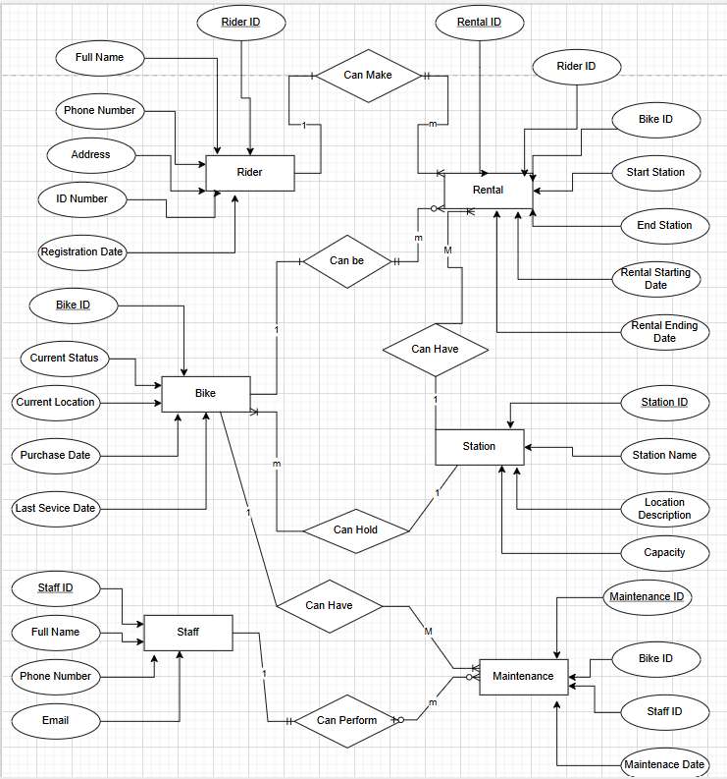
Figure 1 ERD Diagram for the Eco Bike.

1.1 Entities and Attributes
The Eco Ride database system is designed around several core entities that represent the main components of the bike rental scheme. Each entity includes a primary key to identify records and, where necessary, foreign keys to establish relationships between entities [2].

1. Rider
The Rider entity stores information about users registered to use the Eco Ride service.
Attributes:
- Rider ID (PK): Unique identifier for each rider
- Full Name: Rider’s full name
- ID Number: Identification number (e.g. government or national ID)
- Phone Number: Contact phone number
- Email: Email address
- Date Registered: Date the rider registered with the system
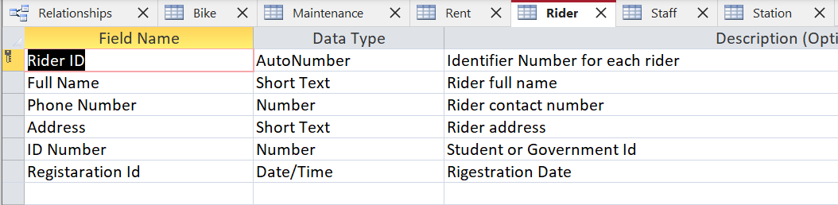
Figure 2 rider design view
2. Bike
The Bike entity represents each electric bike available in the Eco Ride scheme.
Attributes:
- Bike ID (PK): Unique identifier for each bike.
- Current Location: Current Location of the bike.
- Current Status: Current availability status (Available, Serviced, Rented).
- Purchase Date: Date the bike was purchased.
- Last Service Date: Last Service Date of the bike.
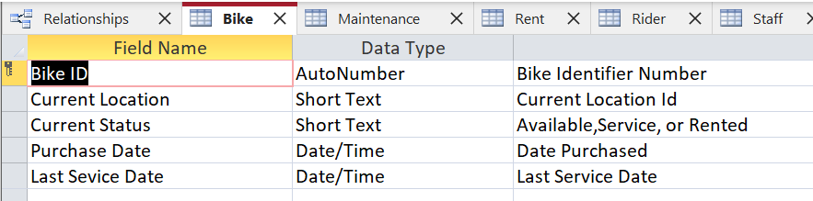
Figure 3 Bike design view
3. Station
The Station entity stores details of Eco Ride stations where bikes can be collected and returned.
Attributes:
- Station ID (PK): Unique identifier for each location
- Station Name: Name of the station
- Station Description: Physical address of the location
- Capacity: Number of bikes the location can hold
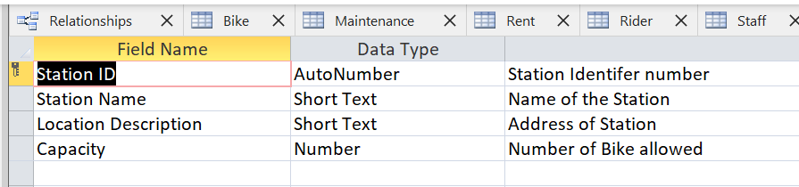
Figure 4 Station design view
4. Rental
The Rental entity records each instance of a bike being rented.
Attributes:
- Rental ID (PK): Unique identifier for each rental.
- Rider ID (FK): References the rider who rented the bike.
- Bike ID (FK): References the rented bike.
- Station Name/Start (FK): Location where the bike was collected.
- Station Name/End (FK): Location where the bike was returned.
- Rental Starting Date: The rental starting Date.
- Rental Ending Date: The rental ending Date.
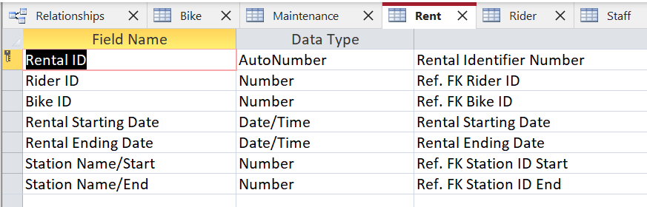
Figure 5 Rental design view
5. Staff
The Staff entity stores information about employees responsible for bike inspections and maintenance.
Attributes:
- Staff ID (PK): Unique identifier for each staff member
- Full Name: Staff member’s full name
- Phone Number: Contact number
- Email: Email address
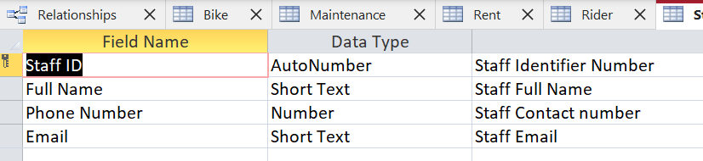
Figure 6 Staff design view
6. Maintenance
The Maintenance entity tracks servicing and repair activities performed on bikes.
Attributes:
- Maintenance ID (PK): Unique identifier for each maintenance record
- Bike ID (FK): References the bike being serviced
- Staff ID (FK): References the staff member who performed the work
- Maintenance Date: Date the maintenance was carried out
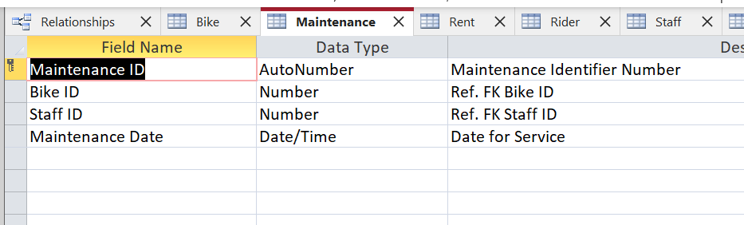
Figure 7 Maintenance design view

1.2 Entity Relationships
The Eco Ride database uses a relational structure in which entities are linked using primary and foreign keys. These relationships reflect real-world interactions within the electric bike rental scheme, ensuring data integrity while supporting efficient querying and reporting. All relationships in the system are designed as one-to-many (1:M) to avoid data redundancy and support normalisation to the Third Normal Form (3NF) [3].
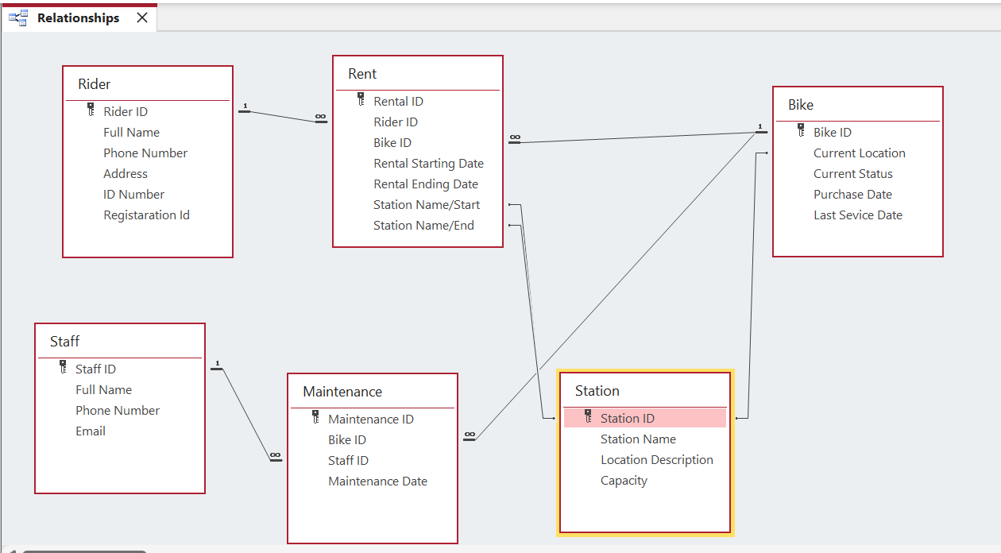
Figure 8 Entity Relationship
Rider – Rental Relationship
One Rider can make multiple Rental Transactions, but each Rental Transaction is associated with only one Rider. It is a one-to-many (1:M) relationship.
- Rider: Rider ID (Primary Key)
- Rental: Rider ID (Foreign Key)
Bike – Rental Relationship
One Bike can be rented many times, but each rental transaction involves only one bike. It is a one-to-many (1:M) relationship.
- Bike: Bike ID (Primary Key)
- Rental: Bike ID (Foreign Key)
Station – Rental (Starting Station) Relationship
One Station can serve many pick-up rentals, but each rental has only one pickup location. It is a one-to-many (1:M) relationship. Every rental must record where the bike was collected.
- Station: Station ID (Primary Key)
- Rental: Pickup Station (Foreign Key)
Station – Rental (Ending Station) Relationship
One Station can be the return point for many rentals, but each rental has only one return location. it is one-to-Many (1:M) relationship. Every rental must record where the bike was returned.
- Station: Station ID (Primary Key)
- Rental: Return Station (Foreign Key)
Bike – Maintenance Relationship
One Bike can have many maintenance records, but each maintenance record relates to only one bike. It is a one-to-many (1:M) relationship. All servicing and repair activities must be for a specific bike.
- Bike: Bike ID (Primary Key)
- Maintenance: Bike ID (Foreign Key)
Staff – Maintenance Record Relationship
One Staff member can perform multiple maintenance tasks, but each maintenance record is completed by a single staff member. Maintenance activities must be linked to a responsible staff member.
- Staff: Staff ID (Primary Key)
- Maintenance: Staff ID (Foreign Key)

Database Design Process
The process of database design involves converting the schema of an application into a domain-structured format that can be effectively supported by a database management System (DBMS). For the Eco ride bike rental, this process starts with analysing real-world requirements and modelling them using an Extended Entity-Relationship (EER) diagram. The EER model was systematically translated into a relational database structure and implemented using Microsoft Access [4].
The Eco ride includes riders, bikes, rental, stations, staff, and maintenance. These real-world objects were first identified as entities, each with descriptive attributes. The relationship between entities was also identified to reflect how these objects interact in practice.
The EER diagram created using draw.io provided a visual representation of:
- Entities and their attributes
- Primary keys and foreign keys
- One-to-many relationships
This conceptual model ensured that all functional requirements were captured before moving to physical database implementation.

2.1 EER Diagram into a Relational Database
Once the EER model was finalised, it was converted into a relational schema suitable for a DBMS. This translation followed standard database design rules:
- Each entity in the EER diagram was converted into a table
- Primary keys were assigned to uniquely identify records in each table
- Relationships were implemented using foreign keys
- One-to-many relationships were resolved by placing the foreign key
- Attributes were assigned appropriate data types supported by Microsoft Access
For example:
- The Rider entity became the Rider table with Rider ID as its primary key
- The Rental entity included foreign keys such as Rider ID and Bike ID to represent relationships
- The Maintenance table linked bikes and staff through their respective foreign keys
This approach ensured compatibility with the DBMS while preserving the structure and rules defined in the EER diagram.
Referential integrity was enforced on all relationships within the database to ensure consistency between related tables. The Cascade Update Related Fields option was unavailable because AutoNumber primary keys cannot be modified after they are created. As a result, cascading updates were not required. This configuration follows best practice in Microsoft Access and does not affect the integrity or functionality of the database.

2.2 Constraints
Constraints are rules that control what data is allowed in your database. They ensure that data is valid and the relationship remains consistent.
Rider constraints
Field | Constraints | Set
Rider ID | Primary Key | Auto Number
Full Name | Required | Yes
ID Number | Required | Yes (No Duplication)
As shown in the above table, the rider constraints prevent duplication.
Bike constraints
Field | Constraints | Set
Bike ID | Primary Key | Auto Number
Current Status | Validation Rule | In ("Available","Rented","Service")
As shown in the table above, it ensures the bike's status.
Rental constraints
Field | Constraints | Set
Rental ID | Primary Key | Auto Number
Rider ID | Foreign Key | Relationship Enforced
Bike ID | Foreign Key | Relationship Enforced
Starting Station | Foreign Key | Relationship Enforced
Ending Station | Foreign Key | Relationship Enforced
As shown in the table above, it prevents invalid rentals.

Station constraints
Field | Constraints | Set
Station ID | Primary Key | Auto Number
Station Name | Validation rule | In ("Train Station, Bus Station, Marine Station, Civic Station, Mumble Station")
Capacity | Validation Rule | >0 Must be greater than zero
As shown in the table above, it prevents invalid station capacity.
Staff constraints
Field | Constraints | Set
Staff ID | Primary Key | Auto Number
Full Name | Required | Yes
Email | Required | Yes
As shown in the table above, it prevents duplication.
Maintenance constraints
Field | Constraints | Set
Maintenance ID | Primary Key | Auto Number
Bike ID | Foreign Key | Relationship Enforced
Staff ID | Foreign Key | Relationship Enforced
As shown in the table above, these constraints collectively ensure the accuracy, consistency, and reliability of the data stored in the system.

Data Population
To demonstrate the database's practical functionality, the system was populated with at least 5 rows of sample data per key table. This sample data reflects realistic usage scenarios within the Eco Ride scheme, including:
- Registered riders with valid contact details
- Bikes assigned to specific locations with varying conditions and availability
- Rental transactions showing completed and ongoing rentals
- Maintenance records linked to staff members and bikes
Populating the database with realistic data allowed the relationships, validation rules, and queries to be tested effectively. It also demonstrated how the database supports real-world operations. The image below shows the sample data of each entity.
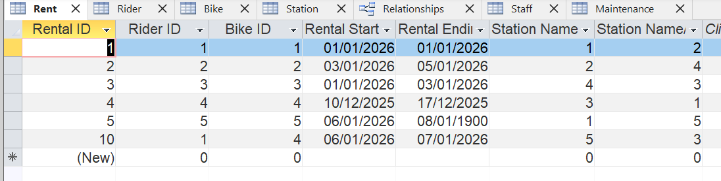
Figure 9: The sample of data population for rental.
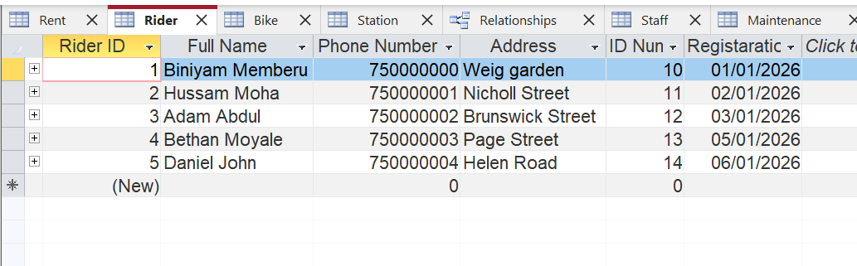
Figure 10: Sample of the data population for riders.
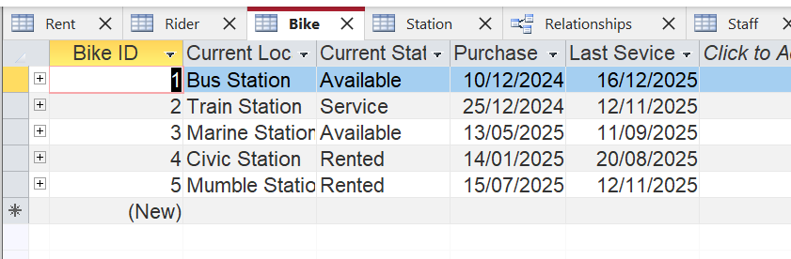
Figure 11: The sample of the data population for the bike.
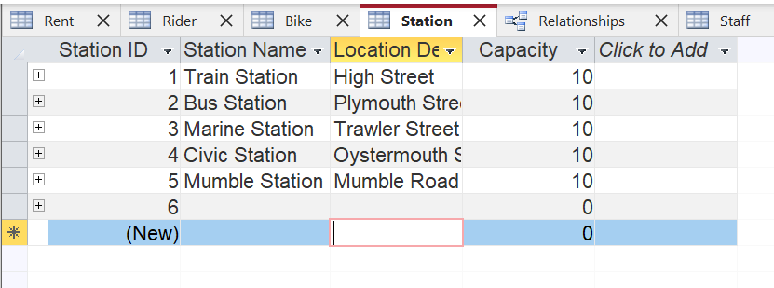
Figure 12: The sample of data population for the station.
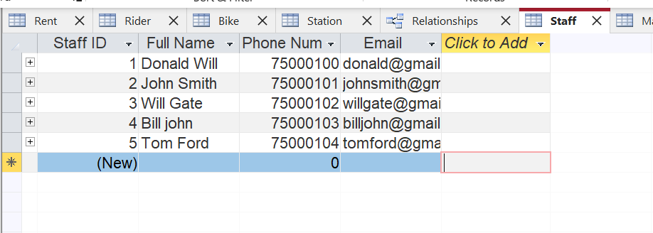
Figure 13: Sample of the data population for staff.
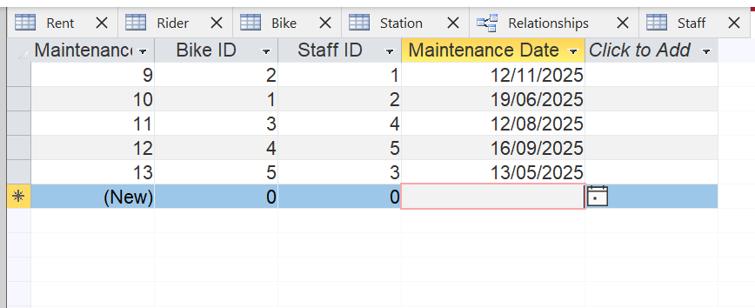
Figure 14: The sample of data population for maintenance.
By converting the application domain into an EER model and then translating it into a relational database structure, the Eco Ride system achieves a clear and organised data structure, compatibility with the chosen DBMS (Microsoft Access), reduced data redundancy, improved data integrity and support for efficient querying, reporting, and future scalability.

Normalisation
The database was normalised to Third Normal Form (3NF) to reduce redundancy and dependency issues. Each table contains attributes that depend on its primary key, and there are no transitive dependencies. Referential integrity constraints were enforced in Microsoft Access to prevent invalid records and ensure data consistency across the database [5].
The Eco Ride database has been designed and evaluated to ensure compliance with Third Normal Form (3NF). Normalisation is applied to minimise data redundancy, prevent update anomalies, and ensure data integrity across the system.

First Normal Form (1NF)
A table is in 1NF, all attributes contain atomic (indivisible) values. There are no repeating groups or multi-valued attributes, and each record can be uniquely identified by a primary key. For instance, Rider phone numbers are stored as a single value per record
Second Normal Form (2NF)
A table is in 2NF; it is already in 1NF, all non-key attributes are fully functionally dependent on the entire primary key, and no partial dependencies exist. All tables use single-field primary keys (AutoNumber), and every non-key attribute depends entirely on its table’s primary key. For instance, in Rental, fields such as Rental Start Date and Rental End Date depend only on Rental ID
Third Normal Form (3NF)
A table is in 3NF; it is already in 2NF, there are no transitive dependencies, and non-key attributes do not depend on other non-key attributes. The Eco Ride database avoids storing or indirectly dependent data by logically separating entities. For instance,
Rider and Rental Data.
Rider contact details are stored only in the Rider table, and Rental stores only Rider ID, not Rider name or phone, so it prevents duplication and eliminates update anomalies.
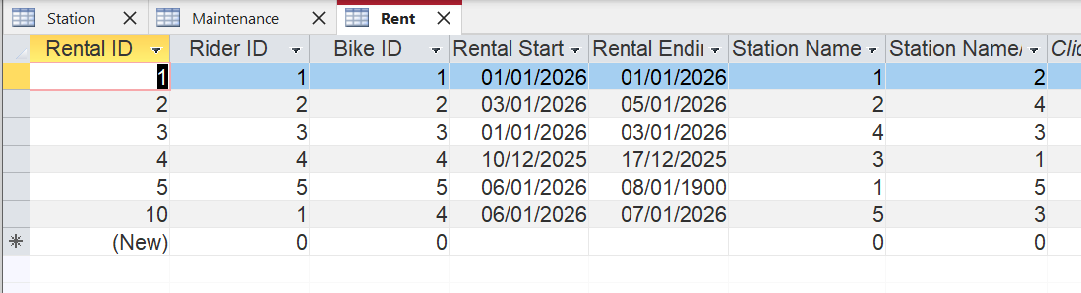
Station Information.
Station name and address are stored only in the Station table, and the Rental reference station via foreign keys. Station Details are not duplicated, and updates occur in a single location.
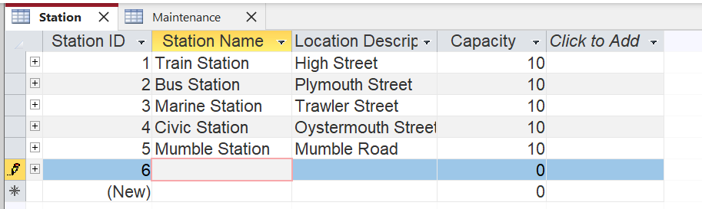

Maintenance and Staff Data.
Staff details are stored only in the Staff table. Maintenance records reference the staff ID rather than repeating staff information, so it ensures accountability and prevents inconsistent staff records
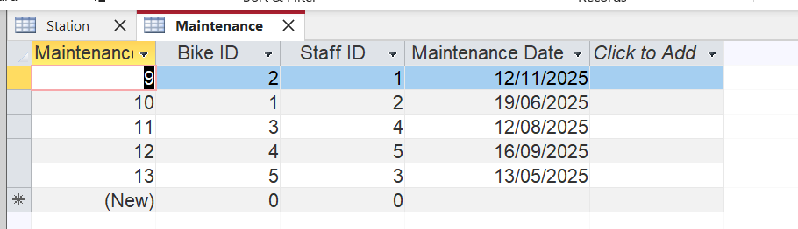
The Eco Ride data model is fully normalised to Third Normal Form (3NF). By ensuring atomic attributes, full functional dependency, and the elimination of transitive dependencies, the database design minimises redundancy and maintains strong data integrity. This normalisation approach supports efficient operations, accurate reporting, scalable database design and reliable data management for the Eco Ride electric bike rental scheme [5].

Practical Queries and Report
Query from one entity.
Bikes Currently Out on Rental. Shows bikes that are currently rented (not yet returned).
This helps staff track availability and prevent double-booking.
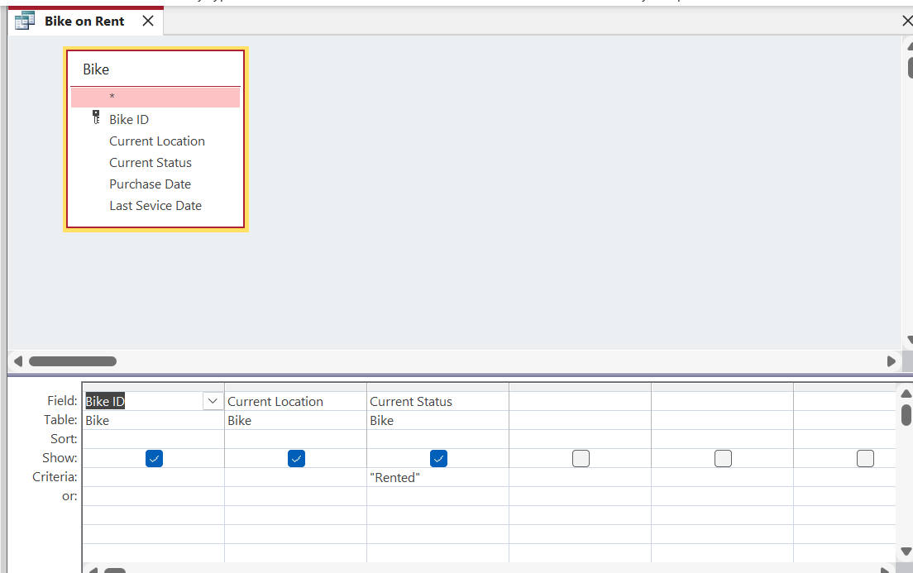
Figure 15: The design view of the query for a bike for rent.

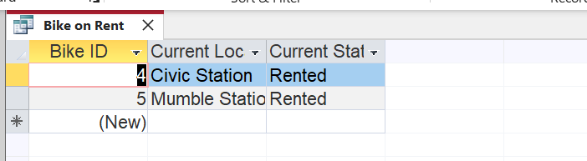
Figure 16: The database query result for the bike rental.
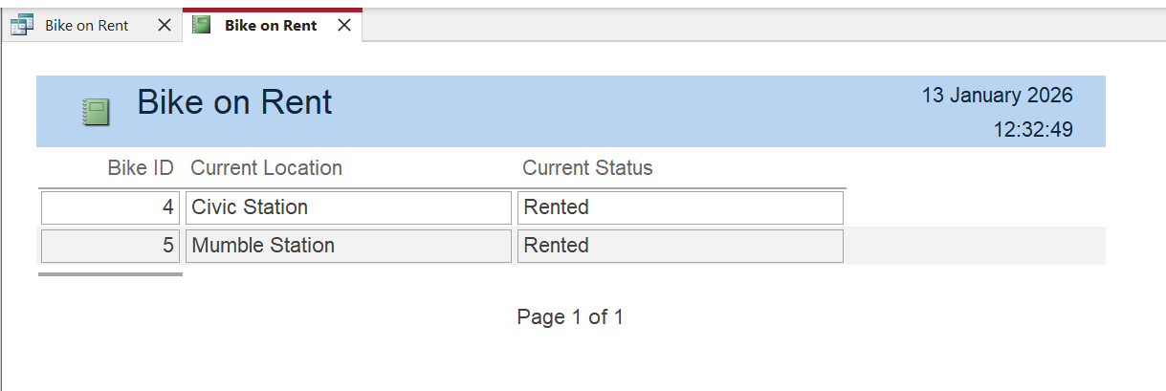
Figure 17: The query report on the bike rental view.
Bikes are currently available. Shows bikes that are currently available. This helps staff track availability for booking.
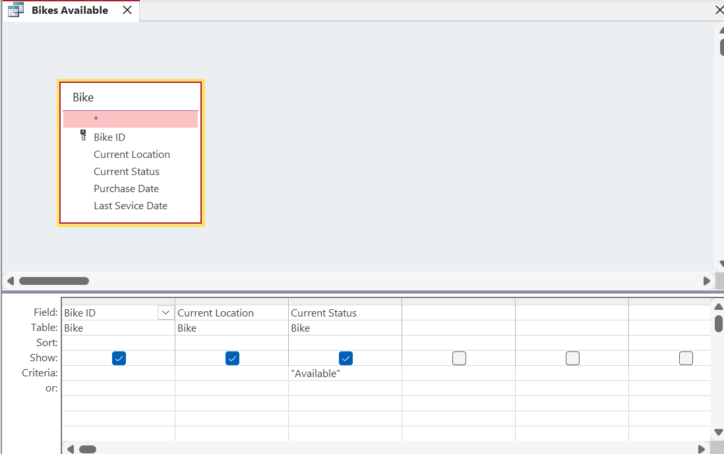
Figure 18: The design view of the query for a bike available.
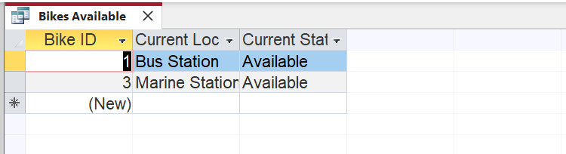
Figure 19: The database query result for the bike rental.

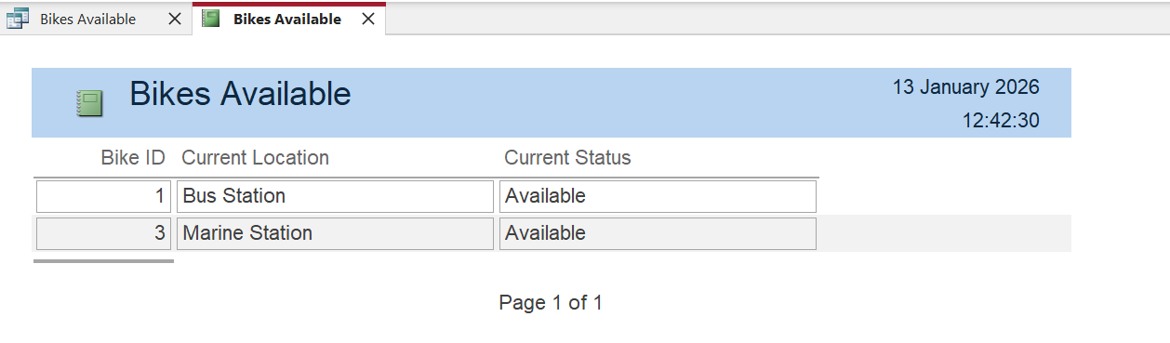
Figure 20: The query reports on the bike availability.

Query from one or more entities.
Rental history of random rider (Biniyam Memberu). Rentals transaction made by a Selected Rider (Parameter Query), which allows the user to enter a rider ID and view that rider’s rental history, including the rental starting and ending date. In addition, it shows which bike he used and allows staff to see the history of the most frequently used bikes for that rider.
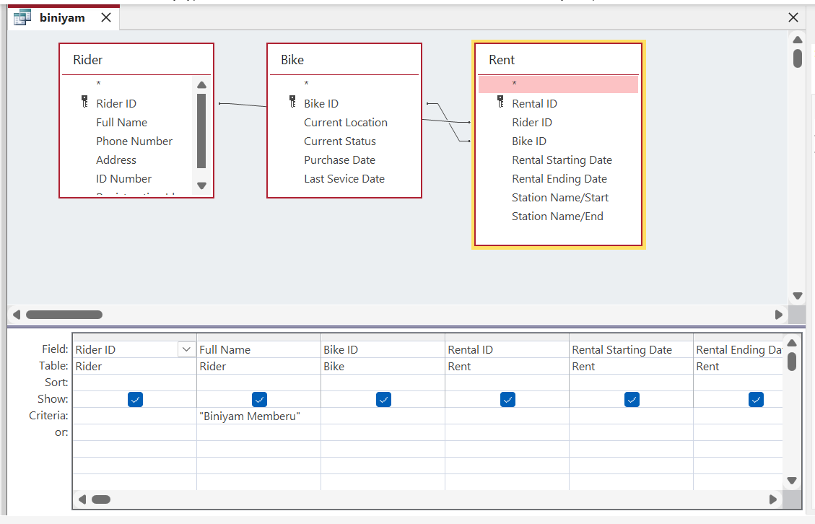
Figure 21: The design view of the query for a random rider.
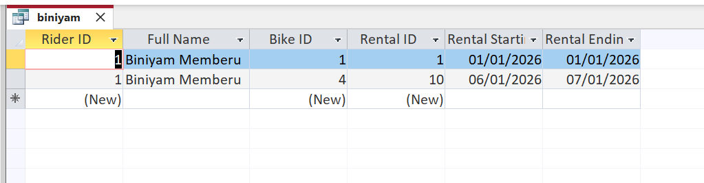
Figure 22: The database query result for the random rider.

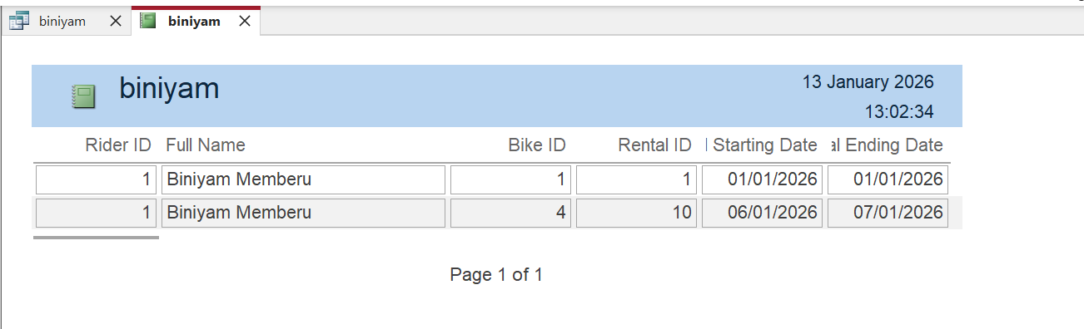
Figure 23: The query reports on the random rider.

Validation
This section evaluates the Eco Ride database system against the stated functional requirements to confirm that it meets user needs. A series of validation checks and practical tests were conducted using Microsoft Access to ensure data accuracy, integrity, and correct system behaviour [6].

6.1 Validation Testing
This validation tests the bike status in the table design view, as well as the field validation rules and the text implemented.
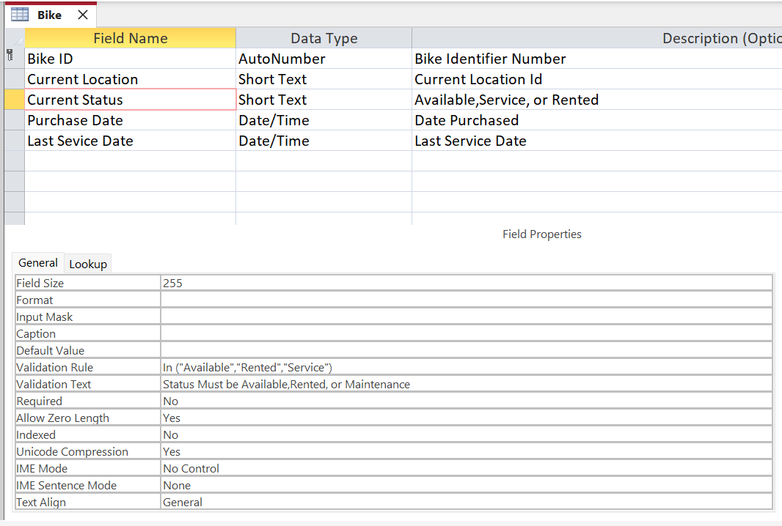
Figure 27: Validation rule for the bike's status.
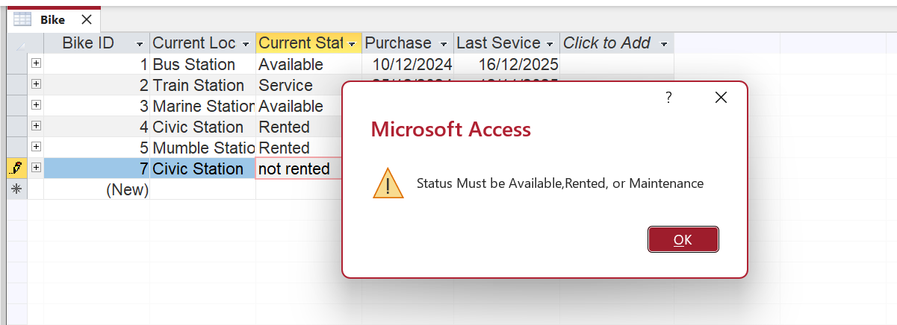
Figure 28: Testing and validation rule results.
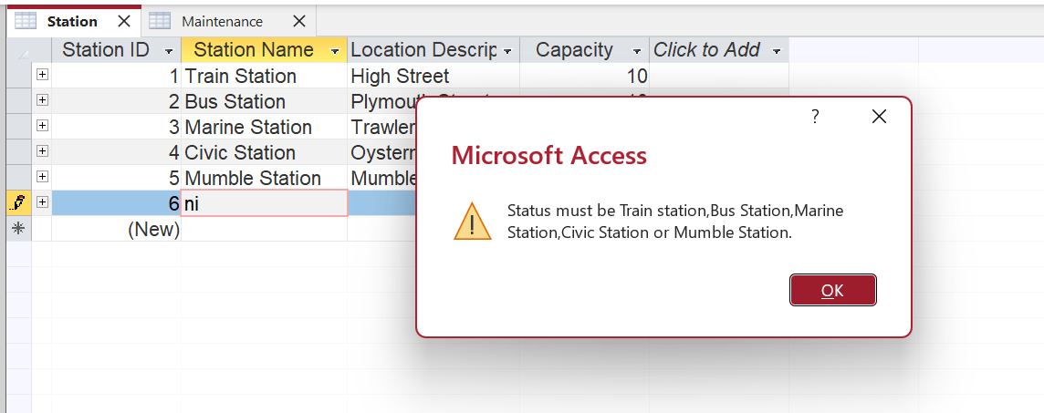
Figure 29: Testing and validation rule result.

Relationships View (referential integrity)
This shows the entities are in referential integrity, can't change or add a record because it is a related record.
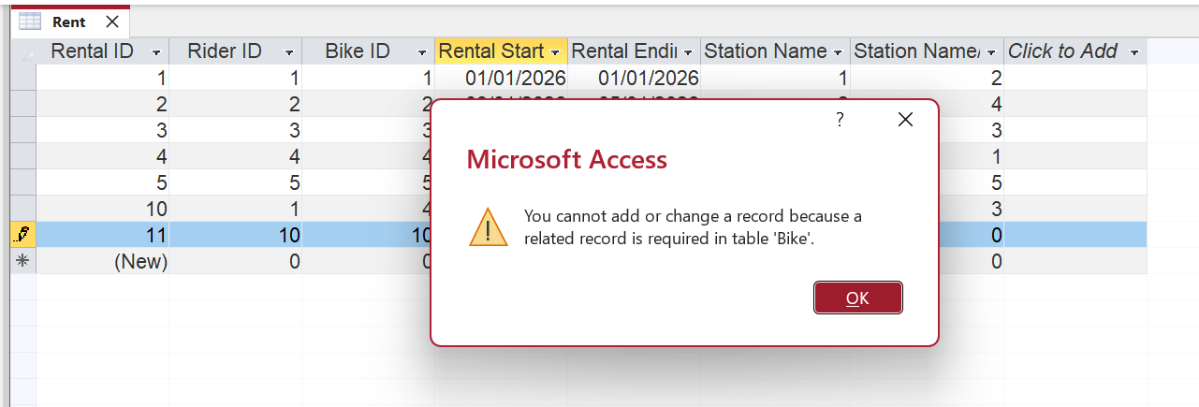
Figure 30: Testing and validation results of integrity.

Data entry tests (valid and invalid inputs)
In the Station, the capacity must be greater than zero. If you add invalid inputs, the validation won't accept
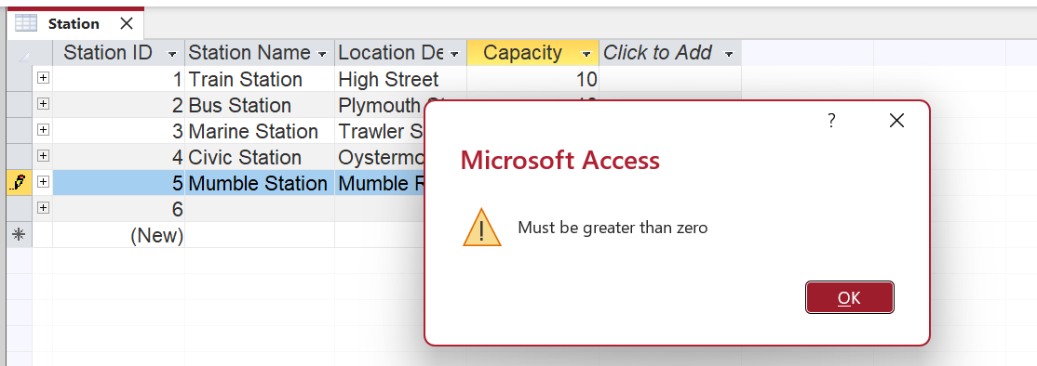
Figure 31: Testing and validation results for invalid input.

Reflection
The design of the Eco Ride database system was guided by the need to replace the existing processes with a structured, reliable, and scalable database solution. Key design decisions included identifying core entities such as riders, bikes, stations, rentals, staff, and maintenance, as these represent the main operational components of the rental scheme. Relational structure emerged due to its ability to maintain accurate information while facilitating fast data retrieval. Microsoft Access acted as the database management tool, suitable for compact to midsize deployments and offering straightforward interaction.
This conceptual model normalises the relation schema, ensuring compliance with Third Normal Form to minimise redundancy and dependency issues. Appropriate constraints, such as primary keys, foreign keys, validation rules, and required fields, were implemented to enforce data integrity. Sample data was added to simulate realistic use cases, and a range of practical and parametric queries and reports were created to demonstrate the system and support operations.
Several Challenges were encountered during development, particularly when implementing the relationship constraint. Starting with Microsoft Access, getting relationship constraints right wasn’t smooth. When trying to update linked fields, the Cascade Update key setting just didn’t appear. It traced back to how AutoNumber fields were used to generate primary keys. That setup blocks certain actions by design. At first, the lack made sense only after digging deeper. It turns out such logic follows common patterns and stronger designs, too. Expected results often get lost in vague error messages. On top of that, getting validation rules right proved tricky [6]. Testing database queries took extra care, so results came out clean, yet avoided clashing with existing data
In future iterations, new tools might help, such as smart triggers that block two rentals at once or code that automatically calculates fees. Alerts could pop when riders take bikes past due dates or approach service times. A simpler dashboard for workers and cyclists might make daily use clearer. Reports could carry more weight, showing patterns others can learn from. Further improvement could include a user-friendly front-end interface for staff and riders, as well as an enhanced reporting and data system.

References

[1] | M. E. &. E. P. l-Yeol Song, “A Comparative Analysis of Entity-Relationship Diagrams1,” A Comparative Analysis of Entity-Relationship Diagrams1, vol. 3 No 4, no. journal of Computer and Software Engineering,, pp. 427-459, 1995.
[2] | UWTSD, “UWTSD,” UWTSD, [Online]. Available: https://moodle.uwtsd.ac.uk/pluginfile.php/1132603/mod_resource/content/0/ERD%20.pdf. [Accessed 20 12 2025].
[3] | H. G. a. C. S. Jensen, “Temporal Entity-Relationship,” Temporal Entity-Relationship Models Survey, vol. Vol 31, pp. 939-1006.
[4] | V. C. Storey, “Relational database design based on entity relation model,” Relational database design based on entity relation model, vol. vol 7 , no. Data & Knowledge Engneermg Untverstty of Rochester, pp. 47-83, 1991.
[5] | UWTSD, “UWTSD Module,” UWTSD, [Online]. Available: https://moodle.uwtsd.ac.uk/pluginfile.php/1132888/mod_resource/content. [Accessed 21 11 2025].
[6] | N. F. T. G. S. G. Marco Di Zio, “Methodology for data validation,” Methodology for data validation, 14 12 2025. [Online]. Available: https://markvanderloo.eu/files/share/zio2015methodology.pdf. [Accessed 10 01 2026].

