Hilton Hotel

[Management and Organizational Behaviour: ASSESSMENT 2]
BMIH5004
Student name: Kamran Ahmed
Student ID: 2118921
Lecturer: Dale Clarke

Contents
Introduction 3
Analysis 3
Overview of organization structure of Hilton Hotel group 3
Reflecting on Hilton Hotel organizational culture and goals 4
Change initiatives by Hilton and their impact and how they are managed 7
Organization’s strategic direction and current business performance 9
Conclusion 10
References 11

Introduction
Performance monitoring systems are developed with the aid of organizational behaviour in an effort to bring about a congruence between individual and group aims. Metrics for success, feedback loops, and evaluation procedures are common components of such frameworks. Business leadership is greatly aided by the study of organizational behaviour. It is that area of research which finds out the influence that individuals, teams, and infrastructure have on behaviour inside an organization, and it utilizes that information to help organisations operate more successfully. In this research, we take a high-level look at Hilton Hotel's management structure and provide our assessment (Lamo, 2019). The hotel's history, vision, strategy, change efforts, impact, and management, as well as the hotel's current financial performance, are all discussed in detail in this report.

Analysis

Overview of organization structure of Hilton Hotel group
There are few hotel chains as well-known across the world than Hilton hotels & resorts. Hilton Hotels, which was created by Conrad Hilton in the year 1919, is said to operate over 6,800 locations with a combined 216,379 rooms in 94 different nations and regions as of 2019.thereby it one among the biggest lodging companies in the world. On the basis of responses from a poll given to all employees, the publication Fortune placed Hilton hotels at the top of its list of the most desirable companies to Work for in the year of 2020. Many Hilton hotels are independently owned, managed, or franchised under various Hilton brands. The Hilton hotel chain's internal structure may be regarded as having many divisions. The term divisional structure refers to a method by which a firm divides its workforce not by departments but by product lines or target markets.
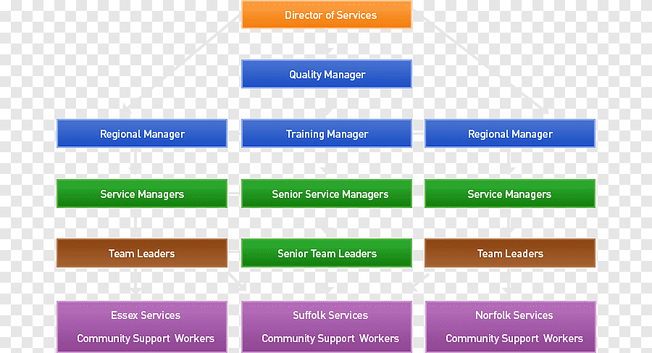
There are some businesses that have separate departments for things like advertising and public relations, while others are structured into divisions with teams that focus on things like regional or product-specific marketing and sales. This is due to the fact that the executive team at Hilton is tasked with overseeing many departments and regions, and that the company itself organizes its properties and, by extension, its activities into three distinct categories: Responsibility: Buildings that belong to directly by Hilton. Hilton manages several hotels, while others have the franchise to run their businesses. The Hilton brand of timeshare homes (Reidhead, 2020).
Hilton hotels oversees the ownership, administration, and authorization facets of the business, while timeshare is handled by Hilton grand vacations, that was spun off from Hilton which is a company that was publicly traded. The Hilton Hotel claims to have adopted such a culture in order to ensure that its workers adhere to a high standard of conduct at all times. The collaboration level also, as well as the authority allocation level both, is weak in this sort of culture. In a person-to-person culture, employees are trusted with more responsibility. Members have complete discretion on how to get things done. Members of the company are influenced by this atmosphere because they do not adhere to the rules set out by a superior. In generally, this way of thinking influences how staff members act at Hilton Hotels.

Reflecting on Hilton Hotel organizational culture and goals
Culture of a company is the norms, practices, and beliefs that employees all have in common. Its primary function is to ensure that all members consistently exhibit the desired behaviours, dress appropriately, and carry out their assigned duties. An organization's culture is its unifying ethos, and it serves as a set of norms by which employees should live while on the job. Hilton Hotel claims that Handy Charles is responsible for the establishment's enduring corporate culture. There are four subsets of company culture, the way of life of roles, the society of power, the society of individuals, and overall culture of tasks. Workplace cultures like this help businesses transform into customer-focused entities. In our society, those three qualities stability, predictability, and safety are paramount.
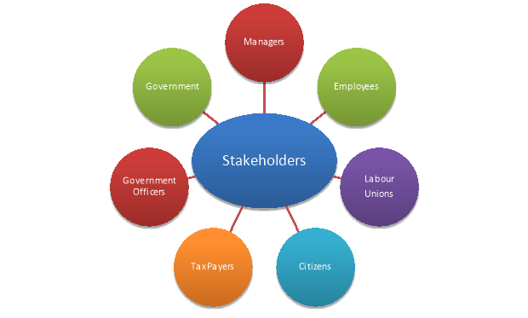
Employees' actions and the quality of the service provided to customers are heavily influenced by the company's culture. Hilton's mission is to generate value for its stakeholders - guests, investors and owners, workers, suppliers, and the populations wherever each hotel is situated - by offering an enduring value strategy. Their innovative technology, worldwide reach, and strategic alliances help them fuel growth, increase profits, and create lasting bonds with their clientele. Market share gains across the board for Hilton's many product lines are the end outcome.
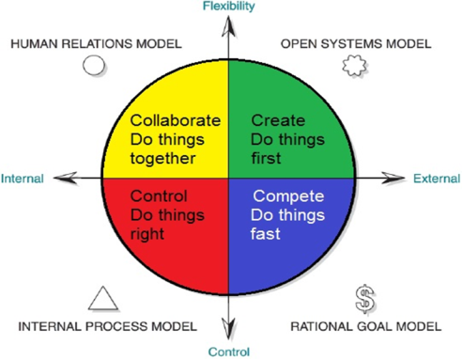
Fig.: Corporate culture at Hilton hotel
Hilton Hotels claims that by adhering to this culture, employees are better able to carry out their duties in a way that allows the company to quickly and easily achieve its goals. since a result, workers may be less inclined to work together inside the company, since they won't be adhering to any standards or norms. Hilton claims that the organization is heavily influenced by its culture, power structure, and politics. These elements serve to both strengthen and challenge the company. The Hilton's well-managed culture ensures that every job gets done well. These businesses often have a flat organizational structure in which workers are encouraged to take initiative, and as a result, they develop and execute innovative ideas that help them gain an edge in the market. Equally important is the fact that whomever holds the reins of authority must use them wisely. Disagreements between a superior and subordinate may have a significant effect on the company as a whole. When a boss is abusive with his authority, his employees tend to lose motivation and provide subpar results. Organizational output suffers as a result. In Hilton, managers use the power constructively and preserve cooperation among the workers and this contributes to the accomplishment of targeted goals with transparent discussion and knowledge of needs (Ma, 2021). Due to the high frequency with which workplace politics occur, employee output is also negatively impacted. Not all managers will put their friends and family members on the line. This has a chilling effect on how people interact with one another at the Hilton and on the hotel's ability to accomplish its goals.

Change initiatives by Hilton and their impact and how they are managed
In field of management, change management is an important process and acknowledges way an organization initiate and adapt to change persisting to their internal or external conditioning (Spiridonova, 2021). For Hilton Hotel Group, it can be seen that the change initiatives have been entitled to be reducing of wastes and driving forth circular economy through waste prevention and use of recycled products so that it can ensure to greener hospitality service context. With the help of ADKAR Change model, the change initiative program by Hilton Hotel Group can be assessed and allowing for their major impact over company’s processes and functions.
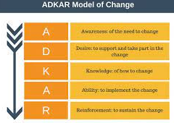
Fig: ADKAR model of change management
ADKAR Change model
The model depicts for bringing over change through the following stages as contemplated to Hilton Hotel Group conditioning towards acquiring sustainable development in their hospitality industry perspective.
Awareness – This stage demonstrates for creating awareness through proper communication plan to the various stakeholders of the business starting from top to the low level employees of the organization. For Hilton Hotel, it can be seen that indicating their sustainability change efforts, the hotel chain is announcing though different digital campaign against waste reduction, energy efficiency, renewable energy sources usage has been prime criteria of their hospitality services (Harrison et al., 2021).
Desire – The step considers for fostering the desire for engaging maximum employees and empowering them against change initiatives allowing other stakeholders to meet their change objectives also. In this aspect, the top-level managers, executive leaders of Hilton hotel are showing their public support for sustainable process to be thoroughly integrated to their hospitality processes. In fact, how their renewable energy sources and waste reduction process has been an integral part of their operation process is circulated by leaders of Hilton hotel through clear roadmap of operations.
Knowledge – Through the step knowledge, it is seen to be referring to equipping employees and stakeholders with various skills and competencies through adequate training and development program. In case of Hilton hotel for bringing on sustainability as major change, the hospitality chain is manifesting for effective employee training programs for executing sustainable practices through workshops so that it can bridge the gap between the employee skills needs and sustainability goal of the firm (Spiridonova, 2021).
Ability – The step ensures for employees being able to overcome the obstacles and make the change inevitable for the organization by showing their confidence through their own competencies (Nicholls, 2022). The Hilton Hotel leaders and managers are aiming forth setting clear guidelines and making sustainable operational procedures mandatory for the employees to make a better decision-making framework. For this reason, it has been found that contemplating to tracking and monitoring of sustainable programs offered by employees in various hospitality operational services has been endured.
Reinforcement – The step reinforcement ensures for solidifying the process of change by integrating them to the organizational culture. For Hilton Hotel group, it can be seen that managing change of sustainability by making it a prime goal of annual strategic plan and ensuring their progress in different sustainability initiatives is fostered by suitable partners and collaborators are being addressed; have been creating a major impact over their hospitality band image in competitive dimension.

Organization’s strategic direction and current business performance
Hilton Hotel Group being one of the most recognized hotel chains in global context has been enduring to the way of finding their strategic direction to be focussed a more digitalized process of their operational service that can bring their way to higher profit or revenue generation. In fact, it has been found that on a global level, Hilton Hotel Group has been tried to be capitalizing on enacting a digitalized channel of business operation that can enforce their shift from vertically-integrated hospitality management to a horizontally-integrated strategic campaigning in next few years (Niemelä, 2019). The main ideology behind this strategic force is to make the Hilton Hotel group as a premium brand in hotel and hospitality service with best of customer service being entailed in front of targeted zone. With the help of Ansoff matrix, Hilton hotel strategic direction toward intensive growth can be assessed.
Ansoff Matrix for growth
It can be seen that Ansoff Matrix is a competitive strategic tol that gives forth four distinctive steps or quadrants for growth in a competitive market landscape. For Hilton Hotel, it can be seen that the matrix can ascertain for developing their diverse needs of business strategic performance standards. It can be seen that considering Hilton Hotel strategic goals and objectives, the company is directed towards market penetration, market development and product development as three main strategic growth criteria.
Market Penetration – The market penetration strategy identifies for current product or service being extended to a sustaining market with innovative approach to their strategic direction for increasing higher market share. Hilton Hotel operating in different parts of global context has been regularly focussing over innovating their hospitality service through digitalization and implementation of online or AI or VR based operational methods so that they can grow continually and make on a higher rank among the competitors (Mishurova et al., 2020).
Market Development – The market development strategy suggests for developing new market opportunity both geographic and new customer segments so that it can find on an extensive business formats. Hilton Hotel Group is encapsulating over finding on market growth potential in various new or emerging markets or approaching to new customer segments through affordable hotel accommodation stayacation (Matteucci, 2020). In fact, their main agenda is to find for a completely different market landscape with immense of opportunities being created for visitors across globe.
Product development – The product development strategy indicates for developing new products in sustaining market to gain on eminent brand imagery among the consumers either through making produces and service more innovative (Nicholls, 2022). Hilton Hotel has been found to be eying their way to campaign for smart and AI enabled hospitality operations for guests’ convenience which has reduced their operational cost and at same time has enhanced the way to luxurious hospitality service in a more redefined way to end customers.

Conclusion
Understanding and applying principles of business behaviour is certainly of utmost importance for organizations, but it also holds significant relevance for individuals in their roles as employees or managers. Research indicates that the proficient management of individuals is a significant predictor of organizational success. The effective functioning and success of a business rely on the ability of its management team to make informed decisions and effectively address issues. This report provides an evaluation of the internal organization of Hilton Hotel (Kim, and Jung, 2022).

References
Harrison, R., Fischer, S., Walpola, R.L., Chauhan, A., Babalola, T., Mears, S. and Le-Dao, H., 2021. Where do models for change management, improvement and implementation meet? A systematic review of the applications of change management models in healthcare. Journal of healthcare leadership, pp.85-108.
Kim, J. and Jung, H.S., 2022. The effect of employee competency and organizational culture on employees’ perceived stress for better workplace. International Journal of Environmental Research and Public Health, 19(8), p.4428.
Lamo, E.G., 2019. The Center of Success: A Case Study on Hilton's Company Culture.
Ma, R., 2021. Human resource management in multinational companies——from the perspective of Hilton Hotels. In E3S Web of Conferences (Vol. 235, p. 02058). EDP Sciences.
Matteucci, V., 2020. How can the hospitality industry increase corporate value aligned with sustainable development goals? Case examples from Hilton, Meliá and Sun. Worldwide Hospitality and Tourism Themes, 12(5), pp.509-523.
Mishurova, I.V., Komarova, S.N., Volovik, M.E., Nikolaev, D.V. and Temirkanova, A.V., 2020, June. Strategic partnership as a form of management structure improvement in the hospitality industry. In Inclusive Development of Society: Proceedings of the 6th International Conference on Management and Technology in Knowledge, Service, Tourism & Hospitality (SERVE 2018) (p. 313). CRC Press.
Nicholls, T., 2022. Managing Change in Organizations: Develop Your Employees for Business Transformation. Kogan Page Publishers.
Niemelä, M., 2019. Brand management strategies of hotel chain sub-brands Sheraton Marriott and DoubleTree by Hilton.
Reidhead, C., 2020. Impact of organizational culture on employee satisfaction: A case of Hilton hotel, United Kingdom. Journal of Economics and Business, 3(1).
Spiridonova, V., 2021. Project management versus Change management: Exploring the most effective change technique to implement a sustainable strategic change in the hotel industry.

