Academic Skills and Employability
B4X 01917
Student: Ionela Vlad
Student ID: 1905718
Lecturer: Dale Clarke

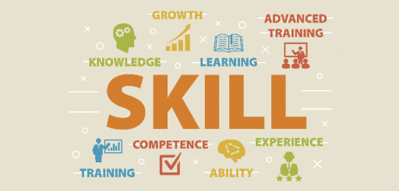

Table of contents
Introduction………………………………………………... Page 3
SWOT……………………………………………………Page 4-5
Personal Development Plan……………………………… Page 6
Current academic and employability skills………………. Page 7
Conclusion…………………………………………………...Page 8
References…………………………………………………Page 9

Introduction
In this assignment I have been asked to list and describe my current academic employability skills, using the two tools SWOT and PDP which will, of course, provide me within the needed support to structure exactly the strength, weaknesses, opportunities, threats and also it will push me to create the personal development plan which contours the path ways and the decisions I am going to take in the following years. Also, the PDP requests me to mention the things I am going to use to drive me at the final point which is based on the dreams job.
To begin this report, I want to mention the fact that my goal is to have a good position in the hotel management. I can say that I am quite familiar with the hotel systems and how they are working overall and this because I have worked in the hotel industry in the house keeping area. While working at the hotel I did learn and developed many skills that will be a plus for me in the future.
I spoke about my previous experience in the hotel industry, but this does not mean that the skills of mine are only based on the work I had to do there, therefore the SWOT and PDP processes will support mention exactly what I am going to do in my life and what are the points and the opportunities that are allowing me to go forward in my career.
Anyway, to be able to apply for a job specifically in the hotel industry you must make sure that you touch the basic standards and that you are touching the very minimum amount of experience and skills. Referring to Skills you need, 2011-2018) Your educational experience may make you suitable to apply for the job you are aspiring for, but to be successful in most roles, you need skills that you are likely to develop over time. If you are not able to prove that you are good enough for the job, they will make you understand that you still need to work on some aspects, and they will accord you time to adjust the skills. Therefore, it is very important that you take as many opportunities as possible to help accumulate as many skills as possible to increase the employment chances.

SWOT
SWOT analysis is a technique that helps you to discover your Strenghts, Weaknesses, Opportunities, Threats. It can be used to test the evolution of the company you are working in/ for or simply for your personal evolution over the years. It helps to value the talents, abilities, experience you have through a test that requests you to write down the specific points. The point of the SWOT is to assess and adjust an individual's qualities and shortcomings to the chances and dangers to create key options. (Phal and richter,2007)
Strengths Are the skills and abilities that a person can be valued for in the career you want to start, and those skills are helping you to find out what are the most important ones that are supporting you to contour your career. My strengths: Communication skills within customers/guests Ability of sharing my empathy with people asking for services Calamity skills The ability of treating people around me with patience well-developed. I have skills in understanding the guests and their expectations I can show up my experience in the hotel industry as I have previously worked in a hotel. Respecting people around me and request being respected back. Well time management Flexibility/ Adaptability skills I can easily engender trust and relationships with professional boundaries with people around me.
Weaknesses Are the minuses you have that are pushing you to have lower chances in doing what you want if you do not keep the amount of strengths higher that the amount and the importance of weaknesses. The weaknesses are usually making the things even difficult that they are already and this because they stop you from touching your goals. My weaknesses: I have low confidence, thing that usually makes me think that I am not good enough to achieve what I want in life My English language knowledge is limited, because it is my second language and I am not able to read and write properly and right grammatically. I am ashamed to make mistakes because I fear people judging what I decided to do, and I know I would be embarrassed and disappointed of myself if I am not doing the things right and people will laugh at me. I am sometimes shy to bring my ideas up and this because I am overthinking a lot about what people would think.
Opportunities The most important opportunity that I took up is the opportunity of coming in this country and try to figure out what exactly I want to do for the rest of my life and this because I did not want to come in a country full of opportunities to limit myself at a warehouse operative job. Currently the opportunity I took is the opportunity of coming at the university to discover the knowledge I need to have to build myself as a person and as a professional in the hotel industry. This will drive me to a better confidence, because I will know exactly what I am capable to do. Other opportunities that I am trying to take everyday are linked with the communication with the people around me which are helping me to develop my knowledge in the English language and, they are helping me to improve the vocabulary.
Threats The principal threat is based on the idea of me having a full-time job in parallel with the university and my child, thing that takes away lot of time. This means that I have a very limited amount of time to get to research or even try to practice methods and theories about jobs in hotel industry or what the requests are. The second threat is the fact that I do not understand my teachers in the way I should understand them. This because of the different accent they have comparing to the accent I got used to.

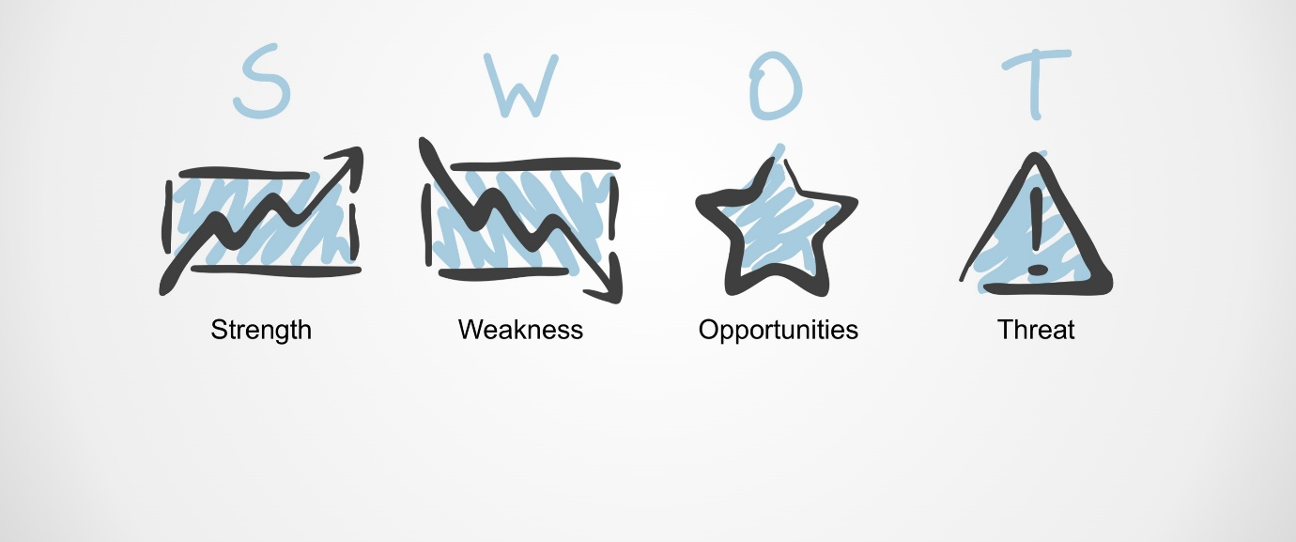

Personal Development Plan
In its definition, a PDP is an explanation of self-reflection and improvement, which gives a lot more details about the plan that is going to be used to achieve academic, personal or career-based goals. As Crawford said, your success (or failure) will link with how well you succeed in performing job responsibilities and achieving the specific objectives of your operation. (Crawford, 2005) When you are thinking about designing a PDP you might consider the easiest checklist which is driving you to designing a very good and detailed plan. The checklist consists on the following: Set your final point or direction; Analyse development needs; Identify learning opportunities; Create an action plan; Undertake the development; Record the outcomes; Evaluate and review the results.
My personal mission is to be able to have a high position in the hospitality industry, for example I would fancy to work at the front desk and next stop would be at the management department. I know and I am concerned about the decreased number of chances now regarding to my English language speaking skills and regarding to the amount of knowledge and experience in the hotel industry as well. I am taking as many opportunities as possible to drive myself slowly onto the best way to the most wanted job. This means that I am trying day by day to find out more about the hotel industry jobs and what the exact responsibilities are. In my mind my plan follows the following cycle: Studying and accumulating skills and knowledge I need for the job work experience in the hotel industry improvements in the English language qualification A basic job to begin my career with Increase the number of responsibilities and prove as much of my aptitudes so I can go up to better positions every time when I get the chance. I cannot speak yet about too many improvements and this because it is my first year of the course which just began. Anyway, I am starting to understand way better things about customer service, business skills and so on.



Current academic and employability skills:
Skills and abilities are very important no matter what you are planning to do. Knowing that I am planning to go into the hotel industry, I will focus on this side. For hotel industry people are looking after achieving their roles in the job and hopefully to develop their careers and the job competencies. Employability is currently identified during curricular design in order to create a relationship between, education and business tasks. Regarding to Guthrie (2009) the competences are separated in two types of competencies, the personal and job competencies.
The most skills that are requested are: Team working skills Customer Service skills Problem Solving skills Communication skills Multi-tasking skills Stress management skills and so on…
The skills I currently have: Time management Rapidity Multi-tasking Communication Team/ individual working
Skills I want to improve: Customer Service Stress Management Interpersonal skills Attention to small details Efficiency

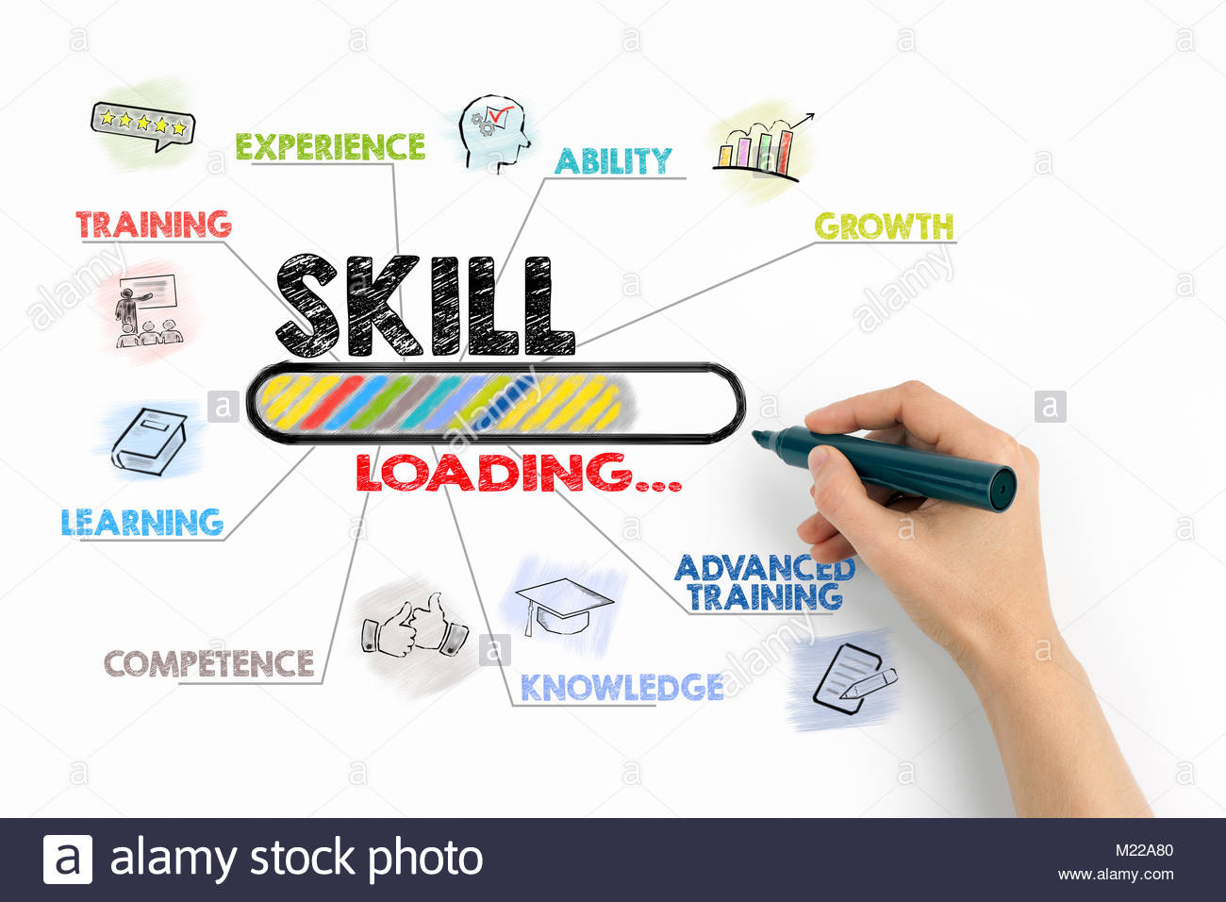

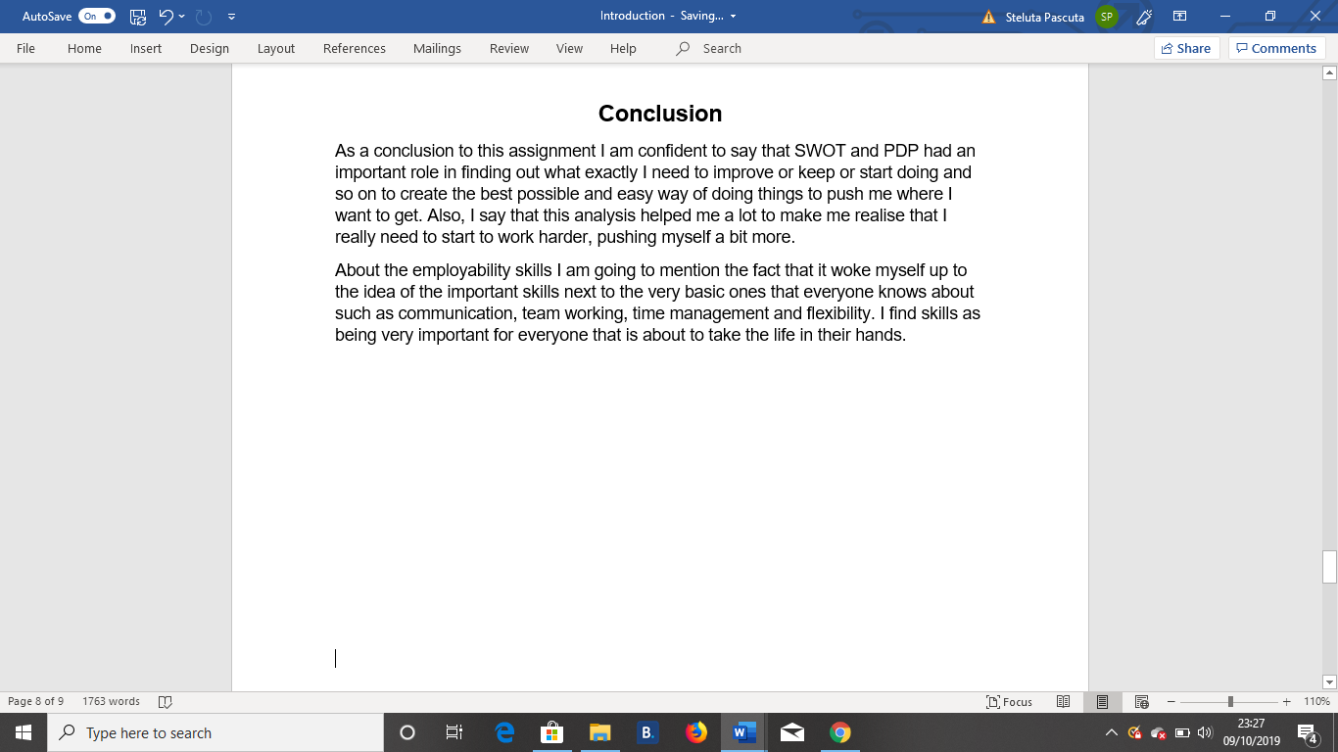



References
Crawford, C. (2005). Corporate rise. 1st ed. Santa Clara, CA: XCEO, Inc., p.38
Guthrie, H. (2009). Competence and competency-based training: What the literature says. Adelaide, Australia: National Centre for Vocational Education Research
https://www.thebalancecareers.com/hotel-front-desk-guest-services-skills-list-2062408
https://www.managers.org.uk/knowledge-bank/personal-development-planning
chrome-extension://oemmndcbldboiebfnladdacbdfmadadm/https://www.researchgate.net/profile/Yao_Fen_Wang/publication/280169039_Employability_of_Hospitality_Graduates_Student_and_Industry_Perspectives/links/56c121b808aee5caccf67f66/Employability-of-Hospitality-Graduates-Student-and-Industry-Perspectives.pdf?origin=publication_detail
Phal, N. and Richter, A. (2007). SWOT analysis. 1st ed. [München]: GRIN Verlag, p.9


