Gower College Swansea
ACCA5012 Application Development
HND Computing and information Systems
WIL13807181
2/12/2020

Contents
Requirements 2
Software requirements specification 3
Software design 3
Implementation 3
Software verification and validation 3
Pseudo Code 4
Evaluation 5
Testing 5
Conclusion 7
Referencing 8
Appendix A 9
Appendix B 10
Appendix C 12
Appendix D 14

Introduction
The purpose of this report is to summarize the design and development of the app created, the app will cover the concepts of application development, it will also lay out the requirements of the app and how they are met, finally the report will discuss the implementation and the design of the app and finish with an evaluation of the overall task, the app is based on a paper based system at a local workmen’s club, the paper based system is a single sheet of paper used to keep information on members another piece of paper for bookings for the upstairs function room and another sheet of paper for bookings for the lounge leaving the filing system for this mass paper trail endless and completely unnecessary, which is why a database driven app would be perfect as the filing issue will be resolved and the member details can be safely stored and edited.
Application Development Concepts
There a lot of applicable trends for application development at the moment the main two I would like to discuss are on demand app and enterprise [1], the expression “there’s an app for that” is not to be taken lightly these days as it’s an accurate phrase, on demand app like uber [2] are widely used and for good reason, the reason I am discussing on demand apps is for good reason as for future development of the Bugbookingsystem App, by making it or introducing a web feature people may access and book events themselves saving time for staff as normally this procedure will take them away from their roles to take a single booking, although the app has met the end user requirements for making the system not paper based and made it digital, there is still room for improvement. There are many on demand apps for booking for example restaurants use this to book tables online for a certain time, the booking details are taken and then displayed on the system for the staff to sit them at their table [3]. Making the bugbookingsystem and on demand app is not only beneficial to the public but also beneficial to the staff as well.
Enterprise Mobile Management (EMM) [1] is the main trend I focused on when making the app, as this trend is peaking now more than ever it was at the utmost importance that the app will make management of bookings and members for the employees of the club helping ease that side of things for the staff.

Requirements
When making the app there was a list of different approaches and requirements we needed to take, these requirements were there to make the app more professional and easier to conduct if the steps were followed. When making the database driven application I utilised sql server as the database backend making sql commands and connections strings throughout the coding of the application, I also followed a suitable ERD (Appendix A) to help follow the structure for the database I had made, the the database driven application that was created was made up of 5 forms a dashboard and a login for a total of 7 forms. For professional practice the application starts with a login, all unsuccessful login and multiple account issues are displayed to the person attempting login if three failed attempts are made then the application is closed. once login is successful then the application will open the dashboard. the application is able to manage and manipulate data from the app to all tables on the database apart from the login information, finally for professional practice and making it easier to read all forms and other components were named accordingly using naming conventions such as frm for forms and btn for buttons.

Software requirements specification
The purpose of the app is to simplify the paper based filing system and workload of the workmen’s club, by the app linking to a database and display data, it make it easier to find and members and their information, in addition the database drive application can also conduct bookings where the user can manipulate date to add edit and delete bookings, this being said the user will now be able to correctly ensure there are no double bookings and all cancelations can be done correctly and efficiently, booking details can also be edited which was a pain before the application.

Software design
See Appendix B for Screenshots of design. The screenshots show how each form will look once developed, all forms and dashboards are created beforehand so that the development of the application has a template to follow.as seen from the frmStaffLogin it consists of two labels two buttons and two text boxes, the labels will state the what the user in to input into the textboxes and the two buttons will allow the user to either login or cancel witch will close the app. once logged into eh app the dashboard will open allowing the user to choose whether to view bookings or add members to the application, the booking button will take the user to the next form where it will consist of a data grid showing all current bookings, the three button will be add edit and delete these buttons will let the user manipulate the data how they see fit, which will then have effect on the data stored in the database. The user may also back out of the booking form and click members where they can add new members to a database, it would have been easy to add an edit and delete to the table for the members but the members side of things are done by comity and the app was only intended for bookings and adding members, removing members or changing member details is a potential addition for the future if the club decide on that addition.

Implementation
One of the main features used in the application is statements, its essential to perform the sql statements when linking the application to a database so that the two can communicated and have an understanding when it comes to transferring data. In order to create my booking form(Appendix C), the sql statement was used to select records from the booking table either from the top of the table or from where the ID was equal to one, the reason being that if the first record was deleted then the id of the next data entry would not be one, there for the app now has a way around this slight mishap. The data is then secured and fetched using a parameter. The parameter will then know the data entered and interoperate it to get the correct data. Parameters are used to identify the values that are used to make a function, in other words the function may be made up of five numbers that means there will be five parameters [4].

Software verification and validation
(See appendix D) As seen in the first screenshot in appendix D the an error message box is displayed to show that the login was wrong so the user needs to redo the username and or password before logging in, this process repeats 3 times until either the user types in the correct credentials or the third attempt is made then the application will close. The last set of images are the validation process the app take to confirm booking details the app will ask the user are you sure you want to make booking and then the user can confirm and will be given the message to say Booking Sucsessful, the process repeats similar in the edit and delete functions of the application. Also, via a list box on the dashboard all booking credentials are displayed from top to bottom via a list box [5].

Pseudo Code
Parameters.Add(BookingID);
Parameters.Add(MemberID);
Parameters.Add(FunctionRoomId);
Parameters.Add(BookedOn);
Parameters.Add(FunctionDay);
MessageBox.Show data Add sucsessful

cmd = new SqlCommand "delete from bookingtable where BookingID =BookingID"
BookingID = new SqlParameter"BookingID"
ParameterName = "BookingID"
BookingID = Delete

attach the parameter
Clear

open the database

prepare the sql statement
cmd = new SqlCommand delete from booking table where BookingID = BookingID

SqlParameter BookingID new SqlParameter"BookingID"
BookingID.ParameterName = "BookingID"
BookingID = Delete

Parameters.Add BookingID
ExecuteNonQuery();

// clear the parameters
MessageBox.Show succsess

if (reader.Read() == true)
else MessageBox.Show “error”
DialogResult NewMember = MessageBox.Show"Add Booking"

if Member == DialogResult.Yes
SqlConnection conn = new
cmd = new SqlCommand insert into booking table

Parameters. Edit(BookingID);
Parameters. Edit (MemberID);
Parameters. Edit (FunctionRoomId);
Parameters. Edit (BookedOn);
Parameters. Edit (FunctionDay);
MessageBox.Show data Edit sucsessful

//user attempt login
Login details form load
If username = username and password = password

//load dashboard
Display dashboard
Form Displayed = action
If action = btnBookings
Load “bookings”
EndIF
If action = btnStaff
Load “StaffLogin”
Loop and load Login Details
EndIF
If action = btnMembers
Load “Members”
EndIF
Endif

if (this.BookingID == 0)
new SqlCommand "Select TOP 1 * from Booking"

else

new SqlCommand"Select * from Booking where BookingID=1 "
SqlParameter booking = new SqlParameter"Booking"
booking.ParameterName "Booking"
booking. = BookingID
Parameters.Add booking

if (reader.Read() == true)
else MessageBox.Show “error”
DialogResult NewMember = MessageBox.Show"Add New Member"

if NewMember == DialogResult.Yes
SqlConnection conn = new
new SqlCommand insert into Members table

Parameters. Add (MemberID);
Parameters. Add (Title);
Parameters. Add (Firstname);
Parameters. Add (Surname);
Parameters. Add (address1);
Parameters. Add (address2);
Parameters. Add (postCode);
Parameters. Add (telephone);
Parameters. Add (DateOfBirth);
Parameters. Add (gender);
ExecuteNonQuery();

MessageBox.Show data entery sucsessful

if (reader.Read() == true)
else MessageBox.Show “error”
DialogResult NewMember = MessageBox.Show"Add Booking"

if Member == DialogResult.Yes
SqlConnection conn = new
cmd = new SqlCommand insert into booking table

Evaluation

Testing
 | Dashboard
Test | description | Excepted result | Actual result
1 | Staff button | Taken back to staff log in | staff log in loads
2 | Member button | Taken to member sign up form | member sign up form loads
3 | Bookings button | Taken to Booking form | Booking form loads
4 | Exit button | Exit application | Exit application
5 | Test connection button | Tests the connection to the database | Connection successful

 | Booking
Test | description | Excepted result | Actual result
1 | DataGrid loads | Data grid displays top results of data in the database | Data grid displays top results of data in the database
2 | Exit button | Exit application | Exit application
3 | Search bar allows you to look up ID numbers | Once an ID is entered then the result will show | Result displayed
4 | Add button | Add form loads | form loads
5 | Edit button | Edit form loads | form loads
6 | Delete button | Delete form loads | form loads
 | Add Form
Test | description | Excepted result | Actual result
1 | Booking id text box | Data entered will then store on the database | Data stored on database
2 | Member id text box | Data entered will then store on the database | Data stored on database
3 | Function room textbox | Data entered will then store on the database | Data stored on database
4 | Booked on date picker | Data entered will then store on the database | Data stored on database
5 | Function date picker | Data entered will then store on the database | Data stored on database
6 | Cancel button | Will take you back to booking form | Redirected to booking form
 | Edit
Test | description | Excepted result | Actual result
1 | Booking id text box | Data entered will then store on the database | Data stored on database
2 | Member id text box | Data entered will then store on the database | Data stored on database
3 | Function room textbox | Data entered will then store on the database | Data stored on database
4 | Booked on date picker | Data entered will then store on the database | Data stored on database
5 | Function date picker | Data entered will then store on the database | Data stored on database
6 | Drop down box will allow you to pick an id then will fill the data in text boxes in correspondence with the ID | Id selected and data shown accordingly allowing edit | Data can be edited
7 | Cancel button | Will take you back to booking form | Redirected to booking form
 | Delete
Test | description | Excepted result | Actual result
1 | Id selector will show all booking Ids that are present on the table | All id shows | All id shows
2 | Delete button | When pressed selected id will delete | deleted
3 | Cancel button | Will take you back to booking form | Redirected to booking form

 | Members
Test | description | Excepted result | Actual result
1 | Textbox Member Id | Data can be entered and then will be added to the database | Data transferred to database correctly
2 | Textbox title | Data can be entered and then will be added to the database | Data transferred to database correctly
3 | Textbox Firstname | Data can be entered and then will be added to the database | Data transferred to database correctly
4 | Textbox surname | Data can be entered and then will be added to the database | Data transferred to database correctly
5 | Textbox address 1 | Data can be entered and then will be added to the database | Data transferred to database correctly
6 | Textbox address 2 | Data can be entered and then will be added to the database | Data transferred to database correctly
7 | TextBox Postcode | Data can be entered and then will be added to the database | Data transferred to database correctly
8 | TextBox Telephone | Data can be entered and then will be added to the database | Data transferred to database correctly
9 | Date of birth date picker | Data can be selected and then will be added to the database | Data transferred to database correctly
10 | TextBox gender | Data can be entered and then will be added to the database | Data transferred to database correctly
11 | Sign up button | All data entered will transfer to database once pressed | Data transferred to database correctly
12 | Cancel button | Will take you back to booking form | Redirected to booking form

 | StaffLogin
Test | description | Excepted result | Actual result
1 | User types incorrect login credentials | Error message displays to say try again | Error message displays to say try again
2 | User types incorrect login credentials twice in a row | Error message displays to say try again | Error message displays to say try again
3 | User types incorrect login credentials for a third time | Error message displays to say to many failed log in attempts close application | Error message displays to say to many failed log in attempts close application
4 | User types correct login credentials | Move on from form and open dashboard | Move on from form and open dashboard
5 | User presses exit to close application | Application closes | Application closes

Conclusion
I think that the database driven application has met its criteria and has a good impact on the workplace, I have enjoyed this application as I think this is an app that can be put into a place of work and have a major impact on the workload. In future reference to this application I think there is a lot of potential improvements for example with the committees permission I will be able to add edit and delete functions to the meber side of the app (as discussed earlier in the report).

Referencing

[1] | “dci,” [Online]. Available: https://www.dotcominfoway.com/blog/top-15-mobile-application-development-trends-that-will-rule-in-2019/#gref.
[2] | “uber,” [Online]. Available: https://www.uber.com/gb/en/.
[3] | “Table Agent,” [Online]. Available: https://tableagent.com/reservation-system/.
[4] | “thoughtco,” [Online]. Available: https://www.thoughtco.com/definition-of-parameters-958124.
[5] | O. a. khan, Director, how to retrieve data in a list box. [Film]. youtube, 2017.

Appendix A
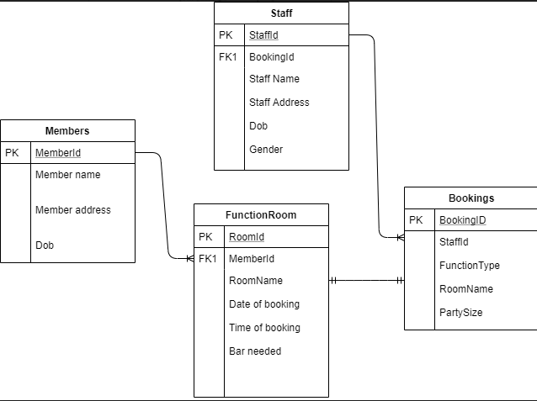

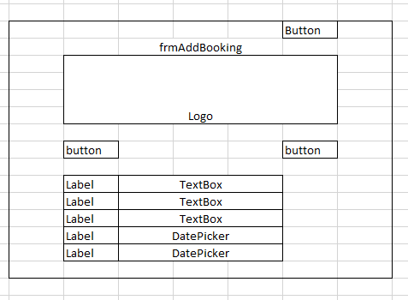
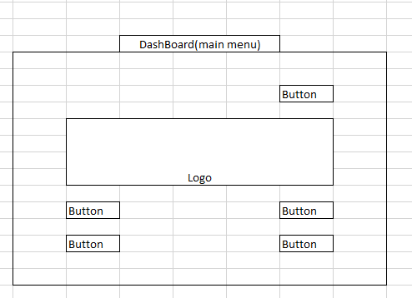
Appendix B
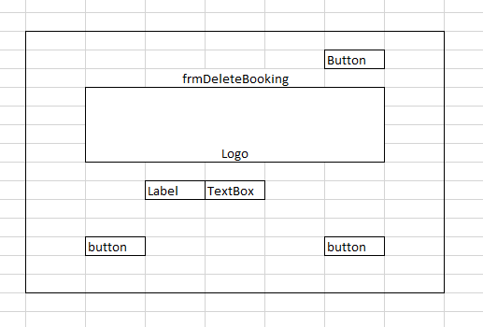
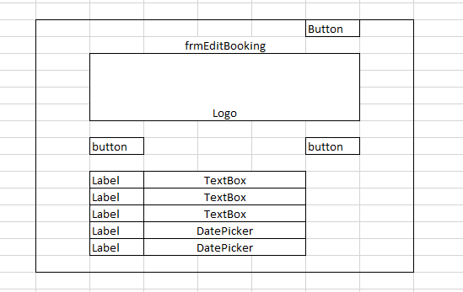
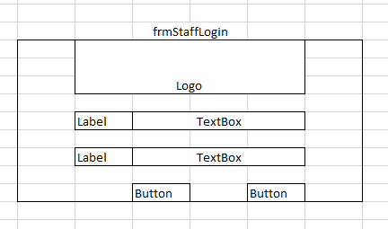
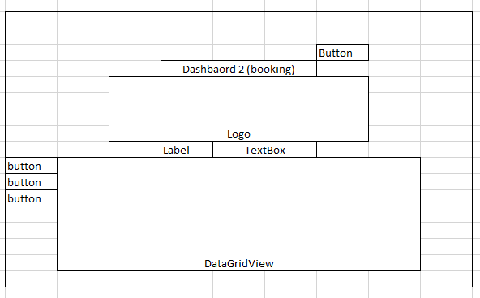
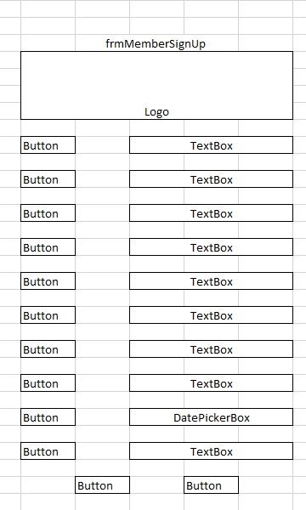

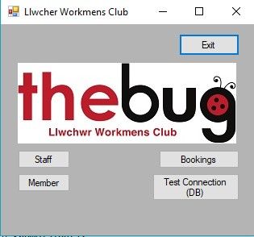
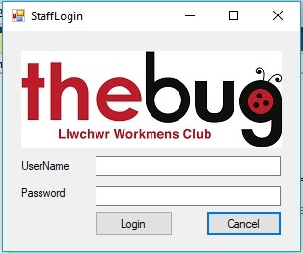
Appendix C
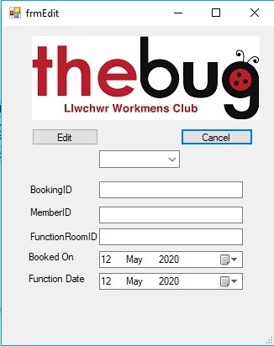
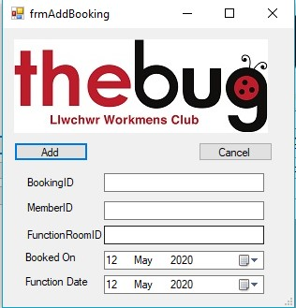

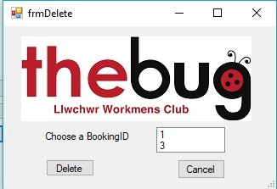

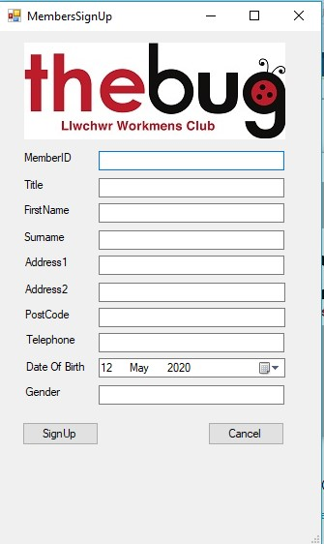
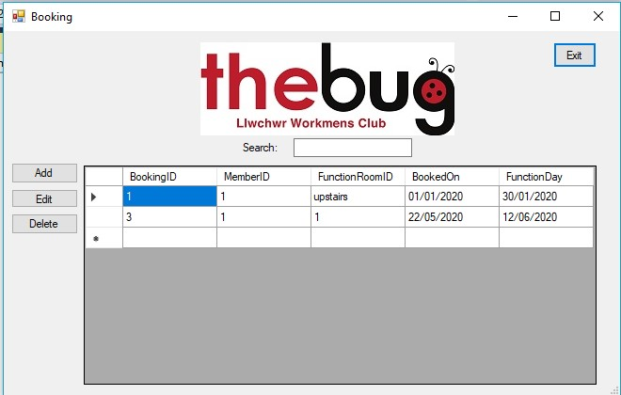

Appendix D
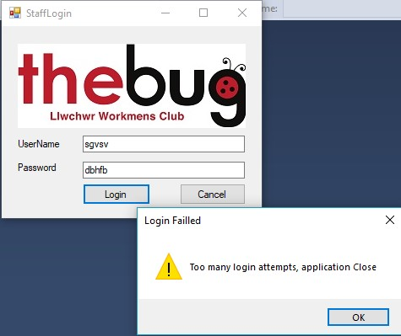
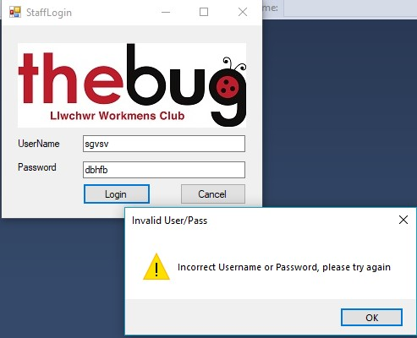

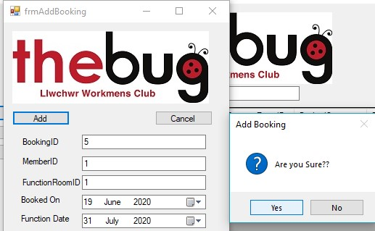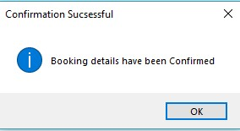

Gower College Swansea
ACCA5012 Application Development
HND Computing and information Systems
WIL13807181
2/12/2020

Here is the start up of the application and it shows the login.
If the user fails to login then the error message will appear and tell the user that the data entered is incorrect.
If user should fail three time then the application will shut down and the user will have to start the application again.

Here is the dashboard for the application where the ser can check the connection to the database and navigate through the app
Here is the member sign up form where the user will fill in data and then the data can be stored in the database from the app
Here is the main feature of the application which is the booking form from here the user can add edit and delete bookings and the data in the database will be manipulated accordingly.
Here you can use the drop down to select an id and then the booking information that belongs to that id will display and from there the information can be edited
Here you can use the drop down to select a id and then the booking information that belongs to that id will display and from there the information can be deleted

Here the user can add bookings and then they will appear in the database and will show up on the DataGrid box on the booking form

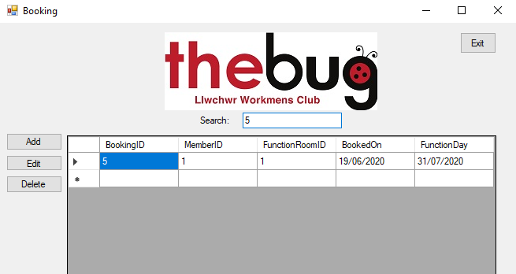
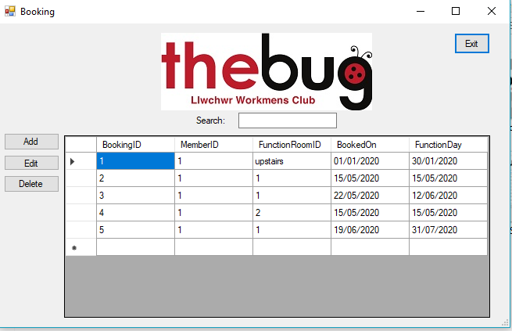
Here shows that the search bar works and the data can be looked for easier creating a better efficiency for the workplace
Here is some of the data I have created as test data to show that the application works

