Student Name: Petru Piron
Student Number: 2233575
Assignment title: Planning and Delivering an International Event.
Croeso Cymru: The International Welsh Welcome Summit 2025
Module title: International Meetings Management BMIH6007
Lecturer’s name:
AI Declaration:
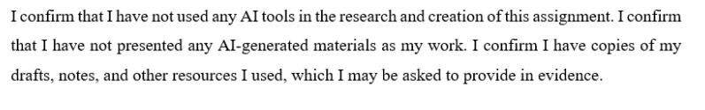

Table of Contents
1 Introduction 4
2 The Event Cycle 4
2.1 EMBOK Model 4
2.1.1 Initiation Phase 5
2.1.2 Planning Phase 5
2.1.3 Implementation Phase 5
2.1.4 Event Phase 5
2.1.5 Closure Phase 5
3 Event Concept 6
4 . Aim and Objectives of the Meeting 7
4.1 Aims 7
4.2 SMART Objectives 7
5 Event Management 8
6 Event Budget 9
7 Industry Trends 10
7.1.1 Hybrid and Virtual Events 10
7.1.2 Personalisation and AI Integration 10
7.1.3 Sustainability practices 11
7.1.4 Health and Wellness 11
7.1.5 Data Privacy and Security 11
7.1.6 Influence on Croeso Cymru 2025 11
8 Situational and Cultural Considerations 11
8.1 SWOT Analysis 11
8.1.1 Strengths 11
8.1.2 Weaknesses 12
8.1.3 Opportunities 12
8.1.4 Threats 12
8.2 PESTEL 12
9 Conclusion 15
10 Recommendation 16
11 References 17

Introduction
The selected event is “Creso Cymru: The International Welsh Welcome Summit 2025”. The event represents Wales as a major centre for cultural business, and it will prioritise sustainable tourism. The goal of the summit is for global tourism experts, investors, and cultural travellers to come together and explore ways to promote innovation, teamwork, and economic development in Wales and across the globe. This event is being held since Wales is gaining attention globally, and its unique nature and partnership opportunities are important (Minto and Morgan, 2019). The summit brings travellers together to discover the special culture, heritage and have enjoyable travel experiences. Wales is where it will be, as a place that encourages everybody to visit, and as an exciting place. The event will be held in Cardiff, Wales, as the city is filled with excellent transport options, first-class conference centres and a rich culture that helps make the city suitable for a big international event of this importance.

The Event Cycle

EMBOK Model
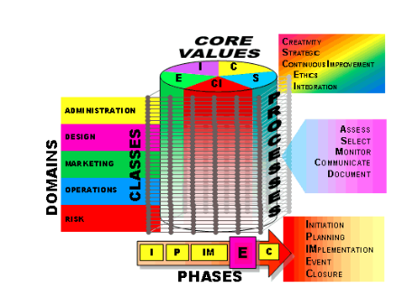
Figure 1: EMBOK Model
(EMBOK, 2019).

Initiation Phase
This step requires determining why the event is necessary, if it can be accomplished and how it fits with the organisation’s goals. The Year of Croeso Cymru 2025 was initiated by Visit Wales following their “Year of Croeso” campaign to aid national tourism, support cultural diplomacy and increase the country’s global name recognition (Hurd et al., 2024).

Planning Phase
At this step, comprehensive plans are prepared that address budgeting, scheduling, marketing and risks. The location for the event and extra activities like Snowdonia, Cardiff Bay were both confirmed in contracts. Tasks for staff resource allocation were hiring people who could speak many languages, booking speakers, designing programs with a strong cultural focus and organising issues such as transport, security and food (Hurd et al., 2024).

Implementation Phase
In this stage, resources are mobilised and work is aligned with the previous stage’s planning outcomes. The deals are signed, broadcast, and web systems are ready, and ads start running digitally and in traditional media. Rehearsals, verification of emergency arrangements and team briefing are carried out to make certain everyone is prepared.

Event Phase
In the live event, there are keynote speeches, networking parts, cultural activities and opportunities to visit connected sites are involved. When operations are monitored live, quality, customer satisfaction and minor issues can all be handled. They feel Welsh hospitality and fun from the carefully organised cultural events.

Closure Phase
The last steps are collecting data, resolving any finance issues and holding discussions with all involved parties. Managers review the feedback to see if employees are reaching their set objectives. Making a post-event impact report enables Wales to learn from experiences and make itself stronger in the competing MICE sector globally (Year of Croeso, 2025).

Event Concept
The event delegates attending Croeso Cymru: The International Welsh Welcome Summit 2025 experience a rich and immersive three-day programme (Year of Croeso, 2025). It blends cultural discovery, strategic dialogue and professional networking. The event is hosted at ICC Wales, it begins with a pre-summit networking reception and formal dinner in Cardiff, which offers guests the opportunity to gain a unique experience from Welsh hospitality. The event consists of three days.
On Day 1, the event opens with a Welcome Ceremony, which features live performances, a keynote speech by Visit Wales, and panel discussions on tourism investment and MICE trends. The event delegates engage in breakout sessions, and an exhibitor represents regional businesses (Bowdin et al., 2023).
Day 2 of the event includes off-site cultural tours to Cardiff Castle, Caerphilly Castle, and Cardiff Bay, which pair with interactive workshops on heritage tourism and sustainable development. In the evening, the event offers Welsh cuisine to the guests and also offers a music showcase.
On Day 3, the event emphasises innovation in tourism, investment opportunities and digital transformation. The summit will end with a closing ceremony and a “Future of Wales” roundtable featuring industry experts.
At the summit, the guests will get multilingual support, networking, guided site visits, and ensure their day becomes productive, global connections, and it is a lasting impression of Welsh “Croeso” (welcome) and “Hwyl” (joyful spirit).
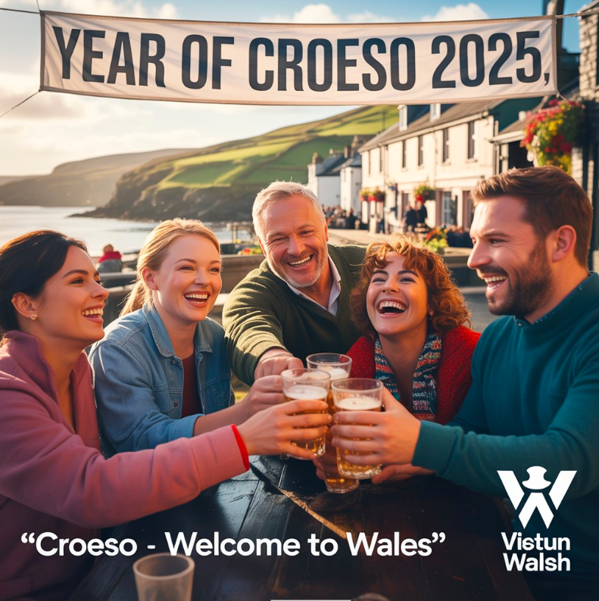
Figure 2: Croeso- Welcome to Wales
(Source: Self-created).

. Aim and Objectives of the Meeting

Aims
The aim is to build Wales as a world-class MICE and cultural tourism destination. It delivers an internationally engaging event that will align with Visit Wales’ Year of Croeso 2025 campaign.

SMART Objectives
Table 1: SMART Objectives
Objective | Specific | Measurable | Achievable | Relevant | Time-bound
Objective 1 | To increase global awareness of Wales as a destination. | 25% increase in media mentions and digital engagement. | Through partnerships with 10+ global media and influencers. | It supports national branding goals and tourism growth. | Achieve by June 2025.
Objective 2 | To facilitate strategic business networking. | Host 100+ scheduled B2B meetings. | It uses digital matchmaking tools and event scheduling apps. | It aligns with economic and investment aims. | During the three-day summit (April 14–16, 2025).
Objective 3 | To deliver immersive cultural experiences to attendees. | 300+ delegates join off-site tours and activities. | In collaboration with local tour operators and DMCs. | It enhances the perception of Wales as an experiential destination. | Completed by the end of Day 3 of the event.
(Source: Author).

Event Management
The successful delivery of Croeso Cymru needs a variety of skills and resources across operational, planning, and marketing activities. The event operationally requires strong project management skills that are important to coordinate, manage budgets, logistics, and oversee the contracts of suppliers. The expertise in venue management make sure for smooth coordination at ICC Wales, including AV technology, health and safety compliance, and catering. The multilingual communication and customer service skills are significant skills that are important to accommodate the international representative profile and ensure a unified experience (Rogers and Wynn-Moylan, 2022). Planning stakeholder involvement and dealing with scheduling are important strategic tasks in activity planning. Destination Management Companies (DMCs) should be involved by the event team to arrange tours, get the needed permits and set up transportation for off-site culture tours. Managing risks and making plans for various surprises is needed to address problems with travel or weather. Besides, it is important to use creativity and analysis to make the summit well-known worldwide (Rogers and Wynn-Moylan, 2022). The digital marketing experts will need to run targeted campaigns across all social media, partner channels and email, utilising the SEO and influencer partnerships to maximise the reach. The event sponsorship management skills are needed to secure and maintain relationships with hotels, airlines, and tech companies that make sure for mutually beneficial brand visibility (Dutta, 2025). The coordinated multidisciplinary team will combine with managers of the project, logistics, marketers, coordinators, technical support, and hospitality staff who will be essential for delivering a successful and memorable event.

Figure 3: Year of Croeso 2025
(Source: Self-Created).

Event Budget
Table 2: Event Budget Breakdown
Budget Area | Details | Amount (£)
Income
 | Ticket Sales | 150,000
 | Sponsorships | 200,000
 | Government Support | 100,000
Total Income |  | 450,000
Expenses
 | Venue Hire | 120,000
 | Catering | 80,000
 | AV & Tech Support | 60,000
 | Marketing & Promotion | 50,000
 | Logistics | 40,000
 | Speaker & Entertainment Fees | 50,000
Total Expenses |  | 400,000
Surplus | Total Income - Total Expenses | 50,000
(Source: Author).
The budget reflects a balanced financial approach, with diverse income streams to mitigate risks. Ticket sales contribute a solid £150,000, supported heavily by corporate sponsorships (£200,000), which underscore strong industry partnerships. Government funding (£100,000) aligns with Visit Wales’ strategic goals to boost tourism. Major expenses include venue hire (£120,000), necessary for a high-profile international event at ICC Wales and accompanying site visits, and catering (£80,000), vital for delivering the warm Welsh hospitality experience. AV and technical support costs (£60,000) ensure accessibility for international attendees via live streaming and interpretation. The marketing (£50,000) invests in global reach through digital and influencer channels. The logistics (£40,000) cover critical operational needs such as transport and security, while speaker and entertainment fees (£50,000) provide event prestige. A projected surplus of £50,000 allows reinvestment into future event initiatives or contingency planning, demonstrating strong financial management.

Industry Trends

Hybrid and Virtual Events
In-person and online parts are being combined in more and more hybrid events. With this model, events can be more accessible and contact more people, considering their many preferences and where they live (Sharad Kumar Kulshreshtha and Webster, 2024).

Personalisation and AI Integration
Guests want to be offered custom experiences these days. Using AI and analysing data helps organisers improve content, networking events and interactions during the event, creating more involvement and pleasure (Ramakrishnan et al., 2020).

Sustainability practices
The event focused is to environmentally friendly event management. When organisers adopt waste reduction, use less energy and source goods sustainably, it supports global environmental goals and meets the needs of people expecting eco-friendly events (Smith and Mair, 2022).

Health and Wellness
After the pandemic, events is focusing on the well-being of participants. Making wellness programs, mental health resources and a safe setting top priorities ensures the event experience is positive and healthy (Yu et al., 2021).

Data Privacy and Security
The use of digital technologies has made it very important to protect attendee data. A company must have effective cybersecurity and honest data usage policies to maintain trust and follow rules (Wylde et al., 2022).

Influence on Croeso Cymru 2025
The design of Croeso Cymru matches these important changes in the industry. It will involve various hybrid options so more people can join, use AI to provide each guest with a tailored experience and practice sustainable procedures throughout the organisation. The summit is organised to handle today’s industry changes and deliver an engaging, responsible and meaningful event that appeals to people around the world.

Situational and Cultural Considerations

SWOT Analysis

Strengths
- The event is modern and well-equipped venue (ICC Wales) with good transport that has capacity for large-scale international events.
- The event targets a diverse target audience, in which professionals, investors, media, and influencers, ensuring broad market engagement.
- The event is integrated to off-site cultural tours that adds immersive experiences, to foster the delegate satisfaction and event distinctiveness (Schuh et al., 2021).

Weaknesses
- Relative lack of international brand recognition compared to established UK competitors like Scotland, Ireland, and London.
- Potential logistical challenges in managing multilingual interpretation and hybrid event technology.
- Budget constraints limit high-profile entertainment or extensive marketing campaigns.
- Post-pandemic travel hesitancy among some international delegates may reduce attendance (Schuh et al., 2021).

Opportunities
- Growing global MICE market with increasing demand for experiential and culturally immersive events such as 8.2% CAGR projected.
- Leveraging technology for hybrid formats to expand international reach and inclusivity.
- Rising interest in sustainable and responsible tourism aligns with Wales’ natural beauty and environmental commitments (Sato et al., 2024).

Threats
- Uncertainties around Brexit-related travel restrictions and visa requirements potentially hindering delegate participation.
- Economic volatility is impacting corporate budgets for event travel and sponsorship.
- Competition from more established MICE destinations is attracting key stakeholders and delegates (Wise and Maguire, 2022).

PESTEL
Political Factors
- Government regulations on large gatherings, health, and safety protocols, especially post-pandemic, influence event planning and capacity limits (WHS, 2024).
- Brexit has altered visa, customs, and travel policies within the UK and EU, impacting international delegate attendance and event logistics (Chu and Kovacevic, 2025).
- Political stability in host countries affects investor confidence and the willingness of international attendees to participate.
- Trade policies and international relations can affect sponsorship from multinational companies and cross-border partnerships.
Economic Factors
- Global economic recovery post-COVID-19 is uneven, affecting disposable incomes, corporate budgets, and event sponsorship availability (IMEX Group Report, 2024).
- Inflationary pressures increase operational costs such as venue hire, catering, technology, and staffing.
- Exchange rate volatility affects the cost for international delegates and suppliers, especially in the UK post-Brexit (OECD, 2024).
- The growth of the MICE sector is projected at a CAGR of 8.2% from 2023-2028, reflecting increasing demand for international conferences and corporate events (Cognitive Market Research, 2023).
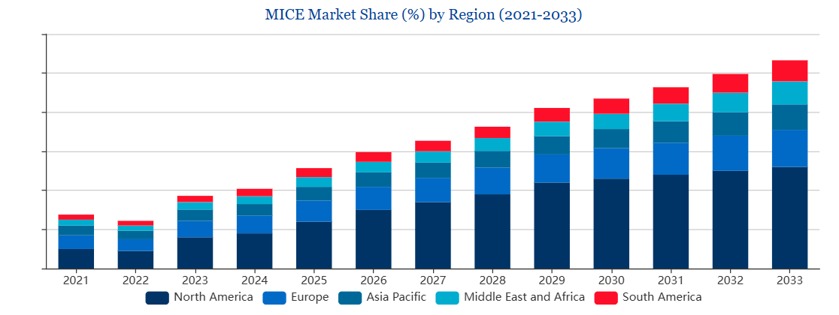
Figure 4: MICE Market Share (%) by Region (2021-2033)
(Source: Cognitive Market Research, 2023).
Social Factors
- Increased awareness and demand for diversity, equity, and inclusion (DEI) in event content, speaker selection, and participant representation.
- Changing demographics with younger professionals valuing sustainable, tech-enabled, and hybrid event experiences.
- The growing importance of mental wellbeing and work-life balance influences the design of event schedules and social activities.
- Cultural sensitivity is crucial when hosting international audiences, especially in bilingual or multiethnic regions like Wales.
- Post-pandemic social behaviours include a preference for smaller gatherings or virtual attendance options, affecting event format planning.
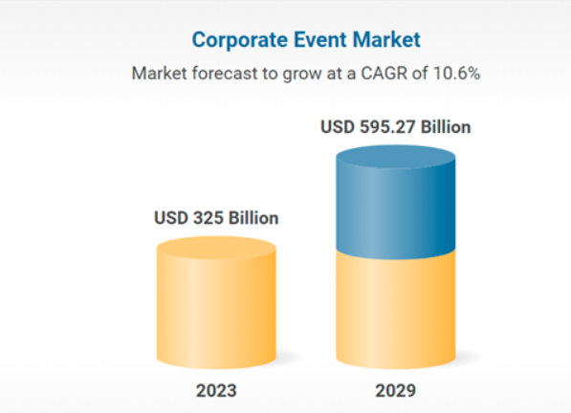
Figure 5: Corporate Event Market
(Source: Research and Markets, 2024).
Technological Factors
- Advancements in hybrid and virtual event technologies enable global participation and reduce physical attendance barriers (EventTech Trends Report, 2024).
- Use of AI and data analytics improves personalised marketing, attendee engagement, and operational efficiency.
- Mobile apps, augmented reality (AR), and virtual reality (VR) enrich delegate experiences and onsite navigation.
- Enhanced cybersecurity measures are essential due to the increasing digital data handling for registrations, payments, and interactions.
- Social media platforms play a critical role in event promotion, real-time engagement, and post-event feedback (Batuhan Aktepe and Demirci, 2024).
Environmental Factors
- Growing emphasis on sustainability requires events to minimise carbon footprints through green venue choices, waste reduction, and sustainable catering.
- Environmental certifications like ISO 20121 for sustainable events are becoming expectations rather than exceptions.
- Climate change risks, such as extreme weather events, can disrupt event logistics and attendee safety.
- Demand for local sourcing of materials and services supports regional economies and reduces transport emissions.
- Public and corporate pressure to demonstrate social responsibility drives the incorporation of eco-friendly practices (Toscani et al., 2024).
Legal Factors
- Compliance with data protection regulations like GDPR ensures the ethical handling of attendee data and reduces legal risks.
- Employment laws influence staffing contracts, volunteer management, and contractor agreements (Kappelides, Cuskelly and Hoye, 2018).
- Intellectual property laws govern the use of content, branding, and recordings during and after events.
- Health and safety legislation, including COVID-19 protocols, must be rigorously applied to protect attendees and staff (WHS, 2024).

Conclusion
Croeso Cymru 2025 is designed to help Wales become an important choice for MICE by highlighting its unique culture and hospitality. Because the event cycle is followed in the planning stages, everyone involved can collaborate smoothly, from idea to implementation. The sustainable execution and the possibility of making a surplus are supported by having a strong budget and funding system. Experiential trips and new hybrid event technologies are listened to because they are in line with the event’s goals, and the PESTEL framework sheds light on important political and environmental influences from the outside. Croeso Cymru focuses on what is unique to Wales and presents market trends to promote its profile globally and make valuable alliances, boosting both tourism and the economy in the region for years to come.

Recommendation
- Invest in advanced hybrid event technology, including interactive apps and virtual reality experiences, to increase global accessibility and engagement, accommodating delegates unable to attend physically (EventTech Trends Report, 2024).
- Utilise data analytics to tailor marketing campaigns by segmenting international audiences and leveraging influencer partnerships, increasing ticket sales and sponsorship interest (Bansal et al., 2024).
- Collaborate closely with local tourism bodies, transport providers, and hospitality sectors to enhance delegate experience and foster economic benefits for Wales (Visit Wales Strategy, 2024).

References
Bansal, D., Bhattacharya, N. and Priyanka Shandilya (2024). Influencer Marketing Unleashed: Leveraging Data Analytics for Success. 12, 14(13), pp.67–87. doi:https://doi.org/10.1007/978-3-031-65727-6_5.
Batuhan Aktepe and Demirci, B. (2024). Emerging technologies in the event industry. Worldwide Hospitality and Tourism Themes, 16(4). doi:https://doi.org/10.1108/whatt-06-2024-0124.
Bowdin, G., McDonnell, I., Harris, R., O’Toole, W., Allen, J., & Leo Kenneth Jago. (2023). Events Management. Routledge. https://doi.org/10.4324/9781003044963.
Chu, B. and Kovacevic, T. (2025). Five key impacts of Brexit five years on. BBC. [online] 30 Jan. Available at: https://www.bbc.com/news/articles/cdrynjz1glpo.
Cognitive Market Research (2023). Global MICE Market Report 2025 Edition, Market Size, Share, CAGR, Forecast, Revenue. [online] Cognitive Market Research. Available at: https://www.cognitivemarketresearch.com/mice-market-report.
Dutta, S. (2025). Business Events. Educohack Press.
EMBOK (2019). EMBOK - Event Management Body of Knowledge - EMBOK Model. [online] Embok.org. Available at: https://www.embok.org/index.php/embok-model.
EventTech Trends Report (2024). 2024 Event Tech Trends You Need to Know - vFairs.com. [online] vFairs.com. Available at: https://www.vfairs.com/newsletter/2024-event-tech-trends-you-need-to-know/ [Accessed 31 May 2025].
Hurd, A.R., Barcelona, R.J., An, J. and Ready, J. (2019). Leisure Services Management. Human Kinetics.
IMEX Group Report (2024). Sustainability at IMEX Frankfurt | Sustainable Event Report. [online] Sustainability at IMEX Frankfurt | Sustainable Event Report. Available at: https://imex-frankfurt.com/newfront/page/sustainability.
Kappelides, P., Cuskelly, G. and Hoye, R. (2018). The Influence of Volunteer Recruitment Practices and Expectations on the Development of Volunteers’ Psychological Contracts. VOLUNTAS: International Journal of Voluntary and Nonprofit Organizations, [online] 30(1), pp.259–271. doi:https://doi.org/10.1007/s11266-018-9986-x.
Minto, R. and Morgan, K. (2019). The Future of Wales in Europe. Edinburgh Law Review, 23(3), pp.423–428. doi:https://doi.org/10.3366/elr.2019.0580.
OECD (2024). OECD Economic Outlook, Volume 2024 Issue 2. [online] OECD. Available at: https://www.oecd.org/en/publications/2024/12/oecd-economic-outlook-volume-2024-issue-2_67bb8fac.html.
Ramakrishnan, A., Lee, S.-C., Wood, M., Hankinson, S., Choe, N. S., Jushchyshyn, N., & Carlton, N. (2020). IMMERSIVE MEDIA AS A MODALITY FOR LIVE MULTI-SITE VIRTUAL CONFERENCE. INTED Proceedings, 1(2340-1079), 7367–7374. https://doi.org/10.21125/inted.2020.1959.
Research and Markets (2024). Corporate Event Market Booms with Digital Solutions, Innovation, and AI-Powered Experiences, Driving the Industry to Generate $595.27 Billion in Revenues by 2029. [online] GlobeNewswire News Room. Available at: https://www.globenewswire.com/news-release/2024/12/19/2999692/28124/en/Corporate-Event-Market-Booms-with-Digital-Solutions-Innovation-and-AI-Powered-Experiences-Driving-the-Industry-to-Generate-595-27-Billion-in-Revenues-by-2029.html.
Rogers, T. and Wynn-Moylan, P. (2022). Conferences and Conventions. Routledge. doi:https://doi.org/10.4324/9781003298953.
Sato, S.N., Condes Moreno, E., Rubio-Zarapuz, A., Dalamitros, A.A., Yañez-Sepulveda, R., Tornero-Aguilera, J.F. and Clemente-Suárez, V.J. (2024). Navigating the New Normal: Adapting Online and Distance Learning in the Post-Pandemic Era. Education Sciences, [online] 14(1), p.19. doi:https://doi.org/10.3390/educsci14010019.
Schuh, G., Guetzlaff, A., Schmitz, S., Schopen, M. and Broehl, F. (2021). Event Log-based Weaknesses Detection in Business Processes. 2021 IEEE International Conference on Industrial Engineering and Engineering Management (IEEM), 12(13), pp.734–738. doi:https://doi.org/10.1109/ieem50564.2021.9672975.
Sharad Kumar Kulshreshtha and Webster, C. (2024). Emerging Technologies in Virtual and Hybrid Events. Advances in hospitality, tourism and the services industry (AHTSI) book series, [online] 13(78), pp.1–18. doi:https://doi.org/10.4018/979-8-3693-2272-7.ch001.
Smith, A.M. and Mair, J. (2022). Events and Sustainability. Routledge eBooks. Routledge. doi:https://doi.org/10.4324/9781003314295.
Toscani, A.C., Vendraminelli, L. and Vinelli, A. (2024). Environmental sustainability in the event industry: a systematic review and a research agenda. Journal of Sustainable Tourism, 32(12), pp.1–35. doi:https://doi.org/10.1080/09669582.2024.2309544.
Visit Wales Strategy (2024). Visit Wales Market Demand Study – UK (2024). [online] gov.wales. Available at: https://www.gov.wales/sites/default/files/statistics-and-research/2024-06/visit-wales-market-demand-study-uk-2024.pdf [Accessed 2024].
WHS (2024). World Health Summit (WHS). [online] Globalhealth.org. Available at: https://globalhealth.org/event/world-health-summit-whs/ [Accessed 31 May 2025].
Wise, N. and Maguire, K. (2022). A research agenda for event impacts. Northampton: Edward Elgar Publishing.
Wylde, V., Rawindaran, N., Lawrence, J., Balasubramanian, R., Prakash, E., Jayal, A., Khan, I., Hewage, C. and Platts, J. (2022). Cybersecurity, Data Privacy and Blockchain: A Review. SN Computer Science, [online] 3(2). Available at: https://link.springer.com/article/10.1007/s42979-022-01020-4.
Year of Croeso, (2025). Online Available at: https://traveltrade.visitwales.com/useful-information/toolkit/year-of-croeso. Accessed Date: [14/05/2025]
Yu, N.N., Mair, J., Lee, A. and Ong, F. (2021). Subjective Well-Being and Events. Event Management, 26(1). doi:https://doi.org/10.3727/152599521x16192004803584.

