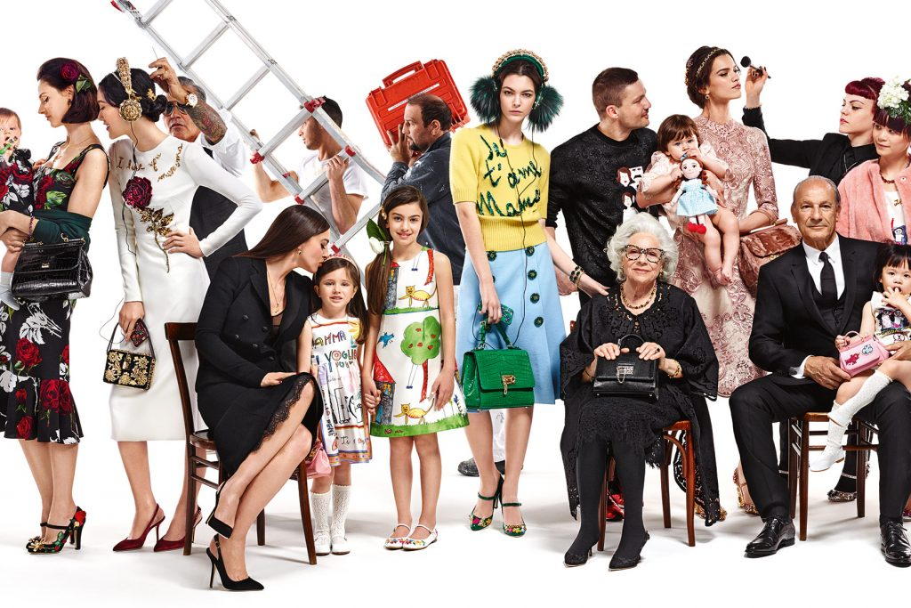
Task 1: Observational Essay
Figure 1: #DGMAMMA, Dolce & Gabbana advertising campaign, 2015
Semiotics is the study of signs and objects; it is a theoretical approach adopted to read images and texts. As Ferdinand de Saussure, one of its founders stated, Semiotics is “the life of signs within society.” (1974: 16). This can be applied when deconstructing a text to analyse the communication and representation within advertisement, so that we can understand how it can be accepted or rejected by society- this will be furtherly scrutinised in this text by deconstructing a ubiquitous advertising campaign created in the fall of 2015 for the fashion brand, Dolce & Gabbana, whilst referencing to semiotic theories.

John Berger begins his seminal text by stating ‘seeing comes before words. The child looks and recognizes before it can speak’, (1972: 7) this epitomises the influence signs have on humans, highlighting the importance it can have in advertisement purposes to symbolise a metaphor, an emotion or a deeper meaning. Linguistic Signs are defined to have two primordial characteristics- this dyad is made up of a signifier (the material aspect of the design) and a signified (the mental concept) (Saussure, 1974: 67). An example of can be perceived in the advertisement from the choice of the elder woman’s clothing- black clothing (the signifier) is signified as morning a family death in Italian culture. This is seen as a tradition or mythological ideology in their society. ‘A sign, in this context, refers to something which conveys meaning – for example, a written or spoken word, a symbol or a myth’ (Robinson, A. 2011) this implies an object is inadequate without a meaningful concept.

According to Louis Hjelmslev, semiotics is first and foremost a hierarchy. Natural language is a denotative semiotic, and the former, connotative semiotics, is the latter meta-semiotics. (1969: 88) This was later adapted by Roland Barthes in his seminal publication, Image, Music, Text (1977), in his concept ‘The photograph paradox’, the idea that an image is made of two comprise, idiosyncratic messages ‘a denoted message, which is the analogon itself, and a connoted message, which is the manner in which the society to a certain extent communicates what it thinks of it.’ (Barthes, 1977: 17). This can be applied to the Dolce & Gabbana advert from the male presences- firstly, is the man holding a ladder, which is denotating an working environment but connotates the responsibly being a care-taker of a family, working for the expense of the women in the foreground so they’re able to wear the rich cloths associated with this brand. The second is the elder men dressed in a black suit, connotating hierarchy and social status- this also aligns with the paradigm of career success and is codification of formal attire. Broadening the discussion of connotations, B.T.S Atkins later developed a lexical conception named Polysemy, constructed from the realisation that a sign can have more than one connotation (Atkins, 2000: 91). In the advertisement, Polysemic feminine patterns are used within the women’s and children’s clothing- the choice of pink colouring for the children can connotate innocence and femininity whereas the red rose imprints on the women’s clothing signifies sexuality, love and passion.

This semiotic analysis is a valuable tool can be exerted to deconstruct any metaphoric, intertextual or metonymic meaning of a sign.

Bibliography

Barthes, R. (1977) Image, Music, Text. London, Fontana Press.

Berger, J. (1972) Ways of Seeing. London, Penguin.

Fillmore, C. J & Atkins, B. T. S. (2000) In Yael Ravin & Claudia Leacock (eds.), Polysemy: Theoretical and Computational Approaches. Oxford University Press.

Hjelmslev, L. (1969) Prolegomena to a theory of language. Madison, University of Wisconsin Press.

Robinson, A (2011) An A to Z of Theory Roland Barthes and Semiotics, Ceasefire Magazine, 23rd September. Available from: https://ceasefiremagazine.co.uk/in-theory-barthes-1/ [accessed on the 25th of October]

Saussure, F. de (1974) General Course in Linguistics. New York, Philosophical Library.

List of Figures:
Fig 1: #DGMAMMA, Dolce & Gabbana advertising campaign (2015) Accessed from: https://www.harpersbazaar.com.sg/fashion/dolce-gabbanas-fall-campaign-is-all-about-family-and-selfies/ [Accessed on 25th of October]

Task 2: Manifesto Writing

- Accept no form of racism. Support all races; We are all one. Be a firm supporter in the 'Black Lives Matter' movement.
- Art has no gender. It can be created by whomever, wherever, whenever. All genders should be paid equally.
- Be kind to the environment- recycle all waste and reuse anything that can be reused within your art.
- Be and create the good you want to see in the world. Allow your work to be positive in a world of negativity.
- Deconstruct art with intellect, but also with emotion. Don't follow the crowd- if you perceive work differently to others, allow/accept it. Artwork affects everyone differently, it’s the power of personal understanding without another's verbal/visual instruction.
- Use reliable resources- do not trust social media for news and information.
- Be present, be active, be a part of the conversation. Ask questions. Learn.
- Opinion and knowledge can change over time. History changes through growth and understanding. If history teaches us anything, it is good to become more understanding and accepting of change.

3 areas of exploration:

Except no form of racism. Support all races; We are all one. Be a firm supporter in the 'Black Lives Matter' movement.
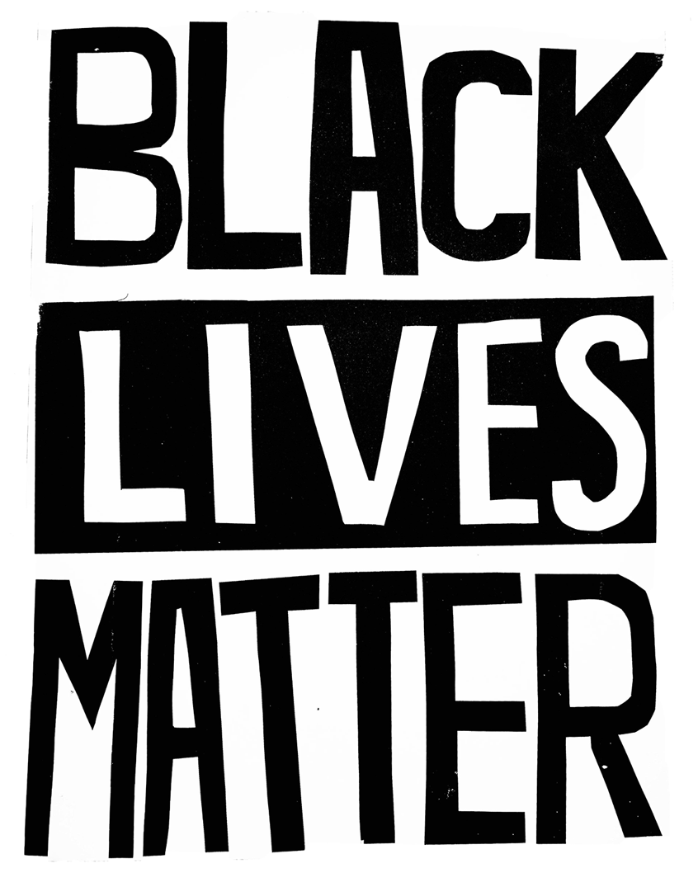

Fig 1. Black Lives Matter Poster, 2016.

On the 25th of May 2020, an African American man, George Floyd, was killed by a Minneapolitan police officer named Derek Chauvin, as he knelt on Floyd’s neck for 8 minutes and 48 seconds- all for an alleged counterfeit $20 bill. His death caused a global uproar, resulting in protests that were held against police brutality, racial injustice and a lack of police accountability. This tragedy shone a harsh light on the racism that is still present in our ‘woke’ generation, as many black people live in fear of the people who are supposed to protect us. As the Black Lives matter website states; We don’t deserve to live like this — and we continue to fight until white supremacy no longer permeates every corner of this country — until we can live full lives — freely. (2020) Racism is still an endemic to our society-it’s seen in, for example, education, income, unemployment and, sadly, in Art. Art is discussed as a representative school subject that concretely demonstrates some of the problems of the multicultural and/or antiracist curriculum. (Sarup, 1991) Artwork should not be defined by race, class nor gender.
Deconstruct art with intellect, but also with emotion. Don't follow the crowd- if you perceive work differently to others, allow/accept it. Artwork affects everyone differently, it’s the power of personal understanding without another's verbal/visual instruction.
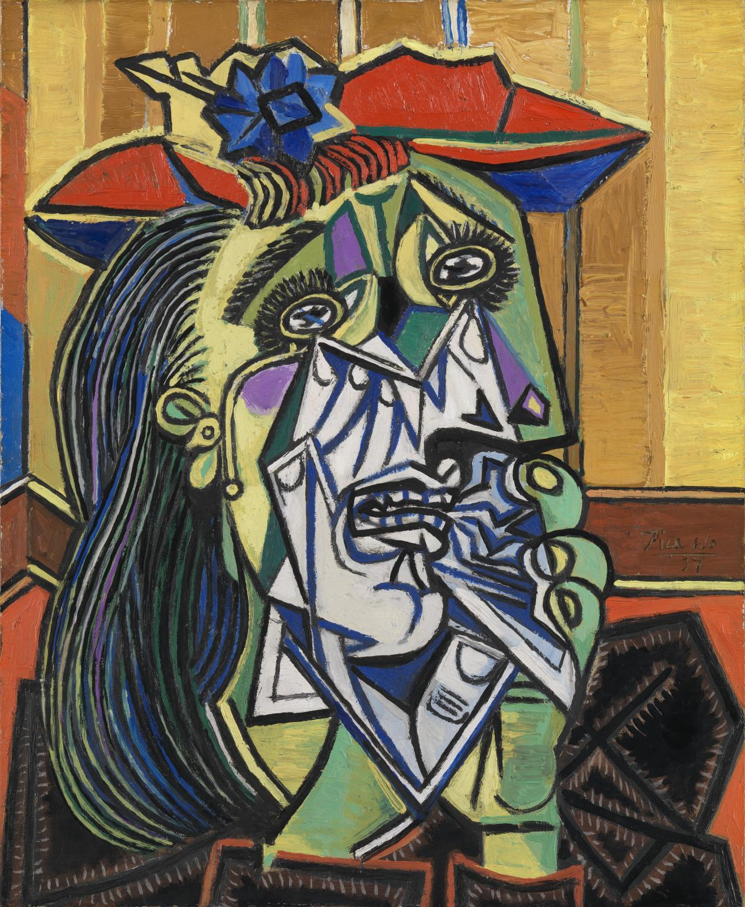

Fig 2. Weeping Woman, Pablo Picasso, 1936-39.
Art isn’t necessarily always about the context of the piece; sometimes, it’s about what every individual person feels when experiencing the artwork for themselves. As stated by Jerrold Levinson in his book ‘The Oxford Handbook of Aesthetics’, expression is understood as a matter of the communication or transmission of emotion or feeling from artist to audience via the work of art. (2003) Just like a person can be moved by or associate to a song without knowing the original perceptive of the artist, audiences can look at a piece of art and be moved by minor or major characteristics involved in it, such as particular colours, symbols that work on a subconscious level or scenes which compared to similar life experiences or memories. In Pablo Picasso’s ‘Weeping Woman’, the painting depicts a great amount of sadness which I gather from the element of intense expression in the model’s eyes. The use of cool colours represents this despondency, as her hands cup her face in fear. This work is a silent protest of the bombing of Guernica, and the family deaths women had endured from war- even without context, viewers are able to perceive the emotion without verbal motive.
Opinion and knowledge can change over time. History changes through growth and understanding. If history teaches us anything, it is good to become more understanding and accepting of change.
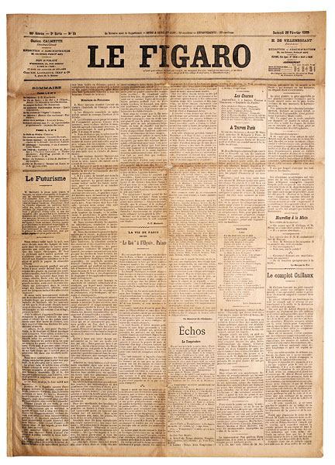

Fig 3. Futurist manifesto, F.T. Marinetti, 1909.
Throughout the years, specifically seen in 20th century Art manifestos, opinions change radically; some manifestos strive for political correctness, some develop questionable ‘antidotes’ for a better environment and some were written by egotistical men who romanticised fascist tenderises. With time, knowledge and new evidence comes a wider range in opinions, this progressing into new declarations and new beliefs. A good example of change within Art is seen when comparing the Futurist Manifesto to my own- As Dan Redding points out in his article, Art Manifestos and their Applications in Contemporary Design (2010), The Futurist manifesto was ‘an avant-garde movement that glorified technology, modernity, and even war.’ Futurists were ‘strongly patriotic, excited by violence and opposed to parliamentary democracy’ The Art Story Contributors (2019). This is extensively different to what is seen in my manifesto, as equality and impartiality are extremely important to me as an artist. I strongly believe that art has no gender, whereas the futurism Manifesto was written by only male artists whom contempt women. ‘Heroes are men, not women.’

Bibliography

Levinson, J (2003) The Oxford Handbook of Aesthetics. Oxford, New York.

Redding, D (2010), Art Manifestos and their applications in Contemporary Design, Smashing
Magazine, February 21st. Available from: https://www.smashingmagazine.com/2010/02/art-manifestos-and-their-applications-in-contemporary-design/ [Accessed on the 16th November]

Rest in Power, Beautiful (2020) Black Lives Matter website, Available from:
https://blacklivesmatter.com/rest-in-power-beautiful/. [Accessed on the 11th November 2020]

Sarup, M (1991) Education and the Ideologies of Racism. United Kingdom.

The Art Story Contributors (2019), Futurism Movement Overview and Analysis, the Art Story,
February 05th. Available from: https://www.theartstory.org/movement/futurism/ [Accessed 16 Nov 2020]

List of figures:
Figure 1. Black Lives Matter Poster, (2020) Accessed from: https://powertotheposter.com/posters/black-lives-matter [Accessed on 11th November 2020]
Figure 2. Weeping Woman, Pablo Picasso, (1936-39) Accessed from:
https://www.tate.org.uk/art/artworks/picasso-weeping-woman-t05010 Accessed from 16th November 2020]
Figure 3. Futurist Manifesto, F.T. Marinetti (1909) Accessed from:
https://sites.google.com/site/kunstfilosofiesite/Home/texts/marinetti-the-futurist-manifesto-1909 [Accessed from 16rh November 2020]

