Name: Marcin Zuchlinski
Student number: 2613725
Reading Task
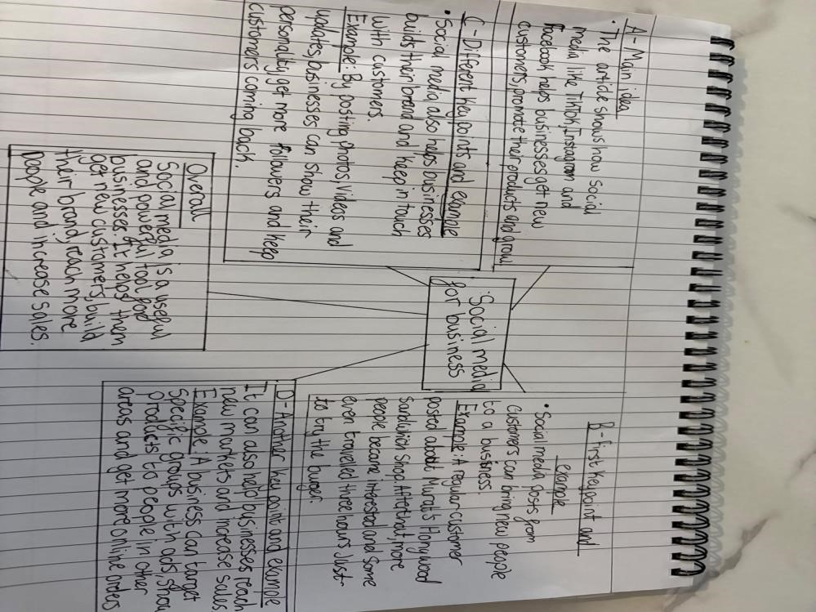

The article shows how social media like TikTok, Instagram and Facebook helps businesses promote their products, get new customers and grow.

Social media posts from customers can bring new people to a business. A regular customer posted about r Sandwich Shop and after that some people travelled three hours just to try the chicken burger.

Social media can help a business grow and change the way it works. Linda Hunter started posting videos in the pandemic, moved her clothing business online and now has 320,000 followers on Facebook and Instagram.

The sandwich shop part is the most important. People travelling three hours just for a chicken burger shows how powerful social media can be and how it can make a small local shop famous quickly.
Reflection
- I found it hard to pick out the main points from the long article. There was a lot of information, and I was not sure which examples were the most important.

Breaking the article into smaller sections and making a simple mind map helped me. It made it easier to see the main idea and the key examples clearly.

