NOSS Coursework 1
Building and deploying a virtualised network

Contents
- Researching the course material 3
  - Research on hypervisors 3
    - Different hypervisors 3
    - Hypervisor architecture 3
    - Hardware specifications 4
    - Advantages, scalability 4
    - Security for hypervisors 5
  - Research on IP addressing 5
    - What is an IP address? 5
    - Representation 5
    - Subnetting 6
    - The efficient use of IP addressing 6
  - Research on routing 7
    - Fundamentals of routing protocols 7
    - Static and dynamic routing 7
  - Research on network services 8
    - VPNs 8
    - DHCP 8
    - AD DS 9
    - CAs 10
- Building and deploying the network 11
  - Choice of hypervisor 11
  - Download and Setup 11
  - IP Address Configuration 14
  - Testing and Troubleshooting 17
- Reflection 20
  - Technical reflection 20
  - Personal reflection 20

Task 1. Researching the coursework material
1.1. Research on hypervisors
1.1.1. Different hypervisors
A Type 1 hypervisor, or bare-metal hypervisor, is the type of hypervisors that runs directly on the hosting hardware: therefore, ridding the user of the need for an OS to host it. This feature which sets it apart from the other hypervisor type, allows it to manage VMs quite efficiently, which provides usually better performance, a lower latency and stronger security (no host OS could be compromised as the result of a security breach) than type 2 hypervisors – thus often being the primary choice of hypervisors for enterprise and data centre environments.
Examples:
- VMWare ESXi
- Bare-metal Microsoft Hyper-V
A Type 2 hypervisor, or hosted hypervisor, is the type of hypervisors that runs using a pre-existing OS as support, instead of directly on the hardware like for type 1. It relies on the host OS to manage hardware resources and isn’t in total control of the hardware like type 1 is. In addition, the setup and usage are far simpler – serving as the main choice for personal use, development and testing environments.
Examples:
- Oracle VirtualBox
- VMware Workstation
- Microsoft Hyper-V (when on Windows)
1.1.2. Hypervisor architecture
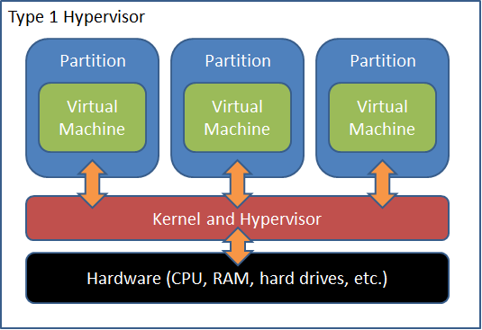
Type 1 hypervisors run directly on the host’s hardware. The kernel is what controls said hardware through interfaces. Parent partitions have access to the kernel and they make up the new OS’s. The interfaces are made up of device drivers and other VM stat tracking windows. The drivers make up the hypervisor.
Graph of a Hyper-V type 1 hypervisor, altaro.com

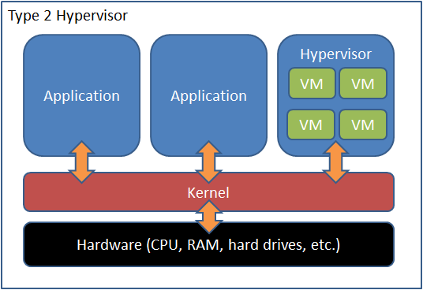
However, type 2 hypervisors, as previously established, work fundamentally differently than type 1 as they run on the hardware’s host OS. So, the kernel and hypervisor are on different layers.
Graphical representation of a Hyper-V type 2 hypervisor, courtesy of altaro.com

Hypervisor architecture for both types are two different ways of virtualisation. They give us insight into their stats, like as type 2 is functionally less adept in its performance; which is visualised by the layer of separation between the kernel and the hypervisor.
1.1.3. Hardware specifications
Hardware specs for a type 1 hypervisor (VMware ESXi, from its website):
- x86-64 CPU (Intel VT-x/AMD-V support required)
- 4GB RAM, recommended 8GB+
- Network card supporting 1GbE+ Ethernet
- 32GB+ of storage
Hardware specs for a type 2 hypervisor (Oracle VirtualBox, from its website):
- x86-64 CPU + virtualisation support
- 2GB RAM, 4GB+ recommended
- 10GB storage per VM
- Supported host OS: Windows, many Linux platforms, etc
1.1.4. Advantages, scalability
Type 1 hypervisors lack the supporting OS that type 2 hypervisor’s functionality are founded on, giving it full control over the hardware and increasing stability. Multiple servers with the same type 1 hypervisors make node groups; several servers with the same hypervisors may be connected to each other, making redundancy in a system. This allows for migration if one of the nodes falters. Additionally, it makes for better infrastructure distribution and balancing, ending up garnering optimisation and scalability.
The scalability on a type 2 hypervisor is different as it’s dependent on the hosting OS. However, they are still very user-friendly. Required scalability is generous so the hypervisor’s operation requires less setup with the hardware. They are far more effective in smaller scale environment.

1.1.5. Security for hypervisors
When using a hypervisor one must consider the risks of inattentiveness. VMs must be securely isolated, to prevent VM escape attacks. MFA is recommended and is a good way to prevent the hypervisor into falling into the wrong hands.
Now, there are different measures to take for both types. For type 1, one can secure BIOS/UEFI, enable TPM, disable unused hardware features and reduce installed components to lighten the load. Encrypting live VM migration will help with interception.
For type 2 hypervisors, protecting the OS is important. The location in which VMs run separately helps with preventing host compromise.
1.2. Research on IP addressing
1.2.1. What is an IP address?
An IP address is a unique numerical label assigned to each device connected to a network using the IP for communication. It identifies a device on a network and it helps determine where the device is located, allowing for a correct routing of the data.
There are two types, IPv4 and IPv6.
IPv4 supports 4.3 billion unique addresses and is written in dotted decimal notation. It’s the most common but has slowly expiring ability.
IPv6 uses a 128-bit address format. It supports TRILLIONS of unique addresses solving IPv4 exhaustion. They’re written in hexadecimal, separated by colons (e.g. 2001:db8::ff00:42:8329). Compared to IPv4 they provide much better security, efficiency and modern network support.
1.2.2. Representation
IPv4 addresses are constituted of 32 bits, divided into four octets each of 8 bits. Each number between the periods of a dotted decimal address represents an 8bit binary number. These addresses are allocated to different classes determined based on network size and maximum host capacity.
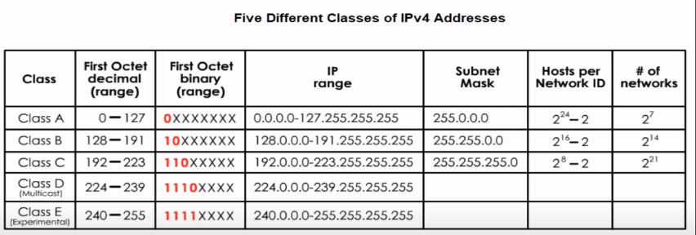
5 classes chart of IPv4, medium.com

IPv6 uses 128 bits, accounting for trillions of possible address combinations. The hexadecimal representation is far more efficient. IPv6 also idealises address auto configuration and simplified header format – enhancing IP efficiency as well as how scalable it is.

People change their IP from v4 to v6 mainly because there is more address space to be given. However, IPv6 also improves the routing, the security and address management. NAT is slowly becoming obsolete because of it, as it could map multiple private addresses inside a local network to a public IP address before transferring the information onto the internet (IPv6 makes that far easier).
1.2.3. Subnetting
Subnetting divides a larger network into smaller, easier to manage networks, helping improve network performance by ridding the congestion created by wasted IP addresses, and optimising IP address allocation.
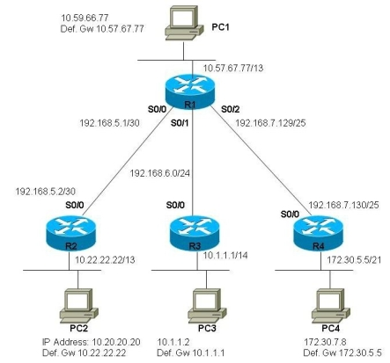
In IPv4, one subnets by idealising the subnet mask, a 32-bit number which separates the IP address into network and host portions. IPv6 subnetting is similar, but it works on a larger address zone, allowing more flexible network design.
Subnetting graph, Doug Vitale Tech Blog

1.2.4. The efficient use of IP addressing
Solutions have been developed to combat challenges like address exhaustion.
Classless Inter-Domain Routing is one of them. In IPv4, it renders division of address spaces (/24, /27, 28, etc) more flexible. In IPv6, it is not necessary because of the address possibilities.
Proper IP address management, which does include using IPv6, helps maintain a stable network architecture.

1.3. Research on Routing
1.3.1. Fundamentals of routing protocols
Routing protocols are essential in networking because they enable the communication between routers and determine optimal paths for data packets. They ensure the data is transferred efficiently, the network is scalable and that there is fault tolerance. They’re designed to discover and maintain network topology, determine the best data transmission path, adapt to network changes like congestion, and exchange routing information between routers.
The steps of a route protocol go as follows:
- Route discovery: routers exchange info about the available paths
- Route selection: The best path is chosen based on price, delay, bandwidth
- Route maintenance: Dynamic route updates to stabilise and ensure efficiency
- Packet forwarding: Data packets transmitted along the second path
1.3.2. Static and dynamic routing
- Configuration: Static is manually configured, while dynamic automatically learns routes.
- Adaptability: Static is manual, dynamic still automatic
- Scalability: Static routing more suitable for small networks/dynamic works far better for bigger networks
- Network Overhead: Dynamic uses bandwidth and CPU resources to exchange routing info/Static does not
- Fault tolerance requires manual intervention for static routing, solution is automatic in dynamic routing
- Convergence time: manual but instantaneous in static, can take time in dynamic
- Static routing is more secure because of lack of automation, exchange between dynamic routers can make updates less secure
- Use cases are small and stable networks for static then large dynamic networks for dynamic.

1.4. Research on Network Services
1.4.1. VPNs
A VPN is a secure encrypted connection between devices over a public or private network. It uses tunnelling, encryption and authentication to boost its security.
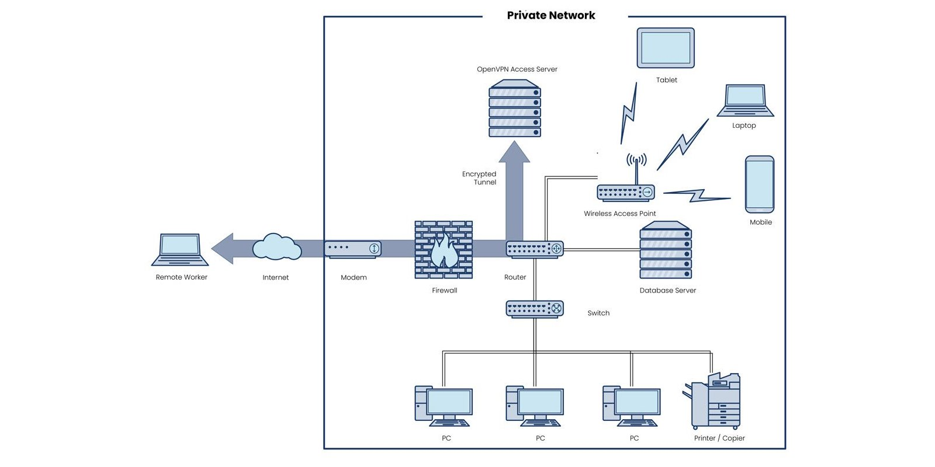
They exist in remote access, where the user may connect to a private network from anywhere, and in site to site, where it connects entire networks across locations on the planet.
VPN diagram representation, ms.codes

To make a VPN more secure, strong encryption like AES-256 and enabling MFA is useful.

In May 2024, Krebs on Security published an article titled “Why Your VPN May Not Be As Secure As It Claims”. It discusses VPN weaknesses which can be exploited in spaces like untrusted networks. Attackers can exploit DHCP features to redirect the VPN traffic, compromising their security, underscoring the need for stronger security options that go beyond VPN usage.
1.4.2. DHCP
DHCP is a network management protocol used to automatically assign IP addresses, subnet mask and default gateways among other configurations to devices.
The DHCP server assigns and manages IP addresses for clients. The lease is a temporary allocation of this IP address to a client which must be renewed occasionally. The DHCP scope is this range of potential IP address allocation. The Relay Agent forwards DHCP requests from clients to the server in different subnets.
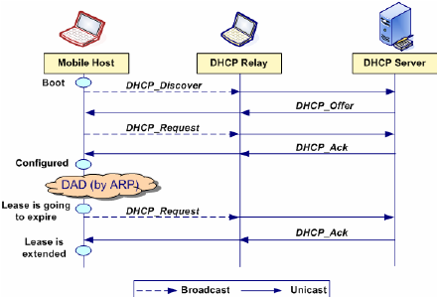
DHCP representative diagram, researchgate.net
DHCP reduces manual configuration errors through automation, reclaims unused IPs after lease expiration, restricts unauthorised access using MAC filtering, and assigns different scopes for different subnets to elevate network efficiency.
DHCP’s simplification of IP address management does not rid it of weaknesses. An article from March 2024, “Abusing the DHCP Administrators Group to Escalate Privileges in Windows Domains” published by Akamai Security Research, demonstrates how attackers can get admin privileges by exploiting the DHCP admin group, underlining misconfigurations in the DHCP settings that could lead into important security breaches, emphasising how necessary it is for admins to review group memberships and roles so risks of that happening are reduced.
1.4.3. AD DS
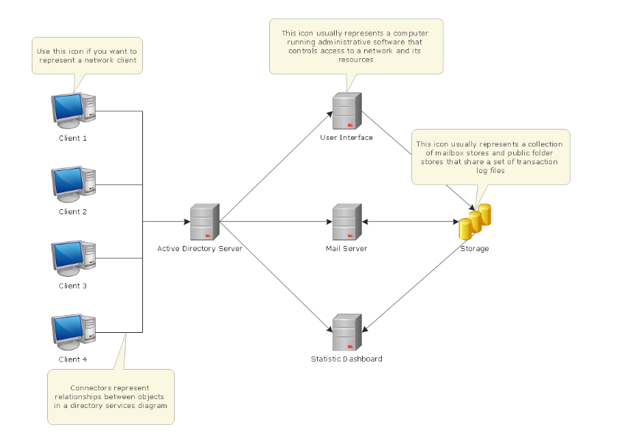
AD DS is a Microsoft directory service that manages user identities, auth, access control in a Windows network. It organises users, computers, and resources into a hierarchical structure using domains, OUs, GPOs while making sure to account for security, scalability, and efficient resource management via replication and access control mechanisms.
A diagram of AD DS, conceptdraw.com

There have been many attempts at compromising AD DS and the article provided by the NSA published in September 2024, “NSA Jointly Releases Guidance for Mitigating Active Directory Compromises”, addresses these techniques and provides insight on protective measures the user can take to combat said compromises.
Intense monitoring, using MFA and least privilege, boosting fault tolerance, placing DCs and backups helps boost the security of using AD DS.
1.4.4. CAs
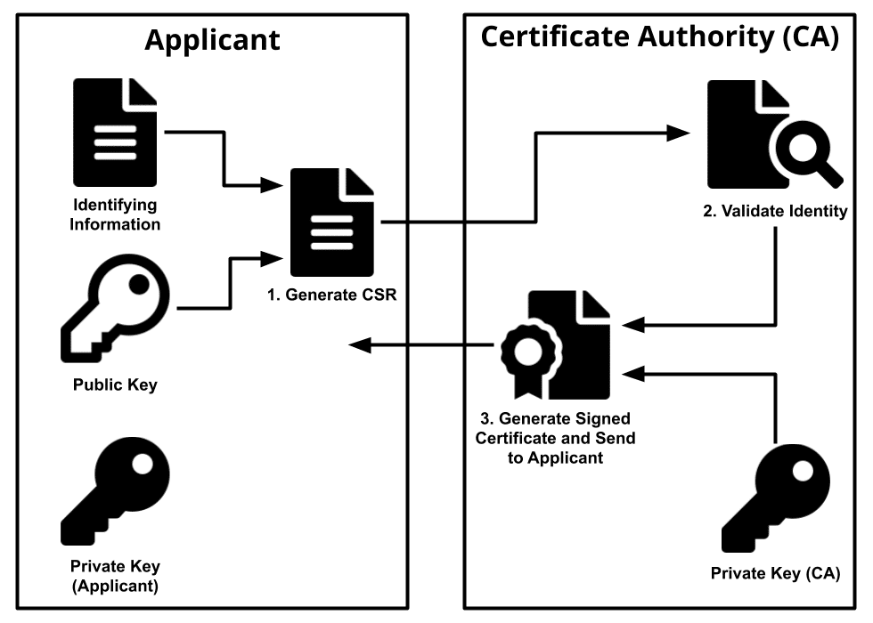
A CA manages digital certificates in PKIs. Through public/private key cryptography and idealising CRLs and OCSP, they ensure the data’s integrity and confidentiality remains.
Diagram of a CA, ssl.com

Securing the Root CA, using a multi-tier CA architecture, and implementing strong key management with HSMs helps increase data safety.
However, this article, “Clients Connected via Virtual Private Network (VPN) Do Not Renew Certificates Automatically”, published in Gradenegger’s Tech Blog in August 2024, discusses issues where the CAs of VPN connected clients cannot renew automatically, causing connection issues upon expiration. It underscores the importance of ensuring that the process of renewing the CA can help keep communication secure.
To make sure a CA renews automatically, auto-enrolment can be used, and certificate management tools, monitoring, and sometimes even the ACME protocol.

Task 2: Building and deploying the network
2.1. Choice of Hypervisor
Type 1 hypervisors are much more performant and useful in larger settings. However, this topology will be using the Oracle VirtualBox type 2 hypervisor for these reasons:
- The platform is free.
- The user-friendliness makes it much easier to understand and navigate.
- The setting does not require performance as good as that of a bare-metal hypervisor.
2.2. Download and Setup
The Oracle VirtualBox was already downloaded on the computer used. On it was downloaded Windows 11’s .iso and Windows Server 2022.
For Linux, the Debian server and Debian client was downloaded.
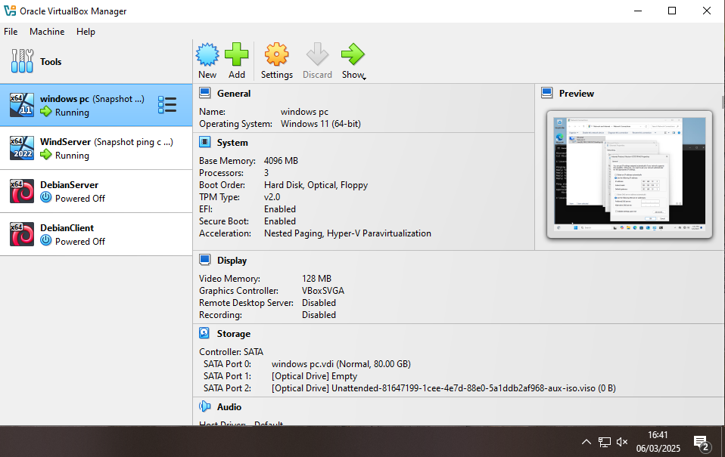
All four VMs installed.
We enable one adapter for the clients and two adapters for the servers. This is due to the clients only needing to connect to their respective servers and the servers needing to connect to both the clients and each other. We connect everything to NAT (the local network) and on different adapters:
Adapter 2 will have client to server and Adapter 3 will have server to server.
intnet is Windows client to server, intnet2 is server to server, intnet3 is Debian server and client.
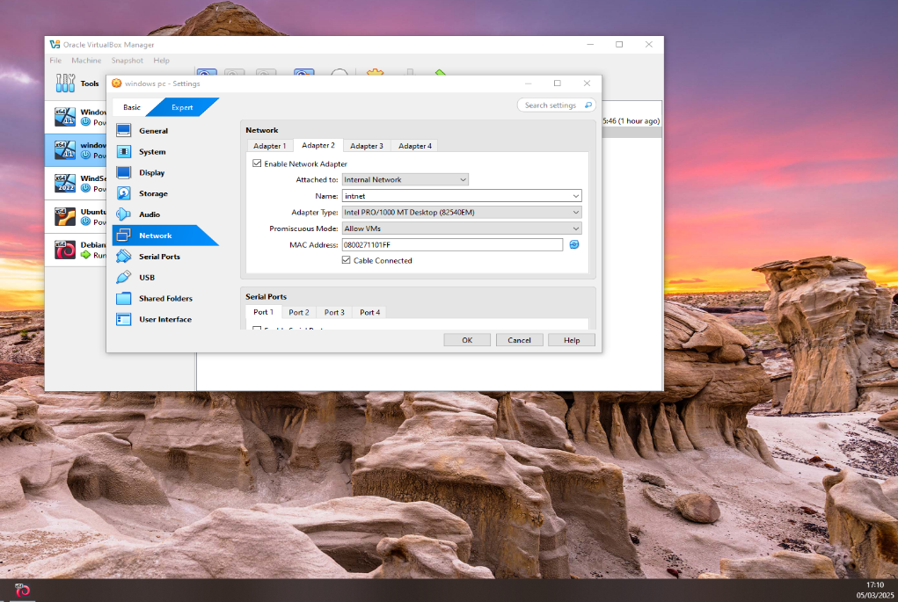
Windows client with a set up intnet network (client to server)

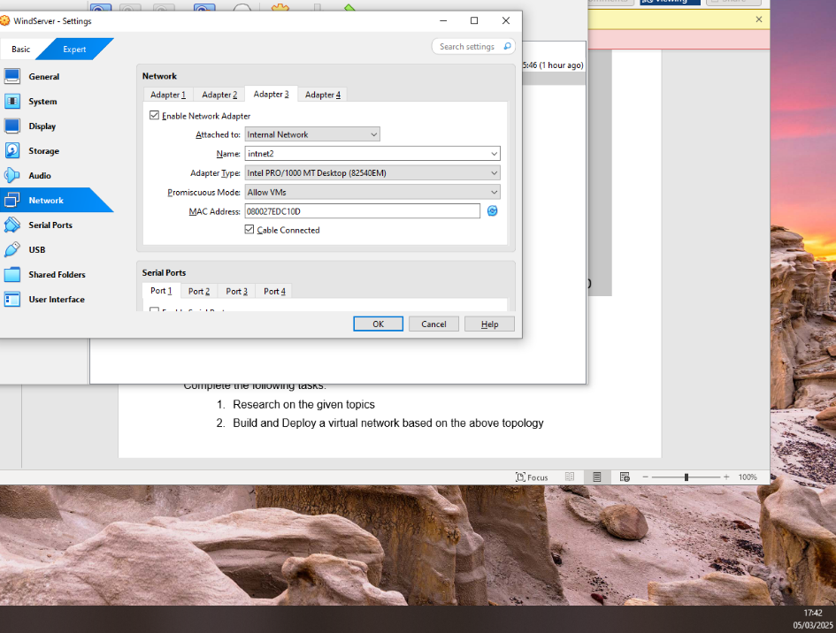
Windows server connected to intnet2 (server to server)
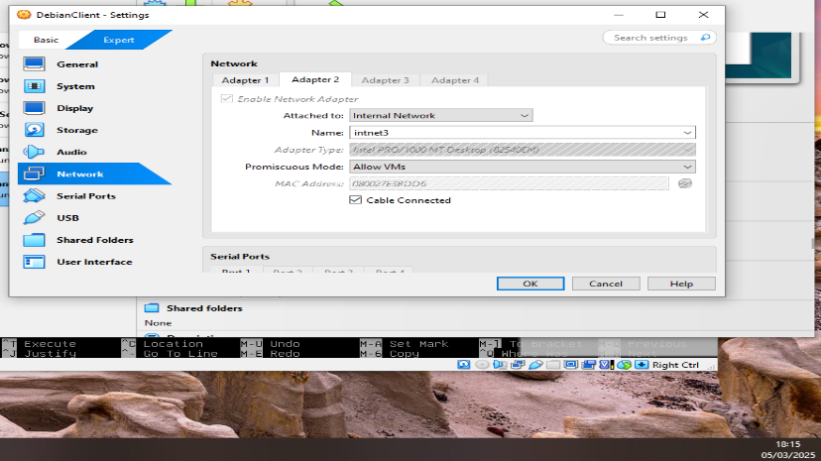
Debian client connected to intnet3 (client to server)
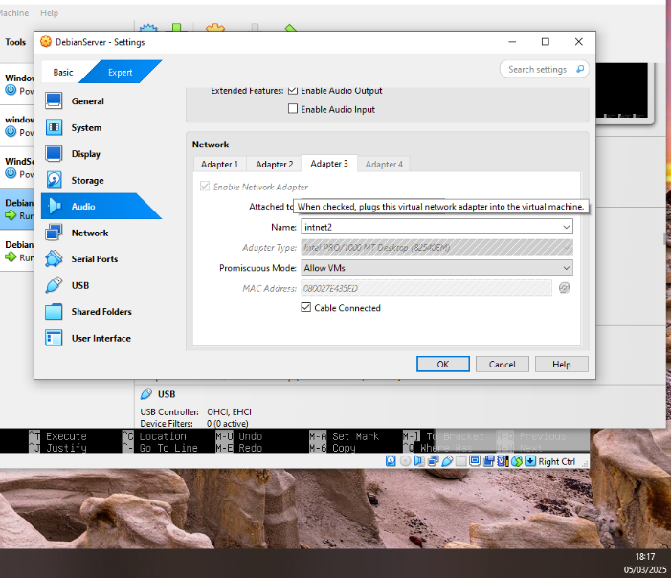
Debian server connected to intnet2 (server to server)
N.B.: The names have changed and the adaptors have been switched around however the functionality is still there.

2.3. IP Address Configuration
For Windows:
The IPs for the PC and server respectively have been assigned through intnet and intnet2. Through MAC address and then network connections, the intnet connections are found then assigned an IP address. The IP for the client and server connections are 192.168.10.4 and 192.168.10.1 respectively, with netmasks of 255.255.255.0 . On the client, we assign a default gateway equal to the server’s IP so connection is fluid. Externally on the server, the IP is set to 192.168.135.2, with a netmask of 255.255.255.252 .
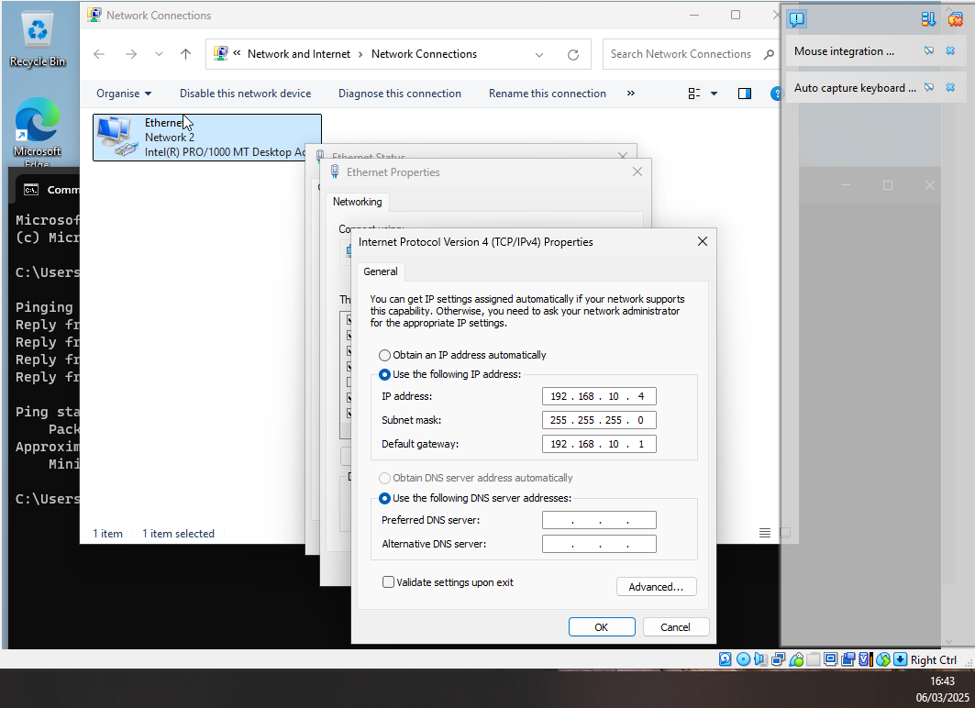
Ipconfig on PC (intnet).
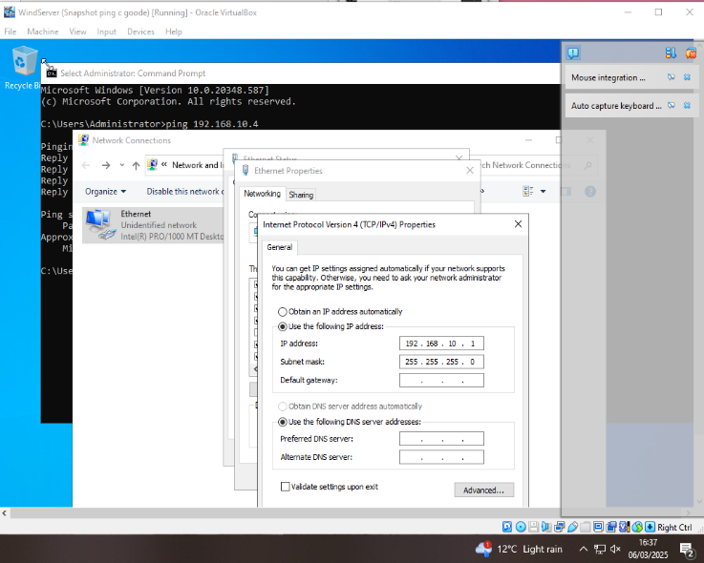
Ipconfigs on server, intnet (left) and intnet2 (right)

For Linux: going into the nano editor to map internal and external networks via the method provided in the resource video, gives us the chance to set up an actual IP address to communicate in Linux. Our address for the server is 10.1.1.1 and for the client it will be 10.1.1.2 . Both will have a netmask of 255.255.255.0 . Externally on the server it will be 192.168.135.1, with a netmask of 255.255.255.252 . Additionally, we run ip ad to make sure the IP addresses are in place.
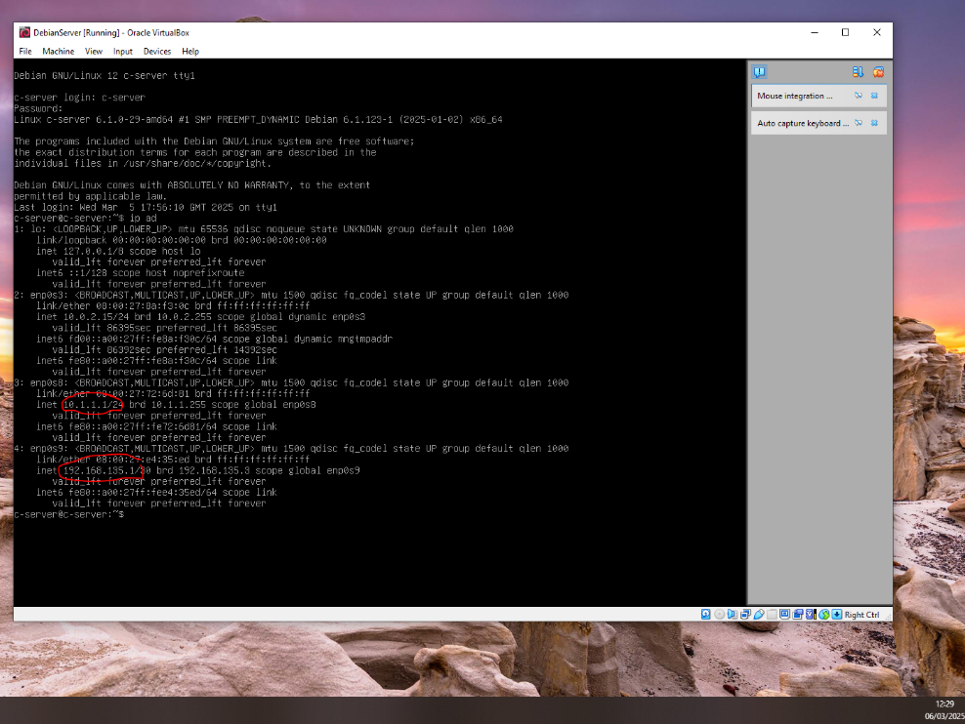
ip ad ran on the Debian server, showing the IP addresses
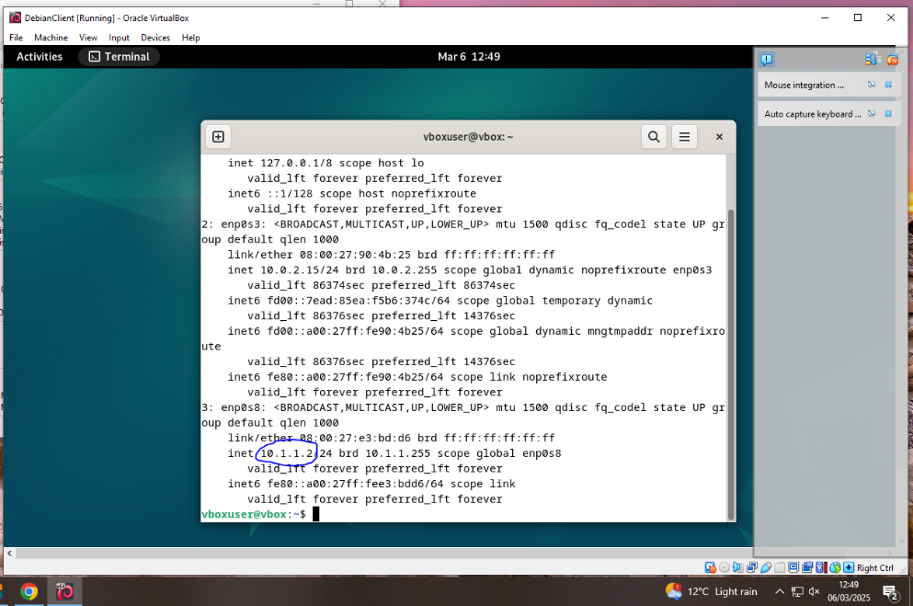
ip ad ran on the Debian client, showing the IP address

The IP addresses set up, we are left with a final topology that should look like this:
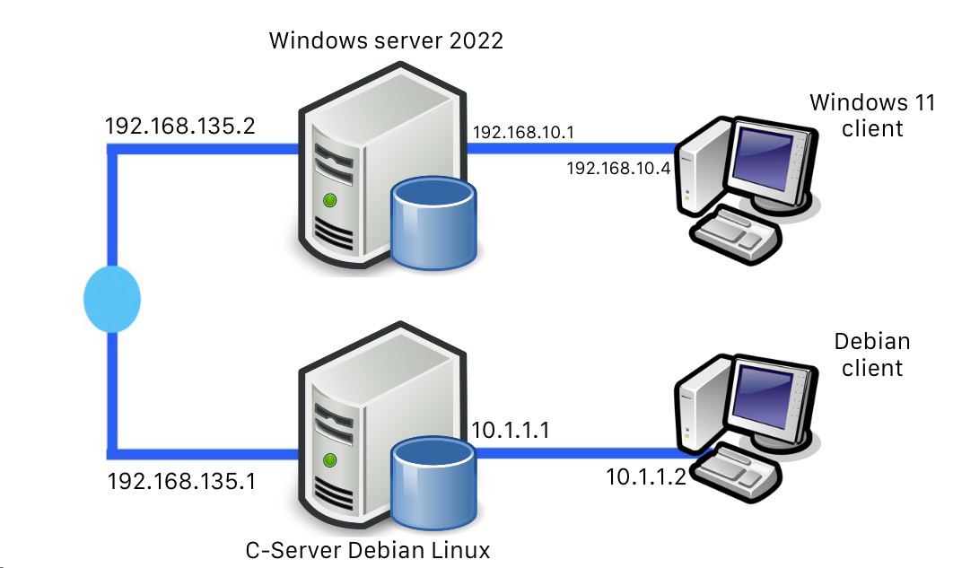

2.4. Testing and Troubleshooting
After setting up the pings on Windows, we are left with the results:
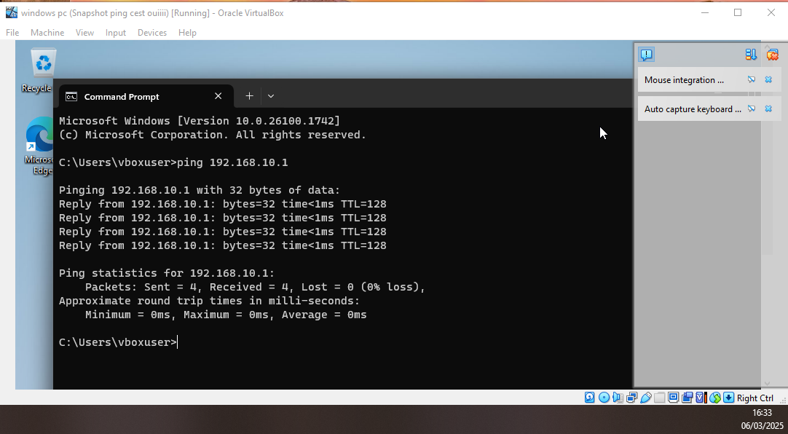
Successful ping from the client PC to the server
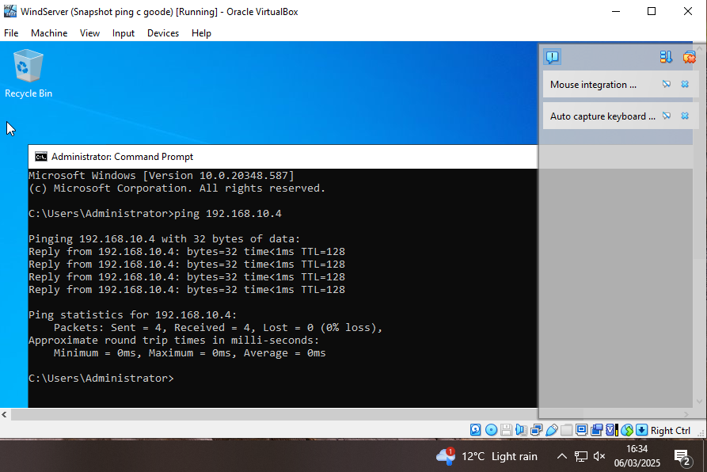
Successful ping from the server to the client PC

On Linux, similar positive results arose and the pings between Debian client and server worked.
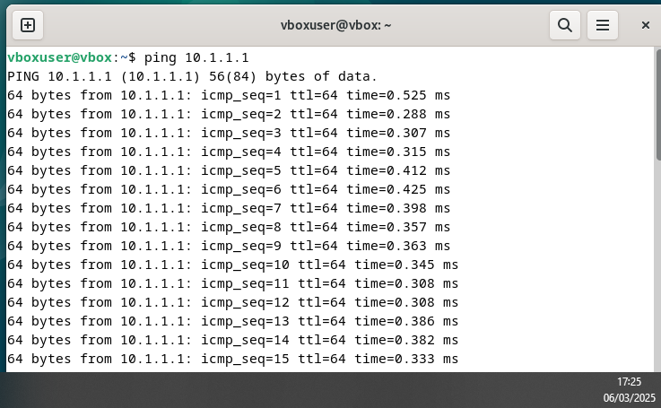
Successful ping from Debian client to server.
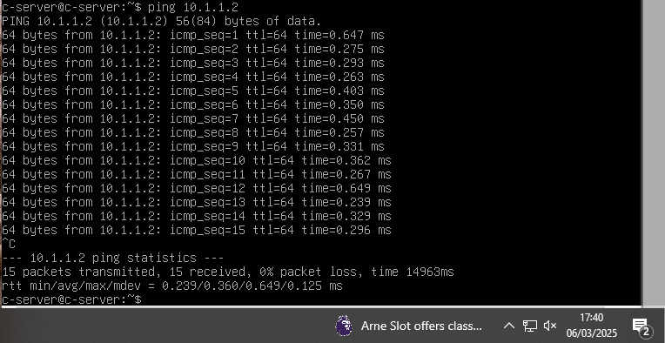
Successful ping from Debian server to client.

According to the topology, the Windows client cannot ping the Debian client, or vice versa.
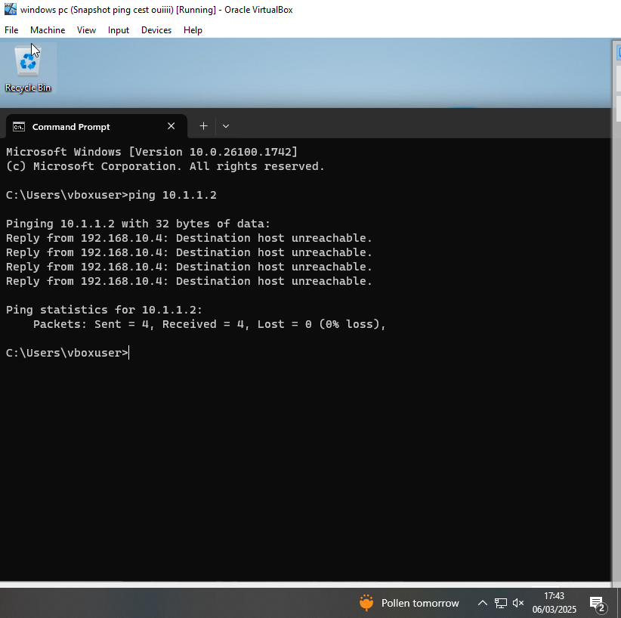
Destination host unreachable. Pings cannot go through one client to the other.
Now for intra-server pings. Through the connectivity of the adapters and external network linking the Debian server and the Windows server are allowed to communicate.
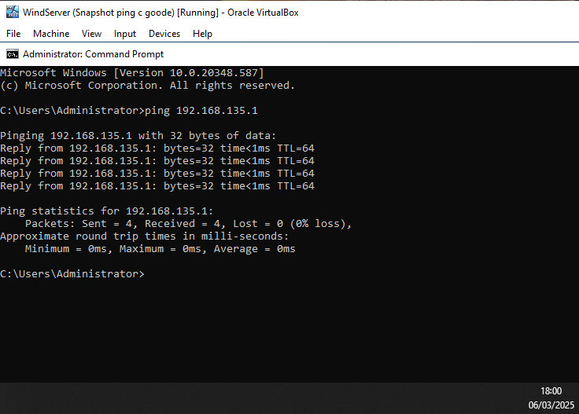
Windows server successfully pinging the Debian server.
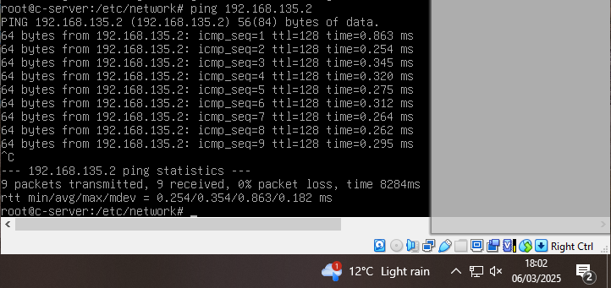
Debian server successfully pinging the Windows server.
Task 3: Reflection
3.1. Technical reflection
Deploying the network was a tough task. DNS issues like the addition of the default gateway was rudely reflected on. The solution to that issue was implementing one on the client’s end for it to divert the ping to the server. The firewalls were also a typical “blink-and-you’ll-miss-it” error where disabling them actually made the pings work.
3.2. Personal reflection
This coursework was challenging; being thrust into a format so unfamiliar in a course no prior knowledge was given – is an incredible feat to complete. However this coursework has allowed for the gain of basic knowledge on the topics addressed, and an important milestone in the field.

