University of Wales Trinity Saint David
Student: Costin-Alexandru Chirita (2210952)
Lecturer: DR. Zahra Mohammadnazari
LCBB5000

Data Handling & Business Intelligence
Table of Contents
Section 1 3
Introduction 3
Part 1 3
Part 2 18
Part 3 22
Conclusion 28
Section 2 29

Figure 1 3
Figure 2 4
Figure 3 4
Figure 4 5
Figure 5 6
Figure 6 6
Figure 7 7
Figure 8 8
Figure 9 8
Figure 10 9
Figure 11 10
Figure 12 10
Figure 13 11
Figure 14 12
Figure 15 12
Figure 16 13
Figure 17 14
Figure 18 14
Figure 19 15
Figure 20 16
Figure 21 16
Figure 22 17
Figure 23 17
Figure 24 18
Figure 25 19
Figure 26 19
Figure 27 20
Figure 28 21
Figure 29 21
Figure 30 22
Figure 31 23
Figure 32 23
Figure 33 24
Figure 34 24
Figure 35 25
Figure 36 25
Figure 37 26
Figure 38 27
Figure 39 27
Figure 40 28

Section 1

Introduction

As businesses progress and increase in size, more and more types of data are stored and classified. All the data that is stored must be sorted and prepared, so that it can be processed, and the desired results extracted from it. Below we have been tasked to extract certain points from a data set, i.e. the mean, median and mode value, standard deviation, along with representing these in a manner that is easy to understand, with the help of Microsoft Excel and SPSS Statistics.

Part 1

- The mean value for coffee consumption per day is an average of how many cups the interviewed people drink and is calculated by dividing the total number of cups by the total number of people. We can calculate it using Microsoft excel, as follows:
  - Select an empty cell and call the function by typing =AVERAGE(.

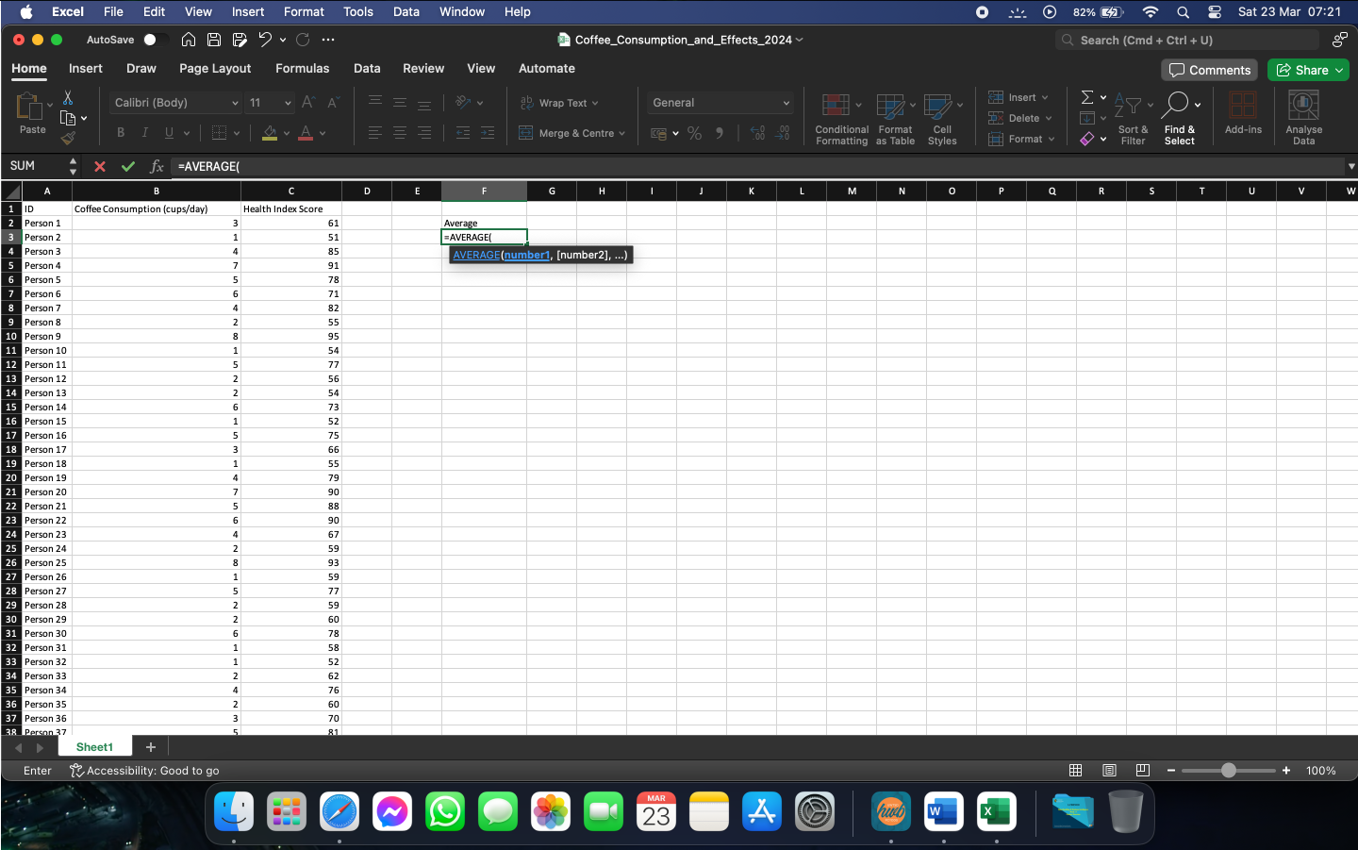
Figure 1
  - After the function is called, we can select the data array we need to calculate the average for and close the brackets after it.

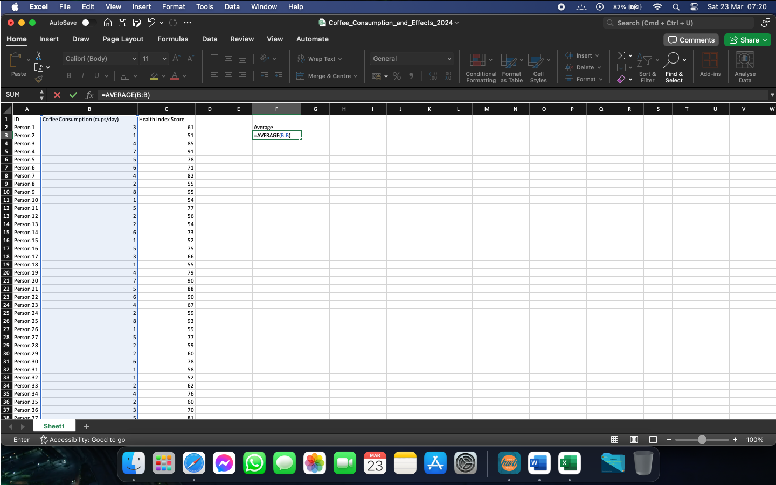
Figure 2

  - By pressing Enter, Excel will return the result we needed. For our given set of data, the mean value for cups of coffee consumed per day is 3.625.

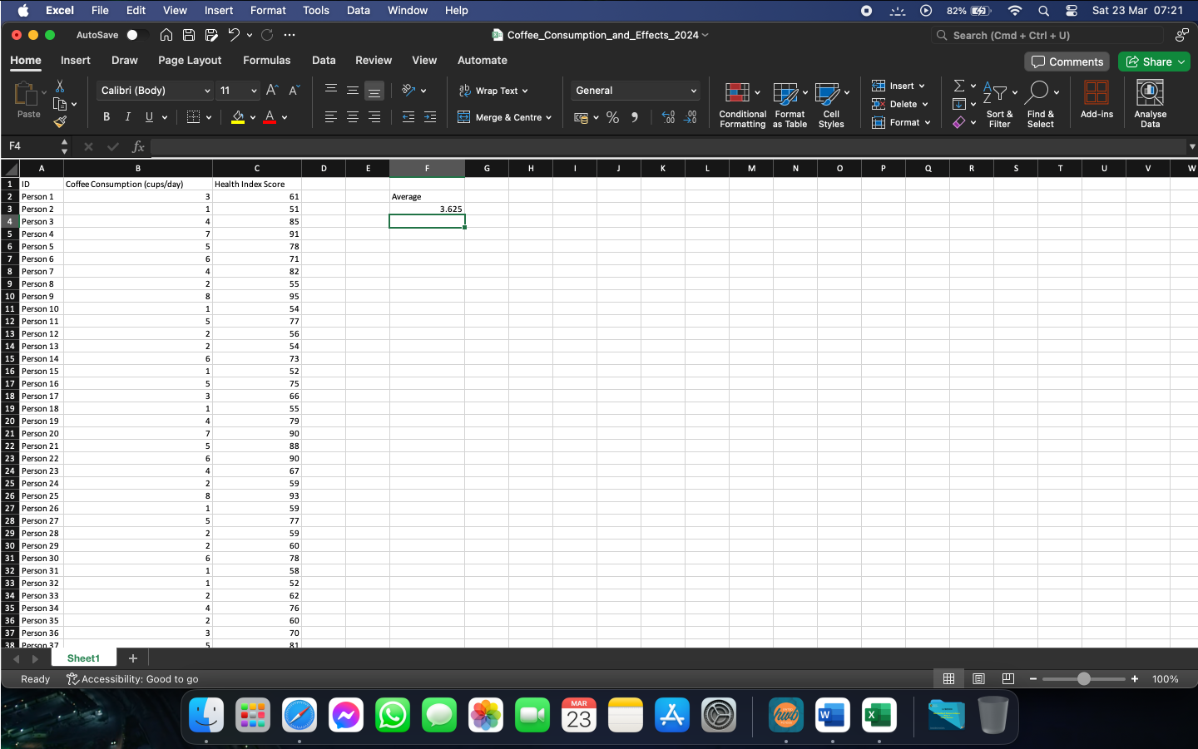
Figure 3

- The median value is the value in the middle of an array, after the array is sorted from lowest to highest. An array can have 1 or 2 median values. If the array has an even number of variables, the function will return only 1 median. If our array has an odd number of variables, then the function will return the 2 middle values, or the average of the 2 values. To find the median value, we can use the following function:
  - Select an empty cell and call the function =MEDIAN(.

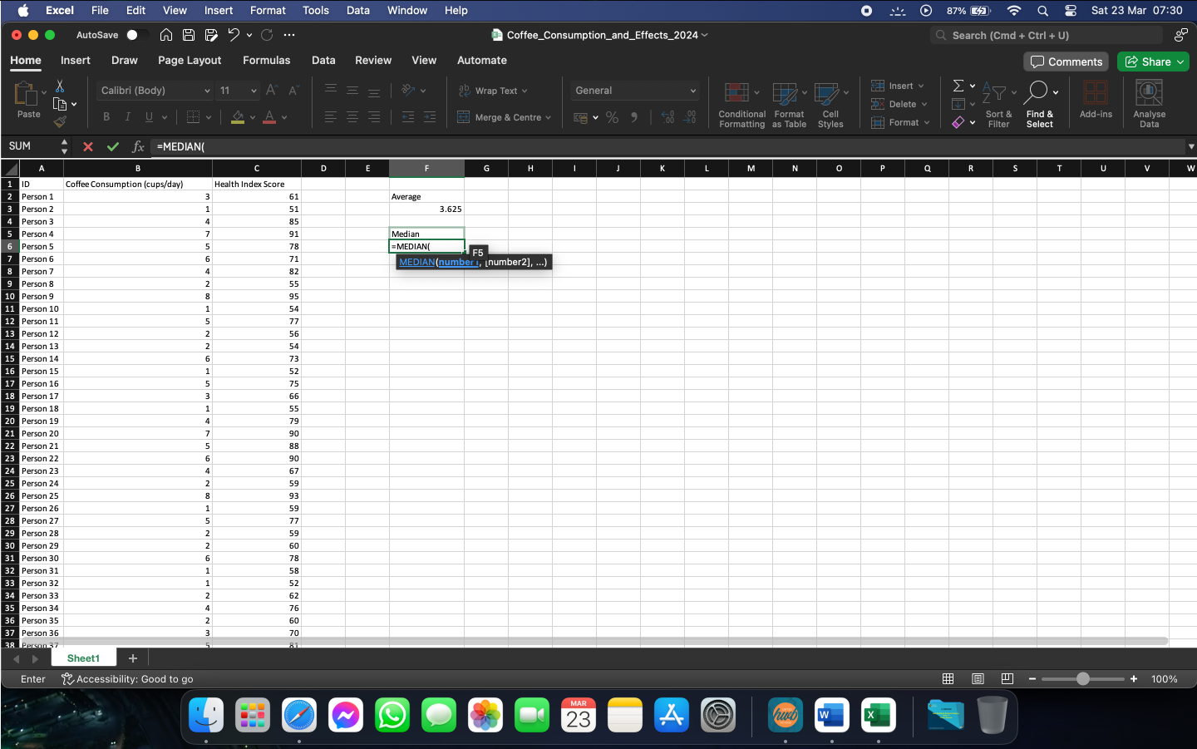
Figure 4

  - We can then select the array we need to get the median for and close the brackets.

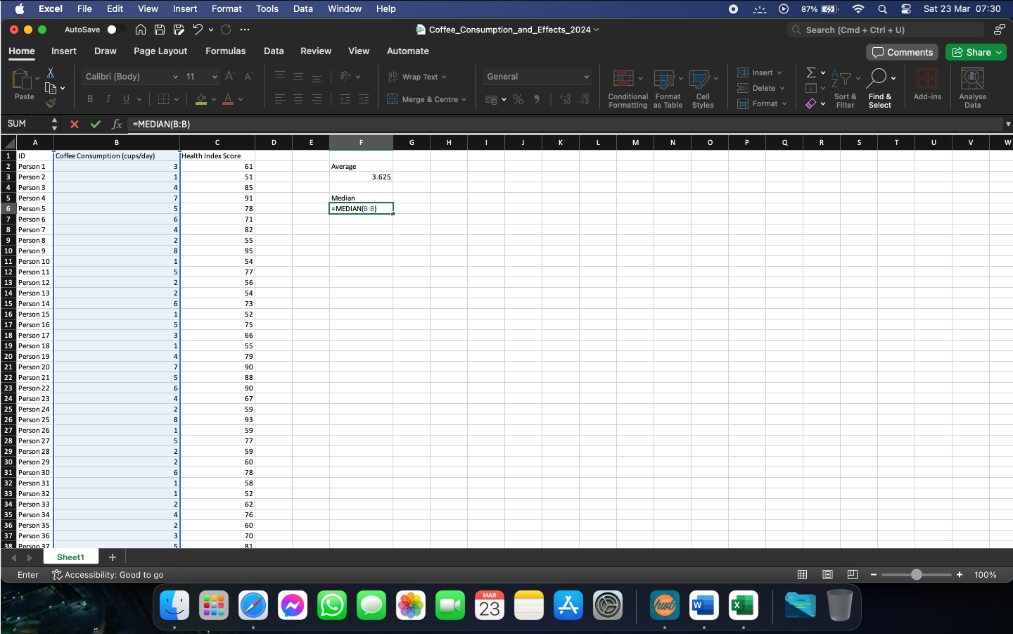
Figure 5

  - Press Enter to obtain the result needed. In our case, the median value is 3.5 cups per day.

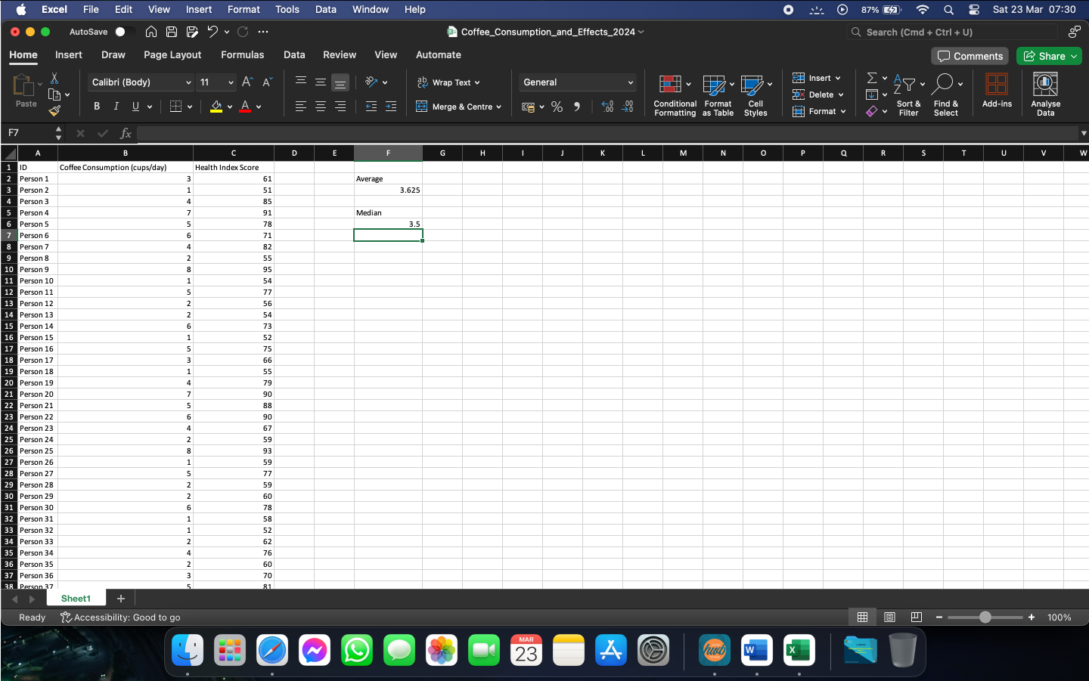
Figure 6

- The mode of a data set is the value that is being repeated the most number of times in the given data set. We can use Excel to help us find it, by using the following:
  - Select an empty cell and call the function by typing =MODE(.

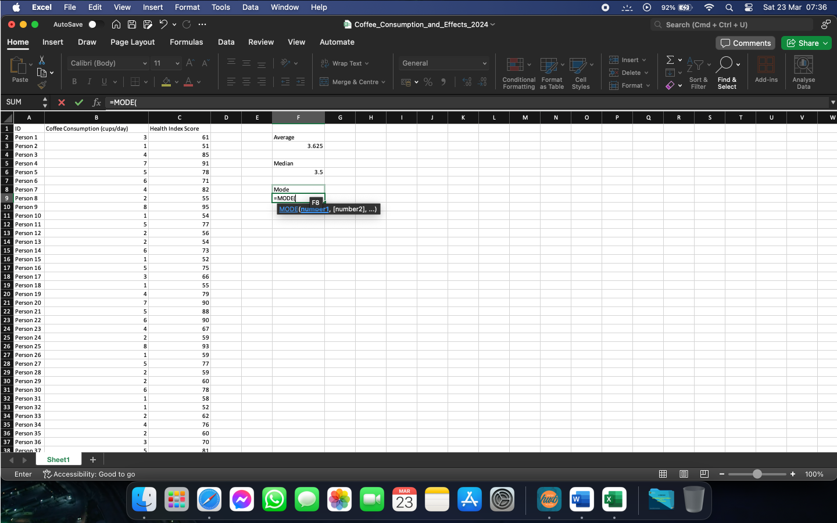
Figure 7

  - Select the data array we need to mode for and close the brackets after it.

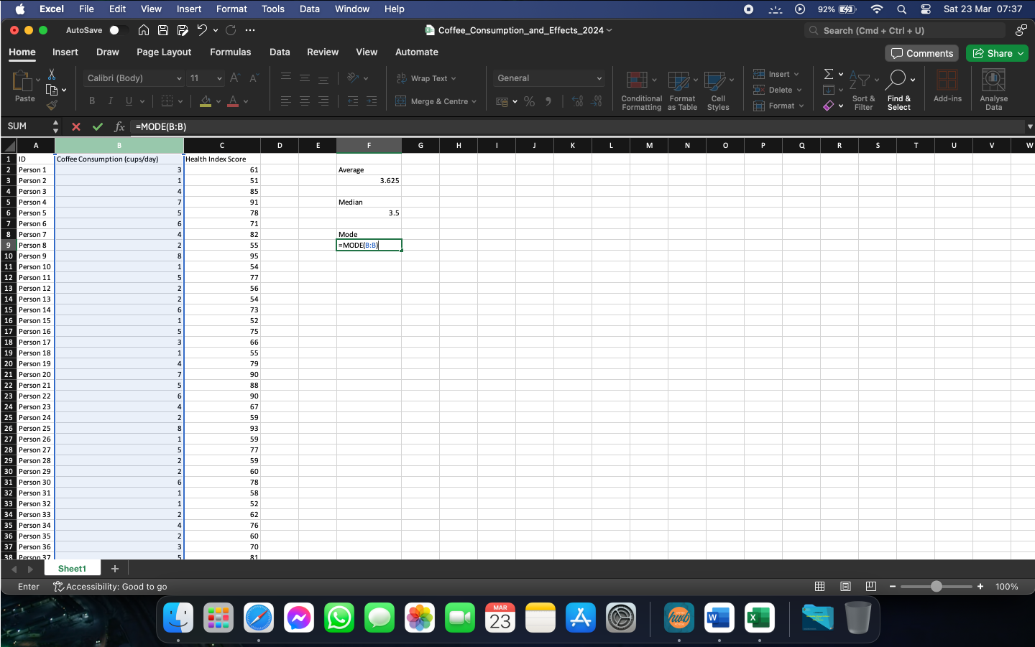
Figure 8

  - Press Enter to calculate the required value. In our case, the mode of the data array is 2.

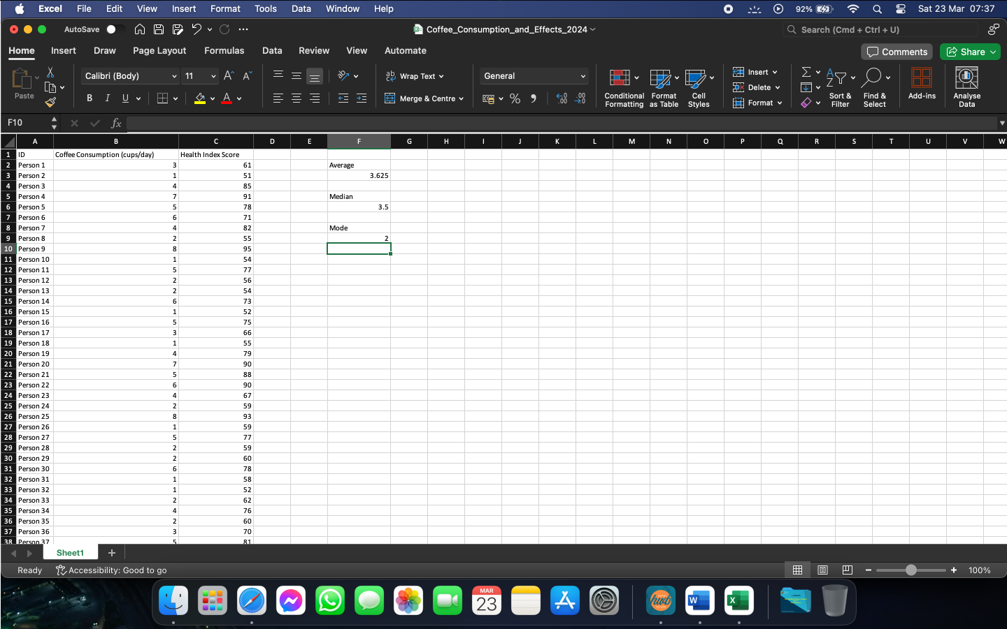
Figure 9

- The standard deviation of an array is the average amount of variability in that specific array. To calculate this using Excel, we can use the following steps:
  - In an empty cell, call the function by typing =STDEV(.

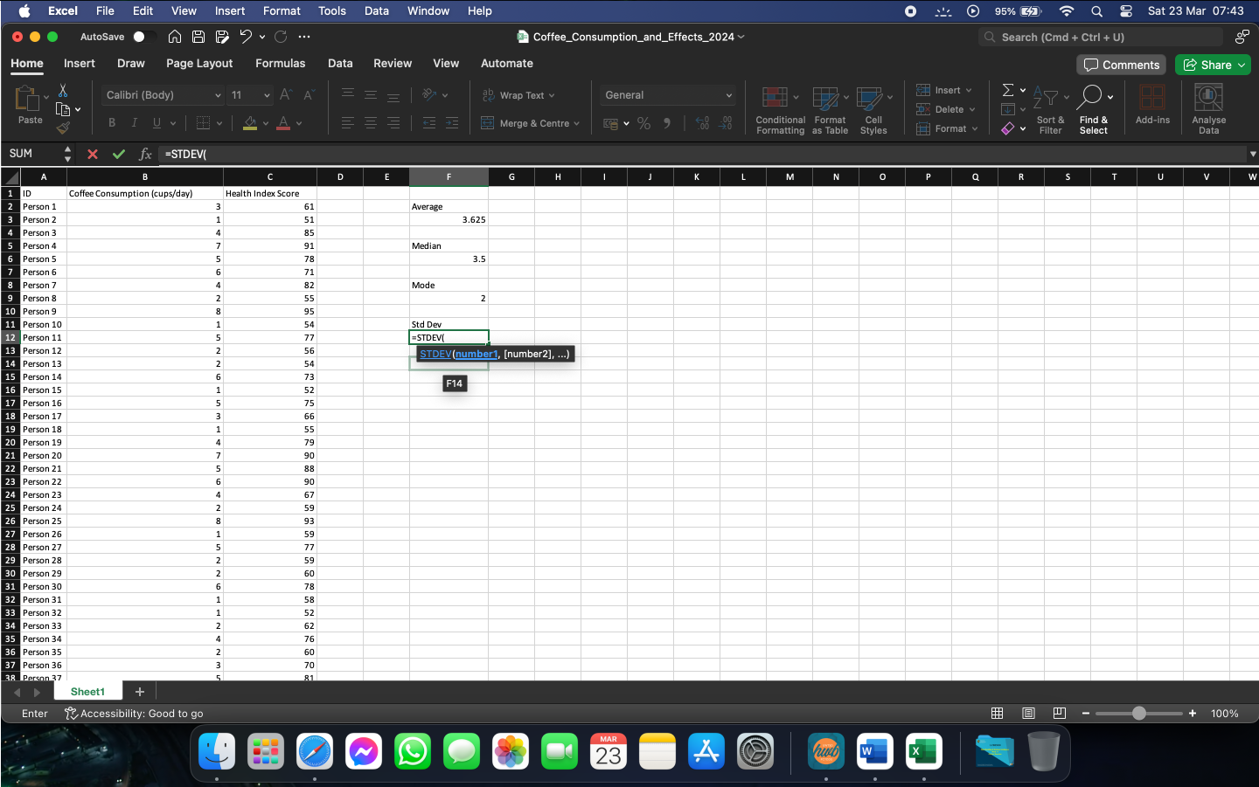
Figure 10

  - Select the array we need to calculate the standard deviation for and close the brackets after it.

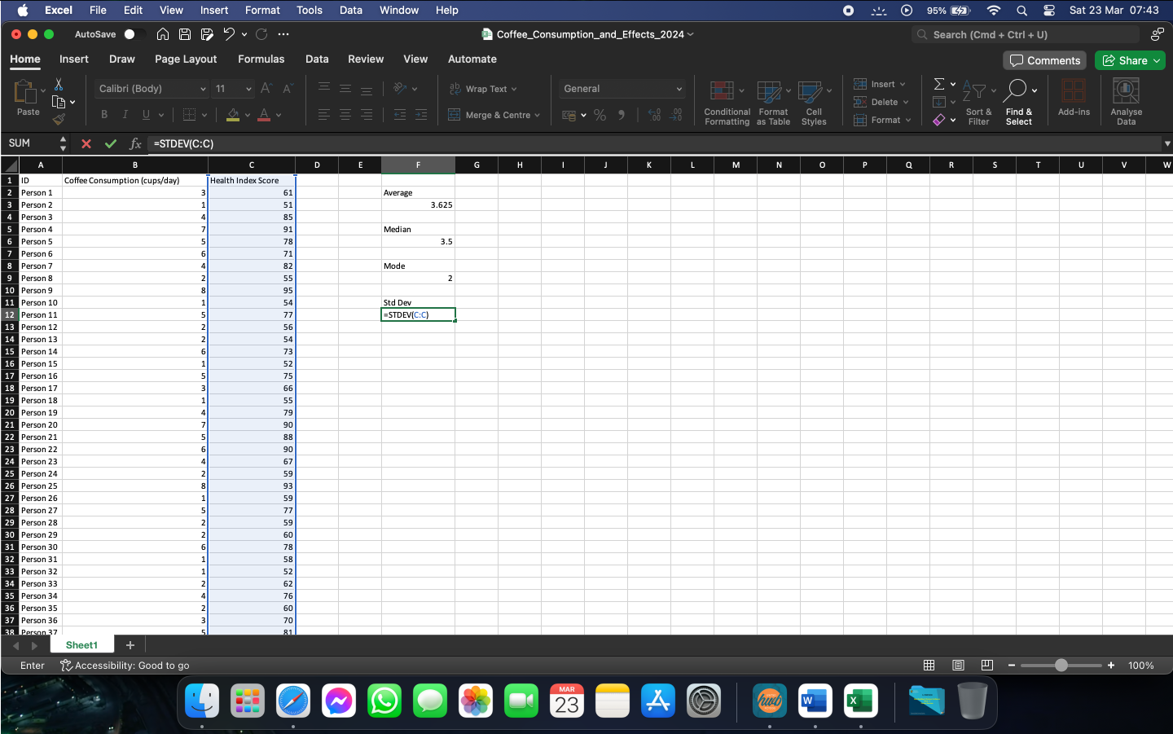
Figure 11

  - Press Enter to calculate the standard deviation. For our example, the value needed is 13.41236991.

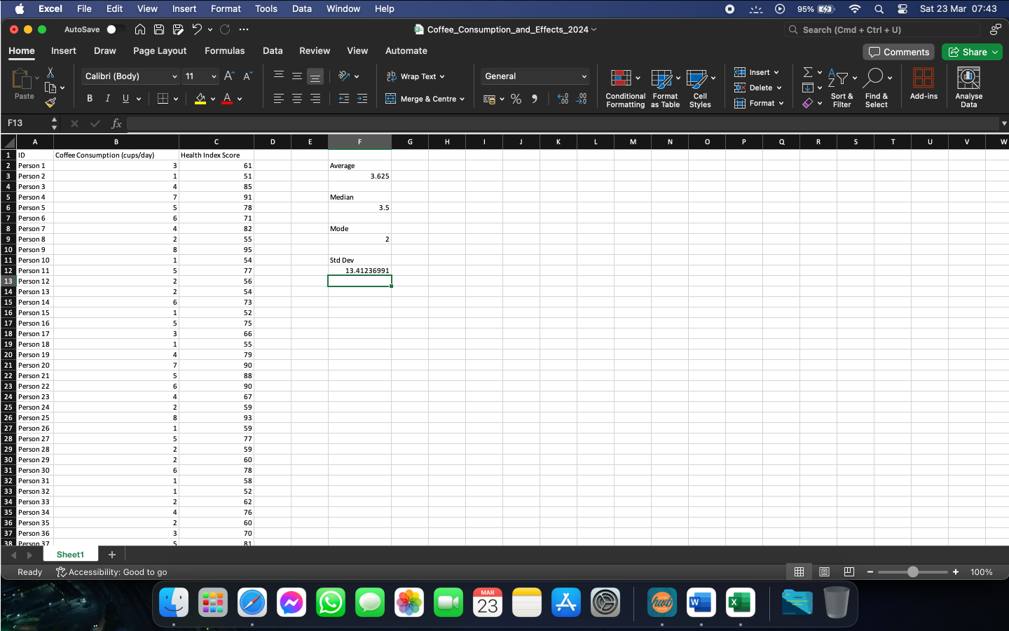
Figure 12

- Excel can be also used to compare 2 or more values, or to calculate and compare 2 or more values. In our example, we can calculate and compare the variance of coffee consumption and the variance of health index score, whilst requiring excel to return the higher value. We can calculate this as follows:
  - Select an empty cell and call the function =IF(.

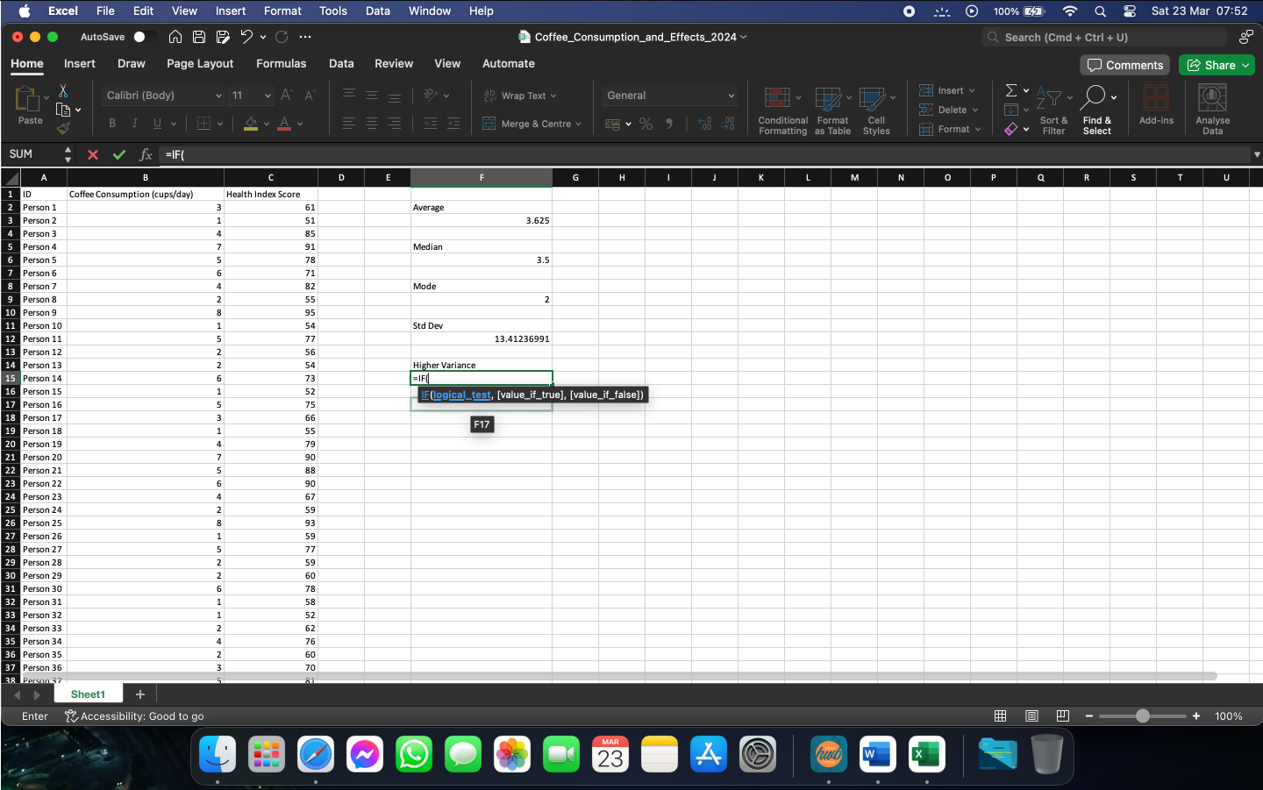
Figure 13

  - Call the function VAR( and select the needed array.

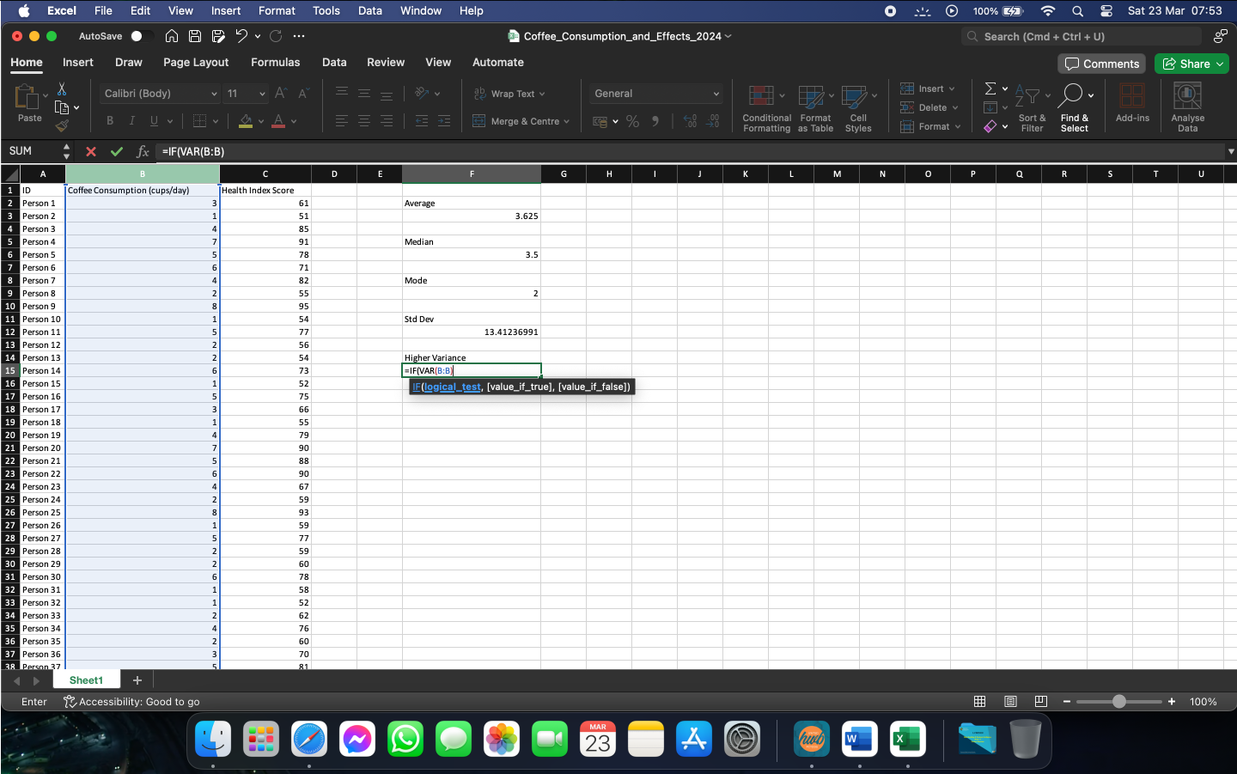
Figure 14

  - Instruct excel to compare it with the variance of the other array.

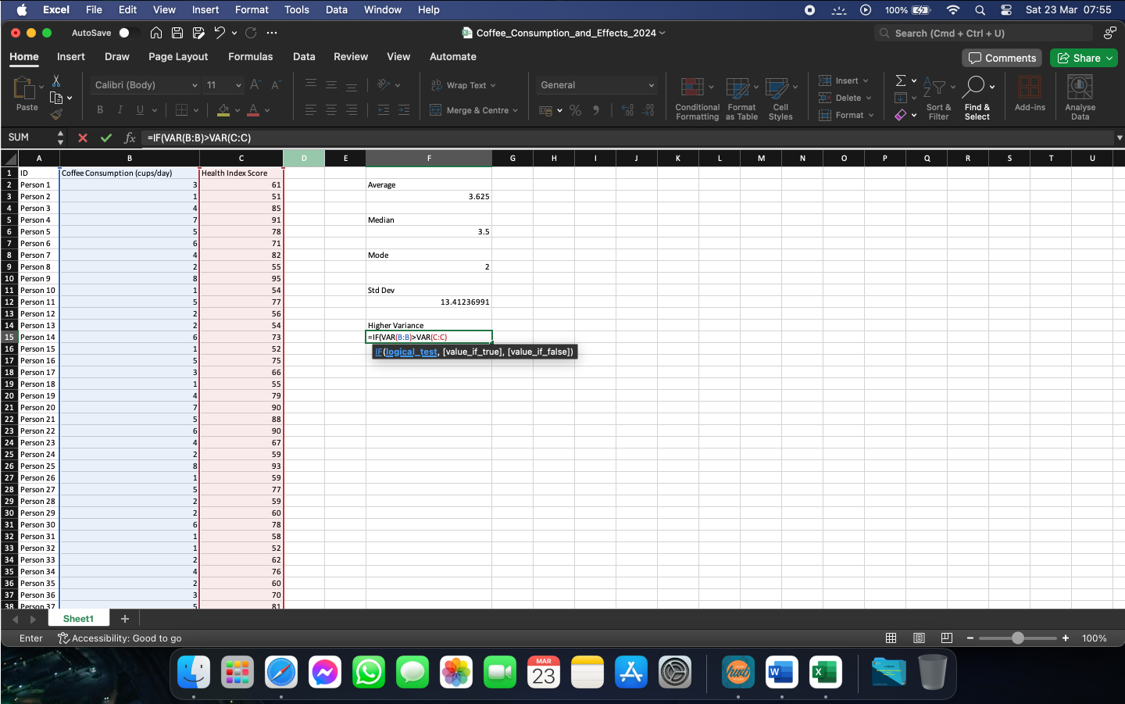
Figure 15

  - Insert the result we need to be displayed if the condition is true.

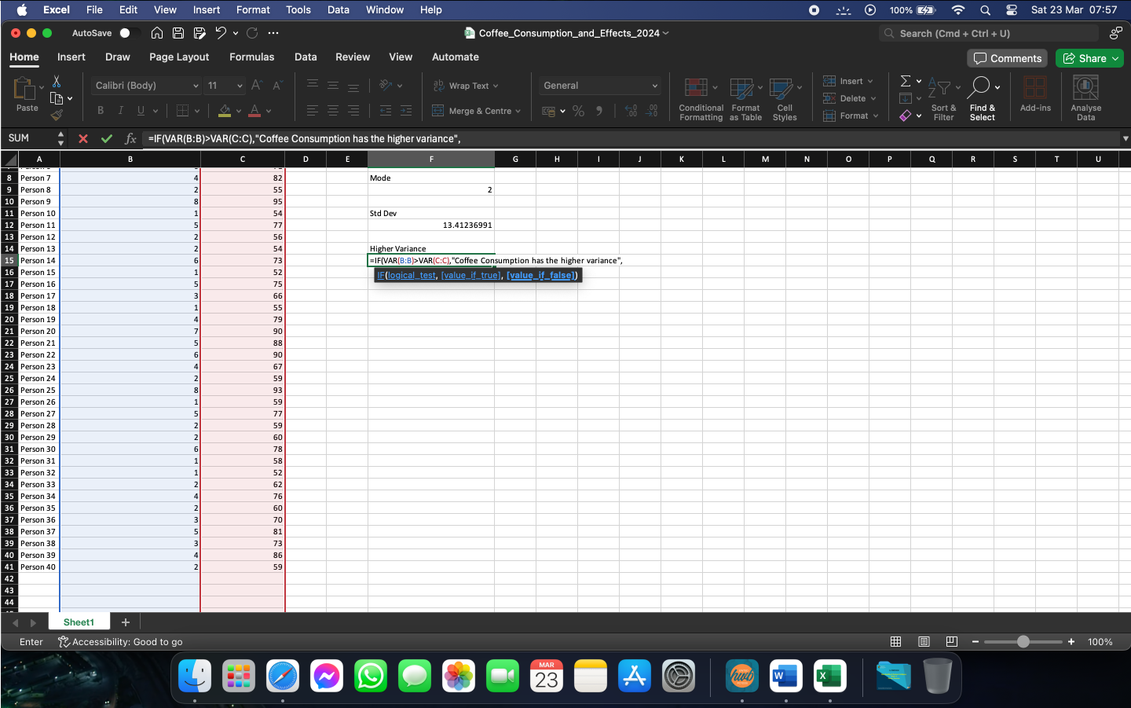
Figure 16

  - Insert the result we need to be displayed if the condition is false and close the brackets.

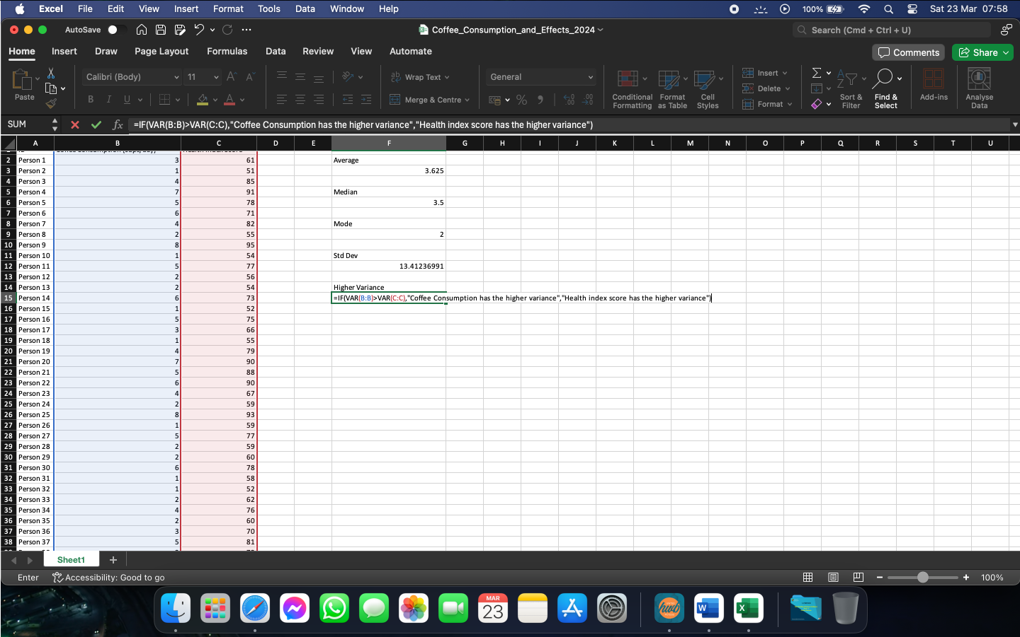
Figure 17

  - Press Enter to calculate the function and display the needed result. Given our set of values, the highest variance is with the Health Index Score.
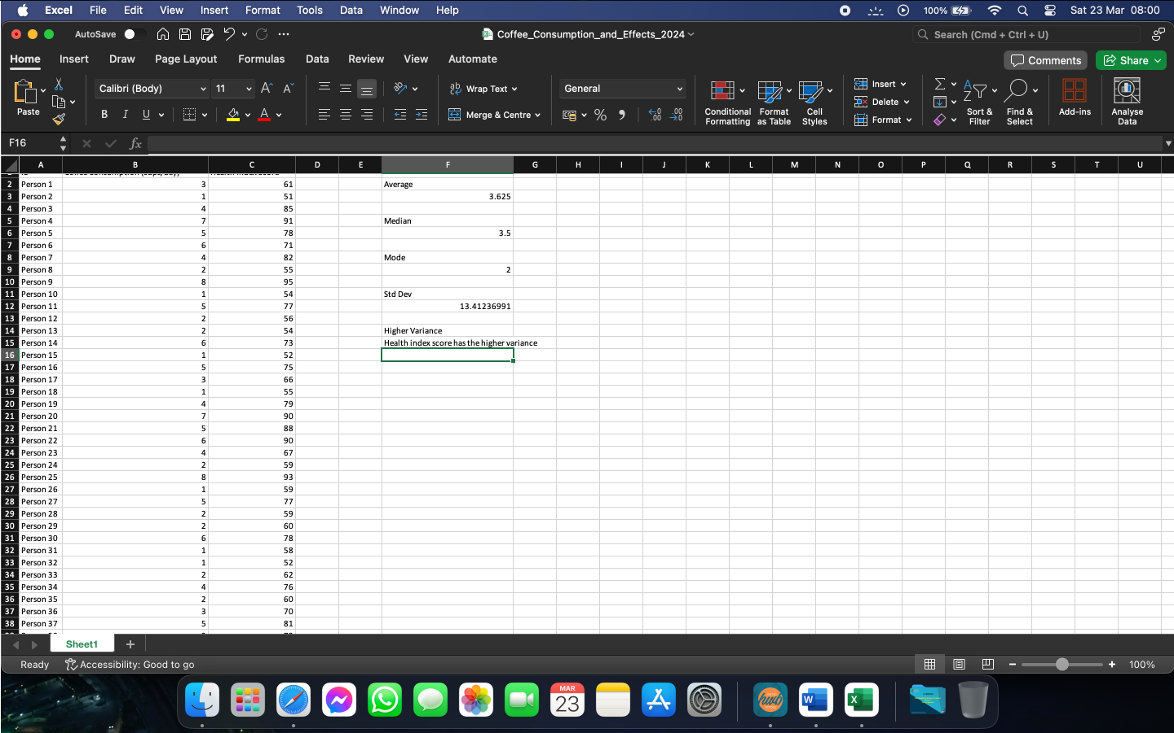
Figure 18

- Following similar steps as before, Excel can calculate and compare standard deviation of 2 or more sets of values and return a result that we can interpret accordingly. In order to do this, we can follow:
  - Select an empty cell and call the function =IF(.

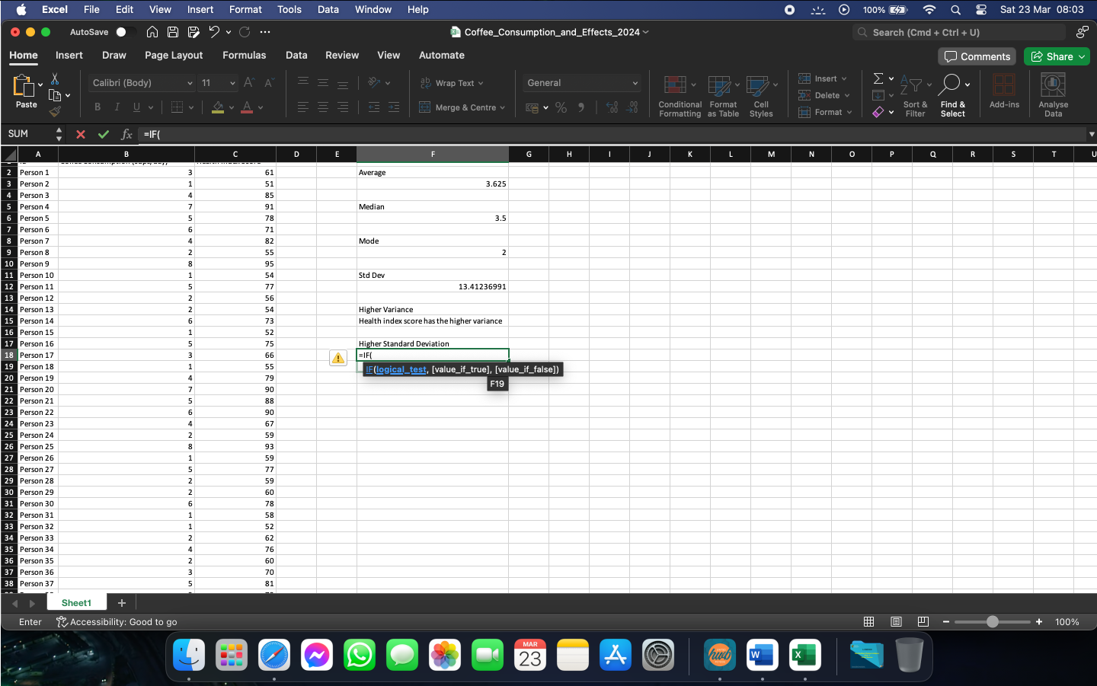
Figure 19

  - Inside the IF function, call the function STDEV( and select the array we want it calculated for.

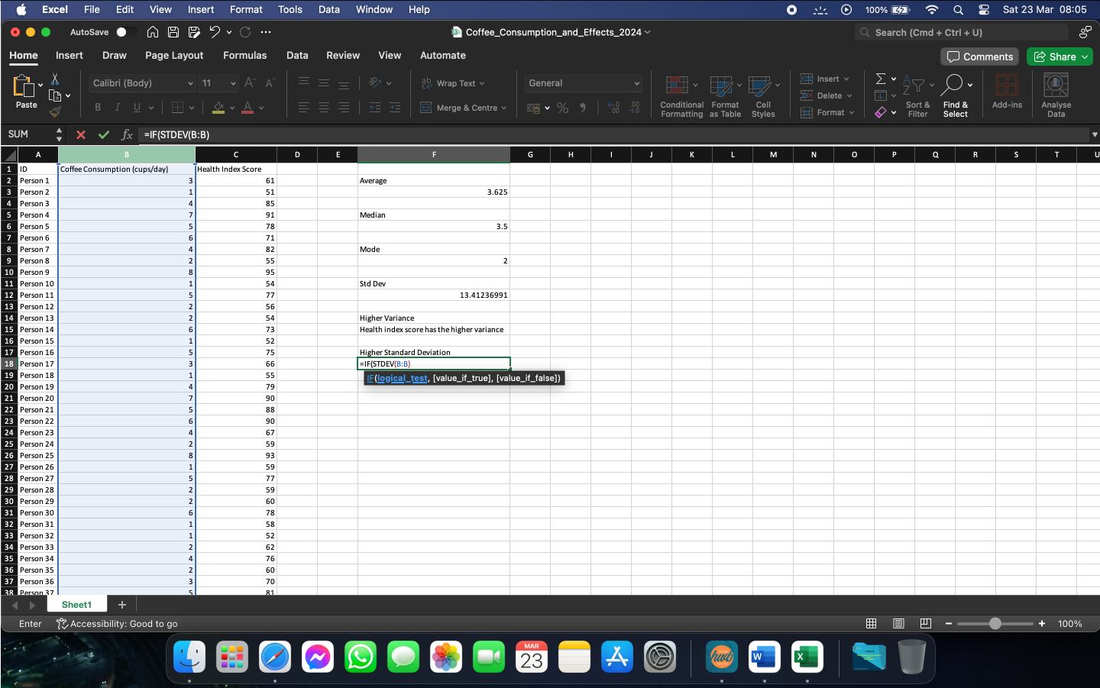
Figure 20

  - Compare it with the standard deviation of the other array of values.

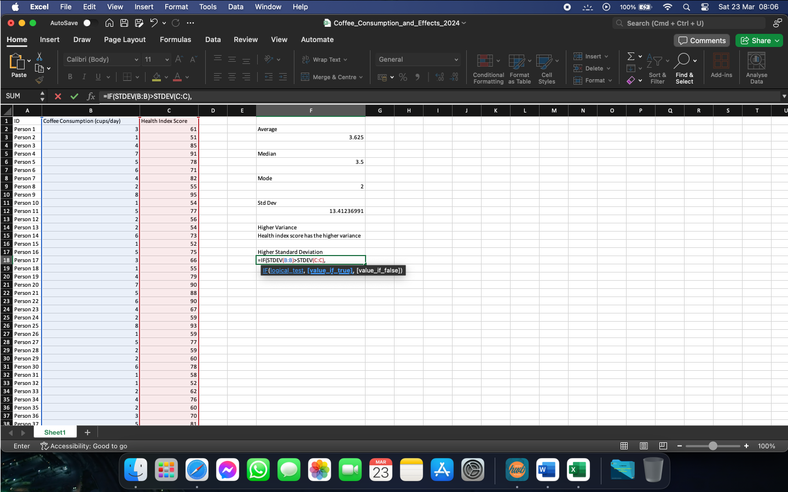
Figure 21

  - Insert the result to be displayed if the condition is true.

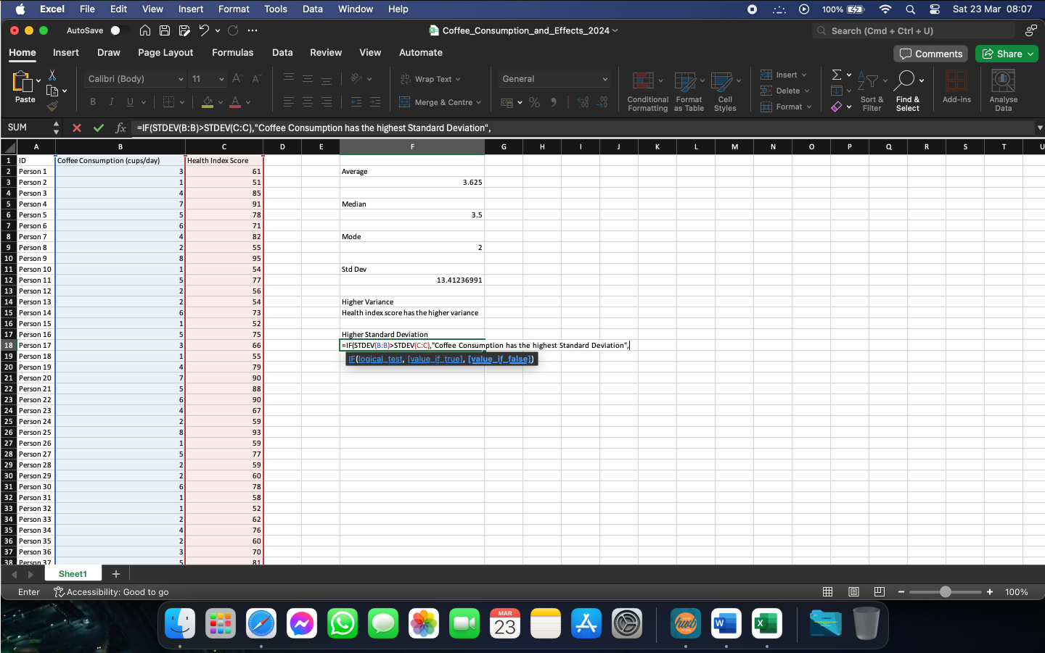
Figure 22

  - Insert the result to be displayed if the condition is false and close the brackets.

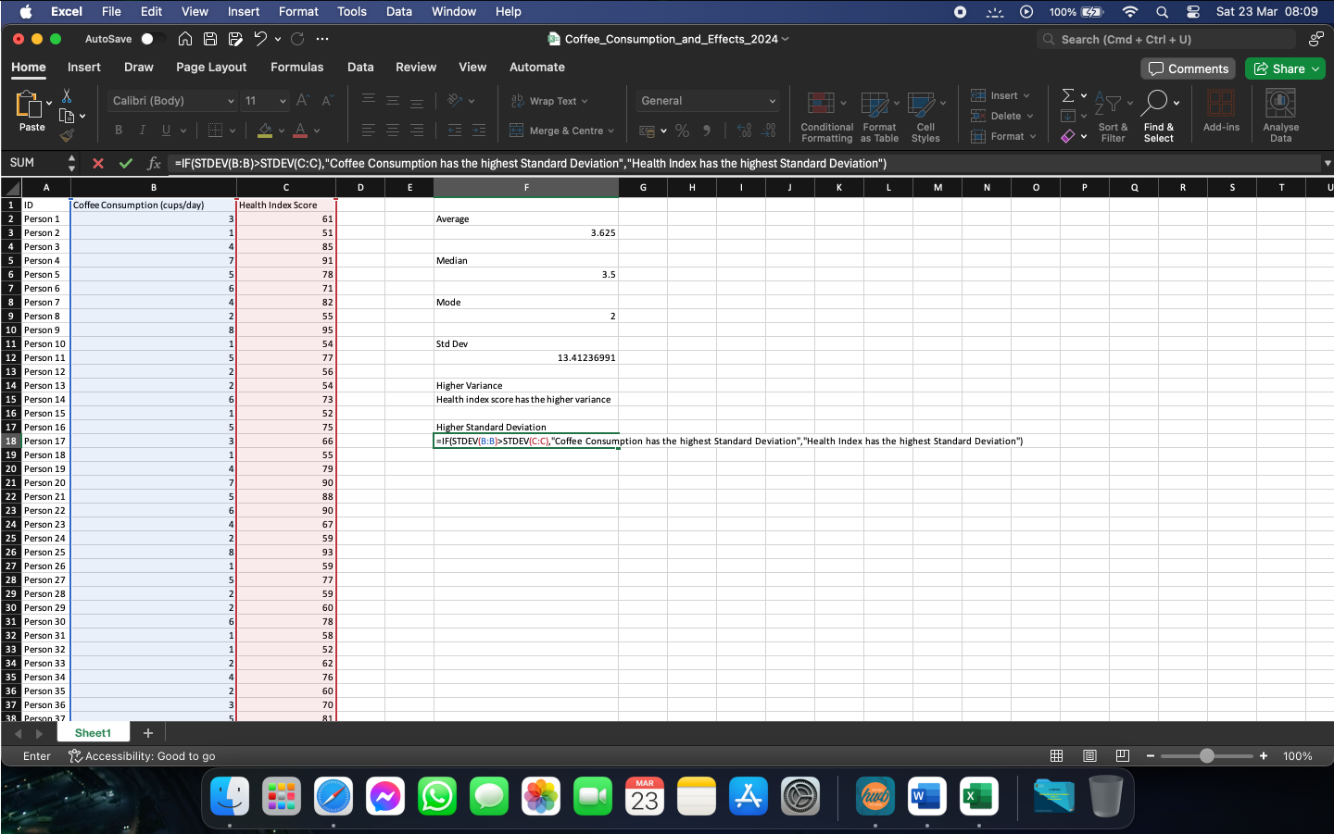
Figure 23

  - Press Enter to calculate and display the adequate value.

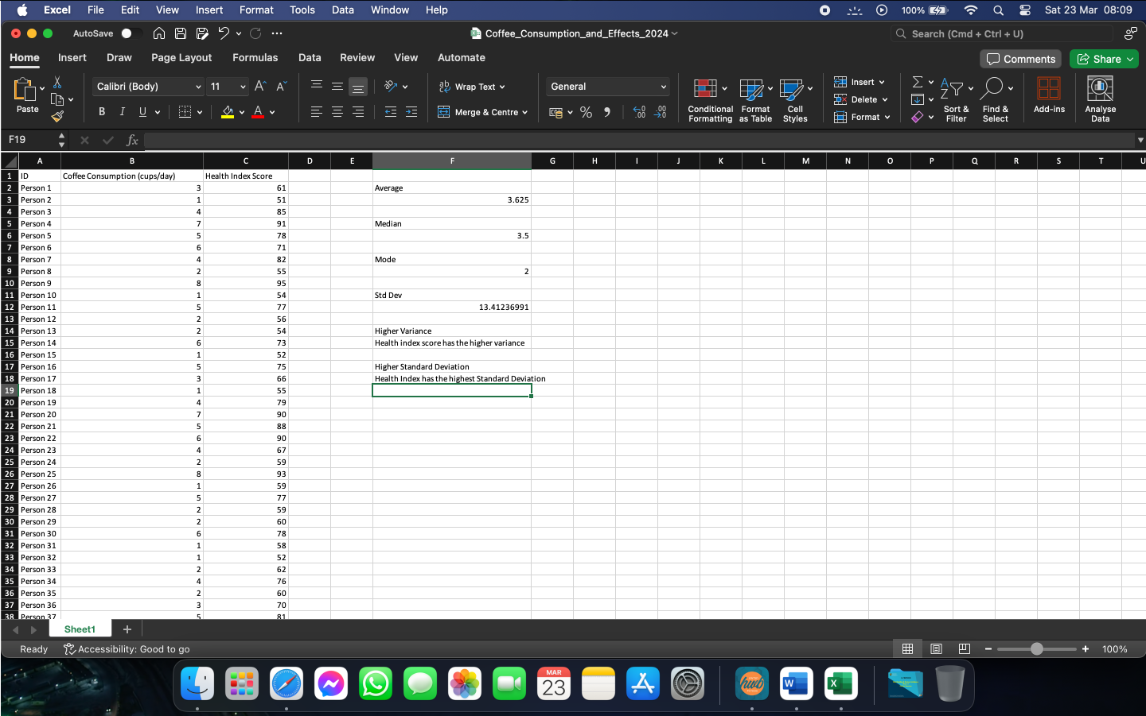
Figure 24

- We can interpret the last 3 values as following:
  - The standard deviation measures how dispersed are the individual values in relation to the mean. In our case, with a standard deviation of 13.41, we can observe that the number of cups of coffee consumed in most days is near the average of 3.625 cups per day.
  - By calculating and comparing the variances of the 2 data sets, we see that the Health Index has the highest variance. This means that the values found in the Health Index array are more spread out than the ones found in Coffee Consumption.
  - Calculating and comparing the standard deviation of our 2 data arrays allows us to see how the obtained values are in relation to the mean. A value that is closer to 0 means that the data points in that array are closer to the mean, whilst a larger Standard Deviation would signify that the values in the data set are spread further away from the mean value.

Part 2

Microsoft Excel’s functions can be used to interpret different arrays of data in ways that are easier to understand. One example of this would be showing how the number of coffee cups consumed in a day can impact the Health Index Score. To achieve this, we can use the following:

- Select an empty cell and call the function =CORREL(.

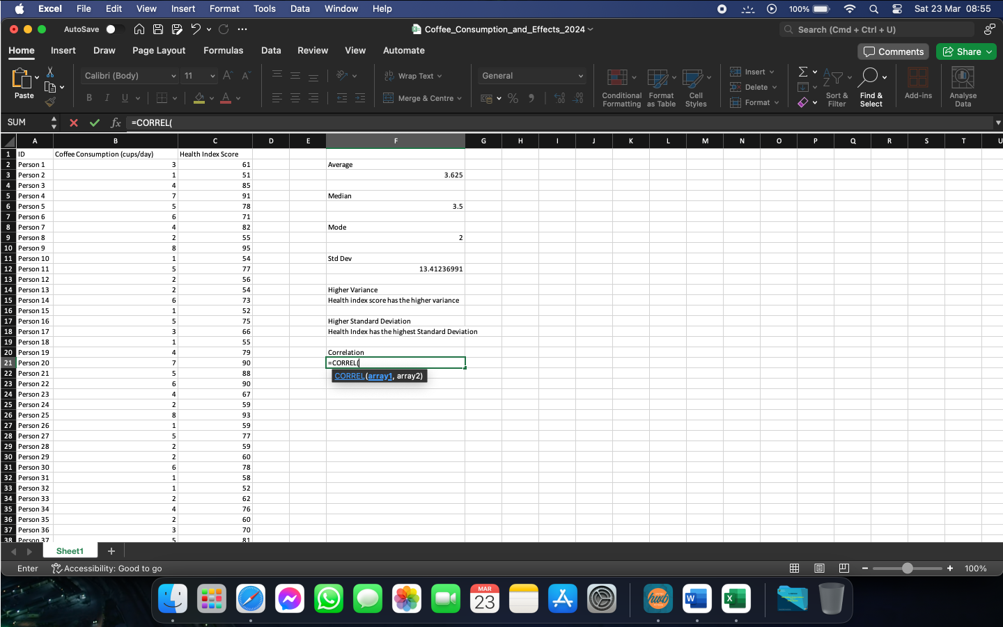
Figure 25

- Select the arrays we need and close the brackets.

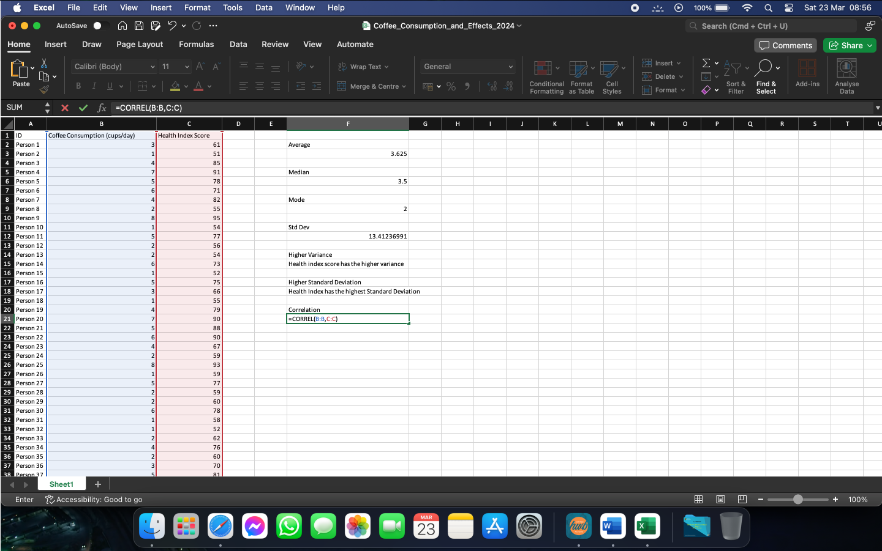
Figure 26

- Press Enter to get the result needed.

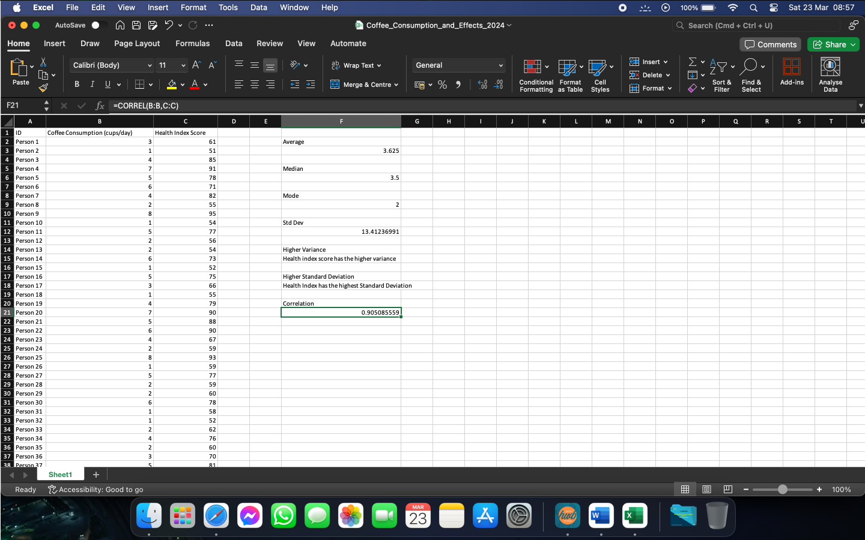
Figure 27

To be able to understand the result, we must know that the closer the correlation value is to 1, the higher the dependency between the values is. In our case, we have a correlation of 0.90, which means that our values are tightly dependant of each other. Any change in the number of cups of coffee drank in a day will impact the Health Index score in a way that would mimic it.
To further help visualize how the 2 arrays are related, we can use a scatterplot, where we can see the actual trendline.
We can generate this scatterplot with the following steps:

- Click the Insert tab, select X Y(Scatter) and choose the desired type.

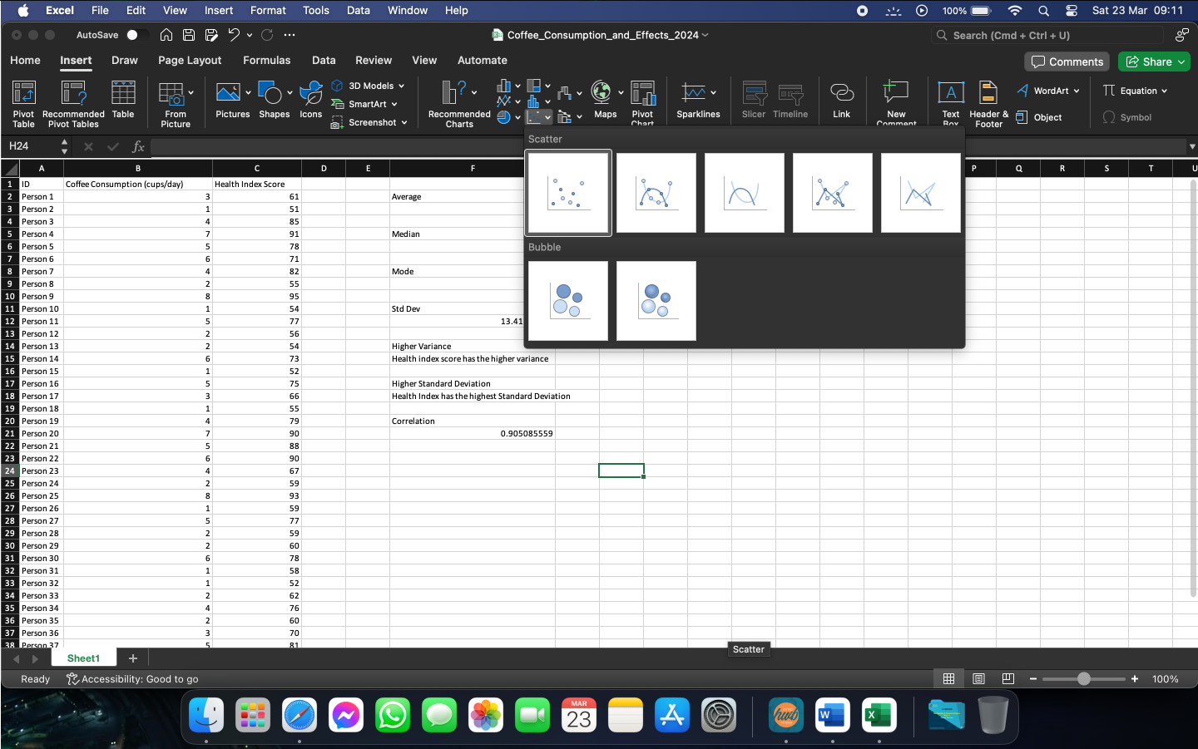
Figure 28

- Click on “Select Data” and choose the arrays we need to see the correlation of, then click OK.

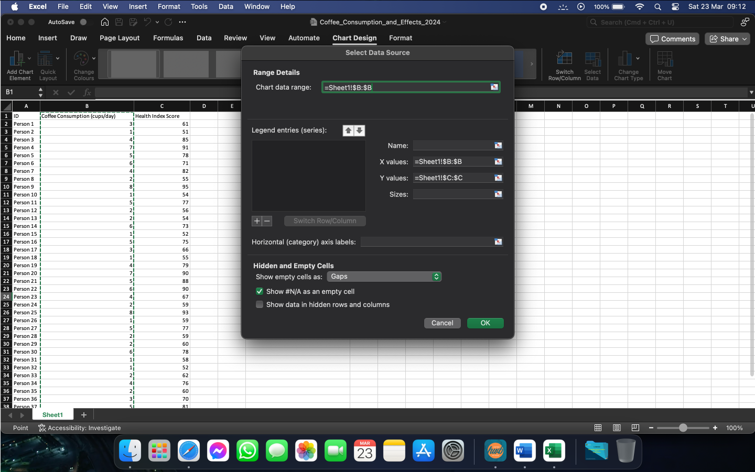
Figure 29

- Click on “Quick Layout” and change the type of chart to show the desired information.

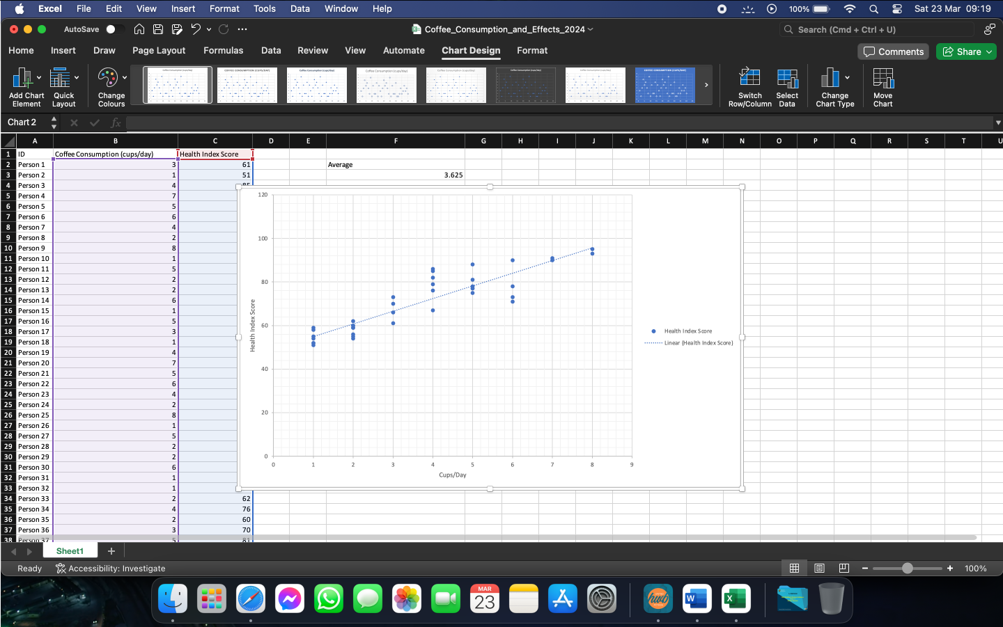
Figure 30

Part 3

Whilst almost every company has got access to Microsoft Excel or any similar type of data processing software, there are other available options on the market. These programs can create or help us interpret the same results as Excel and are preferred by companies according to their needs.
One of these programs is SPSS Statistics, which, in our case, will help find the correlation between coffee consumption and the health index score, as well as producing a scatterplot between these arrays. We can see the workings below.

- In order to see the correlation of 2 arrays using SPSS Statistics, the following steps should be followed:

  - Import the file into SPSS.
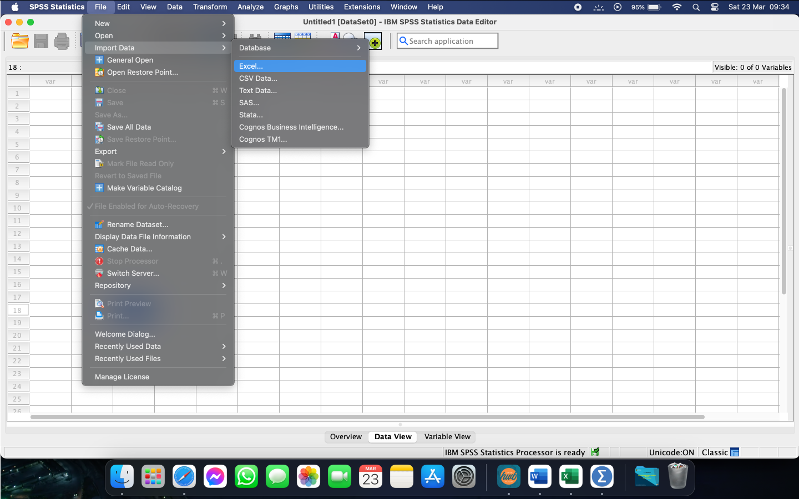
Figure 31

  - Click OK to confirm.

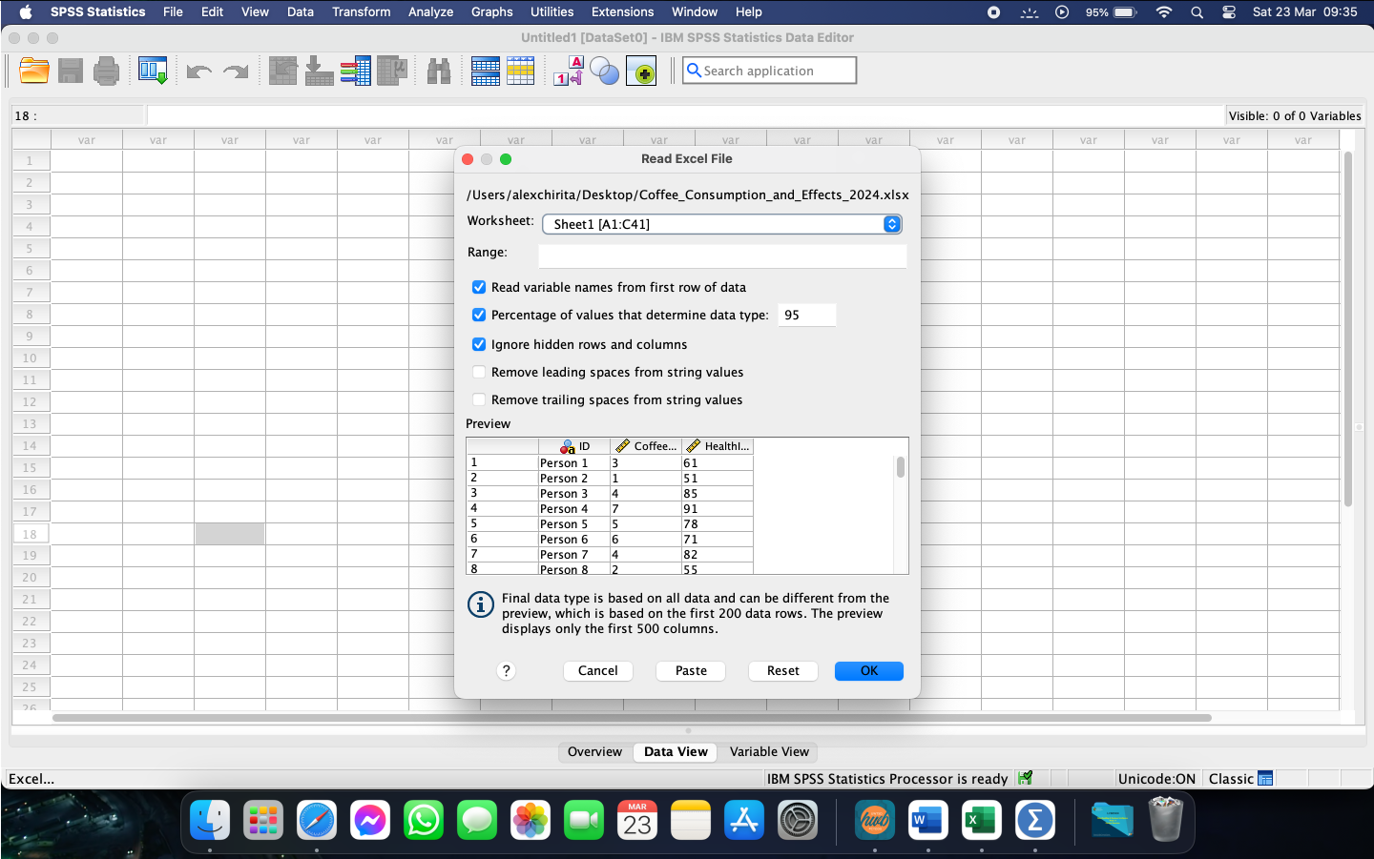
Figure 32

  - In the “Analyse”, select Correlate and the Bivariate.

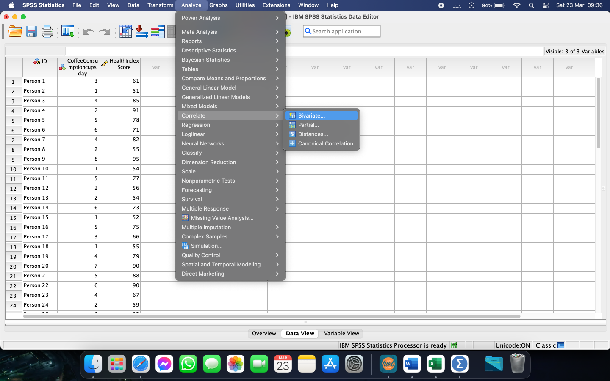
Figure 33

  - Select the variables required.

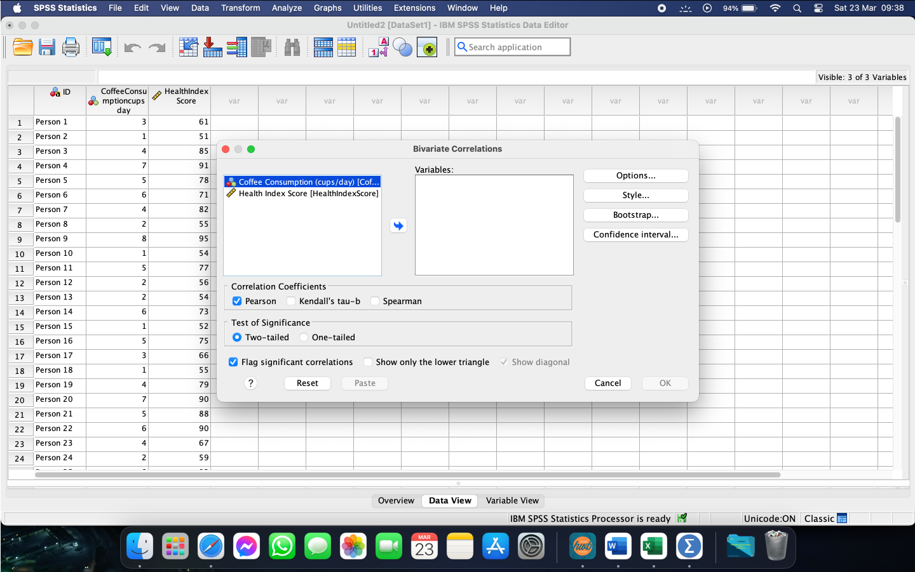
Figure 34

  - Click Options.

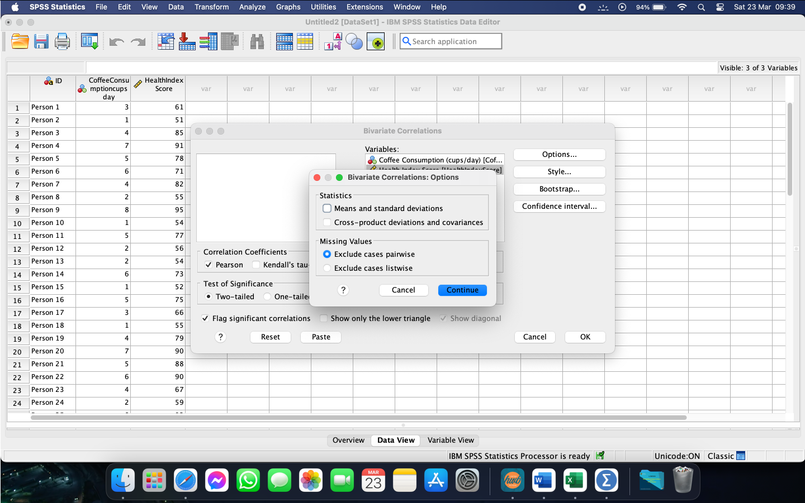
Figure 35

  - Select “Means and standard deviations”, then click Continue and OK.

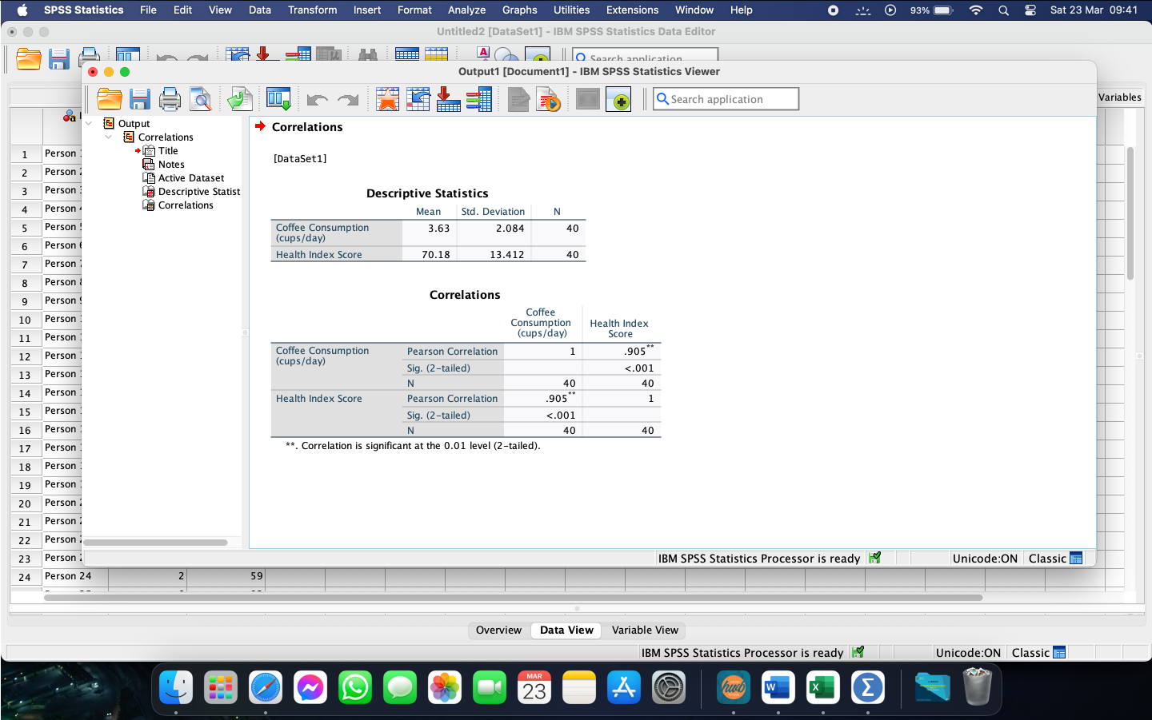
Figure 36

As we can see, the program will return the results in form of a table which we will interpret.

From the displayed results we notice that the correlation of each variable with itself is 1, and the correlation between the 2 variables has a value of 0.90. The high value of this correlation means that the 2 variables that we have analysed are highly correlated between each other. If the number of cups of coffee consumed per day changes, the health index will change too, in a similar manner.

- To create a scatterplot using SPSS, the following steps should be followed.

  - Select “Graphs” and scroll to “Scatter/Dot”.

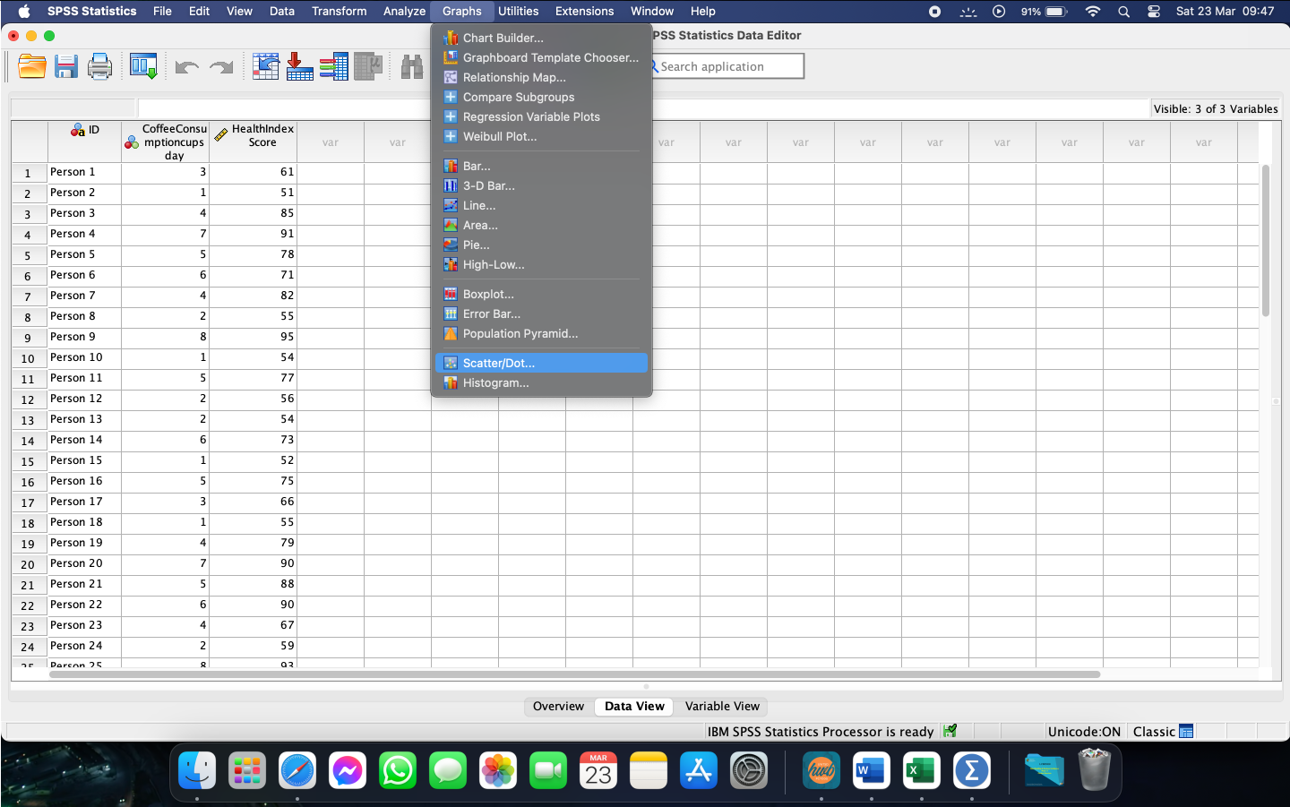
Figure 37

  - Choose the desired type and click define.

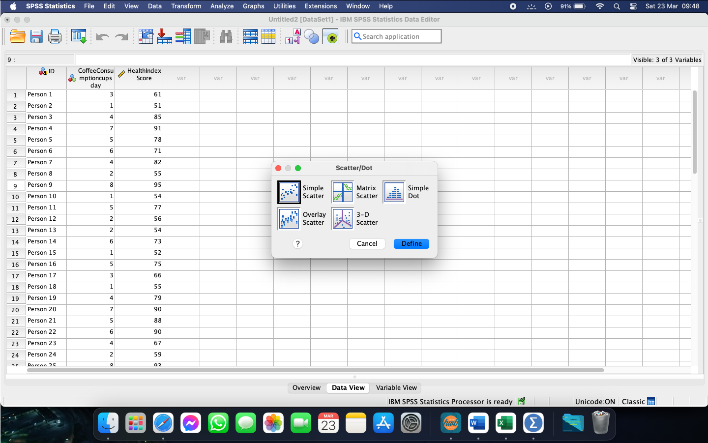
Figure 38

  - Assign the variables to their required axis and click OK.

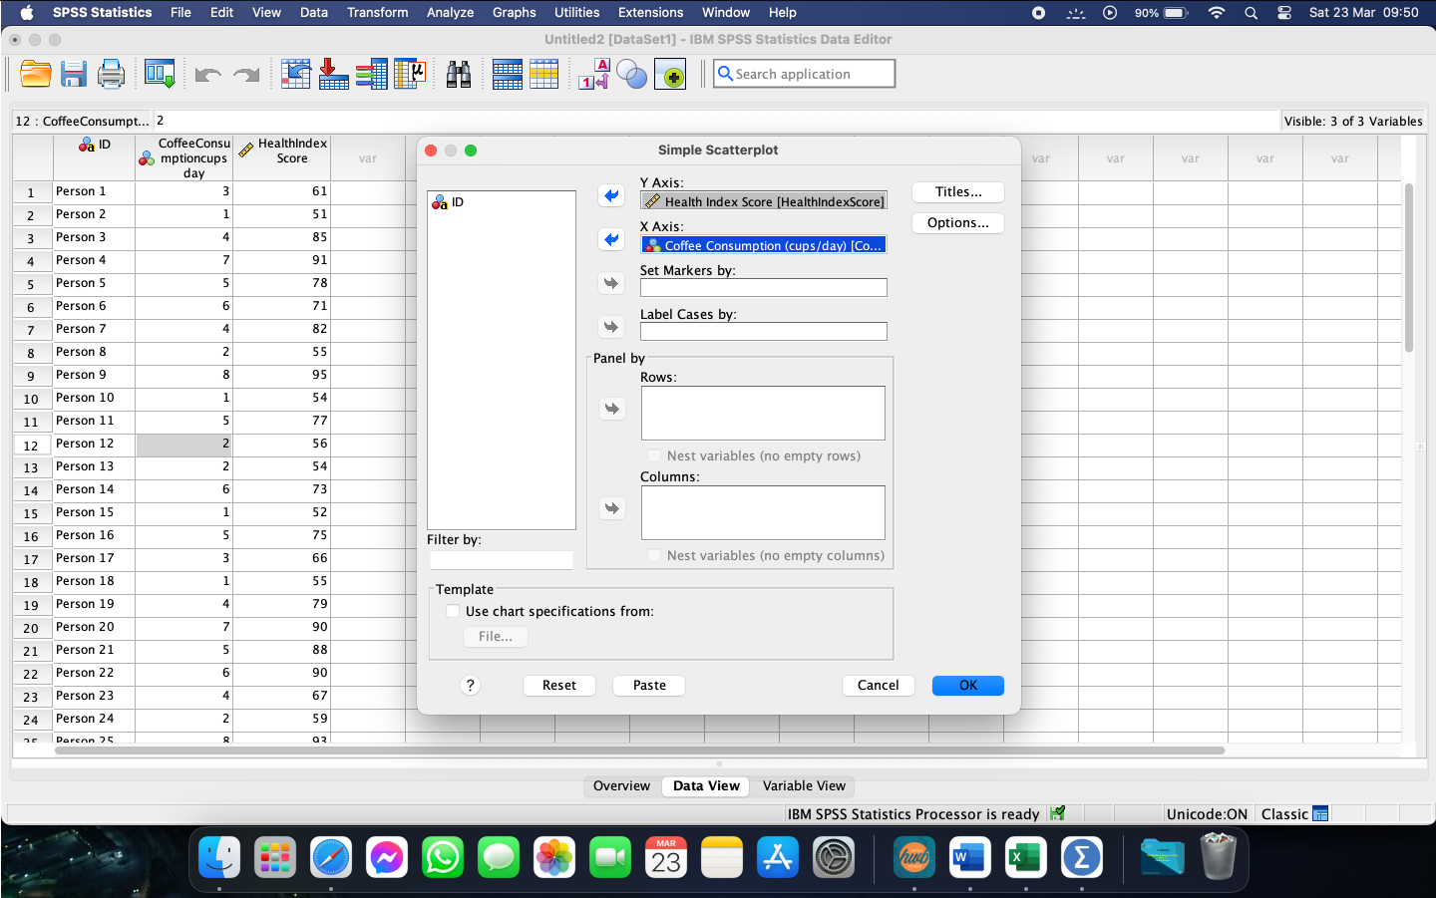
Figure 39

  - Interpret the results as needed.

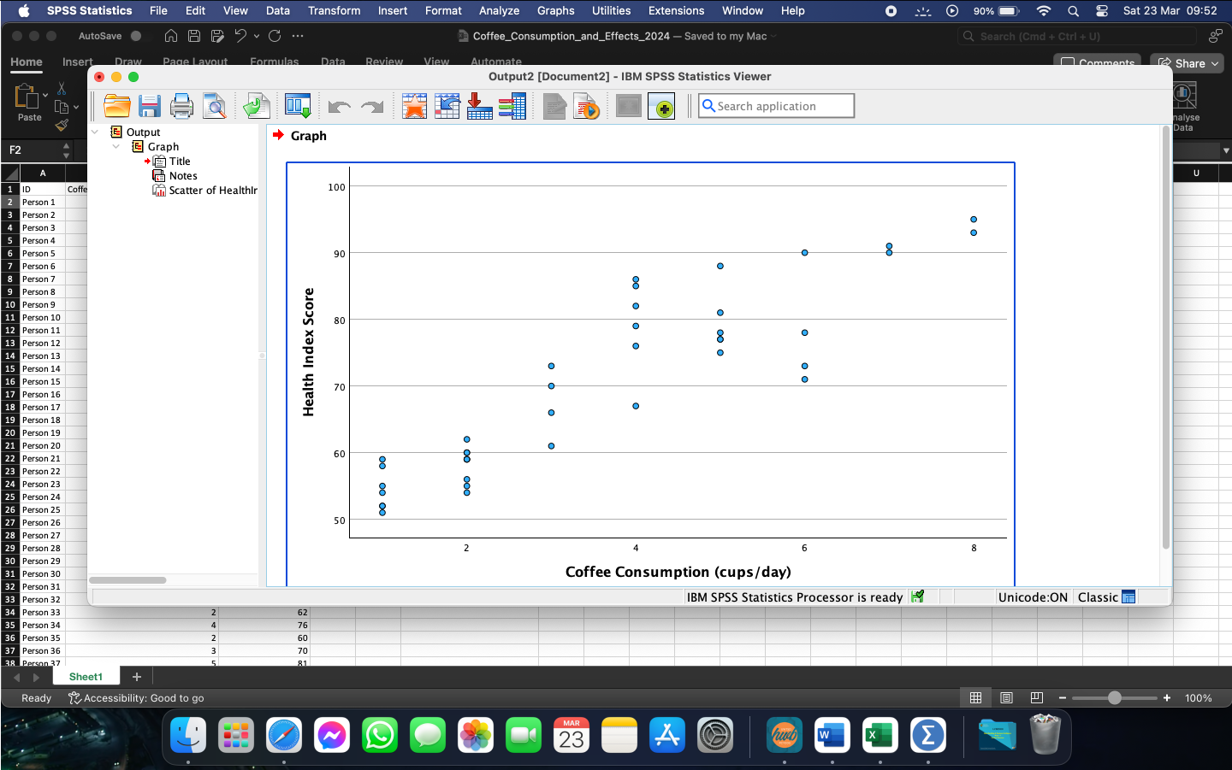
Figure 40

With the help of the newly generated scatterplot, we can see much clearer the interdependency between the variables. It can be noticed that, whilst the number of cups consumed per day is increasing, so does the health index score. This, in turn, proves the validity of the earlier generated value of 0.90.

Conclusion

Considering the technological advancements from the last few years, it has now become easier for us to interpret different types of data, as well as interpret them in a way that suits our needs. Programs and software such as the Microsoft suite, SPSS, Google Docs, and others similar to them provide us with an easier to understand insight in our day-to-day life and how different habits or actions impact us, our health, the environment, or anything that surrounds us. Using one of the multitude of formats available also helps people without an analytical background to understand these and act accordingly to change or improve that specific area.

Section 2

Introduction

As we live in a time of continuous technological advancements, it is believed that more than 80% of the data available nowadays has been created in the last few years. This increase makes more and more important that we can safely store this data, along with being able to efficiently analyse it and prepare it in such a way that will make it easier to extrapolate certain figures, trends, or results from it.
With this increase, there has been an increasing demand on data processing software. With their help, it has now become easier than ever to get the required results from any data arrays or files, also known as Big Data. These results are there to help visualise and interpret the information obtained.
As with every new discovery, these programs have both strengths and weaknesses, which I will discuss in this essay, for some of the most popular programs: Microsoft Excel, SPSS, and Tableau. Along with this, I will be discussing a brief overview of the data mining cycle.

Microsoft Excel

Excel is a program designed by Microsoft, part of the Office suite, which is mainly used to store and analyse numbers and data, with the help of spreadsheets and different types of formulas (Team, 2022). Due to its popularity, Excel is now being used by most of the companies around the world, for functions including, but not limited to data entry and management, time and task management, graphing, and charting.

Being on the market for over 40 years, since 1982, Excel has had numerous iterations, which tried to minimise any disadvantages and increase the number of useful features. Some examples of disadvantages could be the simple fact that Excel cannot manage more than a few thousand rows, before getting stuck. Whilst there are workarounds for this issue, they are not as straight-forward to use. Another downside is the difficulty in learning it, as there are a multitude of functions that need to be recalled and applied to get the desired result. Sometimes, it is found that the functions and formulas are difficult to remember too. Amongst the advantages, data input and retrieval are made much easier, which in turn facilitates analysing, filtering, and processing it. Another strong point of Excel is the fact that it allows multiple spreadsheets to be created within the same document, therefore decreasing the number of required documents needed and minimising the risk of data loss (www.javatpoint.com, n.d.).

SPSS

Created by IBM, SPSS is a powerful statistical software, with an easy-to-use interface and a multitude of features, which allow for quick and accurate extraction of insights from your data set. Same as any other platform, IBM SPSS comes with its own strengths and weaknesses. Ease of use can be one of the strengths of it. The interface makes it a lot easier to remember the steps needed to extract certain types of data, instead of having to write long and complicated formulas. Along with this, SPSS is integrated with Opensource and Python, meaning that is has never been easier to build your own library of extensions. Lastly, SPSS is very comprehensive, allowing businesses to run descriptive statistics and regression analyses, view patterns of missing data and summarize variable distributions with an integrated interface (IBM, 2023). As a limitation of SPSS, we have the inability to use big data sets. This can cause the program to get stuck and to return a result that may not be entirely correct. If the data is being collected by researchers using faulty or biased methods, the resulting statistical analysis will not return the correct answers. For example, if the gap between the sample and the actual population is negligent, then there is no issue. But if the difference is big, then SPSS will produce misleading data (William, 2022).

Tableau

Created in 2003 as a computer science project, Tableau is based on VizQL and is used to visually expresses data by translating drag-and-drop actions into data queries through an intuitive interface (Tableau, 2023).
Same as Microsoft Excel and IBM SPSS, Tableau has its own set of advantages and disadvantages. Amongst the advantages, we can count Tableau’s easy to use interface, which makes everything a lot easier to use and to remember, the support it offers for various data file types, allowing users to upload their own files and create a report much easier, scalability and geographical and spatial visualisation. As for disadvantages, the cost of Tableau can be one of them. At the moment, it is one of the most expensive analytical tools available, which makes it hard to use for SMEs, as they may not have the budget for it. Tableau also has some custom formatting, which in turn may increase the workload instead of minimising it, as adjustments may be needed for the user to obtain the desired result (TheKnowledgeAcademy, n.d.).

Data Mining

Data mining is considered to be the process of working through large sets of data, in order to observe or obtain different patterns or relationships that can help a business resolve some issues, evolve, or take more informed decisions. Data mining is a very important part of data analytics and one of the main disciplines in data science. Due to all the data warehousing advancements, along with the Big Data growth, data mining is a lot more useful today.

Data mining consists of machine learning and statistical analysis, coupled with data management tasks, which are performed to prepare the data for analysis. Whilst the stages can differ, the entire process can be generally broken into four primary stages:

- Data gathering is the process of identifying and assembling the relevant data for the required application. The data can be sourced from different data warehouses and will be stored in a so-called data lake, where it will remain until the entire process is carried out.
- Data preparation is comprised of data exploration, profiling, and pre-processing. After this, some data cleansing work is needed to fix errors and any quality issues that may arise in the meanwhile. Some data transformation is also needed, to make the data sets consistent. The last step is not necessary if the data scientist wishes to analyse raw, unprocessed data.
- Data mining begins once all the above steps are finished. A data scientist will choose the appropriate mining techniques and implement the algorithms to carry on the mining. For machine learning applications, the algorithms are usually trained using sample data before they are run against the full set of data.
- Data analysis and interpretation is the final stage, where the results from the previous steps are being used to create analytical models which influence the decision-making process (Stedman, 2021).

Conclusion

In conclusion, the data mining cycle is a process that encases a series of steps, beginning with understanding a specific business problem to creating and ends with an action that will resolve it.
Every step of the data mining process plays a crucial role in the final result and must be effective and aligned with the required result. By following a step-by-step approach, companies can extract very useful patterns and information from different data sets and lead to very informed decisions.

References

BM (2023). SPSS Statistics . [online] IBM. Available at: https://www.ibm.com/products/spss-statistics [Accessed 30 Mar. 2024].

Stedman, C. (2021). What is Data Mining? [online] SearchBusinessAnalytics. Available at: https://www.techtarget.com/searchbusinessanalytics/definition/data-mining [Accessed 30 Mar. 2024].
Tableau (2023). What Is Tableau? [online] Tableau. Available at: https://www.tableau.com/en-gb/why-tableau/what-is-tableau [Accessed 30 Mar. 2024].

Team, C. (2022). Excel Definition. [online] Corporate Finance Institute. Available at: https://corporatefinanceinstitute.com/resources/excel/excel-definition-overview/.

TheKnowledgeAcademy (n.d.). Advantages and Disadvantages of Tableau You Should Know. [online] www.theknowledgeacademy.com. Available at: https://www.theknowledgeacademy.com/blog/advantages-and-disadvantages-of-tableau/ [Accessed 30 Mar. 2024].

William, K. (2022). What is SPSS? Definition, Features, Types, and Use Cases. [online] SurveySparrow. Available at: https://surveysparrow.com/blog/what-is-spss/#section7 [Accessed 30 Mar. 2024].

www.javatpoint.com. (n.d.). Advantages and Disadvantages of MS Excel - Javatpoint. [online] Available at: https://www.javatpoint.com/advantages-and-disadvantages-of-ms-excel [Accessed 30 Mar. 2024].

