  Component One: Student Journal (learning log) 750 words +/- 10%  Contribution to Overall Module Assessment: 25% | Student No: | 2212249
 | Module Title: | Operating Hotel Facilities
 | Module Code: | BMIH4006
 | Lecturer: | Muhammad Cassamo

Component One- Learning Log

Reflection on the skills and experiences to work within a housekeeping team
Using Gibb’s reflective cycle, a reflection on the skills and experience to work within a housekeeping team is presented below:
Description: I have worked in a housekeeping team for a five-star hotel for the development of my skills and experience so I can build a career in it. There were other people who also worked as a housekeeper (Black and Plowright, 2020). The job was significant for me as I was able to develop some necessary skills and gather experience which is required to succeed in the field. I found that some required skills to work within a housekeeping team are customer service, time management, communication skills, housekeeping hard skills, teamwork and so on that can allow individuals to effectively work in a housekeeping team (Quick, 2020).
Feelings: Before joining the job, I was feeling very nervous because I heard housekeeping is an odd job and the work environment is shallow. After joining the workplace, I found that my colleagues were very friendly and supportive also my manager was highly cooperative helping me to relax about my fear (Finlayson, 2020). Also, I was afraid if I had the required skills and expertise like customer service, communication, time management, housekeeping skills, teamwork and so on to perform the job of a housekeeper so I was feeling nervous (Mullins and Dossor, 2013). After working for a month, I feel confident as I have handled many customers and clients. Now, after finishing my job I feel optimistic about building a career in this sector.
Evaluation: The whole experience was a positive aspect for me because it was my first job. Also, the thing that went well was that I was able to manage my work through effective time management and was able to contribute to the teamwork as housekeepers need to often work in a team because a hotel needs a lot of cleaning that cannot be performed alone (Granger, 2020). Also, I was able to communicate with clients, staff, and managers to understand the roles and tasks effectively because, without good communication skills, housekeepers will not be able to satisfy their clients. I was able to provide satisfactory customer service which was another positive aspect for me as it is one of the most required skills to work within a housekeeping team because their core job role is to achieve customer satisfaction (Joshi, 2020). However, I lacked some housekeeping skills and adaptability to new environments so it did not go well for me because housekeepers must have housekeeping hard skills to perform their roles properly (Lengyel, Domaracki and Lyon, 2018).
Analysis: I was determined to perform all my tasks which allowed me to manage my time properly so it went well. Also, I have worked in a group during high school which allowed me to effectively perform teamwork and contribute to it also housekeepers need to have good teamwork skills to effectively divide their work and successfully complete their tasks so I adopted this skill. The teamwork also helped me to improve my communication skills so I was able to provide satisfactory customer service it also went well because to work in a housekeeping team individual needs to possess good customer service providing skills to succeed in the role so I adopted the skill (Black and Plowright, 2020). However, I did not perform some of the housekeeping hard skills so I was lacking and it did not go well because housekeepers need to perform a lot of cleaning of different things whether in a group or alone so they need proper time management skills to perform their tasks effectively and ensure cleaning on time (Lengyel, Domaracki and Lyon, 2018). Also, it was my first job so I felt shy for this reason I could not adapt to the new environment properly and it did not go well.
Conclusion: I have learned housekeeping plays a significant role in the hospitality industry and it requires a lot of skills like customer service, time management, communication skills, housekeeping hard skills, teamwork and so on to provide satisfactory customer service. If I had good housekeeping skills, I could have performed the job better also adaptability to a new environment could have helped me to make it a better experience.
Action plan: If I had to perform the task again, I would improve my housekeeping hard skills and adaptability skills in a new environment (Granger, 2020). I will take training to improve my housekeeping hard skills I will take help from my manager to improve my adaptability skills so that I can make it a better experience next time.

Component Two: Housekeeping cleaning checklist
Contribution to Overall Module Assessment: 25%

Based on your completed checklist you will need to write 500 words in essay format discussing the following:
- How will you ensure that the rooms are cleaned to brand standards?
- What measures would you introduce to improve team effectiveness?
- Why would you consider your checklist to be the most effective?

References

Black, P.E. and Plowright, D. (2020). A multi‐dimensional model of reflective learning for professional development. Reflective Practice, 11(2), pp.245–258.
Bridger, E. (2018) Employee engagement: a practical introduction. 2nd ed. HR Fundamentals. London: CIPD and Kogan Page.
Cottrell, S. (2019) The Study Skills Handbook. 5th ed. London: Red Globe Press.
Finlayson, A. (2020). Developing a reflective practice model . Reflective Practice, 17(2), pp.87–99.
Granger, G.L. (2020). Training Programs Increase Skills, Foster Efficiency, Good Morale: Housekeeping Services. Hospital Topics, 45(7), pp.53–56.
Joshi, D.B. (2020). ‘Hungry Tigers Talk to the Wall’: An Action Research on Reflective Teaching Practice Cycle. Journal of NELTA, 12(1).
Leiter, M. P. and Bakker, A. B. (2010) Work Engagement: A Handbook of Essential Theory and Research. Hove [England]: Psychology Press.
Lengyel, L.M., Domaracki, J.W. and Lyon, S.R. (2018). General Case Simulation Instruction of Generalized Housekeeping Skills in Blind, Multihandicapped Adults. Journal of Visual Impairment & Blindness, 84(4), pp.166–170.
Mullins, L. and Dossor, P. (2013) Hospitality Management and Organisational Behaviour. 5th ed. Harlow: Pearson.
Quick, L. (2020) Managing Events. Real Challenges, Real Outcomes. London: SAGE Publications Ltd.
Raghubalan, G. and Raghubalan, S. (2016) Hotel Housekeeping - Operations And Management. 3rd ed.India: Oxford University Press.

Component Two: Housekeeping cleaning checklist
Contribution to Overall Module Assessment: 25%
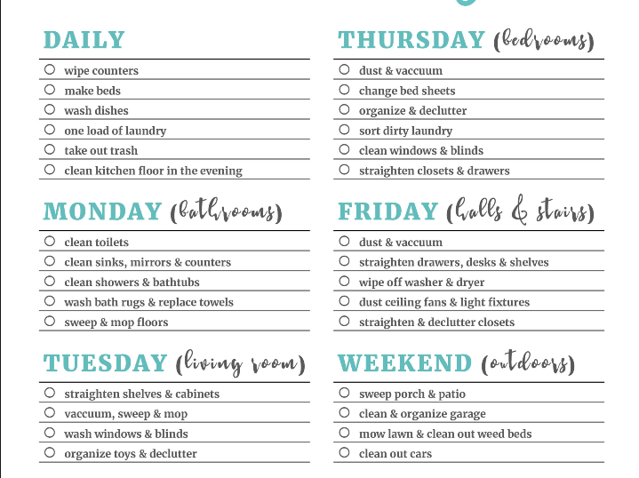

Based on your completed checklist you will need to write 500 words in essay format discussing the following:
The way of ensuring that the rooms are cleaned to brand standards
To maintain the cleanliness of the hotel rooms as per the brand standard, the hotel brands may adopt the Five “S” subsystem of hotel housekeeping. The abbreviation of the five “S” is Sort, Set In Order, Shine, Standardise, and Sustain (Higgs, 2020). In the beginning stage, the businesses need to sort the housekeeping mandatory things and eliminate the unnecessary things for making the work easier by decluttering the work area. Next, businesses need to set the time in order which refers putting everything in the appropriate place in terms of making them easily found and giving an appealing look Magnus and Bo (2023). Then they must maintain shininess ensuring maximum hygienist and cleaning the areas for making it more presentable and inevitable. Then they need to standardise the area maintaining consistency in the cleaning system and finally sustaining the overall cleanliness and standard for maintaining the band standard.
The measures need to be introduced to improve team effectiveness
To maintain the team's effectiveness and improve it, hospitality businesses need to Diversity the team, lead gratitude, remain authentic and vulnerable, prioritize the wellbeing, clarify each person’s role, prioritising as well as ruthless and ensure open communication (Moroz, Wilson and Murzin, 2021). They can direct the team by celebrating individual differences and the different team members can share unique ideas from different minds, share opinions and learn from each other which can foster innovation as well as creativity of the business (Sanon, 2022). They also can lead the gratitude by giving recognition to the unique ideas of the individual team members and praising them rather than taking credit for encouraging them and enhancing efficiency and loyalty. The prioritising well-being and clarifying each person role, individuals can remain on track while carrying out their role without any interruption and discomfort. These all can greatly introduce in terms of improving the team effectiveness.
Things which force to considered the checklist to be the most effective
There are various things in the checklist which influenced in term of considering the checklist to be the most effective (Vestal, 2021). For example, the short and simple presentation of the necessary housekeeping and cleaning duties and shorting them as per the weekly schedule. It also visualises the duties of each of the day and in a short and specific form which help to understand the role and responsibility of each day. The checklist is easily understandable and not many possibilities are included in it which will be easy to carry out (Bridger, 2018). The checklists also keep off days for some work and mentioned some work which need to carry out for a daily basis (Cottrell, 2019). Thus, a consistency in the housekeeping and cleaning service can be maintained a s great scale. The checklist also mentioned the specific rooms for cleaning a day like the hall room, bathrooms, bedrooms, front desk, stairs, outdoors, and living rooms for reducing the rigidity in the cleaning and making it easily manageable as well as maintainable. This all make the checklist most efeftcive.

References
Bridger, E. (2018). Employee engagement: a practical introduction. 2nd ed. HR Fundamentals. London: CIPD and Kogan Page.
Cottrell, S. (2019). The Study Skills Handbook. 5th ed. London: Red Globe Press.
Higgs, M. (2020). Building an effective team. Team Performance Management: An International Journal, 2(4), pp.33–39
Leiter, M. P. and Bakker, A. B. (2010). Work Engagement: A Handbook of Essential Theory and Research. Hove [England]: Psychology Press.
Magnus, G. and Bo, Å. (2023). A1M, an extravascular tissue cleaning and housekeeping protein: a possible drug candidate. Free Radical Biology and Medicine, 75, p.S31.
Moroz, O.V., Wilson, K.S. and Murzin, A.G. (2021). House cleaning, a part of good housekeeping. Molecular Microbiology, 59(1), pp.5–19.
Mullins, L. and Dossor, P. (2013). Hospitality Management and Organisational Behaviour. 5th ed. Harlow: Pearson.
Quick, L. (2020). Managing Events. Real Challenges, Real Outcomes. London: SAGE Publications Ltd.
Raghubalan, G. and Raghubalan, S. (2016). Hotel Housekeeping - Operations and Management. 3rd ed. India: Oxford University Press.
Sanon, M.-A. (2022). Hotel housekeeping work influences on hypertension management. American Journal of Industrial Medicine, 56(12), pp.1402–1413. Available at:
Vestal, A.J. (2021). Housekeeping Services: Pediatric Cleaning Technics Diverse as Unit itself. Hospital Topics, 45(12), pp.55–58.
Vestal, A.J. (2022). Housekeeping Services: Cleaning the OB-GYN Floor: Special Treatment for Special Area. Hospital Topics, 45(5), pp.57–59.

