Part 1.
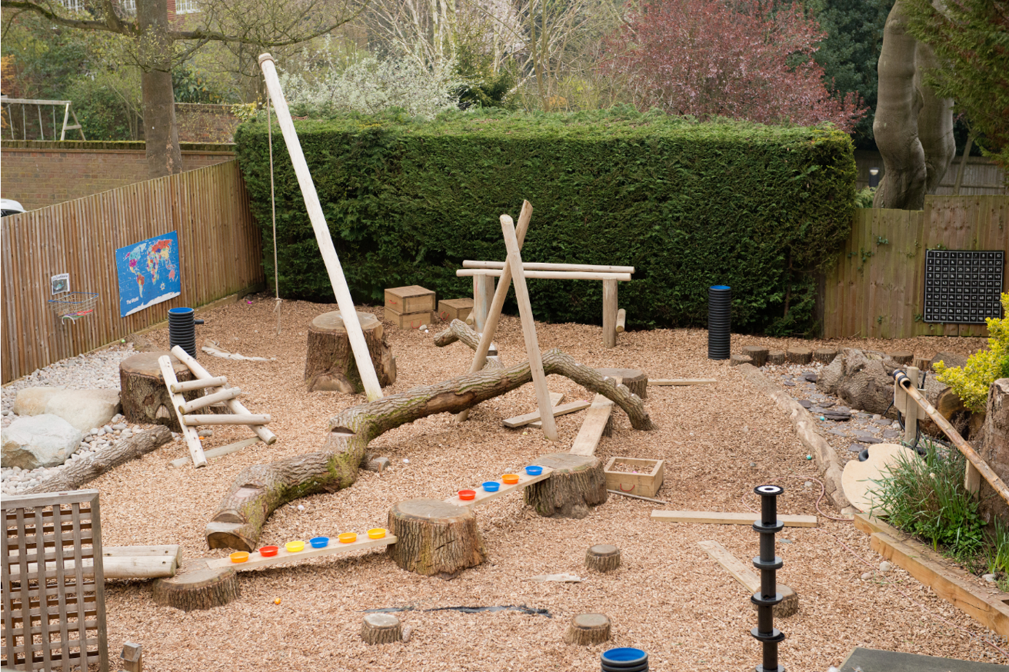
Outdoor learning (Mill Hill Schools, no date)

Part 2.

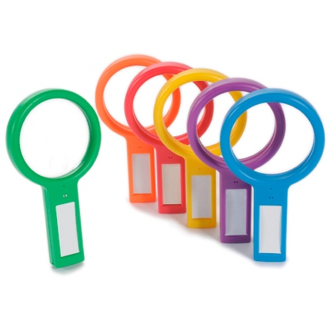
The image I have chosen in part one displays multiple opportunities for children to develop their science and mathematics in the outdoors. Working with children of six and seven years of age I would include materials that are colourful and of different shapes and sizes of different textures that will capture their attention for children to use in different activities to help develop their mathematical and science skills to help them reach progression step two.

To better children’s knowledge and understanding of scientific concepts, I would consider adding extra resources such as magnifying glasses for children to look closely at the wildlife that may be living underneath and around the tree stumps and also in the garden on the right of the wooden play area. By using the magnifying glasses children can identify the different types of insects that live in the area and children could then be encouraged to ask questions such as “why do those insects live in these areas?” and “what do insects need to survive in the outdoors?”
Recordable Magnifying Glasses. (TTS, n.d)

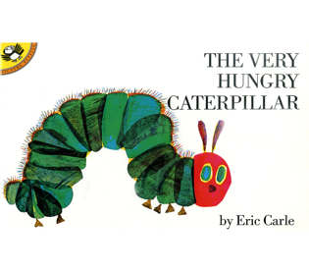
Adults could encourage these discussions further by taking the book ‘the hungry caterpillar’ out to the area for children to develop different concepts about how some insects live differently to others and need different things to survive. Adults can support their curiosity by asking children about the different insects they may know and what do they know about them as this will allow children to have a wider knowledge and development of wildlife, life cycles and living things.

The Curriculum for Wales (2019) states that children should be aware and recognising the variety of different living things that live
The Very Hungry Caterpillar (Book Source, n.d).
around us and how they interact and live in their different
environments. The Welsh government also state that children should also recognise how different species need different resources and conditions to survive compared to other species and why these differences are so important depending on the living thing. In order to reach progression step two, children must be exploring the relationship between living things and the habitats in which they live in and also to recognise how as children they have an impact on the environment and the living things around them.

To guide children’s development in mathematic in the outdoor area, it would be considered to bring in some hula hoops that they can lay on the chippings or onto the stones and they could estimate how many loose items are in the hula hoops. This would allow children to use their knowledge of counting to make educated estimations and guess within a reasonable range. For children to develop into progression step two, the Welsh government states that children should be using their knowledge of numbers up to 100 and using this to estimate and checking the accuracy of their answers to estimate within a reasonable number up to 100. The new Curriculum for Wales (2019) explains that children should be comparing the relationship between different numbers and is essential for problem solving that will develop areas of experience and learning.

The hula hoops could also be used for children to use the resources in the garden and sort them into different groups such as by size, colour, or shape as this will develop their skill of sorting objects into different categories. By doing this activity children asked questions such as “how many different groups could we sort the loose items into?” and adults can encourage these thinking ideas by explaining to children that the same loose item can look different by size and shape such as rocks and sticks and it must be up to children to decide how they are going to sort the loose items into different groups. The new curriculum states that children will reach progression step two by acknowledging the range of two dimensional and three-dimensional shapes and their differences and explore and compare the different size and variety of shapes through play.

A loose part that would be beneficial for children to develop their scientific use further in this area would be to include different sizes of balls for children to have the experience to roll the balls down the wooden planks and also to roll them back up to see how it works. Children will notice that rolling the ball down the wooden planks is easy, using all shapes, as it is going with the force of gravity whereas rolling the balls back up is a lot harder. Questions asked by the children varied from “why did the ball roll down fast but went slow when pushing it back up?” and “did it push up slower because of the different size of the ball?” these questions allow the adult to explain how energy and forces work and they will be able to demonstrate that due to gravity, a lot of energy is needed for the ball to roll back up as it is going against the force of gravity.

Children could also develop their scientific understanding further by using the different shaped balls to see if the balls go faster when rolling down dependant on shape or if there are no differences at all and by doing the same when pushing the balls back up the wooden planks. If wished to do so, adults could explain to children that this may be due to the difference in weight, height or width of the different balls which will encourage children to think about the measurements of different objects and the issues this may have on energy and force.

The new curriculum for Wales explains that children must have an understanding that energy and force is behind the movement of everything from the motions in our universe to the smallest resources in our homes and these ideas care used in everyday life. In order for children to reach progression step two, they must be able to identify how different forms of energy work on themselves and on different objects.

Part 3

RISK BENEFIT ASSESSMENT

Location / Activity: | Outdoor wooden garden/play area. | Date: | September 22nd, 2022.
Assessor: | Mai Jenkins | Review date: | May 24th, 2023.

The boxes in the table below will expand as you type into them; pre-entered text is simply for illustration. You should delete irrelevant items and replace with text relevant to your circumstances.
Your overall risk rating – Low, medium or high – is based on your judgement about whether the BENEFITS of the activity or opportunity outweigh the RISKS.
Experience exploring outdoor space in photograph | How will young people BENEFIT from this activity? | Hazards and risks | Who is at risk? | PRECAUTIONS in place to reduce the risk of injury | Overall risk RATING: L/M/H
Being around and experimenting with different materials such as plastic and wood. | Children will benefit due to experimenting with a range of different materials and how they can play with these materials and the things they can make.  Children will benefit from the range of different materials as it will encourage them to use their creativity and discover what those materials can do, and what others may not be able to do such as bend, twist, and roll. | Children may suffer from splinters as a result from climbing on the wooden planks.  Children may fall onto broken pieces of plastic or glass on the floor which may cut them or graze them.  Children may experiment with materials which may be sharp or may have pointy edges which could hurt them whilst they lift, throw, or push it. | Children and adults | Adults must ensure that there are no small pieces of broken plastic or perhaps glass on the floor which may cause children to cut themselves or to fall onto if it is in the ground. | L
New opportunities to explore new things they see such as flowers and plants, insects, and trees. | Children will learn about different life cycles in the little garden which may contain a number of different insects and mini bugs.  Children will become aware of how plants grow and how living things survive in the outdoors which may result in children becoming kind and caring for living things.  Whilst exploring the outdoors, children can collect natural things and create pictures or make a collage out of them whilst developing their physical development through bending or stretching to collect the resources. | There may be berries or mushrooms growing in the grass or on the hedges which may result in children eating them and becoming severely unwell.  If there are stingy nettles around the garden and the children fall into them, it may cause emotional distress and pain to them.  Some children may be allergic to insect bites which may result in children having an anaphylactic shock. There may be poisonous plants or insects around the area which may cause harm to children. | Children and adults | Children must be told before entering the area that there may be harmful plants or insects there and discuss with the children to stay away from these areas and possibly have an adult to stand in front of the area to prevent children from going close.  Consider boundaries with the children of things they are allowed to touch and collect and make this into a game in which all children can get involved in, where they can go without an adult independently, and where they will need to be supervised.  The golden rule will be explained clearly to children that nothing is allowed to be put in their mouth or near their faces and they must wash their hands at the end of their experience. | L
Being outdoors in different weather conditions | Children will become aware of a range of different vocabulary such as wet, dry, cold, hot and children will be able to identify themselves which surfaces in the environment may be slippery due to the rain and if the sun and the heat has made soil dry. One aware of these risks, children can act upon themselves to reduce the risk to themselves and other children. | Heavy downpour of rain may cause children to become uncomfortable sitting in wet clothes which may also lead further to being distressed.  If exposed to the sun children may experience sun burn or even possibly sun stroke.  Heavy winds may cause gravel and loose objects to fly around which may cause injuries to children if they are hit by them. Different weather conditions may cause the ground to become slippery or very dry which can be harmful to children if they fall. | Children and adults | Children will bring appropriate clothing with them, depending on the weather conditions such as a sun hat and suntan lotion, or waterproof clothing and wellington boots.  Water will be available for children if the weather is very hot.  The weather will be monitored through the Met Office which will allow adults to make decisions to whether the weather conditions are suitable for the children to be out in. | L
Walking on uneven ground | Walking on uneven ground will support children’s vestibular sense as they can learn how to balance and walk forwards and backwards on wooden planks.  Children will benefit from becoming aware of what they can and cannot do whilst walking along the uneven ground which will allow them to become aware of their bodies.  Children will also experience support and understanding of the way gradient and slopes may work by rolling things down or up the uneven ground. | Walking on uneven ground may cause children to trip and fall which may lead to serious injuries. | Children and adults | Children will be able to walk on the uneven surface when they arrive for them to become familiar with it which may lessen the risk of any injuries.  Children must wear suitable footwear if there is any uneven ground which will also prevent them from twisting their ankles or falling.  Adults may play a game such as a ‘wibbly wobbly’ game which will make children aware of the uneven surface whilst also having fun. | L
Children exploring new environments independently | Children can communicate their ideas through group play or with a friend and observe the new environment around them.  Children will benefit from assessing their own risk and identify what may be harmful to them and how they will act upon this to lessen the risk of harm to themselves and others around them. | Children may fall or trip over unfamiliar ground which may result in an injury or a graze.  There may be strangers around the area who may approach children whilst they are exploring independently.  Children may pick up litter and rubbish from the floor which may contain something that may harm them. | Children | Adults must ensure that there is nothing around the area that may cause harm or injury to children.  Children must be in suitable clothing and footwear whilst exploring new environments as they may not be familiar with the grounds which may be uneven, raised, or any hidden dips that may be concealed by leaves.  Children must know the boundaries of the areas they are allowed to explore and which areas they are not whilst exploring independently.  Adults must check the boundaries around the areas such as roads and will there be heavy traffic which will have to be discussed with the children to stay far away from these boundaries.  Children must be told to stay away from people they do not know and if somebody approaches them, they must tell an adult they are familiar and comfortable with. | L

Part 4.

Adults can encourage and support children’s learning in an outdoor environment by engaging in a child’s interest and can allow children to explore and engage in an activity without being a part of the activity or taking control and letting the children be completely independent. Waite (2011) states that outdoor environments give children a wider space to move around freely and familiarise themselves with different landscapes such as uneven grounds or slopes which will eventually better a child’s vestibular sense as they are moving whilst also learning how to balance, skip, or walking on the edge of something. Children should learn to use the skills they have to explore the environment they are in, and adults can support children by adding loose parts into the environment for children to explore how these items would work in their environment and what they will be able to do with them. By doing this, adults can observe how children are responding to these loose items and how they use the items to explore mathematical and scientific concepts by rolling things up and down or by using loose items to count and sort items into different groups, Waters (2019).

Adults can encourage children to engage in mathematical concepts in outdoor environments by ensuring there are resources available for children to use or an area that children can go to that will allow children to bring mathematics into their outdoor learning. Adults can encourage this by using a range of mathematical language and offer suggestions that will encourage children to use their knowledge to learn based on what they have available in the outdoors. Adults must also be aware of the interests and likes of children so that the resources or loose items they bring into the outdoor environment will be used by the children as it something they enjoy learning and playing with whilst also allowing children to understand how some items work and what they can do with them, Robertson (2017).

Learning science through the outdoors can be enabled by adults for children through allowing children to observe closely at the world around them which allows children to develop a sense of curiosity about the world they live in and the insects and mini bugs that live around them. This will allow children to gain knowledge of how the world works and how things around them live. Adults could give children magnifying glasses in their outdoor environment which will give children access to look around t what living things are in the area, what do they look like, and how do they live. Adults could also give children resources or loose parts that will allow children to make things or build things such as dens in which children will have to use their creativity as a group to determine how they will build the den and what they will do to keep it up, Sargent (2015).

Nicholson (1971) theory of loose parts proposes that adults should be encouraging loose parts, such as materials that can be re-designed and moved around, in outdoor environments for children to engage in their natural creativity and discovery and the more loose parts there are in an environment, the more people are able to interact. By using these loose parts in different environments, children can use their creativity skills to design new things, build things and combine different materials together to create new things. Similarly, the Reggio Emilia approach (2010) believe that play is driven by children’s ability to have their own potential and they can question the world we live in based on their interests. The loose parts in which is added into children’s environment allows the opportunity for children to think of their own play and use their creativity to develop their mathematical and scientific thinking by using these loose parts.

The Froebelian approach (2012) looks at the value of play and learning outdoors and aspects that can connect to children’s learning in outdoor environments. whilst engaging with the mystery and wonder of the natural world, children are given freedom to experiment within different opportunities and investigate themselves into how the world around them works. Froebel also emphasises how children’s movement is a big part of the way they are learning in the outdoors as they are exploring new things which keeps children moving and allows space for spontaneous play. Adults must allow time for children to develop and thrive through outdoor learning as it cannot be done in short periods of time and children must have efficient space that is flexible for children to use their knowledge to play in many possible ways in which they have no restrictions over what they can do.

White (2014) state states that children’s bodies and minds develop at their best when they have independent access to stimulating outdoor environments for them to learn through playing and by being in an environment that promotes real life experiences. Children interact with the outdoor environment by doing and moving and using their whole bodies to experience different opportunities and materials that are available to them and use their senses to notice little details and develop new opportunities to learn and play through the outdoors and it allows children to be as loud as they want and to be creative and messy and have access to space that they may not have inside a classroom.

However, one reasons that adults may not be enforcing outdoor learning and play opportunities for children is due to the fact that they do not recognise the learning possibilities that children could have in natural environments. This could be down to the fact that adults and children do not spend as much time exploring the outdoors as they used to and this could be as adults may not have a lot of knowledge on nature and the different kind of species that live there therefore finding it easier to keep children’s learning inside, Skarstein (2020).

The Welsh Government (2010) guides adults to allow access for children to explore outdoor experiences as frequent as they can as it provides children with space to move as freely as they wish, and children can learn and play on a bigger scale and explore the environment and the nature around them. Adults should be planning in an appropriate and purposeful way for children to further gain their skills and knowledge of outdoor experiences and children can engage in activities such as building dens, using music to explore different movements, and using loose items to build and create new things using their creativity skills.

The Welsh Government (2009) also highlights the importance of observation in outdoor learning and play as it allows adults to assess each individual child’s skill development and they can observe how children interact with the outdoor and what loose items or activities they can include into the environment for children to better their play and learning. As well as the indoors, outdoor environments allow adults to ask open-ended questions to children to help them to engage with their learning and a sense of freedom in the outdoors can help children to become confident and more vocal and engage in more practical learning.

Knight (2011) explores into how the forest schools approach can introduce children to take more risks and adventures whilst exploring the outdoors and enabling adults should allow children to partake in activities that may be out of their comfort zones but allow them to do it in a manner that is safe and that children are aware and have an understanding of how they can take a risk but doing it in a safe way. When children have the knowledge of keeping themselves safe in different environments and situations, they will begin to take more risks and adventures which will allow them to develop their range of skills emotionally and physically.

Furthermore, Tim Gill (2010) believes that children partaking in adventurous activities offer children to a wider range of experiences and can allow children to learn deeply about who they are as people. Adults can enable children to become adventurous and to not be afraid of risks by taking children to environments that may have open waters or steep inclines as it allows adults to teach children how they can keep safe whilst gradually increasing children’s exposure to different opportunities.

Piaget’s stages of development consider children as ‘little scientists’ as when they are exploring their outdoor environment to gain a wider understanding over how things around them work and live. Piaget believed that children do this naturally without any adults interfering and children learn through experience and by method of trial and error and gaining an understanding of what they can and cannot do whilst learning and playing outdoors. Piaget also believed that children’s senses also heightened their interest of learning to explore new objects and new sensations and the ability to explore new physical surrounding independently, Piaget (1957).

Reference list

Book Source (n.d) The Very Hungry Caterpillar. Available at: https://www.booksource.com/products/very-hungry-caterpillar--the__0399208534.aspx (Accessed: 21st September 2022).

Gill, T (2010) Nothing Ventured: balancing risks and benefits in the outdoors. Available at: https://www.englishoutdoorcouncil.org/wp-content/uploads/Nothing-Ventured.pdf (Accessed: 28th September 2022).

Hall, K, Horgan, M, Ridgway, A, Murphy, R, Cunneen, M, & Cunningham, D (2010) Loris Malaguzzi and the Reggio Emilia Experience, Bloomsbury Publishing Plc, London. Available from: ProQuest Ebook Central. (Accessed: 27th October 2022).

HWB (2019) Mathematics and Numeracy, Available at: https://hwb.gov.wales/curriculum-for-wales/mathematics-and-numeracy/ (Accessed: 24th September 2022).

HWB (2019) Science and Technology. Available at: https://hwb.gov.wales/curriculum-for-wales/science-and-technology/statements-of-what-matters/ (Accessed: 24th September 2022).

Knight, S (2011) Risk and Adventure in Early Years Outdoor Play: Learning from Forest Schools, SAGE Publications, Limited, London. Available from: ProQuest Ebook Central. (Accessed: 29th September 2022).

Mill Hill Schools (no date) Outdoor learning.
Available at: https://www.millhill.org.uk/pre-prep/learning-beyond-the-classroom/outdoor-learning-7/ (Accessed: 20th September 2022).

Piaget, J. (1957). Construction of reality in the child. London: Routledge & Kegan Paul.

Robertson, J (2017) Messy Maths: A playful, outdoor approach for early years, Crown House Publishing, Carmarthen. Available from: ProQuest Ebook Central. (Accessed: 27th September 2022).

Sargent, M (2015) Developing Early Science Skills Outdoors, Mark Allen Group, Luton, Bedfordshire. Available from: ProQuest Ebook Central. (Accessed: 28th September 2022).

Simon Nicholson (1971) How NOT to cheat children. The theory of loose parts. Available at: https://media.kaboom.org/docs/documents/pdf/ip/Imagination-Playground-Theory-of-Loose-Parts-Simon-Nicholson.pdf (Accessed: 27th September 2022).

Skarstein, T & Skarstein, F (2020) Curious children and knowledgeable adults – early childhood student-teachers’ species identification skills and their views on the importance of species knowledge. Available at: https://www.tandfonline.com/doi/citedby/10.1080/09500693.2019.1710782#tabModule (Accessed: 29th September 2022).

Tovey, H (2013) Brining the Froebel approach to your early years practice. Routledge, London. Available from: VL eBook. (Accessed: 28th September 2022).

TTS (n.d) Recordable Magnifying Glasses. Available at: https://www.tts-group.co.uk/recordable-magnifying-glasses/1005283.html (Accessed: 21st September 2022).

Waite, S (ed.) (2011), Children Learning Outside the Classroom : From Birth to Eleven. SAGE Publications, London. Available from: ProQuest Ebook Central. (Accessed: 27th September 2022).

Waters, J & Rekers, A (2019) Young children’s outdoor play-based learning. Available at: https://repository.uwtsd.ac.uk/id/eprint/1003/1/young-childrens-outdoor-play-based-learning%20PUBLISHED.pdf (Accessed: 27th September 2022).

Welsh Government (2009) Outdoor Learning Handbook. Available at: https://hwb.gov.wales/storage/fcb8539c-9be7-4883-8542-35d7b54b56f2/foundation-phase-outdoor-learning-handbook.pdf (Accessed: 29th September 2022).

Welsh Government (2010) First steps outdoors. Available at: https://hwb.gov.wales/storage/79a90e4b-0385-4cc8-be9b-2b20be3a85d0/first-steps-outdoors.pdf (Accessed: 29th September 2022).

White J, (2013) Playing and Learning Outdoors: Making Provision for High Quality Experiences in the Outdoor Environment with Children 3-7, Routledge, London. Available from: ProQuest Ebook Central. (Accessed: 27th September 2022).

