Computer Architecture Tutorial Worksheet
Topics: Instruction Cycle, CPU Registers, System Clock, and System Buses
Time: 1 Hour

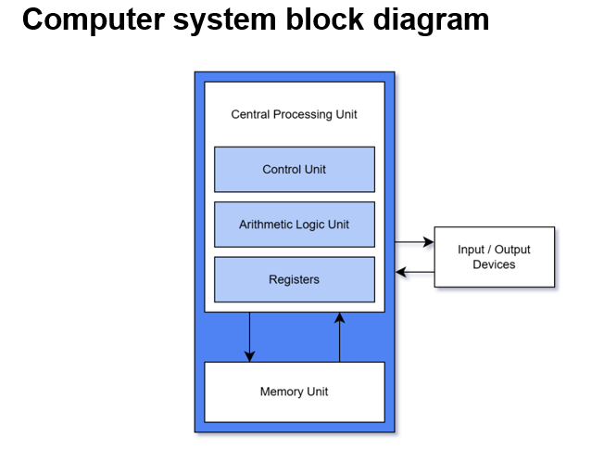

Part A – Basic Concepts
1. Define the following terms:
a) Control Unit
b) Arithmetic Logic Unit (ALU)
c) Register
d) System Clock

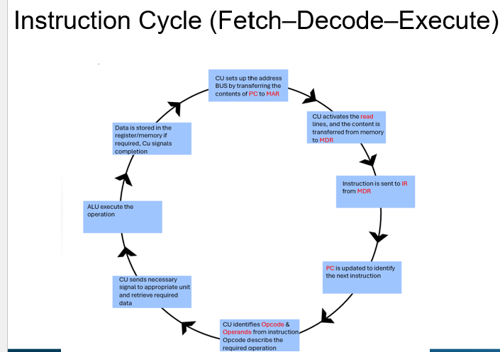
2. Explain the role of the following CPU registers:
Program Counter (PC): ______________________________
Memory Address Register (MAR): ______________________________
Memory Data Register (MDR): ______________________________
Instruction Register (IR): ______________________________
Accumulator (ACC): ______________________________
3. What is a machine instruction? Give an example and identify the opcode and operands.
Example: ADD A, B
Opcode = __________
Operands = __________

Part B – Instruction Cycle
4. List the three stages of the Instruction Cycle.
1. __________
2. __________
3. __________
5. Complete the Fetch sequence:
PC → ______ → Memory → ______ → IR
6. Suppose:
PC = 200
Memory[200] = ADD A, B
Explain what happens during the Fetch stage.
7. During the Decode stage, what two things does the Control Unit identify from the instruction?
a) __________
b) __________
8. Which component performs arithmetic operations during the Execute stage? __________

Part C – System Clock
9. What is the role of the system clock in a computer system?
10. If a processor has a clock speed of 3 GHz, how many clock cycles occur per second? __________

Part D – System Bus

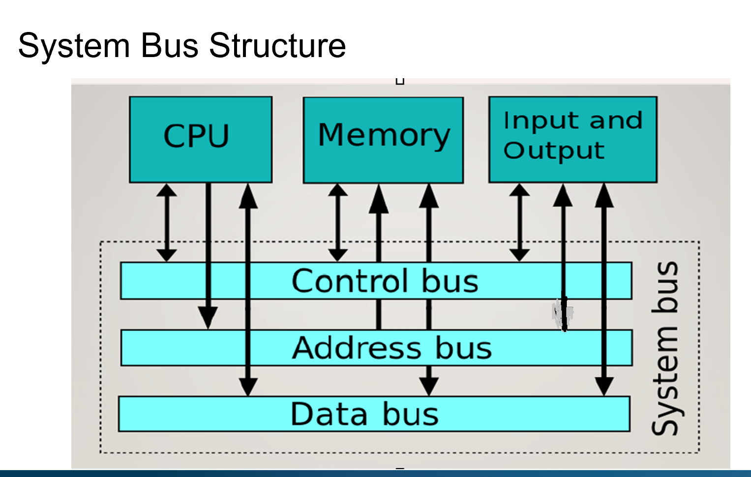
11. Name the three types of system buses:
1. __________
2. __________
3. __________
12. Match the bus to its function:
Data Bus – ______________________________
Address Bus – ______________________________
Control Bus – ______________________________
13. True or False:
a) The data bus transfers addresses. ____
b) The address bus is usually unidirectional. ____
c) The control bus carries READ and WRITE signals. ____

Part E – Applying the Concepts
14. Explain how the three buses work together during the Fetch stage using:
PC → MAR
Address Bus → ?
Control Bus → ?
Data Bus → ?
15. Consider the instruction: ADD A, B
Explain what happens during the Execute stage:
1. CPU retrieves value of ______
2. CPU retrieves value of ______
3. ALU performs ______
4. Result stored in ______

