Danielle Calo –
Professional Behaviours and Valuing People
CIPD: 89415482

1.1
Taylor & Woodhams (2022) provides an insight into what it means to be a people professional. As a People professional it is key to understand the impact of your decision making, consider the influence it might have and to have up to date specialist knowledge. This knowledge is key to taking a fair and consistent approach as your role as a professional will be people centric and have a direct impact on an individual. Within this capacity the individual holds a position of authority and will have influence. It is essential to ensure that ethical behaviour is considered due to the involvement with people, and potentially managing conflicts.

To assess the importance of a people professional it is key to understand the requirement to up-skill themselves. Self-governance is a key consideration as the people practitioner needs to maintain professionalism, be able to communicate clearly and to consider different cultures and professions within an organisation.

There is the requirement to adhere to Codes of Conduct and ethical practices to ensure that the decision taking an evidence based approach. There is a Code of Professional Conduct outlining that a people practitioner is to uphold confidentiality, and to be fair and consistent as they will deal with different professions and managers. The professional is required to take responsibility in their decision making, alongside time management. (CIPD, 2020)
Within the workplace People professionals play a key role in contributing to developing the working environment and providing specialist knowledge. As an example, people professionals will help support with decision making which may be required if there is a business change and help provide support for wellbeing of staff. The people professional will need to demonstrate that they are being fair and consistent alongside keeping up to date with specialist knowledge for people policies and procedures.

People Development Magazine (2019) provides an overview that a People professional adds true value to an organisation as they need to demonstrate flexibility as they are required to manage varying priorities. They need to be a good and active listener, show compassion, manage and to be organised. As an example within my workplace there are outlined policies and guidelines for people professionals to follow i.e sickness and absence management policies and also dedicated teams to support with equality, diversity and inclusion without judgement.

The people professional needs to have well-rounded knowledge to support making effective decision making, alongside ensure that wellbeing at work is adopted for staff members to feel valued.

CIPD (N.D) outlines the People Professional Map and how such values and behaviours outlined above should be maintained.

For each of the levels for core behaviours it includes Ethical practice, Professional courage and influence, Valuing People, Working Inclusively, Commercial drive, Passion for learning,Insights focused, Situational decision-making. The core behaviours demonstrate the key qualities that a people professional will need to have to ensure a positive experience for the organisation and to share best practice, and help deliver a positive experience within decision making. As a people professional they should demonstrate confidence and provide a consistent approach to add true value within the workplace for both staff and organisation.

The main values of the people professional map are:

Principles - Led
Evidence based
Outcomes Driven

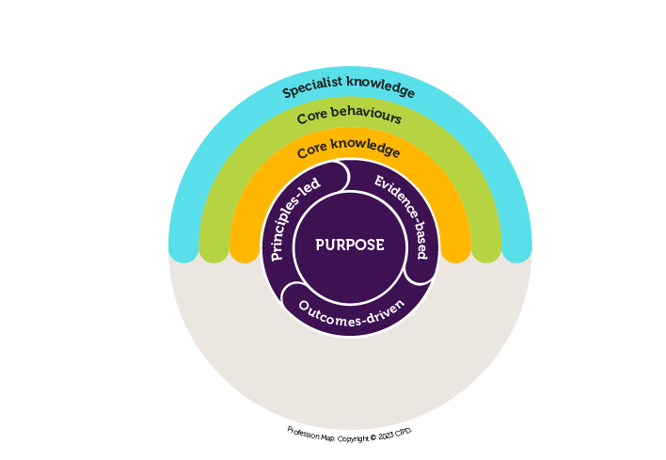

CIPD (2020) further outlines that within People practice it is important need to understand developing policies, and developing the skills within the workplace that can help for better productivity.
The profession map is consistent to all people professionals and can be adopted in all sector. It is importance to consider different stakeholders and the different communities in which you work.
CIPD (2023) also outlines the Code and Conduct and Ethics to ensure that can support for making difficult decisions, also to ensure that it delivers the best outcome for individuals within the workplace.
The code of Conduct has 5 factors which are:
Positive and impact on working lives
Civic Virtue and stewardship
Good Character
Professional service and competence
Personal Responsibility

1.2
Smith and Mitchell (2022) describe three types of ethical values:
Personal – Foundation of your ability to judge right from wrong
Professional – those adopted alongside your profession or workplace
Public – For the common good
Built In (2024) confirms the important of workplace ethics. It outlines that ethics are principles that an organisation aims to live up to. An individual should agree to treat others with respect and act with integrity, by doing so it will help build trust with its stakeholders and staff.
Better Up (2023) outlines eight ethical values for professionals. To apply this to my own work practice I feel that I am able to demonstrate Accountability as when tasked with a problem I ensure that I take ownership. From taking onboard the feedback and issue I ensure that I provide the staff member of updates when I am providing support to setting clear expectations on how long it will take to resolve also to provide them an insight into steps taken to solve a problem. I.e if they have faced an issue with their salary, I assist with reimbursement and clarity around timescales.
Respect is another value that I adopt which ensures that I treat each individual the same and understanding that each background and culture is different. The workplace where I work is quite diverse and its main members of staff I interact with are from different countries and religious beliefs. Whilst assisting with a query I ensure I take the time to fully understand their requirements, and ask open ended questions and show compassion if they don’t understand a certain process.
Honesty is the third value that I feel as if I demonstrate well when working within staff, and stakeholders. The role in which I undertake involves developing processes to make them more streamlined. In particular providing feedback as a user of digital platforms and suggesting realistic improvements for improvement. Also adopting this when working with colleagues by coaching and developing new starters to ensure they develop their knowledge and provide constructive feedback.

1.3
HR Magazine (2022) provides an insight into influencing others. It is key as a people professional that you are patient as a change could take longer to implement. To have the engagement from staff it is key to understand there will be pushbacks and different points of views. For engagement of staff and to keep moral positive it is advantageous to show interest in other peiples perspectives and show the benefits of change. Planning and preparation is also key for influencing as there may be unplanned set backs i.e change of a process taking longer to roll out or constraints with budget costs.

Robert Cialdini (N.D) outlines six overarching principles that can be considered when influencing others.

Reciprocation
Liking
Commitment and Consistency
Scarcity
Authority
Consensus

The above six principles have been adopted within the workplace that I work within to ensure that when processes are changed that all steps are followed.

As an example, I helped prepare a Business Case to support the benefits of having a substantive team to support the ongoing recruitment of Band 5 nurses. Each business decision or change requires sign off from Management/Executive team. The team had temporary contracts and year on year the funding was allocated to support training and development, and to pay for temporary staffing. Alongside my line manager who is the Head of Recruitment we had to assess the benefit of having an ongoing permanent structure in place. The proposal had to outlined key roles and how the permanent structure would work providing costings for different roles such as admin staff or trainers. The influencing of senior members of staff to see the benefits was outlined around that the vacancies had been significantly decrease due to mass recruitment, and it would provide a positive work environment to reduce money on agency spend by utilising substantive members of staff.

Through adopting the Six Principles of influence this helped demonstrate commitment and consistency to continuing to offer career progression, reduction in temporary staffing costs and to demonstrate the importance of delivering effective patient care.

1.4
CIPD (2024) confirms the requirement for Ethical practice and how it impacts the role of people professionals. Within people practice as key decision makers for instances such as grievances and redundancies the practitioner can quite often be blamed. The Code of Conduct & Ethics outlines why it is important to understand the policies and procedures and to ensure that decision making is fair and consistent.

As an example, the policies for raising unethical behaviour within my workplace are outlined in the conduct policy which is a confidential service that staff can raise concerns. SBUHB (2022) highlights the values caring for each other, working together, always improving. This provides consistency for the employee’s organisations to take accountability and be open within the workplace.

Bribery Act (2010) is also outlined that all NHS employees are to follow guidelines and that offers of Gifts and Hospitality needs to be recorded and can only be a token gesture and not demonstrate that staff are benefiting from extravagant offerings. It needs to be recorded on a Gifts and Entertainment Register and signed off by Line Manager. Staff members need to demonstrate they are behaving ethically ‘doing the right thing’ and not having financial gain or prioritising an individual. It further outlines that staff should not abuse their official position to benefit themselves or for family or friends.

As an example, I provided support in a Disciplinary meeting where a staff member had not declared that they had a personal relationship with a colleague working on the same ward. The line manager raised concerns through the HR hub that during working hours the ward was left unattended for periods of time and the staff members were reported on several occasions. There is a declaration form within the staff handbook to confirm if you have a personal relationship within the same workplace. I provided support to the Hearing manager, line manager and contributed towards taking steps towards interviewing both members of staff to remind them of the consequences and impact on providing quality care. The individuals were provided with formal written warnings, and confirmed any reoccurrences would lead to dismissal.

2.1
CIPD (2024) confirms that promoting and delivering EDI in the workplace is a key aspect of good people management. EDI and stands for Equality, Diversity and Inclusion it is essential to create positive working environments and cultures where all staff can feel safe. The social justice case for EDI is based on the belief that everyone should have a right to have equal access to employment, training and are free to do so without any direct or indirect discrimination. Equality Act (2010) outlines the minimum standards as to what is law in regards to treating people fairly.
The ‘psychological contract’ highlights the human side within an organisation. This will have a direct influence on how the staff member will feel valued and create positive outcomes. The psychological contract may include expectations such as training and development opportunities, career prospects, fairness of pay and benefits and management support. This is currently evolving due to the pandemic and cost of living crisis, alongside changes in technology and automation through the development of AI. CIPD (2024) highlights the Good Work Index and helps look at changes, and its intension is to be inclusive of employee’s voice and considers health and wellbeing to promote better job satisfaction, manage potential workplace conflict, and opportunities to develop its workforce.

If an individual is aware of what is expected alongside being aware of understanding what training and development opportunities are available, along side promoting an open employee voice this could see positive performance from the employee.
The business benefits of promoting diversity within the workplace could lead to better staff retention if it promoting diversity within the workplace. Each organisation has Corporate Social Responsibility and across the market place it is favourable if an organisation promotes social inclusion. This will help promote potential growth alongside attract people to apply to work for the organisation. (CIPD, 2024b)

2.2
As a people practitioner it is essential to consider different perspectives from its employees, stakeholders and communities. For individuals to feel included within the workplace people practitioners need to consider Equality, Diversity and Inclusion. Equality Act (2010) provides protected characteristics such as age, gender reassignment, being married or in a civil partnership, being pregnant or on maternity leave, disability, race, religion or belief, sex, sexual orientation these need to be considered by a people practitioner to ensure inclusivity and unbiased views within the workplace.

CIPD (2024) highlights five actions that can be adopted to foster inclusion within the workplace:
Involve all employees in Inclusion
Develop manager capability
Build a senior commitment to inclusion
Evaluate policies and practices
Examine organisational culture, climate and values
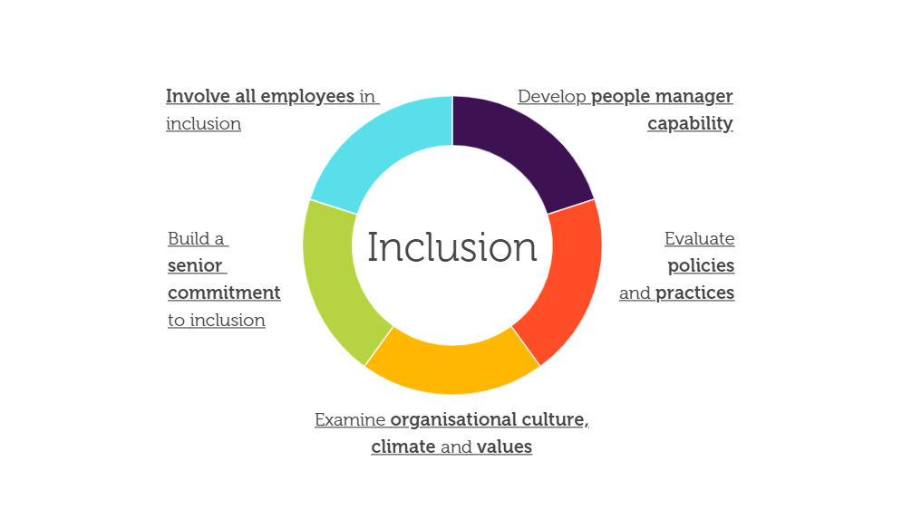

By adopting the above five areas within an organisation it can provide guidance not just for staff but its managers on dealing with ensuring everyone feels valued. It can also help to upskill line managers from senior leadership to line managers as persons in power will have more of an influence on promoting inclusivity and staff members will feel more supported. It will create the opportunity for staff to speak up more freely, provide open communication and to also provide opportunity for feedback.

As an example, to promote inclusivity including staff within decision making could be deemed as positive and help staff feel valued. Within my organisation myself and a colleague created a Post training feedback questionnaire for overseas nurses that had undergone clinical preparation training. It included asking for feedback on a session held called ‘Cultural Conversations’ the main aim of this session is to understand how the overseas candidate has embedded into the organisation. Asking open ended questions around if they felt support i.e knowing about BAME community / adjusting to life in the UK. At first staff felt that they didn’t want to voice their opinions in an open forum so through the development of a questionnaire we encouraged them to leave their true feedback. The main feedback consisted of the ability to be able to network with other nurses that had undergone a similar experience also feedback on line managers and the understanding that there will be different ways of working for clinical procedures. The session is now led by an international nurse that has come through the programme, and this has proven to be successful as the sessions have gauged more ‘honest and ‘true’ feedback on their experience in the clinical setting/life in the UK.
This has created a positive involvement from developing people manages capabilities and also considered involving employees in inclusion. Overall this has led to a positive open feedback forum allowing staff to feel that they can provide experience of their journey and suggest improvements.
CIPD (2024b) provides an insight into the Good Work Index and discusses what is good work? It is to ensure that work is fairly rewarded, provides opportunities to develop and provides a supportive environment. To apply this to my workplace staff were invited to attend a Matron Development Programme if they were of a certain banding. This provides opportunity to upskill their knowledge, share feedback on areas that they feel could be changed and gain more exposure in a dedicated training workshop to developing leadership skills. My team helped contribute and deliver the programme for the Ward Managers, creating open feedback sessions on some of the set backs they face when working in a busy ward environment. Staff overall felt as if they didn’t have sufficient time for 1:1 sessions with managers, and that a lot of the time due to operational pressures development of staff was not a priority. The feedback was collated and shared with HR and we took the time to understand how we can ensure that staff are developing as retention of staff is a key focus.
2.3
To reflect on my own approach in working inclusively within the workplace I have worked collaboratively across two functions. My role involves me working within two directorates which is Workforce and Organisational Development and Corporate Nursing. My role involves managing competing priorities to ensure that the delivery of goals and objectives for International Recruitment are met. At times this can prove difficult due to different working patterns with Senior Managers, and the requirement to prioritise is essential. As an example I need to ensure that daily tasks are met in regards to the recruitment and onboarding of staff and assisting with administrative queries. The nurses work different shift patterns and it can sometimes take me past working hours where I am flexible. Through being adaptable to different shift patterns, and understanding what is considered as urgent work required I receive positive feedback.
The above is supported further by feedback received from my manager.….I can confirm that you do have an inclusive style of working and plenty of occasions when you have demonstrated this in our team. I’ve always found you positive in your attitude and approach to work….’get the job done’. You are intelligent, helpful to managers, your peers and subordinates. Willing to go the ‘extra mile’ when required….and there have been many occasions. You are also patient and kind in your approach. You used to have more of a tendency not to switch off but I’ve seen an improvement in that now and you organise your time better, not working late so often.

To build relationships with others I take the time to upskill administrative members of the team to help support with smaller tasks. I am often seen as the go-to person for queries in relation to policy and procedures for Immigration, DBS practice and Finance queries. This has created a positive impact for both UK / International member of staff as there are many different cultural backgrounds and through time I have developed the understanding on how to work and collaborate with different cultures.

3.1
CIPD (2023) provides an insight into how the people practice profession is evolving. It has seen major shifts in the behaviours of workers and the workplace and has brought about opportunities for enhancing digital changes and creating more of a work life balance. Due to the current financial climate there has also seen a reduction in available budget. This has meant that within my organisation there has been a reduction in available resourcing of staff.
As an example, since the pandemic Hybrid Working has been embedded as the new way of working. Due to the needing to work remotely this brought forward digital developments for inhouse training that used to be delivered in person, and also implemented new procedures.
CIPD (2020) looks further at how the people profession may look in the future. To influence and shape the workplace within the it is key to consider Social factors and how cultural changes may influence the workplace. The people practitioner will need to understand and be kept up to date with knowledge around Diversity and Inclusion, and to understand demographic shifts such as culture, and different languages.
Due to the advancements of technology and Artificial intelligence it will be key to upskill knowledge around how this will impact HR. Taking time to research AI, attending forums and to understand how it can help for people managers to use AI in a strategic way and address any concerns around impacting of job losses, will help to support AI use more efficiently to develop work practices (CIPD, 2020b)
As an example, to apply this to the organisation that I work within the organisation rolled out a questionnaire to staff on technological requirements whilst working at home.
To apply this to my area of work staff have continued to work remote and due to the nature of the role with it being heavily admin based we have had to digitise staff files. Previously documentation was printed for pre-employment documentation checks. We had to enhance the already existing compliance checklist and work with Senior managers in the team to upskill them on the use of digital platforms, and due to different working patterns, it took longer for a file to get signed off.
This has been challenging and due to the ongoing requirement to change procedures as staff aren’t always together in one place. It has meant that during times it has needed additional time spent to roll out changes, and also decision making can sometimes be delayed due to flexible working and a reduction of hours with senior leadership.

3.2

CIPD (N.D) outlines the People Profession Map and I will be referring to two core behaviour areas relevant to the associate level

Core Behaviours
Working Inclusively
Passion for learning
The role in which I undertake is for a Senior Overseas Recruitment Project Manager for an NHS organisation. I have outlined my Job Description below. I have collated feedback from a Senior Manager within the team around my involvement on assisting with providing support to the admin team and wider team.

This is broken down into three areas:

Strengths – Danielle has a Positive attitude and in her approach to work and has a ‘get the job done’ attitude. Helpful to managers. Danielle is helpful to managers, your peers and subordinates. Willing to go the extra mile when required. She is also kind and patient in her approach. To apply this directly to the Job Description for the role I undertake I take the time to understand processes and procedures for most effective ways of execution. I take the time to upskill junior members of staff to ensure their knowledge is kept up to date. Due to the fast faced environment, there has been the requirement to amend policies and adapt to new ways of working at short notice.
Additional comments from Admin staff: Dani is an extremely hard worker, always looking to go over and above to help colleagues and others around her. From my own experience, Dani has helped me to expand my knowledge and gain other experience within my role whilst also learning about other connecting tasks. She involves me in projects which will support me in my own career progression and is always keen to know my thoughts about the work and discuss these with me.
Due to the nature of the role I have undertaken a lot of responsibility around audit and monitoring to ensure that we adhere to legislation and comply with budget. This significantly improved my knowledge around financial monitoring and also being seen as a subject matter expert for international recruitment. I take the time to share knowledge and practice learn with the admin staff to work inclusively together.
Weaknesses – Comment from Senior Manager - Find it difficult to switch off.
This is a reflection from Senior Manager and myself as at times I take on too much workload to get the role done. Often spending time out of hours answering queries as the nurses have different shift patterns which has an impact on my own personal time. A development area here is learning to prioritise and setting expectations that queries are to be answered during business hours. This comes under Planning and Design section of the Job Description.

Development areas – Managing time more effectively and not taking on too much work. Through my own self-reflection also this is a true comment. Due to the high volumes of administrative tasks and mass recruitment there are times where I am unable to focus. I need to work towards prioritising what is essential in order to be more effective and to have more of a work life balance/ Also additional comments have been provided by the admin staff that due to the complex nature of the queries it might take me longer to research certain topics and that I should let the nurse do more research into topics themselves.
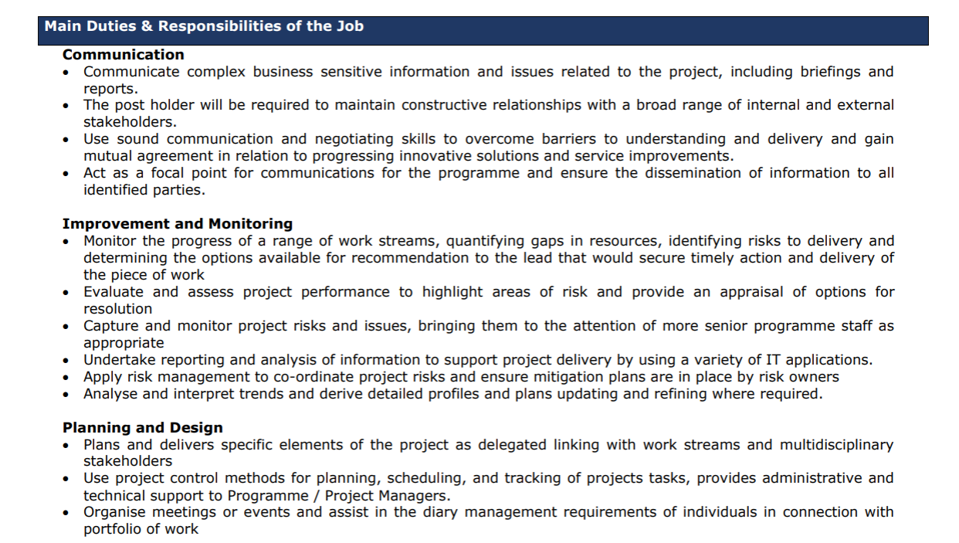

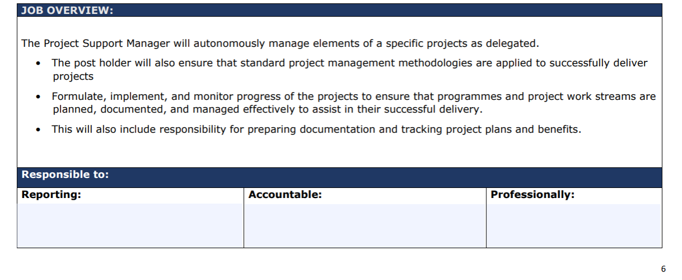
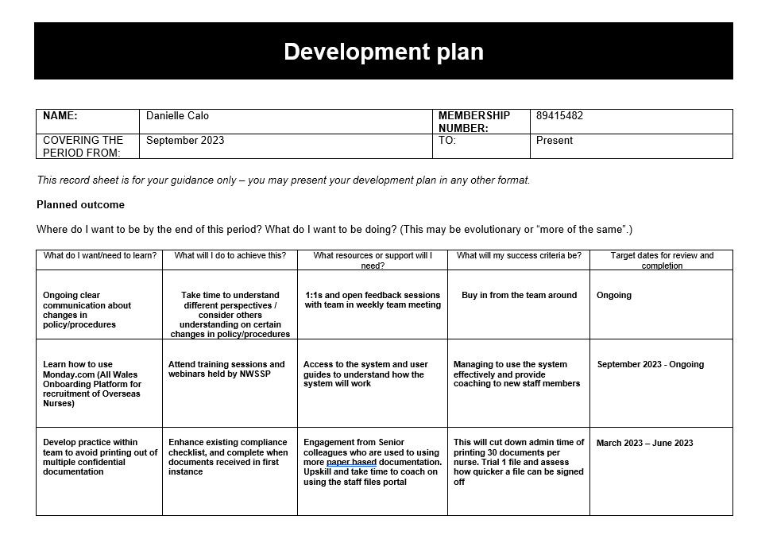

3.3

Following on from your self-assessment, I have identified three areas that I would like to develop in. Firstly to gain experience within Operational HR to enhance knowledge around wider HR policies ultimately as this is an area I would like to work in within the future. Secondly to attend All Wales Recruitment meetings this is to upskill me within my current role and to understand priorities from a Senior Managers perspective providing opportunity for enhanced knowledge and leadership opportunity. Thirdly Reach MENTAL Health Training to support my colleagues with their mental health and to promote wellbeing within the workplace as well as identifying tools for my own wellbeing to support me feel at my best.
Following on from self- assessments There are other areas that I would also like to address which is more from a personal perspective and these are in relation to time management and personal wellbeing. The main aspects are to ensure more of a structure is in place within my working day alongside prioritising my own wellbeing whilst still supporting others.

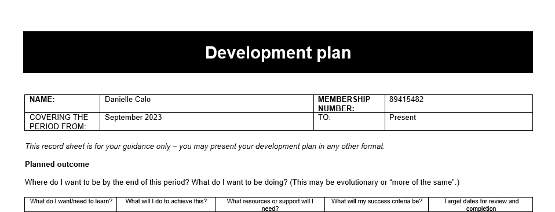

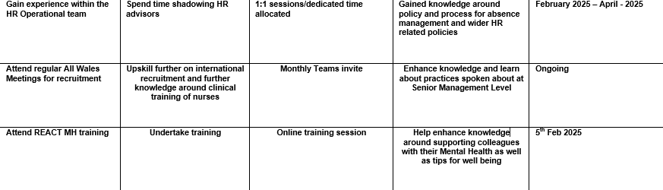

Time Management | Allocate time in calendar to complete own tasks effectively | Use online software such as outlook for blocking time in calendar, and utilising Planner on Teams | Better productivity and completing own work during work hours | Ongoing
Wellbeing sessions/focus on being more active | Attend wellbeing sessions via MS Teams.  Taking time out of day to exercise and take a break | Online Wellbeing Training Session – Steps to wellbeing – Strategies for Stress | Feeling more relaxed and learning to consider taking a break is important  Taking forward tips on how to manage symptoms of stress with busy work load and also promote wellbeing within myself and colleagues | Friday 25th April 2025
Dedicated training time for Admin staff | Open conversation to work towards better way of working | Catch up sessions in form a 1:1 discussion | More structured time as oppose to answering their queries straight away. | Ongoing
Allocate time to read about different HR perspectives | Build reading into daily routine and not just for when assignments are due | Drama Free Workplace by Patti Perez /  Employees Gone Wild – by Richard Burton | Learn a new perspective on effective communication and increase collaboration and how to manage misunderstandings within the workplace | 1st July 2025
Develop knowledge around HR and its changing role | CIPD Essential Insights Learning via CIPD learning Hub | HR in practice course | Putting into practice the skills learnt from the course | 1st June 2025

*Words in red/blue above are a part of the updated Development plan and not included in wordcount*

3.4
Within the outlined Development record I have attended three sessions that have helped me within my work practice alongside attitude to performance. Firstly the session for UKVI helped support with my business performance as I upskilled myself on key legislation and I still use this ongoing to provide support to staff with questions, and also keep my knowledge up to date as it’s a key part of policy within my area of work.
Secondly attending the HPMA conference allowed me to build up a network across the Wales area and to learn about different HR Professionals for working without judgement as this creates positive working relationships.
Thirdly the session via Linked In was more of a networking opportunity to get to know colleagues from other organisations. Whilst they may not be apart of my everyday organisation it added value as the topic of career opportunity was discussed. Therefore through my advanced network and upskilling myself continuously I feel as if I will hopefully get the best out of the profession and learn from experienced HR professionals.
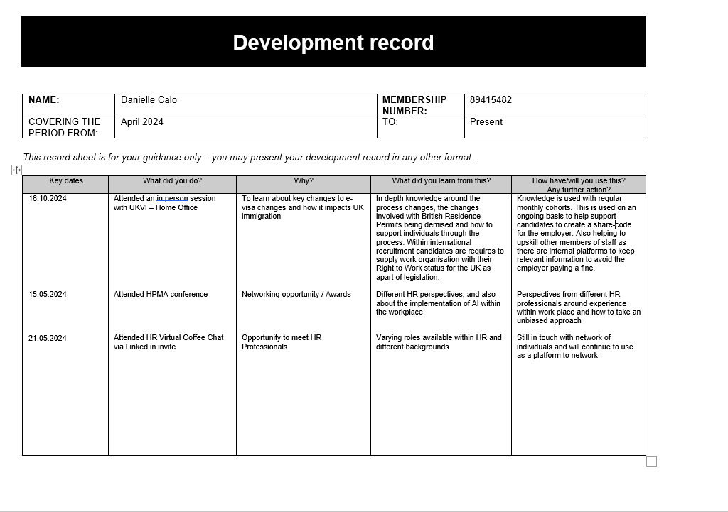

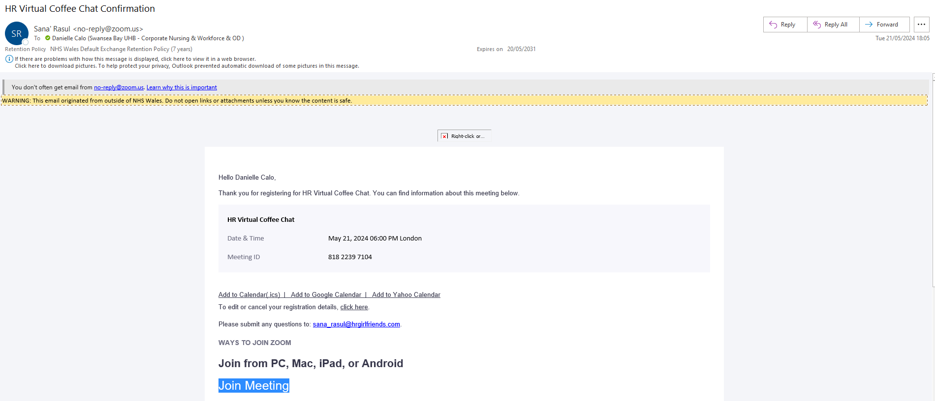

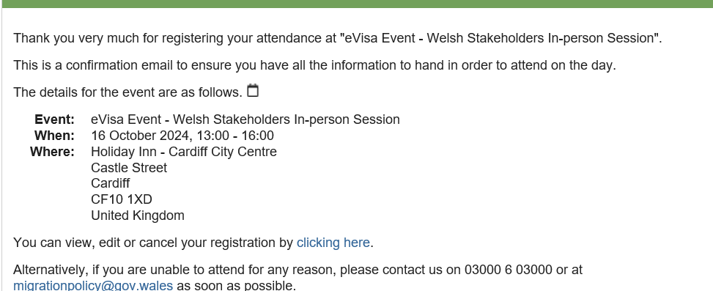

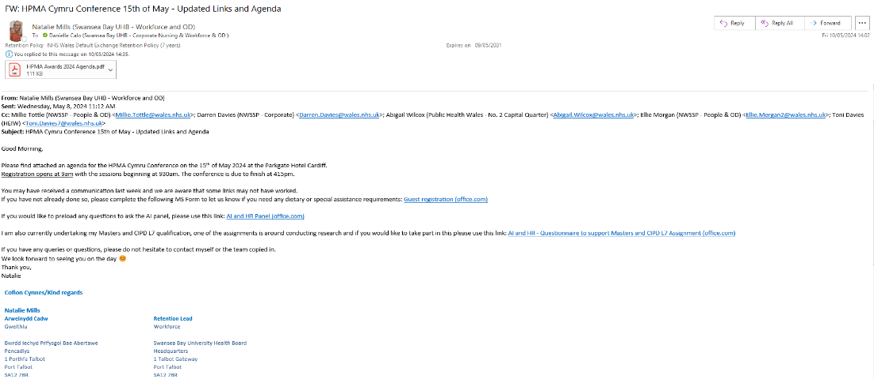

Bibliography:
Better Up (2023) - 8 ethical values every professional should adopt – https://www.betterup.com/blog/ethical-values (Accessed on 20.01.2025)
Built in (2024) – The Importance of Workplace Ethics – https://builtincom/articles/workplace-ethics (Accessed on 20.01.2025)
Bribery Act (2010) – Bribery Act 2010 guidance – https://www.gov.uk/government/publications/bribery-act-2010-guidance (Accessed on 20.01.2025)
CIPD (2020) – People Profession 2030 – A collective view of future trends (Accessed on 26/03/2025)
https://www.cipd.org/globalassets/media/knowledge/knowledge-hub/reports/234people-profession-2030-report-compressed_tcm18-86095.pdf
CIPD (2023) – Code of Conduct and Ethics – https://www.cipd.org/globalassets/media/comms/code-of-conduct/2023-cipd-code-of-conduct-and-ethics.pdf (Accessed on 20.01.2025)
CIPD (2024) – Equality, diversity, and inclusion (EDI) on the workplace (Accessed on 26.03.2025)
https://www.cipd.org/uk/knowledge/factsheets/diversity-factsheet/#Thesocial (Accessed on 26.03.2025)
CIPD (2024) – Ethical Practice and the role of people professionals - https://www.cipd.org/en/knowledge/factsheets/ethics-role-hr-factsheet/ (Accessed on 20.01.2025)
CIPD (2024) – Good Work Index 2024 - https://www.cipd.org/globalassets/media/knowledge/knowledge-hub/reports/2024-pdfs/8625-good-work-index-2024-summary-report-web.pdf (Accessed on 20/01/2025)
CIPD (2024) – Five actions you can take to foster inclusion - https://www.cipd.org/en/knowledge/guies/five-actions-fostering-inclusion/#3-build-senior-commitment-to-inclusion (Accessed on 20.01.2025)
CIPD (N.D) How to use the People Profession Map
https://www.cipd.org/uk/the-people-profession-map/how-it-works/ (Accessed on 20/01/2025)
CIPD Profession Map Webinar (2020)- Understanding Professional Values (Accessed on 20/01/2025) https://bing.com/videos/riverview/relatedvideo?q=cipd+people_professional+map&&mid=E51F5490DB5582EF2767E51F5490DB5582EF2767&mmscn=mtsc&aps=360&FORM=VRDGAR
CIPD (2023) – Code of conduct and ethics – https://www.cipd/org/globalassets/media/comms/code-of-conduct/2023-cipd-code-of-conduct-and-ethics.pdf (Accessed on 20/01/2025)
Equality Act (2010) – Equality Act 2010: guidance – https://www.gov.uk/guidance/equality-act-2010-guidance (Accessed on 20.01.2025)
HR Magazine (2022) – Ten tips for successful influencing – https://www.hrmagazine.co.uk/insights/ten-tips-for-successful-influencing (Accessed on 20.01.2025)
People Magazine (2019) – How to Make Sure HR Adds Value to the Business – https://peopledevelopmentmagazine.com/2019/05/01/hr-adds-value/ (Accessed on 20.01.2025)
Smith, J. A (2020) Reflective Practice, Exeter: Exeter University
Robert Cialdini – Six Principles of Influence – You Tube Video - (N.D) https://www.youtube.com/watch?v=eCNeOga965U – (Accessed on 20.01.2025)
SBUHB (2022) - Standards of Business Conduct Policy - nhswales365.sharepoint.com/sites/SBU_Intranet/Policies and Procedures/Forms/AllItems.aspx?id=%2Fsites%2FSBU_Intranet%2FPolicies and Procedures%2FPolicies%2FStandards of Business Conduct Policy%2Epdf&parent=%2Fsites%2FSBU_Intranet%2FPolicies and Procedures%2FPolicies
(Accessed on 20.01.2025)
Smith, J. A (2020) Reflective Practice, Exeter: Exeter University
Taylor, S. and Woodhams, C. (2022) Studying Human Resource Management,3rd Edition, Kogan Page

