Cloud-based services security issues
Jasitharan Kugathasan, Computer Networks and Cybersecurity; Module: Advanced Cybersecurity, Lecturer: Dr. Carlene Campbell
Abstract – The report provides cloud-based security issues and its architecture layers security issues. Four Penetration tools and prevention method are analyzed and documented in the report. The security measures for smart campus are simulated using cisco packet tracer.

introduction

Increase in internet services with lots of connected devices which increases the cyber threats. The suitable techniques and tools must be used to overcome these cyber threats. There are many different technology sectors which vulnerable to cyber-attack. Cyber-attack is nothing but the art of understanding the full functionality of a technology to take the control over. For example, early days in communication the data sent across was readable, the security issue in this was third person can read the data. To overcome this issue encryption was introduced. Introducing encryption hasn’t put an end to this problem. Ways of cracking those encryption algorithm techniques was found alongside. Fixing or developing new encryption algorithms will provide the security unless the loophole is found. As technology grows the cyber threats also grows along with it. A successful cyber-attack will lead to financial losses or data theft etc. Cyber-attack is for intentional purpose which can be for any reason like data theft. Cyber-attack can be defended with monitoring activities and techniques to handle cyber-attack. These techniques are implemented and developed as a tool. Learning these tools will teach the way of handling cyber threats. This report researched on security issues with cloud-based services. The cloud computing is shared computing resources that organizations and users make use application services or data storage regardless of location. Cloud computing is benefits in saving of capital expenditure for organizations. Despite having such benefits in cloud computing it has major security issues to be always considered[1]. Cloud services can be categorized into private cloud, public cloud, community cloud and hybrid cloud, these clouding need high performance network access. The clouding infrastructure layers can be classified into SAAS (Software as a Service), IAAS (Infrastructure as a Services) and PAAS (Platform as a Services)[1]. Cloud computing rapid development as SAAS are used widely for software licensing and software delivery for organizations and for user[2]. The IAAS are hardware of cloud computers like network storage, virtual servers, processor and memory. Data centers are good examples of IAAS infrastructure. The IAAS infrastructure also focus on security areas like firewall, virtual machine monitoring and intrusion detection[3]. The framework, programs, architectures, integrated development environments and development tools services provided by the PAAS infrastructure. The PAAS faces many security issues like underlying infrastructure security[3]. The private clouding manages data center services withing the organization which provide supplier and customer relationship. The public clouds are services from academia, enterprises or government that provide clouding services to the public. The resources in public cloud service are harder to protect from cyber-attacks. The hybrid cloud services are combination of two or more cloud services. The hybrid cloud is well organized and secured compare to public cloud services. Cloud deployment model are advantages of hybrid cloud service[3]. The overview of cloud computing infrastructures and services are discussed. The security issues with cloud-based services are discussed and researched in this report. Demonstration of hacking tools that may affect organization or users are discussed in this report. Simulation using cisco packet tracer to demonstrate security for Smart campus using Internet of Things (IoT) as part of this project.

Cloud-based services security issues

The user’s private data are store in cloud. The Cloud Service providers (CSP’s) data centers are maintained different location geographically, the users don’t know which location their data is stored and given access to the user. These have several major security issues. The data is not with user’s personal storage such as personal computer. As user data is on cloud, host device based anti-virus, intrusion detection and firewall do not provide enough security when using cloud-based services[1].
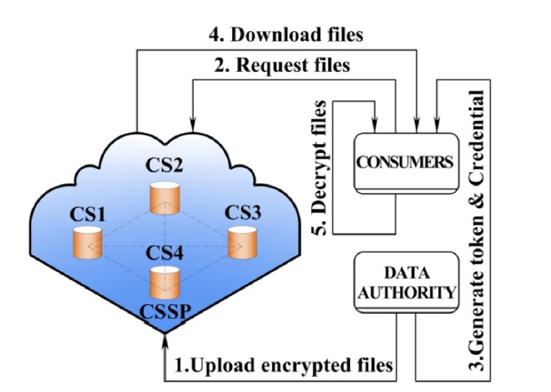
Figure 1: Crypto-Cloud Architecture[1].

The figure 1 shows the function of crypto cloud. The data authority (data owner) uploads encrypted files to the cloud. When consumer need to access the files, consumer request the file. After authentication process is done with consumer and data authority. The consumer will be able to download the file. After the file download, the consumer can decrypt the file. There are several type of security issues with cloud-base services among them the data breaching is the top security issue with cloud-based services.

Threat Number | Threats
1 | Data Breaches
2 | Compromised credentials and broken authentication
3 | Hacked interface and application program interface
4 | Exploited system vulnerabilities
5 | Account hijacking
6 | Malicious insiders
7 | The advanced persistent Threat (APT) parasite
8 | Data loss
9 | Inadequate diligence
10 | Cloud service abuses
11 | Denial-of-Service (DoS) attack
12 | Shared technology Vulnerabilities
Table 1:Top 12 Threats of Cloud-Based services[1][4].
Each layer in cloud computing infrastructure have vulnerabilities. The layer model of cloud computing is shown in figure 2.

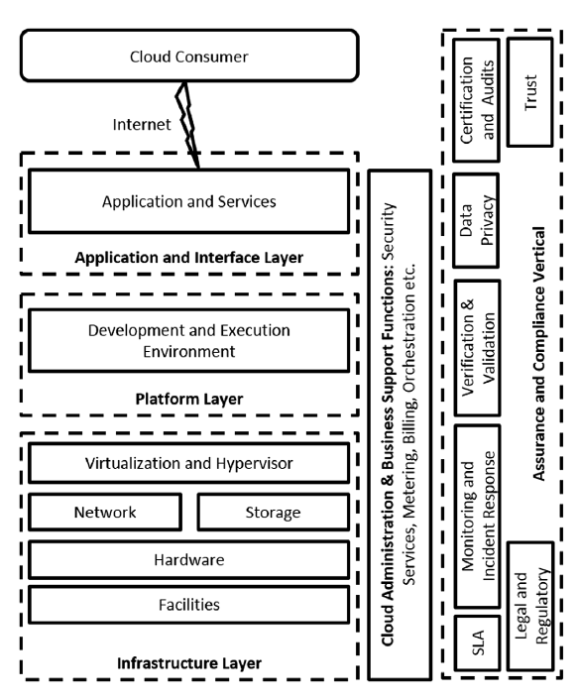
Figure 2: Layered Model of Cloud Computing[4].
Application and interface vulnerabilities: At application and interface layer, cloud provider provides entry service access to consumers. Using web browser, consumers access cloud services. This layer is more vulnerable to threats due to vulnerabilities in web technologies. The web technology critical threats that affects the cloud-based services is insufficient logging & monitoring, using components with known vulnerabilities, Insecure de-serialization, Cross-Site Scripting, Security misconfiguration, broken access control, XML External Entities (XXE), Sensitive data exposure, Broken authentication and Injection. As cloud-based services are based in web technologies these are most vulnerabilities that impact, to handle these vulnerabilities in web technologies new approach must be adopted[1][4].

Unauthorized access to data and data leakage due to the vulnerabilities in web service and interface. The command injection, cross-site scripting and SQL injection are vulnerabilities in web service interface. The web service request could be stolen using session riding and session hijacking. The meta data can be hacked by spoofing attack through the web interface. Data manipulation in web client can also be considered as vulnerabilities to cloud-based services as they use web browsers to read and modify data components like plug-ins and mash-up, the HTTP do not provide data integrity as the login credential are entered through web browsers[4][5]. The attacker creates clone websites in order to obtain the login credentials. Insecure user practice like weak password and reused credentials can also be the reason for security issues with cloud-based services[1].

The data integrity and confidentiality are ensured with the mechanism of encryption algorithms and encryption keys. Encryption and key related vulnerabilities will be major issue with cloud-based services security if there is no strong encryption algorithms are used for cloud-based services[1][4].

Platform layer vulnerabilities: Deployment tools and development tools are provided by the platform layer. The underlaying operating system and custom developed software are decided whether the layer is vulnerable or not. All developed real-time software application and critical business application must undergo performance and security test before using the applications. Incomplete and insufficient validation and verification of deployed software can be vulnerable in platform layer[5]. Generally programming code causes software applications to be vulnerable, secure coding must be considered when developing software applications for cloud-based services. The platform development environment in .net and java are highlighted as security issues which cause memory zone isolation violation and unsafe thread termination[4]. The cloud application code for back-end server are vulnerable to malicious masked code injection[1].

The communication between hardware and application are handled by operating system OS in cloud virtual machines. Any malicious services running in background of cloud operating system will lead to data leakage hence virtual machine have access to all data and if memory isolation is inappropriate which will also lead to data leakage. Monitoring the OS of cloud computing is must, insufficient monitoring OS will expose to malicious threats[4][1].

Infrastructure layer vulnerabilities: The critical enabling technologies for cloud computing are virtualization and hypervisor. The prevention system (IDS/IPS) and intrusion detection, network monitoring tools, network segments, firewalls and Demilitarized Zones (DMZ) like perimeter-security measures for traditional data centers are not enough in order to secure the virtual machines. Authorization and authentication vulnerabilities are cause by when remote access to administrative tasks. There are VM-hopping, cross-VM attacks, side-channel attacks and covert-channel attacks are VM specific attacks that causes vulnerability in cloud computing[5][4]. The malicious VM image causes high risk of giving access to the sensitive information. Dormant VM image and inactive VM image are exposed to higher risk as the administrator haven’t maintained or security patched and encryption of VM image are harder as they are large in size[1]. VM migration technology that allows the VM to relocate its physical server without shutting down. The VM migration have major security issue when copying the VM image across the network from source to destination. When VM images are copied live across the network from source to destination there are higher possibilities of insider attack and man-in-the-middle (MitM) attack[4]. Cloud computing share its hardware and software resources to consumers. Each consumer data and configuration are partitioned separately using an application in multi-tenancy environment. Sharing the same hardware platform among the consumers will create privacy and security challenges. Hosts and co-located services can cause cyber-attack which will lead to advanced persistent threat (APT) and violation of integrity are possible in multi-tenancy[4][1].

VM Monitor (VMM) or hypervisor runs multiple operating system on the same hardware concurrently. Hypervisor also have security and privacy issues like other cloud components. Hypervisor can be attack with VM escape by breaking down the virtual machine and giving access to the host operating system and unauthorised access to other Virtual machines[4][6]. VM’s can cause security issues with untrusted components, malicious components and single point of failure[4][1].

There are two types of communication, internal and external in network of infrastructure layer. The communication between components and consumers through internet are external communication as it communicates external to cloud. VMs and cloud components communicate internally through virtual communication channel are internal communication in network of infrastructure layer. Virtual network and internet protocol and technologies also can be vulnerable to cloud network infrastructure[3]. The communication based on TCP/IP protocol stack like IP, DNS and DHCP are security issue that can be attacked using DNS spoofing, DNS cache poisoning and IP spoofing which causes vulnerabilities in network communication. When consumer visit a malicious website, the attacker can take over the broadband router of that consumer and change DNS settings for the broadband router. If the Broadband router are changed with DNS settings the session handling techniques are used by the attacker to HTTP stateless protocol for session hijacking[4]. When considering cloud-based security issue both side of consumers and Cloud Service providers must be aware of security issue that might cause serious data theft or data loss. The most security issue are considered from consumer side as they are not aware cyber-threats[3]. Unsecure communication between consumers and Cloud service providers when mixing of web client communication protocol HTTPS with HTTP[4]. Direct and indirect DoS are flooding attacks considered as threats. When using web-based communication there are possible of impersonation attack, cookie position and cookie theft. The SSH and TLS are vulnerable because using weak cryptographic key. Man-in-the-Middle attack is possible when HTTPS certificate forged[4].

When considering network shared components which are shared network infrastructure like routers, DHCP servers, DNS servers are inherent vulnerabilities. When sharing network components and resources which may lead to cross-tenant attack[5]. The inter-VM and intra-VM connectivity provide by creating a new network access layer which are identified as virtualizing the server. The user can manage and configure through communication channel and management interface to connect with different VM using same physical platforms. The communication channel used for this purpose are virtual channel, the communication cannot be traced or monitored. When communication is through virtual channel, it is not traceable and monitorable which will result in getting exposed to attacks[4][5]. Sniffing and spoofing attacks are possible for VM as they use virtual network to connect hypervisor. If one VM are malicious, the malicious VM uses ARP spoofing to send packets to other VMs[4].

The cloud computing needs huge storage capacity, stable performance and high availability to support all their consumers when providing cloud-based services. The data storage in cloud have inherent vulnerabilities of multi-tenancy and virtualization. The consumers data are not stored in separate storage for each consumer. The storage is shared and segmented or partitioned for each consumer[1][4]. Cryptography used for cloud storage must be in high level. Poor encryption algorithms, insecure, faulty and poor key management can make stored data vulnerable to Cyber-threats. The insider and outsider are the threats for data stored within the environment of cloud, there are high risk of tampering the data. Due to the application vulnerabilities, shared environment and compromised keys can lead to unauthorized access to data in cloud storage[4][6]. Understanding cloud computing environment are not in single location as they are distributed over geography multiple locations for the purpose of disaster recovery, scalability, redundancy and cost effectiveness. The backup storage in cloud are vulnerable to security issues like tampering and unauthorized access. The vulnerability in physical location of data center hosting the data and its back up, and backup data recovery in cloud storage are vulnerable to cyber-threats[5][4].

The destruction of any media having user sensitive information or user data that need to be changed to the different media or user data is no longer needed due to termination of contract for any possible reason the media get destructed is called data sanitization. If the media having users data or sensitive information’s not destroyed properly that might lead to security issues[4]. The basic components of cloud system are virtualized hardware. In case of hardware complete or partial hardware failures will outage the cloud system. The hardware design must be take care of faulty tolerance and scalability while designing the hardware for cloud computing due to the shared hardware resource have high security issues[1]. The resources of cloud computing are placed physically in data centers, data centers are called facilities. The data centers are vulnerable to malicious inappropriate design, poor infrastructure support like power management or maintaining bad cooling system etc., natural disaster and insider[4][5]. Physical attack to clouding system can cause by the insider. The insider can take physical security control over the system by penetrate the data center. The cold boot attack and hardware tampering possible by insider when physical access are gained[4]. The network has the main security issue against application running one cloud computing. The dangerous network-based attack is Distributed Denial of service (DDoS). The Code injection are the common type of network-based attacks inserting malicious code into application to run the malicious code to vulnerable the computing resources and to gain the access[6].

analysis of hacking tools

There are lots of tools that are used to attack any system or services. In this report four tools are analyzed and demonstrated.

Social Engineering

The term social engineering in cybersecurity industries referring to scamming techniques. Social engineering is gaining access to system or data by exploiting psychology of human instead of using technical hacking techniques. The common techniques of social engineering are quid pro quo, pretexting, baiting and phishing [7]. There are different tool and techniques used for social engineering. For the purpose of analysis and demonstration one techniques of social engineering are demonstrated. In this analysis, the demonstration of sniffing logging credentials is acquired using Social Engineering Toolkit (SET) in Kali Linux[8]. Social Engineering Toolkit (SET) are Python[9] source tool which are developed for penetration testing[10].

In this demonstration, cloning any website that have logging credential forms for the user to login to their account. Instead of real website a cloned website link is sent to the user making the user to sign in with their username and password. When user enters the username and password, the login credential will be sent to the hacker and cloned website will redirect to original website asking the user to sign in again. This technique can be done with Kali Linux SET.

Launching the Social engineering Toolkit in Kali Linux, at the main menu choosing Social-Engineering Attacks.

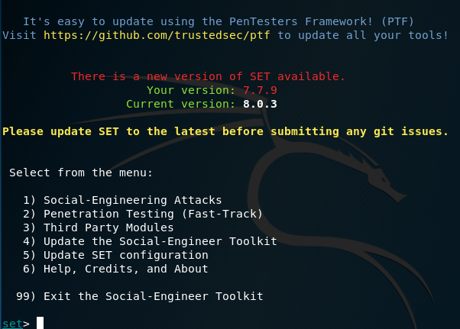

Figure 3: Social-Engineering Attacks.
This attack only target website with login credential field and this method don’t work for any software application. Selecting Website Attack Vectors.

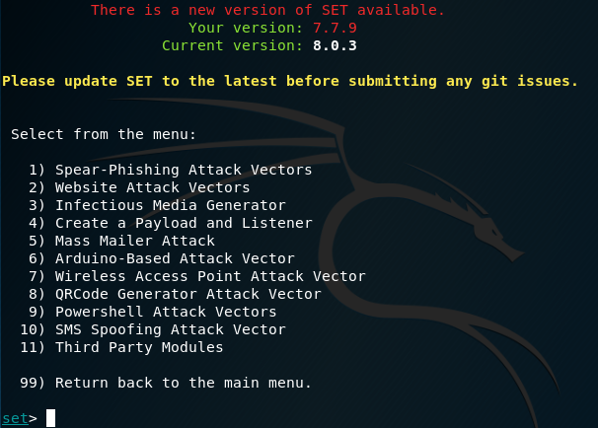
Figure 4: Website Attack Vectors.

The target is getting credential of the user. At this menu choosing Credential Harvester Attack Method.

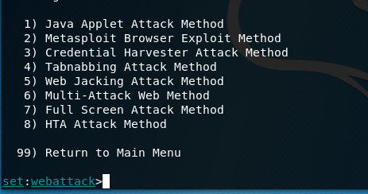
Figure 5: Credential Harvester Attack Method.

As a final menu choose, choosing Site cloner for cloning the website.

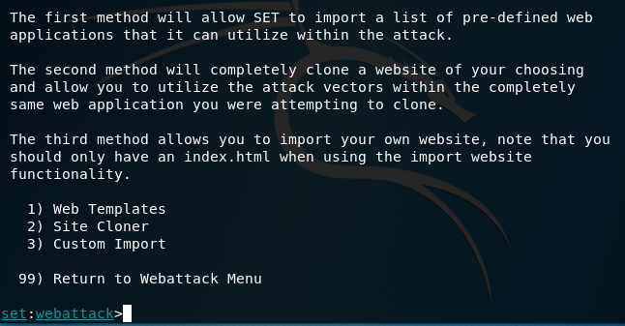
Figure 6: Site Cloner.
At the end of choosing what kind of attack is going to be performed. The SET ask for IP address to post back the Harvester/Tabnabbing. After entering the IP address of the system that need to receive all the credentials of the user. The URL of the site that need to be cloned must be provided to SET. In this demo, twitter login webpage is cloned.

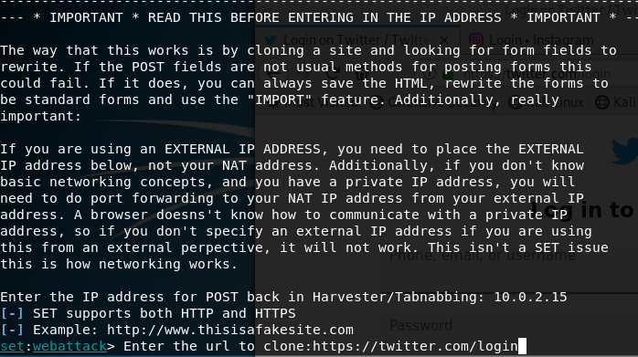
Figure 7: Cloning Twitter login page.
The IP address of Harvester system is sent to the target system. The IP address of Harvester system can be hidden turning the IP address into links. If the user at target system open the link or the IP address it will take to the fake twitter login page.

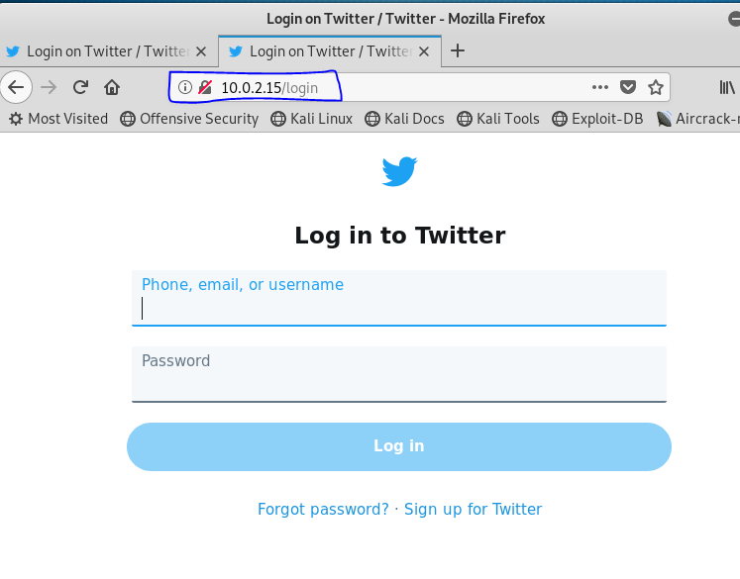

Figure 8: Fake Twitter login page.
The fake twitter page can be noticed at the URL bar conveying the page is not HTTPS. If the user is not aware of it and input the credential details and click login. It will send all the credential details to harvester system and the web page will be redirected to original twitter login page.

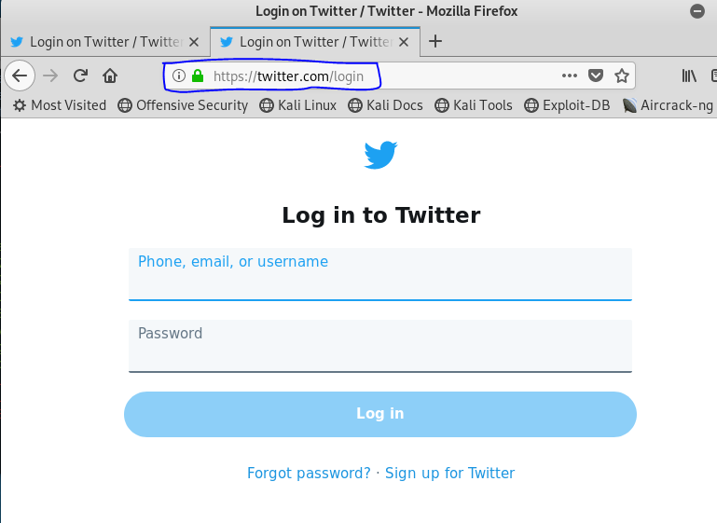
Figure 9: Original twitter login page.
The original twitter login page URL are HTTPS as shown in figure 9.

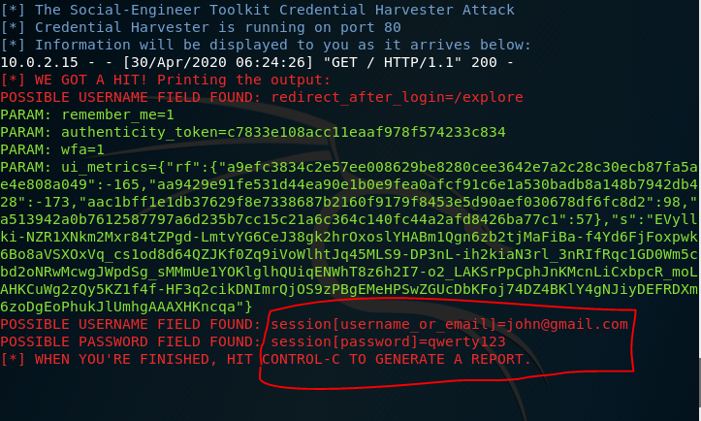
Figure 10: Obtained credential details.
Most of the website like Gmail login has two webpages for logging in to Gmail account username webpage and password web page. In that case this technique is not possible as two web pages need to be cloned and linked to each other.

Most of the organization employees are not aware of spam email as they give access to data of the company. If the user uses web browsers as client to login into cloud storage, there are high possibilities of giving access to the cloud storage when spammer attack is successful using this technique. To avoid this kind of attack, the user needs to make sure the email or any link send through any source are secure. The secure link can be identified by looking whether the link is HTTPS or HTTP. The HTTPS links are secured and encrypted using SSL. The HTTP are insecure links.

Cracking FTP credentials using Dictionary Attack

File Transfer Protocol (FTP), FTP is used for exchanging files between computers over any network[11]. In this demonstration attack is performed on FTP server to finds its login credentials. The technique is dictionary attack using Hydra[12]. Hydra can be used to crack numerous protocols like FTP, HTTPS, IMAP, SSH V1, SSH V2, Telnet, VNC, XMPP, POP3, MS-SQL, MYSOL, SIP [12] etc. The Hydra tool is very fast and flexible which can demonstrate unauthorized access to an remote systems[12]. Using Hydra with dictionary attack, dictionary which have all possible keyword combination present in the dictionary. Using those combination Hydra tries each username and password in the dictionary file to break the login credentials of FTP server. This is a basic technique user can perform it manually. If user have numerous guess with username and password, the user can try each of the guess by manually typing in one by one. As user can’t perform too much manual tries due to the time concern. The Hydra are developed using dictionary attack which can perform much faster than user manual tries.

For demonstration purpose Windows 7 has been set up with FTP service running on the system. The username and password are created using separate text file in order to make dictionary.

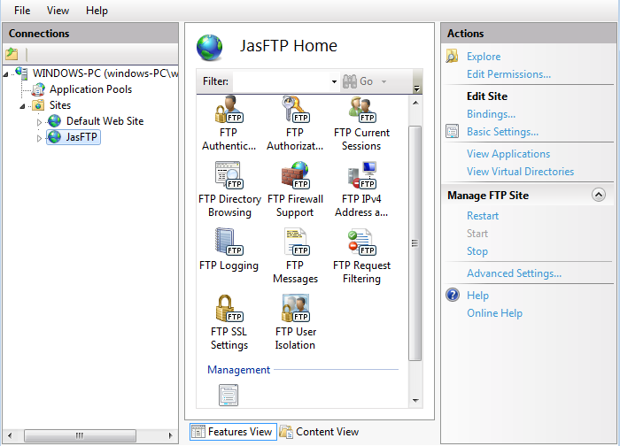
Figure 11: FTP server.
Before using Hydra, using NMAP port scanner to check the target system has FTP port 21 is open.

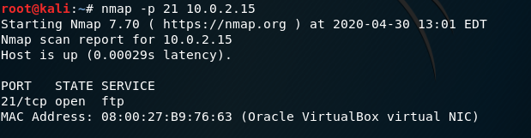
Figure 12: NMAP port scanner.
Confirming the port 21 is open, as shown in Figure 12. Using hydra with dictionary attack is performed in Kali Linux terminal. The target of Username and Password text file are included with the command typed in for Hydra password crack followed by the target system IP address.

Figure 13: Hydra Command in Terminal.
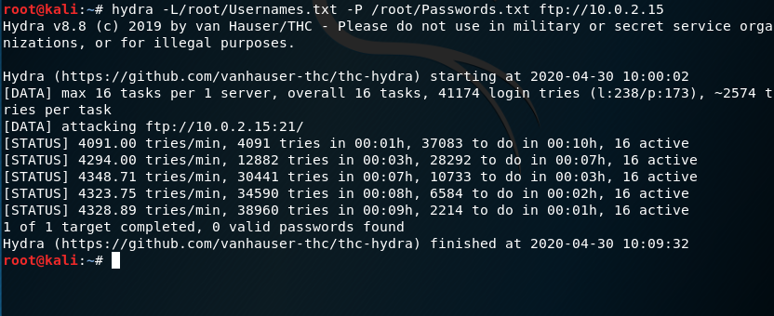
Figure 14: Hydra Password crack test 1.
The Hydra password crack test completed, hydra didn’t find any username and password matched in the dictionary, as shown in Figure 14. The dictionary created for demonstration purpose only, the username and password combination are limited in this dictionary.

Another test was conducted including FTP server credential to dictionary, to check whether Hydra finds the match of username and password found in dictionary.

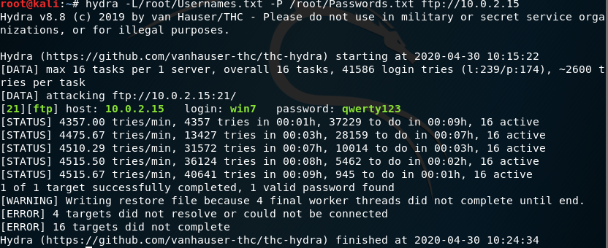
Figure 15: Hydra Password crack test 2.
The Hydra found the match of FTP credential in dictionary, as shown in Figure 15. Using these credential attackers can get in to FTP server remotely and access all the data in the target system. To avoid these kinds of attack, a strong firewall must be implemented, and strong password length more than 8 characters must be created for FTP credential combining letters, numbers and symbols. Using strong password will help to protect FTP server as hacker dictionary will not find the match, example of test 1.

Securing ownCloud with ClamAV antivirus software from Malicious File Uploads

The report provides overall security issues with cloud-based services, there are many ways of protecting data in cloud. When uploading the file to cloud, it must be checked for any malicious file before uploading. This is one way of protecting data in cloud. Any malicious data uploaded to cloud without knowledge it will affect all the files in cloud. It is best practice to check for any malicious file before uploading to cloud storage. In this analysis and demonstration, using ClamAV antivirus software to protect files uploaded ownCloud[13]. ClamAV[14] is open source antivirus software which trace for the virus, malware, trojans and other malicious threats.

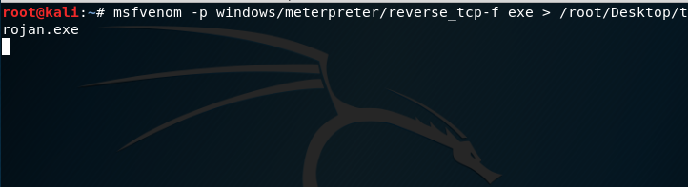
Figure 16:Trojan created using Kali Linux.
Using Kali Linux, Trojan file are created. The Trojan file is uploaded to ownCloud to check whether ClamAV block the trojan file.

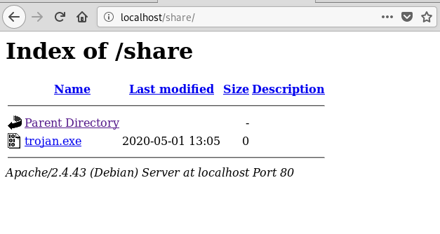
Figure 17: Trojan File transfer to Ubuntu virtual machine.

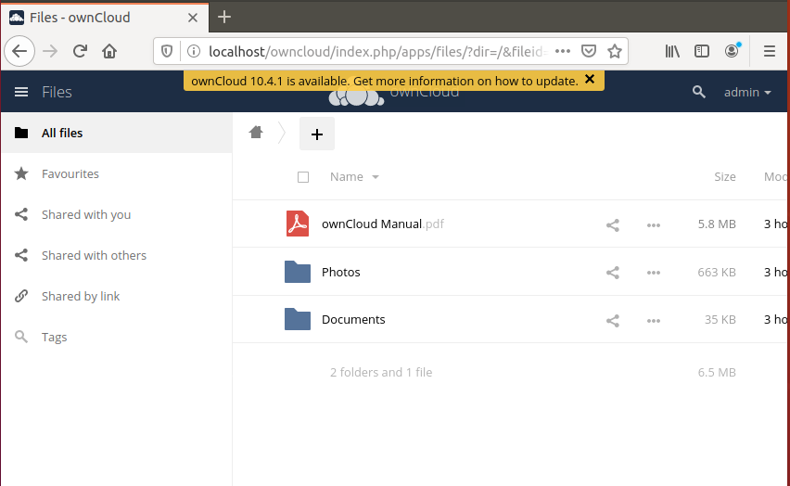
Figure 18: ownCloud.

The trojan file are ready be uploaded to ownCloud data storage.

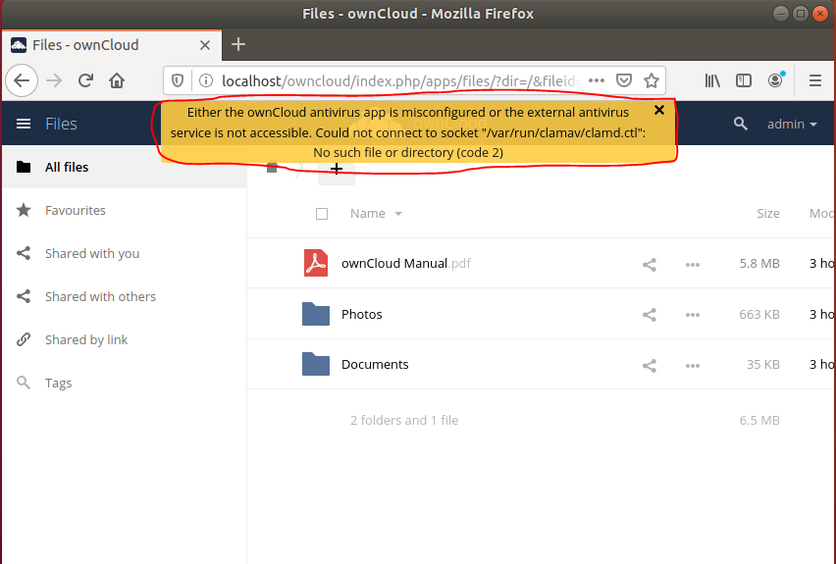
Figure 19: Error Configuration of ClamAV.
The test conducted failed due to the misconfiguration of ClamAV, error message shown in Figure 19. The clamd.ctl file is not created and the ClamAV socket is not created while installing the ClamAV antivirus software on Ubuntu operating system.

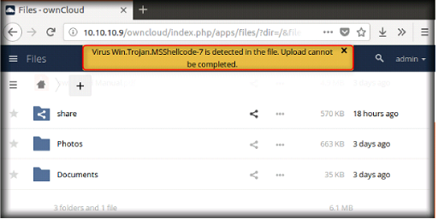
Figure 20: Successful analysis.
A successful test result will look as shown in Figure 20. When uploading trojan files to ownCloud the ClamAV detect the trojan file and block from being uploaded to ownCloud. Enabling and using these kinds of antivirus security also helps to prevent any organization or private user not to upload any malicious files to the cloud that can harm the cloud storage data.

Basic Data encryption Using CrypTool

To maintain the network security encryption is must. It is impossible for attacker to compromise encrypted packets. If packets are captured by attacker, attacker must undergo decrypting each packet which are harder task. In this analysis CrypTool[15] is used for encrypting data, CrypTool is freeware software to analyze mechanism of cryptographic. The CrypTool 1 are open source and support encryption/decryption algorithm RSA, AES, Vigenère, Caesar, Enigma[15] etc.

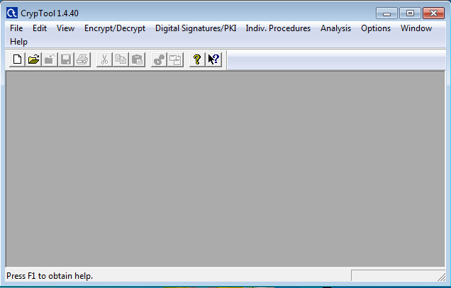
Figure 21: CrypTool.
Create new encryption file and type the message and choose the type of encryption algorithm to encrypt the message.

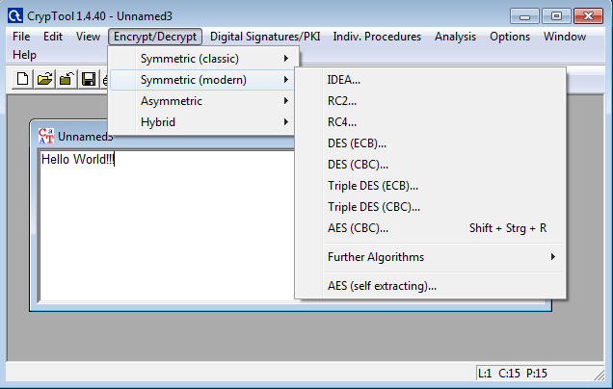
Figure 22: Encryption Algorithm.
The encrypted message can be sent to the intended person by email or any source of communication. The hex value is provided to the end person for decrypting the message. Strong Encryption provide higher security for the data in the network. When organization have their own network infrastructure or cloud-based storage, it is best practice to encrypt the data when sending over network or storing to the cloud. The attacker may capture the data packets but decrypting each packet will be harder task and it consume more time to decrypt each packet.

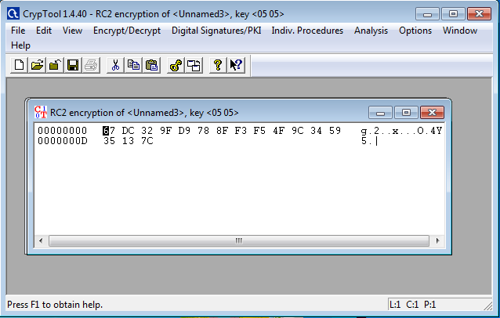
Figure 23: Encrypted Message.

Smart Campus Simulation using Packet tracer

UWTSD smart campus and its security measures are demonstrated in simulation using Cisco packet tracer. Using available Internet of Things (IoT) and resource in cisco packet tracer the security measures has been demonstrated.

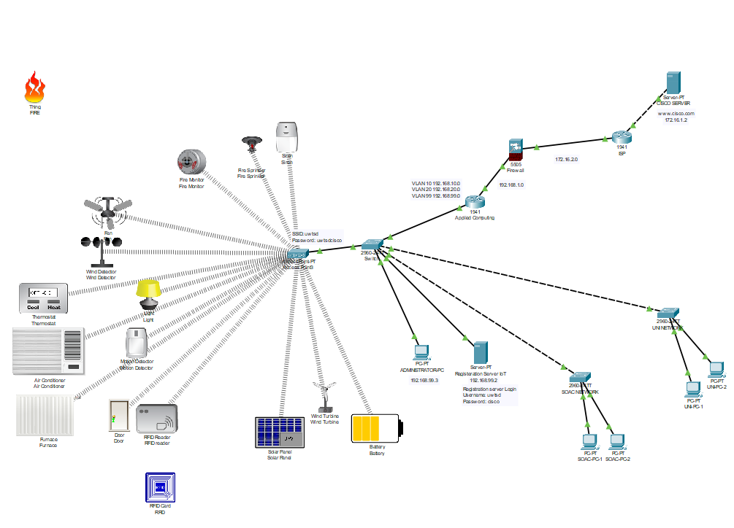
Figure 24: UWTSD Smart Campus.

Separate VLAN (Virtual LAN) has been created for Administrator VLAN 99 which are given full access to control smart campus, SOAC VLAN 10 has been created for SOAC network and UNI VLAN 20 has been created for university network. VLAN network,

VLAN 99 Administrator 192.168.99.0/24
VLAN 10 SOAC 192.168.10.0/24
VLAN 20 UNI 192.168.20.0/24

Inter VLAN routing has been implemented to allow each VLAN to communicate to internet. Using Extended access list, the communication to administrator VLAN from VLAN SOAC and VLAN UNI has been restricted. Applied Computing router acts as gateway to the internet. Applied Computing router provide DHCP server for all VLAN.

The registration sever has been created for all IoT device to access the server. The Registration server are placed internal to administrator VLAN, the registration server username: uwtsd and password: cisco. Administrator VLAN network provide access point to connect all IoT device wirelessly. The access point is created with SSID: uwtsd and WPA2-PSK Password: uwtsdcisco. In order to communicate with registration server all IoT device must connect to the access point and IoT device must be authorized with registration server. The IoT device registration server can only be accessed by administrator PC, registration Server address: 192.168.99.2.

The IoT device implementation. Fire monitor are implemented to detect fire, if there are any fire it turns ON the fire sprinkler and siren. The wind detector has been implemented in order to monitor wind and if there is no wind detected by the wind detector, it turns ON the fan. Motion detector has been implemented to turn ON the light if there are any person in classroom. Thermostat has been implemented, if the temperature goes above 20 degree Celsius it turns ON the air conditioner and if the temperature below 11 degree Celsius it Turns ON the furnace. The RFID reader has been implemented; the authorized RFID cards can unlock the doors. The solar panel, wind turbine and its battery are implemented to monitor.

The firewall has been implemented between Applied computing router and ISP router. The inside zone is UTWSD network configured to security level 100 and outside zone are internet, security level configured to 0. The firewall allows any traffic from UWTSD network to internet (cisco server) but block any traffic from internet to UWTSD network. Only Reply to UWTSD network will be permitted through firewall from internet. The firewall has been configured to allow ICMP, HTTP and DNS. The default route and static route has been configured with routers and firewall. The cisco web server has ben implemented to demonstrate internet, cisco IP address 172.16.1.2 or “www.cisco.com”.

All switch, routers and firewall are configured with basic security setting like securing console port and VTY port. Securing physical ports provide more security by preventing accessing the network device physically. To prevent from MAC address flooding attack the switch are configured with port security and unwanted ports in switch are shut down. It is best practice to change default VLAN 1, in cisco switch there may be possible VLAN hopping attack. In this implementation native VLAN are changed to VLAN 99 and default VLAN 1 has be shut down in all switch.

The few configuration like DNS in firewall disappear when starting the Cisco packet tracer application. All switch, routers and firewall startup configuration text files are uploaded, incase of any configuration disappear.

Conclusion

The report provides security issues with cloud-based service and security issues at each layer of cloud computing. When looking into cyber threats, cyber attacks are increasingly growing along with the technology growth. The prevention measure is taken to minimize and completely protect system. The cloud-based services are widely used by private user and organizations. The cloud-based service is more vulnerable to threats as the data stored in multiple geographical location and providing access or services to the consumers. As the part of this cloud-based security issues, analysis of social engineering tool, Cracking FTP credentials using Dictionary Attack, securing ownCloud with ClamAV antivirus software from Malicious File Uploads and Basic Data encryption Using CrypTool has been documented in this report. Using Packet tracer simulation tool smart campus security and its prevention are demonstrated and documented in this report.

References

[1] N. Subramanian and A. Jeyaraj, “Recent security challenges in cloud computing,” Comput. Electr. Eng., vol. 71, no. July, pp. 28–42, 2018, doi: 10.1016/j.compeleceng.2018.06.006.
[2] C. Lei, H. Dai, Z. Yu, and R. Li, “A service recommendation algorithm with the transfer learning based matrix factorization to improve cloud security,” Inf. Sci. (Ny)., vol. 513, pp. 98–111, 2020, doi: 10.1016/j.ins.2019.10.004.
[3] P. J. Sun, “Security and privacy protection in cloud computing: Discussions and challenges,” J. Netw. Comput. Appl., vol. 160, no. August 2019, p. 102642, 2020, doi: 10.1016/j.jnca.2020.102642.
[4] R. Kumar and R. Goyal, “On cloud security requirements, threats, vulnerabilities and countermeasures: A survey,” Comput. Sci. Rev., vol. 33, pp. 1–48, 2019, doi: 10.1016/j.cosrev.2019.05.002.
[5] A. Singh and K. Chatterjee, “Cloud security issues and challenges: A survey,” J. Netw. Comput. Appl., vol. 79, no. November 2016, pp. 88–115, 2017, doi: 10.1016/j.jnca.2016.11.027.
[6] L. Coppolino, S. D’Antonio, G. Mazzeo, and L. Romano, “Cloud security: Emerging threats and current solutions,” Comput. Electr. Eng., vol. 59, pp. 126–140, 2017, doi: 10.1016/j.compeleceng.2016.03.004.
[7] N. Abe and M. Soltys, “Deploying health campaign strategies to defend against social engineering threats,” Procedia Comput. Sci., vol. 159, pp. 824–831, 2019, doi: 10.1016/j.procs.2019.09.241.
[8] “Kali Linux | Penetration Testing and Ethical Hacking Linux Distribution.” [Online]. Available: https://www.kali.org/. [Accessed: 30-Apr-2020].
[9] “Welcome to Python.org.” [Online]. Available: https://www.python.org/. [Accessed: 30-Apr-2020].
[10] “SET | Penetration Testing Tools.” [Online]. Available: https://tools.kali.org/information-gathering/set. [Accessed: 30-Apr-2020].
[11] M. Gien, “A File Transfer Protocol (FTP),” Comput. Networks, vol. 2, no. 4–5, pp. 312–319, Sep. 1978, doi: 10.1016/0376-5075(78)90009-0.
[12] “THC-Hydra | Penetration Testing Tools.” [Online]. Available: https://tools.kali.org/password-attacks/hydra. [Accessed: 30-Apr-2020].
[13] “✔ ownCloud - The leading OpenSource Cloud Collaboration Platform.” [Online]. Available: https://owncloud.org/. [Accessed: 30-Apr-2020].
[14] “ClamavNet.” [Online]. Available: https://www.clamav.net/. [Accessed: 30-Apr-2020].
[15] “CrypTool 1 - CrypTool Portal.” [Online]. Available: https://www.cryptool.org/en/cryptool1. [Accessed: 01-May-2020].

marking criteria and Student FEEDBACK

This section details the assessment criteria. The extent to which these are demonstrated by you determines your mark. The marks available for each criterion are shown. Lecturers will use the space provided to comment on the achievement of the task(s), including those areas in which you have performed well and areas that would benefit from development/improvement.

Common Assessment Criteria Applied (Assignment 1) | Marks available | Marks  awarded
1. Engagement with Literature Skills
Extent of research and/or own reading, selection of credible sources, application of appropriate referencing conventions.
You have engaged excellently with the literature. Diversity of appropriate sources used with key concepts discusses. The appropriate referencing used (Grade mark: 93.33%) | 45 | 42
2. Knowledge and Understanding Skills
Extent of knowledge and understanding of concepts and underlying principles associated with the discipline.
3. Cognitive and Intellectual Skills
Analysis, evaluation and synthesis; logic, argument and judgement; analytical reflection; organisation of ideas and evidence
You have demonstrated excellent research knowledge in the research aspects. You have given accounts of the lab exercises through discussion and analysis and interrelate them to how they could aid an organisation. (Grade mark: 93.33%) | 45 | 42
4. Practical Application Skills
Deployment of methods, materials, tools and techniques; application of concepts; formulation of innovative and creative solutions to solve problems.
5. Transferable Skills for Life and Professional Practice
Attributes in professional practice: individual and collaborative working; deployment of appropriate media; presentation and organisation.
Very professional work that written, flow and organise excellently. (Grade mark: 90.00%) | 10 | 9

Assignment Mark (Assessment marks are subject to ratification at the Exam Board. These comments and marks are to give feedback on module work and are for guidance only until they are confirmed. ) | Late Submission Penalties (tick if appropriate) |  | 93%
 | Up to four weeks late |  | 93%
 | First Attempt? |  | 93%

marking criteria and Student FEEDBACK

This section details the assessment criteria. The extent to which these are demonstrated by you determines your mark. The marks available for each criterion are shown. Lecturers will use the space provided to comment on the achievement of the task(s), including those areas in which you have performed well and areas that would benefit from development/improvement.

Common Assessment Criteria Applied (Assignment 2) | Marks available | Marks  awarded
1. Engagement with Literature Skills
Extent of research and/or own reading, selection of credible sources, application of appropriate referencing conventions.
2. Knowledge and Understanding Skills
Extent of knowledge and understanding of concepts and underlying principles associated with the discipline.
You have demonstrated coherent knowledge and understanding of the subject area. The report structures excellently following the IEEE report format. (Grade mark: 90.00%) | 20 | 18
3. Cognitive and Intellectual Skills
Analysis, evaluation and synthesis; logic, argument and judgement; analytical reflection; organisation of ideas and evidence
Excellent documentation of the physical packet tracer design. Your evaluation of the implementation could zoom in more how it will combat or enhance challenges to the University. (Grade mark: 90.00%) | 20 | 18
4. Practical Application Skills
Deployment of methods, materials, tools and techniques; application of concepts; formulation of innovative and creative solutions to solve problems.
Your practical design though labelled for ease of understanding was very basic. There was no redundancy considered. Your backbone only utilise a layer 2+ switch. Relevant security measures in place. When tested, pings only successful within a LAN but fail when tested for access outside the LANs. (Grade mark: 66.67%) | 60 | 40
5. Transferable Skills for Life and Professional Practice
Attributes in professional practice: individual and collaborative working; deployment of appropriate media; presentation and organisation.

Assignment Mark (Assessment marks are subject to ratification at the Exam Board. These comments and marks are to give feedback on module work and are for guidance only until they are confirmed. ) | Late Submission Penalties (tick if appropriate) |  | 76%
 | Up to four weeks late |  | 76%
 | First Attempt? |  | 76%

