

MODULE CODE: Digital Skills for Personal Development and Business Growth BMSW4008
ASSESSMENT COMPONENT: PORTFOLIO

STUDENT NAME: Phillip Jokkene Latigo

STUDENT NUMBER: 2504781

LECTURER: Aqsa Shabir

DATE:

Contents
Task 1 3
Assessment of Digital Skills 3
References 3
Task 2 4
LinkedIn Learning Certificates for Office365 4
Task 3 5
Essay on Relevance of Excel in professional and personal life. 5
References 5
Task 4 6
7 Minute Reflective Presentation 6
References 6

AI Acknowledgement
Examples of statements If you have not used AI
I confirm that I have not presented any AI generated materials as my own work.
I confirm that I have copies of my drafts, notes, and other resources I used, which I may be asked to provide in evidence.
Examples of AI statements if you have used AI
Example 1:
I acknowledge the use of Grammarly (https://www.grammarly.com/) on Date to check my work using the prompt(s):
1. Please check the following text for readability, grammar and syntax.
I confirm that I have not presented any AI generated text as my own work. I confirm that I have copies of my drafts, notes, and other resources I used before, and after the use of AI tools which I may be asked to provide in evidence.
Example 2:
I acknowledge the use of SciSpace (https://typeset.io/) on 7 March 2024 to support my research using the prompt(s):
1. Please provide me with materials on the biology of the liver.
2. Please provide me with materials on liver cells.
I confirm that I have not presented any AI generated text as my own work. I confirm that I have copies of my drafts, notes, and other resources I used before, and after the use of AI tools which I may be asked to provide in evidence.
Example 3:
I acknowledge the use of ChatGPT (https://chatgpt.com/) on 13 April 2024 to write my notes into submission format using the prompt(s):
1. Please write up these bullet points as an essay paragraph at university level.
I confirm that I have not presented any AI generated text as my own work. I confirm that I have copies of my drafts, notes, and other resources I used before, and after the use of AI tools which I may be asked to provide in evidence.

Task 1

Assessment of Digital Skills
Screen shot of your JISC report
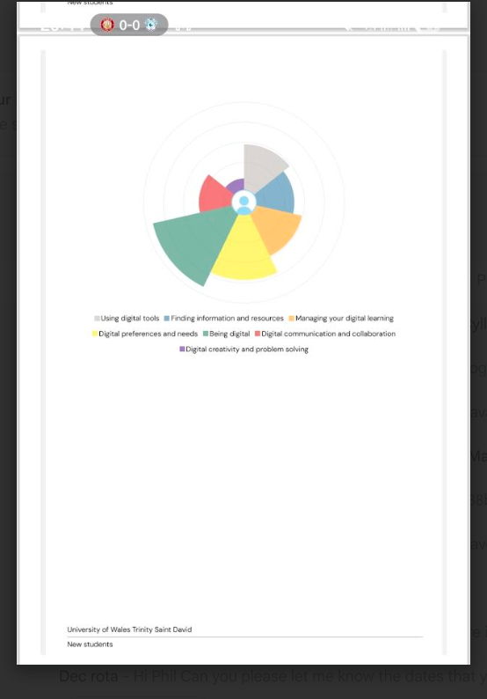

Jisc Discovery Tool is designed to help students and Tutors to evaluate their digital capabilities across all domains, including information literacy, digital creation, communication, and personal and data management. By completing the self assessment, I gained valuable insights into the areas in which I am performing well and the areas that I require improvement to support my academic, professional and personal development. This discusses two key strengths and two weaknesses identified in the assessment. In doing so, it highlights the relevance of digital skills for ongoing personal and academic development
Strength 1: Digital communication and collaboration
The first strength highlighted by my discovery tool result is Digital communication and collaboration. The result showed that i use arange of digital communication platform confidently, incuding email, vitual learning environment and collaborative application such as teams and google workspace. Beetham {2023} argues that communication is a core digital capability that supports teamwork, problem solving and knowledge sharing skills essential in both academic and professional settings. My ability to adapt communication style to suit different platforms and audiences enables me to engage effectively in group work, online discussions and feedback activities. This competence is especially relevant in an era where remote and hybrid working practices have become increasingly common. As a result, my digital communication skills not only enhance my academic performance but also prepare me for the future workplace environment that demands collaboration across digital spaces.
Strength 2: Digital well being
My second strongest area identified by the Jisc discovery tool is digital well being. This is referred to as the ability to maintain a healthy and sustainable relationship with technology, ensuring that digital tools support rather than hinder mental, physical and emotional health. According to Jisc {2022}, digital well being includes managing screen time, recognising the impact of digital habits on wellbeing and engaging positively and safely online. My use of digital devices, set boundaries when necessary and remain aware of the potential stress associated with constant connectivity. For example, I use scheduled breaks when studying online, limit unnecessary notifications and apply plans such as focus modes to reduce distractions. These habits help mitigate digital fatigue and support sustained productivity. Additionally, I demonstrate awareness of online risk and practise responsible online communication. Research from the European commission {2022} suggests that strong digital wellbeing contributes to resilience, better decision making and improved learning outcomes.

Weakness 1 Digital creativity and problem solving
This relates to producing digital content, using creative tools, experimenting with different technologies and applying digital methods to address complex problems. While I am comfortable with the basic productivity software, I lack confidence with more advanced digital tools, such as video editors, graphic design applications or website creation tools. According to Redeecker {2023}, digital creativity is becoming increasingly important in higher education and the modern workplace, as learners and employees are expected to create dynamic and innovative digital artefacts. My limited ability in this area restricts the range of formats i can use for academic assignments and reduces my confidence in tackling unfamiliar technological challenges
Weakness 2: Managing Digital learning
This capability includes organising online study, effectively using learning platforms, managing digital resources and navigating online academic environments. The results indicate that while i can access learning materials and engage with digital tasks, I struggle with structuring online learning effectively. Issues such as managing large volumes of digital information, organising files and prioritising online tasks can affect my productivity. Jisc {2022} emphasises that managing digital learning is essential for academic success as students increasingly reply on virtual learning environments, digital submission systems and online communication tools. My difficulties in this area can lead to inefficiencies such as spending time searching for misplaced files. To improve, I need to adopt systematic organisational strategies such as consistent file naming conventions, create structured folders and using digital calendar tool to manage deadlines. Learning to use digital productivity tools more effectively will help me become more independent and organised in my studies.

Reference
European Commission {2022} Digital competence Framework for Citizens {DigComp 2.2}, Publications Office of European Union.
Jisc{2022} Building digital capability: The six elements of capability
Redecker. C ,{2023} European Framework for the Digital Competence of Educator. European Commision

Task 2

LinkedIn Learning Certificates for Office365
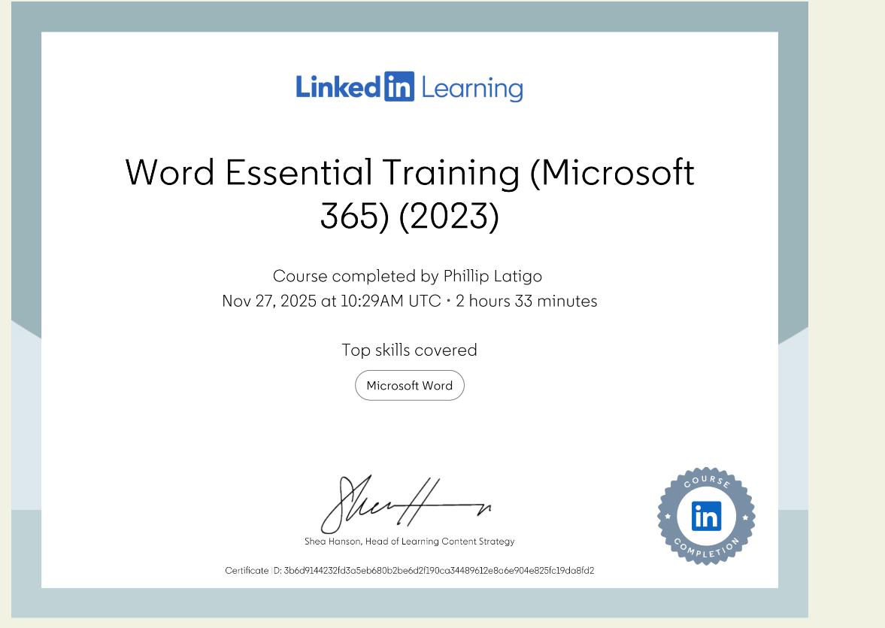

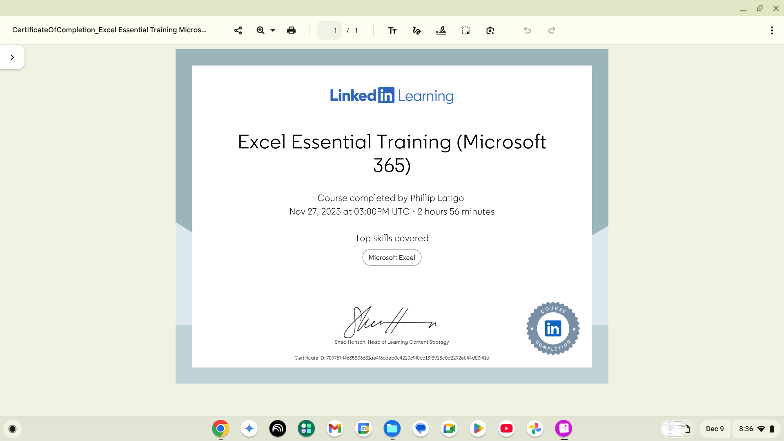

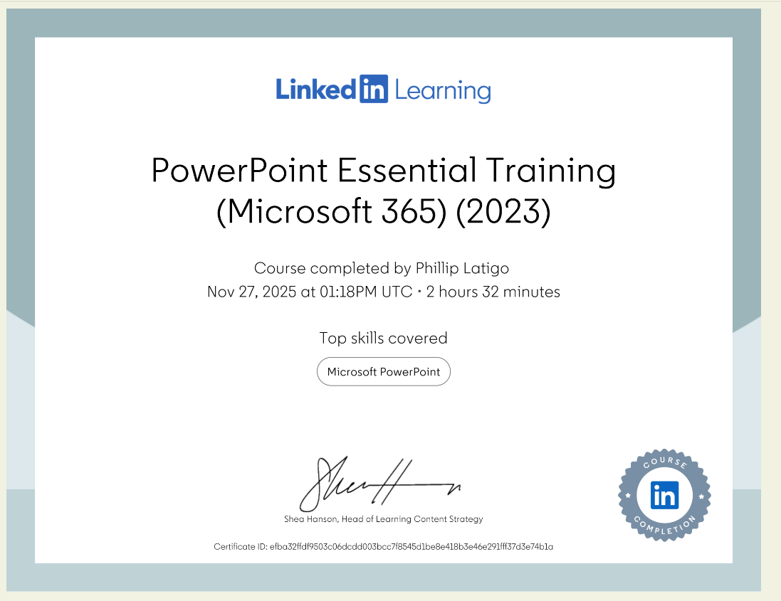

Task 3

Essay on Relevance of Excel in professional and personal life.
Microsoft Excel is a vital tool for both work and personal use. Its flexibility, user-friendly design, and strong data management features make it valuable. Excel helps with financial planning, data analysis, project management, and personal budgeting. By using Excel, people can make better decisions, work more efficiently, and organize complex information easily. This essay will discuss the importance of Excel in different areas of life, with support from academic sources and real-life examples.
Excel in Professional Life
In many industries, people use Excel for important tasks like financial analysis, reporting, data visualization, and decision-making. Excel can handle large amounts of data and perform complex calculations, making it essential for accountants, marketers, project managers, and analysts.
Financial Analysis and Reporting:
Excel lets professionals create financial models, predict revenue, and analyze costs. For example, accountants use spreadsheets to make balance sheets, profit and loss statements, and cash flow analyses. Formulas and functions automate calculations, which reduces errors and saves time (Gaskins, 2014).
Data Visualization and Decision Support:
Charts and pivot tables help people see trends and patterns in data clearly. Managers use these tools to analyze sales data, track key performance indicators (KPIs), and make strategic decisions.
Automation and Efficiency:
Using macros and VBA scripting can boost productivity by automating repetitive tasks. For instance, you can generate monthly reports or update datasets more easily. This saves time, allowing you to focus on analysis and planning (VanderPlas, 2018).
Project Management:
Excel’s Gantt charts and task trackers help project managers with scheduling, managing resources, and tracking progress. This helps keep projects on track and within budget (Kumar & Saini, 2019).
Excel in Personal Life
Excel is a useful tool for personal organization and managing finances. It helps people track their expenses, create budgets, and set goals. This makes it very helpful for individuals and families.
Personal Budgeting:
Excel spreadsheets help people track their income and spending, set savings goals, and spot spending habits. For instance, a family of four can create a monthly budget to manage their finances well (Hogarth & Hilgert, 2002).
Financial Planning:
By entering your income sources and expenses, you can see how much you can save, plan for future costs like vacations or education, and be ready for emergencies. The system can automatically calculate totals, averages, and differences, giving you up-to-date information about your financial health.
Tracking Goals and Expenses:
Excel helps users set financial goals, like saving for a new car or paying off debt, and track their progress over time. Tools like charts can encourage consistent saving and spending habits (Lusardi & Mitchell, 2014).
Organizing Personal Data:
Excel can help you organize personal information like birthdays, appointments, and health records. This way, you can keep all your data in one easy-to-reach place.
Practical Example: Family Income and Expenditure Spreadsheet
To show how useful Excel can be, let us create a spreadsheet for a typical family of four for one year. This spreadsheet will track income sources and spending categories. It will include realistic money amounts and formulas to help analyze the data.
Income Sources (Monthly):
Income | Amount per month £££ | Expenditure | Amount per month £££
Wage 1 | £2,000 | Rent/Mortgage | £800
Wage 2 | £1,500 | Council tax | £150
Trust Funds | £200 | Electric | £60
Stocks/Share payouts | £150 | Gas | £50
Universal credit | £300 | Water rates | £30
Student Finance | £250 | Food | £600
Other | £300 | Car insurance | £70
 |  | Car Tax | £20
 |  | Fuel | £150
 |  | Child Care Costs | £400
 |  | Loans/credit cards | £200
 |  | Other eg Birthdays/savings/holidays | 300

Using Excel formulas, the spreadsheet can calculate total income, total expenditure, and net savings per month. For example:
- Total Income: =SUM(B2:B7)
- Total Expenditure: =SUM(C2:C13)
- Net Savings: =B8 - C14
By using these formulas for each month, the family can track their spending throughout the year. This helps them find areas to cut costs and plan for future financial goals.
The Power of Formulas and Functions
Excel's formulas and functions are key to its usefulness. Functions like SUM, AVERAGE, IF, and VLOOKUP help users calculate, analyze data, and make decisions automatically. For example, an IF function can highlight months when expenses are higher than income, prompting a review and action.
Security and Data Integrity
Excel has features to keep sensitive data safe, like password protection and cell locking. These tools help ensure that personal or confidential information stays secure. Data validation rules also help by preventing incorrect information from being entered, which keeps the data accurate.
Limitations and Considerations
Excel is a powerful tool, but it has limits, especially when dealing with very large datasets or complex data relationships. In these situations, it is better to use a database management system like SQL. However, for most personal and small to medium-sized professional tasks, Excel is easy to use and effective.
Conclusion
Microsoft Excel is very important in both work and personal life. It helps people analyze data, create visuals, automate tasks, and stay organized. This makes it easier to make smart choices, work more efficiently, and manage finances. As technology changes, Excel keeps improving with new features like Power Query and Power BI, which increase its usefulness. Therefore, learning and mastering Excel skills is crucial for anyone who wants to manage their finances well or work accurately and efficiently.

References
- Few, S. (2012). Show Me the Numbers: Designing Tables and Graphs to Enlighten. Analytics Press.
- Gaskins, J. (2014). Excel Data Analysis: Your visual blueprint for analyzing data, charts, and PivotTables. Wiley.
- Hogarth, J. M., & Hilgert, M. A. (2002). The Psychology of Financial Planning. Journal of Financial Counseling and Planning, 13(2), 1-12.
- Kumar, S., & Saini, R. (2019). Project Management Using Excel. International Journal of Management, 10(4), 45-52.
- Lusardi, A., & Mitchell, O. S. (2014). The Economic Importance of Financial Literacy: Theory and Evidence. Journal of Economic Literature, 52(1), 5-44.
- VanderPlas, J. (2018). Python Data Science Handbook. O'Reilly Media. (Note: While focused on Python, the principles of automation and data handling are applicable to Excel automation concepts.)
- Additional sources on Excel's functionalities and applications can be found in academic and industry publications, emphasizing its role in data-driven decision-making.

