In this essay, I will be outlining and describing a Zoomorphic Vessel with the accession number: 74.51.795 from The Metropolitan Museum of Art. From the four objects presented for this analysis, I chose this one specifically because of the interesting animalistic design.

The image shows a “Terracotta zoomorphic askos (vessel) with antlers” as described by the Met Museum (The Metropolitan Museum of Art). It has a height of 14.6 centimetres which suggests it was not a large object. The bottom has four feet which would have held the vessels base off of the table or ground, this would have most likely been for decorative purposes rather than as a product of direct use for the vessel. The feet seem to be made of a mixture of clay and terracotta and around two to three centimetres from the ground to the actual base of the pot.

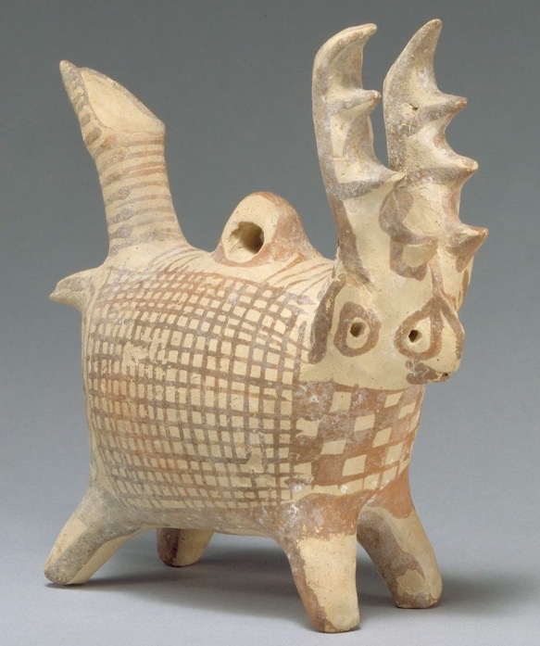
The main proportion of the vessel I can assume to be around 10 centimetres from back to front (left to right on the image). This is heavily covered by quite a simple decoration of ‘criss-crosses’ going vertically and horizontally, the lines are made up of the darker reddish terracotta colour, whilst the base remains the pastier, yellowish clay colour. Although, only one side of the object can be seen, I am making the assumption that the opposing side is made up of the same decoration. The front has the baseline of the same pattern, except the squares are larger and contrast to those of the sides. This is because some are filled in with the deeper terracotta tones and so they stand out more. Again, this is for a decorative purpose rather than to make the design more useful, I will also assume that the back of the vessel is the same. Above this design, there is a head like feature which includes two visible holes and more than likely two on the side which cannot be seen. The bottom of the head starts at what I perceive to be around halfway up the ceramic and as a result around seven centimetres from the bottom of the feet. The design incudes a small mouth at the front and then the holes are on both the front and sides and appear to be where the eyes and ears would be of a deer like creature. I am making this assumption of the overall design and the antlers which come out above the head, this is the clear and distinct feature of what causes the belief that the vessel resembles that of a deer. The holes are very small and would be no more than half a centimetre in both height and width. At the opposite side of the object being the back side, there is a small piece sticking out which is that of a tail.

Figure 1: Terracotta zoomporhic askos (vessel) with antlers. (https://www.metmuseum.org/art/collection/search/240382)
On top of the tail at the back of the object, pointing vertically is what can be perceived as the handle. It seems be around six to seven centimetres in height and two to three centimetres in width. It has reddish brown lines going around the circumference of the handle until it reaches top. At the top of the main component in the centre there is a bridge type structure with a circular hole in the middle which has a circumference of around one centimetre. I believe that this is where the liquid would have been poured into the vessels main chamber before it could be used for its actual use. Above the deer like head are two quite large antlers around six to seven centimetres in height which marks the height of the ceramic object. On each antler there are four points which point to the front of the object, each being around two centimetres apart.

As a result of the above description, it can be deduced that the object would have been used for small quantities of product rather than as a vessel for products such as wine. Therefore, making the assumption that the ceramic would have been used for liquids such as oil is a more accurate belief. The most common use for this kind of ceramic can therefore be that of dining purposes rather than kitchen use.

Although it had a use and purpose as a vessel to hold oil, it was more than likely for decorative purposes rather than that of utilitarian. This can be believed because of the design being animalistic as well as the design and patterns decorated on the piece of pottery. From research it can be thought that these oil jugs were not just subject to deer but also other types of animals. This is because the term ‘askoi’ reflects vases and pottery in the form of animals, thus being coined as zoomorphic (Del Chiara, 1978: 27). Through images and articles, it can also be assumed that this style was not necessarily typical of Cyprus, but instead, more typical of Etruscan artwork and pottery. This could be an emphasis of movement or trade between these regions.

It would have most likely been made for those of a wealthier background and so this could also be an indication of where the object was found. However, this cannot be immediately known because of the lack of detail from the original website of the museum. This means that we have to be very sceptical when analysing these objects and making assumptions of them as much of it is up to our own beliefs. This also suggests that the entire concept of this type of ceramic is completely up to personal interpretation and as a result this pottery could have had many uses both for practical and decorative uses and cannot ne just places in a category due to one person’s identifications.

Bibliography

Del Chiara, M. A. (1978) ‘Late Etruscan “Duck-Askoi”’ Revue Archeologique. 1: 27-38

Hershcher, E. (2000) ‘Reviewed Works: The Coroplastic Art of Ancient Cyprus, Volume V: The Cypro-Archaic Period Small Female Figurines, Part A: Handmade/Wheelmade Figurines by Vassos Karageorghis; The Coroplastic Art of Ancient Cyprus, Volume VI: The Cypro-Archaic Period Monsters, Animals and Miscellanea by Vassos Karageorghis’ Bulletin of The American Schools of Oriental Research. 317: 81-84

Terracotta zoomorphic askos (vessel) with antlers. The Metropolitan Museum of Art
[online] Available from https://www.metmuseum.org/art/collection/search/240382
[Accessed 29th March 2020]

