07/04/2025
Jamie Leung
Renishaw
Plant and Asset Engineering
Evaluating the Effectiveness of Chosen Maintenance Strategies for Dedicated Equipment

Contents
2 List of Figures & Tables 2
3 Introduction 3
4 Current maintenance practices 4
4.1 Purpose 4
4.2 Current Maintenance 5
5 Full evaluation of how the current approaches to maintenance could be improved 6
5.1 Positive Approaches 6
5.2 Negative Approaches 7
5.3 Future Improvements 8
5.3.1 Predictive Maintenance - Condition Monitoring 8
5.3.2 Preventive Maintenance 10
6 Consideration of costs and resources 10
7 Conclusions 12
8 References 12
9 Appendix 12

List of Figures & Tables

Figure 1 - Renishaw Logo (Renishaw, 2020) 3
Figure 2 - CMM 4
Figure 3 - Probe Measuring 4
Figure 4 - L Bearing Way 5
Figure 5 - PMI Documents 7
Figure 6 - CMM Air board 9
Figure 7 - IPA Bottle 11
Figure 8 - Lint Free Cloths 11
Figure 9 - Squareness Check 13
Figure 10 - Probe Orientation 14
Figure 11 - Probe for Contamination 14
Figure 12 - Syteline 14
Figure 13 - Stem 14
Figure 14 -Entering Diameter 14
Figure 15 - Probe above Pivot Assembly 15
Figure 16 – Average Deviation Results 15
Figure 17 - Syteline Gauges 16
Figure 18 - Syteline Booking Out 16

Table 1 - Visual Inspection Costs 11
Table 2 - PM Costs 11

Introduction
Renishaw is an engineering firm that focusses on manufacturing technology, healthcare solutions, and precise measurement. This business is well known for its proficiency in metrology, which includes metal 3D printing, touch trigger probes, encoder systems, and coordinate measuring machines. The firm employs more than 5,000 people worldwide and has 67 strategic locations across 36 countries, with its headquarters located in Gloucestershire, England. In the UK, the company employs more than 3,000 individuals. The majority of the products are manufactured in the United Kingdom (Renishaw plc, 2020).

Figure 1 - Renishaw Logo (Renishaw, 2020)

This report's top priority is to assess the selected manufacturing equipment, known as a CMM. A precision measuring instrument called a CMM (Coordinate Measuring Machine) is used to examine and confirm the dimensional accuracy of products that are created in-house. Although Renishaw currently uses a number of CMMs, the Styli department will be the primary focus. The maintenance of this piece of equipment will be thoroughly examined in this report, along with an assessment of any potential improvements. The study will also examine the resources and expenses associated with the suggested improvements later on.
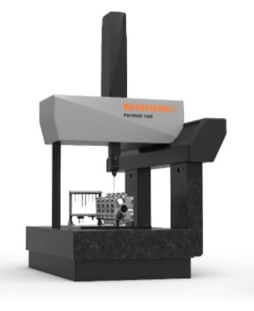
Figure 2 - CMM

Current maintenance practices

Purpose
The chosen equipment is the Renishaw L555 Pixie CMM. The L555 is a smallest variant of the CMM L range where this machine has a sub-micron accuracy. This machine was manufactured in house and is now located in the Styli department where the objective of this machine is to measure different types of styluses. Seen below in Figure 3 are the probes getting measured.
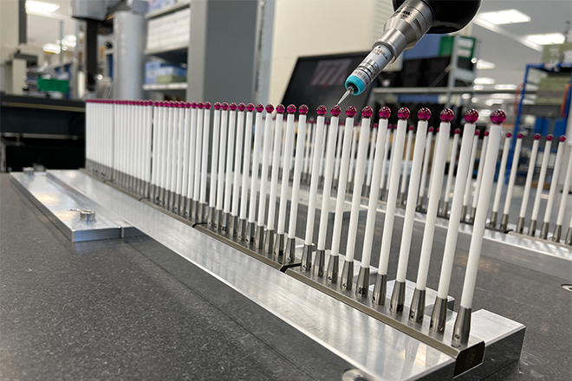
Figure 3 - Probe Measuring

The CMMs operate and move in the directions of XYZ with help using air bearings running across the bearing ways instead of using traditional methods such as driving belts or gantries. If the bearing ways are not cleaned, dust and dirt can obstruct movement, creating friction and decreasing accuracy. Bearing way for this type of machine can be seen in Figure 4.
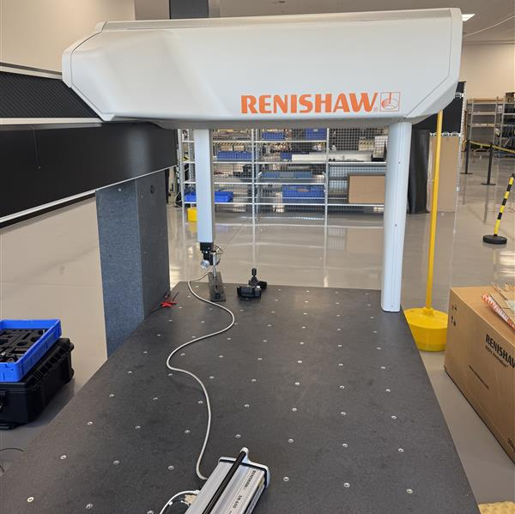
Figure 4 - L Bearing Way

Current Maintenance
Currently at Renishaw, all equipment will have a Preventative Maintenance Instruction (PMI) where it shows how to maintain the selected equipment with clear instructions and photos. The L555 machine is on a 6-month schedule and the PMI can be seen below in the Appendix.
The chosen CMM appears to have no official maintenance method—just a calibration procedure. It looks like the present strategy is based on a Run-to-Failure (RTF) or Corrective Maintenance approach, which may be dangerous. Corrective maintenance involves servicing or repairs only after a failure, flaw, or problem has been identified (Gwilliam, 2024). Although the existing calibration process guarantees measurement accuracy, which is a good thing, there is no systematic attempt to stop failures without maintenance.

These methods work well for non-essential equipment, but they are problematic for precision devices like CMMs as even minor misalignments can result in large measurement inaccuracies. This technique may be viewed negatively for a number of reasons, including the fact that improper routine maintenance may result, contamination of the bearings and or wear of the probe, all of which might compromise the accuracy of the measurements. Furthermore, unforeseen failures that are not monitored may result in unscheduled downtime that will interfere with production. Emergency repairs may also result in higher expenses.
The present method has been used because the machine is relatively new and was manufactured internally. In contrast to external equipment, Renishaw can completely comprehend the design, components, and failure spots of an in-house-built CMM. This implies that since engineering teams have immediate access to replacement components and troubleshooting techniques, maintenance may be first tackled in a more reactive or minimalistic manner.
Furthermore, there are presently no alerts or other mechanisms in place to notify the user that the calibration of the machine is outdated or about to expire. The rejection of good parts or the passing of poor parts due to out-of-calibration findings can lead to customer complaints, product recalls, or rework/scrap, all of which can have negative financial and reputational effects. Additionally, utilising an uncalibrated CMM would invalidate measurement results (Gill, 2019).
Before putting a more demanding plan into place, teams may collect raw information on failure rates and wear trends using a simple maintenance method that is centred on calibration and performance monitoring. In addition to this about the machine's the expenses - the additional sensors and monitoring equipment needed for a fully developed preventive or predictive maintenance plan may be one of reasons why the current approach is set in place right now.

Full evaluation of how the current approaches to maintenance could be improved
The existing maintenance process (Appendix) has a number of advantages and disadvantages. The positive aspects are shown below:

Positive Approaches
This procedure uses a number of efficient techniques, including the documents' accessibility (PMI). This works as a positive approach because not every equipment has the necessary documentation on hand, which makes it more difficult for inexperienced people to maintain the equipment. At Renishaw, all PMIs are kept on the local the drive, where you may download it, if necessary, as pictured in Figure 5.

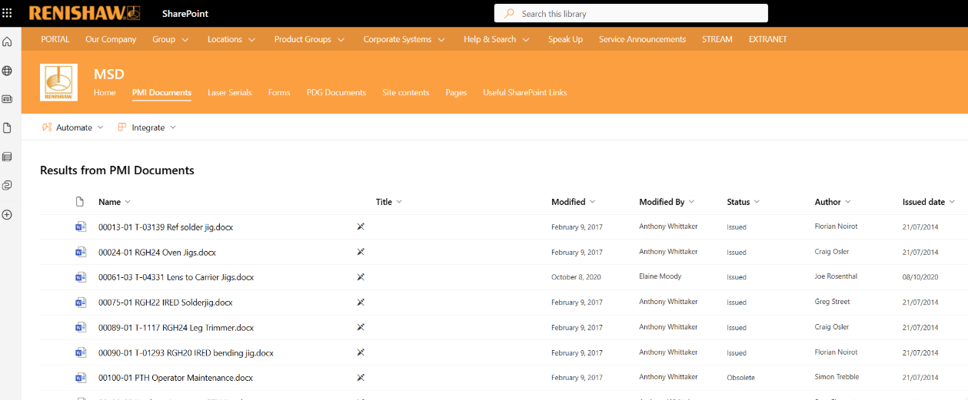

Figure 5 - PMI Documents

In addition to this, the use of figured photographs as well as text, which makes it simple to understand the instructions. Complex processes can be better understood by using visual aids making it easier to understand steps that might be difficult to explain in words (Paul, 2012). Images are also beneficial since they decrease misunderstandings: since text-only guidelines may be unclear, pictures offer a standardised, straightforward reference to guarantee consistency.

With this maintenance strategy, Syteline offers several benefits as well as drawbacks. For example, it serves as a single source of information for all calibration records, which minimises paperwork and human tracking mistakes. It also offers previous data, which makes trend analysis and calibration consistency monitoring possible. Syteline is an enterprise resource planning (ERP) system that helps firms control a number of processes, such as scheduling, inventory management, production planning, and order fulfilment for customers (Corley, 2024). At Renishaw, every machine or piece of equipment is given a "RUK" number, which is effectively a unique number for that particular item. Important information regarding the maintenance, including due dates, may be retrieved on Syteline.

Negative Approaches
The plan begins with the instruction to "ensure no contamination or debris remains on the probe module," but it makes no mention of how to clean it if necessary. How and what to use to clean it should be covered in another section of this article. For instance, use IPA and a lint-free cloth to gently clean the probe module if it is contaminated.
Another aspect that can be seen as negative is when the user is prompted to "enter sphere diameter" later in the PMI, which can be accessed on Syteline. Finding this information on Syteline may be an unwise decision for a number of reasons, one of which is that you need a computer with internet connection in order to determine the diameter. The reliance on ERP System availability is still another disadvantage. Should SyteLine encounter downtime, engineers would not be able to immediately retrieve the sphere diameter, thereby delaying crucial CMM calibration and maintenance.
Furthermore, one drawback of this method is the requirement of performing this maintenance every six months. Since CMMs are extremely sensitive and accuracy drift can result from progressive wear or contamination, maintenance every six months may raise the risk of measurement errors. Since a 6-month delay might lead to inaccurate readings, it would be best practice to decrease calibration to once a month to make sure the CMM is operating as it should.

Future Improvements

Predictive Maintenance - Condition Monitoring
The first step in improving the maintenance of the CMM may be to switch from the existing corrective maintenance strategy to condition monitoring maintenance. Condition monitoring is a predictive maintenance technique that uses real-time data collecting to track the condition of systems and assets and identify flaws and defects (Jagers, 2024). The equipment is observed in actual time to spot early indications of wear or performance deterioration rather than following set maintenance plans. In order to avoid needless downtime and expensive repairs, maintenance is only carried out when data indicates it is required.

Condition monitoring could be implemented in several ways such as:
- Tracking the average deviation figures using the existing calibration process can help you identify any slow drift in trends or outcomes. As previously stated, this is an easy procedure, with all results kept in the Syteline database. Figure 18 above displays the results of the deviations from former calibrations.

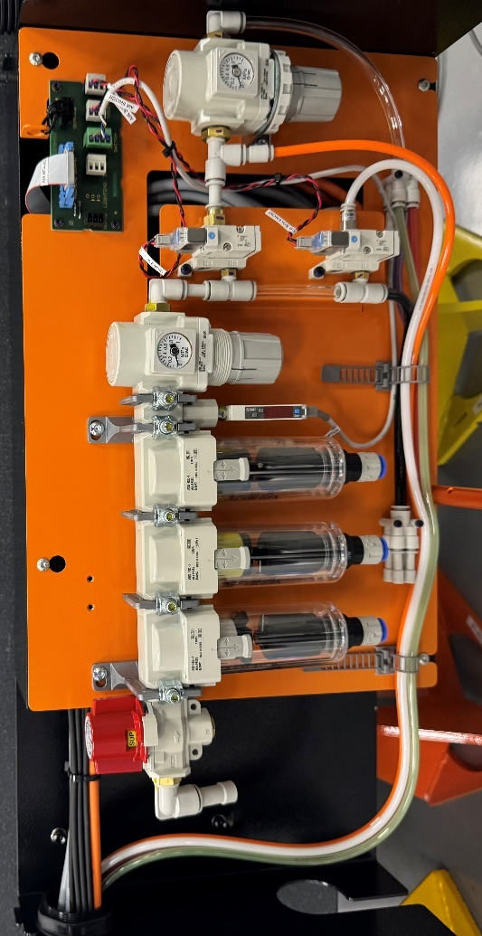
- Pressure and quality inspections for air bearings. Air bearings allow the CMM to move with little friction, hence air pressure stability is essential to its operation. At the moment, the machine is operated by an air board with two regulators that are set at 4 and 5 bar, as shown in Figure 6. Installing a pressure sensor to monitor pressure levels is one of two steps that might be taken to guarantee air stability in the machine. Analysing the regulator values visually each day and entering values into Syteline is the alternative.

Figure 6 - CMM Air board
Condition monitoring with this machine should be carried out by the engineering team (In House) rather than an external specialist contractor. Instead of depending on outside staff, one benefit of implementing everything entirely internally is that all of the experience and information will be housed there (Wascat, 2023).
Condition monitoring is more appropriate for this application than other methods like preventative maintenance primarily because preventative adheres to a set plan, such as replacing air bearings every six months, regardless of their true state. This method makes the assumption that every component wears at the same rate, which might lead to the unnecessary replacement of still-functional components, raising expenses and waste. Even in the case of a perfectly functioning equipment, preventive maintenance requires downtime at certain periods. Condition monitoring makes it possible to plan repairs only when necessary, keeping the machine operational for longer (Saggi, 2024).

Preventive Maintenance
Preventive maintenance (PM) is maintenance approach that involves doing consistently planned maintenance jobs to prolong the life of machines and prevent equipment breakdowns (Niijjaawan, 2015). Even though predictive maintenance is preferred over preventive maintenance in this particular equipment there are some aspects of preventive maintenance that should be carried out such as:
One improvement that could be implemented is that the machine should be cleaned every day or before every use at a minimum especially the bearing ways. This can be seen as a bad approach to maintenance as the current PMI does not state to clean the bearing ways. The bearing ways should be cleaned with IPA and a lint-free cloth while wearing safety goggles and gloves.
It is also crucial to visually inspect the equipment before using it. The bearing ways should be inspected for any damage or defects. cables or probes that are broken or damaged and confirm that all air pipes are in a healthy condition and free of any noticeable air leaks. It is also recommended to capture any unusual sounds that the equipment makes while it is in operation. Since it doesn't instruct you to visually inspect or listen for any unusual sounds, this may be considered a drawback of the present maintenance methods.
Preventive maintenance includes a number of enhancements that are designed to stop the CMM from being used while it is not calibrated, particularly in the form of administrative and procedural restrictions. These include putting in place software lockout mechanisms which shut off the machine when the calibration expires, utilising visual expiration labels so that operators can verify them, and incorporating calibration tracking into Syteline and other systems to provide alarms. These techniques are crucial in minimising machine misuse and lowering the possibility of faulty measurements or quality problems, even if they do not require physical maintenance duties. The best approach would be the first idea which includes adding a lock on the software when it goes out of calibration as the other two ideas does not actually prevent the user from using the machine.

Consideration of costs and resources
There are several different improvements that can be implemented to make this maintenance procedure better which can be seen in section 5.3.1 and 5.3.2, however the two main ones from PM and one from CM will be looked at. All costs and resources related to these improvements can be seen below:
Visually examining the air regulator and recording the data on Syteline every day is the first step towards condition monitoring improvement. Since installing a pressure sensor would be expensive and unnecessary, this is the recommended alternative. The indirect cost of hiring an engineer to do these daily inspections is £60 per hour. Table 1 lists all of the expenses associated with this visual examination.

Item | Estimated Cost (£) | Frequency | Annual Cost
Visual Regulator Check | No direct cost | Daily | £0
Logging Data on Syteline | No direct cost | Daily | £0
Labour Time (2 min/day @ £60/hr) | £2 Day | 250 days per year | £500
Total Annual Cost |  |  | £500
Table 1 - Visual Inspection Costs
The results show that it will cost on average £500 per year to perform these checks costing £2 per day.
The first improvement related to preventative maintenance is cleaning tasks which require for IPA and lint-free cloths. A bottle of IPA costs £18.80 (Figure 7), whereas a box of cloths costs £14.20 (Figure 8). An engineer's indirect charges are around £60 per hour, and it will take around two minutes each day to clean the equipment.



Figure 7 - IPA Bottle
Figure 8 - Lint Free Cloths

Item | Cost (£) | Frequency | Annual Cost (£)
IPA (Isopropyl Alcohol, 1L) | £18.80 | Monthly | £225.60
Lint-Free Cloths (Pack of 120) | £14.20 | Monthly | £170.40
Labour Time (2 min/day @ £60/hr) | £2/day | 250 days/Year | £500
Total Annual Cost |  |  | £896
Table 2 - PM Costs

From Table 2 the results show that total annual costs for cleaning the machine down equals to £896 approximately working 250 days a year. These cleaning tasks will cost approximately £3.58 per day.
In terms of resource, all maintenance procedures will be done by in house employees specifically the CMM engineering team. The engineering team will be responsible for the whole procedure including, installation of new improvements, carrying out the maintenance and logging the results onto Syteline. From adding these checks and basic maintenance it totals to £1396 per year.

Conclusions
To conclude, the CMM's current maintenance plan only includes calibration operations; regular cleaning, visual inspections, and condition monitoring are not included. Although calibration guarantees measurement accuracy, it ignores possible mechanical wear, unstable air pressure, or bearing way contamination, all of which might have an effect on the machine's long-term performance.

Since preventive maintenance relies on regular schedules and manual interventions, it is usually less expensive and simpler to carry out in short-term situations. However, condition monitoring reduces unexpected downtime and prevents needless part replacements, but it comes with a greater upfront cost for sensors, data systems, and integration (Mobley, 2002).

Maintenance may become more proactive and lower the chance of unplanned failures by implementing regular cleaning schedules, visual inspections, and air pressure monitoring.
In order to maintain machine accuracy, prolong component lifespan, and reduce operating costs, a shift from calibration-only maintenance to a predictive and preventive will guarantee the CMM stays in excellent condition throughout time.

References
Corley, T. (2024). What Is SyteLine ERP & Is It Worth It? [online] Godlan. Available at: https://godlan.com/what-is-syteline-erp/ [Accessed 26 Mar. 2025].
Gill, D. ed., (2019). Calibration in Manufacturing | Why is it Important? | ATS. [online] Advanced Technology Services, Inc. Available at: https://www.advancedtech.com/blog/why-manufacturers-should-care-about-calibration/ [Accessed 6 Apr. 2025].
Gwilliam, A.G. (2024). What Is Corrective Maintenance? | MaintainX. [online] www.getmaintainx.com. Available at: https://www.getmaintainx.com/learning-center/corrective-maintenance [Accessed 28 Mar. 2025].
Jagers, S. (2024). What Is Condition Monitoring? (The 2024 Guide) | Samotics. [online] Samotics. Available at: https://samotics.com/blog/what-is-condition-monitoring [Accessed 6 Apr. 2025].
Mobley, R.K. (2002). An Introduction to Predictive Maintenance. [online] Elsevier. Available at: https://www.google.co.uk/books/edition/An_Introduction_to_Predictive_Maintenanc/SjqXzxpAzSQC?hl=en&gbpv=1&dq=An+Introduction+to+Predictive+Maintenance&pg=PA3&printsec=frontcover [Accessed 6 Apr. 2025].
Niijjaawan, N. and Niijjaawan, R. (2015). Modern approach to maintenance in spinning. [online] New Delhi: Wpi Publishing. Available at: https://www.sciencedirect.com/book/9780857090003/modern-approach-to-maintenance-in-spinning [Accessed 30 Mar. 2025].
Paul, Y. (2012). Pictorial Instructions – What are they Good For? [online] TechWhirl. Available at: https://techwhirl.com/pictorial-instructions-what-good/ [Accessed 25 Mar. 2025].
Renishaw plc (2020). Renishaw: About Renishaw. [online] Renishaw. Available at: https://www.renishaw.com/en/about-renishaw--6432 [Accessed 16 Mar. 2025].
Renishaw plc (2025). Renishaw: AGILITY CMMs. [online] Renishaw. Available at: https://www.renishaw.com/en/AGILITY-CMMs-with-5-axis-technology--48532#ElementHTML175483 [Accessed 26 Mar. 2025].
Saggi, A.K. (2024). Preventive vs. Predictive Maintenance: What’s the difference? [online] CheckProof. Available at: https://www.checkproof.com/predictive-vs-preventive-maintenance-explained/ [Accessed 30 Mar. 2025].
Wascat, B. (2023). Predictive maintenance : Making the right choice between in-house and outsourced data collection - Acoem. [online] Acoem. Available at: https://www.acoem.com/en/blog/predictive-maintenance-making-the-right-choice-between-in-house-and-outsourced-data-collection/ [Accessed 30 Mar. 2025].

Appendix

Engineering Annual Maintenance – MCG Check
Health & Safety
- Read full procedure before commencing work.
- Ensure all tools and consumables are present/available.
- Observe COSHH.
- Use PPE where appropriate.
Equipment Required
- Lint Free Cloth
- IPA
- MCG Kit

Procedure
- Clean the bed with a Lint Free Cloth and IPA.
- Open UCCassist-2.
- UCCassist-2 will open. Select Squareness check and click Play (Figure 9). The screen shown in Figure 9 will be displayed.

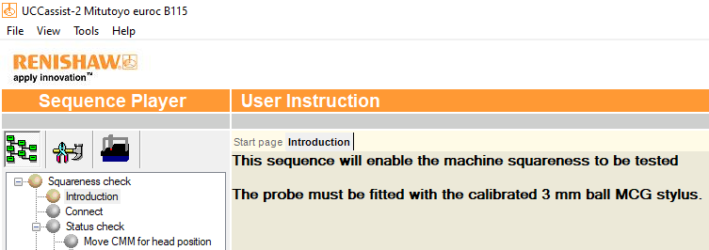

Figure 9 - Squareness Check

- Take the 3mm probe from the MCG Kit and ensure no contamination or debris remains on the probe module (Figure 11).
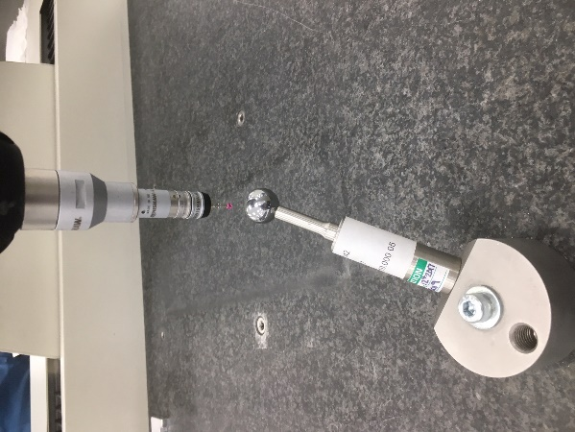
- Fit the 3mm probe to the module. Ensure the triangle on the probe lines up with the triangle on the module (Figure 10).

Figure 13D
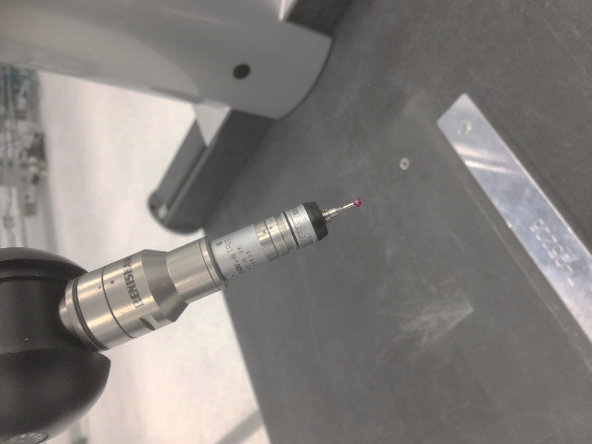
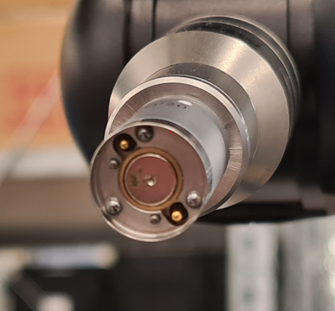

Figure 10 - Probe Orientation
Figure 11 - Probe for Contamination

- Enter the calibration sphere diameter and -210 in the boxes indicated in Figure 14.
- The calibration sphere diameter will be different on each machine and can be found on the SyteLine Gauges screen. Check the serial number of the calibration sphere – this is located on the stem (Figure 13). Enter this into the ‘Ser Num’ box on the SyteLine Gauges screen and filter. The diameter will be given in the ‘Range Size’ box (Figure 12).

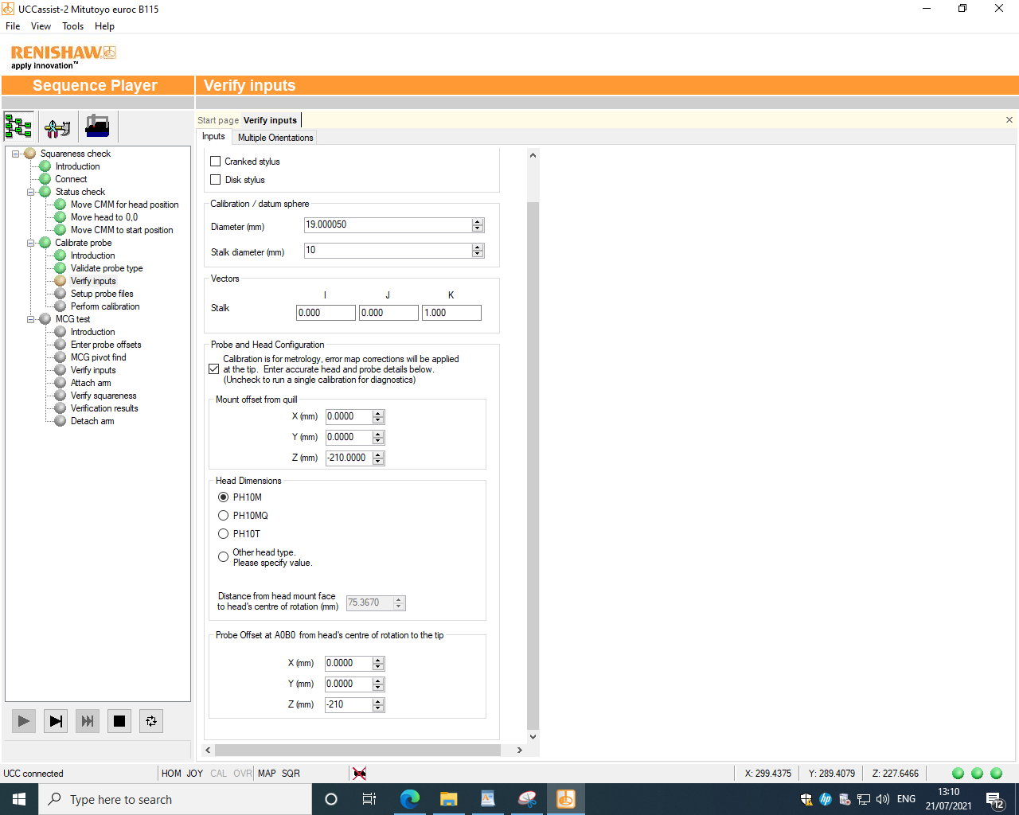
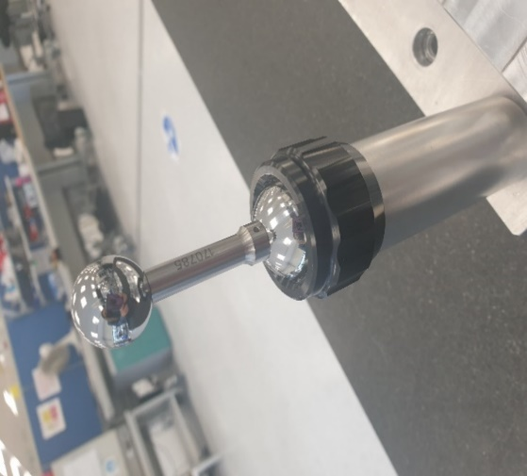

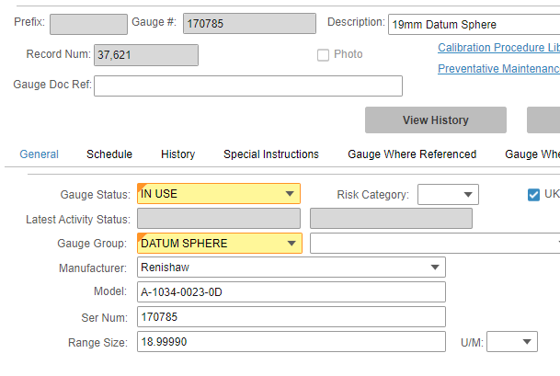

Figure 12 - Syteline
Figure 13 - Stem
Figure 14 -Entering Diameter
- Position the probe 20mm above the pivot assembly using the joystick (Figure 15).
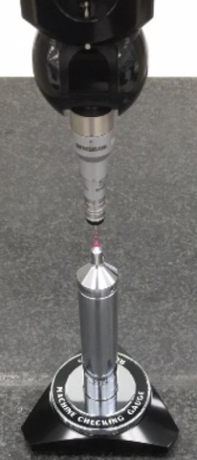
- Select Start.
- The routine will be carried out.

Figure 15 - Probe above Pivot Assembly

- Upon completion of the squareness check, the results will be displayed as shown in Figure 16. IF THE RESULT IS OUTSIDE OF THE SPECIFIED TOLERANCE FOR THE MACHINE AN ERROR MESSAGE WILL BE DISPLAYED. IF THIS HAPPENS, REPEAT THE CHECK UP TO 3 TIMES. IF THE RESULT IS STILL NOT WITHIN TOLERANCE AFTER 3 ATTEMPTS, RAISE A CALL WITH CMM SUPPORT.

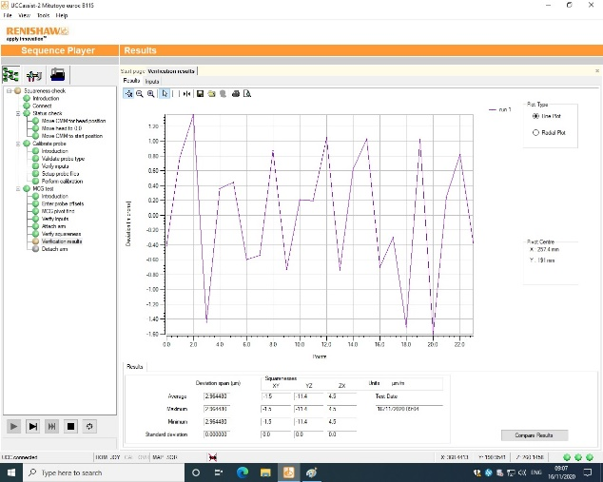
Figure 16 – Average Deviation Results

- The Average Deviation should be entered into the SyteLine Gauges for each machine when booking out the maintenance.
- Enter the result in the format shown in Figure 17 when completing the ‘Process Completed’ section.
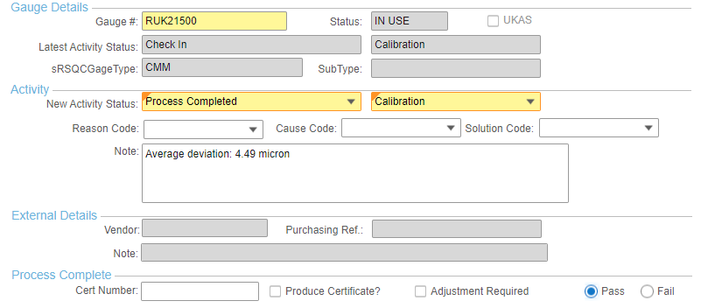
- Results will be displayed in the ‘History’ tab (Figure 18).
Figure 17 - Syteline Gauges

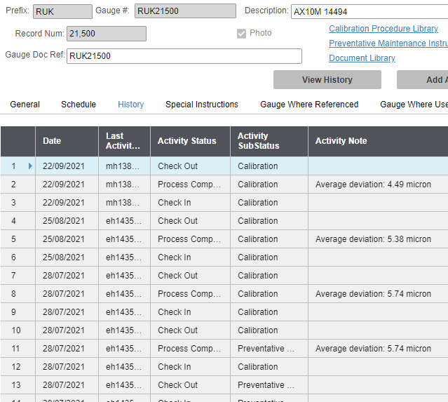

Figure 18 - Syteline Booking Out

