STRATEGIC MANAGEMENT FOR SMES

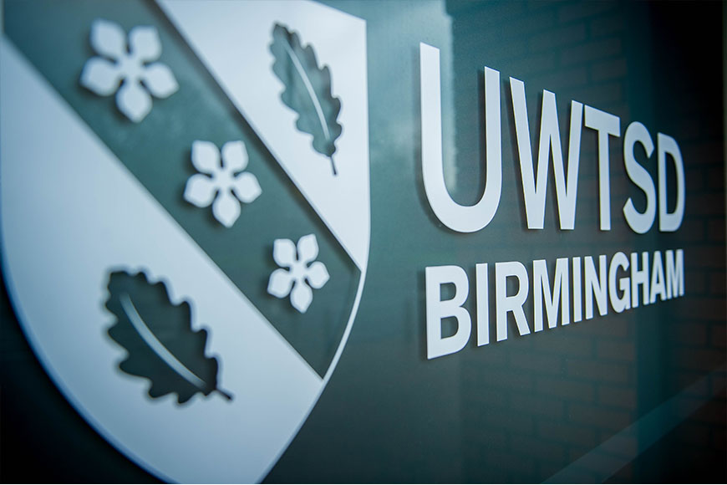

STUDENT NAME: LUBOIA BARROS
STUDENT ID NUMBER: 2017955
MODULE CODE: BMSW6104
MODULE: LEADING AND IMPLEMENTING WORKPLACE CHANGE
LECTURER: Bente Fatema
ASSIGNMENT TITLE: Strategic Management for SMEs

Table of content
INTRODUCTION 2
BUSINESS DESCRIPTION 3
BCLEAN VMOST ANALYSIS 3
BCLEAN VMOST ANALYSIS 4, 5
BCLEAN SWOT ANALYSIS 5
4PS OF MARKETING 5, 6
BCLEAN STAKEHOLDERS 7
POWER INTEREST 8
WHY USING SUSTAINABILITY STRATEGY? 9
WHAT ARE THE ADVANTAGES OF ADOPTING SUSTAINABLE PRACTISES WITHIN THE ORGANISATION? 10
WHAT SUSTAINABLE ACTIONS TO ADOPT? 11, 12
COMPANY POSTER 13
CONCLUSION 14
REFERENCES 15

INTRODUCTION
In this report I present the company BCLEAN, a company that decided to implement sustainability in its products and services to make a difference within the market. As a way of trying to minimize risks in the face of rivals in the same line of business, this plan was prepared. It addresses the different areas of a company and also includes market research that aims to discover whether there is market viability for a change. in the area of cleaning and laundry services. This plan has several topics such as the description of the business where its essence is addressed: target audience, needs that the company will seek to meet. After that, some market research data is presented.

BUSINESS DESCRIPTION
BCLEAN is a cleaning and sanitising solutions company that works to motels, apartments, and short-term rental properties.
The ease of evaluation through hosting websites and applications led to the observation of the need for a company in this type of business. Renters' growing desire for higher quality to provide to their clients has also had an impact on how cleaning is done.
When a customer is searching for a place to stay, this is one of the most crucial considerations. To make a difference, a laundry service was added in addition to the cleaning service. This would allow for the completion of the entire process in one location and would provide convenience, standardisation, and high-quality service.
Barcelos (2009) claims that the daily rush characterises modern society. Individuals set new goals and confront new difficulties. Not every task that has been prioritised gets done.
Making the most of the current era, this new business, a cleaning that specialises in seasonal rentals, was developed largely through the extensive use of technology. This came about as a result of observation of the area and its demands, as some property owners have trouble with this because of the dependability, quality, and cost of the services they receive, according to marketing research.
In an effort to address the issues raised by the owners, the company is working to standardise the methods used by all staff members to clean and sanitise bed linens with a more efficient business strategy. Thus, in order to define the business of the company, we looked for an objective indicator of the market segment that the company operates in.
BCLEAN VMOST ANALYSIS
VISION
Tavares (2010) asserts that having a clear vision enables one to project potential business opportunities and focus resources on pursuing them. And a plan outlining the steps we need to take today to get the organisation where we want it to be in its surroundings tomorrow. Focus is brought to bear on the future's direction by the vision.
The company's vision to be a leader in products and materials for laundry and household cleaning services was defined based on the authors' comments and what the company hopes to achieve for the future of your business by providing a service that values customer satisfaction.
MISSION
The purpose of the company is its mission. Right now, we're trying to figure out what the company does, why it exists, and even what kinds of things it should concentrate on in the future. Here, we attempt to respond to the most fundamental query: "Where do you want to go with the company?" (p. 116, OLIVEIRA, 1995).
Making sure that different points of view have something special and meaningful to contribute to your goals is one of the mission's duties. corresponds to the mission statement regarding the organization's intended response to the opportunities and risks your business environment presents. It is the magnitude of the enterprise, which is reflected in the members' daily activities within the organisation. It is composed of logic.
Objectives
According to Tavares (2010), quantitative objectives are typically employed when the desired outcomes are connected to elements that are challenging to measure and quantify. The following are quantitative goals for BCLEAN:
a) concentrate on enhancing cleaning process techniques with no chemical’s products.
b) enhance the team's trainings about recycling materials.
c) assume accountability for adhering to environmental solutions.
Most cleaning products on the market have been composed of chemicals derived from fossil fuels for many years. Considering this, BCLEAN is making investments to incorporate ingredients from other recyclable and renewable sources such as plants and plastic waste into their cleaning solutions. By doing this, it is possible to create a better planet for future generations by ceasing to use fuels.
Strategies
Partnerships between businesses are crucial for maintaining market competitiveness because they help both parties by bringing in more clients and cutting expenses. As Sbcoaching (2019) points out, a partnership is a cooperative strategy that benefits both parties and can arise even between competitors. It matters that they are connected in some way, whether it is to goods or services or to the people they are trying to reach.
Tactics
BCLEAN will therefore look to collaborate with environmentally conscious and sustainably run businesses that adhere to the Sustainability Tripod, which covers social, environmental, and economic practises that support growth and a better world.

BCLEAN SWOT ANALYSIS
Strengths:  - Unique service.  - Business provides products.  - Provides low noise equipment.  - Service quality.  - Description and agility. | Weakness:  - Control and trust in hired professionals.  - Reliability.  - Initial difficulty to increase public loyalty due to be a new strategy on the market.
Opportunities:  - Massive entry of women into the labour market work.  - Sector where everyone is a demander, from materials for cleaning services.  - Rising market; | Threats:  - Market resistance.  - Competition.  - Unqualified labour.  - Appearance of new  - Competitors.

Through the SWOT matrix, BCLEAN will seek the best strategy to be competitive in the market, mainly by paying attention to threats to anticipate future problems, also seeking to reduce weaknesses so that they do not delay the long-term growth of the organization. Strengths and opportunities always need to be improved so that the company can be up to date with the market seeking to innovate in this segment.

4PS OF MARKETING
“It can be considered that there will always be a need to sell. However the The objective of marketing is to know and understand the customer so well that a good or service I can adapt to it and sell it myself.” (KOTLER; KELLER, 2019, p.
Product/Service
BCLEAN is a company that grows with the idea that the transition to a fair, green and low-carbon economy and optimizing domestic services and clothing hygiene bedding and which seeks innovation in the sector to meet the main needs of Anyone looking for this type of service, cleaning of seasonal rental homes that requires agility and quality, and with the laundry service for cleaning of bed linen, in addition, above all, fidelity is sought of customers, with well-trained, polite and discreet employees, who carry out your tasks quickly and without waste.
PLACE
Kotler (2000) states that the greater the effectiveness of logistics, the greater the consumer satisfaction and lower costs for companies.
We chose a location in an industrial neighbourhood, as it has the laundry service it is important that there is space for machines, stock, place to store the vehicles and the office installation, was considered of location, infrastructure, space for events and training security and access to the site.
PROMOTION
According to Cobra and Urdan (2017), one of the four main instruments available to an organisation for persuasion is advertising, which can influence consumers to purchase a different good or service.
Since people must have faith in the business and it is best for them to have faith in the organisation when it comes to having an unknown individual in their home, Limp Mais has opted to market itself traditionally through word-of-mouth.
The business will employ website-based e-commerce marketing to facilitate the sale of goods and services.
PRICE
The quality leadership of the product is the defined pricing strategy. Kotler and Keller (2012) state that a business that chooses this course of action aims to make its goods and services affordable for customers, showcasing them as superior, tasteful, and high-status items at a price point that is somewhat expensive but still within the means of the intended market. While cleaning seasonal rental homes may be done by the residents themselves, The Clean
More strives for a high standard of service and provides a service that may be regarded as luxurious. However, for reasons of convenience, quality, and distinction, the customer will not tolerate paying a higher price for the service.
BCLEAN STAKEHOLDERS
Figure 1
Shareholder: The decision-making power over the company's future lies with partners and shareholders. As a result, they directly affect the goals and growth of the organisation. They also have high expectations for their income, the growth of the company, reaching a target, and getting certified.
Government: By intervening in the macroeconomic environment, resolving crises, or overseeing the economy, it directly impacts the organization's external environment.
Employees: Without them, no industry could exist, including infrastructure, quality management, customer relations, marketing, production, and human resources. The employees are responsible for carrying out the policies of the company.
Suppliers: There are several reasons why a supplier could affect your company. For example, the cost of the product at the end is largely determined by its raw materials. Delivery delays may affect manufacturing schedules, customer service, and execution capacity.
Customers are by far the biggest group of stakeholders. Most of the time, the satisfaction of the customer is at stake because it is he who uses the company's products or services.
Community: A business's decisions regarding a wide range of issues, including employment growth, economic development, and worker health and safety, may have an effect on the greater community.
Financial Institution: These companies can manage a client's or business's money in addition to performing basic bank clearance. Consequently, the main role of financial institutions in the market is to arbitrate disputes between traders.
Media: are tools made to help people or groups of people communicate information to one another.
Manager: Projects, programmes, and other related work must be identified, prioritised, authorised, and controlled by managers in order to meet specific strategic business objectives. They must also continuously strive to guarantee that projects and programmes are evaluated to ascertain the most efficient use of resources and that portfolio management is in line with organisational strategies.
POWER INTEREST

HIGH
POWER

INTEREST
LOW
LOW HIGH
Figure 2

“The Wide Sense of Stakeholder: Any identifiable group or individual who can affect the achievement of an organization´s objectives or who is affected by the achievement of an organization´s objectives. The Narrow Sense of Stakeholder: Any identifiable group or individual on which the organization is dependent for its continued survival”. (Freeman, 1983, p. 91)

One of the primary aspects that Freeman (1983) attempted to explain was the company's relationship with its external environment and its behaviour within it.

WHY USING SUSTAINABILITY STRATEGY?
With the development of actions that preserve the environment, concepts such as "sustainable companies" or "eco-friendly companies" have emerged, which are increasingly standing out in the market.
In other words, the business world and sustainability go hand in hand: it is in this context that ecological and sustainable companies emerge. They not only seek to carry out actions that favour their development, but also respect the environment and society globally.
In the social sphere, its function is to provide quality of life for people linked, directly or indirectly, to the company, inside or outside the company.
In the economic context, the focus is profitability, but profits must be made while the company sustains the use of natural resources and benefits employees. Therefore, planning and actions responsible for profitability must be aligned with conscious attitudes that respect the environment and provide a better quality of life for its employees.
For these reasons At BCLEAN, the sustainable strategy will be implemented in this way:
- Doing business with suppliers and partners who declare themselves sustainable and who focus on preserving the environment is a logical and coherent attitude.
- By encouraging your employees and the community around your company to practice recycling, it is a relatively simple action, but one that generates a huge environmental impact and also makes the company gain notoriety for its actions.
- The amount of disposable plastic items used in the company over the course of a year can be exorbitant. So, employees will bring their own mugs or items into the office. Furthermore, policies will be created to reduce unnecessary printing of documents, reducing the amount of wasted paper, and promoting conscious consumption. Also implementing natural products and low-noise materials.

First, sustainability promotes the wellbeing of people and communities while maintaining the environment's health and biocapacity. Additionally, sustainability encourages a more equitable distribution of wealth, more jobs, lower emissions, waste and pollution, and reduced emissions.
WHAT ARE THE ADVANTAGES OF ADOPTING SUSTAINABLE PRACTISES WITHIN THE ORGANISATION?
- An edge over competitors
Gaining a competitive edge is one of the main advantages of implementing sustainable practises in a business. The market is getting more specific about what businesses can and cannot do. Ultimately, it is no longer acceptable to acknowledge that a business generates enormous profits at the expense of society's overall well-being.
- Lowering of cost First and foremost, it's important to realise that businesses still need to turn a profit in order to be considered sustainable. They must make money from social and environmental behaviour in addition to having positive financial outcomes and a long-term vision.
- Improving the company's reputation
Society no longer holds an organisation that solely generates outstanding financial results in high regard. Neglecting social and environmental issues can lead to pressure from the public, governments, media, and even non-governmental organisations. The community at large is becoming more watchful and demanding, pushing businesses to take steps that enhance their reputation and demonstrate their commitment to the community.
- Entry into new markets
At the same time, adopting a more sustainable stance directly contributes to businesses that want to expand their operations. New markets and greater public reach can be achieved when the organization puts sustainable actions into practice,
- Employee satisfaction
Another important aspect that adopting sustainable actions helps is employee satisfaction. The social side is very important, but the focus cannot just be external,
What sustainable actions to adopt?
- Natural and easy alternatives for cleaning.
It is a very good idea to switch to more natural cleaning products because some of them contain harsh or even toxic chemicals or irritants for example:
- vinegar + lemon for degrease any surface
- vinegar + baking soda + water for general cleaning
- Natural bar soap, such as those made from coconut oil or reused cooking oil.
- Reuse of citrus fruit peels
- Give preference to brooms and sponges with natural bristles
The main benefits of this conscious exchange are:
- Prevents the waste of plastic packaging and the emission of polluting components into water and soil;
- Without the presence of chemical components that harm human health.
- Ideal for those who have babies, children and animals at home.
- Minimizes the risk of allergies and poisoning.
Beyond reducing toxicity to humans, using natural cleaning products has many advantages. The harm that conventional cleaning products cause to the environment can be minimised by cutting back on the use of products in the home that contain synthetic dyes and fragrances, phthalates, ammonium, etc., as well as by avoiding disposable items like baby wipes and disposable mops.
- Become paperless.
One of the simplest and most efficient sustainable actions to put into practice is to become paperless. In other words, reduce and eliminate the use of paper within your organization, replacing the physical version with the digital one. Instead of sending contracts by mail, why not do it via email? After all, if a large part of your work routine tasks are digitalized, why not do the same with the rest of the company?
Adopting the paperless concept also contributes to more efficient management of all of a company’s documentation.
- Have sustainable suppliers.
To ensure sustainability throughout a company's production chain, it is important to have partners who have the same understanding, which makes it necessary to have suppliers who also adopt sustainable actions. After all, efforts to reduce impacts on the environment or society can be lost when financing practices that go against the values ​​and purposes of your business.
- Train the team
Over the decades, economic development has always been placed ahead of other issues, whether environmental, social, or cultural. Therefore, it is necessary to undergo a complete change in philosophy and behaviour for a brand to adopt sustainable practices, and this involves training employees.
Recycle and reuse.
Recycling is also a practice that must be part of any sustainable industry planning. Making the most of each resource not only represents financial savings, but also helps to considerably reduce your company's impact on the environment. The same material that was delivered to the customer at the end of the chain can be returned to be used in a new cycle.
- Reduce waste.
Reducing waste should be another priority and extend to areas of a company, regardless of its segment. Whether it is a restaurant that takes care of food waste, or a factory that disposes of food throughout the production process, the entire operation must be reviewed to find ways to optimize production, doing more with fewer resources along the way.

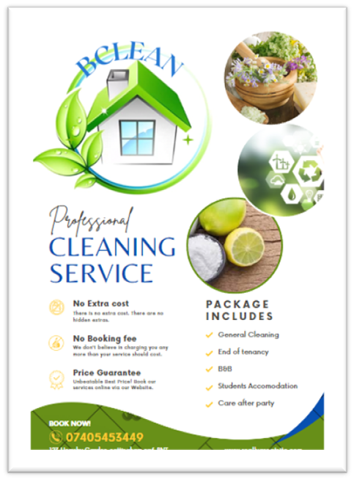

CONCLUSION
As we can see throughout this report, by opting for natural cleaning products, in addition to their proven effectiveness in removing dirt, strong odours and bacteria spread throughout the corners and objects of the house, we are also choosing to maintain the good health of the environment and life on Earth.
The starting point for the planet's sustainability comes precisely from seemingly small attitudes - such as the use of natural products available in the kitchen cupboard -, but which have the superpower to impact everything around us.
After all, “in nature nothing is created, nothing is lost, everything is transformed”.

REFERENCES
- Ruggerio, C.A., 2021. Sustainability and sustainable development: A review of principles and definitions. Science of the Total Environment, 786, p.147481.
- Zhou, B., 2016. Lean principles, practices, and impacts: a study on small and medium-sized enterprises (SMEs). Annals of Operations Research, 241, pp.457-474.
- Gherghina, Ș.C., Botezatu, M.A., Hosszu, A. and Simionescu, L.N., 2020. Small and medium-sized enterprises (SMEs): The engine of economic growth through investments and innovation. Sustainability, 12(1), p.347.
- Morgan, N.A., Whitler, K.A., Feng, H. and Chari, S., 2019. Research in marketing strategy. Journal of the Academy of Marketing Science, 47, pp.4-29.
- Kumar, A., Paul, J. and Unnithan, A.B., 2020. ‘Masstige’marketing: A review, synthesis and research agenda. Journal of Business Research, 113, pp.384-398.
- Benzaghta, M.A., Elwalda, A., Mousa, M.M., Erkan, I. and Rahman, M., 2021. SWOT analysis applications: An integrative literature review. Journal of Global Business Insights, 6(1), pp.55-73.
- Puyt, R., Lie, F.B., De Graaf, F.J. and Wilderom, C.P., 2020. Origins of SWOT analysis. In Academy of management proceedings (Vol. 2020, No. 1, p. 17416). Briarcliff Manor, NY 10510: Academy of Management.
- Vo, T.L.U. and Nguyen, T.N., 2023. Application of SEM in analysing the effect of competitiveness, operating effectiveness and risk management on the stability of Vietnamese construction corporations. The VMOST Journal of Social Sciences and Humanities, 65(1), pp.11-23.
- Ozhava, D., Bhatia, M., Freman, J. and Mao, Y., 2022. Sustainable Cell Sources for Cultivated Meat. Journal ISSN, 2766, p.2276.

