DS 1 Lavern’s Digital Skills

My Screenshots/Photos
- Below are 4 screenshots or photos of my digital life.
- I have used recently updated mobile phone and laptop.

Screenshot/Photo 1
Screenshot of Moodle
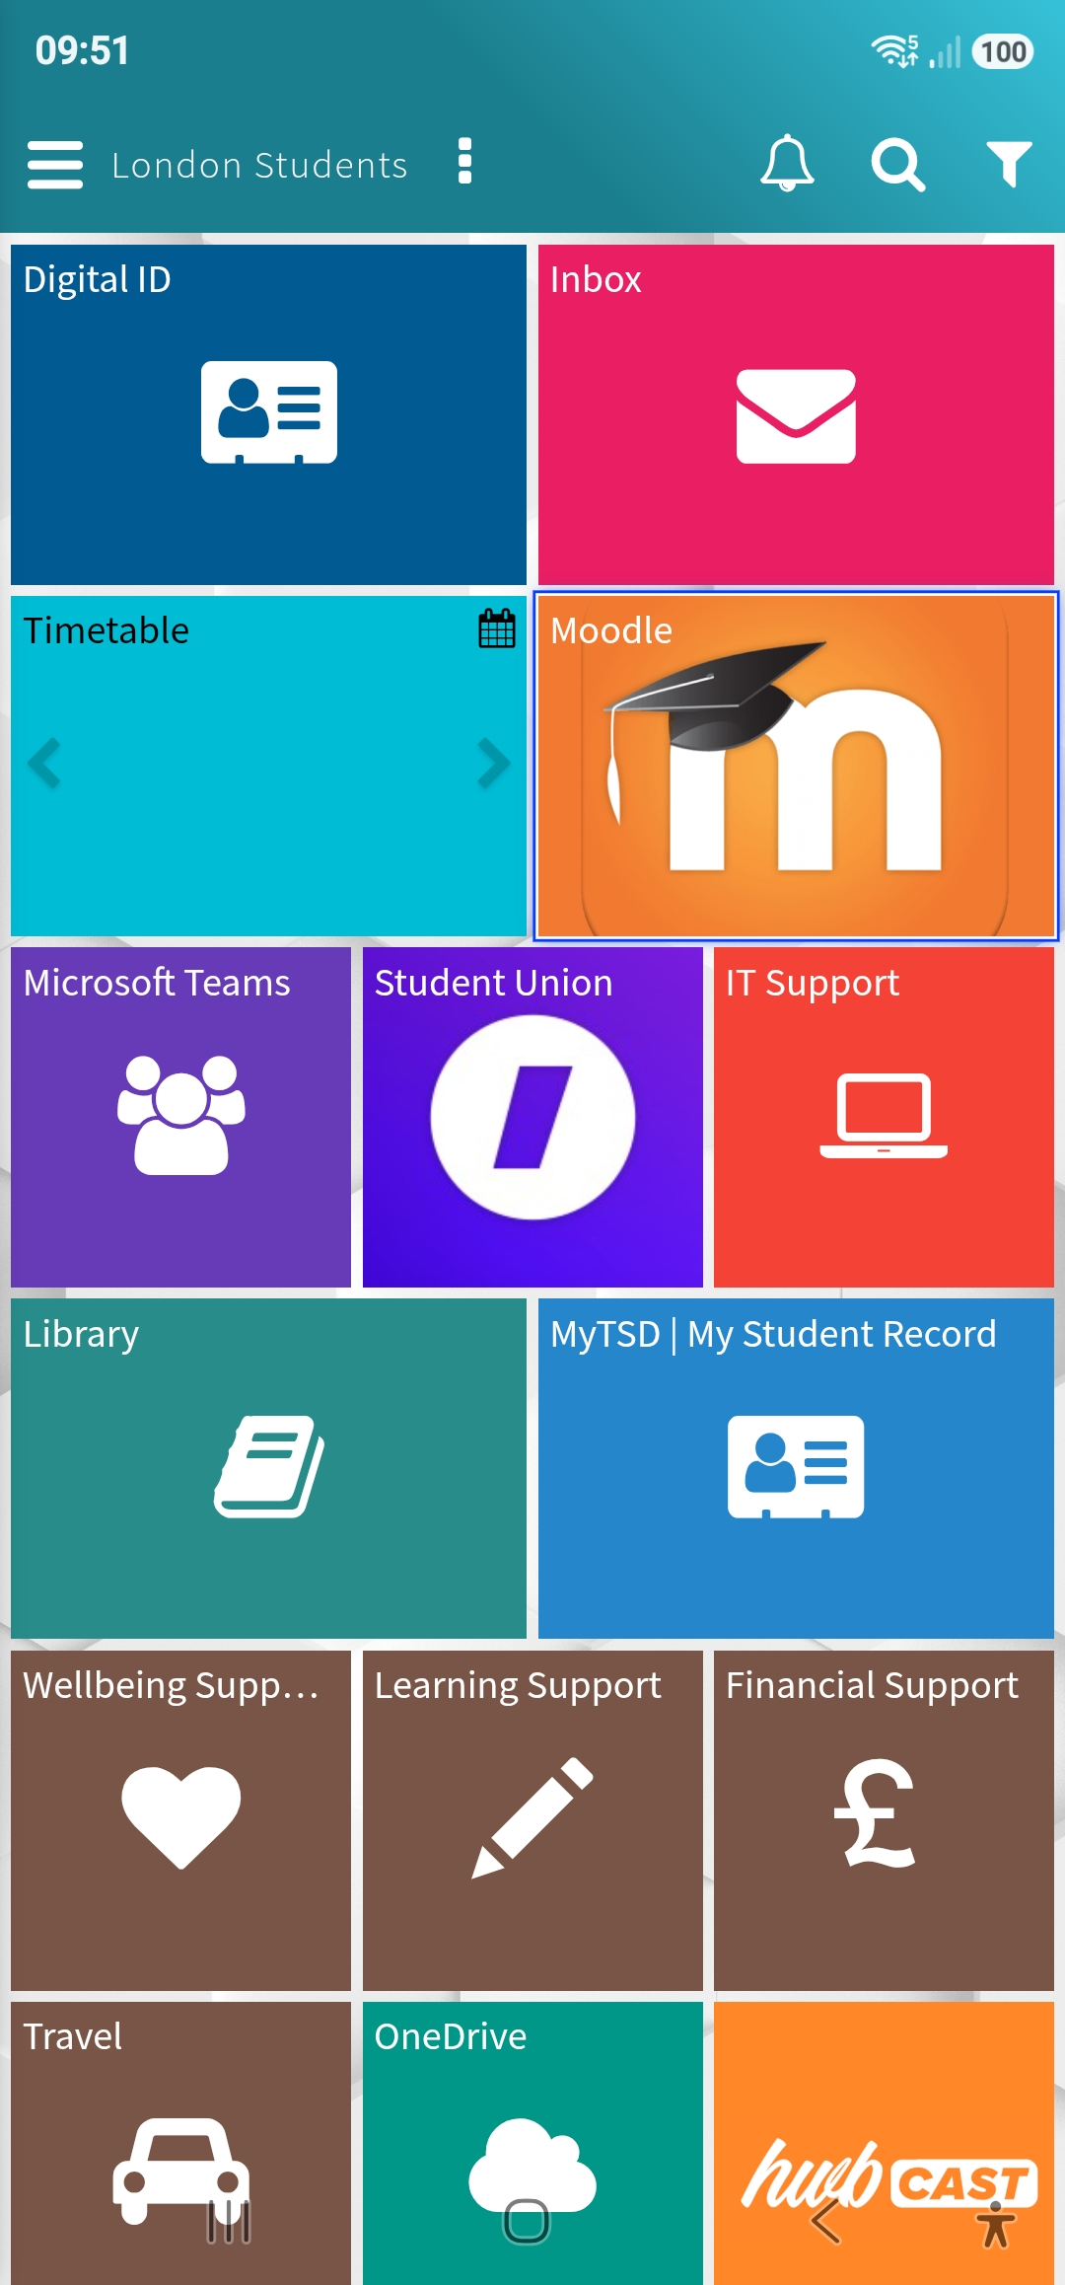
I use Moodle at UWTSD to access my class materials, check announcements, and keep track of my weekly tasks. I also use it to submit assignments and assessments and view my feedback, which helps me stay organised throughout my course.

Screenshot/Photo 2
Screenshot of an email
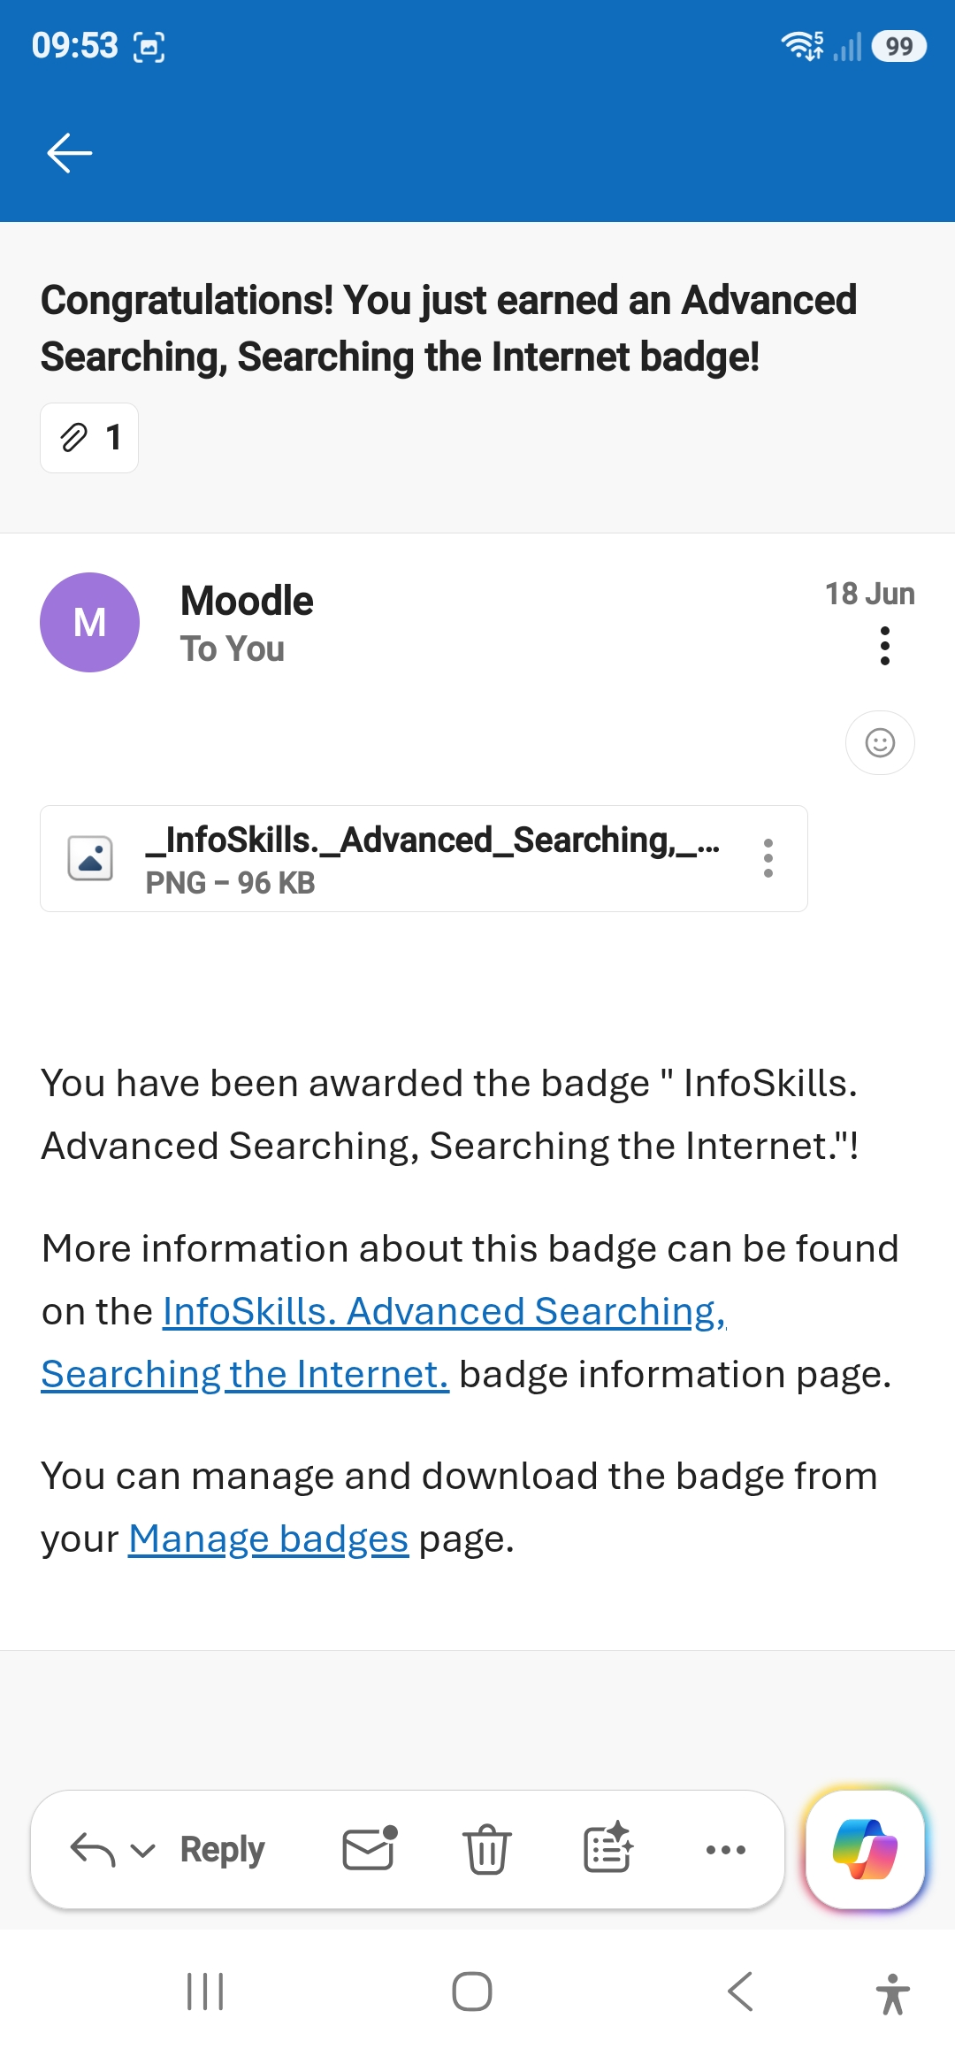
This image is a screenshot of an email I received from UWTSD regarding my studies, providing important information.

Screenshot/Photo 3
Screenshot of a hairstyle

This screenshot shows a hairstyle I’m considering because it matches the look I’ve been wanting for myself.

Screenshot/Photo 4
Photo of mobile banking app
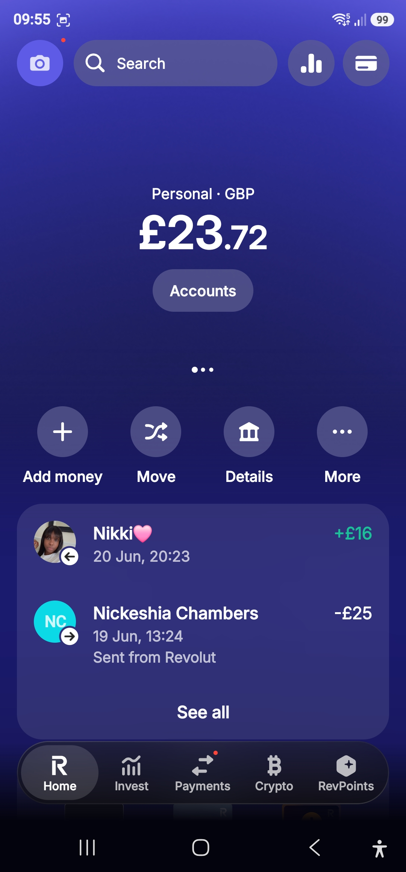
This image is a screenshot of my banking app, where I manage my finances, review recent transactions, and keep an eye on my day-to-day money management.

Screenshot/Photo 5
[Insert Photo/Screenshot below]

[Write what this shows of your digital life]

Screenshot/Photo 6
[Insert Photo/Screenshot below]
[Write what this shows of your digital life]

My Short Reflection
- Write 5–8 simple sentences about your digital life.
- You can use the sentence starters below if helpful.

Sentence starters
- I use digital tools to manage my studies and support my family in Croydon.
- I feel confident when I use my phone and laptop for social media, coursework and job applications
- I want to improve my skills with new admin and receptionist software.
- I often use these tools: email, Google, WhatsApp, social media, online learning platforms.
- I sometimes feel nervous about using tools I haven’t tried before.
- I hope this module will help me feel more confident for customer service and admin roles.
- Digital skills are important for me because they help me progress in my new career path.

You can write more if you want.

Submission Checklist
Before you submit, please check:
​​​ ☒ I added 4–6 screenshots
☒ I wrote short sentences for each screenshot
☒ I wrote my short reflection
☒ My work is my own
☒ My file opens correctly
​​☒ My file opens correctly

