

Data Analysis and Visualisation

Cloud Computing
Lecturer: Suneth Fernando

Student ID: 2019923
Enachi Iulian

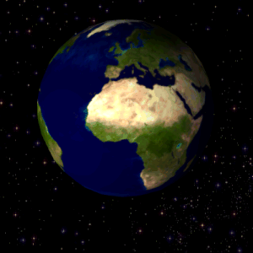

Contents
Introduction. 2
What do we need to know? 2
Colors and concept. 2
Suggested ideas to improve the Poster offered. 4
Conclusion 6
Bibliography 6

Introduction.

This paper is meant to highlight the main aspects of rendering and presenting information in an Academic Poster, as well as trying to evaluate and improve a paper already offered in the module. The basic purpose is to reflect the knowledge gained during this module.

What do we need to know?

Before evaluating the work given in the module, it is necessary to clarify some basic aspects regarding the purpose of each Academic Poster. According to some sources [1], 90% of any scientific post created has a terrible appearance. To get to this topic first of all we will try to understand the fact that an academic poster is not just a bottomless bag, where you can throw all the necessary information to be already informative.
Instead, an Academic Poster has as its main purpose an introduction, that poster should not reflect every aspect and every detail of scientific research but to attract people's attention and serve as a start of conversations reflecting only the key aspects of scientific research.
So it is actually a communication tool that could make the introduction or could make a generalization, a conclusion of scientific growth.

Colors and concept.

In general, [1] the appearance of the given Poster is attractive, but the main concept or idea is not well defined.
For example, a title is missing that would clearly define the zero point in connecting with viewers.
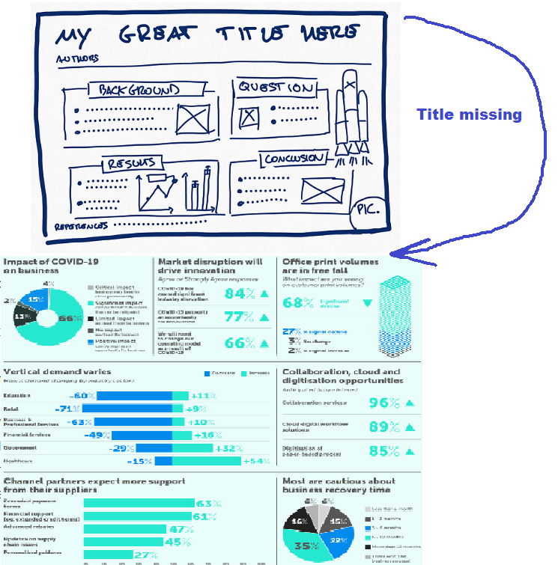

The title and the main idea are missing !!!!

Layout and size: vertical or horizontal? This is also not clear. It is an A3 Poster and its orientation.
At the point: how easy it is to read the information on the body of the Poster and how it is organized for the eyes of the viewers. It can be mentioned that it is a well-structured work and each of the 7 basic points are well delimited. They have easy-to-notice borders and are easy to read, giving a pleasant appearance.
We have a visual organization in tiles. Which is very good. But the central idea should obviously be centralized, in order to attract distant eyes.
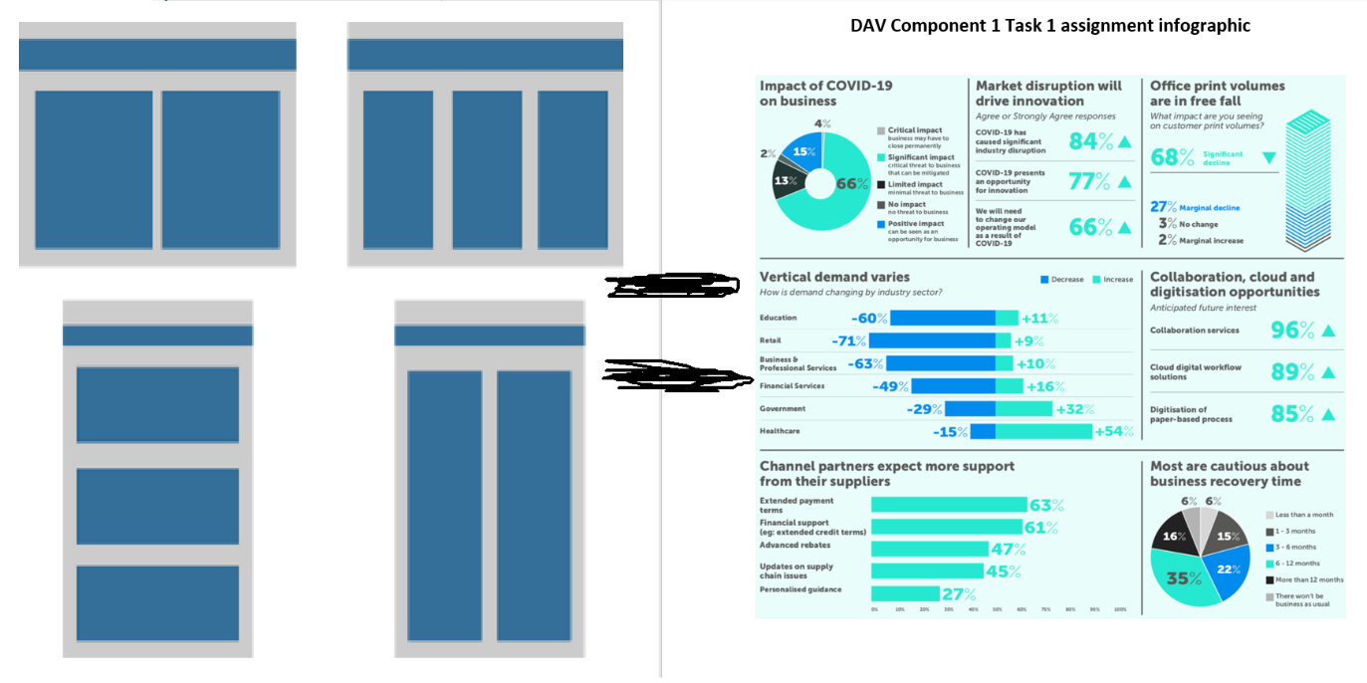
Negative space: For some reason the information is easier to read when we have more empty space on the poster without loading any square millimeter with information. So, we have a plus again.
It is recommended that almost 40% of the entire poster surface be clear!!!
The colors in this paper are active without the tendency to "burn the reader's retina." We do not see a wide range of colors, and they are easily perceptible. As in the following example:

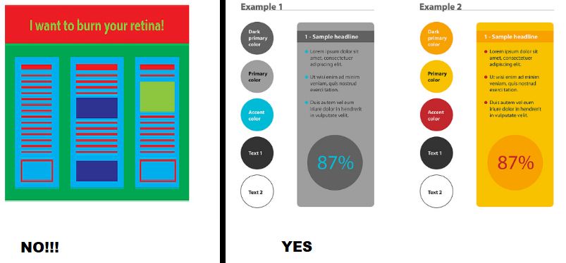
However, there are cold and warm colors and it would be suggested that it is welcome to highlight the idea of danger with a bright color that associates fire or danger, such as red.
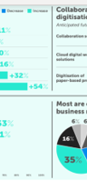
In the background we have an open background, and it is not a photo or a dark background that would make it impossible to identify negative spaces, so the background used by the academic poster is perfect for viewing information.
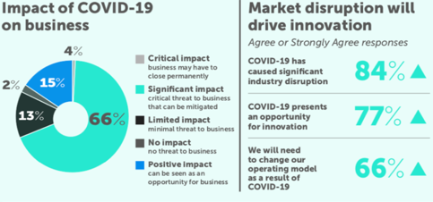
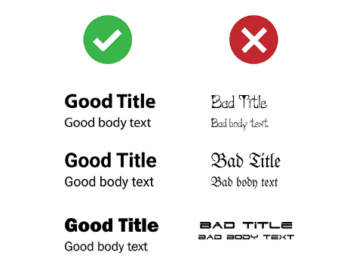
Fonts: in reality it works exactly like the colors and therefore the same rules apply. Fonts are not very differentiated and have common aspects that the reader already knows so it makes it easier to read and understand the key message. The image below shows the correct use of funds correctly.
We have a good example of using fonts…

Contact information: It would seem strange to some, but this information can sometimes play a decisive role in the perception of the message because the author's initials are often related to his reputation, so it is important to have them on our poster.
Graphics used: They are well defined, have a legend in sight, are easy to read and are diverse, which does not bore the reader or confuse him.

Suggested ideas to improve the Poster offered.

It is obvious that in order to generate these ideas it is necessary to review the above steps in examining the given poster.[3] In a generalization of all the above steps it is seen that:
- We must include a title or a motto that will describe the main idea. For example: "Business and the impact of covid-19 on it" or a motto like "Money still gets sick of Covid-19".
- The use of Color that would suggest danger, or something unpleasant: what is the color red.
- Adding contact information that reflects his reputation and brings clarity to the image.
- The centralization of the central ideas, so the reorganization of the tiles and the central highlighting of the graph that generalizes the central idea.
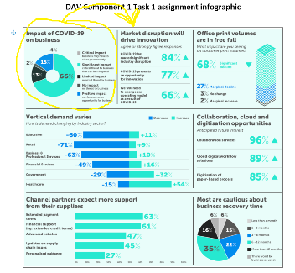
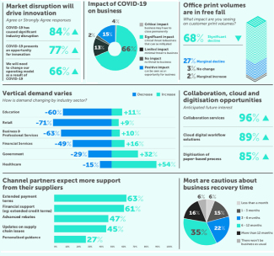

Before After
- Like any creation, a scientific investigation needs a little artistry so you need to add some images or logos, which could attract views and determine the general idea.

In the end, the given work will look like this after writing and adding some aspects to capture attention and render more visual information:
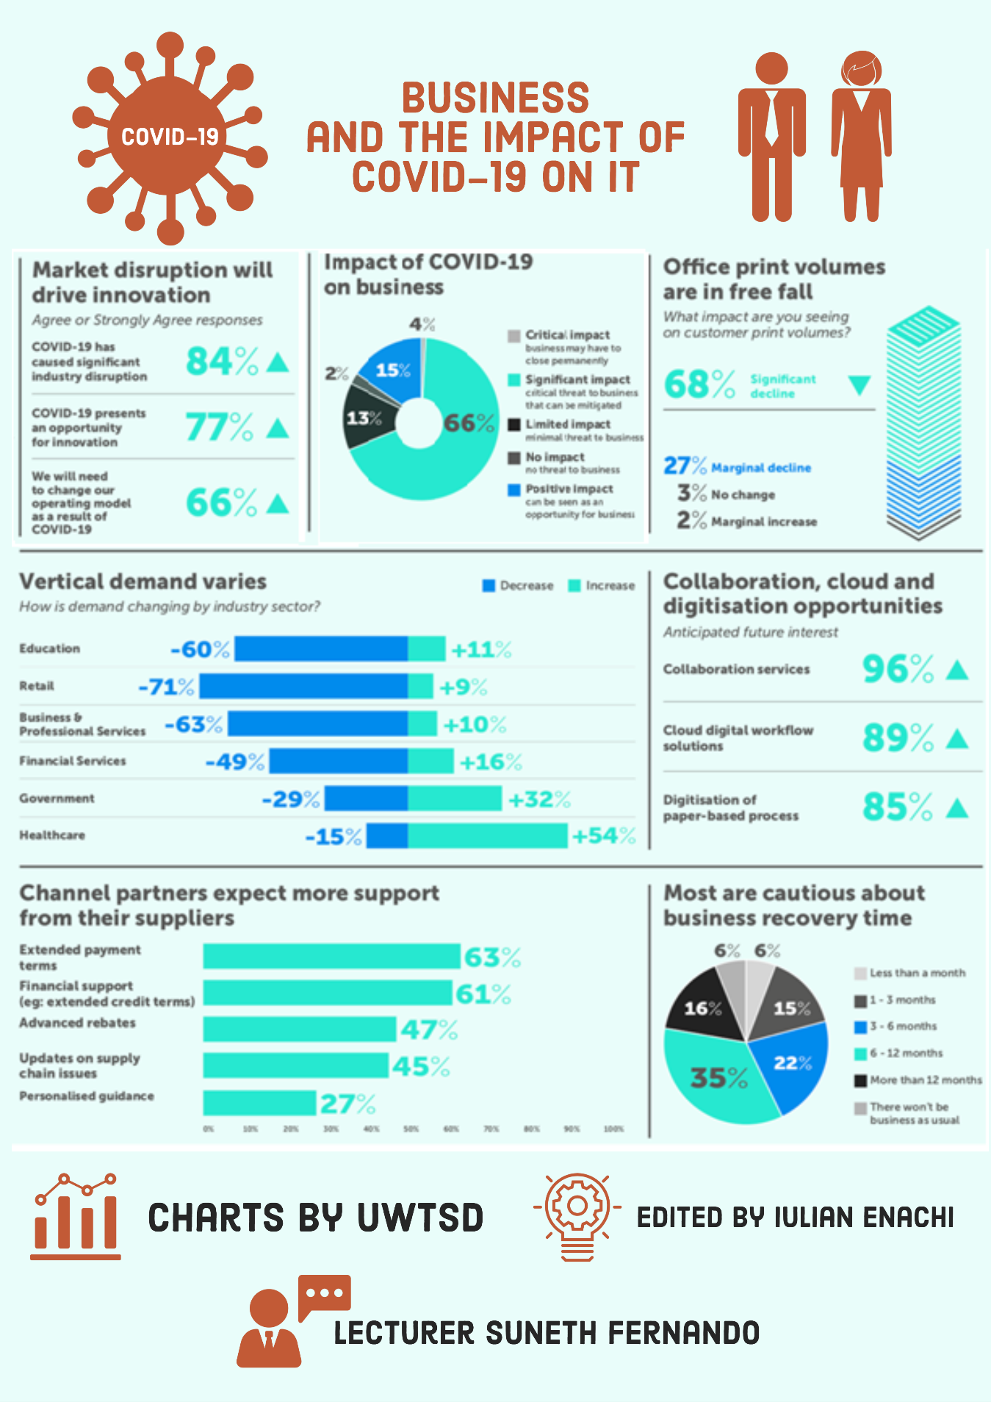

Conclusion

It is worth mentioning that visual information is perceived and processed by the human brain thousands of times faster than raw numbers. [2]. Hence the idea of designing and producing easy-to-understand graphics.
However, this information must be advanced to a higher level to be perceived by the human brain more easily. A graphic is something informative, but it must be completed with correct titles, colors, backgrounds. If we are talking about combining several graphics, then we must keep in mind that the information that is presented should not be mixed and therefore cannot be perceived by readers.
Thanks to the Data Analysis and Visualization module, students will be able to fully understand the meaning and correctness of the visualization. Plus, the accessibility of the information presented will be essential in other areas such as WEB-DESIGHN.

Bibliography
[1]“How to design an award-winning conference poster,” Impact of Social Sciences, May 11, 2018. https://blogs.lse.ac.uk/impactofsocialsciences/2018/05/11/how-to-design-an-award-winning-conference-poster/ (accessed Jul. 17, 2021).
[2]Wikipedia Contributors, “Data visualization,” Wikipedia, Apr. 14, 2019. https://en.wikipedia.org/wiki/Data_visualization.
[3]M. Nediger, “What is an Infographic? Infographic Examples, Templates, and Design Tips - Venngage,” Venngage, Mar. 2019. https://venngage.com/blog/what-is-an-infographic/.

