How many Hearing-Impaired Children and Young people within Mainstream Education receive additional support within Wales?
Introduction
The purpose of this research is to establish if hearing impaired children and young people receive the appropriate support within mainstream education across Wales. Appropriate support can be defined as the level of care which is provided to ensure the health and wellbeing of a child or young person is considered (Contact for families with disabled children, 2022). According to Contact for families with disabled children (2022) it is the role of the school to provide a level of standard ensuring that work and support is being fairly provided to each hearing impaired child or young person.
From a personal perspective, many communication barriers were faced during mainstream education. There are many examples of daily communication barriers which hearing impaired individuals face. From a personal experience one of these being, lectures carried out via teams, making it harder to lip read and understand what is being said by peers. This causes an individual to rely heavily on a notetaker and the ability to review recorded lectures. However, this is a communication barrier that can be overcome. But for hearing impaired children and young people within mainstream education, barriers like these arise everyday which results in disruptive learning. Weber (2016) highlight the challenges in which hearing impaired and deaf individuals face within a school environment. The acoustic of a room and the way it is structured can have a detrimental effect on the hearing-impaired child or young person such as sitting next to a window, will amplify the surrounding noises from outside, not having carpet or having high ceilings can also cause the sound to be amplified making it overwhelming for the hearing-impaired individual (Weber,2016).
Hearing loss can affect one or both ears, this can influence the individual's ability to hear conversations, making it harder for the individual to concentrate. If an individual has a hearing impairment, it means that their hearing is not effective (National Health Service, 2018). Hearing loss can occur at any stage of an individual's life. For example, hereditary, birth asphyxia or age related in adulthood (World Health Organisation, 2021).
Hearing loss can either be considered as mild, moderate, severe or profound (World Health Organisation, 2021). The National Deaf Children’s Society (2021) state there are different levels of deafness which are measured in decibels. If an individual has a Mild Hearing Loss, the hearing range would be within 21-40dB. A moderate Hearing loss is between 41 – 70dB and a severe Hearing Loss is in the range of 71 – 95dB. If an individual is profoundly deaf, the hearing range would be 95 decibels (National Deaf Children’s Society, 2021). A table obtained from Healthy Hearing (2021) show the frequencies and ranges which individual can hear. This can be seen in appendix 3.
Healthy Hearing (2021) state that children who have a high frequency hearing loss have difficulty hearing high pitched sounds but can hear low pitch noises. The reverse of this is a low frequency hearing loss. According to Healthy Hearing (2021) some children may have a flat hearing loss, this means the child may have difficulty hearing both low and high pitch noises.
Communication plays a key role with everyone's day to day life. According to Schramm (1954) when individuals communicate with each other, they are trying to find the commonness of the conversation. Individuals who are hearing impaired, highly depend on communication as a form language.
University of California San Francisco (2022) highlight several strategies which could be considered when communicating with an individual who is hearing impaired, Facing the hearing impaired individual, ensuring there is sufficient light, being able to see the individuals face helps with lip reading and facial expressions. Making sure that the individual is in the same room when communicating. This is important as speech can become distorted. Ensuring background noise is minimised as it can lead to great difficulty when trying to understand a conversation. Making sure the speaker is clear, distinct and does not exaggerate their mouth when talking. The speech should be spoken at a normal tone as shouting will only distort sound. Talking rapidly and the use of complex sentences can be misleading, so by pausing between sentences will help reduce the conversation from being misled. Language is also a barrier as the hearing impaired individual may have limited understanding of complex words which could lead to a breakdown in conversation. Hearing impaired children have a limited vocabulary as they have to learn the meaning of words, whereas normal hearing children hear unfamiliar words in their every environment. Before speaking, it is important to say the individuals name, this ensures that the hearing impaired individual is playing attention as they will have a chance to focus their attention on what is going to be said, rather than trying to process on what they think is being said. Covering the face can be a huge disadvantage when communicating with hearing impaired children as many rely on facial expressions and lip reading when in conversation. Facial hair such as beards and moustaches can also interfere as well as hands or face masks (University of California San Francisco, 2022). Roy and Duncan (2021) highlight the challenges in which children and young people face with regards to face masks in a classroom. They suggest several outcomes to help teachers and students overcome barriers such as exaggerating body language and facial expressions or increasing the use of technology, such as adding subtitles when watching videos (Roy and Duncan, 2016).
The National Deaf Center on Postsecondary Outcomes (2019) suggest that Individuals who are hearing impaired communicate, visually, auditory, or use tactile methods. Visual communications can be classed as lip reading, American Sign Language (ASL), or British Sign language (BSL) (National Deaf Center on Postsecondary Outcomes,2019).
Communicating auditory, means the individual depends on a hearing aid or cochlear implant. This means sound is transferred to their ear, enhancing the ability to hear sounds (National Deaf Center on Postsecondary Outcomes,2019). A hearing aid can be described as a wearable technology device which sits inside and over the ear. It has the ability to enhance sound, making it clearer and better for the individual when communicating (Hearing Link, 2018). According to, National Institute on Deafness and other communication disorders (2016) a cochlear implant is an electronic device which provides sound to those who are profoundly or severely hard of hearing. The electronic device consists of two parts, one section can be seen behind the ear and the second is surgically placed under the individual’s skin. A diagram obtained from the National Institute on Deafness and other communication disorders (2016) show how the cochlear implant is situated on an ear, this can be seen in appendix 4.
An individual who is deaf blind requires tactile communication, this means they would use touch as a form of communication (National Deaf Center on Postsecondary Outcomes,2019). The National Deaf Children’s Society (2021) state that the deafblind individuals place their hands over the signer to follow what is being communicated.
Being hearing impaired within mainstream education has many potential communication barriers. Lunenburg (2010) highlights the process and effectiveness of communication and Keyton (2011) explains the definition of communication as the procedure which helps information to be conveyed to individuals. Cheney (2011) describes the action of how communication requires two components, the sender and the receiver. It is important to understand that the sender begins the conversation, and the receiver is the individual who takes in the information being conveyed. When a message is conveyed and there is a barrier between the sender and the receiver, such as noise, then the receiver may not have received the full message or may have misinterpreted what was said, this is common in hearing impaired individuals and only through feedback it is determined what the receiver heard.
There are several ways hearing-impaired children and young people can be supported within education, such as with a Statement of Educational Needs, a Learning Support Assistant, a Teacher of the Deaf and with technology equipment. To help hearing impaired children and young people overcome barriers within mainstream education, the requirement of relevant bodies, such as a Specialist Teacher of the Deaf or a learning support assistant would be needed. This would provide the appropriate support for the individual, making sure the child has access to the appropriate support and that learning is not being disrupted. For the appropriate support to be put in place, the appropriate individuals would give recommendations to the local authority on how to enhance the child or young person's support and environment. Appropriate support is when a Teacher of the Deaf liaises with other members of staff to ensure that the child receives specific support to enable them to access the curriculum without barriers.
According to the National Deaf Children Society (2021) Teachers of the Deaf are qualified teachers who have taken additional training to support individuals with a hearing loss. The qualified teachers arrange support which is tailored to the hearing-impaired individual and their family, but also give guidance to professionals who may be included within the individual's education. A Teacher of the Deaf can be seen as the main individual who is liable for the support of the child/young person throughout their education (National Deaf Children Society, 2021).

Methodology
The information will be obtained from the Consortium of Research into Deaf Education (CRIDE) (2018, 2019, 2020), and StatsWales (2018, 2019, 2021). The figures will focus from 2017 to (present day), which will provide a more accurate insight on the number of hearing-impaired children and young people but also on the various forms of support which is being allocated. The research will focus on the children and young people within Wales, this will highlight and give an insight into the specific number of hearing-impaired children and young people within each county. The information will only be obtained from within Wales as the scale for the United Kingdom and globally would be too wide of a scope to research. To ensure a fair number of statistics are obtained, focusing on data from 2017 to present day will give a wide and a fair range of information which will justify the reason of research. Having a selection of years will give a better insight and will help with identifying the number of hearing impaired children and the type of support received within mainstream education in Wales. The information will focus on the hearing impaired children and young people who are receiving the additional support within mainstream education in Wales.
Consortium of Research into Deaf Education (CRIDE) (2018, 2019, 2020) can be sourced by using the search engine, by searching ‘Number of hearing impaired in Wales report’ which leads to a PDF document provided by the National Deaf Children Society. The document contains the CRIDE report for 2017, highlighting the number of hearing-impaired children and young people within Wales. To obtain the 2018, 2019 and 2020 reports, the website provided at the bottom of the first page, leads to previous CRIDE reports (National Deaf Children Society, 2021).
StatsWales (2018, 2019, 2021) can be sourced by using the search engine and searching ‘Reports on Special Educational Needs by local authority’ and ‘Reports on Special Educational Needs by type of need’ which leads to the relevant information provided by the Welsh Government. The information opens in an interactive table which can be adjusted to the appropriate years or disability to obtain the relevant statistics for this research.

Results
From the information obtained from the CRIDE Report (2018, 2019, 2020), it shows the number of teachers or the deaf within the local authorities in Wales and the number of children they provide a service to. During 2017 and 2018, the figures show that each local authority has a designated Teacher of the Deaf. In 2018, the table (Appendix 2) shows there were 33 Teachers of the Deaf providing support in Wales to hearing impaired children (The Consortium of Research into Deaf Education, 2018).
Comparing the statistics from 2019/20 with 2017/18, it shows that there was an increase with support for hearing impaired children and young people. The table (appendix 2.1) shows 36 teachers of the deaf were supporting children and young people (The Consortium of Research into Deaf Education, 2019). This implies that 3 more Teachers of the deaf were available for support. In 2020/21, the statistics (Appendix 2.2) show that 17 Teachers of the deaf supported hearing-impaired children and young people (The Consortium of Research into Deaf Education, 2020). In comparison to 2017 and 2019, this is a significant decrease.
Hearing Impaired Children and Young people are entitled to a statement of educational needs. This is a document that legally binds the child/young person’s special educational needs, the amount of provision they require and the educational placement they may attend. It will be issued by the local authority after an assessment has been made on the child/young person's needs (Special Educational Needs Advice Centre, 2021). This document details the support the child/young person is entitled to during their education. For example, Teacher of the Deaf, Learning Support Assistant (LSA) and other specific support they may require (Special Educational Needs Advice Centre, 2021).
In 2018, it shows that the total figure of hearing-impaired children/young people within Wales was 3,085. The table can be seen in Appendix 1. It clearly shows that, 613 hearing impaired children have a statement of educational needs, 830 children and young people who have an action plan but do not receive support and 2,472 hearing impaired children who do not receive any type of support (StatsWales,2018).
In 2019, the table (Appendix 1.1) shows that the total figure of hearing-impaired children and young people within Wales is 2,916. It highlights that 587 hearing impaired children have a statement of educational needs, 798 children and young people who have an action plan but do not receive support and 2,329 hearing impaired children who do not receive any type of support (StatsWales,2019).
In 2020, the figures shows that the total number of hearing-impaired children and young people within Wales is 2,652. This indicates that 559 hearing impaired children have a statement of educational needs, 709 children / young people who have an action plan but do not receive support and 2,093 hearing impaired children who do not receive any type of support (StatsWales,2020). Table can be seen in appendix 1.2.
The Consortium of Research into Deaf Education (CRIDE) (2018,2019,2020) was a useful source of information when researching how many deaf children are in each area in Wales. All three Reports obtained from CRIDE (2018, 2019, 2020) highlight and give an insight into the number of Hearing-Impaired children and Young People within Wales. The Reports (The Consortium of Research into Deaf Education,2018, 2019, 2020) also gives a brief outline of how many hearing impaired children and young people are receiving support within mainstream education and specialist schools.
Based on information obtained from CRIDE (2018), it indicates that in 2018, 2,625 children/ young people in Wales were hearing impaired. The report is based on responses from 15 services, which covers 22 local authorities within Wales (The Consortium of Research into Deaf Education, 2018).
Looking at the CRIDE Report in 2019 (The Consortium of Research into Deaf Education, 2019) the number of hearing-impaired children and young people was reported as 2,486. Looking at the statistics, it shows a 5% decrease of deaf children within the space of year (The Consortium of Research into Deaf Education, 2019).
In the CRIDE Report for 2020 (The Consortium of Research into Deaf Education, 2020) the statistics show that 1,384 children were hearing impaired. However, the Consortium of Research into Deaf Education (2020) mention that due to the coronavirus pandemic, it derived in the closure of schools and interruption to specialist education services for hearing impaired children / young people. This shows that the figures and statistics for 2020 are not as accurate at the previous years. The response rate was 55% which means that out of 22 authorities, 12 were covered (The Consortium of Research into Deaf Education ,2020).
StatsWales (2018, 2019, 2021) was a reliable informant when obtaining information on the number of hearing-impaired children/young people in each county within Wales. In 2018, the figures show that 3,085 children/ young people were hearing impaired (StatsWales, 2018). A table and graph highlighting this information can be seen in appendix 6. In 2019, StatsWales (2019) recorded, 2,910 children and young people who were hearing impaired within Wales. A table and graph highlighting this information can be seen in appendix 6 .1. The table for 2020 (Appendix 6.2) shows the figures of each local authority and the type of needs the child/ young person endures. Looking at the table, it is clear that out of the 15 Special Educational Needs, 2,650 children and young people are hearing impaired (StatsWales, 2021).
Solution
A new campaign that came into force in September 2021. The campaign ensures that a plan is in place displaying all the key information to ensure that all hearing-impaired learners receive the relevant information with regards to support. This plan is aimed to establish, identify, and implement the needs required from an early age (Welsh Government, 2021). According, the National Deaf Children’s Society (2021) their focus is to close the attainment gap between deaf and hearing children. This shows that the charity helps and support the wellbeing of hearing-impaired children and the challenges they encounter.
There are many support groups and charities which provide help and support for hearing impaired children and their families. According to Hearing Link (2021) there are several charities which provide help, such as UK Council on Deafness which is a voluntary organisation which help by working with hearing impaired children within the UK. Royal National Institute for Deaf People is another helpful charity which support hearing impaired and deaf individuals with their day-to-day life. Ability Net is another example of a charity which help provide assistance for disabled individuals by ensuring technology for education, work or at home is easily accessible.

Conclusion
Hearing impairment influences the individual’s ability to hear sounds and conversations which makes it harder to concentrate. For many individuals, this forms several communication barriers, which for children and young people with hearing impairment this may results in disruptive learning with their education.
After researching and obtaining the relevant information from Consortium of Research into Deaf Education (CRIDE), National Deaf Children Society (NDCS), StatsWales and other sources, it shows that there is a decrease in the number of hearing-impaired children and young people within Wales. The current situation, due to the pandemic could be influencing the figures causing an inaccurate reflection of the number of hearing impaired children within Wales. This could be inaccurate due to school closures, staff shortages and lack of resources.
In 2018, it showed that there were 3,085 hearing impaired children and young people within Wales. In 2018, there were 33 Teachers of the deaf supporting individuals with hearing impairment. These results show a positive outcome as there was additional support being provided across Wales. However, in 2020, it was recorded that were 2,652 hearing impaired children and young people within Wales and there were 17 Teachers of the deaf who were supporting hearing-impaired children within Wales. These figures show a negative impact as there were less teachers of the deaf supporting children. This shows a decrease in the number of hearing-impaired children but also a huge decrease with the number of teachers of the deaf supporting the children. The huge decrease could be influenced due to the current situation, the pandemic.
The data also shows the number of children who are within mainstream education and are receiving the additional support within Wales. However, the information also highlights that many children and young people are not receiving the additional support that they require which could be due to the current situation or not having access to an assessment for their statement of educational needs. The data obtained in this scoping review shows that each county has a teacher of a deaf in place to help support. However due to the current situation, the pandemic, it is very clear that there has been an impact on the number of specialist teachers of the deaf which is shown by the dramatic decrease in numbers. From the findings pre pandemic, each county within Wales had at least 1 teacher of the deaf supporting children the needs of hearing impaired individuals within their county. With the implementation of new procedures set by the Welsh Government, this will ensure that all hearing impaired children and young people will receive the appropriate support and funding to ensure that they have access to the full curriculum and with this support in place, they will have the opportunity to achieve their potential.
Reference List

British Association of Teachers of the Deaf (2018) CRIDE reports. Available at https://www.batod.org.uk/information/cride-reports/ (Accessed: 5 January 2022)

Cheney, G. (2011). Organizational communication in an age of globalization: Issues, reflections, practices. Long Grove, IL: Waveland Press. Available at: https://www.mcgill.ca/engage/files/engage/communication_lunenburg_2010.pdf (Accessed: 15 December 2021)

Contact for families with disabled children (2022) Education in Wales. Available at : https://contact.org.uk/help-for-families/information-advice-services/education-learning/education-in-wales/ (Accessed: 7 January 2022)

Healthy Hearing (2021) Hearing Loss in Children. Available at: https://www.healthyhearing.com/help/hearing-loss/children (Accessed: 5 January 2022)

Hearing Link (2018) What is a Hearing Aid. Available at: https://www.hearinglink.org/your-hearing/what-is-a-hearing-aid/ (Accessed: 5 January 2022)
Hearing Link (2021) Useful organisations UK. Available at: https://www.hearinglink.org/connect/useful-hearing-loss-organisations/useful-organisations-uk/ (Accessed: 17 November 2021)

Keyton, J. (2011). Communication and organizational culture: A key to understanding work experience. Thousand Oaks, CA: Sage. Available at: https://www.mcgill.ca/engage/files/engage/communication_lunenburg_2010.pdf (Accessed: 15 December 2021)

Lunenburg, F.C (2010) Communication: The process, barriers, and improving effectiveness. Schooling, 1(1), pp.1-10. Available at: https://www.mcgill.ca/engage/files/engage/communication_lunenburg_2010.pdf (Accessed: 15 December 2021)

National Deaf Center on Postsecondary Outcomes (2019) Communicating with Deaf Individuals. Available at: https://www.nationaldeafcenter.org/sites/default/files/Communicating%20with%20Deaf%20Individuals.pdf (Accessed : 22 October 2021 )

National Deaf Children Society (2021) Children, Young People and Education Committee Sixth Senedd Priorities Consultation. Available at: https://www.ndcs.org.uk/media/7243/ndcs-cymru-response-to-education-committee-remit-consultation.pdf (Accessed: 17 November 2021)

National Deaf Children Society (2021) Consortium of Research into Deaf Education (CRIDE) Reports. Available at: https://www.ndcs.org.uk/CRIDE (Accessed: 5 January 2022)

National Deaf Children Society(2021) Education Services. Available at: https://www.ndcs.org.uk/information-and-support/first-diagnosis/people-you-may-meet/education-services/ (Accessed: 8 November 2021)

National Deaf Children’s Society (2021) Levels of Deafness. Available at: https://www.ndcs.org.uk/information-and-support/childhood-deafness/what-is-deafness/levels-of-deafness/ (Accessed: 22 October 2021)

National Deaf Children’s Society (2021) Tactile Signing. Available at: https://www.ndcs.org.uk/information-and-support/language-and-communication/sign-language/tactile-signing/ (Accessed: 22 October 2021)

National Health Service (2018) Hearing Loss. Available at: https://www.nhs.uk/conditions/hearing-loss/ (Accessed : 22 October 2021)

National Institute on Deafness and other communication disorders (2016) Cochlear Implants. Available at: https://www.nidcd.nih.gov/health/cochlear-implants (Accessed: 5 January 2022)

Roy. D and Duncan. J (2021) 7 tips for making masks working in a classroom. Available at: https://theconversation.com/7-tips-for-making-masks-work-in-the-classroom-164777 (Accessed: 7 January 2022)

Schramm, W (1954) How communication works. 1954, pp.3-26. Available at https://books.google.co.uk/books?id=ib1JgaGuwqwC&lpg=PA357&ots=3AXwmHXvSN&dq=communication%20&lr&pg=PA357#v=onepage&q=communication&f=false (Accessed: 5 January 2022)

Special Educational Needs Advice Centre (2021) What is a Statement? Available at: https://senac.co.uk/advice/what-is-a-statement/ (Accessed: 22 October 2021)

StatsWales (2018) Reports of Special Educational Needs (SEN) by local authority and type of need. Available at: https://statswales.gov.wales/v/Kk87 (Accessed: 8 November 2021)

StatsWales (2018) Reports of Special Educational Needs (SEN) by type of need and type of provision Available at: https://statswales.gov.wales/v/Kk-X (Accessed: 8 November 2021)

StatsWales (2019) Reports of Special Educational Needs (SEN) by local authority and type of need. Available at: https://statswales.gov.wales/v/Kk84 (Accessed: 8 November 2021)

StatsWales (2019) Reports of Special Educational Needs (SEN) by type of need and type of provision Available at: https://statswales.gov.wales/v/Kk-e (Accessed: 8 November 2021)

StatsWales (2020) Reports of Special Educational Needs (SEN) by type of need and type of provision Available at: https://statswales.gov.wales/v/Kk-l (Accessed: 8 November 2021)

StatsWales (2021) Reports of Special Educational Needs (SEN) by local authority and type of need. Available at: https://statswales.gov.wales/Catalogue/Education-and-Skills/Schools-and-Teachers/Schools-Census/Pupil-Level-Annual-School-Census/Special-Educational-Needs/reportsofspecialeducationalneeds-by-localauthority-typeofneed (Accessed: 8 November 2021)

The Consortium of Research into Deaf Education (2018) 2018 report for Wales - CRIDE report on 2017/18 survey on educational provision for deaf children in Wales. Available at: https://www.ndcs.org.uk/media/4315/cride-2018-wales-report-final-english.pdf (Accessed: 8 November 2021)

The Consortium of Research into Deaf Education (2018) 2018 report for Wales - CRIDE report on 2017/18 survey on educational provision for deaf children in Wales. Available at: https://www.ndcs.org.uk/media/4315/cride-2018-wales-report-final-english.pdf (Accessed: 8 November 2021)

The Consortium of Research into Deaf Education (2019) 2019 report for Wales - CRIDE report on 2018/19 survey on educational provision for deaf children in Wales. Available at: https://www.batod.org.uk/wp-content/uploads/2018/02/CRIDEW2019v2.pdf (Accessed: 8 November 2021)

The Consortium of Research into Deaf Education (2019) 2019 report for Wales - CRIDE report on 2018/19 survey on educational provision for deaf children in Wales. Available at: https://www.batod.org.uk/wp-content/uploads/2018/02/CRIDEW2019v2.pdf (Accessed: 8 November 2021)

The Consortium of Research into Deaf Education (2020) 2020 report for Wales - CRIDE report on 2019/20 survey on educational provision for deaf children in Wales. Available at: https://www.batod.org.uk/wp-content/uploads/2018/02/CRIDEW2020.pdf (Accessed: 8 November 2021)

The Consortium of Research into Deaf Education (2020) 2020 report for Wales - CRIDE report on 2019/20 survey on educational provision for deaf children in Wales. Available at: https://www.batod.org.uk/wp-content/uploads/2018/02/CRIDEW2020.pdf (Accessed: 8 November 2021)

University of California San Francisco (2022) Communicating with People with Hearing Loss. Available at: https://www.ucsfhealth.org/education/communicating-with-people-with-hearing-loss (Accessed: 5 January 2022)

Weber. M (2016) 10 Challenges Deaf students face in the classroom.[Blog] Available at : https://www.gettingsmart.com/2016/08/21/10-challenges-deaf-students-face-in-the-classroom/. (Accessed: 7 January 2022)

Welsh Government (2021) The Additional Learning Needs Code for Wales 2021. Available at: https://gov.wales/sites/default/files/publications/2021-03/210326-the-additional-learning-needs-code-for-wales-2021.pdf (Accessed: 17 November 2021)

World Health Organisation (2021) Deafness and Hearing Loss. Available at : https://www.who.int/news-room/fact-sheets/detail/deafness-and-hearing-loss ( Accessed: 22 October 2021)

Appendix
Appendix 1 - Number of Hearing impaired children in Wales - 2018
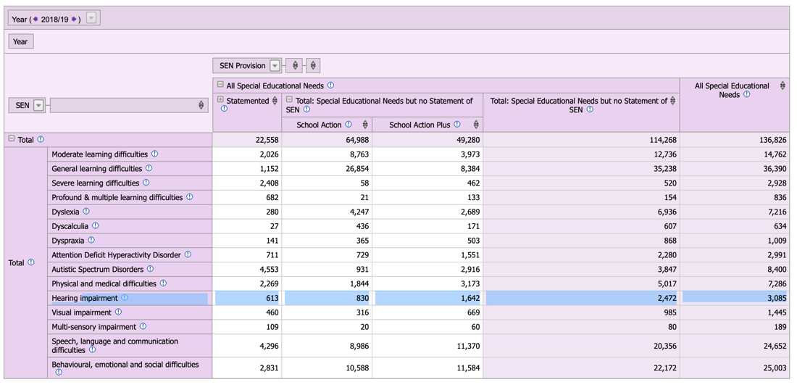
Appendix 1.1 - Number of Hearing impaired children in Wales - 2019
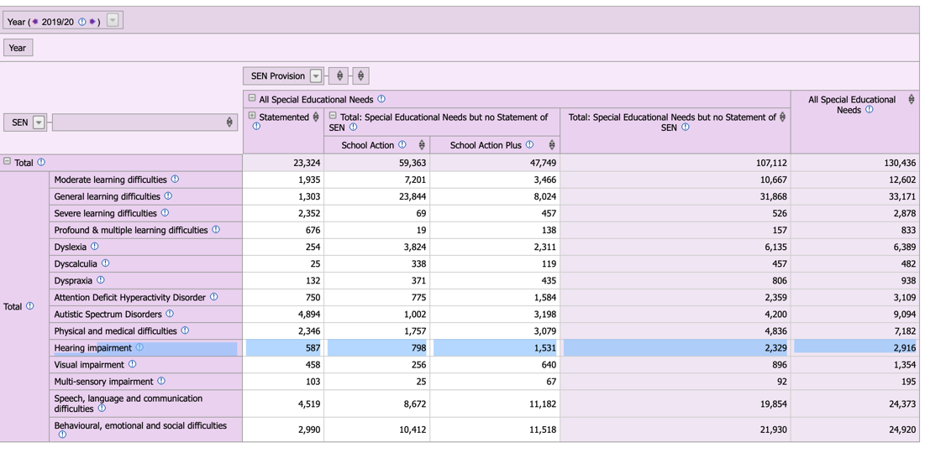

Appendix 1.2 - Number of Hearing impaired children in Wales – 2020
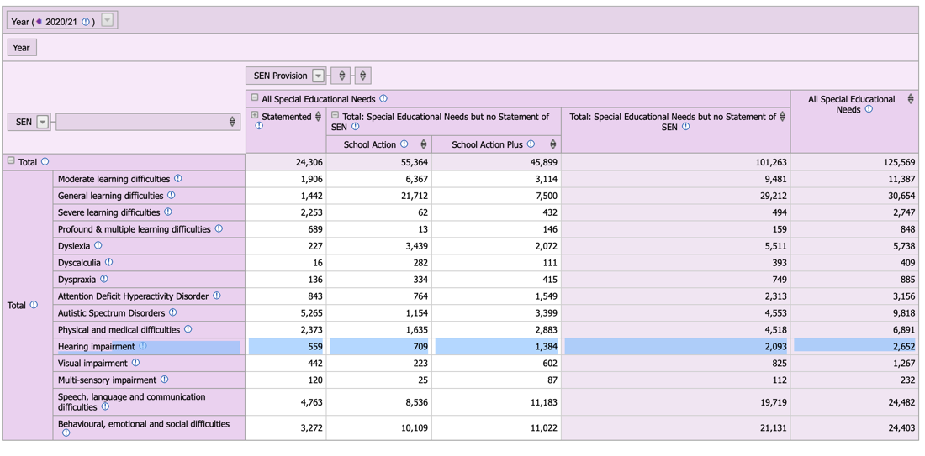
Appendix 2 – Teachers of the Deaf in 2018
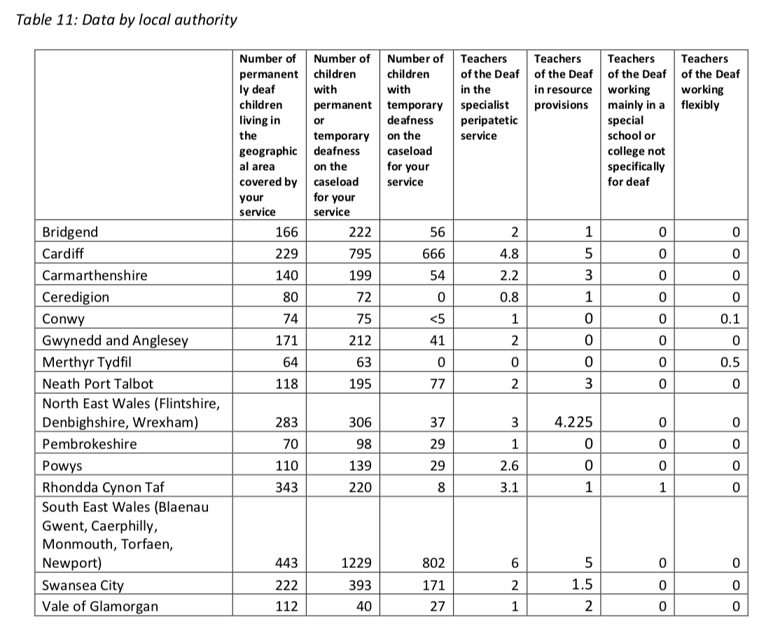

Appendix 2.1 - Teachers of the Deaf in 2019
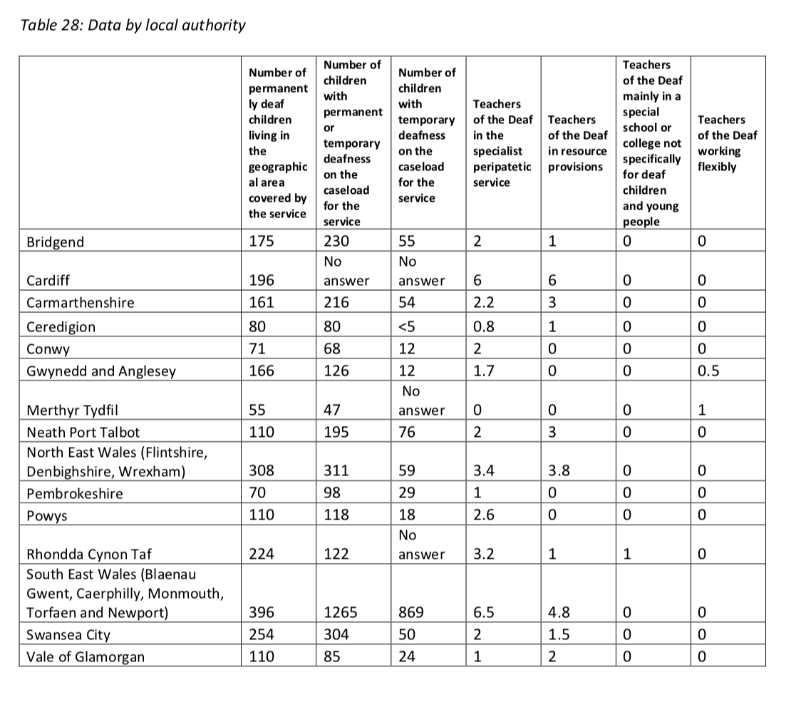
Appendix 2.2 - Teachers of the Deaf in 2020
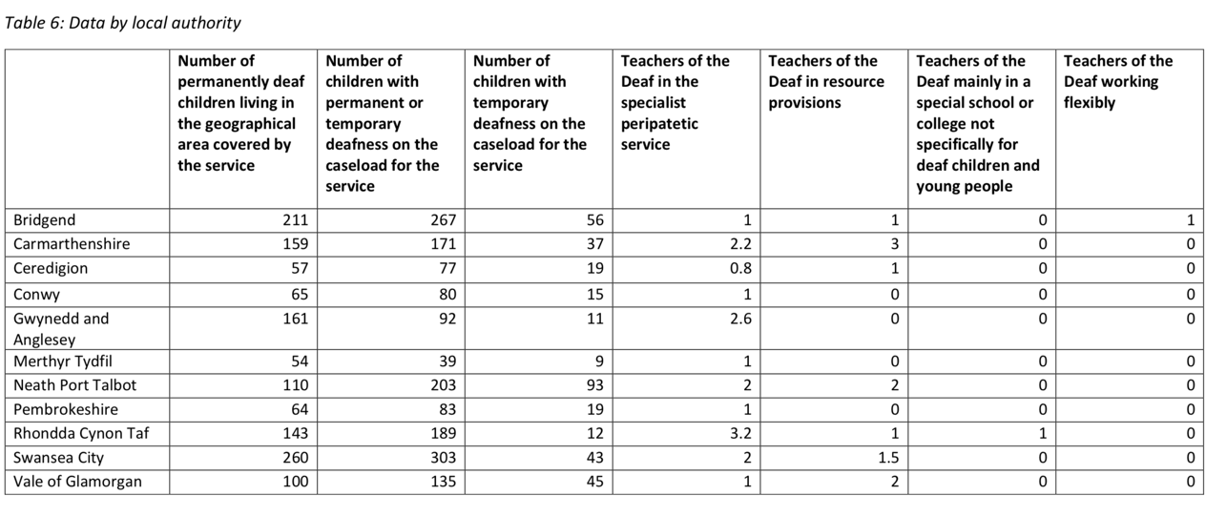

Appendix 3 – Hearing Loss Ranges
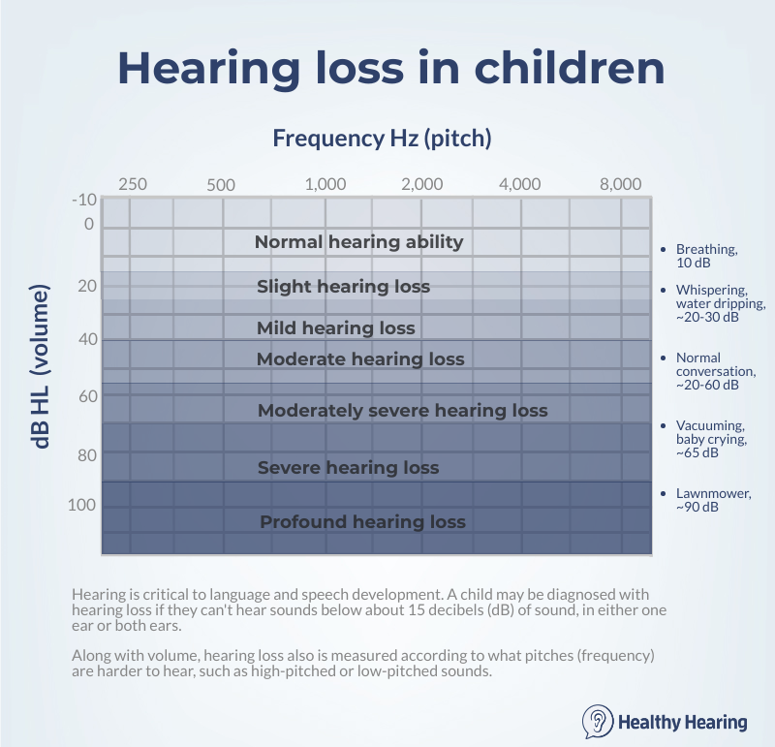

Appendix 4 – Cochlear Implant Diagram
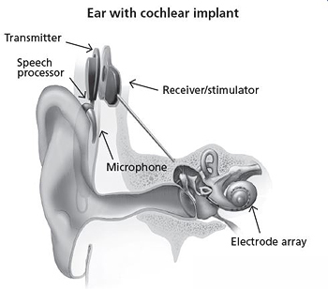

Appendix 6 – StatsWales
2018
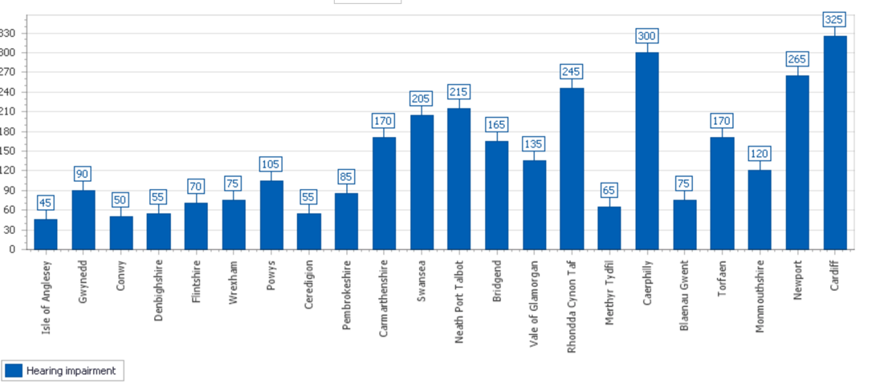
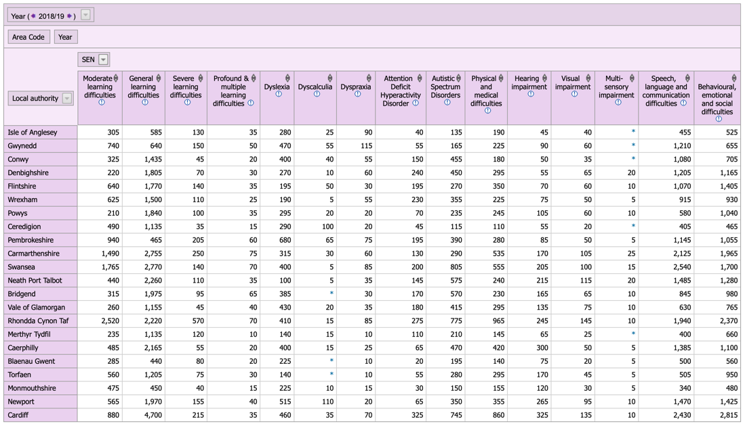

Appendix 6.1 - Statswales - 2019
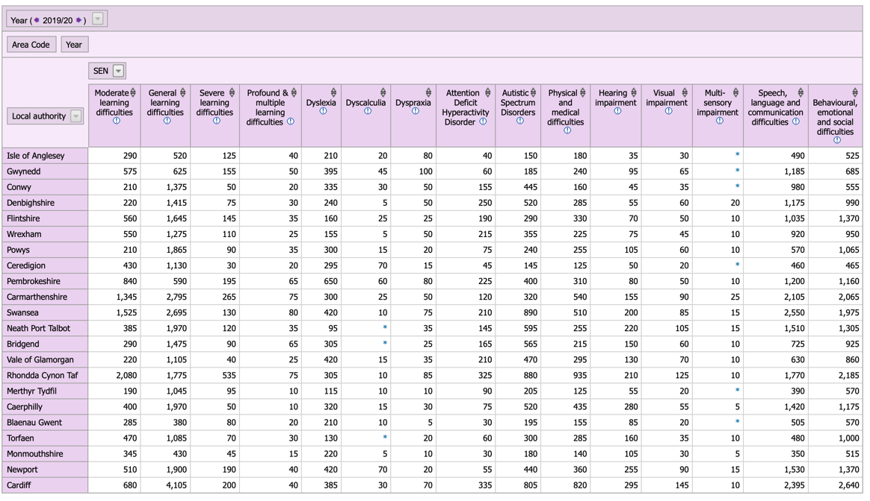

Appendix 6.2 - Statswales – 2020


