

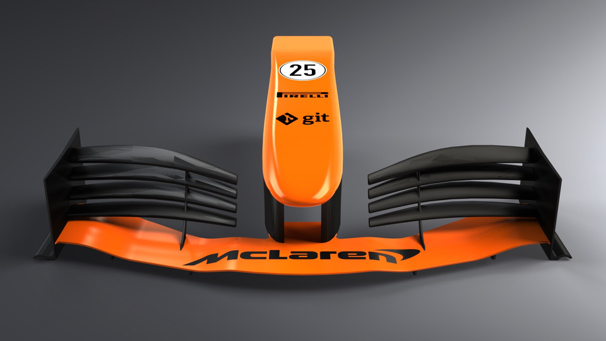

Christopher Scrine

BEng (Hons) Engineering Portfolio

Level 5 – Stress Analysis & Dynamics

Contents

1 - Introduction Page 3
2 - History & Development Page 4
3 – Calculations Page 6
4 – Conclusion Page 10
5 - References Page 11

1 – Introduction
The front wing of a racing car plays a pivotal role in creating downforce which allows the car to grip, accelerate and corner more effectively, and therefore become faster. Due to regulations within the sport, aerodynamics is becoming one of the greatest aspects to gain advantages over competitors and as the front wing is the first part of the car to come in to contact with the oncoming air it plays an essential role in not only creating part of the downforce required but also helps prepare the air as it travels to different parts of the car.
This report will investigate the design of a new front wing for a sports car for a new race series. The structural section which runs to the end of the wing will be made from steel (E=210GPa) and will be manufactured from a tube of circular cross section with a gauge of 2mm. The support will have an aerodynamic profile attached but will be assumed to be non-structural. The attachment to the vehicle will be assumed to be holding the wing in all 6 degrees of freedom and the deflection of the wing must be limited to 10mm to comply with racing regulations. The report will also look at how a prototype of the wing would be manufactured and then tested to prove the calculations are correct.
Assumptions will be made with regards to the conditions of the wing to complete the calculations and limitations to the calculations discussed along with how these limitations could be overcome.
The report will also look at different types of front wings that are used on racing cars and look at the history of how they have evolved over time and where they could possibly evolve to in the future.

2- History & Development
Until 1968 formula one racing cars were produced without any wings, this was due to the lack of knowledge and understanding of aerodynamics. During the 1960’s racing car engines had progressed and became more powerful, but lap times struggled to improve as although they now had faster cars they struggled to get the grip to use the new power(Fagnan, 2018). Engineers were then tasked to improve the grip of the cars which lead to the creation of the front wing which took inspiration from Michael Mays 1956 upside down lift generator which was fitted to his Porsche.
Graham Hills Lotus was the first F1 car to race with a front wing of a basic design and lead to a race win for the Lotus. Wings then became out of control with their design and manufacture which lead to accidents in races due to the wings not being able to withstand the forces they were creating and breaking off the cars, this then resulted in rules being introduced make the wing designs safer and less efficient which could no longer be mounted to the uprights of the cars. These regulations changed the shape of the formula 1 cars which evolved to the shape we see today.
As time evolved so did engineering and the understanding of aerodynamics along with the complexity of the designs of the front wings. During the 1960’s and 70’s formula 1 cars and their wings were constructed using aluminium monocoques which would have been the most suitable material and process available until the development of carbon fibre during the 1980’s(OnThePitWall, 2021).
Since the development of carbon fibre and its introduction into Formula 1 as the choice of material the front wing designs have changed drastically. The ability to test and understand aerodynamics with the use of wind tunnels and fluid dynamics have also been a large contributing factor to the development of the front wing. The front wings have evolved from basic aerofoil wings which were designed to create faster flow on the longer bottom edge of the wing, therefore creating low pressure which would then allow the slower travelling air across the top of the wing to create downforce. Modern front wings now contain many parts such as endplates, vanes, flaps and cascades to not only create downforce but to shape and condition the air in preparation for its contact with the rest of the car.
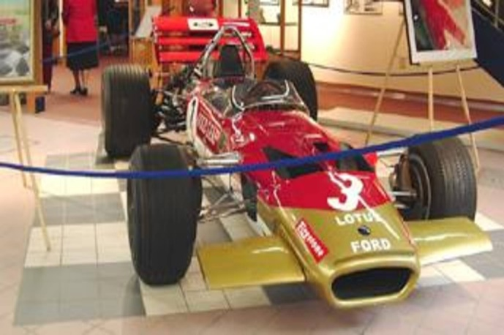
The evolution of the wing and the parts on it created issues in recent times as race teams were so determined to create perfect airflow over their wing and rest of their vehicle it was leading to the creation of ‘dirty air’ which was causing issues with other cars in close competition and was leading to unfair advantages. This has resulted in the FIA bringing in new regulations which simplifies the design of the front wings to limit this issue. The Images below show the evolution of the front wing from its introduction into racing to what they have become on modern cars.
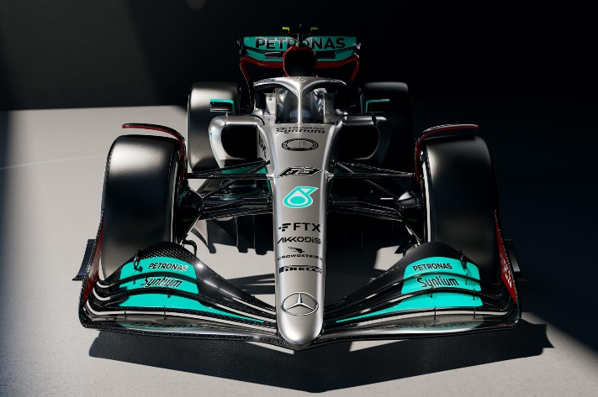

Figure 1: Lotus 1968 Front wing Figure 2: Mercedes 2022 Front wing

As mentioned, the first front wings of racing cars were manufactured from aluminium using a monocoque and lined with aluminium sheeting. This would have provided a strong a lightweight solution until carbon fibre was discovered.
Carbon fibre components are made by laying sheets of carbon fibre in moulds and set with resin, this process then gives very strong but lightweight parts, and with weight being crucial to racing it quickly became the choice material for Formula 1 components. The introduction of Carbon Fibre also allowed it much easier and quicker to alter designs if required with the use of CAD. Testing could be carried out on their front wings and if required changes could be made with new moulds designed and manufactured ready for their new wing to be built. A recent further improvement to this process would be the introduction of additive manufacturing. CAD can now be used to create designs/components are quickly be printed into useable parts, which again can be even lighter with the ability to now use honeycomb patterns to save on material and therefore weight and cost.
Depending on the race teams funds either carbon fibre models could be manufactured, or models created using additive manufacturing. It would be extremely costly to set up production facilities to design and build these prototypes themselves so it is advisable that they be contracted out to engineering companies who could provide prototype models based off designs sent to them.

3 - Calculations
Due to the limited information which has been provided several assumptions will have to be made in order to complete the calculations which will be used to find the adequate size tubing for the front wing to be made from and be within the deflection tolerance.
The first assumption which will have to be made is the force which is acting upon the wing. As the downforce for the new wing is not known this will be assumed by doing some research into what typical front wings are put under. Reading through the most recent regulations from FIA(2021), it says that current testing conditions for front wings is to apply a 60N point load. As this is the latest regulations which all current race teams will be testing their wings to, it will be assumed that this wing will also face the same test so for this calculation 60N will be used as the force.

As mentioned, the brief has stated that the wing is attached to the vehicle and held in all 6 degrees of freedom and is therefore a cantilever beam. To carry out the calculations to determine the beam diameter required it is necessary to know whether the load on the beam is universal (UDL) or concentrated point load. This will be a second assumption that will have to be made, as the final aerodynamic profile which will be attached to the wing is not known, it will be assumed that it will create a downforce with a uniformly distributed load, however in reality this is highly unlikely.
To obtain the minimum outside diameter which must be used to achieve the specification of no more than 10mm deflection, known figures will have to be used to calculate the maximum deflection of the wing using the formula for the maximum deflection of a cantilever beam with UDL. The equation used is shown below:

$$Ymax= \frac{-WL^{4}}{8EI}$$

Looking at the formula, some of the figures of the figures are known. Ymax, maximum deflection, is given in the specification as 10mm, E is also given in the specification as 210GPA. W will be 60, which is my downforce as explained above. L will be a third assumption which will have to be made to complete the calculation. One of the household names of Formula 1 racing, Mclaren(2022), state that their front wing is 1.65m in width, it will be assumed that this wing will be the same size, again this figure will need to halve this figure as 1.65m is the width of the whole wing and the calculation is for one half. Therefore, L in this equation will be 0.825m.
This leaves I, the second moment of area to find. The equation shown will have to be rearranged to use the figures to calculate I.
The equation rearranged to achieve a value for I is shown below:
$$I= \frac{-WL^{4}}{8YmaxE}$$

With the equation rearranged, figures can be input to calculate I, the second moment of area. Once a value of I has been achieved, this can be used to calculate the second moment of area of a circle. The equation with figures and result are shown below.

$I= \frac{-60 x {0.825}^{4}}{8 x 0.01 x 210GPA}$ = 1.65E-9$m^{4}$ (0.00000000165)

With the second moment of area calculated, this figure can be used to calculate the second moment of area of a circle. The equation for the second moment of area for a circle is shown below:

$$I= \frac{πD^{4}}{64}$$

As the material being used for the front wing is a tube this equation will have to be amended to represent this. The amended equation to work out the second moment of area for the tube is as shown below:

$$I= \frac{π(D^{4 }- d^{4})}{64}$$

It is known from the specification that the material is a tube with a gauge of 2mm. The altered equation above will take that into consideration by subtracting the smaller diameter from the larger and therefore working out the second moment of area of a tube. A spreadsheet has been created to make these calculations quicker and easier to display as shown.

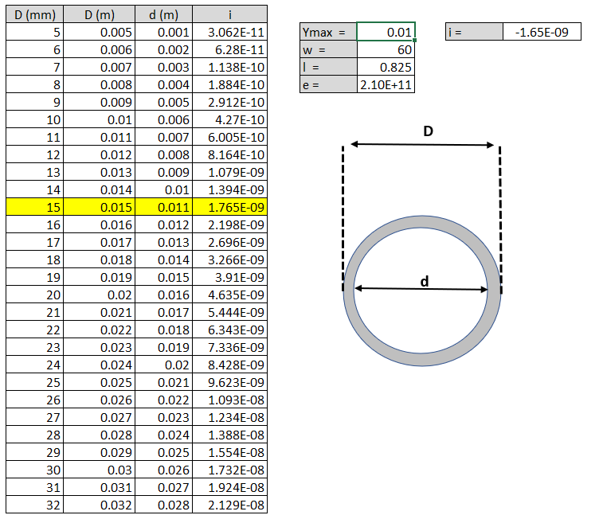

$$I= \frac{π(D^{4 }- d^{4})}{64}$$

From previous calculations, it is known that the minimum second moment of area value that would be permitted to keep within the 10mm deflection tolerance would be 1.65E-9$m^{4}$. By looking at the spreadsheet above its evident the minimum size tube to achieve this would have an outside diameter of 15mm as the 14mm would deflect too much and fail regulations.
Carrying out some research online for suppliers of steel tubing with the required outside diameter of 15mm and gauge of 2mm has proven difficult to source without requesting a custom-made product. Depending on the finances available to the racing team an off the shelf product may be more suitable which can be bought from a range of suppliers, two that have been found online are Metals4U and SteelExpress. The closest tubing Metals4U offer to the 15mm outside diameter required is 19mm x 2mm at £5.14 per metre and SteelExpress offer a tubing which is very close to the required size at 19.05mm x 2mm at £5.78 per metre.
However, despite the off the shelf option as being a cheaper product for the team to use on their car it will come with the disadvantage of being a heavier material as it will be a larger diameter than required, although the weight difference would negligible so the choice between cost and weight would have to be decided.

Although calculations have been completed to determine a tube size to manufacture a wing from the race team will need to conduct testing to ensure the wing is fit for purpose and within regulations. Further research shows that formula one racing cars can generate up to seven times the cars weight in downforce when travelling at full speed (Howson, 2021) and with F1 cars weighing in at just under 800kg that is a downforce of 5600kg. With front wings generating around 25% of the total downforce of the race-car that would result in the front wing being under a force of around 1400kg, 700kg per side of the wing. This is considerably more than the weight which is been calculated for so it would be recommended to test the wing at higher forces than calculated to see how the wing will deflect under higher downforces. This could have a large impact depending on how the wing was designed as at high speeds when the wing is deflecting its most the wing may come in contact which the track depending on its design so this would need to be taking into consideration when designing the aerodynamic profile. If feasible, a jig could be manufactured which would be able to hold the 700kg weight that the wing would be exerted too at maximum speed and monitor how the wing reacts.

4 - Conclusion
To conclude, using the direct integration method, a minimum diameter tube size has been calculated for the racing team to use for their front wing on their new race car which will be within racing tolerances and flex no more than 10mm. Assumptions had to be made during these calculations and have been justified through research to aid the completion of the calculation, however, some of these assumptions are not truly realistic. One of the assumptions was the force acting upon the front wing, research showed that FIA regulations require front wings be tested with a 60N force, however when cars are travelling at speed the downforce acting upon the wing would be much greater than this and therefore the wing would be likely to deflect more than the 10mm. A second assumption which was made that could be questioned that the force acting upon the wing was uniformly distributed, this would almost certainly not be the case as the air movement over the wing would act differently at different sections which would be governed by the design of the aerodynamic profile. To obtain more accurate results and data for this the use of a wind tunnel would be required however that would come at a great cost to the race team.
Another method which could have been used in the calculation and testing of the front wing is the use of CAD software packages which can aide in the design and testing one of which being Finite Element Analysis(FEA). This could have provided more detailed and accurate results resulting in a more suitable tubing size, this however would come at a greater cost as engineers and software packages would have required funding.

5 - References

Fagnan, R (2018) - The first appearance of wings on Formula 1 cars [Online]-https://us.motorsport.com – Accessed 20/07/2022

FIA(2021) – 2022 Formula 1 Technical Regulations [Online], P41 - https://www.fia.com/sites/default/files/2022_formula_1_technical_regulations_-_iss_6_-_2021-09-13_0.pdf - Accessed 23/07/2022

Formula1(2022), ANALYSIS: Delving into the details on the new-for-2022 Mercedes W13 [Online] - https://www.formula1.com/en/latest/article.analysis-delving-into-the-details-on-the-new-for-2022-mercedes-w13.5Fu1Lt4LfA8RuR8Y69tPtR.html - Accessed 28/08/2022

Howson, G (2021), F1 Chronicle, How Do Formula 1 Cars Generate Downforce? [Online] - https://f1chronicle.com – Accessed 02/08/2022

MclarenRacing(2022), Front Wing [Online] - https://www.mclaren.com/racing/f1-playbook/front-wing - Accessed 22/08/2022

MechanicalC(2022), Beam Deflection Tables [Online] - https://mechanicalc.com/reference/beam-deflection-tables - Accessed 20/08/2022

Metals4U(2022), Mild Steel Tube [Online] - https://www.metals4u.co.uk/materials/mild-steel/mild-steel-tube/tube/2341 - Accessed 25/08/2022

MotorsportMagazine(2022), 1968 Monaco Grand Prix race report: Lotus gives Hill wings [Online] - https://www.motorsportmagazine.com/archive/article/july-1968/43/xxvi-monaco-grand-prix - Accessed 28/08/2022

On The Pit Wall (2021) - A Comparison: F1 in the 70s vs Now [Online] - https://www.onthepitwall.com/ - Accessed 21/07/2022

Rimmer, L (2022), Autosport, How much does an F1 car weigh in 2022 and what's included in the limit? [Online] - https://www.autosport.com/f1/news/how-much-does-an-f1-car-weigh/10246442/#:~:text=How%20much%20do%20F1%20parts,wheel%20which%20weighs%201.3kg. – Accessed 24/08/2022

SteelExpress(2022), ERW Mild Steel Tube [Online] - https://www.steelexpress.co.uk/shop/product/erw-mild-steel-tube-5-8-meter/ - Accessed 25/08/2022

