Reflective Report
The importance of battle imagery on commemorative monuments in the Roman Empire during the 4th century AD has turned out to be far more significant than I had previously imagined. This is because of the suggestions of notable modern scholars such as Gibbon who present the 3rd and 4th centuries AD as a period of general Roman decline with a distinct military aspect due to the ever-present threat of enemy action. However, upon visiting the arch of Galerius in Thessaloniki my views on the importance of warfare and battle during the 4th century AD has been altered significantly. Throughout this report I will reflect on the importance of battle and warfare for Roman emperors during the tetrarchy which has been informed by my experience of the arch of Galerius. This report will also consider the impact of the figure of Alexander III on propagandistic monuments such as the arch of Galerius.
In the first instance, the images of warfare which are preserved on the surviving four sections of the arch of Galerius are far more prominent then I had initially envisaged. While an examination of the scholarship discussing the images contained on the arch had made clear that such images of warfare and battle were to be expected, it did not make clear to me just how prominent such depictions were. This also strongly contrasts with the image of a Roman empire in military decline. My initial opinion was formulated primarily from an article by Pond Rothman which emphasized the pictographic complexity of the arch and the wide thematic range of its imagery. Indeed, while both views were largely correct, Pond Rothman failed to highlight the eye-catching prominence of panels such as that depicting the combat between Galerius and Narses or the number of panels showing Roman soldiers. This became instantly obvious to me upon a physical examination of the arch.
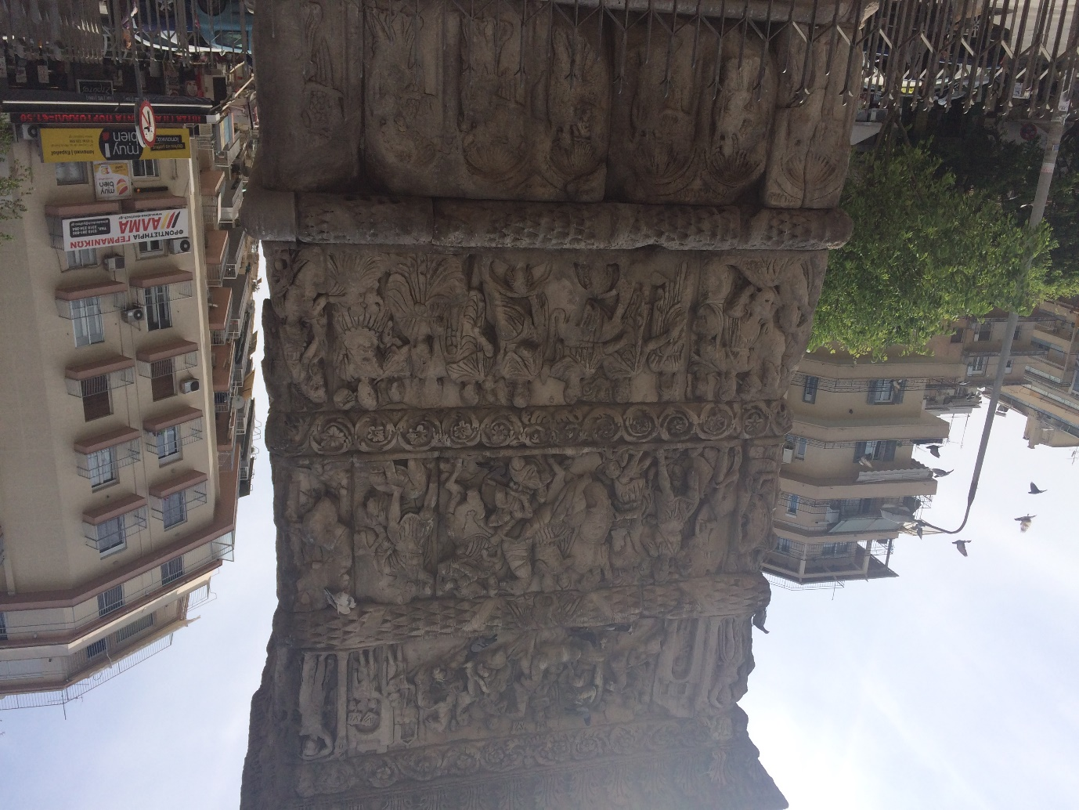
Figure 1: Panel from the arch of Galerius depicting the combat between Galerius and Narses.
This altered view of the importance of warfare and battle fits both with our ancient sources and other modern scholarship far better than my initial view which had been informed by Pond Rothman’s article, since sources such as Ammianus Marcellinus depict the Roman conflicts with the Parthians as a defining feature of Roman activity in the east during the 4th century AD. Moreover, modern scholars such as Potter rightly recognise Galerius successful campaign against Narses as one of the most significant Roman victories since the time of Marcus Aurelius. Thus the continued significance of warfare and battle only became fully obvious to me on examination of the arch of Galerius.
Aside from the obvious importance of warfare and battle visiting the arch of Galerius also highlighted to me just how the arch seems to have been designed to clearly display images which may be considered ‘propagandistic’ in nature amongst which those depicting warfare and battle seem to have played an important part. This prompted me to conduct a further investigation which made clear to me the impact of Alexander III on the specific depiction of Galerius shown on the arch. Modern scholars have correctly identified such monuments as the arch of Galerius or Trajan’s column as propagandistic in nature due to their placement within major cities of the empire and the militaristic and triumphalist nature of their imagery. However, the specific influence of the image of Alexander III of Macedon on the iconography of the arch of Galerius only became apparent to me upon a physical examination and a consideration of the historical context of the city of Thessaloniki.
Even though the city of Thessaloniki was founded in 315 BC by Cassander several years after Alexander’s death in 323 BC the city retained important connections to Alexander since it was named after his half-sister. Moreover, emulation of Alexander seems to have been an important concern for many of the later Hellenistic monarchs and indeed, Roman military leaders. This indicates that despite Thessaloniki’s later foundation the legacy of Alexander would continue to have a significant impact on the region and the key individuals who controlled it. The impact of the image and legacy of Alexander moreover, does not seem to have been lost on the Roman leaders of the late Republic with Suetonius clearly suggesting that Alexander had a deeply motivational impact on figures such as Julius Caesar.
Seeing the arch of Galerius and the image of the combat between Galerius and Narses strongly indicated to me that the legacy and image of Alexander had continued to have a significant impact for Roman leaders in the east during the 4th century AD, as Erickson has rightly shown was the case for Pompey and other members of the Roman elite. The image of the combat depicted on the arch while not specifically referencing Alexander certainly bears strong resemblances to the Alexander medallion, the combat against Porus and the mosaic from Pompeii showing Alexander facing Darius. Indeed, this latter example makes the depiction on the arch even more significant since it shows Galerius facing a monarch on equal terms. This is somewhat different to the image of Darius on the Pompeii mosaic which places the two kings greatly at odds as Darius attempts to flee rather than face Alexander. Therefore, the arch of Galerius seems to be placing the person of Galerius on par or even above that of Alexander. This attempt to exceed his actions seems to have been another common feature of the Roman attitude towards Alexander.
Visiting the arch of Galerius in Thessaloniki has helped me develop a far greater understanding of such monuments of the imperial period. It has helped me appreciate that despite slightly misleading readings of modern scholarship successful warfare and battle was still a significant and present feature of Roman government during the 4th century AD. It has also helped me appreciate the intricate complexity of the ‘propagandistic’ imagery of monuments such as the arch of Galerius which rather than simply utilising generic images of triumph and victory may also use more subtle and detailed influences from the historiographic past of the region in which it was placed, in this case, the figure of Alexander.

Bibliography
Ancient Sources
Ammianus Marcellinus, Res Gestae 1982. Rolfe, C. J (trans). Cambridge Mass: Harvard University Press.
Suetonius, The Twelve Caesars 2007. Graves, R (trans). London: Penguin Group.

Modern Scholarship
Berthold, H 2006. ‘Trajan’s Column.’ In Cancik, H and Schneider, H (eds.) Brill’s New Pauly Antiquity Volumes. http://referenceworks.brillonline.com.ezproxy.uwtsd.ac.uk/entries/brill-s-new-pauly/trajans-column-ct-e15305100?s.num=1&s.f.s2_parent=s.f.book.brill-s-new-pauly&s.q=Trajan%27s+Column+#e15305110 (Accessed 24/04/18)
Cohen, A 1997. The Alexander Mosaic Stories of Victory and Defeat. Cambridge: Cambridge University Press.
Drijvers, J. W 2010. ‘Rome and the Sassanid Empire: Confrontation and Coexistence.’ In Rousseau, P (ed.) A Companion to Late Antiquity. Oxford: Weily-Blackwell. 441-454.
Erickson, K 2018. ‘Sons of Heracles: Antony and Alexander in the Late Republic.’ In K. Moore (ed.) Brill's Companion to the Reception of Alexander the Great. 253-273.
Errington, R 2006. ‘Thessalonica.’ In Cancik, H and Schneider, H (eds.) Brill’s New Pauly Antiquity Volumes.
Gibbon, E 1901. The History of the Decline and Fall of the Roman Empire Volume III. London: Methuen & Co.
Holt, F 2003. Alexander the Great and the mystery of the elephant medallions. Berkeley: University of California Press.
http://referenceworks.brillonline.com.ezproxy.uwtsd.ac.uk/entries/brill-s-new-pauly/thessalonica-e1210990?s.num=0&s.q=Thessalonica (Accessed 24/04/18)
Huckster, O 2008. ‘The Roman Army and Propaganda.’ In Erdkamp, P (ed.) A Companion to the Roman Army. Oxford: Weily-Blackwell. Pages
Matthews, J 1997. ‘Gibbon and the later Roman Empire: causes and circumstances.’ In Mckitterick, R and Quianult, R (eds.) Edward Gibbon and the Empire. Cambridge: Cambridge University Press. 12-33.
Pond Rothman, S. M 1977. ‘The Thematic Organisation of the Panel Reliefs on the Arch of Galerius.’ American Journal of Archaeology. Vol 81. 427-454.
Potter, D 2009. Rome in the Ancient World from Romulus to Justinian. London: Thames and Hudson.

Images
‘Panel of the arch of Galerius showing the combat between Galerius and Narses. © Troy Wilkinson. 18th April 1018, Thessaloniki.

Gibbon 1901: 415; Matthews 1997: 13.
Pond Rothman 1977: 427; 448; See Figure 1 ‘Panel of the arch of Galerius showing the combat between Galerius and Narses. © Troy Wilkinson. 18th April 1018, Thessaloniki.
Gibbon 1901: 415.
Pond Rothman 1977: 429.
Pond Rothman 1977: 445-447; See Figure 1.
Drijvers 2010: 442; Amm.16.9.1-4; 17.14.1-3; 18.3.9-4.
Potter 2009: 272.
Heckster 2008: 343-345; Berthold 2006.
Errington 2006.
Erickson 2018: 254-255.
Suet.Iul.7.
Erickson 2018: 255.
Cohen 1997: 87; Holt 2003: 125; See Figure 1.
See Figure 1.
Cohen 1997: 87.
Erickson 2018: 254.

