

The Rise of Predictive Marketing: How AI Forecasts Consumer Behaviour.

Dissertation proposal
Name: Pankaj Kumar
Student ID: 2418436
Lecturer: Sheng Feng Mei

Table of Contents
Introduction 3
Research Background 3
Research Significance 3
Purpose of the Study 3
Aims and Objectives 4
Research Questions 4
Literature Review 5
Role of predictive marketing in forecasting consumer behaviour 5
Factors affecting the outcome of predictive marketing in determining the purchase intentions of customers 6
Interrelationship of usage of predictive marketing and business growth 7
Methodology 8
Research Philosophy 8
Research Approach 8
Research Design 8
Research Strategy 9
Data Collection Method 9
Sampling and Data Analysis 9
Ethical Consideration 10
Expected Findings 10
Limitations 11
Conclusion 12
References 14

Introduction

Research Background
The current business scenario is dynamic and is surrounded by a digital environment where Artificial Intelligence plays a crucial role in reshaping marketing practices. In relation to this, Potwora et al. (2024), asserted that presently, marketers with the assistance of AI are able to anticipate customer needs and preferences even before they are expressed. Taking this into account, predictive marketing has emerged as a data-driven approach that is suitable for forecasting purchase intent and consumer behaviour by leveraging AI and machine learning.
Based on this, it can be stated that the research rationale relies on understanding the role played by predictive marketing in reshaping business strategies and enhancing competitiveness. However, the problem arises due to the limited understanding the existing literature delivers regarding the true effectiveness in forecasting consumer purchase intent.

Research Significance
It is important to conduct research on predictive marketing as it will highlight how AI-driven data analytics predicts the behaviour of consumers prior to the occurrence of purchasing intention. It will enable business managers to optimise allocation of resources, personalise campaigns and increase customer engagement. Therefore, it will help in understanding proactive marketing strategies leading to competitive advantage and enhanced decision-making in the highly dynamic digital market.

Purpose of the Study
The research will be conducted with the intention of investigating the effectiveness of predictive marketing in conjunction with AI to enhance the potential of the business in forecasting purchase intent and consumer behaviour, and thereby increase the feasibility of improving customer engagement, marketing effectiveness, and sustaining business growth in this digital and data-driven environment.

Aims and Objectives
Aims
Presently, technology is advancing at a rapid pace and is changing the way individuals use to perceive business. Taking this into account, this particular research will aim to highlight the impact of the evolution and rise of predictive marketing and its benefits in forecasting consumer behaviour and purchase intent.
Objectives
- To determine the different types of AI that play roles in digital marketing.
- To assess the role of predictive marketing in shaping customer behaviour, particularly purchasing intention.
- To determine the factors affecting the integration of AI tools for better predictive marketing.
- To analyse the relationship between predictive marketing and business growth.

Research Questions
- What are the different types of AI that play a significant role in digital marketing?
- What role of predictive marketing play in shaping customer behaviour, particularly purchasing intention?
- What are the different factors influencing the integration of AI tools for better predictive marketing?
- What is the relationship between predictive marketing and business growth?

Literature Review

Role of predictive marketing in forecasting consumer behaviour
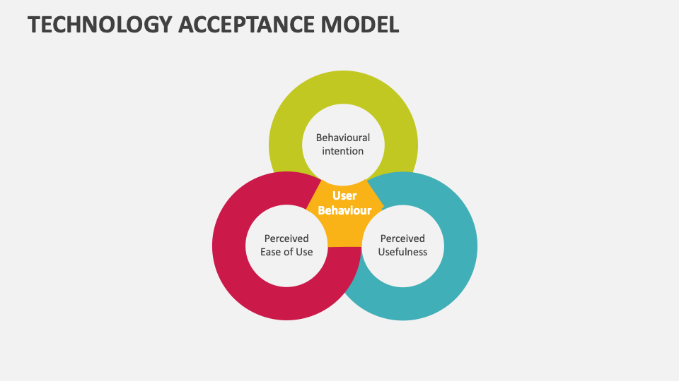
Figure 1: Technology Acceptance Model
(Source: collidu, 2024)
Predictive marketing, according to Sharma and Sharma, (2025), is defined as the effective marketing approach by utilising data analysis, statistical algorithms, and machine learning for determining the outcome efficiently. Eventually aiding the different organisations to recognise the latest trends before they enter the market. Further, by embracing the Technology Acceptance Model (TAM), organisations explain the proper response of customers. According to Akter et al. (2024), this model is responsible for analysing the AI-driven predictive marketing tools based on customers' behaviour. Perceived Usefulness (PU) and Perceived Ease of Use (PEOU) are the key insights of this framework in tailoring the initial acceptance stage of customers. On one hand, the perceived usefulness of predictive marketing is to align with customers' needs efficiently and customise accordingly. On the other hand, perceived ease of use basically determines the ease with which customers blend with organisations' predictive interfaces. In addition, Basal et al. (2024), stated that these factors also include the external variables that play a crucial role in determining purchase intentions of customers. Therefore, it can be stated that the incorporation of TAM into predictive marketing highlights the behaviour insights of customers towards any organisation efficiently.

Factors affecting the outcome of predictive marketing in determining the purchase intentions of customers
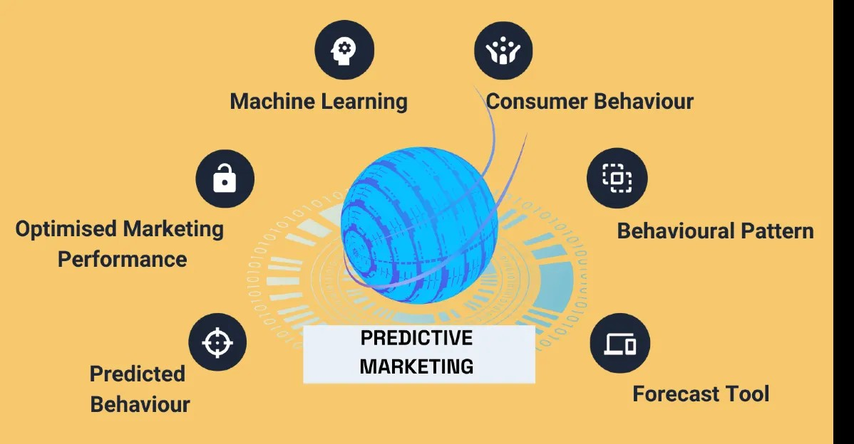
Figure 2: Factors influencing the outcome of predictive marketing efficiently
(Source: mediaone, 2025)
In the view of Chowdhury et al. (2024), while determining an organisation's long-term success and overall growth, perceived marketing plays a vital role seamlessly. However, there are various factors that predictive marketing relies on, and thus it is crucial to meet these factors to avoid further risks. According to Chowdhury et al. (2024), machine learning capability is one of the key factors that affect predictive marketing for organisations. This ability helps in evaluating unstructured data in large volumes easily, eventually helping to recognise the behavioural correlations. This, in turn, impacts the outcome of predictive marketing efficiently in any organisation. Similarly, Choudhary, (2025), stated that consumer behaviour insights and proper behavioural pattern recognition are crucial in predictive marketing. It aids in generating better behavioural data of customers and personalises product recommendations. Therefore, strengthening the prediction outcomes via proper optimisation of predictive marketing.

Interrelationship of usage of predictive marketing and business growth
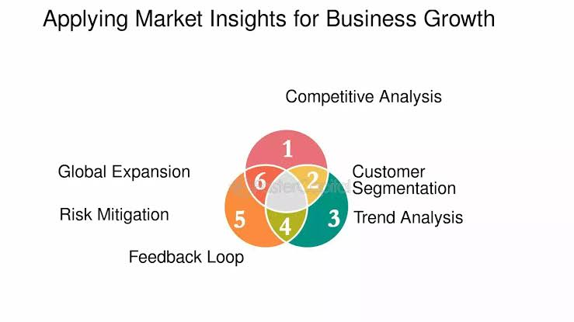
Figure 3: Interrelationship of usage of predictive marketing and business growth
(Source: fastercapital, 2024)
Proper implementation of predictive marketing by an organisation has been observed in boosting the purchase intentions of customers. As per Okeleke et al. (2024), a direct and influential relationship is observed with business growth. This approach helps in allocating the resources efficiently as per the customers' requirements and the organisation's capability. Eventually, minimising the wastage of expenditure while developing the return on investment of the organisation. Customer segmentation is further tailored by means of advanced technologies in predictive marketing for attracting targeted audiences. Therefore, as per Alshaketheep et al. (2025), through proper utilisation of predictive marketing, organisations are able to enhance the purchase intentions of customers. This, in turn, helps in optimising resource utilisation, enhancing customer satisfaction, and boosting the overall business growth.

Methodology

Research Philosophy
The philosophy for conducting research acts as the moral direction for the topic, designating the subjective meaning and context of social phenomena (Haque, 2022). This research will follow a primary quantitative research methodology, which deals with positivist philosophy. This research will definitely choose positivism to analyse the rise of predictive marketing through AI. This philosophy is supported by data-driven dealings, which identify correct patterns and predict future trends (Ali, 2024).

Research Approach
The approach deals with the data modification process to come to an enriched conclusion (Lekevičius, 2022). In this primary research, the investigators will opt for a deductive approach to determine the thrive of AI-driven predictive marketing. This approach will help researchers to analyse existing theories and align the practical knowledge with theoretical concepts. Based on this approach, the researchers will align a top-down method with the factors that influence AI-driven predictive analysis in the current retail business.

Research Design
The sequential and systematic analysis of the collected and generated information defines the research design (Kar et al. 2023). Following the primary quantitative methodology, an exploratory design will be appropriate to examine the interrelation between AI-driven predictive marketing and consumer loyalty. This design will allow researchers to conduct a flexible exploration based on the current data acquired from regular customers. The outcome will be independent and bias-free.

Research Strategy
Research strategy, in the view of Sammut et al. (2021), is a systematic plan summarising the entire approach of the research to answer the set research questions. Focusing on the present context, the survey research strategy will be most suitable as it will help in gathering data related to customers on AI-driven marketing, along with measuring their trust, awareness and perceived influence on purchasing intention through quantitative responses.

Data Collection Method
This research will use primary quantitative evaluation to discover the relationship between predictive marketing and AI-driven consumer behaviour analysis. However, the researcher will conduct a survey to acquire information regarding the topic. Around 80 customers of online retail customers will naked how predictive data analysis through AI has altered their purchase decisions. The survey questionnaire will be designed in a structured manner, starting with easy and general questions to more specific and complex questions. This will be distributed through Google Forms, and the participants will be allowed to represent their constructive opinions in the responses. The surveys will be cost-effective and context-specific (Pienkowski et al. 2021). It will facilitate researchers to grasp the current perception of customers regarding predictive marketing through AI.

Sampling and Data Analysis
This research will follow an 80-participant survey frame to attain the testing variables. In a systematic manner, this research will conduct a thorough analysis of the data. According to the basics of the primary method, this research will undertake a statistical analysis to synthesise gathered data and interpret it thoroughly. However, the researchers will consider IBM SPSS v20 to perform regression analysis and correlation analysis through different variables.

Ethical Consideration
This research will entail asterisk regulation policy to maintain the privacy concerns of the participants. The participants will be given an alert to give consent first before filling out the form. The researchers will ensure the confidentiality and anonymity of the data sourced from the participants. The collected data will be sorted with various codes of conduct and shielded with password-protected files.

Expected Findings
For this particular research survey will be conducted to obtain crucial findings. Additionally, to gather valuable and insightful information, SPSS will be used for the research. Based on the research objective, i.e., evaluating the role played by predictive marketing in forecasting consumer behaviour, it can be analysed that predictive marketing contributes to different aspects, such as personalisation, strategic planning, campaign performance development, and others. Predictive models have made crucial contributions to enabling hyper-personalisation, as if utilisation real-time data to provide the right messages (Okeleke et al. 2025). Thus, based on the objective, it can be expected that predictive marketing is actually beneficial for forecasting consumer behaviour by offering personalised campaigns and recommendations. Moreover, it can also be analysed that predictive marketing comprises future market shifts along with consumer preferences, which significantly contribute to the forecast of consumer behaviour. Apart from that, the objective can also expect that predictive marketing has a crucial role in enhancing customer retention by anticipating diverse needs of diverse customers, which further increases customer satisfaction by meeting their demands.
Based on the objective, i.e., factors affecting predictive marketing in understanding the purchase intention of customers, the expected findings highlight different factors, such as predicted behaviour, optimised marketing performance, and machine learning are highly important factors that positively influence the outcomes of predictive marketing. It can be obtained as findings that predict consumer behaviour in our organisations to optimise their marketing practices accordingly, using modern technology such as machine learning to improve performance. Additionally, consumer behaviour is considered one of the most important factors that influences the outcome of predictive marketing by anticipating the constantly changing demand of customers (Choudhary, 2025). Thus, from the objective, it can be expected as findings that these factors have a potential influence on the positive outcome of predictive marketing in analysing the purchase intention of customers.
Moreover, from the objective, i.e., the correlation between predictive marketing usage and business growth, it can be expected that predicting marketing utilisation contributes to business growth. Through predictive marketing, organisations are able to predict the changing behaviour of customers, which further helps them to optimise their offerings to satisfy them, increasing the profitability of the businesses (Chowdhury et al. 2024). Thus, the findings can be expected that predictive analytics enables organisations to segment their customers for constantly analysing changing trends among them to constantly optimise their offerings, and leads brands towards growth.

Limitations
Based on the methodology, it can be stated that the research on the effectiveness of predictive marketing will be conducted by adopting primary methods. In relation to this, it can be stated that as the data will be collected by means of a survey, the researcher will face issues in getting access to diverse participants, which in turn will result in getting generalised results. Moreover, due to data confidentiality, finding accurate insights regarding AI-driven predictive marketing practices will be challenging. Limited availability of time can also result in lowering the depth of primary data collection, which can ultimately result in introducing potential biases in participant responses. Even after such constraints, the research will aim to develop a structured questionnaire and emphasise careful sampling, which will guide the researcher to conduct a transparent analysis and will aim to maintain research reliability and credibility.
Timeframe
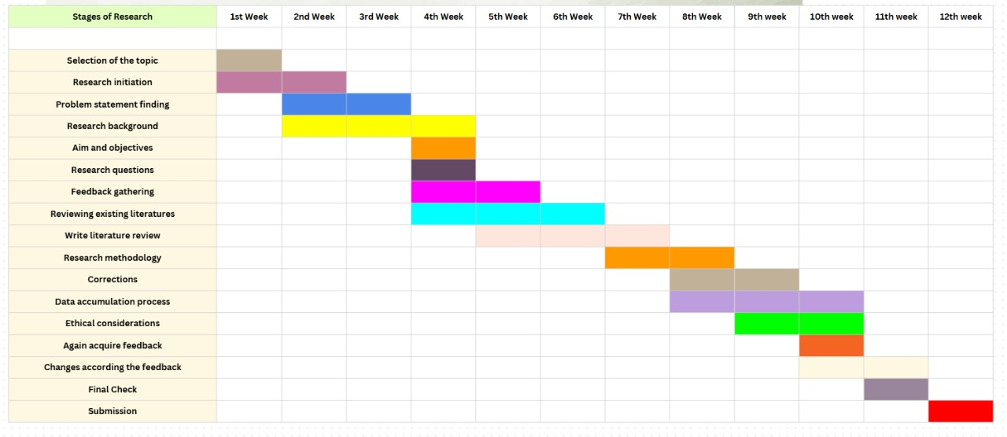
Figure 4: Gantt Chart
(Source: Self-Developed)

Conclusion
The research proposal is based on the topic, i.e., the rise of predictive marketing in the context of how AI forecasts consumer behaviour before purchasing intent. A precise research background, along with the research aim, objective, and research questions, is given in the introduction. Objectives of the research proposal are the role played by predictive marketing in forecasting consumer behaviour, factors affecting predictive marketing in understanding the purchase intentions of customers, and the correlation between predictive marketing usage and business growth. The literature review section analyses the research objectives precisely, including a Framework called the technology acceptance model. A precise methodology has been given, highlighting the primary data collection method usage for the particular research. Moreover, brief expected findings are given along with limitations and a time frame.

References
Akter, S., Talukder, M.A.F., Ashrafi, T. and Ahmed, F. (2024). The effects of artificial intelligence and machine learning on consumer behaviour, demand prediction, and chatbots in the realm of digital marketing. Business Forecasting and Marketing Intelligence, pp.1-25. [Available at: https://www.researchgate.net/profile/Salma-Akter-21/publication/386548857_The_effects_of_artificial_intelligence_and_machine_learning_in_consumer_behaviour_demand_prediction_and_chatbots_in_the_realm_of_digital_marketing/links/6755b087ea30b90cbc6681e1/The-effects-of-artificial-intelligence-and-machine-learning-in-consumer-behaviour-demand-prediction-and-chatbots-in-the-realm-of-digital-marketing.pdf]
Ali, I.M., (2024). A guide for positivist research paradigm: From philosophy to methodology. Idealogy Journal, 9(2). [Available at: https://www.researchgate.net/publication/389903751_A_Guide_for_Positivist_Research_Paradigm_From_Philosophy_to_Methodology]
Alshaketheep, K., Al-Ahmed, H. and Mansour, A., (2025). Beyond purchase patterns: harnessing predictive analytics to anticipate unarticulated consumer needs. Acta Psychologica, 257, p.105089. [Available at: https://www.sciencedirect.com/science/article/pii/S0001691825004020?dgcid=rss_sd_all]
Basal, M., Moulai, K. and Cetin, A., (2025). Predictive Analytics for Customer Behavior Prediction in Artificial Intelligence. Economics, 12(2), pp.142-154. [Available at: https://www.davidpublisher.com/Public/uploads/Contribute/67945ce87b2cc.pdf]
Choudhary, S. (2025). Predictive Analytics in Marketing: Exploring How AI Can Predict Future Customer Behavior and Trends. [Available at: https://www.theseus.fi/handle/10024/881480]
Chowdhury, S., Basu, S., Ashoka, N. and Singh, P.K., (2024). Influence of AI driven digital marketing on consumer purchase intention: An empirical study. Journal of Informatics Education and Research, 4(2), pp.575-582. [Available at: https://www.researchgate.net/profile/Soummya-Chowdhury/publication/380096002_Influence_of_AI_driven_Digital_Marketing_on_Consumer_Purchase_Intention_An_Empirical_Study/links/662a6df99d2a69723f64a2aa/Influence-of-AI-driven-Digital-Marketing-on-Consumer-Purchase-Intention-An-Empirical-Study.pdf]
collidu.com, (2024), about Technology Acceptance Model. [Available at: https://www.collidu.com/presentation-technology-acceptance-model] [Accessed on: 30.10.2025]
fastercapital.com, (2024), about the relation between predictive marketing and business growth. [Available at: https://fastercapital.com/topics/the-importance-of-market-insights-in-business-strategy.html/1] [Accessed on: 30.10.2025]
Haque, M.S., (2022). Inductive and/or deductive research designs. In Principles of social research methodology (pp. 59-71). Singapore: Springer Nature Singapore. [Available at: https://link.springer.com/chapter/10.1007/978-981-19-5441-2_5]
Kar, A.K., Angelopoulos, S. and Rao, H.R., (2023). Guest Editorial: Big data-driven theory building: Philosophies, guiding principles, and common traps. International Journal of Information Management, 71, p.102661. [Available at: https://www.researchgate.net/profile/Arpan-Kar/publication/352177492_Applications_of_big_data_in_emerging_management_disciplines_A_literature_review_using_text_mining/links/64f69938827074313ffd9925/Applications-of-big-data-in-emerging-management-disciplines-A-literature-review-using-text-mining.pdf]
Lekevičius, E., (2022). Methodological Excursion: An Apology for Theoretical Synthesis, Simplicity, Deductive Method, and Conceptual Modelling. In Biodiversity: Maintenance, Function, Origin, and Self-Organisation into Life-Support Systems (pp. 11-25). Cham: Springer International Publishing. [Available at: https://link.springer.com/chapter/10.1007/978-3-031-11582-0_2]
mediaone.com, (2025), about factors influencing the outcome of predictive marketing efficiently. [Available at: https://mediaonemarketing.com.sg/how-to-master-predictive-marketing/] [Accessed on: 30.10.2025]
Okeleke, P.A., Ajiga, D., Folorunsho, S.O. and Ezeigweneme, C., (2024). Predictive analytics for market trends using AI: A study in consumer behavior. International Journal of Engineering Research Updates, 7(1), pp.36-49. [Available at: https://www.researchgate.net/publication/383410055_Predictive_analytics_for_market_trends_using_AI_A_study_in_consumer_behavior].
Pienkowski, T., Cook, C., Verma, M. and Carrasco, L.R., (2021). Conservation cost‐effectiveness: A review of the evidence base. Conservation Science and Practice, 3(5), p.e357. [Available at: https://conbio.onlinelibrary.wiley.com/doi/full/10.1111/csp2.357]
Potwora, M., Vdovichena, O., Semchuk, D., Lipych, L. and Saienko, V., (2024). The use of artificial intelligence in marketing strategies: Automation, personalization and forecasting. Journal of Management World, 2, pp.41-49. [Available at: https://www.researchgate.net/profile/Volodymyr-Saienko/publication/380423097_The_use_of_artificial_intelligence_in_marketing_strategies_Automation_personalization_and_forecasting/links/6641ce0308aa54017a055107/The-use-of-artificial-intelligence-in-marketing-strategies-Automation-personalization-and-forecasting.pdf]
Sammut, R., Griscti, O. and Norman, I.J., (2021). Strategies to improve response rates to web surveys: a literature review. International journal of nursing studies, 123, p.104058. [Available at: https://pubmed.ncbi.nlm.nih.gov/34454334/]
Sharma, A.K. and Sharma, R., (2025). The transformative role of predictive analytics, artificial intelligence and machine learning in digital marketing. Journal of Cultural Marketing Strategy, 9(2), pp.196-212. [Available at: https://www.ingentaconnect.com/contentone/hsp/jcms/2025/00000009/00000002/art00008]

