

Assessment 1 – Reading Task Template
PART 1: Upload your photo of your A3 in-class notes here:
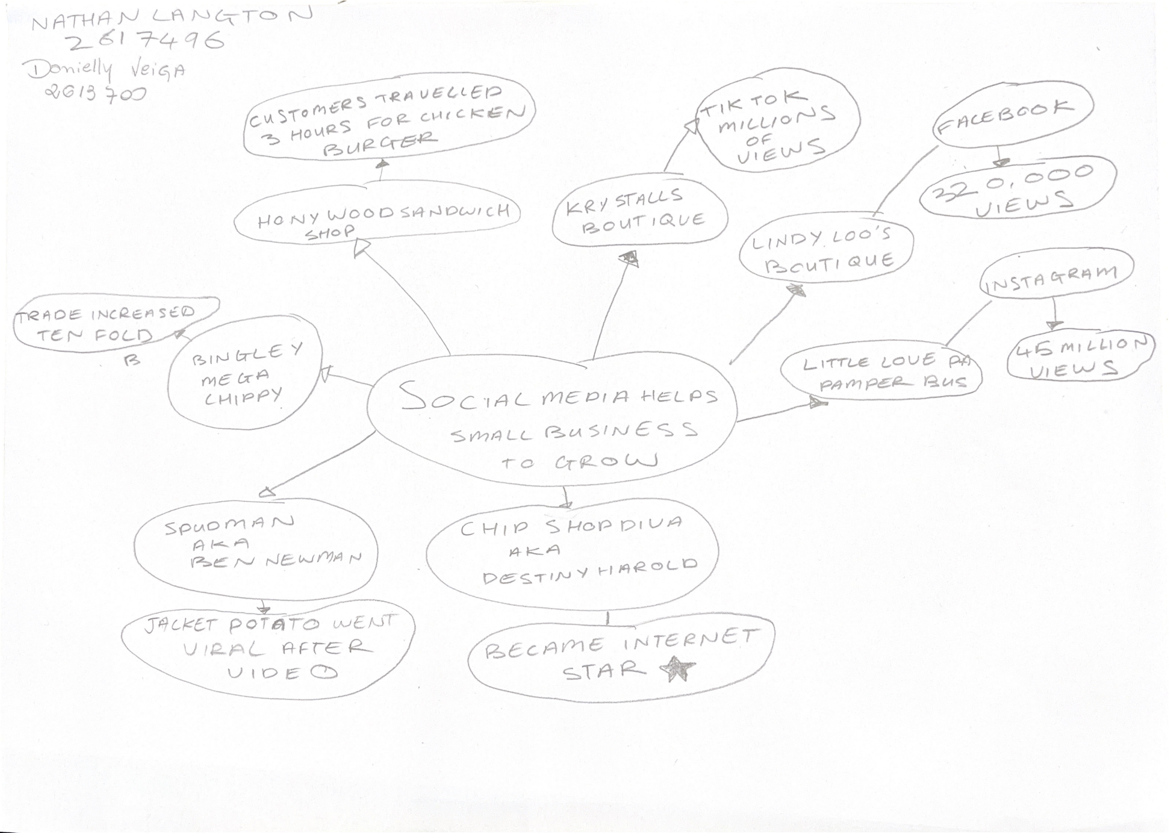

PART 2:
- Answer every question below in 1-3 full sentences.
- Use your own words. Do not use generative AI to answer these questions.
- Include a specific detail from the text when asked.
REMINDER
- The main idea is the overall message of the whole text.
- A key point helps to explain the main idea.
- A specific detail or example from the text shows that the key point is true.

- What is the main idea of the whole text?

The Main idea is that social media helps small businesses to grow.
It's shown how the viral trends attract people's attention, and small businesses enjoy the viral tends to grow.

- What is one key point that supports the main idea, and which specific example from the text shows this?

The key point, viral trends can make customers travelled long distances, as the case of Honywood sandwich shop, "It's a big surprise to me hear customers had a travelled for our chicken burger for 3 hours", this shoe that social media helps small businesses.

- What is a different key point that supports the main idea, and which specific example from the text shows this?

Another key point is that social media help business. For example: Little Love's Pamper Bus set up after posted children's parties on platforms " the response on social media has honestly change our business".

- Which part of the text do you think is most important, and why?
"People buy from people".
It's the most important in my view, because social media opens the doors to small businesses show your products to the world, and keep contact between seller and customers, this is important, because in the social media the new customers look good feedback from regular customers.

Reflection:
- What did you find difficult in this task (including in-class components), and why was it difficult?

In this task, I had difficulty to explain my ideas to my classmate, when we did the mind map, we forgot to the key points, and when I answered the questions, I noticed that it was missing from the mind map, I believe my difficult is in class, because we have a limited time to finish the tasks.

- What helped you with this difficulty, and how did it help you?
When we started to make a mind map, helped me explain my ideas, and when I studied at home without limited time is easier to understand what I needed to do in class.

