4/28/2026
University of Wales Trinity Saint David
London campus
Module Name: Scripting and Programming Concepts
Module Code: ACCA 5036

Student Name: Okpahwa felix amrovhe
Student ID:2414768

Lecturer’s Name: Koushik Modak

SPC Assignment on
Student Equipment Booking System
Code Link: https://github.com/lixo19
00/sample-project1.git

Table of Contents
Introduction 2
Main Body 2
1. Analysis 2
2. Software Design and Development 3
Design: 3
Implementation Decisions 3
Source Code 3
3. Testing and Debugging Report 4
4. Evaluation 4
Conclusion 4
References 4
Appendices 4

Introduction.
Bright Minds Academy, a private tutoring center, currently relies on a paper-based system to manage equipment bookings (e.g., laptops, projectors, tablets). This manual process is inefficient and error-prone, frequently resulting in:
- Double bookings (overlapping reservations).
- Lost or unclear records (missing entries, illegible notes).
- Time-consuming coordination as the number of students and equipment grows.
To address these challenges, this project develops a console-based Python application that simplifies equipment management. The system will:
- Replace paper records with in-memory data storage (using Python dictionaries and lists).
- Offer a user-friendly, menu-driven interface for staff to:
- Add new equipment.
- Record and track bookings.
- View and search booking history.
- Prevent common errors (e.g., invalid dates, duplicate bookings) through basic input validation.
Key Design Principles:
- Simplicity: No database or advanced features (e.g., user logins, maintenance tracking).
- Clarity: Intuitive prompts and error messages for non-technical users.
- Reliability: Reduces manual errors and improves visibility of equipment availability.
By digitizing the booking process, the academy can minimize conflicts, save time, and scale operations efficiently.

Key Improvements from Original Text:
- Conciseness: Removed redundancy while preserving clarity.
- Structure: Broken into bullet points for readability.
- Stronger Problem Statement: Explicitly lists pain points (double bookings, lost records).
- Solution Focus: Emphasizes how the Python app solves the problem.
- Design Principles: Highlights simplicity and user-friendliness upfront.
1, Analysis.
Bright Minds Academy is a small private tutoring centre that relies on laptops, projectors, and tablets to support personalised learning. Currently, tutors record equipment bookings on paper, which frequently leads to double bookings, missing entries, and confusion about which student has which device on a given date. This manual process is inefficient and error-prone.
The purpose of this project is to design and implement a simple, user-friendly Python program that allows staff to manage equipment bookings digitally. The system will not use a database; instead, it will rely on Python lists and dictionaries to store data in memory. The focus is on clarity, usability, and preventing common booking errors.
The system will allow staff to:
- Add new equipment
- Record bookings
- View all bookings

- Search bookings by student or equipment.
1.2 Requirements Analysis
Functional Requirements
- Add Equipment
a. Staff can add new equipment items (e.g., “Laptop 1”).
b. The system must prevent duplicates.
- Record Bookings
a.Staff can assign equipment to a student for a specific date.
b.The system must prevent double bookings.
- View Bookings
Staff can view all bookings in a readable format.
- Search Bookings
- Staff can search by student name.
- Staff can search by equipment name.
Non-Functional Requirements
Usability: Simple menu-driven.
2. Software Design and Development.
a) Design.
Flowcharts.
+------------------+
| START |
+--------+---------+
|
v
+------------------+
| Display Menu |
+--------+---------+
|
v
+------------------+
| Input Choice |
+--------+---------+
|
v
+---------------------------+
| 1? Add Equipment |
| 2? Record Booking |
| 3? View Bookings |
| 4? Search Bookings |
| 5? Exit |
+-------------+-------------+
|
+-------------+-------------+
| Branch to Selected Option |
+-------------+-------------+
|
v
+-------------+
| END |

Add new equipment.
+------------------------+
| Start Add Equipment | projector.
+-----------+------------+
|
v
+------------------------+
| Input Equipment Name |
+-----------+------------+
|
v
+------------------------+
| Name Empty? |
+-----+-----------+------+
| Yes | No
v v
+-----------+ +------------------------+
| Display | | Already Exists? |
| Error | +-----+-----------+------+
+-----------+ | Yes | No
v v
+-----------+ +------------------------+
| Display | | Add to Equipment List |
| Error | +-----------+------------+
+-----------+ |
v
+------------------+
| End |
Record bookings.
+---------------------------+
| Start Record Booking |
+-------------+-------------+
|
v
+---------------------------+
| Input Equipment Name |
+-------------+-------------+
|
v
+---------------------------+
| Equipment Exists? |
+-----+-------------+-------+
| No | Yes
v v
+-----------+ +---------------------------+
| Display | | Input Student Name |
| Error | +-------------+-------------+
+-----------+ |
v
+---------------------------+
| Input Date (YYYY-MM-DD) |
+-------------+-------------+
|
v
+---------------------------+
| Valid Date? |
+-----+-------------+-------+
| No | Yes
v v
+-----------+ +---------------------------+
| Display | | Already Booked? |
| Error | +-----+-------------+-------+
+-----------+ | Yes | No
v v
+-----------+ +---------------------------+
| Display | | Add Booking to List |
| Error | +-------------+-------------+
+-----------+ |
v
+------------------+
| End |
View booking records.
+------------------------+
| Start View Bookings |
+-----------+------------+
|
v
+------------------------+
| Bookings Empty? |
+-----+-----------+------+
| Yes | No
v v
+-----------+ +------------------------+
| Display | | FOR EACH Booking |
| "None" | +-----------+------------+
+-----------+ |
v
+------------------------+
| Display Booking Info |
+-----------+------------+
|
v
+------------------+
| End |
Simple search.
+---------------------------+
| Start Search Bookings |
+-------------+-------------+
|
v
+---------------------------+
| Display Search Menu |
+-------------+-------------+
|
v
+---------------------------+
| Input Search Choice |
+-------------+-------------+
|
v
+---------------------------+
| Student or Equipment? |
+-----+-------------+-------+
| Student | Equipment
v v
+----------------+ +----------------------+
| Input Student | | Input Equipment Name |
| Name | +----------+-----------+
+--------+-------+ |
| v
v +----------------------+
+----------------+ | Search Bookings |
| Search Student | | for Equipment |
+--------+-------+ +----------+-----------+
| |
v v
+----------------+ +----------------------+
| Display Match | | Display Match |
+--------+-------+ +----------+-----------+
| |
v v
+------------------------------+
| End |

b) Implementation Decisions.
Data structures: equipment list = ["Laptop 1", "Projector A", ...]
bookings = [
{"equipment": "Laptop 1", "student": "Alice", "date": "2026-05-01"}.
The choice of data structures I used is the two primary python data structures, Lists and Dictionaries.
Equipment list: List stores the names of all equipment’s which has been added by a staff member. And each items is represented as a (string) because it makes it easy to add new equipment, check if an item already exist, and also validate bookings against available equipment.
1, Programming construct;

Selection structures, ( If/Elif /Else) are used extensively throughout the system to control program flow based on user input and data validation. For example, the main menu uses a series of if, elif, and else statements to determine which function to execute depending on the user’s choice. This ensures that only valid menu options trigger system actions, improving usability and preventing unexpected behaviour.
Selection is also used for validation. For instance, when adding equipment, the program checks whether the input is empty or already exists in the equipment list. Similarly, when recording a booking, selection statements verify that the equipment exists, the student’s name is not empty, and the date is valid. These checks prevent invalid or duplicate data from entering the system, which is essential for maintaining accurate booking records.
The use of selection constructs is justified because they allow the program to respond dynamically to different conditions, ensuring that only appropriate actions are taken based on the user’s input.
Iteration loops
a) The system uses two main types of loops, (The while loops & For loops).

While Loop (Main Menu Loop)
A while True loop is used to continuously display the main menu until the user chooses to exit. This design ensures that staff can perform multiple actions in one session without restarting the program. It also simplifies navigation, as the user is always returned to the menu after completing an action.
For Loops (Searching and Displaying Data).
b) Functions and modular programming:
The system is built using several user-defined functions, including:
- add equipment ()
- record booking ()
- view_bookings ()
- search bookings ()
- is_valid_date ()
Each function handles a specific task, which supports modularity and improves readability. This approach also makes the program easier to maintain and extend. For example, if the academy later wants to add booking cancellation or time-slot management, new functions can be added without disrupting existing ones.
Each function handles a specific task, which supports modularity and improves readability. This approach also makes the program easier to maintain and extend. For example, if the academy later wants to add booking cancellation or time-slot management, new functions can be added without disrupting existing ones.
Functions also reduce code duplication. Instead of repeating validation or display logic, the program calls the appropriate function whenever needed. This leads to cleaner, more efficient code.
c) Input Validation.
Validation is a crucial construct in this system because it prevents incorrect or incomplete data from being stored. Examples include:
- Ensuring equipment names are not empty
- Preventing duplicate equipment entries.
C), Error Handling
The system uses error handling in the is_valid_date () function, which relies on a try/except block to detect invalid date formats. If the user enters a date that does not match the required YYYY-MM-DD format or represents an impossible date (e.g., 2026-02-30), the function returns False.
This prevents the program from crashing due to invalid input and ensures that only valid dates are accepted. Error handling is justified because it improves the robustness of the system and provides a better user experience by giving clear feedback when mistakes occur.
2. Python Modules and Libraries
2.1 The datetime Module
The only built-in Python module used in this project is the datetime module. It is used specifically for validating date input in the is_valid_date () function.
Why datetime Was Used
- It provides a reliable way to check whether a date string matches the required format.
- It automatically detects invalid dates (e.g., 31st of February).
- It prevents the need for complex manual validation.
The function uses:
datetime. strptime(date_string, "%Y-%m-%d")
If the date is invalid, Python raises a (Value Error), which is caught by the except block. This makes the validation process both accurate and efficient.
Justification
Using datetime is appropriate because:
- It is part of Python’s standard library, so no installation is required.
- It ensures professional-level date validation.
- It reduces the risk of human error in manual date checking.
Given that booking dates are central to the system, reliable date validation is essential.
3. Summary
The Student Equipment Booking System uses a combination of fundamental programming constructs—selection, iteration, functions, validation, and error handling—to create a reliable and user-friendly solution. These constructs ensure that the system behaves predictably, handles invalid input gracefully, and maintains accurate booking records.
The use of the datetime module further strengthens the system by providing robust date validation. Overall, the chosen constructs and modules are appropriate for the project’s requirements and support the development of a simple yet effective booking management tool for Bright Minds Academy.

Pseudo-code.
Main program of the pseudocode:
If equipment_list ← empty list
If bookings ← empty list

FUNCTION main()
WHILE TRUE DO
DISPLAY "1. Add Equipment"
DISPLAY "2. Record Booking"
DISPLAY "3. View Bookings"
DISPLAY "4. Search Bookings"
DISPLAY "5. Exit"

INPUT choice

IF choice = "1" THEN
CALL add equipment ()
ELSE IF choice = "2" THEN
CALL record booking ()
ELSE IF choice = "3" THEN
CALL view_bookings ()
ELSE IF choice = "4" THEN
CALL search bookings()
ELSE IF choice = "5" THEN
DISPLAY "Exiting system."
EXIT LOOP
ELSE
DISPLAY "Invalid option. Please try again."
END IF
END WHILE
END FUNCTION
Add Equipment.
FUNCTION add equipment()
INPUT equipment name
SET equipment name ← TRIM (equipment name)

IF equipment name = "" THEN
DISPLAY "Error: Equipment name cannot be empty."
RETURN
END IF

IF equipment name IN equipment list THEN
DISPLAY "Error: Equipment already exists."
RETURN
END IF

APPEND equipment name TO equipment list
DISPLAY "Equipment added successfully."
END FUNCTION
Record bookings.
FUNCTION record booking ()
INPUT equipment name
SET equipment name ← TRIM(equipment name)

IF equipment_name NOT IN equipment_list THEN
DISPLAY "Error: Equipment not found."
RETURN
END IF

INPUT student_name
SET student_name ← TRIM(student_name)

IF student name = "" THEN
DISPLAY "Error: Student name cannot be empty."
RETURN
END IF

INPUT date string
SET date_string ← TRIM(date string)

IF NOT is_valid_date(date_string) THEN
DISPLAY "Error: Invalid date format. Use YYYY-MM-DD."
RETURN
END IF

FOR EACH booking IN bookings DO
IF booking. Equipment = equipment name AND booking. Date = date string THEN
DISPLAY "Error: Equipment already booked on this date."
RETURN
END IF
END FOR

CREATE new booking AS DICTIONARY:
equipment ← equipment name
student ← student name
date ← date string

APPEND new booking TO bookings
DISPLAY "Booking recorded successfully."
END FUNCTION
View booking records.
FUNCTION view_bookings ()
IF bookings IS EMPTY THEN
DISPLAY "No bookings available."
RETURN
END IF

FOR EACH booking IN bookings DO
DISPLAY booking. date, booking. equipment, booking. Student
END FOR
END FUNCTION.
Simple Search.
FUNCTION search bookings ()
DISPLAY "1. Search by Student Name"
DISPLAY "2. Search by Equipment Name"

INPUT search choice

IF search choice = "1" THEN
INPUT student term
SET student term ← LOWER (TRIM(student term))
SET found ← FALSE

FOR EACH booking IN bookings DO
IF LOWER (booking. Student) CONTAINS student term THEN
DISPLAY booking details
SET found ← TRUE
END IF
END FOR

IF found = FALSE THEN
DISPLAY "No matching student bookings found."
END IF

ELSE IF search choice = "2" THEN
INPUT equipment term
SET equipment term ← LOWER (TRIM (equipment term))
SET found ← FALSE

FOR EACH booking IN bookings DO
IF LOWER (booking. equipment) CONTAINS equipment term THEN
DISPLAY booking details
SET found ← TRUE
END IF
END FOR

IF found = FALSE THEN
DISPLAY "No matching equipment bookings found."
END IF

ELSE
DISPLAY "Invalid search option."
END IF
END FUNCTION.

Python code for bright minds academy.
Add equipment.
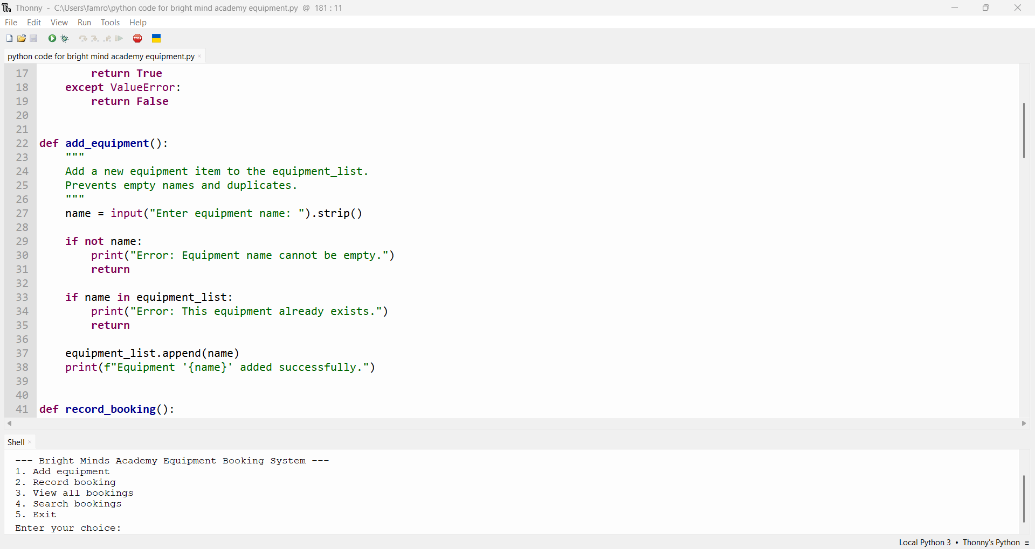
The add to equipment is responsible for allowing staffs to add new equipment item into the system. It consists of collecting user input, validates the input, and updates the equipment list.
Record bookings.
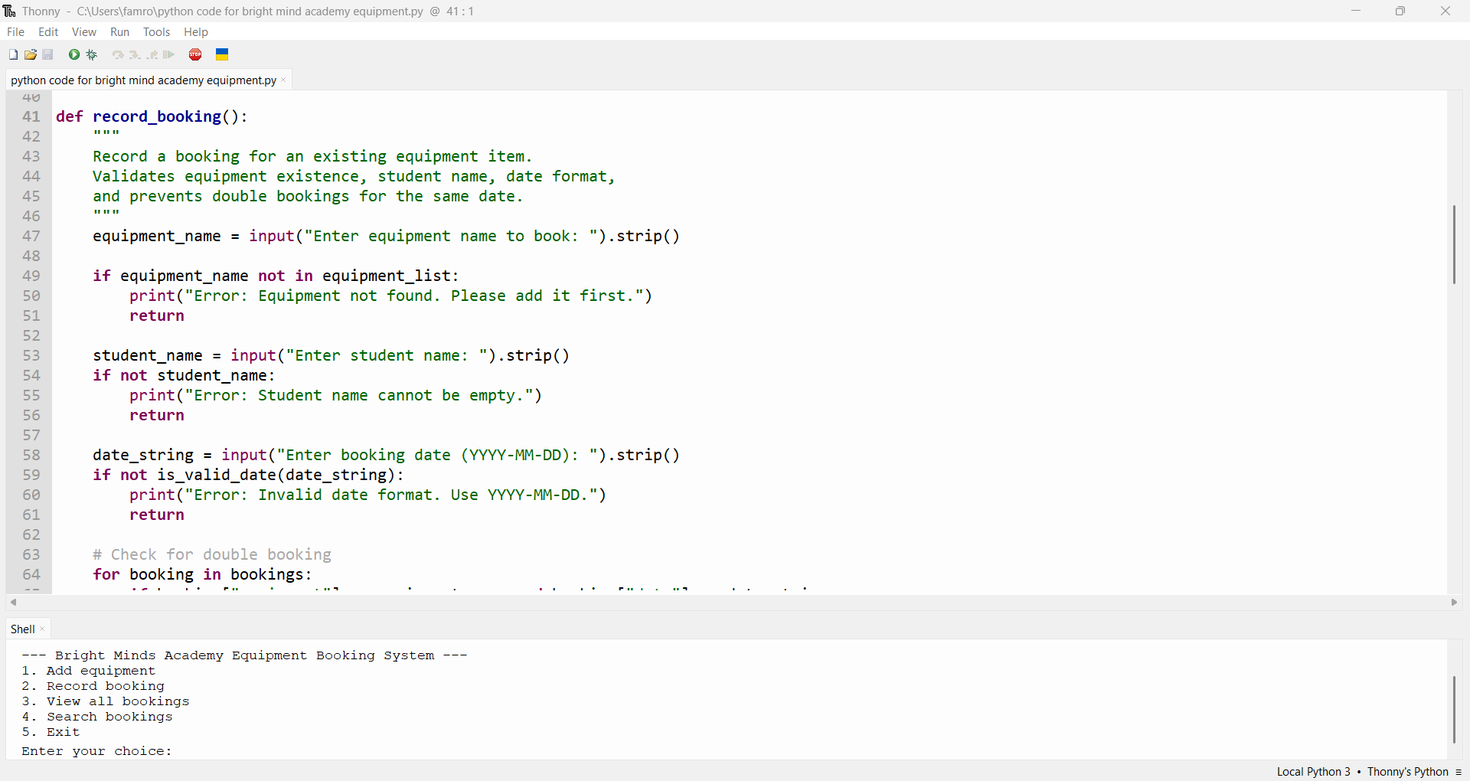
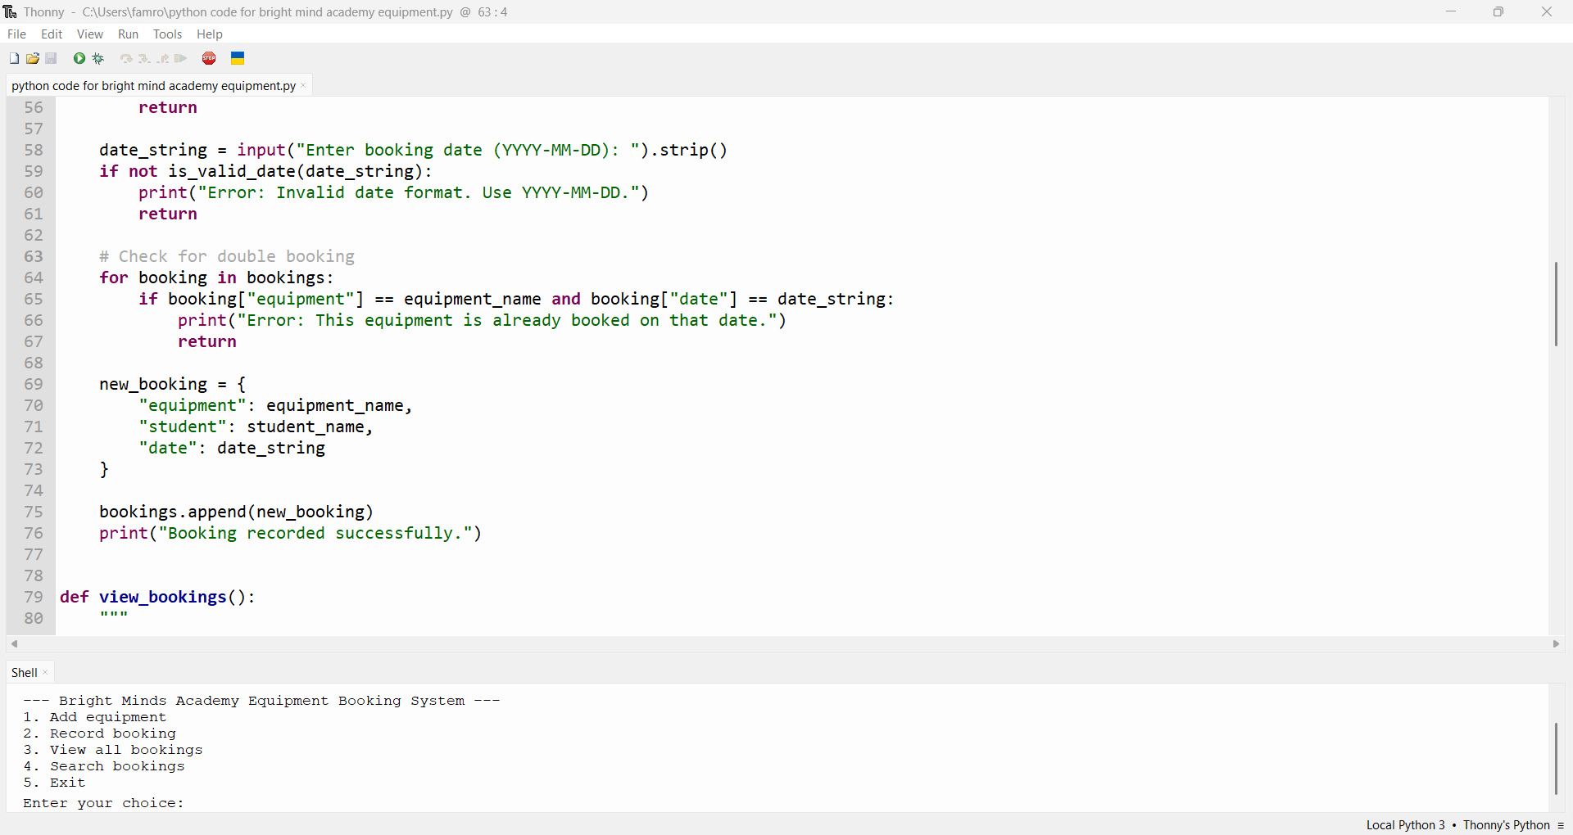
The record bookings allows staff to create a new booking entry to the system, and makes sure all necessary entries is valid before updating the booking to the system.
View booking records.
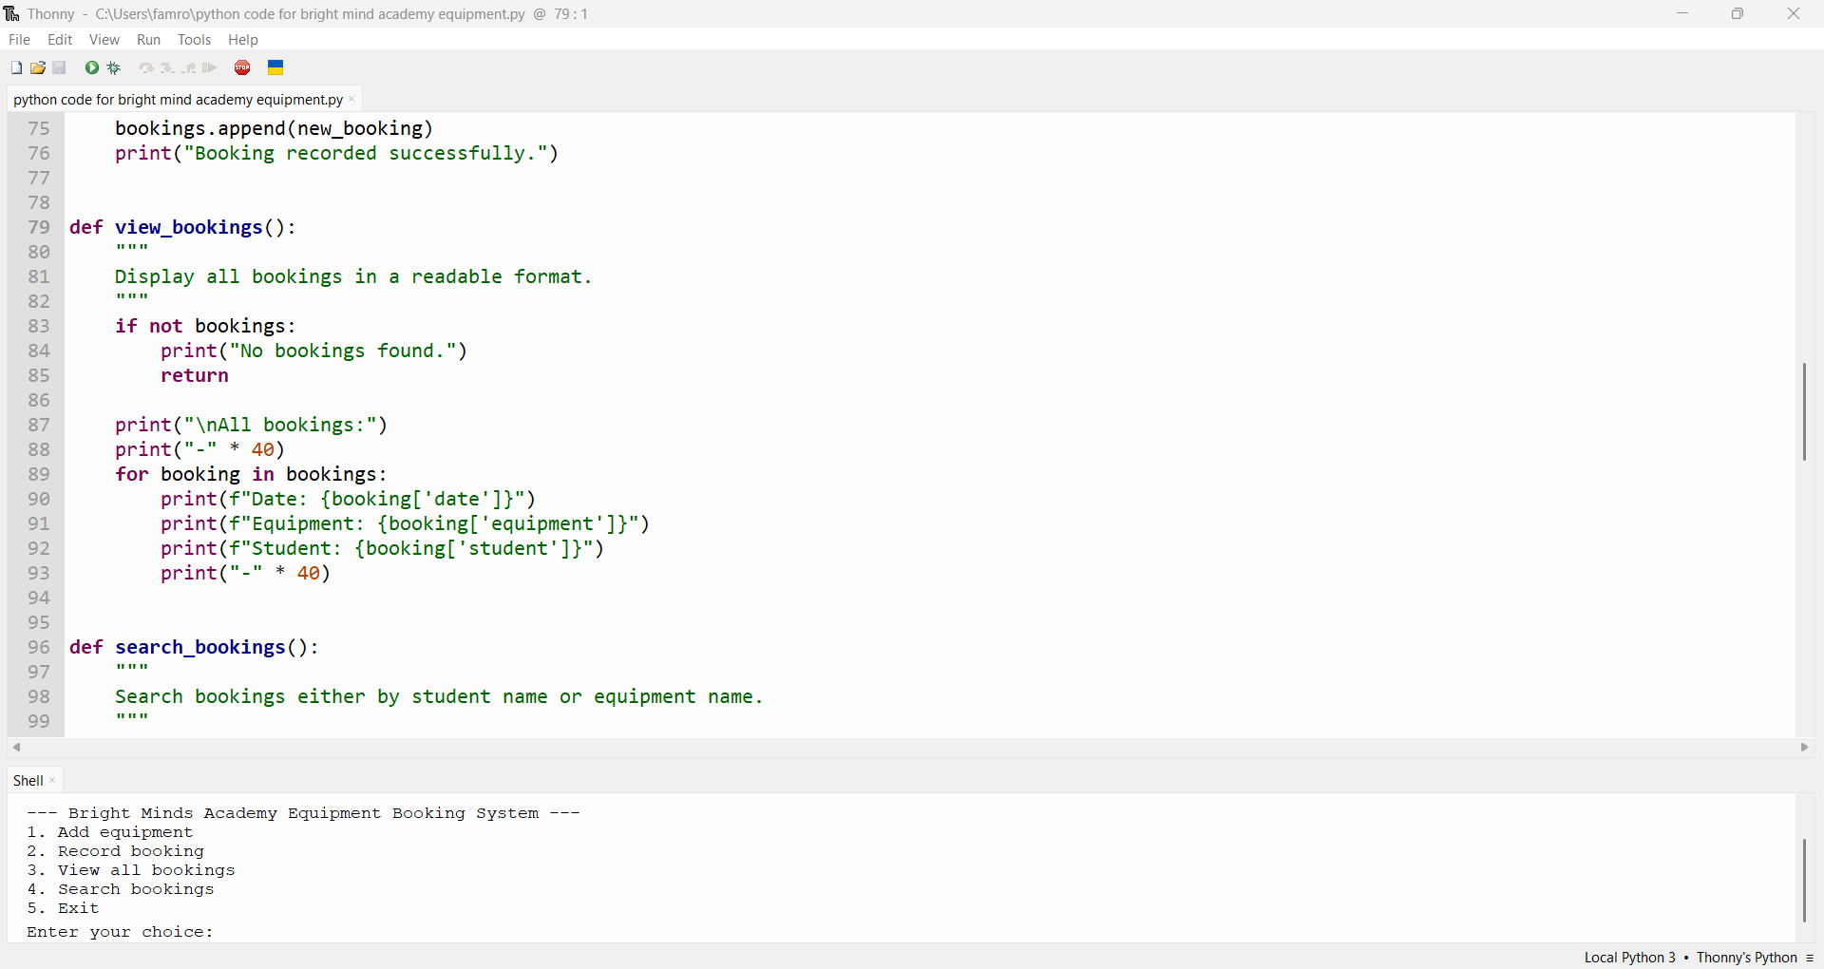
The view booking function displays all existing booking records in a readable and clear format. It also checks whether booking is available/empty. If there are know stored bookings it relates a message to inform the users that know bookings is available and exits the function.
Simple search.
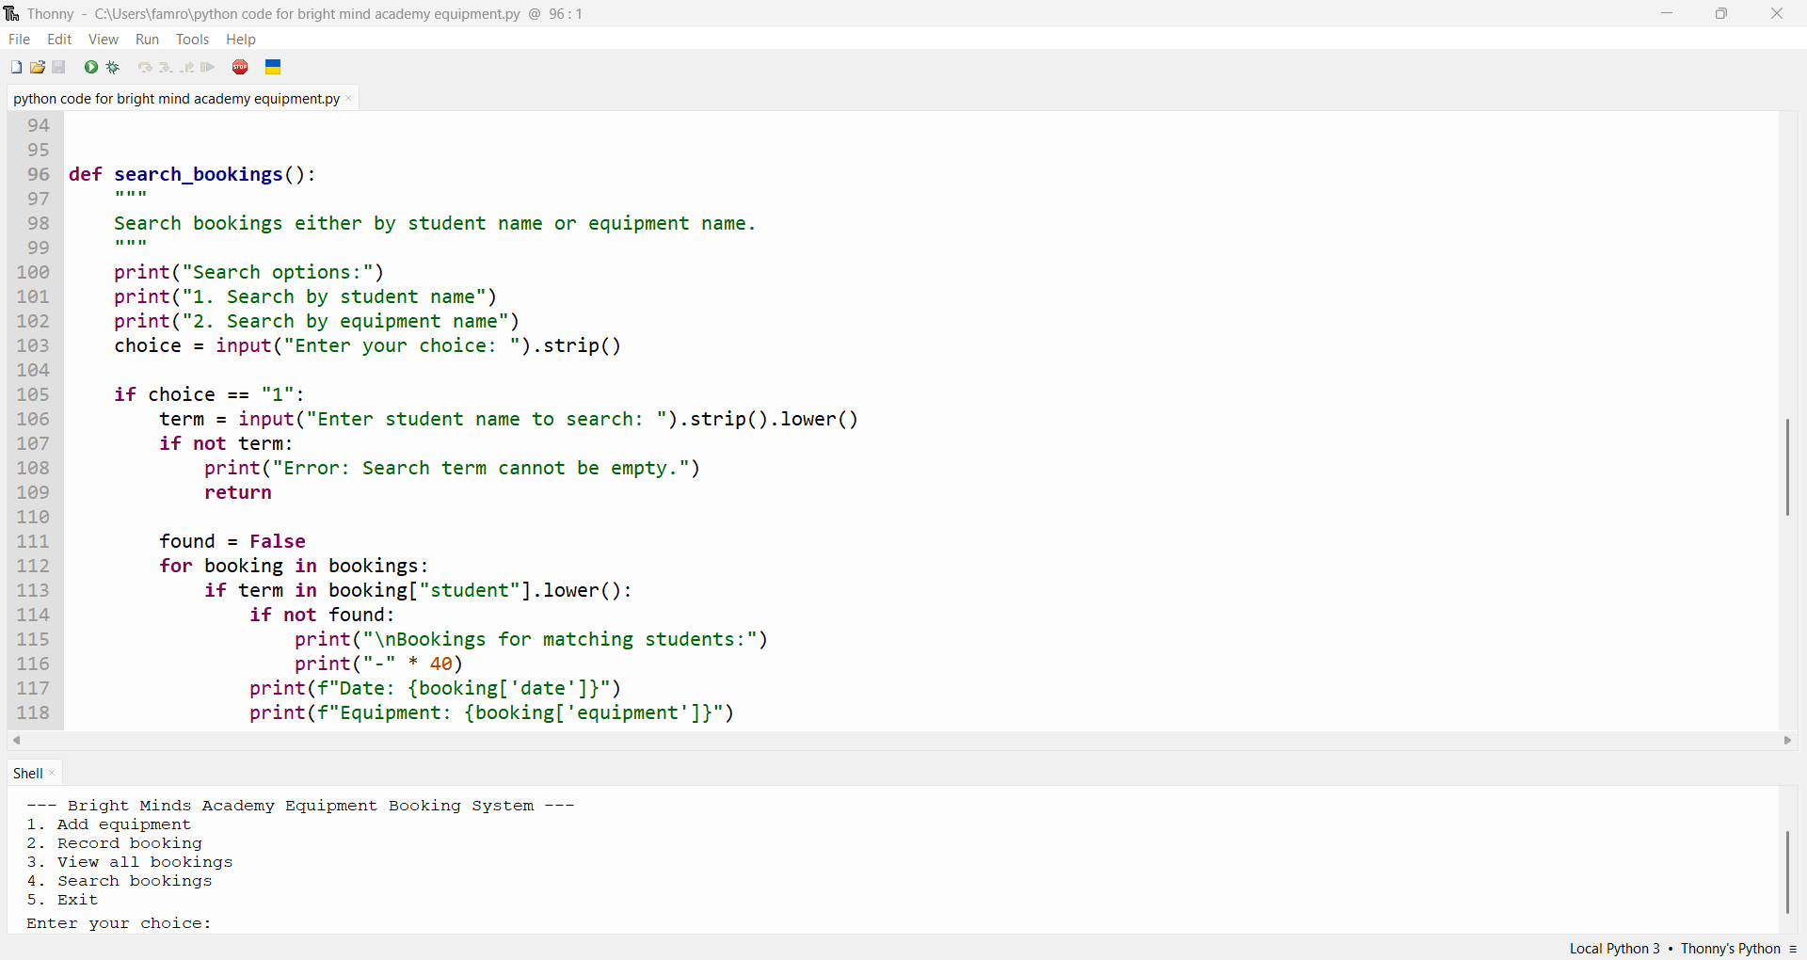
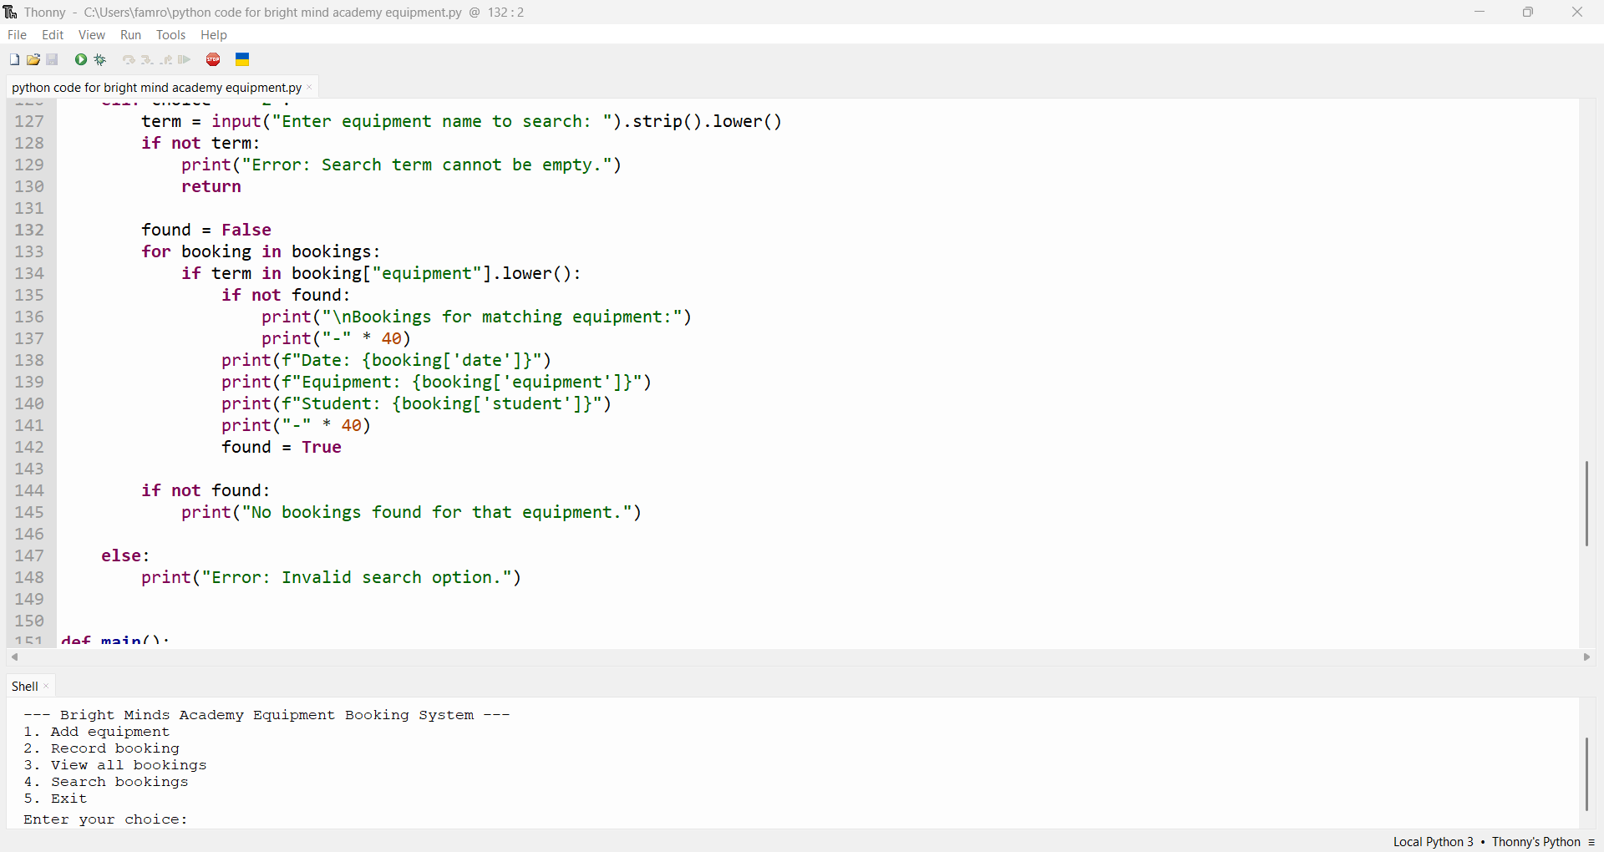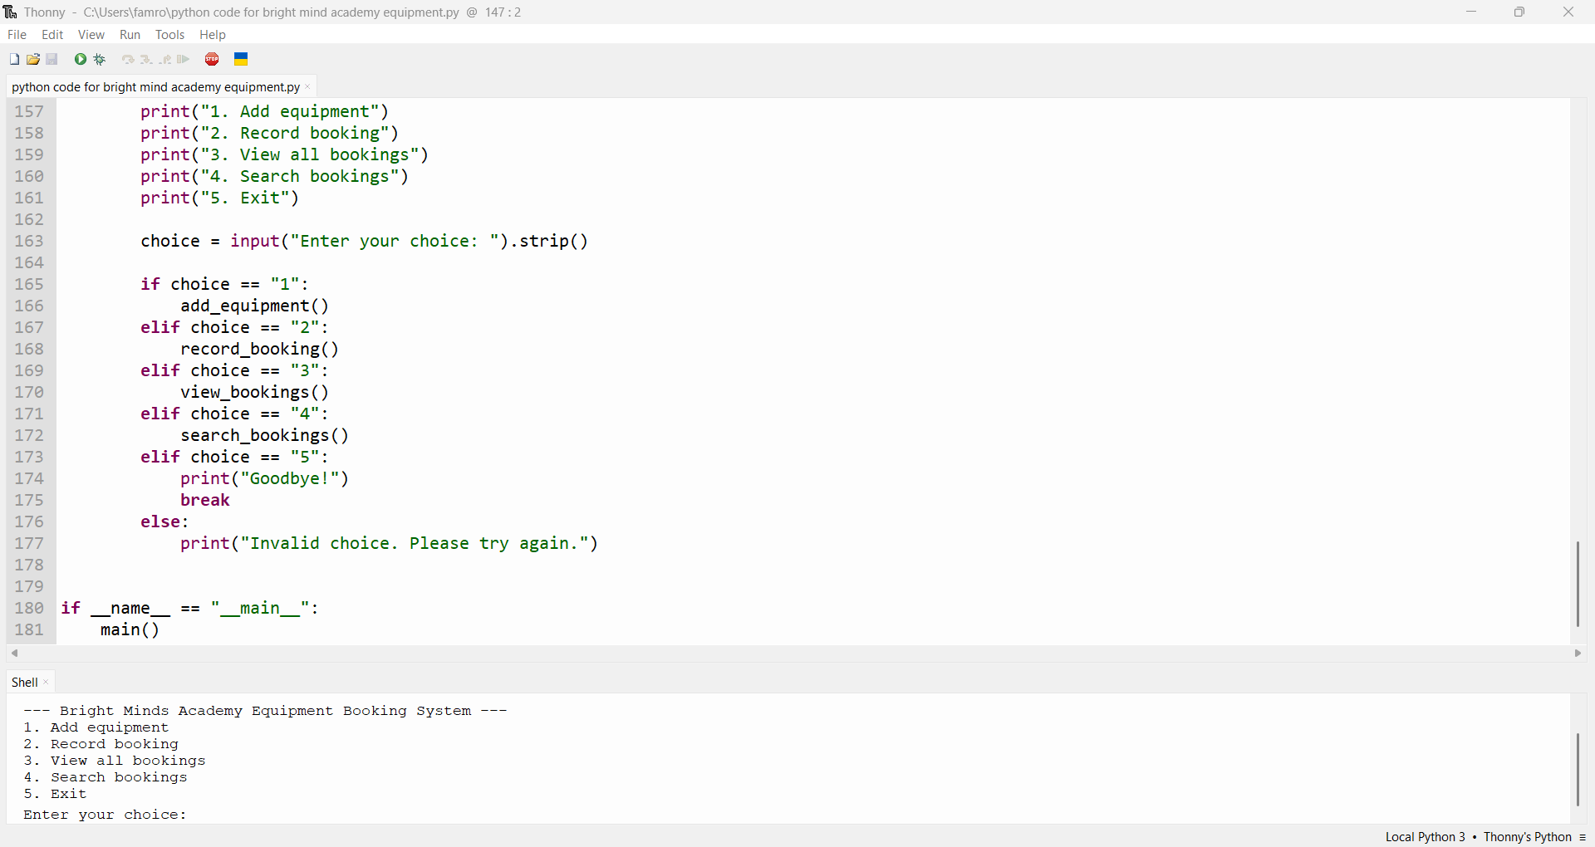
This function allows staff to check booking records by using either equipment or user which displays two options. If user selects option 1, the function will ask for the user name , but if option 2 is select, it still goes through the same process but the search is performed on the equipment field instead of the user field.

- Implementation
- Testing & debugging report.
3. Implementation
The implementation of the Student Equipment Booking System follows the pseudocode and design created earlier. The program was developed in Python using a modular approach, where each major task is handled by a separate user-defined function. This ensures the system is easy to understand, maintain, and extend. The implementation focuses on usability, validation, and preventing common booking errors such as double bookings or invalid input.

3.1 User-Friendly Menu System
The system uses a simple text-based menu that allows staff to navigate through the available options:
- Add new equipment
- Record a booking
- View all bookings
- Search bookings
- Exit the system
The menu is displayed inside a while True loop, ensuring that the program continues running until the user chooses to exit. This makes the system intuitive and efficient for staff who may need to perform multiple actions in one session.

3.2 User-Defined Functions
The program uses several user-defined functions to implement the pseudocode. Each function performs a specific task, improving readability and reducing duplication.
Function: add_equipment()
This function allows staff to add new equipment items. It validates that:
- The equipment name is not empty
- The equipment does not already exist
If validation passes, the equipment is added to equipment_list.
Function: record booking()
This function handles the creation of new bookings. It validates:
- The equipment exists
- The student’s name is not empty
- The date is in the correct format
- The equipment is not already booked on the same date
If all checks pass, a new booking dictionary is appended to the bookings list.
Function: view_bookings ()
This function displays all existing bookings in a clear, readable format. If no bookings exist, it informs the user.
Function: search_bookings()
This function allows staff to search for bookings by:
- Student name
- Equipment name
The search is case-insensitive and displays all matching results.
Function: is_valid_date()
This function uses the datetime module to validate date strings. It ensures that dates follow the YYYY-MM-DD format and represent real calendar dates.
Function: main()
This function controls the main program loop and calls the appropriate functions based on the user’s menu selection.

3.3 Validation Techniques
Validation is used throughout the system to prevent incorrect or incomplete data from being stored. Examples include:
- Rejecting empty equipment names
- Preventing duplicate equipment entries
- Ensuring student names are provided
- Validating date format using datetime.strptime()
- Preventing double bookings
- Handling invalid menu choices
These validation techniques ensure the system remains reliable and user-friendly.

3.4 Python Code Implementation
Below is the complete implementation of the system:
from datetime import datetime

equipment_list = []
bookings = []

def is_valid_date(date_string):
try:
datetime.strptime(date_string, "%Y-%m-%d")
return True
except ValueError:
return False

def add_equipment():
name = input("Enter equipment name: ").strip()

if not name:
print("Error: Equipment name cannot be empty.")
return

if name in equipment_list:
print("Error: This equipment already exists.")
return

equipment_list.append(name)
print(f"Equipment '{name}' added successfully.")

def record_booking():
equipment_name = input("Enter equipment name to book: ").strip()

if equipment_name not in equipment_list:
print("Error: Equipment not found. Please add it first.")
return

student_name = input("Enter student name: ").strip()
if not student_name:
print("Error: Student name cannot be empty.")
return

date_string = input("Enter booking date (YYYY-MM-DD): ").strip()
if not is_valid_date(date_string):
print("Error: Invalid date format. Use YYYY-MM-DD.")
return

for booking in bookings:
if booking["equipment"] == equipment_name and booking["date"] == date_string:
print("Error: This equipment is already booked on that date.")
return

new_booking = {
"equipment": equipment_name,
"student": student_name,
"date": date_string
}

bookings.append(new_booking)
print("Booking recorded successfully.")

def view_bookings():
if not bookings:
print("No bookings found.")
return

print("\nAll bookings:")
print("-" * 40)
for booking in bookings:
print(f"Date: {booking['date']}")
print(f"Equipment: {booking['equipment']}")
print(f"Student: {booking['student']}")
print("-" * 40)

def search_bookings():
print("Search options:")
print("1. Search by student name")
print("2. Search by equipment name")
choice = input("Enter your choice: ").strip()

if choice == "1":
term = input("Enter student name to search: ").strip().lower()
if not term:
print("Error: Search term cannot be empty.")
return

found = False
for booking in bookings:
if term in booking["student"].lower():
if not found:
print("\nMatching bookings:")
print("-" * 40)
print(f"Date: {booking['date']}")
print(f"Equipment: {booking['equipment']}")
print(f"Student: {booking['student']}")
print("-" * 40)
found = True

if not found:
print("No bookings found for that student.")

elif choice == "2":
term = input("Enter equipment name to search: ").strip().lower()
if not term:
print("Error: Search term cannot be empty.")
return

found = False
for booking in bookings:
if term in booking["equipment"].lower():
if not found:
print("\nMatching bookings:")
print("-" * 40)
print(f"Date: {booking['date']}")
print(f"Equipment: {booking['equipment']}")
print(f"Student: {booking['student']}")
print("-" * 40)
found = True

if not found:
print("No bookings found for that equipment.")

else:
print("Error: Invalid search option.")

def main():
while True:
print("\n--- Bright Minds Academy Equipment Booking System ---")
print("1. Add equipment")
print("2. Record booking")
print("3. View all bookings")
print("4. Search bookings")
print("5. Exit")

choice = input("Enter your choice: ").strip()

if choice == "1":
add equipment ()
Elif choice == "2":
record booking ()
Elif choice == "3":
view_bookings ()
Elif choice == "4":
search bookings ()
Elif choice == "5":
print("Goodbye!")
break
else:
print ("Invalid choice. Please try again.")

main ()

4. Testing and Debugging
Testing was carried out using a structured test plan that included normal, boundary, and invalid inputs. The aim was to verify that validation worked correctly and that the system behaved as expected under all circumstances.

4.1 Test Cases
Test ID | Description | Input | Expected Result
T1 | Add valid equipment | Laptop 1 | Added successfully
T2 | Add duplicate equipment | Laptop 1 | Error message
T3 | Add empty equipment | "" | Error message
T4 | Record valid booking | Laptop 1, Alice, 2026-05-01 | Booking added
T5 | Book non-existent equipment | Projector X | Error message
T6 | Invalid date format | 05/01/2026 | Error message
T7 | Double booking | Same equipment/date | Error message
T8 | View bookings when empty | N/A | “No bookings found”
T9 | Search by student | Alice | Matching bookings
T10 | Invalid menu choice | 9 | Error message

4.2 Debugging Summary
During testing, several issues were identified and corrected:
- Invalid date handling → fixed using datetime. strptime()
- Case-sensitive search → fixed using. lower()
- Trailing spaces in input → fixed using. strip()
- Duplicate equipment entries → prevented using membership checks
These corrections ensured the system is robust and user-friendly.
4, Evaluation.
6.1 Challenges Faced
One of the main challenges encountered during the project was designing a system that remained simple enough for non-technical staff to use while still incorporating essential validation and error-prevention mechanisms. As highlighted by Sommerville, simplicity and usability are critical factors in small-scale software systems [1]. Ensuring that the menu-driven interface was intuitive required several iterations and refinements.
Another challenge involved implementing robust input validation. Incorrect user input—such as invalid dates, empty fields, or duplicate entries—could easily compromise the reliability of the system. To address this, the datetime module was used to validate date formats, which aligns with best practices for defensive programming [2]. Additionally, careful use of conditional logic helped prevent double bookings and ensure data integrity.
Debugging the system also presented challenges, particularly when identifying logical errors in the booking process. For example, early versions of the program allowed equipment to be booked multiple times on the same date due to incorrect loop conditions. This issue was resolved through systematic testing and step-by-step tracing, a technique recommended by McConnell for improving software reliability [3].
Finally, ensuring that the system remained modular and maintainable required disciplined use of functions and structured programming principles. Modular design is widely recognised as a key factor in producing maintainable software [4], and adhering to this principle helped reduce complexity and improve clarity.
6.2 Future Improvements
Although the system meets the core requirements, several enhancements could significantly improve its functionality and scalability.
1. Persistent Storage
Currently, the system stores data only in memory, meaning all bookings are lost when the program closes. Implementing persistent storage using a database or file system would make the system more practical for real-world use. SQLite or JSON storage would be suitable lightweight options [5].
2. Graphical User Interface (GUI)
A GUI would make the system more accessible to staff who may not be comfortable with command-line interfaces. Tools such as Tkinter or PyQt could be used to create a more user-friendly interface [6].
3. User Authentication
Adding login functionality would allow different tutors to manage their own bookings securely. Authentication is a standard requirement in modern software systems to protect data integrity [7].
4. Time-Slot Management
The current system only records dates. Adding time slots would allow more precise scheduling and reduce conflicts, especially for equipment used multiple times per day.
5. Reporting and Analytics
Future versions could include features such as usage statistics, most-booked equipment, or monthly booking summaries. Data analytics is increasingly important in educational environments for decision-making [8].
6. Cloud Integration
Integrating the system with cloud services would allow tutors to access bookings remotely. Cloud-based systems are now widely used in education due to their flexibility and scalability [9].
6.3 Self-Reflections
This project provided an opportunity to apply theoretical knowledge of programming constructs, data structures, and software design to a practical problem. One of the key lessons learned was the importance of planning and designing before coding. Producing flowcharts and pseudocode helped clarify the system’s logic and reduced errors during implementation, supporting the view that structured design improves software quality [10].
I also gained a deeper understanding of validation and error handling. Ensuring that the system could handle incorrect input without crashing required careful thought and reinforced the importance of defensive programming techniques [11].
I also gained a deeper understanding of validation and error handling. Ensuring that the system could handle incorrect input without crashing required careful thought and reinforced the importance of defensive programming techniques [11].
Working with user-defined functions improved my ability to write modular and maintainable code. This experience highlighted the value of abstraction and decomposition, which are essential skills for any software developer [12].
Finally, the project strengthened my debugging skills. Through systematic testing and iterative refinement, I learned how to identify and resolve logical errors more efficiently. This process helped me grow as a developer by improving my problem-solving abilities and attention to detail.
Overall, the project enhanced my confidence in designing and implementing small-scale software systems. It also provided valuable experience in applying SDLC principles, validating user input, and producing clear documentation—skills that will be essential in future academic and professional development.

Conclusion.
This project successfully delivered a functional and user-friendly equipment booking system that meets the needs of Bright Minds Academy. Through structured design, modular implementation, and thorough validation, the system effectively prevents double bookings and improves reliability compared to the previous paper-based process. Developing the solution strengthened my understanding of programming constructs, problem-solving, and software design principles. The experience also highlighted opportunities for future enhancements, such as persistent storage and a graphical interface, ensuring the system can continue evolving to support the academy’s growing needs.
References:
[1] I. Sommerville, Software Engineering, 10th ed. Boston, MA: Pearson, 2016.
[2] B. Kernighan and R. Pike, The Practice of Programming. Addison-Wesley, 1999.
[3] S. McConnell, Code Complete, 2nd ed. Redmond, WA: Microsoft Press, 2004.
[4] R. Pressman and B. Maxim, Software Engineering: A Practitioner’s Approach, 8th ed. McGraw-Hill, 2014.
[5] P. Barry and P. Crowley, Modern Database Management. Pearson, 2019.
[6] M. Dawson, Python Programming for the Absolute Beginner, 3rd ed. Cengage Learning, 2010.
[7] W. Stallings, Cryptography and Network Security, 7th ed. Pearson, 2017.
[8] J. W. Creswell, Educational Research: Planning, Conducting, and Evaluating Quantitative and Qualitative Research. Pearson, 2018.
[9] T. Erl, Cloud Computing: Concepts, Technology & Architecture. Prentice Hall, 2013.
[10] E. Yourdon, Modern Structured Analysis. Prentice Hall, 1989.
[11] M. Sipser, Introduction to the Theory of Computation, 3rd ed. Cengage Learning, 2012.
[12] G. Booch, Object-Oriented Analysis and Design with Applications, 3rd ed. Addison-Wesley, 2007.

