


Hi,
It's my pleasure to introduce myself. I'm __Marin-Silviu Buse___________, and I attend Trinity Saint David University in Wales. A course on Research Methods and Digital Skills examines how Grit can affect academic achievement and success levels for students. Consequently, I have done extensive research on Angela Duckworth's work on grit scores. I have intended to recreate the experiment in my university group, to see whether GRIT affects student academic achievement, and if so, what should we do about it? Using Microsoft Forms, I created a survey for my colleagues where they answered two simple questions: "What is your grit level? Which is the highest level of academic achievement you've achieved based on British Government standards?". Furthermore, I incorporated the DIKW triangle principle, which will eventually assist me in finding the wisdom that I seek (Ackoff, 1999). It consists of four steps: a collection of data, the transformation of Data into Information, understanding of Information and transformation into Knowledge, and understanding of Knowledge and transformation into Wisdom.


Angela Duckworth’s work on grit appeared to be the basis for my research. She hypothesized that grit was an indicator of academic success (Duckworth et al., 2007). My investigation of Angela Duckworth's work revealed that her claim is supported by facts, study, and research, which are similar to the credentials of academic institutions. I believe she passed the CRAAP test since she has done further research on her work.
Let's start by defining grit. Grit is the ability to demonstrate your courage and your character strength. In her book, an excitable, hard-working person with grit will stick to long-term objectives and help ensure the future becomes a reality (Duckworth, 2013). The research results of Duckworth (2013) show that grit outperforms social perceptions of well-being, as well as intelligence. Most successful individuals are not only successful because of all the above characteristics, but because they possess greater courage to take risks and greater determination to battle through any challenges.
Grit is defined as a state of being persistent and enthusiastic toward long-term goals (Duckworth, 2007). Grit is the ability to work arduously on challenges and maintain both interest and exertion over time, regardless of failure or disappointment (Duckworth, 2007). Research performed by Angela Duckworth and her colleagues found that cadets at the United States Défense Academy at West Point who have higher levels of grit drop out at a lower rate than their less motivated counterparts. Carol Dweck's concept of a "growth mindset" is the best idea in developing people's grit, according to Angela Duckworth.

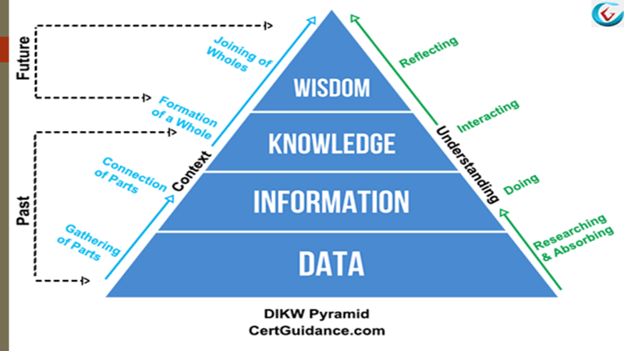
My experiment was recreated by using the DIKW triangle framework as I mentioned above, and I will describe why I believe this principle will come in handy for future research. All the facts, intelligence, and statistics we encounter every day are simply data, and unless they are transformed into information, they have no meaning. The word 'information' describes images that describe things such as properties of articles, events, and current circumstances. These are the products of perception. The information is not useful until it is presented in an appropriate structure (for example, applicable) (Duckworth et al., 2007). We distinguish between information and data based on utility differences, not underlying concepts. It is time to transform the data into information because as a data set, information alone has no purpose and must be explained. Comparison of your data with others can help you understand the information more easily, leading to knowledge. time to come to the last part of the triangle principle: Wisdom. After data are collected and converted to information, followed by a comparison with secondary data, knowledge is obtained. Critical judgment is involved in this process.


Now we need to begin collecting data, which we will then transform into information. In my research, I created a survey using MS form and sent it to members of my research group. I used my primary data to represent all of my co-workers’ responses to a survey that was exported from an Excel spreadsheet. To obtain two sets of quantitative information, I utilized two simple questions that could then be exported to Excel and analyzed.
Here is the first question, "What is your grit score? Obtaining the Grit questionnaire score format from a number with two decimals was done on the Angela Duckworth website and by my colleagues by visiting the website. A second question asked is "What is your highest level of academic achievement, as determined by the British Government? To answer this question, my colleagues and I conducted a survey that resulted in a variety of different answers.

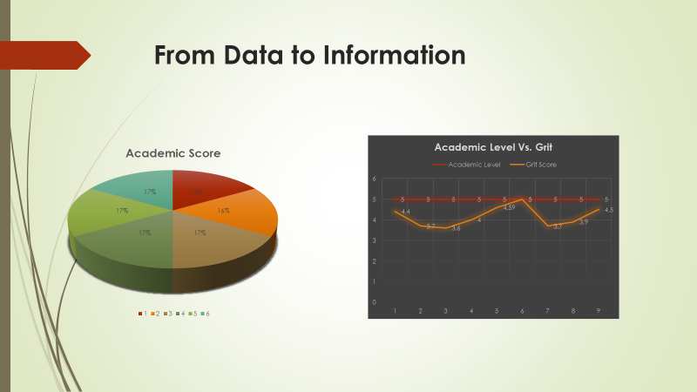
Taking primary data and transforming it into information is the next step. To fully understand the data, we need to know that sometimes the numbers do not speak for themselves and that the numbers need to be transformed in such a way that they can be easily understood. Data analysis can significantly improve decision-making at the end if a good analysis is done.
To calculate the average grit based on an academic level, I export the excel file from MS Form, where the results of my survey were contained in a table. My understanding of those numbers didn't improve with a table of numbers. I used charts that helped me visualize the results better so that I could better understand the data.
Consequently, I created a table containing the average data and then turned it into a scatter chart. The trend line for Grit versus academic level demonstrates that Grit is on the rise.
According to the analysis of the information, the research of Angela Duckworth and mine converge in that the trend indicates that grit impacts academic achievement.
However, as I did not manage to collect answers from thousands of students, my data collection quality is not so good. Angela Duckworth, for example, collected answers from thousands of students.

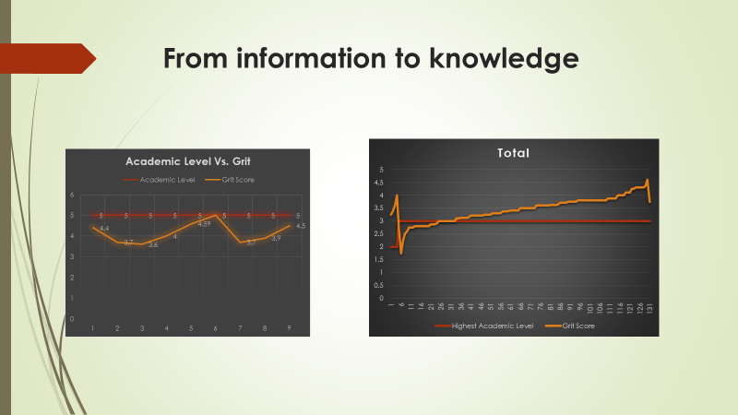
The primary data I have, however, does not convince me much due to a lack of response to my survey, so I decided to look at secondary information to ascertain if there is a similar trend. As a result of the same research being conducted at UWTSD in 2020 (Moodle), I used the exported excel table containing the secondary data to create a chart with a trend line.
Primary and secondary data are trending upwards, which means that greater grit corresponds to better academic performance. According to the data, the average grit score is higher for level 2 compared to level 1 or level 3, and that could be attributed to old age because older people are generally grittier but are not necessarily academically superior.
We could better understand why academic level 2 students have a higher GRIT if we collected more data, such as demographic information, such as age, and gender.


DIKW triangle ends with wisdom. Human intuition, the ability to receive, and the ability to translate are far more important than frameworks. Wisdom can help contextualize information and knowledge. Therefore, we must now reflect deeply and dive deep to bring wisdom to life once we have the information and knowledge.
Among just a few institutions that Angela Duckworth has researched are West Point Military Academy, the National Spelling Bee, teachers, as well as private companies, and after studying these institutions, Duckworth determined that grit is more useful in estimating success than social insight, happiness, or intelligence (Duckworth, 2013).
When I researched grit, I discovered that it is indeed a determinant of achievement since individuals with a higher grit score have higher educational levels as well as the Angela Duckworth theory is proven to be true.
Having discovered that grit is a sign of success, it remains a question: How can we help people develop grit? What could be done to make people more gritty? We should dedicate more time and effort to finding out how. "Growth mindset" is one concept by Carol Dweck that can be used to build grit in people.

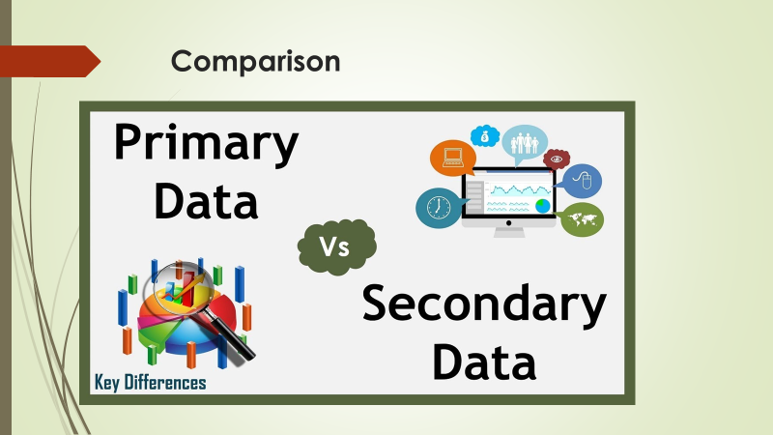
The data which I collected via the primary and secondary sources has been compared with the DIKW triangle. Based on the data, I have found that the grit value increases when the score level increases also. Sources that are secondhand or interpretive accounts of a person, object, or event are called secondary sources. First-hand or original data is considered primary data. Jones, Duckworth, and Duckworth (2017) conducted surveys and focus groups. As opposed to primary data, secondary data is collected information that has already been obtained by someone else. For example, conducting an internet search, reading articles in newspapers, and consulting company reports. A CRAAP analysis was included in this report. This test provides a list of questions to ask yourself when deciding to use a source in your academic research paper. This test provides a list of questions to ask yourself. A CRAAP list should include currency, relevance, authority, accuracy, and purpose.
The analysis of tests is based on academic sources. In an academic research paper, you will need to cite credible sources because your audience expects the evidence to back up your claims. A reader will not be convinced that your claim is plausible or even correct if your evidence does not come from a credible source.

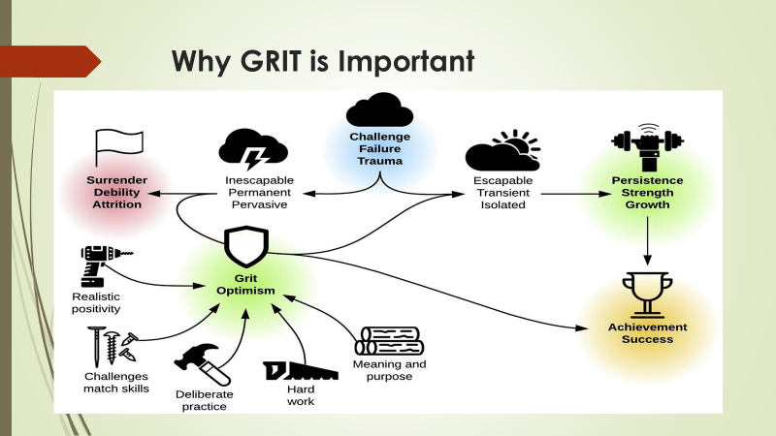
Grit is a better indicator of GPAs and graduation rates, according to a Grit Scale developed by Duckworth and Peterson. Standardized test scores are highly correlated with IQ. Albert Bandura's self-efficacy research is thought to contain the idea of grit, and resilience is also mentioned. "Character education" can't replace the concept of teaching grit. Character education partnerships divide the concept of character into four broad areas: ethics, performance, and personal attributes. Grit, in my opinion, should be classified as a performance value (Dweck, 2014).
Angela Duckworth, a pioneering research scholar, believes that grit can be taught. There may be misperceptions about how kids develop their skills that stand in the way of their ability to tap into their best qualities. In these situations, students may believe that their abilities to complete a task are lacking, and give up. When students are learning something new, it is normal to feel confused; it is even expected. Our students can be taught that mistakes are normal aspects of learning, and they are not indicative of failure.


According to Carol Dweck, people's intellectual abilities can grow over time, if they develop a growth mindset. Mindsets can be categorized into two categories. A fixed mindset does not engage with failure but focuses on understanding where it went wrong so that it can be fixed. A growth mindset explores failure, who reflects on their inabilities and their willingness to learn and grow (Dweck, 2014).
We should recognize that failure is merely a stepping stone to success when it comes to developing the growth mindset (Dweck, 2014). Working toward a goal generally means facing failure, reflecting on the failure, understanding it, and then improving our efforts. Students with grit persevere despite setbacks. When you think failure is due to your fixed traits, it makes no sense to try again. Grit is related to mindset in this way. In contrast, growth mindsets are associated with greater resilience and grit.

References
Ackoff, R. L. (1999) Ackoff’s Best. New York: John Wiley & Sons, pp 170 – 172.
Duckworth, Angela L, et al., 2007. Grit. Journal of personality and social psychology, 92(6), pp.1087–1101.
Duckworth, A.L., Peterson, C., Matthews, M.D. and Kelly, D.R. (2007). Grit: Perseverance and passion for long-term goals. Journal of Personality and Social Psychology, 92(6), pp.1087–1101
Duckworth, Angela Lee, and Patrick D. Quinn. “Development and Validation of the Short Grit Scale (Grit–S).” Journal of Personality Assessment, vol. 91, no. 2, 17 Feb. 2009, pp. 166–174,
Duckworth, A.L. (2013). Grit: The power of passion and perseverance.
Jones, M., Duckworth, M., and Duckworth, J. (2017). Evaluation of Insect-Resistant Cotton Against Bollworm, 2016. Arthropod Management Tests, 42(1).
Dweck, C. (1418). The power of believing that you can improve. [online] www.ted.com. Available at: https://www.ted.com/talks/carol_dweck_the_power_of_believing_that_you_can_improve?langu [Accessed 4 Dec. 2021].

