University of Wales Trinity Saint David School of Engineering

Report “Proposal of Coldbox and Gravity Diecast techniques”

Oksana Gomzjakova

1706480

Energy and Environmental Engineering

20.12.2018

Materials and Introduction to Manufacturing Technology

(M4X01163)
Contents
1. Introduction 3
2. Current Process 4
3. Suggested Methods 6
4 Conclusion 10
References 11

Introduction

In casting industry, the range of mold and molding methods is a challenging task and each method has its benefits and downsides. The aim of this report is to evaluate the advantages and disadvantages of the current manufacturing process, such as sand-casting. In this paper two different techniques are described, investigated and proposed. These methods are chosen to meet the company’s requirements, such as improvement of surface quality and waste and cost reduction.

Current Process
The company currently uses the sand-casting and secondary machining process to produce bushes and sleeves. This manufacturing technique is one of the most popular and has many advantages. It is quite cheap cost wise as doesn’t involve complex processes and thus doesn’t require an expensive machines and materials to produce the parts, and the quality of products is relatively good. Sand is used in metal casting processes as it is able to absorb and transmit heat. Despite the sand casting is cost-competitive casting, the quality of sand is a crucial key in the quality of finished product. Thus, to insure quality bushes and sleeves, molding sand must be continuously tested and controlled (Penton Media Inc, 2004).
Sand casting is one of the oldest and most common manufacturing methods. The purpose of sand casting is to pour molten metal into a mold and it gets solidified. Moist bonding sand is packed around a pattern. The pattern is then removed to create a mold. The mold is then broken to remove the part (Unknown, 2014). This process involves few stages, such as melting, alloying, molding, pouring, solidification and finishing, using a secondary machining process (Zheng Jun, Huang Binbin, Zhou Xingjian, 2018). Sand casting process (see Picture 1) involves controllable and uncontrollable factors. Some of the factors that affect the quality of the finished product are metal filling pressure, velocity, solidification, hot spot location, stress distribution, and porosity (Hassan Iqbal, Anwar K. Sheikh, AbdulHadi Al-Yousef, M. Younas, 2012). To get the good quality of bushes and sleeves many factors in the process should be considered. These also include the speed of meniscus- it shouldn’t go too fast or shouldn’t stop. As well as quite difficult to avoid bubbles, core blows and shrinkage in the sand casting.
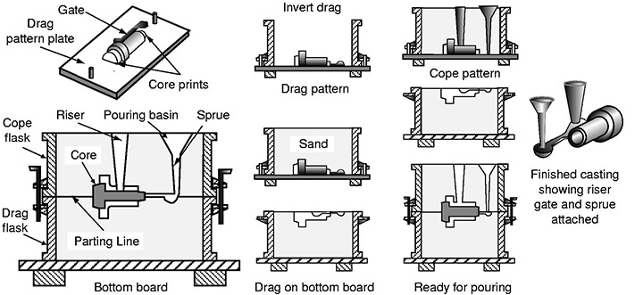
Picture 1: Sand casting process (Unknown, 2014)
Some factors in sand casting which affect the quality must be especially controlled. For instance, when metal is poured into a mold, the sand heats as the casting solidifies and, thus, expands. This expansion, if excessive or uncontrolled, can cause the sand could crack and molten metal enters the crack and therefore this leads to the surface defects (Penton Media Inc, 2004)
Green sand-casting provides good dimensional stability. Nevertheless, defects, which are developed in casted components play a vital role in maintaining the desired surface quality (A. Kumaravadivel; U. Natarajan, 2013)
The current process of metalcasting has the all economics advantages, pretty fair dimensional accuracy, availability of raw materials, established process equipment as well as the ease of recycling of molding material. However, the green sand casting is unable to meet requirements of original manufacturers in terms of dimensional accuracy and surface finish and also, the need to use a secondary machining to finish the surface. (Khandewal Himanshu, Ravi B, 2016).
The benefits of sand casting are:
- The cheapest technique of casting
- Patterns easy to make and set and they are reusable
- Easy to change design during production
- Equipment and costs aren’t expensive
- Castings have good bearing and damping properties
- The properties of are same in all directions due to small cooling rate (Chennu, 2017)
The main disadvantages of sand casting are:
- The mold itself has low strength and high moisture content
- Molding sand must be conditioned and controlled
- Possible problems such as casting shrinkage and distortion during cooling
- High porosity and inclusion levels
- Material utilization is low to moderate. Despite mold material and runners and risers maybe recycled, there is still high percentage of material lost in runners and risers.
- The strength of material is fairly poor
- Finishing costs are high. The casted parts should be cleaned and fettled to remove gates and risers before secondary processing (Unknown, 2014)
- Sand casting is labor intensive (throughout all the stages of the process)

Suggested Methods

There are different methods of manufacturing of bushes and sleeves that could be used to improve the quality and reduce the waste, which are described and proposed in this part.
- Chemically Bonded Molding System, such as Gas Catalyzed (or Coldbox)
This manufacturing method is broadly used in the metalcasting manufacturing world for its economics and improved productivity benefits. This is a core binder process that uses a gas or vaporized catalyst to cure resin coated sand which is in contact with a room temperature pattern. The gas or vapor are added to the sand and resin component, thus this this not allowing the mixture to cure until it’s brought into the contact with a catalyst see Picture 2). If some parts of sand mixture didn’t come into contact with catalyst, it’s still is possible to cure. Therefore, many small cores/molds can be produced from a large batch of mixed sand. There are few coldbox processes, these include phenolic SO2, phenolic ester, furan/SO2, epoxy/SO2 and sodium silicate/CO2. (Anon., 2016) There are two types of chemical binders- organic and inorganic.
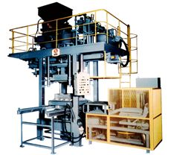
Picture 2: Horizontal Parting cold box Core making Machine – KHN Series (Sintokogio LTD, 2012)
Chemically bonded sand molds have better mechanical properties and produce more dimensionally accurate castings, compared with a green sand molds. No heat curing is used in the coldbox. Almost all the coldbox systems have the typical blow, gas, purging, strip core making sequence; and the curing process is fast and could be finished in seconds (MTDS Cold Box Binder System , 2016)
Following above there are the main points and benefits of using the gas catalyzed method:
- Great dimensional accuracy due to cure without using heat;
- Excellent surface finish, no gas defects and low metal penetration;
- Excellent features for high-production runs, as production cycles are short;
- Excellent core and mold shelf life (Anon., 2016);
- No expensive tools and machinery needed;
- Since no heat needed for curing, there is reduction in energy consumption;
- The process is very precise as there is no thermal related expansion, shrinkage or warpage of cores and molds;
- Core scrap is reduced as the cores at ejection are near full strength, and ready for use (South African Institute of Foundrymen, 2018)
Downsides of coldbox:
- The main issue is an environmental pollution

- Permanent Mold Casting (Gravity Diecasting)
Gravity diecasting is also referred to chill casting, or permanent mold casting. A metal die is usually made of cast iron, tool steel or tungsten carbide and the choice of material depends on the type of metal to be cast (aluminum, lead, tin, zinc etc). A metal die is manufactured in two parts to form a mold (see Picture 2). The mold halves are preheated and the internal surfaces are covered with a refractory. In this process a molten metal is poured into the mold (directly or by tilting the mold into a vertical position). Once the metal is solidified, the die is opened, and the casting removed. Scrap metal is then re-used in the manufacturing cycle by re-melting (Unknown, 2018)
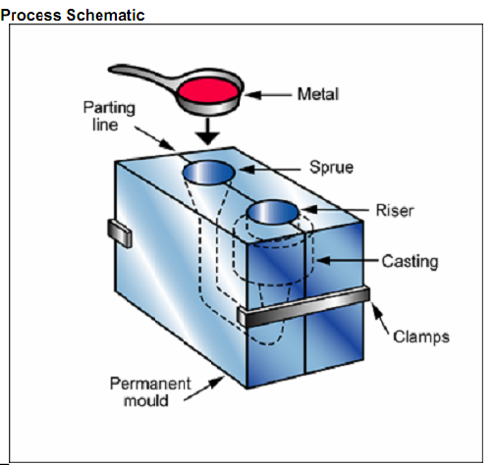
Picture 2: Gravity diecast mold (Unknown, 2016)

The Table 1 shows some comparison criteria between sand casting and gravity diecasting. From this table it is clear that gravity diecasting has much more benefits than sand casting.
 |  |  |  | Sand Casting | Gravity Die Casting
Tolerances on  Critical Dimensions |  | Up to 25mm  Each Additional cm  Across Parting Line Ad. |  | ± 1mm  ± 0.39mm  ± 1mm | ± 0.4mm  ± 0.02mm  ± 0.25mm
Minimum Taper |  | On Inside Walls  On Outside Walls |  | 2°  2° | 1°  1°
Minimum Wall Thickness |  | On Small Castings  On Large Castings |  | 3mm  5mm | 3mm  4mm
Minimum Size of Cored Hole |  |  |  | 15mm | 3mm
Ability to use Sand Cores |  |  |  | Yes | Yes
Surface Finish |  |  |  | Poor  6.5-12.5 μ | Fair  4-10 μ
Typical Production Quantities per annum |  |  |  | 1-500 | 250-50,000
Typical Tool Life |  |  |  | 5,000 | 100,000
Table 1. Comparison of sand casting and gravity diecasting (MRT Castings Limited, 2018)

Compared to other casting methods, the gravity diecasting is at the top of both velocity and pressure. Gravity diecasting method has a higher casting rate than sand casting, but the main disadvantage is that metal molds are more expensive than sand patterns.
The main benefits of gravity diecasting are:
- Uniform casting shape because molds are made of metal
- The ability to selectively insulate or cool sections of the mold, which helps control the solidification and thus improves overall casting processes (Anon., 2016)
- Excellent dimensional accuracy, which offers stability and repeatability
- Smooth cast surfaces
- Secondary machining is reduced or even eliminated
- Production rates are faster, which makes longer production runs possible combined with a low scrap rate
- Tensile strength is higher than with sand casting (Unknown, 2018)
- Greater mechanical and physical properties of casting compared to sand casting
- Low gas porosity possible (Unknown, 2017)
The downsides of gravity diecasting:
- Complicated shapes can’t be produced
- Cost of this method is quite high
- Not all metals can be casted
- Because of the high costs for tools and equipment it is only economically feasible option for high production run

4 Conclusion

The modern market requires best quality at the lowest costs. That’s why the company needs to consider and adopt the different techniques of manufacturing bushes and sleeves.
One of the main benefits of sand casting is the production of complex shapes. However, the surface finish and tolerances of the finished casting are poor relative to gravity die casting and coldbox. Production run times can also be a lot longer than other casting processes such as gravity die casting and coldbox.
With no doubts, the sand casting is the most common and the cheapest casting in the foundry, but if company is looking for different techniques, they should consider the other benefits and advantages of suggested methods to compare them and make the final decision.
The Gas Catalyzed method (coldbox) one of the methods which could meet the company’s requirements. This method has shown many benefits, such as dimensional accuracy, surface finish, relatively cheap process, where fewer labor required. Because this technique doesn’t use a heat cure, there is reduction of energy consumption. Thus, this method suggests better quality at almost same costs as sand casting is, on a long-term run. The only main disadvantage of coldbox process is that during this process lots of pollutants are emitted into the air. Due to environmental policy is changing all the time, the legislation is also changing and new laws appearing, that could restrict this type of casting. However, organic binders could be used in this process, as well as new binder materials are discovering.
Another casting technique, such as Gravity Diecasting offers the important benefits, such as excellent dimensional accuracy, smooth surface finish, which eliminates a secondary machining, great mechanical and physical properties of casting and tensile strength is higher than with sand casting. The downside of this process is quite high cost of this method because of expensive tools and equipment. But again, on a long-term run this could be improved as production rate is high and scrap rate is low.

References
A. Kumaravadivel; U. Natarajan, 2013. Optimization of sand-casting process variables—a process window approach. International Journal of Advanced Manufacturing Technology, 01 05, Issue 66, pp. 695-709.
Anon., 2016. Guide to Casting and Molding Processes. [Online]
Available at: https://pdfs.semanticscholar.org/2fa7/9ad6d87450d1f12ffb718ed58199b1bc7240.pdf
[Accessed 10 12 2018].
Chennu, V. R., 2017. www.me-mechanicalengineering.com. [Online]
Available at: https://me-mechanicalengineering.com/casting-process-advantages-and-limitations/
[Accessed 30 11 2018].
Hassan Iqbal, Anwar K. Sheikh, AbdulHadi Al-Yousef, M. Younas, 2012. Mold Design Optimization for Sand Casting of Complex Geometries Using Advance Simulation Tools. Materials and Manufacturing Processes, Volume 27, pp. 775-785.
Khandewal Himanshu, Ravi B, 2016. Effect of molding parametres on chemically bonded sand mold propertiess. Journal Of Manufacturing Processes, Volume 22, pp. 127-133.
MRT Castings Limited, 2018. www.mrt-castings.co.uk. [Online]
Available at: https://www.mrt-castings.co.uk/pressure-diecasting-methods.html
[Accessed 15 12 2018].
MTDS Cold Box Binder System , 2016. www.mancusochemicals.com. [Online]
Available at: http://www.mancusochemicals.com/wp-content/uploads/2013/05/Cold-Box-Binder-Use.pdf
[Accessed 10 12 2018].
Penton Media Inc, 2004. Sand/Binders/Preparation and Coremaking. Foundry Management & Technology , 132(1), pp. 33-40.
Sintokogio LTD, 2012. www.sintoco.co.jp. [Online]
Available at: http://www.sinto.co.jp/en/product/foundry/core/khn/index.html
[Accessed 04 12 2018].
South African Institute of Foundrymen, 2018. www.foundries.org.za. [Online]
Available at: http://www.foundries.org.za/event-registration/cores-and-core-making/
[Accessed 15 12 2018].
Unknown, 2014. www,mechanicatech.com. [Online]
Available at: http://www.mechanicatech.com/Casting/resources/sandcasting1.jpg
[Accessed 30 11 2018].
Unknown, 2016. www.expertsmind.com. [Online]
Available at: http://www.expertsmind.com/questions/gravity-die-casting-3019940.aspx
[Accessed 11 12 2018].
Unknown, 2017. www.carltondie.com. [Online]
Available at: https://www.carltondie.com/gravity-die-casting/
[Accessed 11 12 2018].
Unknown, 2018. www.novacast.co.uk. [Online]
Available at: https://www.novacast.co.uk/services/casting/gravity-die-casting/
[Accessed 15 12 2018].
Zheng Jun, Huang Binbin, Zhou Xingjian, 2018. A low carbon process design method of sand casting based on process design parameters. Journal of Cleaner Production, Volume 197, pp. 1408-1422.

