

Student name: Kartikkumar Dharmendrabhai Raval

Student ID: 2537202

Module Name: Marketing Management
Module code: LCMB7024

Lecturer name: Dr. Sinan He
Word count: 2500

Assignment 1, Individual report,
Weight: 50%

Term: 1

Table of Contents
Task 1: Marketing environment analysis…………………………………………3
1.1: Natural Environment Actor…………………………………………….4
1.2 The political and regulatory reactor……………………………………5
Task 2: Strategic growth and competitive positioning………………………….7
2.1: Product development strategy…………………………………………7
2.2: Market development strategy………………………………………….8
2.3: Securing sustainable competitive advantage………………………..9
Task 3: Critical Reflection on AI usage………………………………………….10
3.1 Tool disclosure………………………………………………………….10
3.2 Critical Evolution of AI output………………………………………….10
3.3 Contribution analysis…………………………………………………...11
3.4 Ethical and professional reflection…………………………………….11
References………………………………………………………………………….11

Task 1: Marketing environment analysis
The global steel sector is currently confronting an unprecedented decarbonization imperative. As the industry generates roughly 7% to 9% of global carbon emissions, heavy industrial players face escalating structural, systemic, and financial pressures to transition away from carbon-intensive production processes (Fuel Cell Works, 2025). Tata Steel (India), a major integrated steel producer within the emerging markets landscape, must continuously align its corporate identity and commercial strategies with rapid shifts in its macro-environment.
This analysis evaluates two external marketing environment actors that are shaping Tata Steel’s transition towards lower-carbon products: The Natural Environment and Political/ Regulatory Environment.
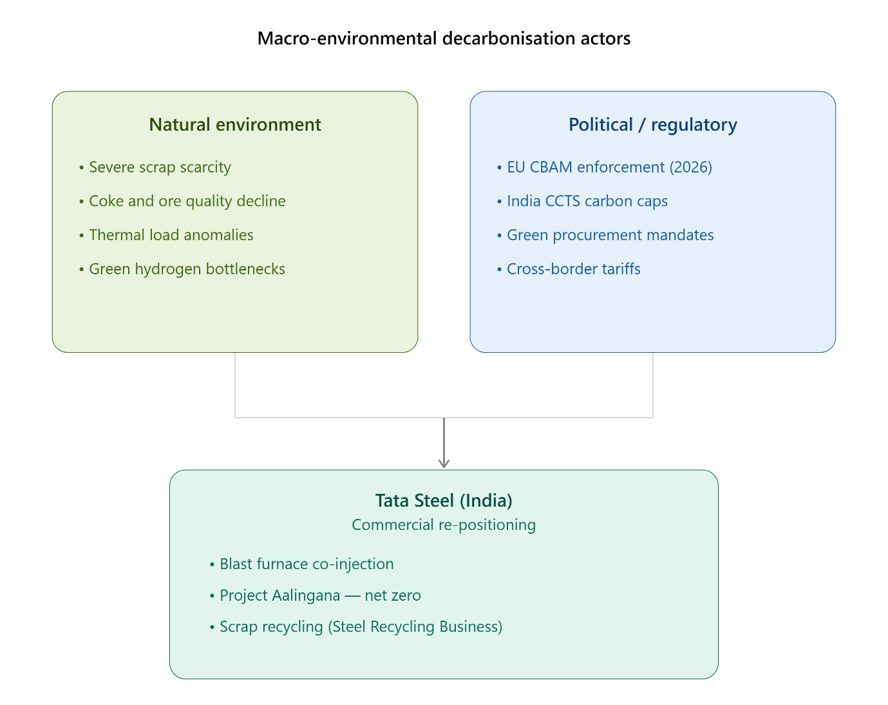
Figure:1 Macro-environmental forces influencing Tata Steel India’s low carbon transition (Source: Authors original conceptual model informed by Influence Map,2026 and Tata Steel, 2025)

1.1 The Natural Environment Actor:
The natural environment actor encompasses the physical environment, ecological systems, and natural resource inputs that are affected by or directly influence an organization’s marketing activities (Kotler and Armstrong 2020). For Tata Steel, the natural environment acts as a restrictive operational boundary, presenting severe resource scarcity, changing raw material properties, and physical climate risks that challenge legacy production methods.
Historically, India’s domestic steel industry has relied heavily on the Blast Furnace-Basic Oxygen Furnace (BF-BOF) model. This integrated production method relies on metallurgical coal as reducing agent to extract Iron from domestic iron ore. This process creates an inherent chemical dependency on carbon generating approximately 2.0 to 2.5 tonnes of Carbon dioxide (CO₂) per tonne of crude steel product produced in India─ a carbon intensity significantly higher than the global average (LSE Grantham Institute, 2025). The natural environment imposes a clear boundary here: continuing with unmitigated coal-based metallurgy accelerates the depletion of high-grade cooking coal reserves and creates severe ecological externalities, exposing the company to asset stranding and reputational risks in eco-conscious markets.
Furthermore, changing environmental conditions directly threaten Tata Steel’s manufacturing hubs in eastern India (Jamshedpur and Kalinganagar). These areas face rising average temperature more frequent heatwaves, and seasonal water shortages. Because traditional integrated steelmaking requires significant water cooling, these natural shifts threaten operational continuity and elevate financial risk.
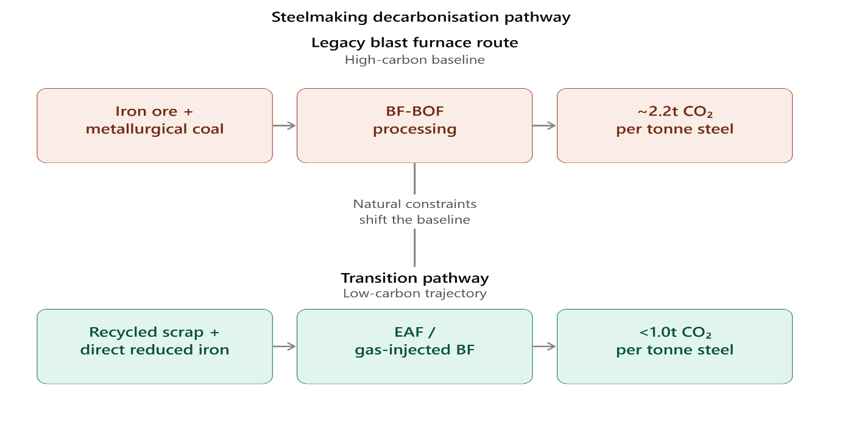
Figure 2: Thermodynamic process shift driven by natural resource boundaries. (Source: developed by author based on Carbon Tracker Initiative, 2025)

In response to these natural resource constraints Tata Steel has integrated circular economy principles into its material procurement through its steel recycling business. This model introduces a new product category by establishing scrap processing yards across India to supply cleaner inputs for steelmaking.
However, the natural environment presents a structural challenge: India faces a structural shortage of high-quality domestic steel scrap. This shortage requires the company to rely on imported scrap or continue operating blast furnaces that use natural gas and hydrogen co-injection (Reclimatize, 2026).
While Europe subsidiaries can access growing wind and solar grids to pursue hydrogen-based Direct-Reduced Iron (DRI) pathways, Tata steel’s domestic Indian facilities are constrained by the regional scarcity of renewable energy infrastructure. The domestic grid continues to rely heavily on coal-fired power, which temporarily limits the company’s ability to manufacture entirely zero-carbon steel in India. To manage this constraint, Tata Steel operates under project Aalingana─ the Tata group’s overarching sustainability framework which sets a net-zero target for 2045 (Tata Steel, 2026). This framework guides the company’s efforts to balance raw material use, improved energy efficiency, and gradually lower the carbon content of its core industrial products.

1.2 The Political and Regulatory Actor:
The political and regulatory actor consists of law, government agencies, and influential pressure groups that restrict or guide corporate decisions and marketing practices (Kotler and Armstrong 2020). For Tata Steel (India), this actor transforms sustainability from voluntary public relations initiative into a mandatory legal requirement for market entry and financial viability. The primary regulatory mechanism driving this shift is the European Union’s Carbon Border Adjustment Mechanism (CBAM). CBAM applies is a carbon emissions tariff to carbon- intensive goods entering the EU market, effectively matching the price of the EU Emission Trading System (ETS) allowances (S&P Global, 2026).
Historically, Europe has served as a high-margin export market for Indian steel manufacturers (ScienceDirect, 2025). Because Indian steel carries a high average carbon footprint than European alternatives, CBAM tariffs threaten to erode Tata Steel’s price competitiveness in Europe (Fast markets, 2026).
This regulatory pressure forces the company to separate its product lines, designating lower-carbon batches for strict international export markets while optimizing domestic operations to meet compliance standards.

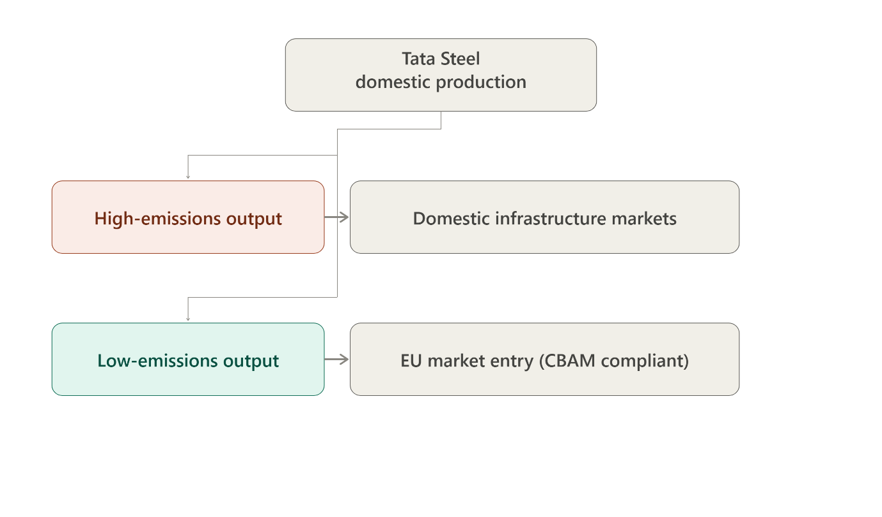
Figure 3: Export market separation forced by CBAM regulatory boundaries. (Source developed by author based on Reclimatize, 2026)
Concurrently, domestic regulatory frameworks in India are tightening. The government has introduced the Carbon Credit Trading Scheme (CCTS), which establishes specific greenhouse gas emission compliance targets for energy-intensive industries, including iron and steel (LSE Grantham institute, 2025). Under the CCTS, facilities that exceed their allocated emissions intensity targets face escalating financial penalties, while cleaner operations receive tradable carbon credits. This domestic carbon pricing framework directly impacts Tata Steel’s product positioning and cost structures. The company can no longer view environmental compliance as an isolated operational cost. Instead, it must treat low-carbon metrics as a central part of its product value proposition to shield downstream industrial buyers from regulatory costs.
To manage these changing cross-border and domestic regulation, Tata Steel engages with international public-private coalitions. The company became the first Indian steel manufacturer to join the Leadership Group for Industry Transition (LEADIT), an UN-supported initiative backed by the governments of India and Sweden (Tata Steel 2026).
By collaborating with international regulatory bodies, technology developers, and sustainability think thanks, Tata Steel aligns its long-term product roadmap with emerging international environmental standards. This active regulatory engagement helps ensure the company retains market access and maintains it competitive standing as global trade policies increasingly favour lower-carbon products.

TASK 2: Strategy Growth and Competitive Positioning
To sustain its market leadership during this structural and transition, Tata Steel (India) must design its long-term commercial goals using the Ansoff Matrix. This framework evaluates growth opportunities along two dimensions: products and markets (Ansoff ,1957). For an industrial manufacturer transitioning to a low-carbon business model relying on legacy, carbon-heavy commodities poses high risks. Tata Steel (India) can achieve a sustainable competitive advantage by balancing a product development strategy for established markets with a targeted market development strategy for green global supply chains.
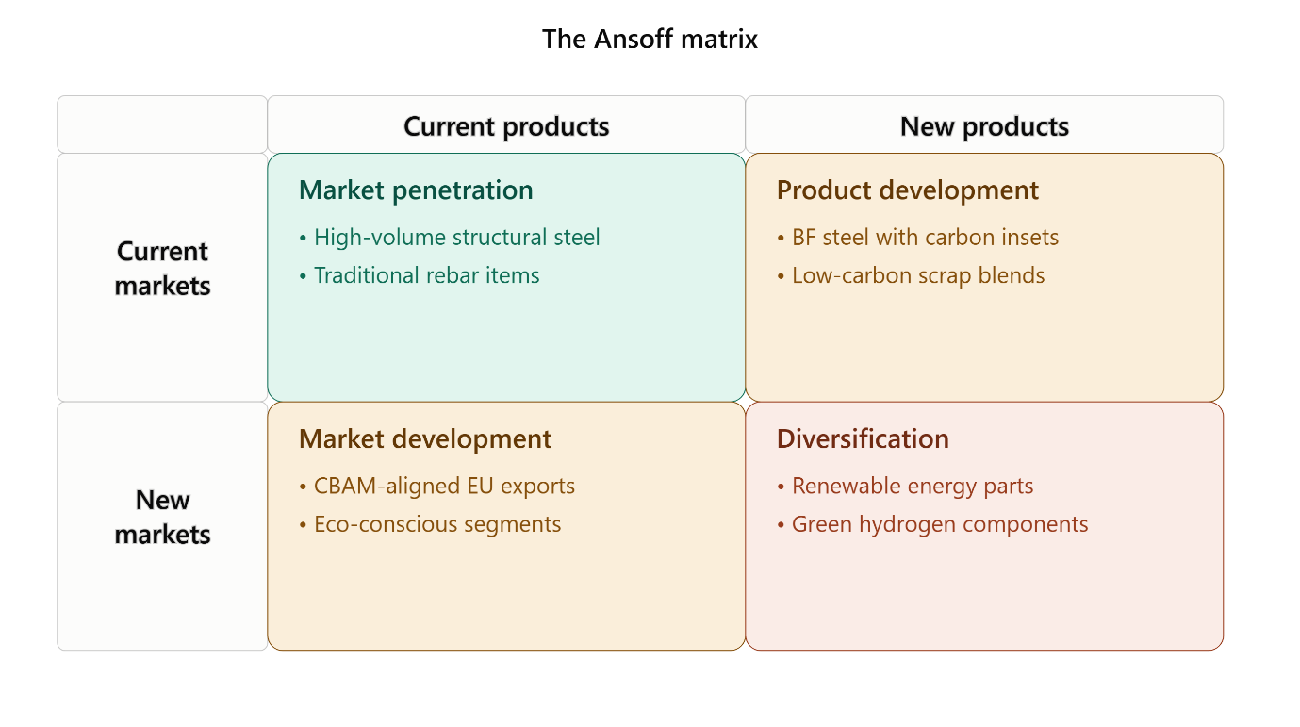
Figure 4: Tata Steel India’s growth options mapped on the Ansoff Matrix. (Source adapted by author from Ansoff, 1957)
2.1 Product Development Strategy:
Product development involves introducing modified or entirely new products into existing market segments (Kotler and Armstrong, 2020). Tata Steel (India) applies this strategy by adjusting its core metallurgy low-carbon variations of its established structural and automotive steel portfolios.
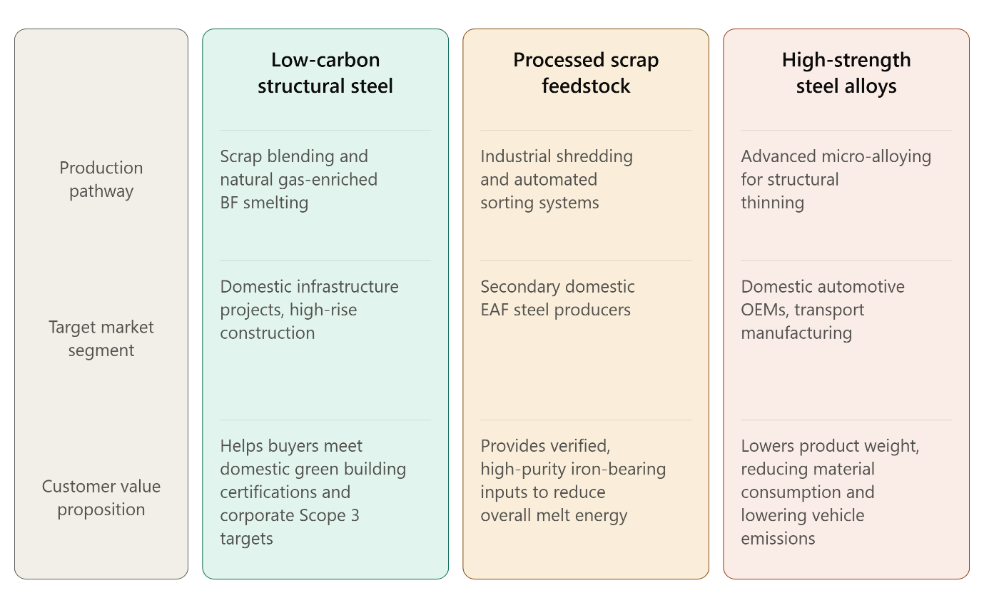
Figure 5: Tata Steel India’s developing low-carbon product portfolio. (Source compelled by author from Tata Steel UK, 2024 and Reclimatize, 2026)
By offering these advanced products, Tata Steel addresses the changing requirements of its domestic industrial clients. Major automotive manufacturers and consumer appliance brands in India face increasing pressure to lower their Scope 3 value chain emissions to satisfy international investors and local green procurement guidelines. By providing high-strength, lower-carbon steel alloys, Tata Steel allows these manufacturers to reduce the embedded carbon of their finished goods without requiring them to redesign their existing assembly lines. This strategy forms a strong competitive barrier against low-cost, unmitigated commodities steel imports, which face increasing regulatory and corporate scrutiny.
Furthermore, expanding the Steel Recycling Business represents an industrial-scale product development effort. By establishing organized sourcing and processing networks for scrap metal, Tata Steel transforms raw scrap into high-purity, standardized industrial inputs. This product line supports secondary steel manufacturers across India by providing reliable access to produced scrap, which requires significantly less energy to melt than processing raw iron ore. This initiative helps position Tata Steel as a key partner in circular resource management within the domestic industrial economy.
2.2 Market development strategy:
Market development focuses on finding and entering new market segments or geographic territories using an organization’s current product capabilities (Kotler and Armstrong, 2020). Tata Steel (India) executes this strategy by targeting international supply chains that require verified low-carbon credentials, positioning its compliant product lines to navigate changing global trade barriers. As European regulatory bodies face in full CBAM enforcement, traditional steel exports that do not invest in carbon reduction phase higher entry costs in Europe (S&P Global, 2026). Tata Steel can leverage its carbon monitoring systems, developed in partnership with World Steel Associations Climate Action Program, to position its lower-emission product batches to capture high-margin European segments (Tata Steel 2026). This strategy allows the company to fill supply gaps left by international competitors who cannot provide verified emissions data, transforming regulatory compliance into an advantage for international market expansion.
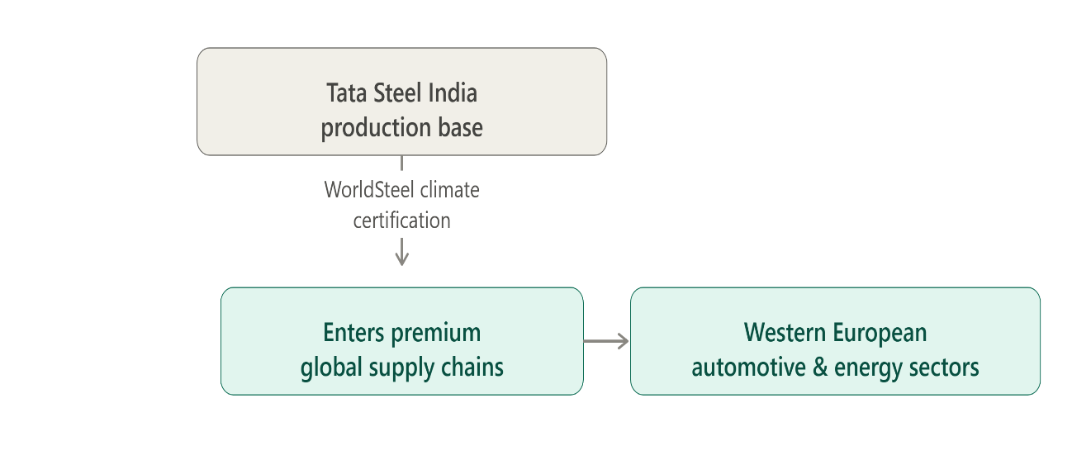
Figure 6: Market development pathway using verified sustainability credentials. (Source: developed by author based on Tata Steel, 2026)
Concurrently, this market development approach applies to specialized clean energy infrastructure segments within India. The rapid deployment of national solar arrays, wind turbine networks, and green hydrogen infrastructure requires specialized structural steel that can withstand diverse environmental conditions. By targeting renewable energy developers with certified, durable structural products, Tata Steel enters an expanding domestic market segment this strategy reduces the company’s long-term dependence on traditional volatile commercial real estate markets, aligning its commercial growth with national green energy investments.
2.3 Securing Sustainable Competitive Advantage:
According to Porter (1985), organizations can achieve competitive advantage through cost leadership, differentiation or a focused niche strategy. Tata Steel (India) is positioned to secure a sustainable differentiation focus advantage in its target markets. Because green hydrogen access and low-carbon scrap supplies are projected to face structural shortages through the turn of the decade, verified lower- carbon steel will remain premium product (Bellona, 2024). By establishing early, audited supply chains and securing recognized sustainability certifications, Tata Steel can command a green premium from commercial buyers who must meet strict Scope3 targets. This differentiation is further supported by deep technique technical integration with long-term customers. Co-engineering specialized, high-strength steel compositions for specific automotive platforms or infrastructure applications creates high switching cost for industrial buyers.
Consequently, Tata Steel protects its market share and insulates its revenue streams from the price volatility of the global commodity steel market. This approach demonstrates that a structured, low-carbon transformation can serve as an effective driver of commercial growth and long-term asset value.

TASK 3: Critical Reflection on AI Usage
3.1 Tool Disclosure:
In developing this industrial research report, Large Language Models (LLMS) were used as research assistants to improve data organization, review long corporate publications, and refine the structural flow of analysis. Specifically, the AI assistant was utilized to scan long public documents, including the Tata Steel Corporate Sustainability reports and industrial briefs regarding the European Union’s Carbon Border Adjustment Mechanism (CBAM). The AI was introduced instructed to find specific operational timelines, investment, numbers and technological definitions, such as the target milestone for Project Aalingana and the emission baseline associated with the Indian Carbon Credit Trading Scheme (CCTS). Furthermore, the AI help draft the initial layout of Ansoff Matrix diagram and tables, ensuring that the theoretical definitions aligned with established marketing literature.

3.2 Critical Evaluation of AI Output:
While the AI tools provided strong structural support, the generated text required close critical evaluation to identify and correct factual errors, temporal confusion, and logical gaps. A major limitation of raw LLM outputs is their tendency to merge distinct regional data or generate hallucinations concerning regulatory enforcement dates. For instance, in early AI draft stated that the Indian CCTS had already mandated a 40% reduction target for all domestic steel plants by 2025. Recognizing this as inaccurate, I cross-referenced the assertion against primary academic briefs, which confirmed that the initial phases of the CCTS focus on establishing reporting frameworks and gradual intensity reduction of roughly 2% annually (LSE Grantham Institute, 2025).
Additionally, the ai mixed operational details between Tata Steel’s domestic operations in India and its subsidiaries in Netherlands and UK. I manually corrected these errors by verifying that the 1.25 billion GBP Electric Arc Furnace investment applies specifically to the Port Talbot works in the UK (Tata Steel UK, 2026), whereas domestic Indian operations primarily utilize blast furnace optimizations, carbon captures pilots, and expanded scrap recycling yards due to regional energy grid limitations.

3.3 Contribution Analysis:
The final report reflects a clear division between automated processing and original analytical synthesis. The AI tool acted as an efficiency aid, organizing data, ensuring parallel grammatical structures in the comparative tables, and refining the text to meet professional clarity standards. In contrast, the critical evaluation of the macro- environmental forces and strategic positioning is entirely my own original work. Connecting Kotler’s marketing environment theory with material constraints of domestic scrap steel shortages in India require human synthesis to link corporate strategy with physical resources limitation. Furthermore, the evaluation of cross-border trade mechanics─ such as the margin pressure Indian exports face under CBA M (Science direct, 2025) ─ was manually developed to ensure the report looked beyond general corporate statement to evaluate the competitive challenges facing emerging-market industrial firms.
3.4 Ethical and Professional Reflection:
The integration of AI into strategic corporate analysis introduces important ethical considerations regarding intangible intellectual honesty, analytical transparency, and data integrity. Relying excessively on automated tools can lead to superficial analysis if an analyst accepts synthesized findings without verifying the primary source material. In industrial marketing, where corporate greenwashing carries significant reputational and legal risks, presenting unverified AI claims about carbon reduction metrics can mislead stockholders and violate professional standards. Professionally, an analyst must ensure that using AI tools does not compromise proprietary company data or run counter to institutional academic standards. By applying strict cross-verification against credible, peer-reviewed sources and corporate disclosure, this report maintains a high standard of analytical integrity. This balanced approach shows that AI can be used responsibly to improve research efficiency while keeping human oversight central to strategic analysis.

REFERENCES:
Ansoff, H. I. (1957) 'Strategies for Diversification', Harvard Business Review, 35(5), pp. 113–124.
Bellona (2024) Case study: H2 in Steel | Climate Solutions, Oslo: Bellona Foundation. Available at: frompollutiontosolution.org (Accessed: 19 July 2026).
Carbon Tracker Initiative (2025) Measuring Transition: Tata Steel, London: Carbon Tracker. Available at: carbontracker.org (Accessed: 19 July 2026).
Fastmarkets (2026) CBAM front-loading: how aluminium and HRC trade flows turned in late 2025. Available at: https://www.fastmarkets.com/insights/cbam-front-loading-how-aluminium-and-hrc-trade-flows-turned-in-late-2025/ (Accessed: 19 July 2026).
Fuel Cell Works (2025) Tata Steel's €2Bn Hydrogen-Driven Decarbonization in Netherlands Pledges. Available at: fuelcellsworks.com (Accessed: 19 July 2026).
InfluenceMap (2026) Climate Policy Engagement in India's Steel Sector, London:
InfluenceMap. Available at: https://influencemap.org/briefing/Indian-Steel-Sector-s-Climate-Policy-Engagement-38845 (Accessed: 19 July 2026).
Kotler, P. and Armstrong, G. (2020) Principles of Marketing. 18th edn. Harlow: Pearson Education.
LSE Grantham Institute (2025) What does the CCTS mean for the Indian steel sector, London: London School of Economics. Available at: https://www.lse.ac.uk/granthaminstitute/wp-content/uploads/2025/08/What-does-the-CCTS-mean-for-the-Indian-steel-sector.pdf (Accessed: 19 July 2026).
Porter, M. E. (1985) Competitive Advantage: Creating and Sustaining Superior Performance. New York: Free Press.
Reclimatize (2026) CBAM and Indian Steel: What the Carbon Levy Actually Costs. Available at: https://reclimatize.in/cbam-indian-steel/ (Accessed: 19 July 2026).
S&P Global (2026) Sustainability Insights: CBAM's Initial Impact Signals Divergent Prospects for Companies' Earnings. Available at: https://www.spglobal.com/ratings/en/regulatory/article/sustainability-insights-cbams-initial-impact-signals-divergent-prospects-for-companies-earnings-s101676323 (Accessed: 19 July 2026).
ScienceDirect (2025) 'Assessing the susceptibility of India's energy-intensive and trade-exposed industries to cross-border carbon tariffs', Journal of Cleaner Production, 412(1), p. 137320.
Tata Steel (2025) Climate Action - Corporate Decarbonisation Strategy. Available at: https://www.tatasteel.com/sustainability/environment/climate-action/ (Accessed: 19 July 2026).
Tata Steel (2026) Tata Steel partners with UN-backed LeadIT group to accelerate heavy industry transition. Available at: https://bit.ly/3OoiERx (Accessed: 19 July 2026).
Tata Steel UK (2025) Tata Steel advances low CO2 steelmaking plans. Available at: https://www.tatasteeluk.com/corporate/news/tata-steel-advances-green-steelmaking-plans (Accessed: 19 July 2026).
Tata Steel UK (2026) Green Steel Future: Electric Arc Furnace Transformation. Available at: https://www.tatasteeluk.com/green-steel-future (Accessed: 19 July 2026).
Diagram/table/chart references:
Figure 1: Author's original conceptual model, informed by InfluenceMap, 2026 and Tata Steel, 2025
Figure 2: Developed by author based on Carbon Tracker Initiative, 2025
Figure 3: Developed by author based on Reclimatize, 2026
Figure 4: Adapted by author from Ansoff, 1957
Figure 5: Compiled by author from Tata Steel UK, 2025 and Reclimatize, 2026
Figure6: Developed by author based on Tata Steel, 2026
All figures, diagrams design created by https://claude.ai

