

Cover Page

BMHP5014 Changemakers: Creativity and Value Creation
Component 1 – Portfolio
Name: Joan Miller
Student number: 2406689
Lecturer: Danni Dunne

Table of contents
Task 1 – Concept Map 3
Task 2 - Self-Reflection of Group Activity 3
Task 3 - Case Study of a UK innovation 4
Task 4 - Research Task 5
Task 5 - Podcast 6
Task 6 - NHS Leadership Framework Analysis 8
Task 7 - Self-Reflection Journal Entry 9
Reference List 10

Task 1 – Concept Map
Create a concept map that outlines the relationship between creativity, value creation, and health and social care improvement. Within the concept map explain how these concepts interact in a health and social care context (250 words).
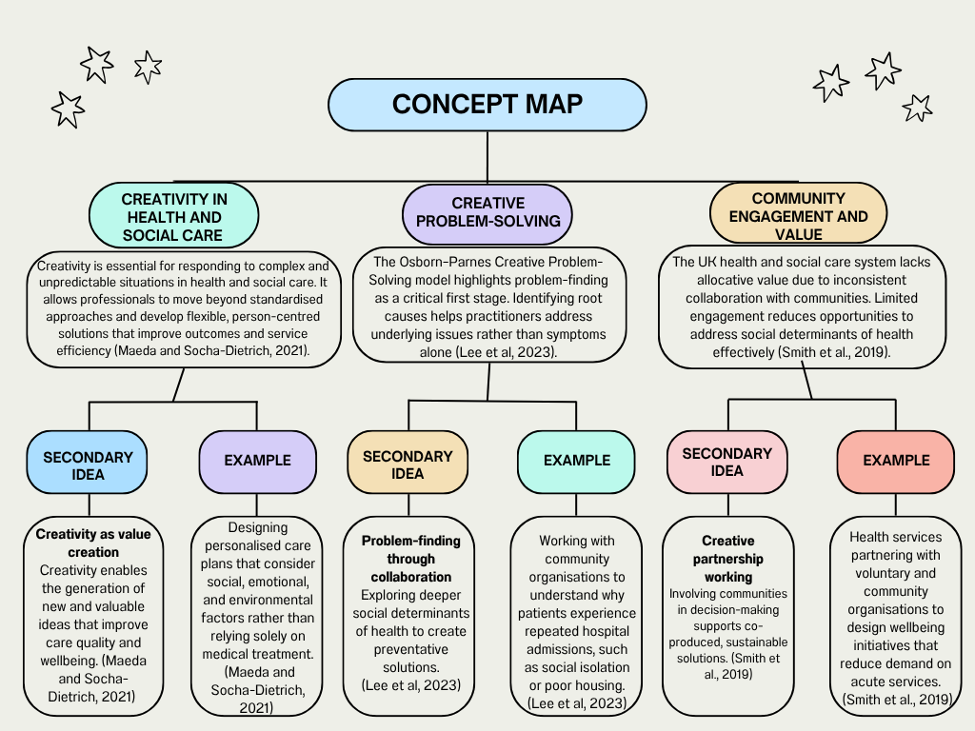

Task 2 - Self-Reflection of Group Activity
Complete a self-Reflection on the Convergent/Divergent paperclip thinking class activity using a reflective model (250 words, 1 source)
This reflection is based on the Gibbs Reflective Cycle (1988) and explores my experience of the paperclip creativity activity (Gibbs, 1988).
In a small group, we were given ten minutes to generate as many uses as possible for a paperclip. Although the task was general, I personally approached it from a health and social care perspective, as this is the focus of my course.
Because of this, I found the activity more challenging, and as a group we only came up with three general ideas that are commonly associated with paperclips, such as clipping papers together, acting as a temporary fastening, and pressing buttons on small devices. In the second part of the activity, I reflected individually and assessed whether these ideas were possible and whether they were the best options.
At the start, I felt quite stuck and slightly pressured by the time limit. I also felt frustrated that I was limiting my thinking to one sector, which made it harder to be creative. However, this made me more aware of how assumptions can restrict idea generation.
I did not play a large role in producing ideas during the divergent thinking stage, but I was more involved in the convergent thinking stage. I focused on evaluating the ideas, considering practicality, safety and whether they were realistic to use (Wang et al, 2023).
This activity helped me understand that divergent thinking involves generating ideas freely, and convergent thinking is about narrowing ideas down and making decisions. In future, I will try not to limit my thinking and to think more openly instead of narrow thinking, this will also improve my creativity.

Task 3 - Case Study of a UK innovation
Write a concise case study analysis of an innovative project or initiative within the NHS or UK social care. Focus on how creativity was used to drive change and the value it created for patients or service users (400 words, 2 sources).
Finding out, innovation in the NHS is more about doing more with few staff, rising patient numbers, and long waiting lists. For this case study I will analyse, one of the most innovative projects recently has been the use of artificial intelligence (AI) in diagnostics, particularly for conditions like skin and lung cancer. One example is in Leicester, Leicestershire, and Rutland, NHS teams partnered with tech developers to use AI to speed up skin cancer diagnoses (NHS England, 2023).
The idea was to take high-quality images of suspicious lesions using smartphones, run them through AI software, and flag the ones that needed urgent attention. This changes the whole diagnostic pathway so patients could get answers faster without necessarily needing a hospital appointment (NHS England, 2023).
The creativity in this project came from collaboration and the strong motivation to experiment. Healthcare professionals, IT experts, and AI developers did not put a tool onto the existing system, they redesigned workflows (Elechi et al, 2025). Patients could have their images taken in GP practices, the AI triaged the cases instantly, and specialists only reviewed the urgent ones. This freed up hospital resources and allowed doctors to focus on cases that genuinely needed their expertise (Elechi et al, 2025).
The impact on service delivery has been significant. In Leicester, around a third of referrals were discharged without a hospital appointment, which is a huge relief for both patients and overworked specialists (NHS England, 2023). In this scenario, AI did not replaced human judgment it works alongside it, speeding up decision-making while keeping care safe. Of course, there are challenges, like ensuring the AI is accurate and training staff to use it effectively, but the positives outweigh the negatives.
For patients, the value is clear that quicker reassurance, fewer unnecessary appointments, and faster access to treatment when needed. For the NHS, AI helps tackle capacity issues and improves efficiency, which ultimately benefits everyone (Elechi et al, 2025). These innovations demonstrate that creativity in healthcare can reimagine how care is delivered and using technology in ways that genuinely make a difference.

Task 4 - Research Task
Identify a current issue in health and social care (e.g. e.g., mental health stigma, access to care for vulnerable populations). Find two pieces of academic research (journal articles) that explain the reason for this problem. Paraphrase the findings of each article (300 words, 2 sources).
A significant current issue in health and social care in the United Kingdom is socioeconomic and ethnic inequality in screen-detected breast cancer. Although the breast screening programme provided through the National Health Service aims to promote early diagnosis and improve survival rates, participation and outcomes are not equal across all groups (Butnari et al, 2025). Women from deprived socioeconomic backgrounds and those from Black, Asian and minority ethnic communities are less likely to attend screening appointments (Butnari et al, 2025). Consequently, breast cancer in these populations are more frequently diagnosed at a later stage, contributing to poorer outcomes and widening health inequalities.
Research by Scott and Hoskin (2024) looked at why these inequalities exist in the UK. Their review found that people from lower-income areas often have lower awareness of cancer symptoms and screening and face practical barriers like getting time off work or traveling to appointments. Ethnic minority groups can also face language difficulties, cultural differences, or less trust in healthcare services. These factors mean many people delay going to the doctor or getting referred for tests, which can result in cancer being diagnosed at a later stage (Scott and Hoskin, 2024).
Another study by Baird et al., (2021) focused specifically on women from Black, Asian, and minority ethnic backgrounds. They found three main reasons why these women might skip breast screening: not knowing enough about it, practical difficulties like transport or scheduling, and cultural or personal beliefs about cancer and healthcare. For example, some women were uncomfortable with the procedure, worried about stigma, or didn’t understand why screening mattered. The researchers suggest that outreach needs to be culturally sensitive and community-based to help more women attend (Baird et al., 2021).
In conclusion, socioeconomic and ethnic inequalities in screen-detected breast cancer remain a pressing issue in UK health and social care. Evidence demonstrates that later diagnosis among disadvantaged and minority groups is influenced by a complex interaction of health literacy, structural access barriers, and cultural factors. Addressing this issue requires targeted public health strategies, improved accessibility, and culturally competent services in order to reduce disparities and promote equitable cancer outcomes.

Task 5 - Podcast
Record a two-minute Podcast introducing your idea for component 2.
Podcast link: Joan Miller Breast cancer podcast.mp3
My idea is an AI culturally sensitive digital tool designed to improve early breast cancer detection by providing tailored education, interactive self-check guidance, and a symptom tracker that links directly to NHS referral pathways. It specifically targets women from ethnic minority and socioeconomically deprived communities, empowering them to engage with their health while addressing barriers that contribute to late-stage diagnosis.
Podcast script: Welcome to this podcast episode, exploring an innovative solution to improve health and social care in the UK. I am Joan Miller, and today I want to introduce a project aimed at improving early breast cancer detection: A culturally sensitive AI risk assessment and breast awareness tool.
Research shows that women from ethnic backgrounds and social economically deprived backgrounds are more likely to be diagnosed with breast cancer at a later stage. Barriers such as cultural myths, language differences, and limited knowledge about self-checking contribute to this inequality. This tool will address these challenges by providing tailored education that respects cultural beliefs and stop common breast cancer myths.
The AI tool includes interactive self-check guidance, using gamification and visual demonstrations to encourage regular breast awareness. Many women from different backgrounds, do not routinely practice breast self-checks, and this tool makes this process engaging, informative, and culturally sensitive. Users can also log symptoms through a visual tracker, which links directly to NHS two-week wait referral pathways, ensuring timely follow-up when needed.
Importantly, there is a successful example, the ReCITE project in Liverpool successfully increased breast screening attendance among Black and South Asian women. The project led to a 25% reduction in missed mammogram appointments, showing that culturally sensitive approaches can improve early detection in practice.
By combining education, self-assessment, and direct referral pathways, this innovation supports both patients and healthcare professionals. It empowers women to take an active role in their health, reduces inequalities in early detection.

Task 6 - NHS Leadership Framework Analysis
Write a short summary (200 words) explaining the key components of the NHS Leadership Framework. Then, choose one component and describe (150 words) how a leader might use it to encourage creativity and improve care in the NHS (2 sources).
The NHS Leadership Academy developed the NHS Leadership Framework to describe the behaviours and skills needed for effective leadership within the National Health Service (NHS Leadership Academy, 2011). The framework distinguishes that leadership is not limited to senior managers, it can be shown by staff at all levels of healthcare. Its main goal is to support better leadership practices that improve patient care, staff performance, and the overall value of healthcare services.
Often referred to as domains, the framework consists of several key components. These include demonstrating personal qualities, working with others, managing services, improving services, and setting direction (NHS Leadership Academy, 2011). Each domain highlights important behaviours that help leaders guide teams and deliver effective healthcare. For example, demonstrating personal qualities focuses on self-awareness, honesty, and continuous learning. Working with others emphasises teamwork, respect, and good communication. Managing services involves organising staff, resources, and daily operations efficiently. Improving services focuses on reviewing current practices and making changes to improve care quality. Finally, setting direction involves creating a clear vision and planning for the future of healthcare services (NHS Leadership Academy, 2011).
Overall, the framework helps NHS organisations develop strong leadership that supports safe, effective, and patient-centred care (NHS Leadership Academy, 2011).
One important component of the NHS Leadership Framework is improving services, which focuses on finding ways to make healthcare delivery more effective and patient-focused (Zarif et al, 2024). A leader in a GP medical centre can use this component to encourage creativity by involving staff in discussions about how services can be improved.
For example, a practice manager at a GP surgery may notice that patients often wait a long time for routine appointments. Instead of making changes alone, the manager could ask receptionists, nurses, and doctors to share ideas. Staff might suggest introducing online booking or allocating certain appointment slots for same-day consultations. These ideas can then be tested to see if they help reduce waiting times.
By encouraging staff to share suggestions and try new approaches, the leader creates an environment where creativity is welcomed. This improves patient access to care and makes staff feel more involved in improving how the GP practice operates (Zarif et al, 2024).

Task 7 - Self-Reflection Journal Entry
Write a short journal entry about what you learned in this module. Focus on how your understanding of creativity and value creation withing H&SC has changed and how it has informed your professional practice (200 words).
This module has heightened my view on creativity and value in health and social care. At the start, I did the paperclip thinking task, and I had to think of as many ideas as possible for a paperclip. I didn’t get many ideas at all and realised I was just stuck thinking in the usual way, inside the box.
Over the weeks, though, I’ve noticed my creativity improving. I’ve learned to think in different ways, using both convergent thinking, focusing on practical solutions, and divergent thinking, to explore lots of different possibilities. It’s made me see that creativity isn’t just about having random ideas; it adds value in health and social care. New ideas can improve how care is delivered, make patients’ experiences better, and help solve problems in smarter ways.
This new creativity also helped with my idea for Component 2. It allowed me to dig deeper into my innovation, adding more detail and refining how I could bring it all together
This has changed how I approach my work. I’m more open to trying new ideas and thinking differently about everyday tasks. Even small changes in the way we do things can make a real difference. I feel more confident suggesting ideas and understanding that being creative can go hand in hand with providing good care with others.

Reference List
Baird, J., Yogeswaran, G., Oni, G. and Wilson, E.E. (2021) ‘What can be done to encourage women from Black, Asian and minority ethnic backgrounds to attend breast screening? A qualitative synthesis of barriers and facilitators’, Public Health, 190, pp. 152–159. https://doi.org/10.1016/j.puhe.2020.10.013
Butnari, V., Scantlebury, P., Green, T., Pattni, D., Mansuri, A., Chinnery, W., Rajendran, N., Brannan, M., Cole, M. and Banerjee, S. (2025) ‘The crucial role of early diagnosis for patients and the nation, understanding the costs of late-stage cancer diagnosis from a large district general hospital in England’, Cost Effectiveness and Resource Allocation, 23(1), p. 60.
Elechi, U., Orobator, E.T., Udoh, K., Ngozi, E.O., Uzoma, C.A.E., Forson, K.A.A.M., Akanbi, O.O. and Tarawallie, M.A. (2025) ‘Artificial intelligence in healthcare: A narrative review of recent clinical applications, implementation strategies, and challenges’, Journal of Healthcare Leadership, pp. 863–876.
Gibbs, G. (1988) Learning by doing: A guide to teaching and learning methods. Oxford: Further Education Unit, Oxford Polytechnic.
Lee, T., O’Mahony, L. and Lebeck, P. (2023) ‘Creative problem-solving’, in Creativity and innovation: everyday dynamics and practice. Singapore: Springer Nature Singapore, pp. 117–147.
Maeda, A. and Socha-Dietrich, K. (2021) Skills for the future health workforce: Preparing health professionals for people-centred care. OECD Health Working Papers, (124), pp. 1–42.
NHS England (2023) Artificial intelligence helping to speed up skin cancer diagnosis in Leicester, Leicestershire and Rutland Integrated Care System. Available at: https://www.england.nhs.uk/long-read/artificial-intelligence-helping-to-speed-up-skin-cancer-diagnosis-in-leicester-leicestershire-and-rutland-integrated-care-system/ (Accessed: 6 February 2026).
NHS Leadership Academy (2011) Healthcare Leadership Model: The nine dimensions of leadership behaviour. Available at: 65589 Leadership Framework_Layout 1 (Accessed: 7 March 2026).
Scott, E.C.S. and Hoskin, P.J. (2024) ‘Health inequalities in cancer care: a literature review of pathways to diagnosis in the United Kingdom’, eClinicalMedicine, 76, 102864. https://doi.org/10.1016/j.eclinm.2024.102864
Wang, X., Hommel, B., Colzato, L., He, D., Ding, K., Liu, C., Qiu, J. and Chen, Q., 2023. The contribution of divergent and convergent thinking to visual creativity. Thinking Skills and Creativity, 49, p.101372.
Zarif, A., Bandyopadhyay, S., Miller, G. and Malawana, J. (2024) Delivering medical leadership training through the Healthcare Leadership Academy: a four year analysis’, BMC Medical Education, 24(1), p. 194.

