A study to explore the word length effect
Introduction
Memory, which is described as a “faculty by which the brain encodes, stores, and retrieves information.” ("Memory", n.d.), is important to everyday life.
A way in which memory was studied was exploring the word-length effect and the phonological loop. The phonological loop is “part of working memory that deals with spoken and written material” (McLeod, 2012) it consists of two parts; short-term phonological store and articulatory rehearsal component. It is part of the Working Memory Model from Baddeley and Hitch, 1974. The word length effect is the assumptions that “lists of short words are better recalled than lists of long words”. (Jalbert et al, 2011). The word-length effect is dependants on the articulatory control process, the word-length effect should be disrupted regardless of how it was presented. This is due to the length of the word and the corresponding time it takes to go through the articulatory control process, the longer the word, the more time it takes, the higher the chance of fading. James Nairne and Ian Neath (1997) suggest that decay-based theories of short-term memory and immediate retention, is greatly supported by the word-length effect. They state that “long words take up more rehearsal time than short words” (Nairne et al, 1997)), this means that the number of long words that can be rehearsed during the typical “2-sec decay window” (Nairne et al, 1997), is fewer than the number of short words being rehearsed. However, they do also explore how time is not the only factor involved in forgetting, and how other interferences, such as concentration, are involved in the process also. Comparing these finding to those of a study done with bilingual (Welsh and English) speaking children carried out by Ellis and Hennelly, (1980), this study lead to the prediction that “mental calculation in the Welsh language will be more difficult than that in English” (, as it is common for Welsh words to be longer than the English translation.
It is important to explore this particular area, especially with children as it can be the cause of students failing exams and struggling in schools compared to their classmates, overloading students with information can be harmful to them and put their phonological loop into overdrive, causing stress which could further impact their short-term memory. This study is a partial replication of the work that Baddeley, Thomson and Buchanan, (1975). The aim of this study is to explore whether the word length effect exists to effect memory recall.
Hypothesis
Participants will recall significantly more short words than long.
Method
Design
A within-subjects design was used. There was one independent variable with two conditions: the short words and long words. There was one dependant variable: the number of words recalled. Participants took part in both conditions of the experiment.
Participants
Convenience sample of 26 participants, all females. Age range 198-46 (M = 29.32. SD = 3.79). Participants were all undergraduate students from West Wales who took part in the study. All participants were naïve to the purpose of the experiment.
Materials
- Computer
- Large screen
- Pen and paper
Stimuli
- 2-word lists (see appendix 1) – 15 long (e.g., transaction, physician), 15 short (e.g. leap, tomb), chosen by Chief Researcher.
- Words presented on a blue background with white text (Ariel, size 72),
- words held on screen for 1 second, next shown after another second.
Procedure
See appendix 2
Results
The following results present the findings for the study on word length effect, on recall memory.
Chart 1

Chart 1 shows the median scores for short words was longer than the median for long words.
To examine if the median scores for both conditions are significantly different to the probability of .005, the non-parametric Wilcoxen statistical test was carried out.
A Wilcoxen signed-rank test showed a significant difference between the long and short words conditions (Z= -4.136, P = .001). Median recall scores for the short words were significantly better than for long words (7 and 3 respectively).
The results indicate that the hypothesis (participants will recall significantly more short words than long), was supported and provides support for the word length effect.

References
Ellis, N., & Hennelly, R. (1980). A bilingual word-length effect: Implications for intelligence testing and the relative ease of mental calculation in Welsh and English. British Journal Of Psychology, 71(1), 43-51. https://doi.org/10.1111/j.2044-8295.1980.tb02728.x
Greenway, C (2022). Report 1 – Word-length effect Intro and method. [Lecture to BSc Applied Psychology Level 4]. https://moodle.uwtsd.ac.uk/pluginfile.php/460348/mod_resource/content/2/Lecture%205%20WLE%20and%20report%20info%20powerpoint.pptx
Jalbert, A., Neath, I., Bireta, T., & Surprenant, A. (2011). When does length cause the word length effect?. Journal Of Experimental Psychology: Learning, Memory, And Cognition, 37(2), 338-353. https://doi.org/10.1037/a0021804
McLeod, S. (2012). Working Memory Model. Simplypsychology.org. Retrieved 8 March 2022, from https://www.simplypsychology.org/working%20memory.html.
Memory. Psychology Today. From https://www.psychologytoday.com/us/basics/memory.
Nairne, J., Neath, I., & Serra, M. (1997). Proactive interference plays a role in the word-length effect. Psychonomic Bulletin & Review, 4(4), 541-545. https://doi.org/10.3758/bf03214346

Appendices
Appendix 1
Word List Table
Condition 1 – Long Words | Condition 2 – Short Words
Transaction | Desk
Forgiveness | Leap
Physician | Mood
Proximity | Tank
Constitution | Rules
Rationalise | Roof
Interaction | Mend
Deductions | Snap
Representation | Tomb
Impatiently | Slow
Reinstate | Tape
Intimidating | Rack
Disorganised | Snore
Understanding | Lose
Illuminate | Paid

Appendix 2
Standardised procedures
To ensure that all participants have the same experience, researchers should ensure that they are all tested:
- In the same place, with the same equipment and materials placed in the same way.
- Under the same conditions, so the level of lighting, noise and heat remains the same for all
participants.
- At roughly the same time of day, as people may behave differently if tested at nine o'clock in the morning rather than five o'clock at night.
- Given identical standardised instructions in exactly the same way

Standardised Instructions: these are given in the chosen location and there may be more than one set for different (IV) conditions of the investigation. The standardised instructions are important, as each participant must receive the same instructions so they understand what to do in the study. Also, it ensures that each participant is treated the same and should help eliminate experimenter effects. You can read the instructions to the participant(s), or let them read the instructions themselves.

Standardised procedure for the word length effect study
An opportunity sample of students was used. Presumptive consent was gained.
The following instructions were presented verbally:
- Participants were asked to sit quietly facing the projector screen situated on the wall in front of them.
- You will take part in a short memory task.
- Please ensure that you have a pen and paper in front of you.
- Can you all see the screen and text on the power point clearly?
- You will be presented with 2 word lists – consisting of 15 words each.
- Following the first list – you will be asked to write any words remembered from the list (in any order). The next 15 words were presented in the same way.
- Participants received the long words first followed by the short words. They had 90 seconds to recall and write down the words from list one and list two.
- Words were presented in the middle of a blue screen every 2 seconds, for 1 second.
- The font was Arial, white, size 72.
- Participants were thanked for their participation.
- Participants were fully debriefed regarding the aim and hypotheses of the experiment.
Following the making of the accuracy of recalled words, raw data was analysed using a Wilcoxon signed-rank test on SPSS 26.

Appendix 3
Raw Data
Condition 1 (Long Words) | Condition 2 (Short Words
3 | 5
4 | 6
4 | 7
2 | 3
3 | 9
3 | 7
4 | 7
4 | 9
2 | 7
3 | 6
6 | 8
7 | 9
3 | 7
5 | 7
4 | 7
5 | 4
3 | 8
3 | 3
6 | 8
3 | 4
4 | 7
4 | 3
2 | 3
1 | 3
2 | 2
3 | 7

Appendix 4
Output Data
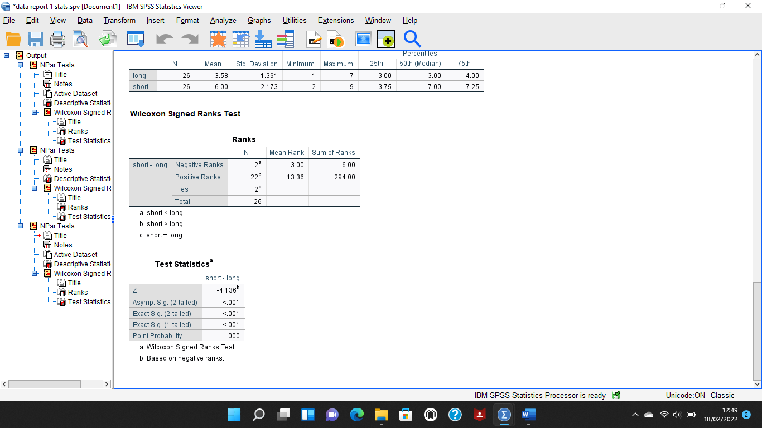
Appendix 5
Information and informed consent form

Centre for Psychology and Counselling

Study Consent Form
I understand that this research study is being carried out by a 3rd year Psychology Student for their dissertation, and that taking part in this study will involve taking part in two cognitive tasks.
This study will take approximately 15 minutes to complete.
I understand that participation in this study is voluntary and I am free to withdraw participation during or at the end of the study without giving a reason. I understand that once I leave the study, I will not be able to withdraw my data, as it will be anonymised. I am aware that if I have concerns about the study, I can discuss these concerns with the researcher at any time during or after the study. I understand that I will be provided with the contact details of the research supervisor at the end of the study, should I have any concerns.
I understand that the information provided by me will be held confidentially, with a code assigned in place of my name. These data will be stored indefinitely in accordance with the Data Protection Act.
I also understand that at the end of the study I will be provided with a debrief form and the opportunity to discuss any issues with the researcher.

I, ___________________________________(NAME) consent to participate in the study conducted by Georgina Brignell, Centre for Psychology and Counselling, University of Wales Trinity Saint David, under the supervision of Charlotte Greenway.

Participant Signature:________________________________________________
Date:___________________
Name and signature of researcher taking consent
_____

Appendix 6
Debrief sheet
Centre for Psychology and Counselling

Study Debrief Sheet
Study to explore the word-length effect

Thank you for taking part in the study.

The aim of this study was to explore the impact theword-length effect had on memory recall We specifically wanted to find out whether there was a difference in the recall scores of the participants depending on the length of the words they studied.

If you wish to withdraw your data from the study, you must tell the researcher now. After this point, all of your data will be anonymised and we will not be able to trace it back to you.

If taking part in this study has raised any questions, please speak to the researcher on Georgina Brignell (1901787@student.uwtsd.ac.uk) or contact the academic supervisor Charlotte Greenway (C.Greenway@uwtsd.ac.uk).

Thank you once again for taking time to participate in this study.

Georgina Brignell

BSc Applied Psychology

University of Wales Trinity Saint David

