University of Wales Trinity Saint David
Wales Institute of Science & Art



Dual Final Test 2 – Rideheight Variation Investigation

Six Sigma Green Belt ACMA5005

Rhys O’Shea
2415783
April 2026
Word Count - 4398

Table of Contents
Table of Contents 2
Table of Figures 3
Table of tables 5
1 Introduction 6
1.1 Company Background 6
1.2 Problem Context 6
1.3 Project Aim 6
2 Define 7
2.1 Problem Statement 7
2.2 Process Overview and Rideheight Measurement 9
2.3 Process Mapping 10
2.4 Project Charter 12
2.5 Voice of Customer/Critical to Quality 13
3 Measure 13
3.1 Identify Measurement Variation 13
3.2 Data Type Identification 14
3.3 Data Collection Plan 14
3.4 Measurement System Analysis 16
3.5 Baseline Performance/Process Capability 17
3.5.1 A:B Testing 18
3.5.2 Run At Rate 21
4 Analyse 25
4.1 Initial Data Analysis – A:B/ RaR Data 25
4.2 Elimination of Potential Root Causes 26
4.2.1 Cause and Effect (Ishikawa) Analysis 26
4.2.2 Equipment and Calibration Analysis 26
4.2.3 Comparative analysis by product type 27
4.3 Identification of Root Cause – FPC Units 30
4.3.1 Process Observation and Physical Investigation 30
4.3.2 Hypothesis Testing – Clamp force Investigation 31
4.3.3 Confirmation through Dataset Reintergration. 32
4.4 Root Cause Analysis 33
5 Improve 34
5.1 Generate Improvement Alternatives / Payoff Matrix 34
5.2 PFMEA 36
5.3 Should be/Future State map 37
5.4 Prevent Further Re-Occurrence 39
5.5 Validation of Change 40
6 Control 42
7 Bibliography 43
8 Appendices 46
8.1 Appendix A – FTPR and Yield Breakdown 46
8.2 Appendix B – SQL RaR Query 47
8.3 Appendix C – Minitab Commands 48

Table of Figures
Figure 1 - COPQ Report - AX Test Fails 8
Figure 2 - AX Rideheight Example (Renishaw, n.d.) 9
Figure 3 - ATOM Installation Guide (Renishaw, n.d.) 10
Figure 4 - ATOM Process Map (SmartDraw, n.d.) 11
Figure 5 - Project Charter (Croft-Bednarski, 2022) 12
Figure 6 - Run at Rate Concession (DU00092563) 15
Figure 7 - Run at Rate Concession Text (DU00092563) 16
Figure 8 - Measurement System Analysis - Repeat testing of 1off AX unit - Process Capability Report 17
Figure 9 - Histogram of Rideheight Midspan - DX A:B Test results 18
Figure 10 - Histogram of Rideheight Midspan - AX A:B Test results 19
Figure 11 - Process Capability Sixpack Report - Rideheight Midspan - DX units 20
Figure 12 - Process Capability Sixpack Report - Rideheight Midspan - AX units 20
Figure 13 - Histogram of Rideheight Midspan – Split by Variant (AX/DX) - RaR Test results 21
Figure 14 - RaR Capability Analysis Summary - Rideheight Midspan - AX units 22
Figure 15 - RaR Process Performance Report - Rideheight Midspan - AX units 22
Figure 16 - RaR Control Charts for Rideheight Midspan - Split by Variant (AX/DX) 23
Figure 17 - Yield by Month across Dual FTJ 2 (RUK52542) and Dual FTJ1 (RUK27163) 24
Figure 18 - FTPR by Month across Dual FTJ 2 (RUK52542) and Dual FTJ1 (RUK27163) 25
Figure 19 - Ishikawa Diagram (Eby, 2024) 26
Figure 20 - Layout of Rideheight Midspan Histograms - Split by Variant (AX/DX) - A:B Test Results across DFT2 and DFT1 - Pre and Post re-commissioning 27
Figure 21 - Layout of Rideheight Midspan Histograms - Split by Cable connector type - RaR results (1/3) 28
Figure 22 - Layout of Rideheight Midspan Histograms - Split by Cable connector type - RaR results (2/3) 28
Figure 23 - Layout of Rideheight Midspan Histograms - Split by Cable connector type - RaR results (3/3) 29
Figure 24 - Interval Plot of Rideheight Midspan vs Cable Connector 30
Figure 25 - Clamping Mechanism Not Contacting an FPC Body when clamped 31
Figure 26 - Layout of Rideheight Midspan Histograms - Split by Scale Period (20um/40um) and Clamping force 32
Figure 27 - Histogram of Rideheight Midspan - A:B test results - AX units - New Clamping force integrated 33
Figure 28 - 5 Why's Analysis (Weller, 2017) 34
Figure 29 - Payoff Matrix (LearnLeanSixSigma, 2026) 35
Figure 30 - Initial PFMEA 36
Figure 31 - Refined PFMEA 37
Figure 32- Current State Process Map 38
Figure 33 – Future State Process Map 38
Figure 34 - Dual Final Test Calibration Procedure (CP937-02) 39
Figure 35 - Updated Dual Final Test Calibration Procedure (CP937-03) 40
Figure 36 - Histogram of Yaw Midspan, OCL X, OCL Y and RM Width - Pre and Post Clamp Force Adjustment – DX units 41
Figure 37 - Histogram of Yaw Midspan, OCL X, OCL Y and RM Width - Pre and Post Clamp Force Adjustment - AX Units 41

Table of tables
Table 1 - RaR Result Summary 8
Table 2 - RaR Failure reasons 8
Table 3 - Voice of Customer/ Critical to Quality (VOC/CTQ) 13
Table 4 - Identification of Measurement Variation 14

Introduction

Company Background
Renishaw plc is a global engineering company, which specialise on high-precision measurement, motion control, and manufacturing technologies (Renishaw, 2026). Within the company, the Encoder Division is involved in the design and manufacture of high-accuracy position encoders for which are used in advanced motion control applications. These encoders are critical in providing real-time feedback of position, speed, and direction in applications such as machine tools, robotics, semiconductor manufacturing, and many other types of automated manufacturing systems. The accuracy of these products is critical in ensuring performance in high precision applications.

Problem Context
Manufacturing environments that produce high-precision components require strict control of process variation to ensure product quality and reliability. Six Sigma is a data-driven methodology that aims to reduce variation and improve process capability by applying structured problem-solving techniques to engineering problems (Six Sigma Institute, n.d.). This project utilises the Six Sigma DMAIC methodology to analyse variation in encoder rideheight measurements during production testing, where an instability in results was found during the validation of the new Dual Final Test Jig.
Rideheight is a critical to quality parameter that directly affects encoder performance and reliability. Excessive variation leads to increased failure rates, false pass/fail results, reduced yield, and increased cost of poor quality (COPQ), ultimately impacting production efficiency and customer satisfaction.

Project Aim
The goal of this project is to use the Six Sigma DMAIC methodology to investigate the reasons for the variation in encoder rideheight measurements encountered during validation and run at rate testing of the Dual Final Test 2 jig at Miskin facility. The project aims to identify the reasons for variation in encoder rideheight measurements and explore possible improvements to increase test capability, reduce failure rates, and lower costs of poor quality associated with this issue.

Define

Problem Statement
While conducting the validation of Dual Final Test Jig (DFT2), which is part of the Encoder Division at Renishaw, it was noticed that there was unexpected variation in the rideheight test results of the ATOM encoder assemblies. The DFT2 project was intended to upgrade an existing final test jig to provide dual testing functionality, rather than single mode functionality, i.e., instead of being able to conduct either analogue or digital testing, it can conduct both types of testing. This upgrade was intended to significantly increase production capacity and improve operational flexibility by allowing both analogue (AX) and digital (DX) encoder variants to be tested on the same platform.
Although initial validation of the upgraded jig was carried out using an A:B comparison test against the existing production jig (DFT1), preliminary tests had suggested there was possibly variation between the two test systems. However, as only 78 units had been tested at this stage, it was not enough to determine whether there was a significant measurement/process issue. As a result, a run-at-rate validation exercise was performed to collect a larger dataset under normal production conditions.
During this validation stage, it was noted that a significantly larger number of rideheight failures occurred compared to what had been anticipated (Table 2). Most of these failures were linked to analogue (AX) units and had a direct impact on the First Time Pass Rate (FTPR) and yield of the jig. The FTPR and Yield results sat below Renishaw’s set standard of 95% (Powell, 2011), these values can be seen in Table 1 and are split by variant , whereas the breakdown can be found in Appendix A.
Table 1 - RaR Result Summary
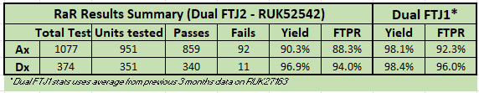
Table 2 - RaR Failure reasons
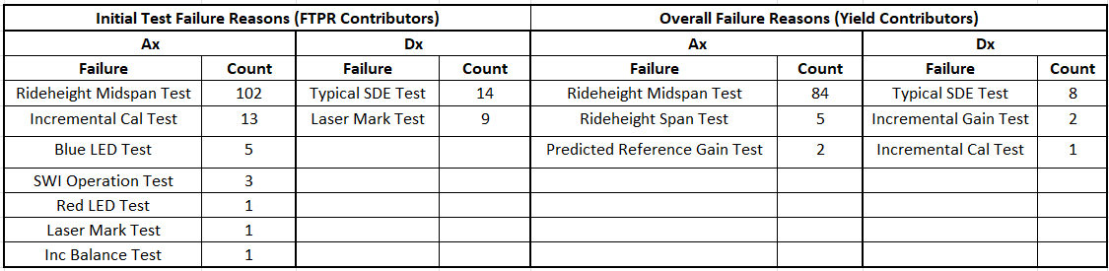
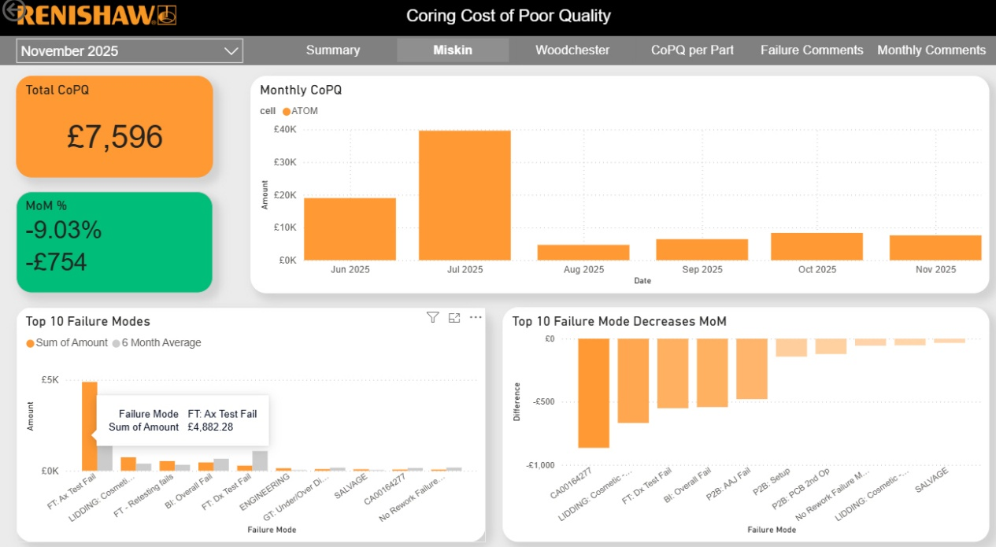
Additionally, there was a significant COPQ impact (£4,882) due to re-tests, scrap costs and production delays. This is highlighted in figure 1 below.

Figure 1 - COPQ Report - AX Test Fails
These initial observations indicated that the upgraded jig may not be capable of measuring rideheight consistently within the required tolerance limits. As rideheight is a critical parameter that directly influences encoder performance and installation reliability, it is important to identify and resolve the source of this variation, which became a primary objective of this investigation.

Process Overview and Rideheight Measurement
ATOM encoders rely on precise optical alignment between the Readhead and scale, where positional accuracy is critical to system performance. Within this system, rideheight is defined as the vertical distance between the Readhead and the scale surface (Renishaw, n.d.). Figure 2 illustrates the concept of rideheight within an AX encoder assembly, highlighting the measured distance between the Readhead and scale.
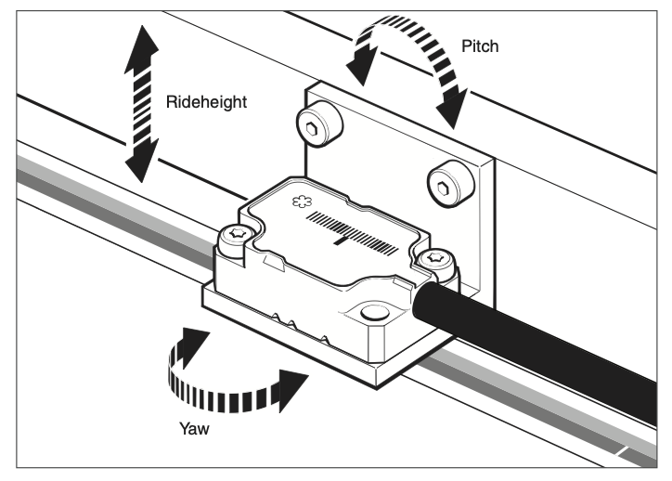

Figure 2 - AX Rideheight Example (Renishaw, n.d.)
Rideheight has a direct impact on the signal amplitude, signal quality, and precision of the encoder measurement system. If the rideheight is incorrect, the optical signals generated by the encoder can degrade, leading to reduced signal margin and potential tracking issues during operation (Renishaw, n.d.).
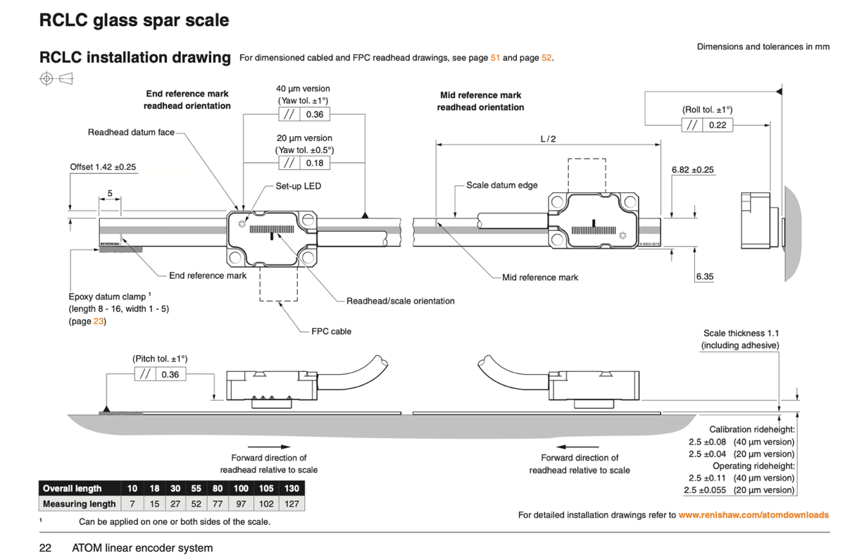
For the ATOM encoder family, the optimum rideheight is 2.5mm, which will ensure the encoder produces the maximum signal amplitude and has the required tolerance to installation variation, this can be seen highlighted in Figure 3.
Figure 3 - ATOM Installation Guide (Renishaw, n.d.)

During final test, rideheight is measured by vertically sweeping the Readhead across the scale and analysing the signal response. From this, the rideheight midspan is calculated and assessed against specification limits (2.487mm to 2.513mm) to determine pass or fail. Rideheight is therefore treated as a critical-to-quality (CTQ) parameter, where failure indicates either a product defect or an issue within the testing process.

Process Mapping
In the Define stage, a process flow chart (Figure 4) was created to provide a clear and organised view of the current process. Process mapping is an essential element of Six Sigma, as it segments the process into smaller units, thereby aiding the pinpointing of potential defect areas within the process (Hessing, n.d.) This will ensure that the data gathered in following stages is precise, which will provide a solid foundation for future analysis.
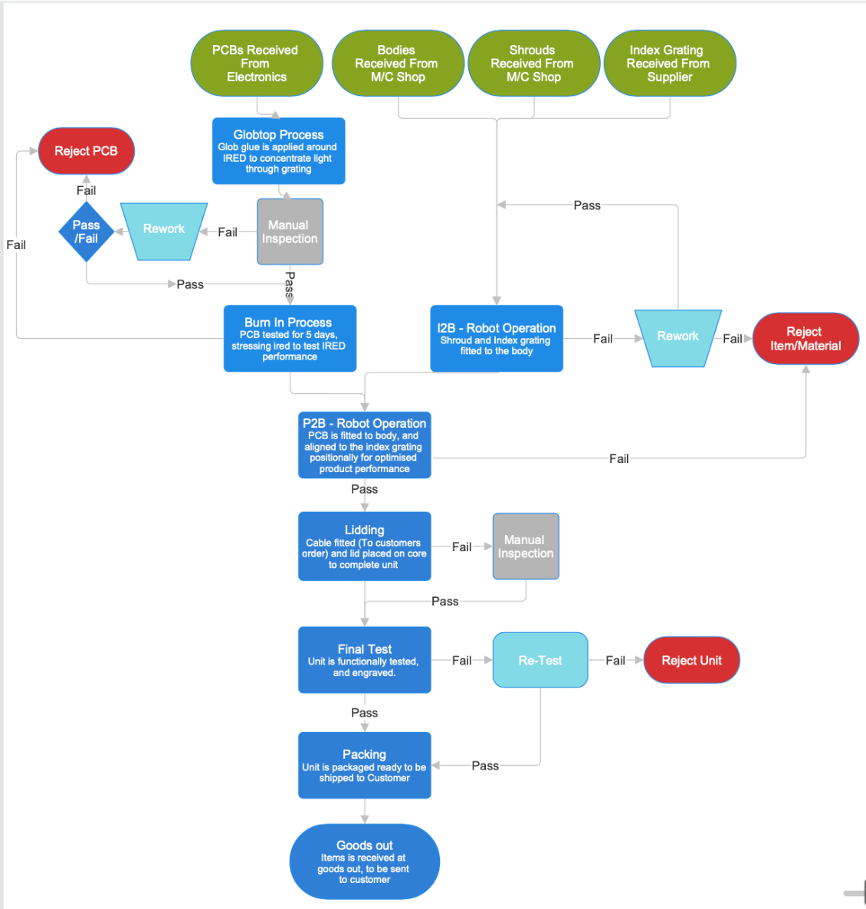
Figure 4 - ATOM Process Map (SmartDraw, n.d.)

Project Charter
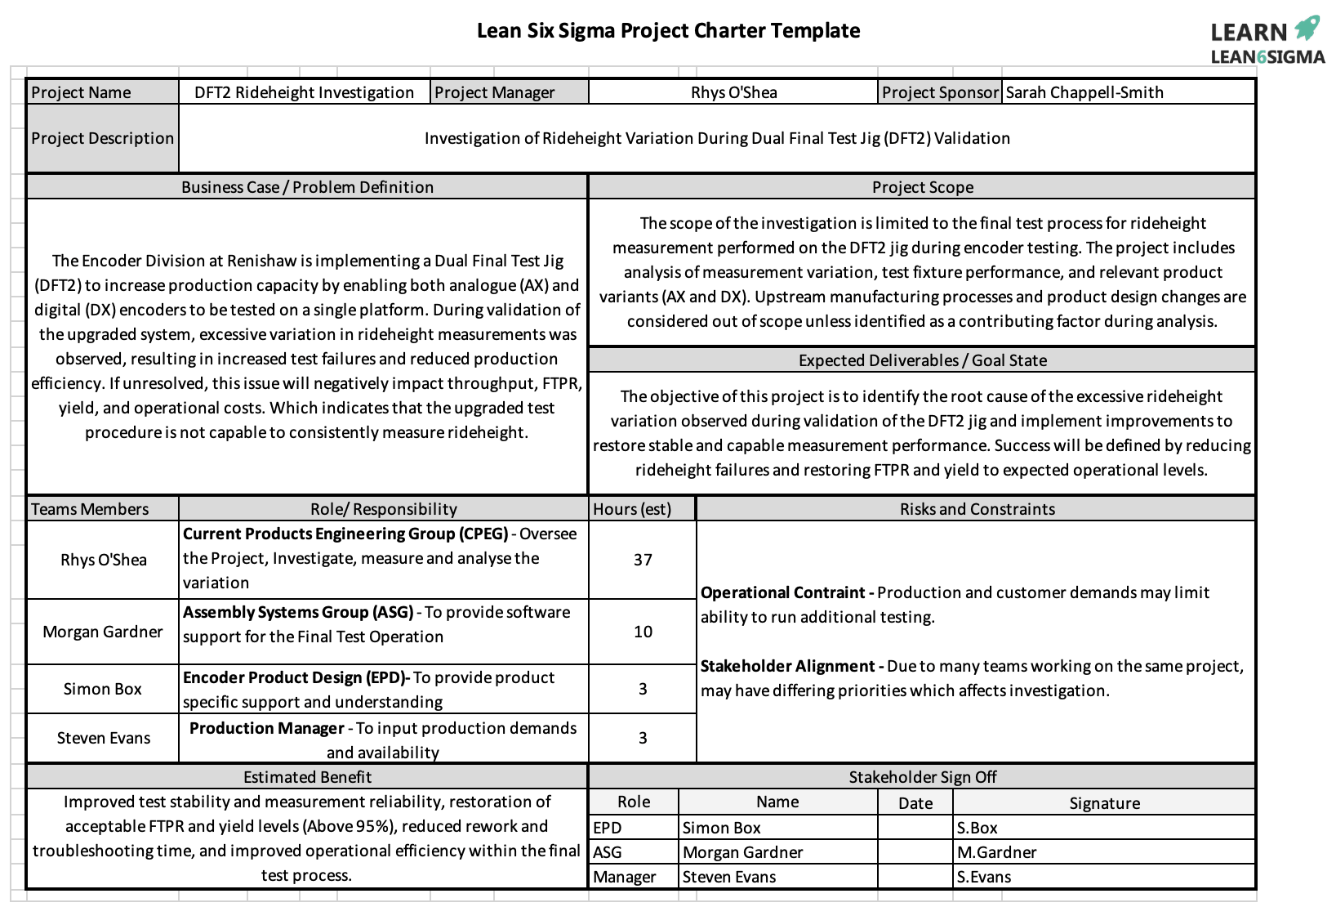
A project charter, shown in Figure 5, was developed to clearly define the direction of the project from the start. The project charter includes critical information about the project, such as the problem being addressed, the results expected, critical milestones, and the roles of all parties involved in the project. Bringing all the information together in one document helps in aligning all parties involved in the project, therefore creating a clear understanding of the purpose of the project and its success criteria (Institute Project Management, 2025)
Figure 5 - Project Charter (Croft-Bednarski, 2022)

Voice of Customer/Critical to Quality
Table 3 - Voice of Customer/ Critical to Quality (VOC/CTQ)
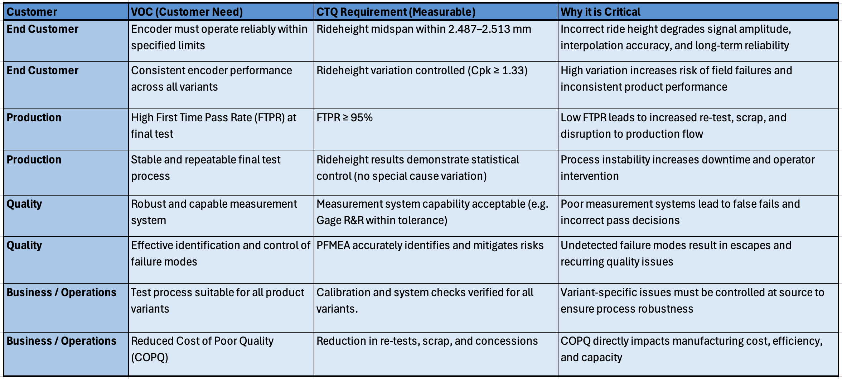

Measure

Identify Measurement Variation
Before analysing the performance of the process, it is important to identify and understand potential sources of variation in measurement, this ensures that any variation in rideheight is due to the process and not to any variation in the measurement system itself. This is an important aspect of understanding and defining variation in the Measure phase of DMAIC, and failure to do so might lead to inappropriate conclusions and improvement strategies (Hassing, n.d.)
Table 4 lists the potential sources of variation in measurement identified in relation to the Dual Final Test 2 (DFT2) rideheight variation investigation.
Table 4 - Identification of Measurement Variation
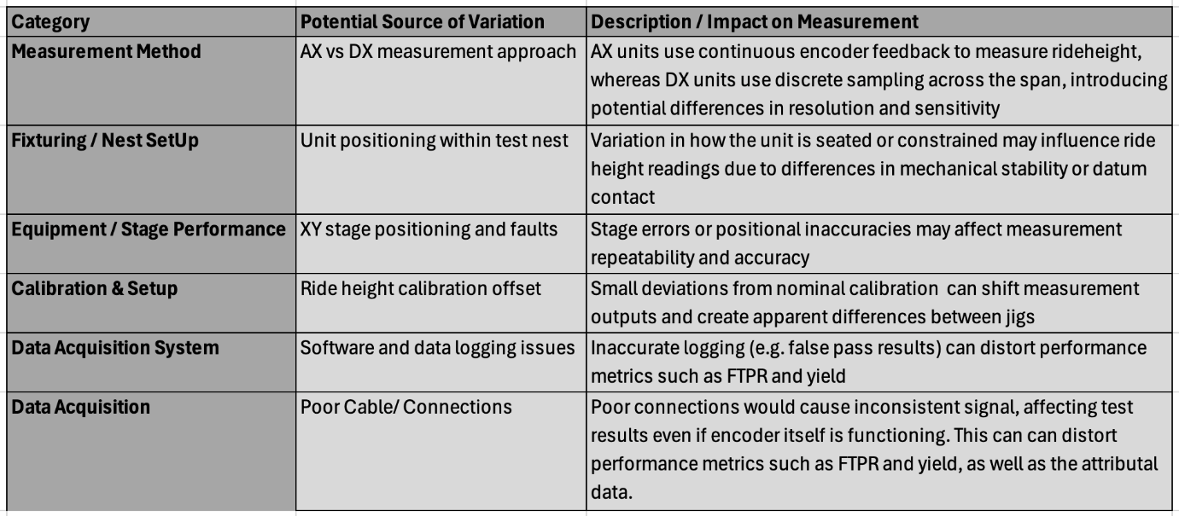
At this stage, several factors have been identified as potential contributors to variation in measurement. However, there is no single root cause identified. Therefore, these factors will be further analysed in the Analyse phase to determine their impact on rideheight variation.

Data Type Identification
The data collected for this investigation is mainly continuous data, and this primarily includes rideheight midspan, however other related data outputs, such as OCL and yaw are also to be considered. This type of data is useful in applying various statistical data analysis methods such as histograms, control charts, and process capability to analyse and interpret data variation (Hassing, n.d.).Along with this, other discrete data such as pass/fail, yield, and First Time Pass Rate (FTPR) have also been utilised to get a general idea of data variation in the Dual Final Test 2 system.

Data Collection Plan
A structured plan for data collection was established, ensuring that data collected for this investigation is consistent, reliable, and representative of both controlled and production environment tests. The main method for data collection was A:B testing, where a set of units were tested on both the Dual Final Test 2 (DFT2) jig and a known good jig Dual Final Test jig 1 (DFT1). This method ensures that direct jig comparisons can be made, as variations in measurements can be attributed to differing test processes instead of differing part to part results.
In addition to A:B testing, a Run at Rate (RaR) was also performed, where units were tested under standard production conditions for a period of approximately one month. A minimum of 100 units per variant was established as a requirement for sufficient data coverage, to capture data for different product types (AX/DX/20um/40um).
The Run at Rate was conducted under an approved concession (DU00092563) shown in Figure 6, at Renishaw a concession means a controlled deviation from standard process conditions (Powell, 2014). This enabled production to continue with the process and output product under a controlled environment whilst the issue and ongoing rideheight performance is under investigation/being analysed. This approach to using a concession is consistent with the principles of Six Sigma experimentation and verification (Bizmasters, 2024)
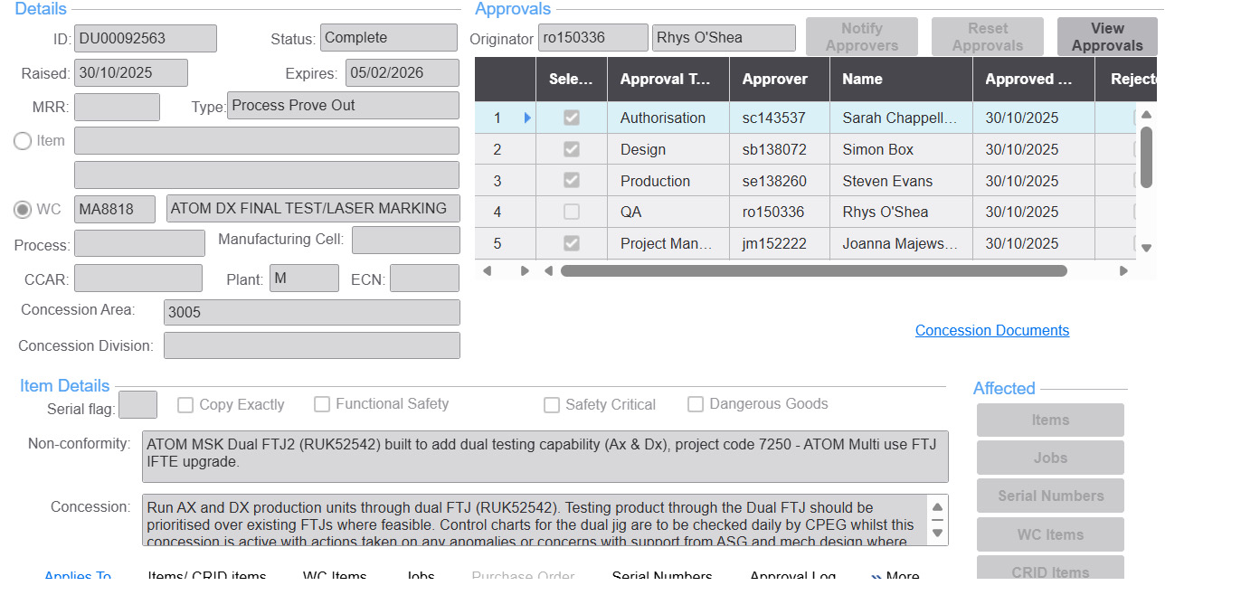
Figure 6 - Run at Rate Concession (DU00092563)
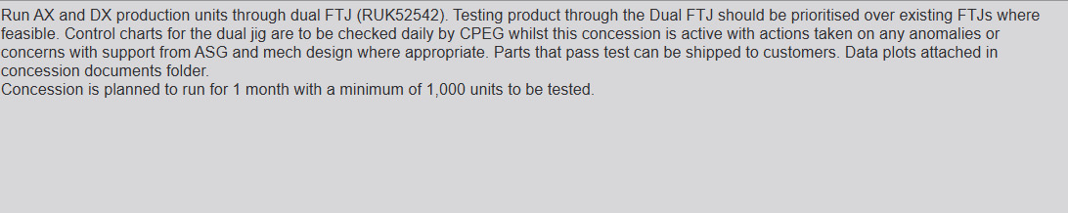
Figure 7 - Run at Rate Concession Text (DU00092563)
Using a combination of controlled A:B testing and concession-based Run at Rate has provided a robust and statistically viable dataset. This approach ensures consistent measurement and performance evaluation, providing a reliable baseline for analysing variation and capability. In order to conduct the statistical and graphical analysis accurately, Minitab statistical software has been used, as it is a widely recognised tool for performing robust statistical analysis and process capability evaluation within engineering and Six Sigma applications (iCertGlobal, 2023).

Measurement System Analysis
A Measurement System Analysis (MSA) was carried out to validate the reliability of the measurement system used to measure the rideheight on the Dual Final Test 2 (DFT2) jig. In Six Sigma DMAIC methodology, the MSA step plays an important role in ensuring that variation is due to the process rather than errors in the measurement system, this is because there is a risk of drawing wrong conclusions from the data without the validation (Lean 6 Sigma Hub, 2025).
The MSA mainly focused on the evaluation of the repeatability and reproducibility of the rideheight measurement process. The repeatability of the process was evaluated by conducting repeated tests on the same unit under the same conditions. From the results obtained, as presented in figure 8 below, it is evident that the results obtained from the process are highly consistent, given that the CPK value is 48.89, indicating that the equipment is highly capable of producing consistent results. This indicates that equipment related variation is minimal.
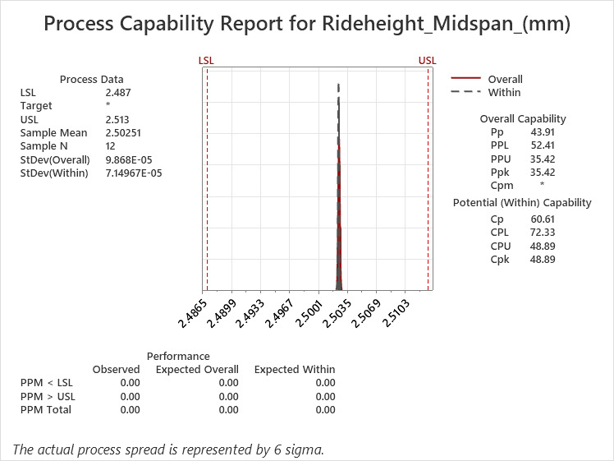
Figure 8 - Measurement System Analysis - Repeat testing of 1off AX unit - Process Capability Report

Reproducibility was evaluated through A:B testing, where the same units were used for both DFT2 and a known, established Dual Final Test jig. This allows for a comparison of measurement output results for different systems to ensure that consistent results are obtained. The results obtained from this process are further discussed in Section 3.5.
The results obtained from the MSA indicate strong repeatability of the measurement system under controlled conditions, with further evaluation of reproducibility and system variation being explored through comparative results in the following section.

Baseline Performance/Process Capability
By following the proposed data collection plan, data collection took place through controlled A:B testing as well as RaR production trials. This section presents the data collected, which provides a baseline before further analysis is conducted.

A:B Testing
A:B testing was carried out, using a specified number of units, which were then tested across Dual Final Test 2 jig as well as a proven Dual Final Test jig. This ensured that any discrepancies noted during the A:B testing could be attributed to the differing test systems.
A histogram of the results of the A:B testing for rideheight midspan are as shown in Figure 9 (DX) and Figure 10 (AX units).
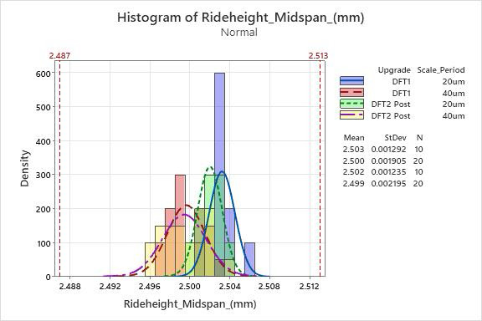
Figure 9 - Histogram of Rideheight Midspan - DX A:B Test results
After reviewing the data in Figure 9, it can be noted that the results of the DX units show a tight distribution with a high population density of over 180, which indicates that there is minimal variation in the data. This is further emphasised by low standard deviation values of 0.002 or less, therefore meaning that the rideheight results of DX units are highly consistent across both jigs.
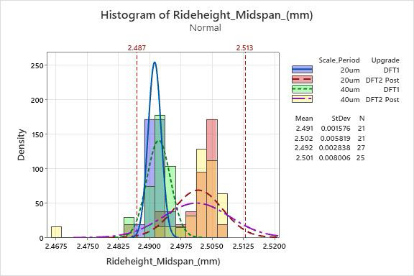
Figure 10 - Histogram of Rideheight Midspan - AX A:B Test results
On the other hand, it can be noted from the data in Figure 10 above that the results of the AX units show a wider distribution with a flatter curve. This indicates that there is greater variation in the data which is further supported by relatively higher standard deviation values of up to 0.008. This shows that the rideheight results of AX units are much less consistent.
The difference in variation of the data of the AX and DX units is further illustrated through process capability six pack analysis, as shown in Figures 11 and 12 below.
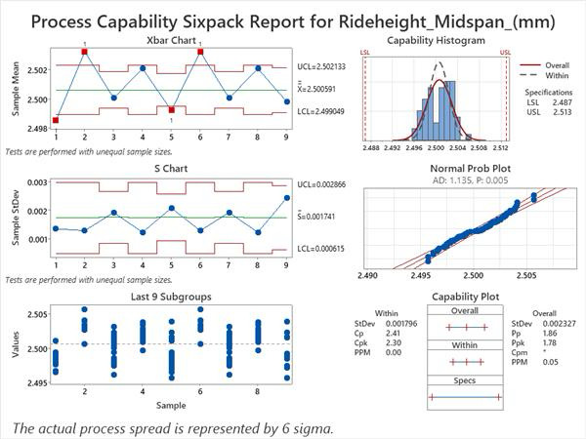
Figure 11 - Process Capability Sixpack Report - Rideheight Midspan - DX units
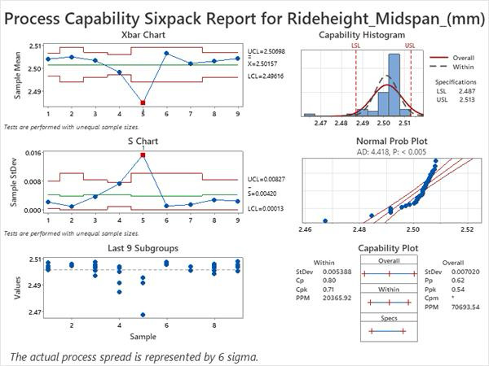
Figure 12 - Process Capability Sixpack Report - Rideheight Midspan - AX units

The results of the capability analysis conducted on the A:B test units show that the DX process is capable, as supported by the Cpk value of 2.3, which implies that the process is functioning well within the specification limits with minimal variation. However, the AX process is less capable, as shown by the Cpk value of 0.71, therefore suggesting that the process is not capable and has excessive variation beyond the specification limits. For comparison, the industry standard for a capable process is Cpk >1.33 (Six Sigma Principles, 2024).

Run At Rate
To analyse the process under typical production conditions, a Run at Rate test was performed for approximately 1 month. This enabled the collection of performance data with various operators, shift times, and environmental factors, which provides a representative view of the jig’s performance.
A histogram of rideheight midspan results from the RaR is shown in Figure 13 below and is separated by variant (AX/DX) as well as scale period (20µm / 40µm) to assess how they performed.
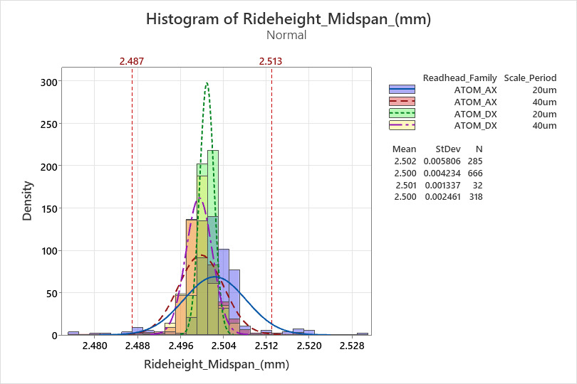

Figure 13 - Histogram of Rideheight Midspan – Split by Variant (AX/DX) - RaR Test results

The histogram shows similar behaviour to what was seen in the A:B testing. The DX units again show a similar tight distribution; however, the AX units show a wider distribution, again supporting that increased variation is present in this particular variant.
A process capability analysis was also performed on the RaR dataset, as shown in Figures 14 and 15 below.
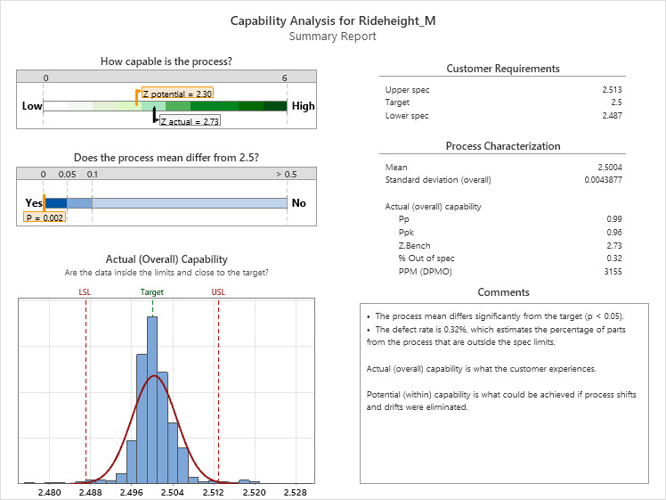
Figure 14 - RaR Capability Analysis Summary - Rideheight Midspan - AX units
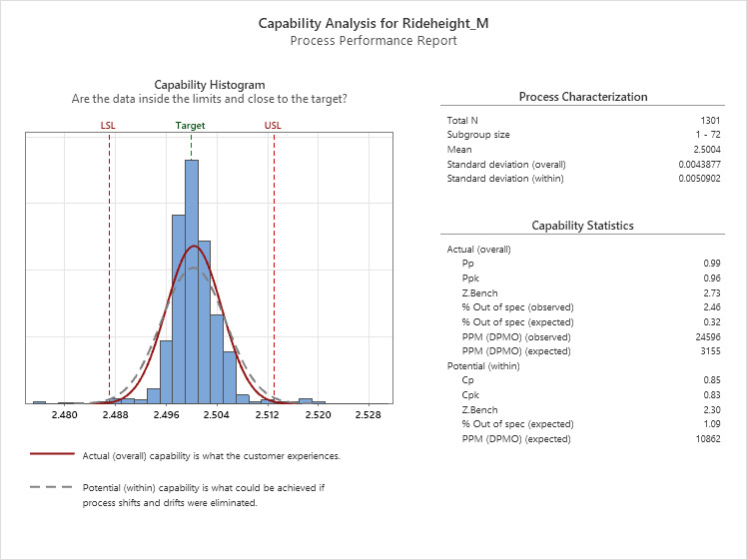
Figure 15 - RaR Process Performance Report - Rideheight Midspan - AX units
From the results, it is evident that the rideheight process is not capable, as indicated by a Cpk value of approximately 0.83. This means that under production conditions, the variation in the process is beyond acceptable limits and may result in results that are out of specification.

Control Charts
During the RAR control charts were set up using the Power BI software, in order to monitor all test modes and assess the performance of the test jig, using Dual Final Test 1 (RUK27163) as a comparator. The control charts for rideheight midspan results can be seen in figure 16 below.

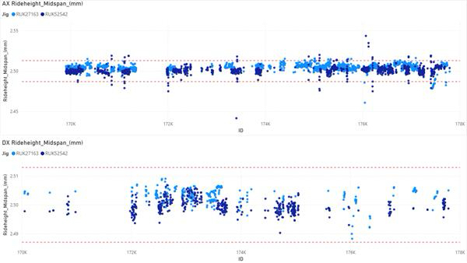
Figure 16 - RaR Control Charts for Rideheight Midspan - Split by Variant (AX/DX)

From the above control charts, the DX results appear to be generally very steady, all staying within the rideheight limits and no fails. There is some slight variability between batches, which is expected since units are being made across different robots.
For the AX results, the control charts demonstrate special cause variation characteristics on Dual Final Test 2 (RUK52542). This is due to the failures being bunched together at certain jobs or batches and are not spread out evenly throughout the entire dataset. This indicates that the variation is not entirely random and could be related to conditions or factors attributed to the individual units or batches (Hassing, n.d.).
Furthermore, the fact that this type of variation is not consistently seen across the other final test jigs indicates that the issue is not limited to being part related but could be related to the interaction between the part characteristics and the testing process, which will be investigated further in the Analyse phase.

Yield and FTPR
As mentioned in the problem statement, it is evident that the yield and FTPR in the Run at Rate do not meet the required standard at Renishaw. In order to evaluate the performance, these two metrics have been plotted monthly and Dual FTJ1 was taken as a benchmark to compare the results. It is seen that the Yield and FTPR of Dual FTJ2 is 92% and 89% respectively, which are both lower than the standard established. This comparison is illustrated in Figures 17 and 18 below.
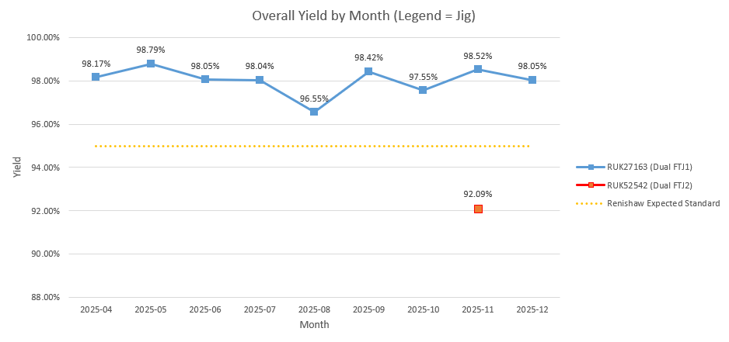
Figure 17 - Yield by Month across Dual FTJ 2 (RUK52542) and Dual FTJ1 (RUK27163)
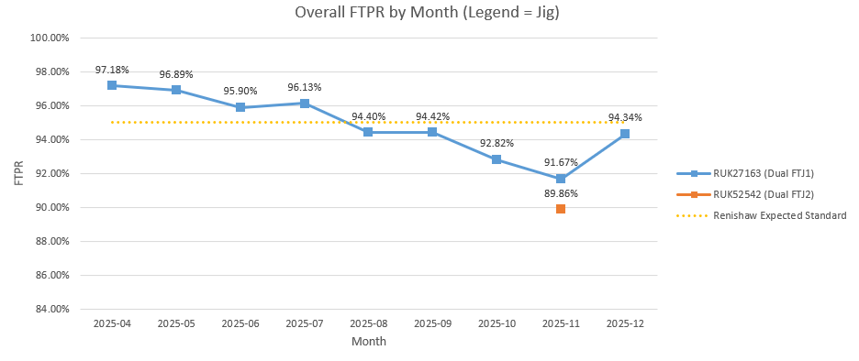
Figure 18 - FTPR by Month across Dual FTJ 2 (RUK52542) and Dual FTJ1 (RUK27163)

Figure 18 also demonstrates that Dual FTJ1 FTPR also dropped below Renishaw standard, however this is due to the de-commissioning of an old final test jig, which uncovered a separate issue with Dual FTJ1, Relative Phase, which is out of this projects scope.

Analyse

Initial Data Analysis – A:B/ RaR Data
As highlighted in the measure stage, Initial analysis of A:B and Run at Rate data confirmed that rideheight variation was predominantly associated with AX units, whereas DX units were stable. When compared to DFT1, this issue was only present on DFT2, indicating a process specific problem rather than part variation.
Process capability analysis further supports this, with AX units showing poor capability (Cpk < 1.33), making the process unsuitable for production, whereas DX units achieved acceptable capability (Cpk > 1.33), as established in the Measure phase.
These findings confirm that the source of variation is isolated to AX units on DFT2, providing a clear direction for further investigation in the Analyse phase.

Elimination of Potential Root Causes

Cause and Effect (Ishikawa) Analysis
To investigate rideheight variation an Ishikawa diagram was created, shown in Figure 19 below. An Ishikawa diagram (Cause and Effect Diagram) is a tool used in six sigma, to identify and organise potential causes of a problem. It does this by grouping possible causes into categories, which therefore allows a structured exploration of all contributing factors (Goldman, 2018). It can be seen that all categories which could affect rideheight variation have been considered, before then diving into specific factors, ensuring all potential causes are considered.
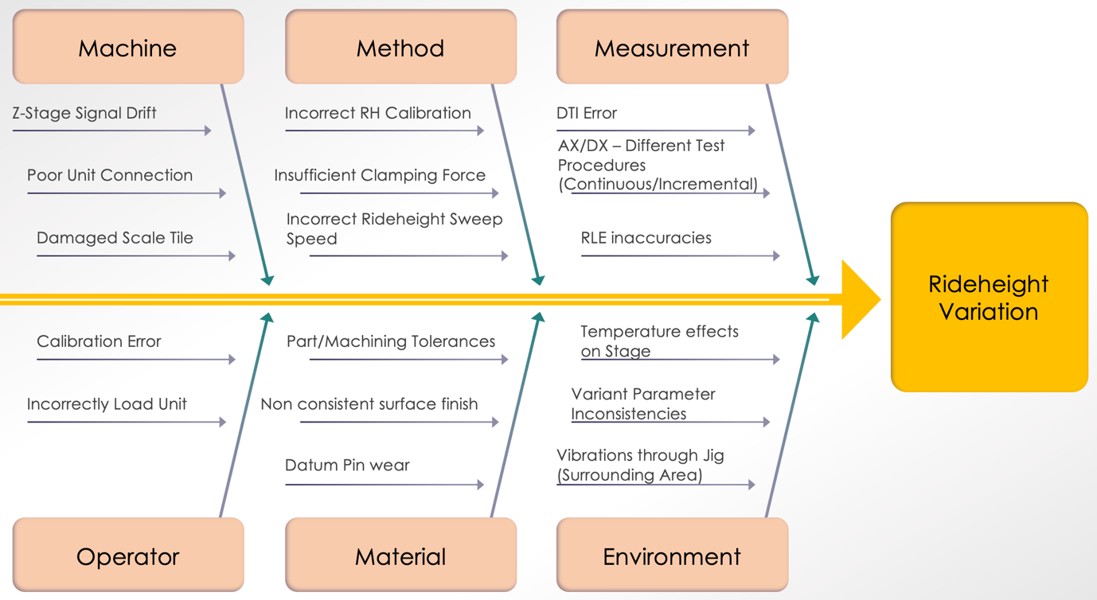
Figure 19 - Ishikawa Diagram (Eby, 2024)

Equipment and Calibration Analysis
The investigation started by looking at the Z-stage (Aerotech stage) and was transferred to ASG for calibration, as the equipment falls under their responsibility. Additionally, for better confidence/accuracy in measurements, a newly calibrated RLE system was used. After carrying out these processes, a full jig calibration was conducted by CPEG as per the required calibration process, CP937 (Janeway, 2025). Subsequently, A:B testing was repeated, and the pre and post results were analysed and presented using histogram plots.
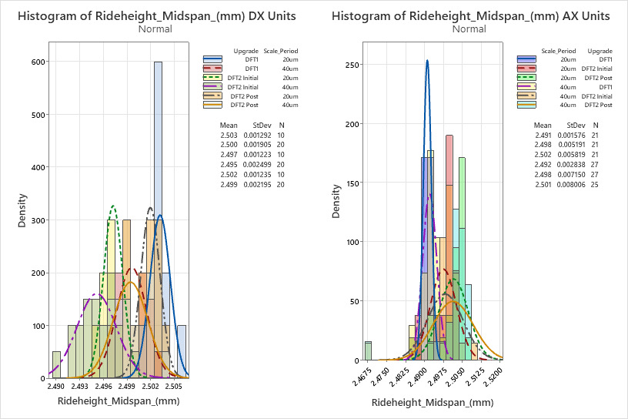
Figure 20 - Layout of Rideheight Midspan Histograms - Split by Variant (AX/DX) - A:B Test Results across DFT2 and DFT1 - Pre and Post re-commissioning
As shown in Figure 20, there is no improvement in results for AX units, the variation still exists as suggested by the population density falling under 75. On the other hand, there have been slight improvements in the accuracy of DX units, where the results are closer to the nominal value, which could be attributed to the calibration process. In summary, after significant hardware changes and improvements, it did not reduce the AX variation, which therefore meant it could be eliminated as a primary root cause.

Comparative analysis by product type
In order to further isolate the root cause, the data collected from the run at rate was separated by scale period and connector type, in order to see whether the issue was isolated to a specific type. These histograms are shown in Figures 21, 22 and 23 below.
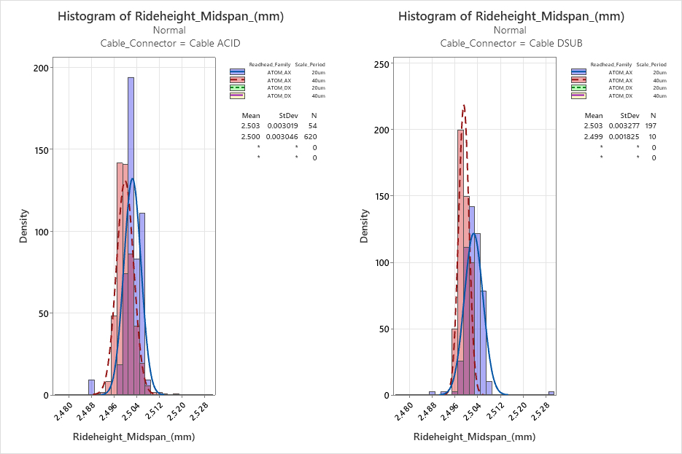
Figure 21 - Layout of Rideheight Midspan Histograms - Split by Cable connector type - RaR results (1/3)
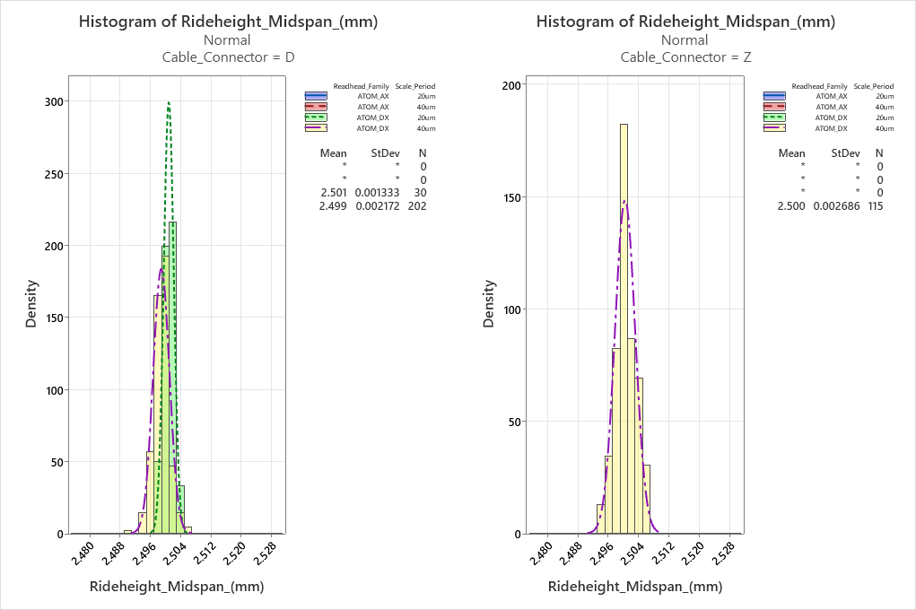

Figure 22 - Layout of Rideheight Midspan Histograms - Split by Cable connector type - RaR results (2/3)
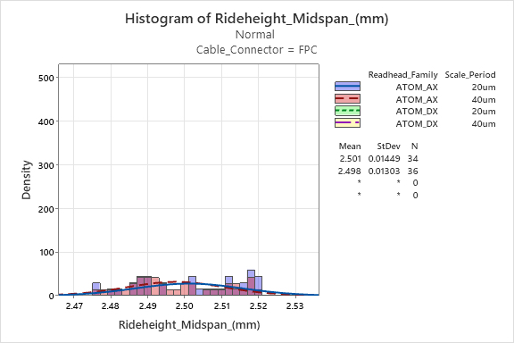

Figure 23 - Layout of Rideheight Midspan Histograms - Split by Cable connector type - RaR results (3/3)

It can be seen in Figure 20 and 21, that there is very consistent data for the different cable connectors (Cable ACID, Cable DSub etc..), as the population density for the results are high (>120). However, when looking at the FPC connector type, shown in figure 23, there is significant variation, a high standard deviation value (0.014 and 0.013) and there is no present curve on the histogram. This highlighted that the source of the variation is not totally random but is driven by a specific cable connector (FPC), indicating that this is where the rideheight issue lies. This is further emphasised in Figure 24, which is an interval plot of rideheight midspan against cable connector.
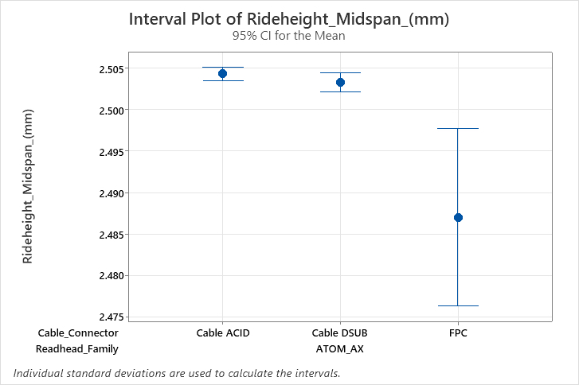
Figure 24 - Interval Plot of Rideheight Midspan vs Cable Connector

Identification of Root Cause – FPC Units

Process Observation and Physical Investigation
Due to discovering that the variation was originating from FPC units, the test process of these units was reviewed. When testing a unit, it was found that the FPC unit was not completely clamped within the nest even though the clamping mechanism was engaged and the sensor was activated. This issue is illustrated in Figure 25 below.
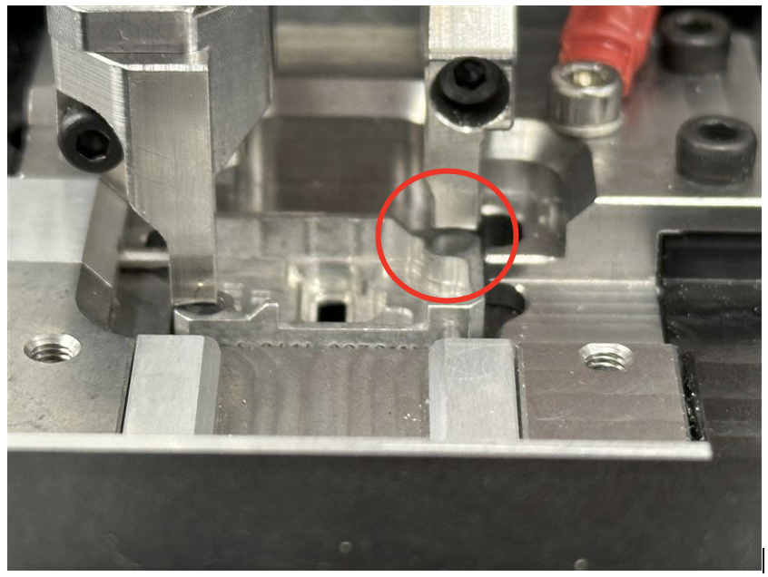

Figure 25 - Clamping Mechanism Not Contacting an FPC Body when clamped

As the unit is not being correctly clamped, that means there is inconsistent seating of the unit, which introduces potential for movement throughout the test, and no force holding it to the datum face. This strongly indicates a link to the rideheight variation.

Hypothesis Testing – Clamp force Investigation
In order to validate the theory that the clamp force is the source of the variation; hypothesis testing was conducted. To validate this, testing was done with no clamp force, manual clamp force (applying force by hand), and a new clamp force. The results can be seen as a histogram in Figure 26 below.
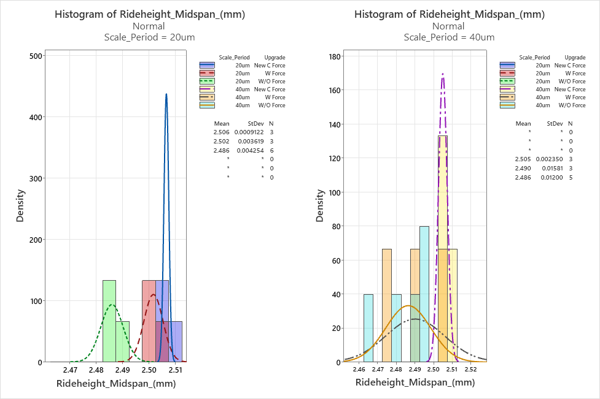
Figure 26 - Layout of Rideheight Midspan Histograms - Split by Scale Period (20um/40um) and Clamping force

It can be seen that when manual force was applied, the rideheight result is closer to nominal, however there is only slight improvement in variation of the results. Whereas when a new clamping force is applied, there is very little variation in test results. It must be considered that it is only a small dataset, nevertheless it shows clear improvement on rideheight results.

Confirmation through Dataset Reintergration.
To further validate that FPC units were causing the poor variation. The A:B test dataset was updated with the new clamp force FPC results (DFT2 Post) and were compared to the old/no clamping force dataset (DFT2 Initial), this can be seen in Figure 27.
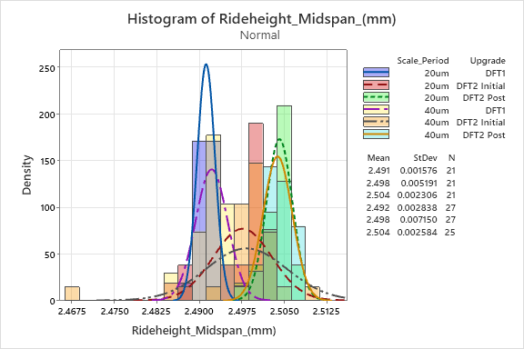
Figure 27 - Histogram of Rideheight Midspan - A:B test results - AX units - New Clamping force integrated
As shown in the histogram, after removing the identified cause (poor clamping) it also removes the observed variation. Therefore, it can be concluded that the clamping issue is the true root cause of the rideheight variation.

Root Cause Analysis
The 5 Why’s analysis identified that the inadequate clamping force originated from the initial calibration process. During calibration, clamp force was verified using AX/DX cabled bodies, in accordance with the existing procedure. However, this did not account for FPC units, which have a reduced body height of 3.65 mm compared to 4.15 mm for AX/DX units. This 0.5 mm height difference occurs at the clamping interface, resulting in the overarm failing to make contact when FPC units were loaded. Consequently, insufficient clamp force was applied, leading to increased variation in rideheight measurements.
As the calibration procedure did not require clamp force verification for FPC units, this issue was not detected during initial setup. The 5 Why’s analysis (Figure 28) therefore confirms that the root cause is a gap within the calibration process.
To address this, the calibration procedure must be updated to include clamp force verification for both FPC and cabled body types, ensuring consistent clamping across all product variants. clamp force verification for both FPC and cabled body types, ensuring consistent clamping across all product variants.
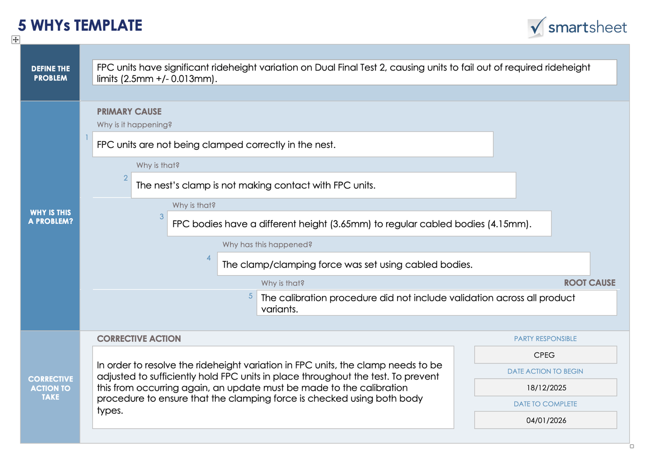
Figure 28 - 5 Why's Analysis (Weller, 2017)

Improve

Generate Improvement Alternatives / Payoff Matrix
A Payoff Matrix, was used to assess the different improvement ideas by taking into consideration the level of effort required in implementing and the potential benefit of each alternative solution, which is a typical practice under the Six Sigma methodology (Six Sigma DSI, 2023). The Payoff Matrix is beneficial as it allows teams to concentrate their efforts on achieving the most significant results with minimal input (Six Sigma DSI, 2023).

The payoff matrix, shown in Figure 29, allowed prioritisation of low cost and high benefit fixes, like updating the calibration documentation. This is very low cost as it is a documentation update, however it ensures that the clamp force is set correctly each time. Medium and long-term improvements could also be considered, such as an automated clamp sequence that would check the clamp force through the software/a sensor and would not allow the test to begin if the clamp force is not sufficient. These improvements would reap big benefits and resolve the problem, however it would require significant costs and effort to put into practice, therefore could be considered for future implementation.

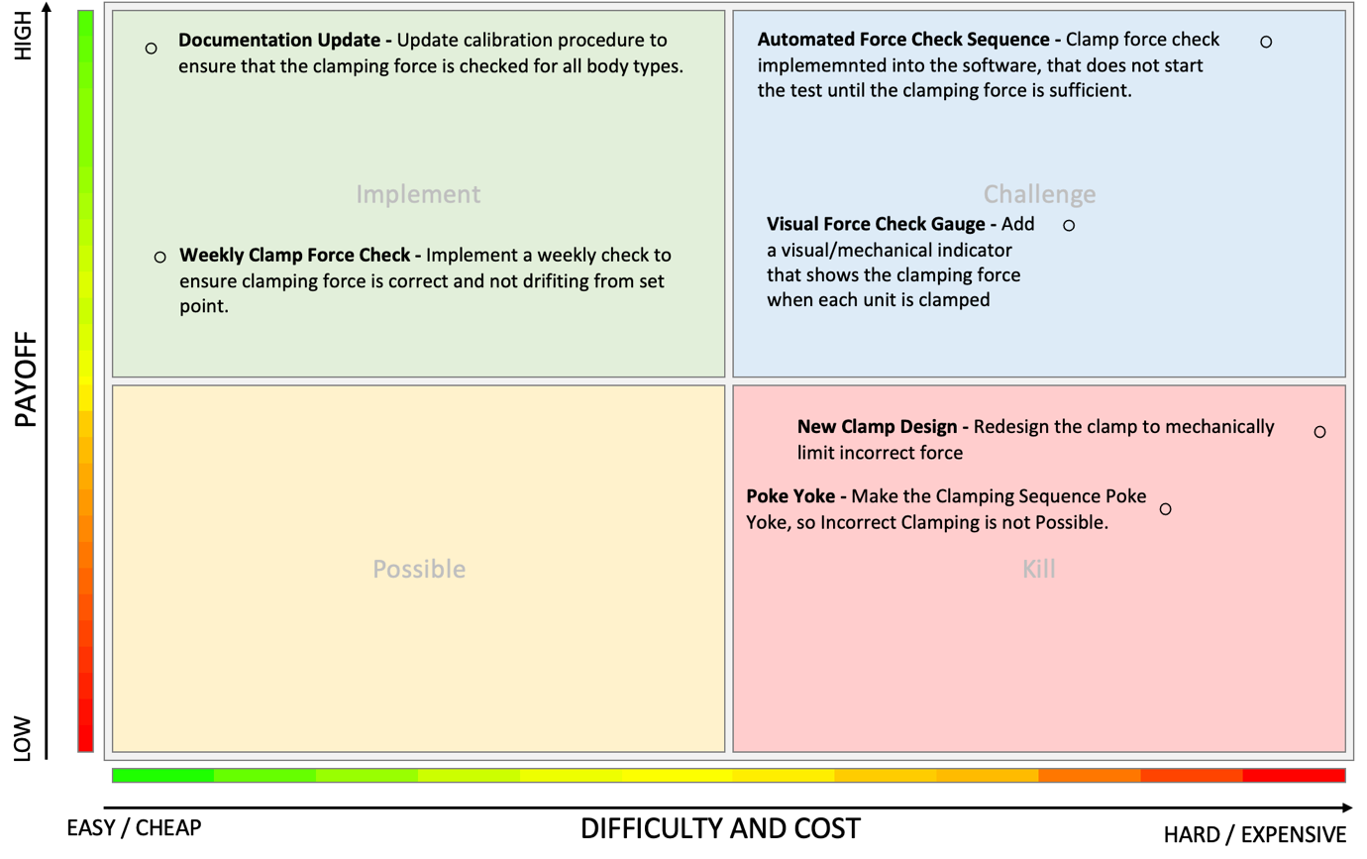
Figure 29 - Payoff Matrix (LearnLeanSixSigma, 2026)

PFMEA
A Process Failure Mode and Effects Analysis (PFMEA) was completed post jig upgrade but before the problem with clamping force was discovered. PFMEA is one of the main tools of Six Sigma that aims at identifying failure modes, analysing their effects, and evaluating them based on severity, occurrence, and detection levels to produce a Risk Priority Number (RPN) (Six Sigma, 2024). This enables proactive risk management and supports data-driven improvement decisions (Six Sigma, 2024).

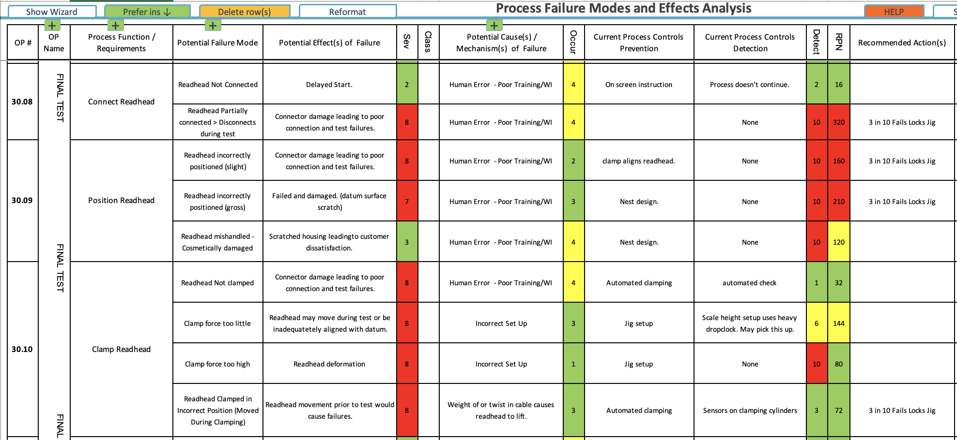
Figure 30 - Initial PFMEA
Even though a PFMEA was completed, the clamping force problem was not highlighted appropriately since its RPN value was moderately low at 144. The failure mode “clamp force too low” was raised, however it was never addressed. The detection control assumed that rideheight calibration would identify the issue, however this process uses a cabled body rather than an FPC body. Since the clamp force was not checked for FPC bodies, it was overlooked which led to the ongoing issue. This means that the detection rating was overstated since the control method was not reflective of the real situation/conditions.
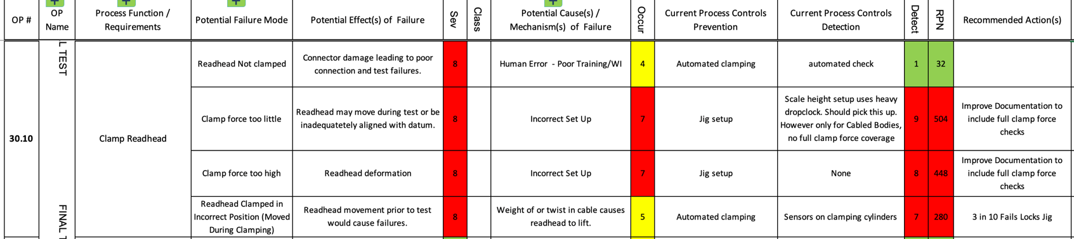
After identifying the root cause, the PFMEA was updated to reflect the correct risk level, shown in Figure 31. The detection criteria for the process were updated accordingly, resulting in a higher RPN, hence highlighting the need for corrective action, including updating the calibration procedure to cover both FPC and cabled bodies.
Figure 31 - Refined PFMEA

Should be/Future State map
A “Should be/Future State” Process Map, shown in figure 32 and 33, was established to gain a clear vision of the process before and after the corrective actions are implemented.
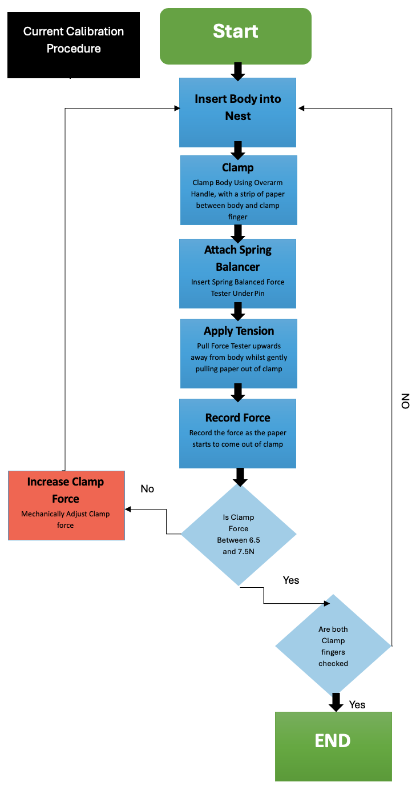
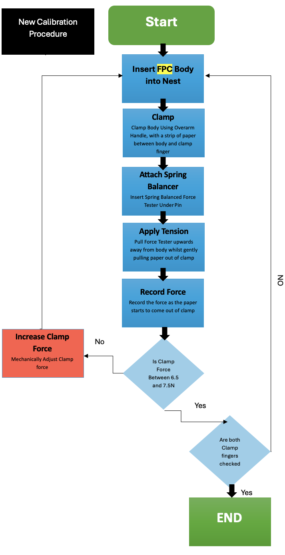
Figure 32- Current State Process Map
Figure 33 – Future State Process Map

Prevent Further Re-Occurrence
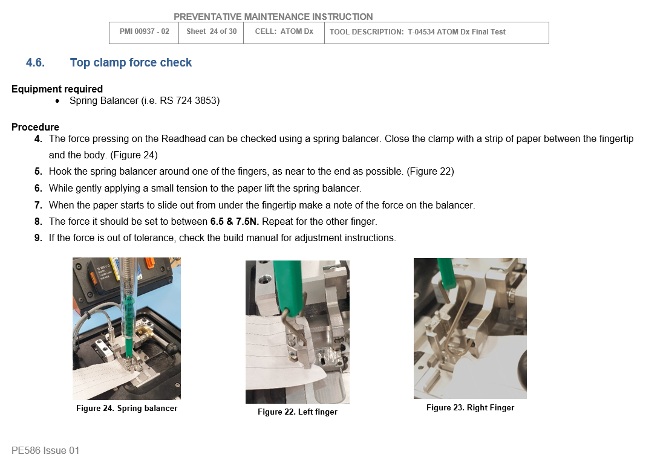
As found in the analyse phase, the root cause was due to the calibration procedure not specifying which body type to use whilst carrying out the clamp force check, this is demonstrated in Figure 34. Due to this, the procedure did not represent worst case scenario, as FPC bodies are thinner they are more susceptible to insufficient clamp force, which allowed opportunity for error and inconsistency, which is why the problem occurred.

Figure 34 - Dual Final Test Calibration Procedure (CP937-02)

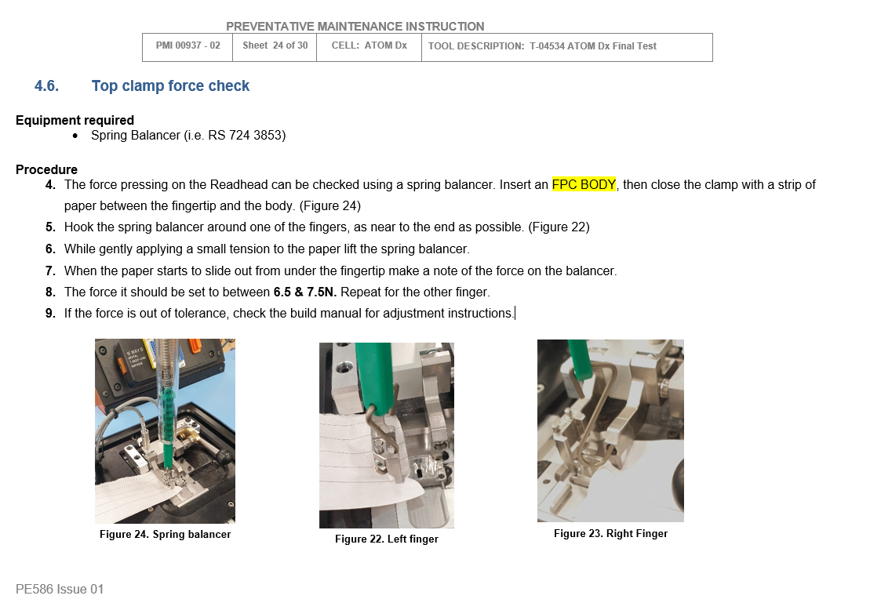
The payoff matrix highlighted that updating the documentation is a low cost but high benefit improvement, aligning with six sigma principles by improving process standardisation, reducing variation and preventing re-occurrence within minimal cost (Six Sigma DSI, 2023). Therefore, the procedure has been updated to explicitly require the use of FPC units when carrying out the clamp force check, as highlighted in Figure 35 below. This is due to the FPC body representing the most critical condition, by ensuring the FPC clamp force is sufficient it also guarantees adequate clamp force for cabled units. This simple improvement makes the procedure more robust and repeatable.
Figure 35 - Updated Dual Final Test Calibration Procedure (CP937-03)

Validation of Change
Following the implementation of an increased clamping force, additional testing was required to confirm that the increased clamp force (for cabled units) does not impact any other test parameters, as the new clamp force could potentially overcome the pneumatic datum pins that are used to properly yaw the units within the nest. Whilst visual checks confirmed that the pins were capable of overcoming the new clamp force, standard unit tests with further units showed that the revised clamp force did not have a significant impact on any other parameters, as demonstrated in figures 36 and 37 below.

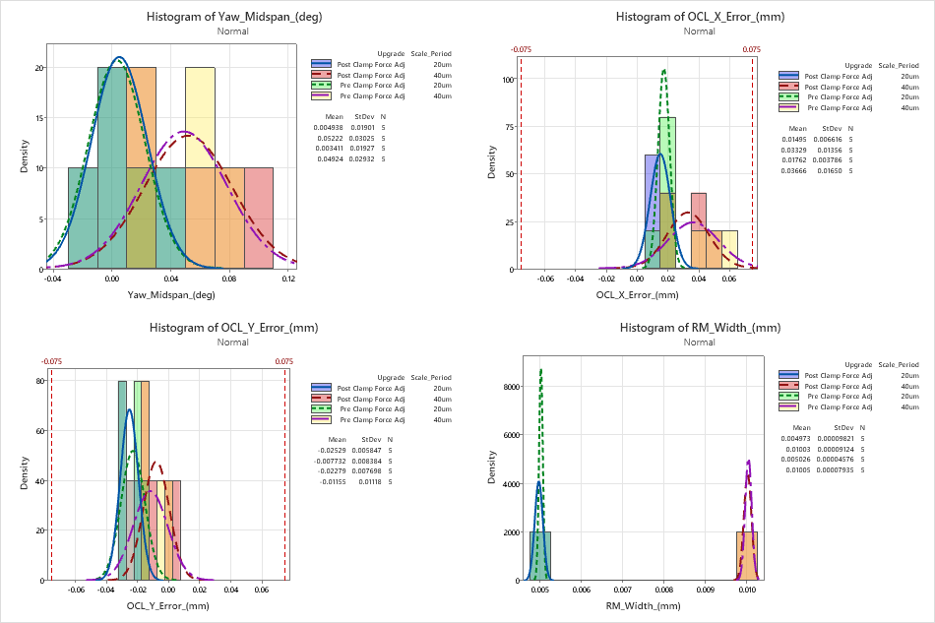
Figure 36 - Histogram of Yaw Midspan, OCL X, OCL Y and RM Width - Pre and Post Clamp Force Adjustment – DX units

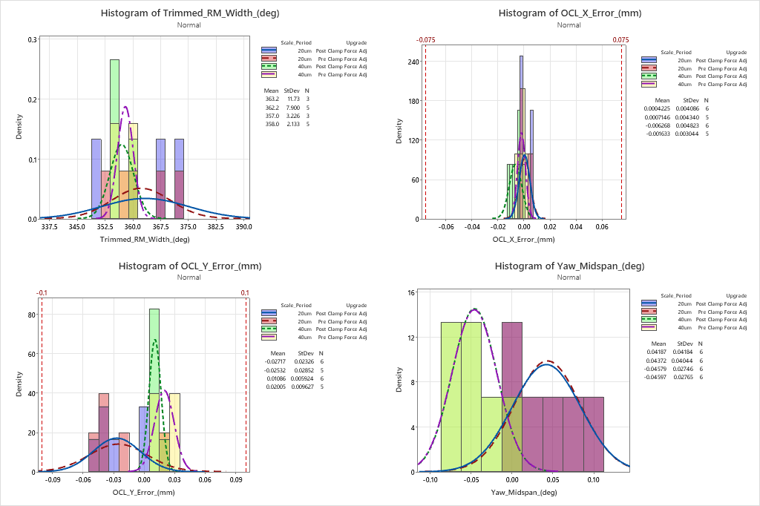
Figure 37 - Histogram of Yaw Midspan, OCL X, OCL Y and RM Width - Pre and Post Clamp Force Adjustment - AX Units

Control
Following the implementation and validation of improvements, controls need to be put in place to ensure that the successful resolution of the issue is sustained and the process is stable going forward.
Firstly, Statistical Process Control (SPC), will be used to monitor all process parameters such as Rideheight, Yaw and OCL values via control charts. These control charts are already in place for the Final test process, and a maintenance schedule will be set up to ensure that they are routinely checked, in order to monitor process performance on a week-by-week basis. Any trends or changes can therefore be identified early, and corrective action can be taken before it has a great effect on the process.
Similarly, daily checks using gold standard units are carried out on the Final Test jig to monitor and verify its condition. These checks prevent the operator from proceeding if the units fail, as they represent a known, stable reference. By consistently testing the same units, variation from the product itself is minimised, allowing a more accurate assessment of the jig’s performance over time.
In order to prevent recurrence of the root cause, the calibration procedure has been updated accordingly as mentioned in the Improve stage.
These control measures collectively ensure that the process improvements are sustained, maintaining high yield, improved FTPR, and reduced cost of poor quality over time.

Bibliography

Bibliography
Bizmasters, 2024. What is a Concession in Quality?. [Online]
Available at: https://bizmasterz.com/what-is-a-consession-in-quality/#google_vignette
[Accessed 10 Feburary 2026].
Croft-Bednarski, D., 2022. Six Sigma Project Charter Template. [Online]
Available at: https://www.learnleansigma.com/project-management/lean-six-sigma-project-charter-template/#google_vignette
[Accessed 20 January 2026].
Eby, K., 2024. Free Excel Fishbone Templates. [Online]
Available at: https://www.smartsheet.com/content/excel-fishbone-templates?srsltid=AfmBOopPl1rtTV_XHKoibZq3lPLpq5LZwkOCeH-7LVqoK0qZqXKywdgK
[Accessed 20 March 2026].
Goldman, M., 2018. The Ultimate Guide to Cause and Effect Diagrams. [Online]
Available at: https://www.juran.com/blog/the-ultimate-guide-to-cause-and-effect-diagrams/
[Accessed 13 March 2026].
Hassing, T., n.d. Control Charts Study Guide. [Online]
Available at: https://sixsigmastudyguide.com/control-charts-study-guide/
[Accessed 4 Feb 2026].
Hassing, T., n.d. Variation. [Online]
Available at: https://sixsigmastudyguide.com/variation/
[Accessed 3 February 2026].
Hessing, T., n.d. Process Mapping. [Online]
Available at: https://sixsigmastudyguide.com/process-mapping/
[Accessed 16 January 2026].
iCertGlobal, 2023. The Role of Minitab in Quality Control and Six Sigma. [Online]
Available at: https://www.icertglobal.com/blog/role-of-minitab-in-quality-control-and-six-sigma-blog
[Accessed 13 Feburary 2026].
Institute Project Management, 2025. Project Charter: Guide with Template and Examples. [Online]
Available at: https://instituteprojectmanagement.com/blog/what-is-a-project-charter/
[Accessed 20 January 2026].
Janeway, G., 2025. CP937-02 - Dual Final Test Calibration Procedure, s.l.: Renishaw.
Lean 6 Sigma Hub, 2025. What is Measurement Systems Analysis and Why It Matters in Six Sigma. [Online]
Available at: https://lean6sigmahub.com/what-is-measurement-systems-analysis-and-why-it-matters-in-six-sigma/
[Accessed 13 Feburary 2026].
LearnLeanSixSigma, 2026. PICK Chart Template. [Online]
Available at: https://www.learnleansigma.com/template/pick-chart/#google_vignette
[Accessed 2 April 2026].
Powell, T., 2011. Quality Management System, s.l.: Renishaw.
Powell, T., 2014. Concession, s.l.: Renishaw.
Renishaw, 2026. About Renishaw. [Online]
Available at: https://www.renishaw.com/en/about-renishaw--6432?srsltid=AfmBOooAh445S3Ki7mZ2zDbgHtyjDijA0rXK-mRo4OIsKptxgXUvPc6Q
[Accessed 10 January 2026].
Renishaw, n.d. ATOM Linear Installation Guide, s.l.: Renishaw.
Renishaw, n.d. Optical and inductive encoders glossary. [Online]
Available at: https://www.renishaw.com/en/optical-and-inductive-encoders-glossary--27382?srsltid=AfmBOoqzCsa65-6Qqm9JI3EzugYo-ULKXjx7Z_1wjehfr8Rv8rmN7EKe
[Accessed 15 January 2026].
Six Sigma DSI, 2023. How to Use a Payoff Matrix to Prioritize Solutions. [Online]
Available at: https://sixsigmadsi.com/payoff-matrix/
[Accessed 10 April 2026].
Six Sigma Institute, n.d. What is Six Sigma and Why is it Six Sigma?. [Online]
Available at: https://www.sixsigma-institute.org/What_Is_Sigma_And_Why_Is_It_Six_Sigma.php
[Accessed 10 January 2026].
Six Sigma Principles, 2024. Six Sigma Principles. Process Capability Index (Cpk) for Business Success. [Online]
Available at: https://www.6sigma.us/process-improvement/process-capability-index-cpk/
[Accessed 24 Feburary 2026].
Six Sigma, 2024. Process Failure Mode & Effects Analysis (PFMEA) in Lean Six Sigma. [Online]
Available at: https://www.6sigma.us/fmea/process-failure-mode-effects-analysis-pfmea/
[Accessed 15 April 2026].
SmartDraw, n.d. Process Mapping Tool. [Online]
Available at: https://www.smartdraw.com
[Accessed 18 January 2026].
Weller, J., 2017. Free Root Cause Analysis Templates: The Complete Collection. [Online]
Available at: https://www.smartsheet.com/free-root-cause-analysis-templates-complete-collection?srsltid=AfmBOoptLAaFIY9vmxRbVFn9lsBYp66hHVHzA7nZ_Rx8qa6LpaPmN0E7
[Accessed 27 March 2026].

Appendices

Appendix A – FTPR and Yield Breakdown
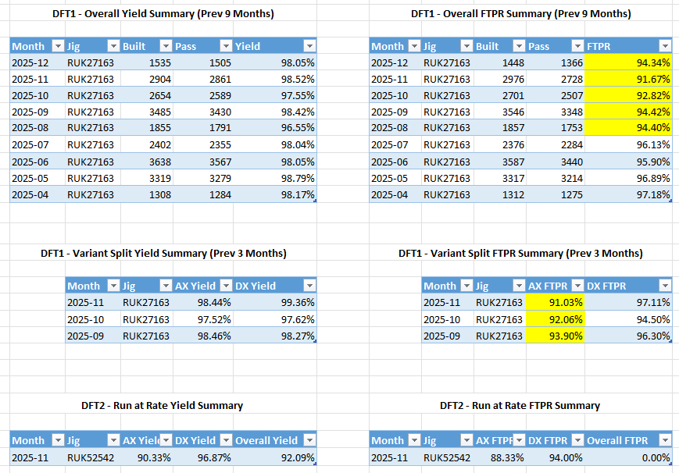

Appendix B – SQL RaR Query
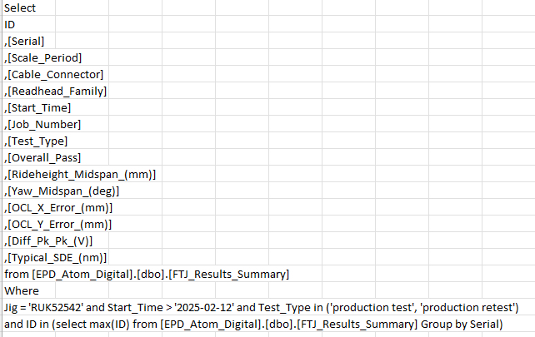

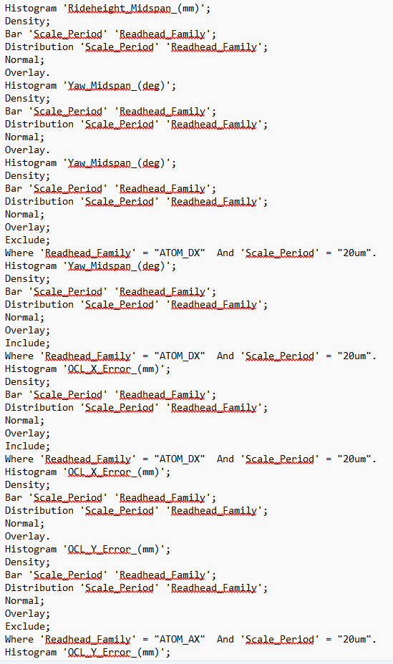
Appendix C – Minitab Commands


