
Name: Ronak Yusuf Sheikh
Student id: 2436884
Module : Health Care system organisation and leadership (LCHS7002))I
Lecture’s name: Shepherd Ziko
Assignment title. Case Study Analysis Report: Comparative report on
COVID19 leadership Responses

Executive Summary

In this report, the author provides a comparative study of COVID-19 leadership responses and governance of the healthcare system of Spain, South Korea, and Canada. It discusses the strengths and weaknesses of different levels of centralisation and decentralisation in determining the national strategies, coordination systems, and health results during the pandemic. The highly decentralised structure of Spain was initially a detriment to the coordinated action, but subsequent centralisation offered efficiency within the systems. The centralised nature of governance in South Korea that was backed by excellent digital infrastructure, strong leadership, facilitated quick containment and low initial mortality. The federalism system of Canada permitted regionally customized answers yet ended with disjointed policies and uneven results especially in long-term care. The leadership styles assessed in the report critically include the transactional, transformational, situational, distributed and crisis leadership and how the leadership styles affect the public trust, effectiveness in communication, and enactment of the policy. Altogether, the results indicate that effective communication, the property of political-scientific leadership, and the promptness of decision-making are crucial factors of successful crisis management, and centralised coordination is always associated with greater resilience of health systems.

Table of Contents
1. Introduction 4
2. Comparative Analysis of Healthcare System Organisation and Response 4
2.1 Spain’s Healthcare System and COVID-19 Response 4
2.1.1 Overview of Spain’s Healthcare System 4
2.1.2 Centralized/Decentralized Approaches During the Pandemic 5
2.1.3 Advantages & Disadvantages of Spain’s Approach 6
2.1.4 Impact on Health Outcomes 7
2.2 South Korea’s Healthcare System and COVID-19 Response 8
2.2.1 Overview of South Korea’s Healthcare Governance 8
2.2.2 Centralised/Decentralised Characteristics 8
2.2.3 Advantages & Disadvantages 9
2.2.4 Impact on Health Outcomes 10
2.3 Canada’s Healthcare System and COVID-19 Response 10
2.3.1 Overview of Canada’s Healthcare System 10
2.3.2 Pandemic Governance Approach 11
2.3.3 Advantages & Disadvantages 11
2.3.4 Impact on Health Outcomes 12
2.4 Cross-Country Comparative Discussion 12
3. Critical Analysis of Leadership Approaches 13
3.1 Leadership in Spain 13
3.1.1 Key Leadership Figures 13
3.1.2 Leadership Style Analysis Using Theory 13
3.1.3 Strengths and Weaknesses 14
3.1.4 Influence on Health System Outcomes 14
3.2 Leadership in South Korea 15
3.2.1 Key Leadership Figures 15
3.2.2 Leadership Style Analysis Using Theory 15
3.2.3 Strengths and Weaknesses 16
3.2.4 Influence on Health System Outcomes 17
3.3 Leadership in Canada 17
3.3.1 Key Leadership Figures 17
3.3.2 Leadership Style Analysis Using Theory 17
3.3.3 Strengths and Weaknesses 18
3.3.4 Influence on Health System Outcomes 19
4. Conclusion 19
References 20

1. Introduction
The COVID-19 pandemic emerged in late 2019 and also evolved rapidly into a global public health emergency that places unexpected pressure on the health systems across the world. Countries deal with varying degrees of disruption relying on their system structures, governance mechanisms, and leadership responsiveness (Salvador and Sancho, 2023). As the virus spread, governments needed to make some rapid decisions regarding testing, containment, communication, and vaccination strategies. These decisions have highlighted massive differences in the functioning and organization of the national healthcare system, along with the weaknesses and strengths of the leadership approaches that are adopted by those in important authority positions. This report aims to compare critically the organization of the healthcare systems as well as pandemic responses in Canada, South Korea and Spain. In addition, it examines the way that varying degrees of decentralization and centralization influenced their COVID-19 outcomes. In addition, it analyses the leadership approaches integrated by important government figures in every country, assessing the way that leadership behaviour contributed to the overall effectiveness of the public health measures. The analysis also guided by 2 important concepts such as the centralisation vs decentralisation in health system governance, and leadership theory, including transformational, transactional, distributed, situational, and crisis leadership. These concepts form the analytical lens through which every country’s response and the leadership performance are evaluated.

2. Comparative Analysis of Healthcare System Organisation and Response

2.1 Spain’s Healthcare System and COVID-19 Response

2.1.1 Overview of Spain’s Healthcare System
In recent times, Spain operates a hugely decentralized healthcare system known as the Sistema Nacional de Salud (SNS) that is identified for the universal coverage and regionally governed the service delivery. Within normal circumstances, the Ministry of Health sets some national policy, delivers regulatory oversight and coordinates important health approaches (Asamoah, 2025). While the 17 autonomous communities retain some primary responsibility for the service delivery, hospital management, public health interventions, and workforce planning. This developed structure helps regions to tailor health services as per the local demographic requirements, delivering better innovation and flexibility within the system. Therefore, decentralization has also created historical disparities in resource distribution as well as the variability in the strength of the regional public health infrastructure. Prior to the pandemic, the preparedness of Spain hugely relied on the regional capacity that resulted in uneven surveillance and some emergency response mechanisms. This structural fragmentation played a massive role to shape the initial Covid 19 response of the country that contributed to some coordination challenges and also delays during the primary stages of the crisis.
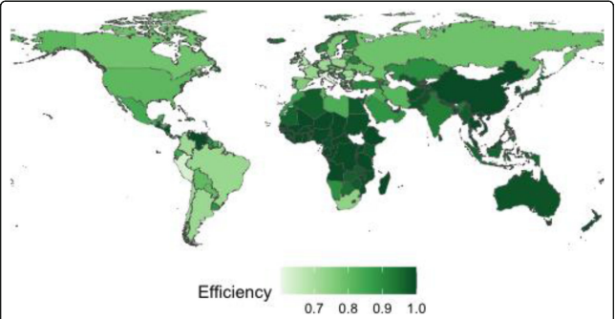
Figure 1: Graphic representation of efficiency levels of Spain
(Source: Martínez-Córdoba et al. 2021)

2.1.2 Centralized/Decentralized Approaches During the Pandemic
The primary response of Spain to the COVID 19 has been influenced hugely by the decentralized division of the responsibilities. During January and February 2020, decision-making was hugely regional with the autonomous communities considering improper surveillance and mitigation measurements. However, the Ministry of Health already issued some public updates and risk assessments, and national authorities mostly underestimate the scale of the threat that leads to delayed central action. Regions including Madrid and Catalonia deal with huge rising case numbers without any unified national guidance that resulted in fragmented early interventions. However, the main turning point came in the mid of March 2020 when Spain was declared a national State of Alarm. This measure also temporarily decentralised authority, granting the national government control over the public health, mobility restrictions, procurement, and hospital coordination. The Ministry of Health also began directing all the regional health services, applied nationwide lockdown measurement and also coordinated procurement of important supplies including the PPE and ventilators (Aljafari, 2021).
This centralization aimed to improve the decision-making and also ensure a better consistency towards the regions, although application deals with administrative delays because of the abrupt shift in governance. As the first wave subsided, Spain gradually returned all the responsibilities to the autonomous regions, which transitioned into a hybrid governance model. In addition, the national government also continued setting some general pandemic guidelines, thus regions executed the local restrictions, testing approaches and capacity management. The vaccination phase was initiated in the late of 2020 that marked a return to centralized planning (Altmann and Boyton, 2022). The national government designed a unified vaccination approach that ensured an equitable distribution of vaccines and coordinated communication campaigns. This structured national approach contributed massively to the later success of Spain in the vaccine uptake and enhanced consistency towards the regions.

2.1.3 Advantages & Disadvantages of Spain’s Approach
Advantages
The pandemic governance model of Spain provided various advantages (Martínez-Córdoba et al. 2021). The transition to the centralization during the State of Alarm has occurred a unified command structure which facilitated mobility restrictions across the world and helped resources to be redistributed where they were required most. In addition, national procurement minimized competition between the regions and allowed expanded access to the protective equipment. In the later stages, decentralisation helped regions to tailor interventions as per the local epidemiological trends and improving the responsiveness. The centralized vaccination strategy has proved to be a significant strength that ensures similar access and higher coverage.
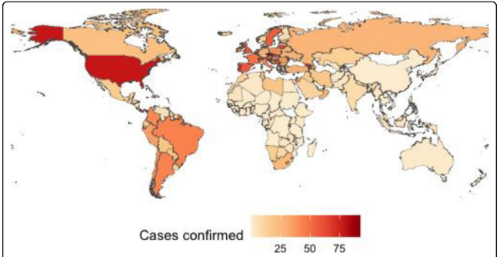
Figure 2: Graphic representation of the output Cases confirmed in Spain
(Source: Martínez-Córdoba et al. 2021)
Disadvantages
Therefore, the approach of Spain also represented some major disadvantages. Early decentralisation has contributed to improper regional responses that delays to identify the chances of the outbreak as well as fragmented surveillance data (Louis et al. 2025). The sudden transition to centralization generated some administrative bottlenecks and also limited regional flexibility. In this context, political tensions between the regional and national governments also limit the collaboration. In addition, the lack of early national coordination has contributed to some rapid transmission, healthcare system overload, and avoidable challenges in the first wave.

2.1.4 Impact on Health Outcomes
Spain experienced some of the huge infection and mortality rates in Europe during the 1st wave of the pandemic, with hospital overcrowding, high ICU utilization, and massive fatalities towards the older populations, especially in the long-term care facilities (Garcia-Carretero et al. 2023). Regional disparities in the resource and responses capacity also intensified the primary impact. Therefore, health outcomes enhanced sustainability in the later phases. The centrally coordinated vaccination programme allowed Spain in order to achieve one of the maximum vaccination rates in Europe that contributed to less mortality, reduced hospital admissions and enhanced outbreak management. The evolution from the fragmented early action to more effective national strategy that stabilized the response of the company and improved resilience in subsequent waves.

2.2 South Korea’s Healthcare System and COVID-19 Response

2.2.1 Overview of South Korea’s Healthcare Governance
South Korea mostly operates a centralized healthcare governance model that is coordinated through the national organizations, especially the Ministry of Health and Welfare (MOHW) and the Korea Disease Control and Prevention Agency (KDCA). While the delivery of healthcare includes both the private and public providers, strategic planning, disease surveillance, emergency preparedness and the public health decision-making remains coordinated. Considering the Covid 19 pandemic, South Korea had already invested hugely in infectious disease management following the 2015 MERS outbreak that resulted in improving the surveillance systems, digital contact-tracing capabilities, and legislative reforms which improved central government authority during the health crises (Muttamba et al. 2022). The KFCA plays a massive role in the response of the outbreak, managing all the testing process, data reporting and the epidemiological monitoring. These pre-existing structures allowed a rapid mobilization of resources and also facilitated some cohesive national action when the Covid 19 pandemic emerged and positioned South Korea as one of the earliest countries to apply technology-based interventions.
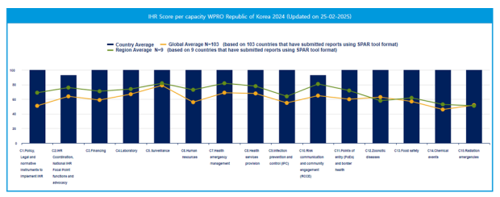
Figure 3: The Republic of Korea's Scores of the IHR States Parties Self-Assessment Annual Report (SPAR) in 2024
(Source: Chu, 2025)

2.2.2 Centralised/Decentralised Characteristics
The pandemic response of South Korea is hugely described as a hugely centralized model with chosen decentralized application. From the outset, the central government has coordinated some national strategies, dissemination of insights and the resource allocation. The KDCA activated all the emergency protocols, increased testing capacity and developed a standardized national framework for the surveillance and contact tracing (Chu, 2025). In this context, central authorities issued regular briefings, coordinated larger controls and developed unified guidelines for the health providers and local governments. Instead of this strong central command, operational responsibilities have decentralized partially. Local governments were tasked with applying quarantine management, operating screening centres, enforcing public health rules, and supporting community-oriented monitoring systems. Public-private partnerships are also playing a vital role, particularly to scale up large testing through the collaboration with the private laboratories and biotechnology firms.
South Korea also pioneered drive through and walk through testing centers by coordinated central guidance along with the local delivery. In addition, digital governance also improved the central oversight and adopted data systems allowing real-time sharing of the case insights between the local and national authorities facilitating rapid determination of the transmission clusters. However, regional authorities retained some discretion to take some measures, and the entire pandemic response followed an effective national strategy with the continuous application of the guidelines towards the country.

2.2.3 Advantages & Disadvantages
Advantages
Rapid, coordinated national action allowed early containment, especially during the first wave of the pandemic (Aung et al. 2021). In addition, latest digital systems facilitated accurate contact tracing, reducing widespread lockdowns. A strong public communication from the central authorities that maintained better transparency and trust and also supported compliance. Public-private collaboration also increased the testing capacity, setting a global example for early mass testing. The combination of the central leadership and the local execution developed a proper and responsive mechanism in terms of the outbreak management.
Disadvantages
In the context of disadvantages, the emphasis on digital surveillance causes privacy concerns, promotes debates over the data use as well as the individual rights. Some strict central guidelines that occasionally limited the local innovation or the adaptation to particular community contexts (Colavitti and Serra, 2021). In addition, dependence on the high levels of public corporations might lead to some social pressure, stigmatization of infected individuals, or surveillance fatigue. Apart from that, the absence of the strict nationwide lockdowns needs continuous vigilance and resource-based monitoring systems.

2.2.4 Impact on Health Outcomes
The health outcomes of South Korea in the COVID-19 pandemic were one of the best in the world, particularly at the initial phase. The nation was able to have relatively low mortality rates, prompt rate of case detection, and had managed to contain community spread without lockdown measures within the country. Mass-testing and intensive contact-tracing minimized the number of widespread outbreaks, and the hospital capacity became well-managed, due to the tiered care system and special isolation facilities (Knöbel, 2023). Despite the subsequent trends and difficulties caused by new variants and pandemic exhaustion, the overall health results were an expression of the advantages of South Korean coordinated governance, technological base, and national decisive leadership. The presence of powerful central leadership and cooperation of operation delivery made South Korea a global model of managing pandemics.

2.3 Canada’s Healthcare System and COVID-19 Response

2.3.1 Overview of Canada’s Healthcare System
Canada mostly operates a hugely decentralized healthcare system in which governance and the service delivery responsibility lies with the territories and provinces. While the federal government delivers required funding support and sets large national health standards through the Canada Health Act, provincial governments independently manage hospitals, public health agencies, workforce planning, and emergency preparedness. As a result, the capacity, organization and the performance of the healthcare services can depend massively on the country. Considering the pandemic situation, this decentralized structure mostly supported regional autonomy and the improved service provision thus also occurred disparities in resources, public health infrastructure, and surveillance systems. Some federal organizations including the Public Health Agency of Canada (PHAC) deliver national guidance and the surveillance oversight, thus the decision-making power also rests hugely at the provincial level (Denis et al. 2023). This structural arrangement also shaped the response of Covid 19 and it contributed to varied approaches and outcomes towards the jurisdictions.
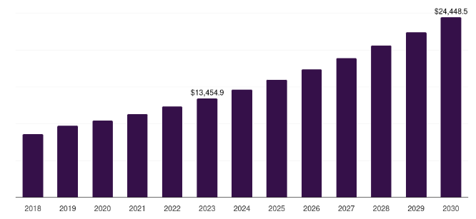
Figure 4: Canada’s Healthcare System overview
(Source: Denis et al. 2023)

2.3.2 Pandemic Governance Approach
Pandemic governance in Canada entailed the dual level response that included provincial and federal leadership. The federal government at the national level coordinated actions at the borders, vaccine purchases, stockpiles, and communication plans. PHAC and PM Justin Trudeau both conducted daily national briefings and came up with overarching guidance via federal public health guidelines (Graefe and Fiorillo, 2023). Provinces were allowed to impose measures like lockdowns, school shutdowns, mask testing policies, and long-term care policies. This caused a significant policy divergence among jurisdictions such as timing, stringency, or implementation of societal healthcare. The federal government managed to supply the vaccines, but the provinces were in charge of the rhythm and priority of the rollout, and this led to lumpy initial advancement. During the pandemic, the effective intergovernmental cooperation was ensured by means of federal-provincial meetings, although the lack of uniform policy set across the country became one of the peculiarities of the response.

2.3.3 Advantages & Disadvantages
Advantages
Decentralization helped provinces to improve the public health interventions to regional epidemiological patterns and health system capacities (Oliveira et al. 2023). In addition, federal leadership ensured better national communication and coordinated vaccine procurement. Some collaborative federal provincial mechanisms supported sharing of data, best practices and research.
Disadvantages
In terms of the disadvantages, fragmented decision-making contributed to improper measures towards the provinces that confused the public and weakened the national coherence. In addition, variation in the regional capacities, especially in long-term care that contributed to unequal outcomes. Early-stage coordination challenges among the provincial and federal authorities reduced the primary vaccine rollout (Oliveira et al. 2023). Apart from that, lack of uniform surveillance and reporting systems also limited actual national situational awareness.

2.3.4 Impact on Health Outcomes
Canada has experienced massive variation in the health outcomes towards the provinces, showing disparities in the public health infrastructure and the policy implementation (Jarvis et al. 2023). The country has recorded a substantial mortality during the primary waves, especially within the long-term care facilities, where the systemic weaknesses have been exposed. In this context, capacity of hospitals has strained in some provinces that leads to regional surges and the interprovincial sourcing sharing. Instead of the slow start, the vaccination campaign has achieved a high coverage, minimizing various illnesses and mortality in the later stages. Provinces which applied earlier and stricter measures mostly experienced better containment, while the others dealt with outbreaks.

2.4 Cross-Country Comparative Discussion
A detailed examination of South Korea, Spain and Canada highlights the way that structural governance models and the decision-making mechanism shapes every country’s capability to respond perfectly to the pandemic. Canada and Spain both operate in decentralized healthcare systems, thus they differ sustainably in the way authority has exercised during this crisis (Greer et al. 2022). The early fragmented regional responses of Spain described the barriers of decentralized governance during the rapidly escalating outbreaks. The subsequent temporary centralization within the State of Alarm brought better coherence to national decision-making, yet the delay to unify the measures contributed to the early effects. On the other hand, Canada has maintained decentralization throughout the pandemic that depends on the provinces for designing as well as implementing the public health interventions.
South Korea is the opposite, where it is a largely centralized system with coordinated national leadership and well-constructed infrastructure to deal with infectious diseases. Technology-based interventions carried out by the central government and KDCA were rapid and focused and backed by the integration of data, mass testing, and open communication. The local governments were also assisted in operations, but the national governments always retained control of the strategy, which allowed containment to be early, avoiding a national lockdown (Machin, 2023). Centralised governance was relatively stable and transparent, which was a major factual element in determining the relatively better health of South Korea. In the three countries, it was visible that centralisation is linked with the coordination of decisions made, speediness of the mobilization of resources, and explicit public messages.

3. Critical Analysis of Leadership Approaches

3.1 Leadership in Spain

3.1.1 Key Leadership Figures
The Minister of Health, Salvador Illa, chaired the coalition government which took a leading role in Spain in responding to COVID-19 (Navarro and Velasco, 2022). The leadership roles of the 17 Autonomous Communities were also played by the regional presidents because the healthcare system in Spain was highly decentralised. The leadership of these regions, particularly Madrid, Catalonia and the Basque Country were at the middle of the decision-making and implementation of policies concerning hospital coordination, restrictions and testing policies. The existence of these various centres of power provided a complicated leader situation in the face of the pandemic.

3.1.2 Leadership Style Analysis Using Theory
The crisis leadership theory can be used to analyze the leadership response of Spain, especially its focus on sense-making, making decisions under uncertainty and communication (Grasser, 2022). The government demonstrated the signs of the reactive crisis leadership style in the early years. The main features of this style are the delayed changes in policies, small expectations and difficulties in coordinating the actions of regions and the nation. This was more or less in tandem with transactional leadership where the central government employed command-and-control structures, particularly once the state of alarm had been declared, temporarily centralising power.
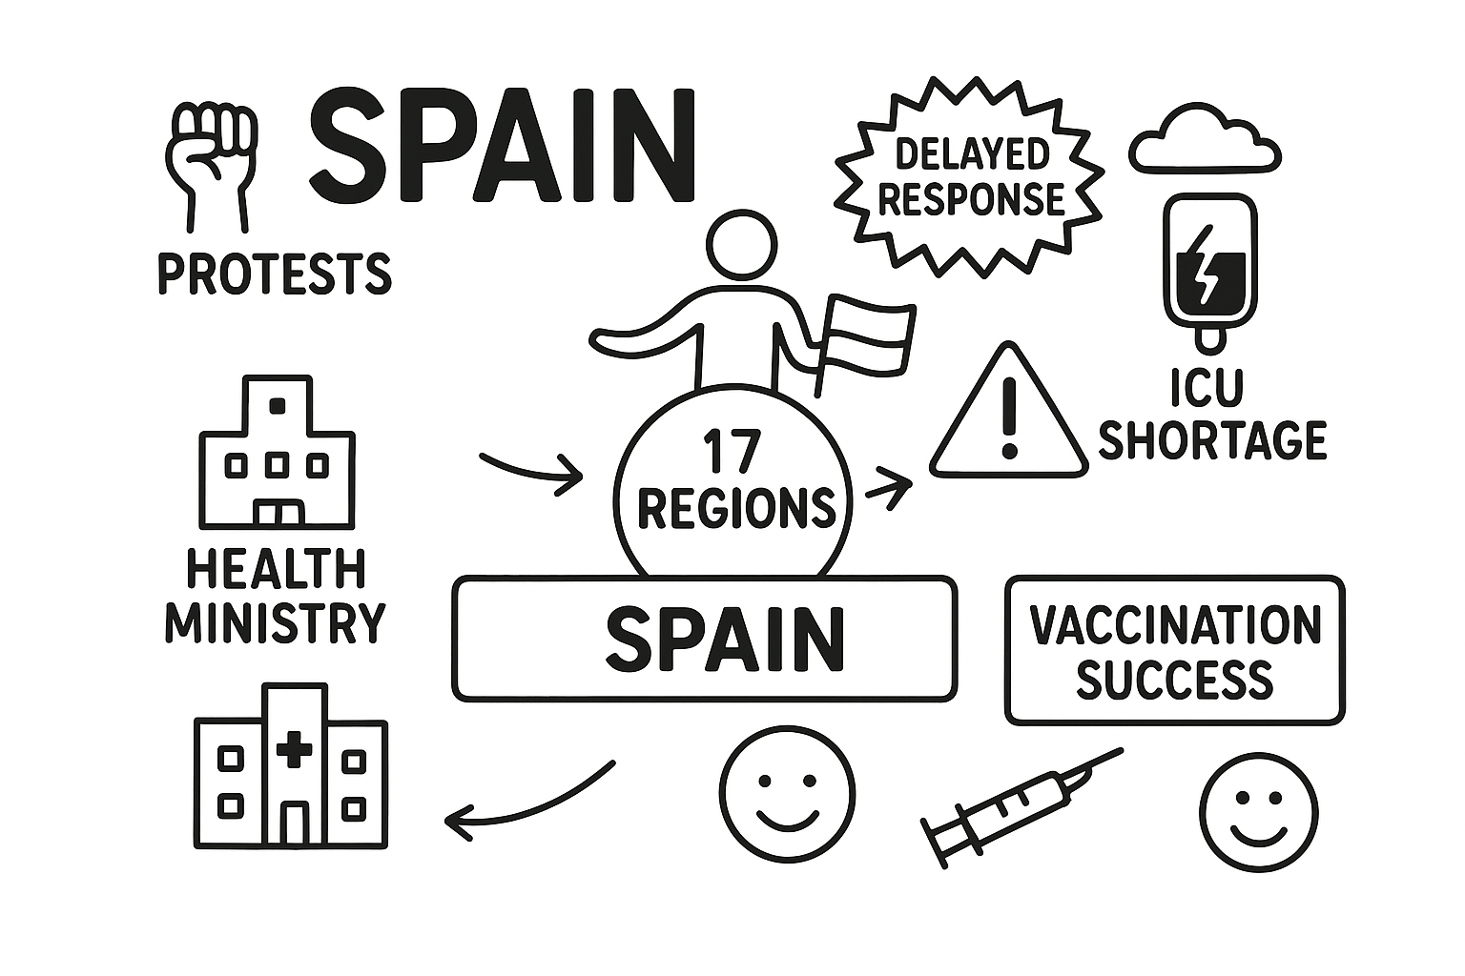
Figure 5: Rich Map for South Korea
(Source: Self-developed)
The situation leadership also characterised the leadership of Spain, modifying the strategies as the crisis changed. As an example, following the initial wave, the leaders of the country started to exercise a more cooperative leadership. This was seen in common pandemic surveillance committees, joint coordination councils and local authority regarding containment decisions. But transformational leadership was not as consistently witnessed and was characterised by strong vision, inspiration and proactive direction. Inadequate early transparency and ambiguous information messages between national and regional leaders decreased the level of trust and understanding between citizens (Eaosinsup and Kulachai, 2025). It showed a lack of strong, integrative leadership.

3.1.3 Strengths and Weaknesses
One of the greatest strengths of the Spanish leadership was the fact that facilitated coordination at all levels was eventually developed. After emergency centralisation was introduced, the uniformity of lockdown regulations and the national procurement strategies empowered the system in terms of reactiveness. The leadership was also more organised during the vaccination phase as it had a consistent national guideline and effective plan on how to roll out the vaccination in the regions (Quaggia et al., 2024).
The first phase was characterized by more weaknesses. The decentralised structure of Spain caused fragmentation of leadership and missed the ability to deliver similar messages and timely decision-making. Indicatively, the national and regional governments have different interpretations of the epidemiological risks’ indicators, which led to confusion among the people. The communication of leadership was not coherent at crucial times, and inability to predict the speed of transmission helped Spain to reach such high figures of initial cases. Cohesive leadership was also weakened by political tensions between the central and the regional leaders.

3.1.4 Influence on Health System Outcomes
The disjointed leadership strategy affected the health outcome of Spain. In the first outbreak, the inability to coordinate in a timely manner caused the quick saturation of hospitals, particularly in Madrid. But the transmission was minimised with better resource allocation and unification of effective measures as soon as the governance became centralised under the state of alarm. There was also stabilisation in leadership during the period of vaccination that led to high immunisation rates and low mortality. In general, the discrepancies in leadership were primarily influencing initial results whereas subsequent adjustment contributed to a better system resilience.

3.2 Leadership in South Korea

3.2.1 Key Leadership Figures
The leadership of the Korea Disease Control and Prevention Agency (KDCA) (especially the director of the agency, Jeong Eun-kyeong) and the leadership of the Prime Minister of South Korea (Chung Sye-kyun) influenced the response to the pandemic in Korea (Hong, 2022). These characters were key decision makers in the planning of speedy testing, tracing systems in the digital era and open communication. In contrast to most of the western systems, the executive leadership in South Korea could easily synchronize action within and between ministries which raised national alignment.

3.2.2 Leadership Style Analysis Using Theory
The leadership of South Korea exhibited a very strong element of transformational leadership which is evident in the elements of vision, innovation and proactive decisions. The proactive approach of the government towards mass testing, open communication and mobilisation of the biotech companies to manufacture test kits quickly demonstrated visionary leadership (Yen, 2025). Leaders were constantly communicating with the mass direct messages, produced trust and influenced the mass behaviour.
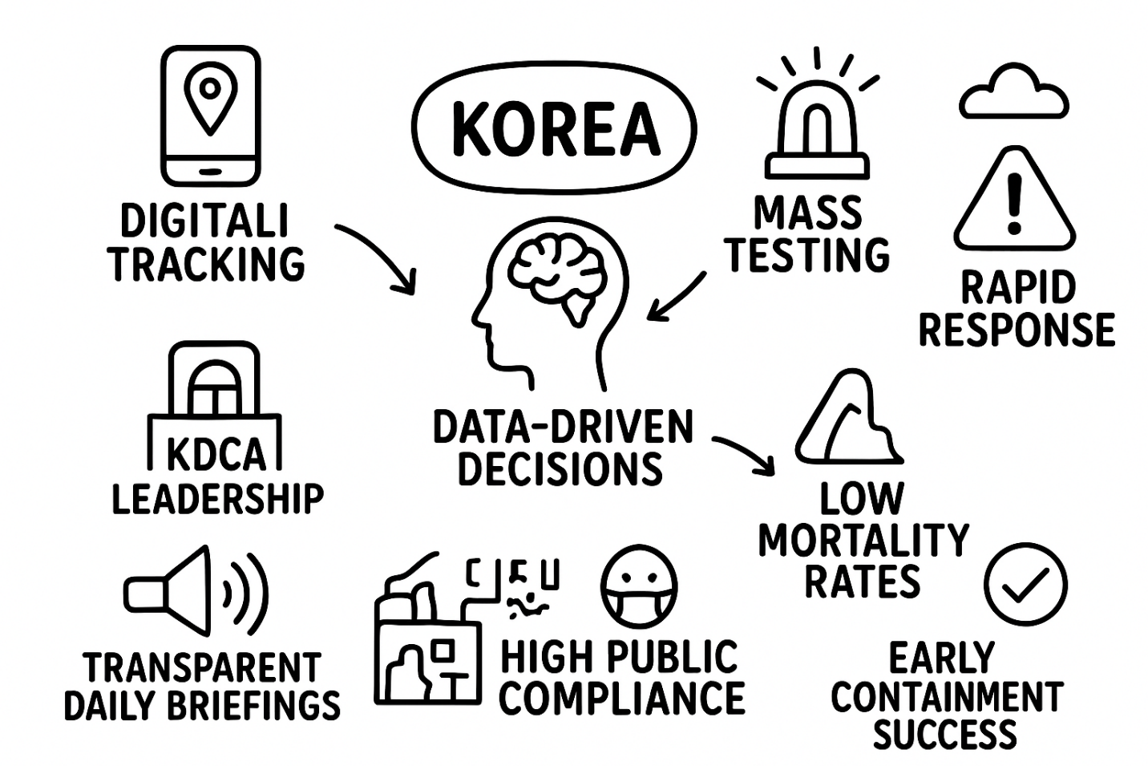
Figure 6: Rich Map for South Korea
(Source: Self-developed)
Simultaneously, distributed leadership was evident in South Korea in the form of inter-ministerial coordination of health, technology and security departments. The KDCA was a technical authority that received legitimacy and resources through the political leaders (Chu, 2025). This congruency aligns with the theory of crisis leadership, the elements of prompt decision-making, the ability to learn the lessons of past crises (the MERS crisis in particular) and promote organisational agility. Data-driven leadership was also a part of the leadership model since the decisions were based on the current case trends and demographic risks evaluation. Digital tracking as a means of adaptation to leadership also resulted in certain concerns regarding privacy.

3.2.3 Strengths and Weaknesses
The major strengths of the South Korean leadership were its ability to mobilise expertise fast, high transparency and good communication to the populace. The government continued to use regular press conferences, offered public data dashboards and created a clear and consistent message (Zhao et al., 2021). These exercises enhanced civil obedience and trust. The other strength was good cooperation between political leaders and scientific agencies that minimized political interference experienced in other countries.
One of the weaknesses was the fears of civil liberties as digital tracing was very invasive. It was an effective practice although it brought up an argument regarding the trade-off between privacy and health. Moreover, South Korea was early struggling with high-density religions groups and workplaces and this citation showed that it lacked social compliance and enforcement beyond the mainstream society.

3.2.4 Influence on Health System Outcomes
The leadership of South Korea led to superior results especially during the initial phase of the pandemic. Quick testing and contact tracing restricted the widespread and saturation of the healthcare system (Yang, 2022). The first waves of mortality were one of the lowest in the world. The coordination of leadership between agencies ensured effective use of resources whereas the use of the trust-based communication was used to ensure compliance with the formulated guidelines. Though subsequent waves were more difficult, the leadership strategy of South Korea went a long way in reducing the intensity of the effects of national health.

3.3 Leadership in Canada

3.3.1 Key Leadership Figures
Canada Prime Minister Justin Trudeau and Chief Public Health Officer Dr. Theresa Tam led the country in its response to COVID-19 at the federal level (Combden et al., 2022). The decentralised health governance structure in Canada also gave a significant role to provincial premiers and leaders of the local health. This resulted in a stratified leadership climate in which decisions made by the federal and provincial governments were often similar but different in implementation.

3.3.2 Leadership Style Analysis Using Theory
The leadership style of Canada was collaborative and situational leadership due to the necessity of coordinating with several jurisdictions. On the federal level, the leaders used the aspects of transformational leadership in the sector of the public messages about unity, empathy and shared responsibility. The consistency of the communication style of Trudeau also minimized uncertainty and it brought a sense of security during lockdowns (Farhan, 2021).
However, leaders in provinces were different in their leadership styles. As an example, some of them were more transactional with the focus on the rules, enforcement and operational choices. Some others assumed more adaptive leadership and adapted policies depending on the local epidemiological trends. This difference depicts the ideologies of federalism-based distributed leadership in which the leadership is shared but not necessarily harmonised.
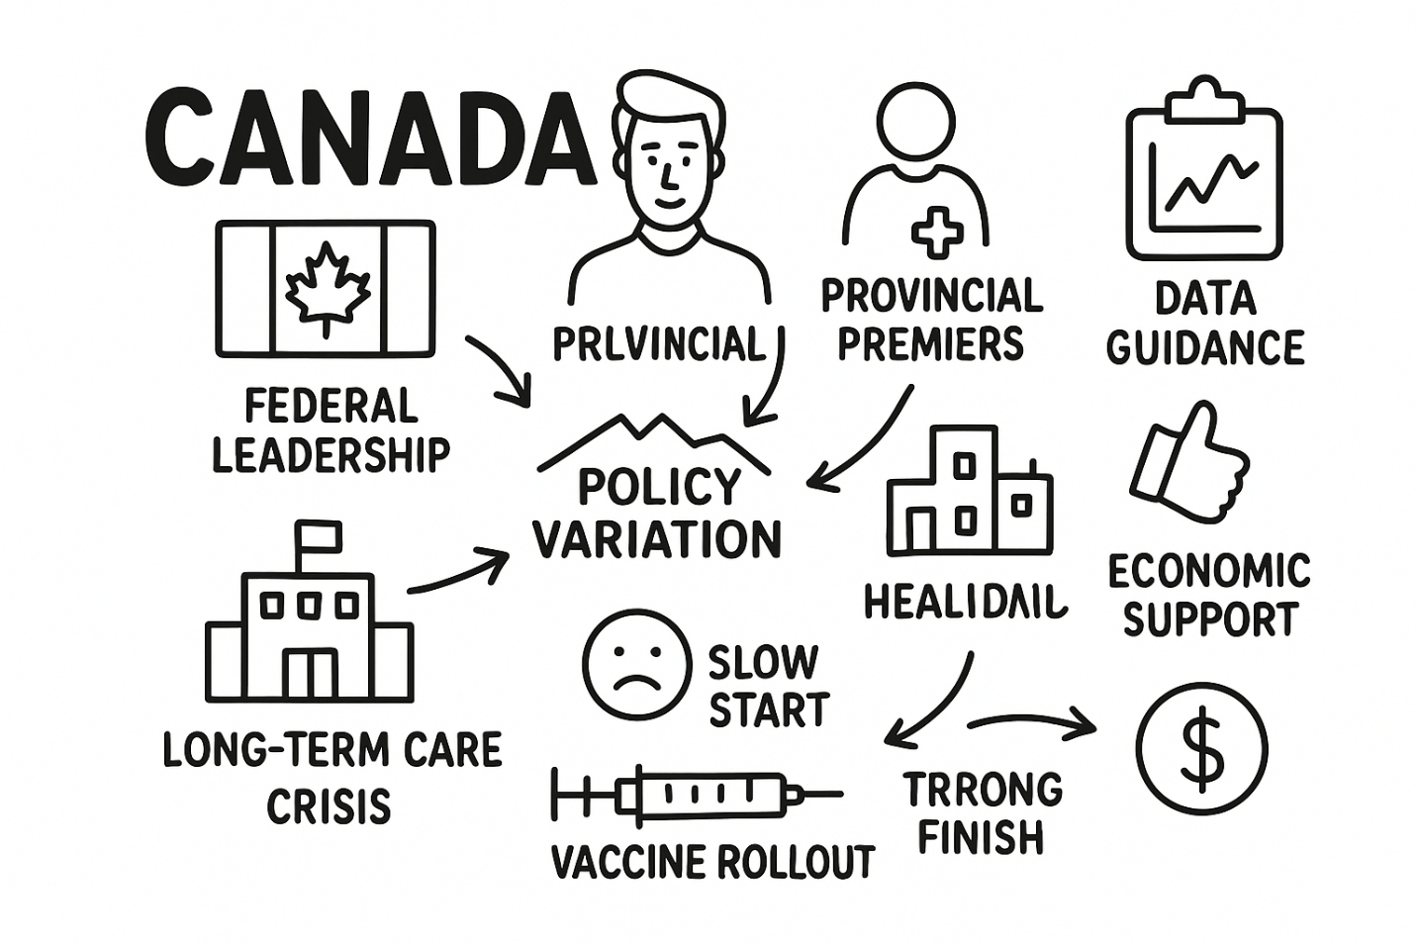
Figure 7: Rich Map for Canada
(Source: Self-developed)
The Canadian leadership followed the crisis leadership theory, at least in part, due to the use of the scientific knowledge of the country through the representatives of the public health sector who became the key communicators throughout the pandemic. Nevertheless, the coherence of getting the responses as anticipated in effective models of crisis leadership was curtailed due to political differences among the provinces and the federal government.

3.3.3 Strengths and Weaknesses
The main element of the Canadian Leadership was the overall high transparency and the use of effective or expert-based communication. Federal briefings were frequent and popular. The leadership of Canada in responding to socio-economic impacts was shown in the access of financial support in the form of wage subsidies and emergency response benefits. Divided provincial decision-making that leads to fragmented decisions especially on long-term care homes, travel limits and school closures proved to be the areas of weaknesses. Such provinces as Ontario and Quebec experienced intermittent policies and the slow pace of reaction to the major waves meaning the absence of a coherent leadership (Cameron-Blake et al., 2021). Moreover, interprovincial messaging undermined national unity and citizen trust, especially in the initial phases of the vaccination campaign.

3.3.4 Influence on Health System Outcomes
The leadership model in Canada influenced the health outcomes to some extent. The level of infection and mortality caused by the disease in provinces was extremely uneven, particularly in long-term care facilities where the lack of leadership qualities led to grave outbreaks. Simultaneously, according to the Public Health Agency of Canada (2021), Canada later obtained high vaccine coverage through federal acquisition and the trust of people towards the health officials. The decentralised leadership model enabled interventions to be tailored locally which however lacked the uniformity. This lack of uniformity slowed the process of national containment relative to other more centralised countries.

4. Conclusion
In Spain, South Korea and Canada, leadership was at the core of determining the result of the pandemic. South Korea was an example of active, integrated and evidence-based leadership styles which led to effective early containment. Spain initially showed much better leadership under the ultimate emergency rule. Canada was an example of understanding and open federal leadership but lacked provincial uniformity. The comparison reveals that effective communication, alignment of the political and scientific leaders, and the decision-making should be timely as the key to successful crisis management. Those countries that had more definite governance and leadership styles were able to have a better overall health system result.

References
Aljafari, A., 2021. Quality and efficiency of health care systems during the COVID-19 pandemic: assessment of G20 unified procurement systems for medical equipment. https://www.researchsquare.com/article/rs-844381/latest.pdf
Altmann, D.M. and Boyton, R.J., 2022. COVID-19 vaccination: The road ahead. Science, 375(6585), pp.1127-1132. https://www.science.org/doi/pdf/10.1126/science.abn1755
Asamoah, D., 2025. The role of health services regulation in healthcare delivery. ELECTR J MED DENT STUD, 14(1). https://www.ejmds.com/download/the-role-of-health-services-regulation-in-healthcare-delivery-16003.pdf
Aung, M.N., Stein, C., Chen, W.T., Garg, V., Saraswati, M., Thu, N.T.D., Gundran, C.P.D., Hassan, M.R., Suthutvoravut, U., NaingSoe, A. and Nour, M., 2021. Community responses to COVID-19 pandemic first wave containment measures: a multinational study. Journal of infection in developing countries, 15(8), p.1107. https://pmc.ncbi.nlm.nih.gov/articles/PMC9218967/pdf/nihms-1809538.pdf
Cameron-Blake, E., Breton, C., Sim, P., Tatlow, H., Hale, T., Wood, A., Smith, J., Sawatsky, J., Parsons, Z. and Tyson, K., 2021. Variation in the Canadian provincial and territorial responses to COVID-19. Blavatnik School of Government Working Paper Series, 39.https://www.bsg.ox.ac.uk/sites/default/files/2021-03/BSG-WP-2021-039.pdf
Chu, C., 2025. Effect of the establishment of the Korea Centers for Disease Control and Prevention/Korea Disease Control and Prevention Agency from the perspective of global health security. Global Health & Medicine. doi:https://doi.org/10.35772/ghm.2025.01015.
Colavitti, A.M. and Serra, S., 2021. Regional landscape planning and local planning. Insights from the Italian context. Journal of Settlements and Spatial Planning, (7), pp.81-91. https://iris.unica.it/bitstream/11584/314141/1/07JSSPSI072021.pdf
Combden, S., Forward, A. and Sarkar, A., 2022. COVID‐19 pandemic responses of Canada and United States in first 6 months: A comparative analysis. The International journal of health planning and management, 37(1), pp.50-65.https://onlinelibrary.wiley.com/doi/am-pdf/10.1002/hpm.3323
Denis, J.L., Usher, S. and Préval, J., 2023. Health reforms and policy capacity: The Canadian experience. Policy and Society, 42(1), pp.64-89. https://academic.oup.com/policyandsociety/article-pdf/42/1/64/49155773/puac010.pdf
Eaosinsup, D. and Kulachai, W., 2025. Decoding trust: How transparency, political stability, and leadership shape public confidence in government institutions. วารสาร การ บริหาร การ จัดการ และ การ พัฒนา ที่ ยั่งยืน, 3(1), pp.258-271.https://journals.plos.org/plosone/article/file?id=10.1371/journal.pone.0239247&type=printable
Farhan, B., 2021. A new strategic leadership model for surviving and coping: Lessons from Canada’s leadership approach to COVID-19. Cogent Business & Management, 8(1), p.1883221.https://doi.org/10.1080/23311975.2021.1883221
Garcia-Carretero, R., Vazquez-Gomez, O., Gil-Prieto, R. and Gil-de-Miguel, A., 2023. Hospitalization burden and epidemiology of the COVID-19 pandemic in Spain (2020–2021). BMC infectious diseases, 23(1), p.476. https://link.springer.com/content/pdf/10.1186/s12879-023-08454-y.pdf
Graefe, P. and Fiorillo, N., 2023. The Federal Spending Power in the Trudeau Era: Back to the Future. IRPP Study, (91). https://centre.irpp.org/wp-content/uploads/sites/3/2023/06/The-Federal-Spending-Power-in-the-Trudeau-Era-Back-to-the-Future.pdf
Grasser, K., 2022. Sensemaking and crisis communication: How school leaders communicate in times of crisis. The George Washington University.https://search.proquest.com/openview/14df96992933b48c7e49bc36a4f8de4c/1.pdf?pq-origsite=gscholar&cbl=18750&diss=y
Greer, S.L., Rozenblum, S., Falkenbach, M., Löblová, O., Jarman, H., Williams, N. and Wismar, M., 2022. Centralizing and decentralizing governance in the COVID-19 pandemic: The politics of credit and blame. Health Policy, 126(5), pp.408-417. https://www.sciencedirect.com/science/article/pii/S0168851022000604
Hong, S.A., 2022. Six pivotal lessons learned in South Korea for whole-of-government approach to successful COVID-19 vaccine rollout in planetary health. OMICS: A Journal of Integrative Biology, 26(10), pp.567-579.https://doi.org/10.1089/omi.2022.0064
Jarvis, T., Smith, R.W., Sandhu, H.S., Mac-Seing, M., O’Neill, M., Rosella, L., Allin, S. and Pinto, A.D., 2023. Promise and peril: how health system reforms impacted public health in three Canadian provinces. Canadian Journal of Public Health, 114(5), pp.714-725. https://link.springer.com/content/pdf/10.17269/s41997-023-00785-2.pdf
Knöbel, S., 2023. Affect, the Master Pulling the Strings: Emotional states and their influence on cognitive strategies and social polarization: A semi-automated analysis of online textual data. https://publications.ait.ac.at/ws/portalfiles/portal/38724538/MEiCogSci_MasterThesis_Affect_the_Master_Pulling_the_Strings_Knoebel.pdf
Louis, F.J., Nichols, L., de la Torre, C. and Dahourou, A.G., 2025. Strengthening outbreak detection in Africa to achieve the 7-1-7 global framework: challenges and opportunities. Public health reviews, 46, p.1608039. https://pmc.ncbi.nlm.nih.gov/articles/PMC12392278/
Machin, R., 2023. UK local government experience of COVID-19 Lockdown: Local responses to global challenges. Local Economy, 38(1), pp.80-91. https://journals.sagepub.com/doi/pdf/10.1177/02690942231181562
Martínez-Córdoba, P.J., Benito, B. and García-Sánchez, I.M., 2021. Efficiency in the governance of the Covid-19 pandemic: political and territorial factors. Globalization and health, 17(1), p.113. https://link.springer.com/content/pdf/10.1186/s12992-021-00759-4.pdf
Muttamba, W., O'hare, B.A.M., Saxena, V., Bbuye, M., Tyagi, P., Ramsay, A., Kirenga, B. and Sabiiti, W., 2022. A systematic review of strategies adopted to scale up COVID-19 testing in low-, middle-and high-income countries. BMJ open, 12(11), p.e060838. https://bmjopen.bmj.com/content/bmjopen/12/11/e060838.full.pdf
Navarro, C. and Velasco, F., 2022. From centralisation to new ways of multi-level coordination: Spain’s intergovernmental response to the COVID-19 pandemic. Local Government Studies, 48(2), pp.191-210.https://doi.org/10.1080/03003930.2022.2042683
Oliveira, R., Santinha, G. and Sá Marques, T., 2023. The impacts of health decentralization on equity, efficiency, and effectiveness: a scoping review. Sustainability, 16(1), p.386. https://www.mdpi.com/2071-1050/16/1/386
Public Health Agency of Canada., 2016. Immunization Partnership Fund - Canada.ca. [online] Canada.ca. Available at: https://www.canada.ca/en/public-health/services/immunization-vaccine-priorities/immunization-partnership-fund.html.
Quaggia, D., Votta, M., Evans, S., Moya, E., Fava, V. and Nicoletti, T., 2024. Enhancing Lifelong Vaccination: Insights from Spain, France and Italy. Journal of Medical Case Studies, 2(1), pp.1-6.https://medwinpublisher.org/index.php/JMCS/article/download/1832/1658
Salvador, M. and Sancho, D., 2023. Local governments facing turbulence: robust governance and institutional capacities. Social Sciences, 12(8), p.462. https://www.mdpi.com/2076-0760/12/8/462
Yang, C., 2022. Digital contact tracing in the pandemic cities: Problematizing the regime of traceability in South Korea. Big data & society, 9(1), p.20539517221089294.https://doi.org/10.1177/20539517221089294
Yen, W.T., 2025. Leveraging Coordination Capacity: Medical Resource Mobilization in Asia’s Developmental States During COVID-19. Journal of East Asian Studies, pp.1-20.https://doi.org/10.1017/jea.2025.3
Zhao, B., Kim, M. and Nam, E.W., 2021, November. Information disclosure contents of the COVID-19 data dashboard websites for South Korea, China, and Japan: A comparative study. In Healthcare (Vol. 9, No. 11, p. 1487). MDPI.https://doi.org/10.3390/healthcare9111487

