What do I know already / What have I learnt so far?

Have over 10 years’ experience in a Ks2 setting. Where I have attended many courses including: Safeguarding, First Aid, Dyslexia training, THRIVE, Behaviour support, ALN training, PECS training. I was also part of the improvement in reading and literacy scheme within cluster schools in Swansea, implementing programs to enhance children’s reading ages and understanding. I have attended RWI training, maths catch up and up to date with the new curriculum and polices.

What do I want to develop?

Improve confidence and knowledge in my ICT skills.
Improve my Harvard Referencing in assignments.
Gain knowledge in sensory Needs with ALN children.
Improve communication with non-verbal children using PECS and communication boards.

Objective | Actions (How will I achieve this objective/ what needs to be done?) | Resources (What support and resources are needed to achieve this objective?) | Target Date for achieving objective. | Success criteria (How will I know I have achieved this goal; how will I review this?)
Improve and become more confident in my ICT skills. | Watch helpful videos on you tube that explain step to step guides how to do something.  Get help from the university library. | Support from peers,  discussing problems and techniques.  Book an appointment with digital skills from the university library. | Within the month  01.11.2023 | Practice my skills independently that I have gained and use in future assignments and research.  Check I have fully understood and question any ongoing issues with others.
Complete Sensory needs Practitioner Training. | Discuss with my boss/ headteacher if I can go/complete the Sensory needs practitioner training course and book training day. | Liaise and talk with other staff members about the benefit of the course and knowledge for the children in our class and suggest a suitable time to complete course. | Within 3 months.  01.01.24 | Attended the course and be implementing new skills and strategies within the class, discuss with colleagues if skills are achieved and children gaining and progressing from new ideas.
Improve my Harvard referencing in assignments. | Ensure I follow the Harvard referencing handbook when referencing and check.  Use the online library and book an Academic and InfoSkills Appointment. | Use the website cite them right to gain a deeper understanding and check that my referencing is correct. | Within a month.  01.11.23 | Use knowledge gained in upcoming assignments and check the lecturers feedback to ensure my referencing is correct, or what improvements I still need to make.
Improve communication with non-verbal children in the classroom and school by improving my knowledge of PECS and communication boards. | Refresh my PECS (Picture Exchange Communication System) training by either attending more courses or working with the speech and language practitioner on new techniques and skills.  Watch videos on YouTube regarding PECS. | Liaise with Speech and language practitioner when she attends and discuss with her options of a refresh course or tips and advice on current children within the classroom.  Ensure I have the correct PECS available to help the children communicate effectively. | Within 3 months  01.01.24 | Implement these skills and techniques with colleagues and within the classroom and discuss improvements of communication between children and the use of PECS and alter accordingly.
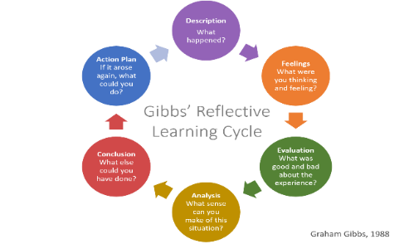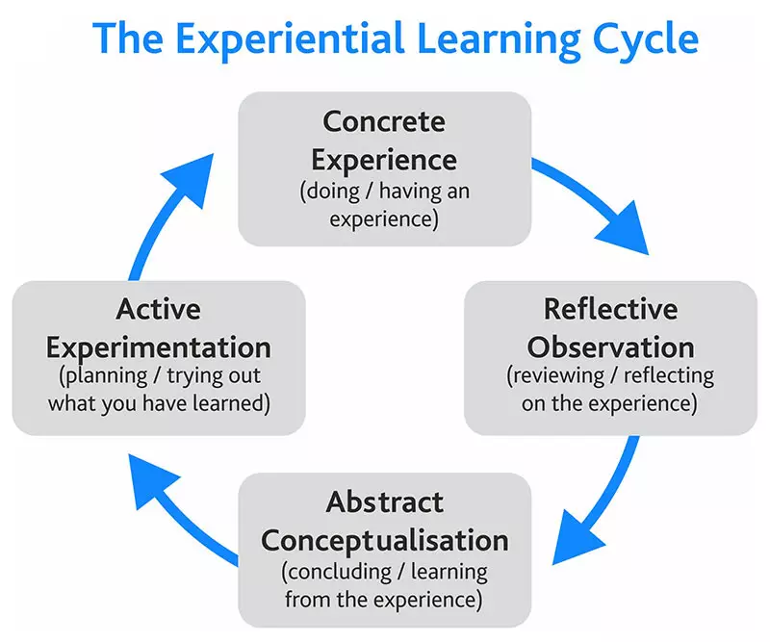
Reflective practice is important in early years as the Welsh Government want to raise the standard in schools, particularly in early years, to improve children’s outcomes in later years. To invest in good quality teaching and care providers, by ensuring they play an active role in their own professional development, reflecting on their skills and experience to enhance the standard of care within their role. (Social Care Wales 2017) Abiding by the National Minimum Standard and Early Years Framework to ensure all children learn and develop well by ensuring professionals working with children follow the framework. (EYFS 2023)
Reflection and reflective practice are essential for practitioners to reflect on their skills and understanding to continue to adapt and improve. Reflection is the ability to look upon a person’s own actions and evaluate what they did, why they did it and how they could improve it. Brookfield (1995): and Thiel (1999) explain that reflective practice is a continuous cycle of viewing what actions were taken, why and reflect on what they would do differently next time to refine and improve themselves as professionals and learners. Understanding that learning is a continuous cycle of adaptation and benefits not only the practitioner but those who they are working with.
“Reflective practice is the process of thinking about and analysing your practice, with the aim of challenging, changing, modifying, developing and improving it. This should be a continuous cycle of reflection and improvement. (Pacey, 2016)
Reflective practice plays an essential part in personal development, whether a practitioner uses Kolbs or Gibbs learning cycle, the fundemental importance of reflecting on ones actions remain the same, as dewy expalins that “we do not learn from experience, but reflecting on experience.”( Dewey 1933). It is essential that all practitioners working with children abide by the Legistlation and Standards and include reflective practice in their everyday roles.
Both Gibbs and Kolbs reflective learning cycle allow structure to reflective practice, encouaging individuals to reflect on experiences, both reflective models enable practitioners to process, scrutinise and learn from situations, allowing areas of personal development and growth. However they contain key differences, Kolbs learning cycle focuses on experimental learning, the learning process, emphasising the importance of observing, reflecting and the development of new ideas and suggestions. Its an in depth analysis as well as a continuous learning cycle, it benefits from being flexible, to reflect and apply in many different situations, developing social awerness and understanding. Although many practitioners claim this can be time consuming and requires practitioners to trail their new approch to see if sucessful and if not repeat the process. (Kolb 2015) Whereas Gibbs is focused on what went wrong and problem solving and what decisions were made. Gibbs is a more structured approach, analysisng reflection in a systematic way, it includes how an individual was feeling, as feelings can sometimes be overlooked although they play a significant part in why a decision was made at the time. Gibbs’ cycle is more simplistic, allowing practitioners to write reflective practice in a journal or diary, its less detailed and more about finding a solution or goal. However, Gibbs’ cycle is critised for not allowing deep reflection therfore not ensuring reflection will result in change. (Open University 2014)
Kolbs Model of reflection is another learning cycle used for reflective practice he again believed in transferring experience into knowledge, his cycle however only consists of four stages, it begins with Concrete Experience, here Kolbs recognised that in order for an individual to acquire new knowledge, they have to actively have expereince and engage in a task not just read about it. Next is Reflective Observation, where a practitioner reflects upon the task or situation, allowing the practitioner to ask questions and discuss experiences with collegues, communication is vital and it allows practitioners to have a detailed understanding of the situation. Following this Abstract Conceptulisation- this step is where an individual draw conclusions reflecting on their knowledge and theories from colleuges, making comparisons on previous ideas and analysing the event. Lastly in the cycle is Active Experimentation- here practitioners, return to a previous task or situation but with a modified goal or objective, this is to analyse if the appropriate changes that were made were a sucsess and if not repeat the cycle as with any learning cycle, it’s a continuous cycle of adaptation and learning. (Kolb 1984)
How to implement reflection in practice can be achieved by following Models of reflection, one of the most famous models of reflection was created by Gibbs in 1988, he created a cycle to give structure to learning from experiences, these include 6 stages: Description- explaining what happened, Feelings- what your thoughts are about the experience, here Gibbs wants a professional to understand what they were feeling and how that initiated a certain response, Evaluation- allowing a practitioner to look at both the poor and the good decisions. Analysis- why those decisions were made and making sense of a situation. Conclusion- this allows professionals to look at what they have learned and what could be altered, Action Plan- How to respond to similar experiences in the future better or make appropriate changes
The theory of reflection and reflective models were created by Dewey and Schon over a century ago, Dewey states the importance of practitioners reflecting on their practice, Dewey explains that reflection is a way of processing events that have occurred, discussing with colleagues why particular events have led an individual to make certain a decision. (Schon 1983)
Dewey explains that reflective practice is defined by two segments, Routine action and Reflective action. Routine action is followed by habit, adhering to policies or guidelines, this is a more static and unlikely to change model. However reflective action is contrast to this, it allows self-evaluation, to question whether you can control or change the outcome and a way of developing from experiences and growing as a practitioner. (Dewey 1933)
This is similar to Schon’s theory of reflective practice, he divides reflective practice into two parts: Reflection in action and Reflection on action, here he identifies that reflection in action is an instant response when something happens, conversely reflection in action is a more in-depth analysis of what happened and how a practitioner could change and improve situations for the future, enabling them to become better practitioners. (Schon 2016)
.

References
Care Wales (2017) Continuing Professional Development Principles for the early years and childcare workforce in Wales, Care Council for Wales Cardiff
Brookfield (1995): and Thiel (1999)
Locating Article...
Leontiev’s Theory of Activity and Donald Schön’s Reflective Professor: reflections on teacher education
Acta Scientiarum : Education
Yaegashi, Solange Franci Raimundo; Shigunov Neto, Alexandre; Ruiz, Nathália Fafarão; Gasparin, João Luiz
Vol. 43, p. e48355, 2020.
Reflective Practice in Early Years Education Copyright © 2022 by Sheryl Third, RECE; ECE.C, B.A., M.A is licensed under a Creative Commons Attribution-NonCommercial-ShareAlike 4.0 International License, except where otherwise noted.
PACEY (2016) Developing Self Reflective Practice. Available at: https://www.pacey.org.uk/Pacey/media/Website-files/PACEY%20member%20practice%20guides%20(PDFs)/PG04-self-reflective-practice.pdf (Accessed: 25th July 2023).
Schön, D. (2016) The reflective practitioner : how professionals think in action. England: Routledge
University of Cambridge Libraries (No Date). Models of Reflection. Available at: Models of reflection - Reflective Practice Toolkit - LibGuides at University of Cambridge Subject Libraries
Gibbs G (1988). Learning by Doing: A guide to teaching and learning methods. Further Education Unit. Oxford Polytechnic: OxfordGibbs' Reflective Cycle | The University of Edinburgh

Kolb’s Experiential Learning Theory & Learning Styles - Educational TechnologyModels of reflection - Reflective Practice Toolkit - LibGuides at University of Cambridge Subject Libraries

Experiential Learning: Experience as the Source of Learning and Development Hardcover – 23 April 2015
by David Kolb (Author)

Early years foundation stage (EYFS) statutory framework - GOV.UK (www.gov.uk)

